

BSc (Hons) Health and Social Care

Psychopathological Classifications & Provisions
Module code – 6029 – BIRM
Lecturer – Neale Haddon

Component 1 – Individual Presentation Schizophrenia

Student - Claudia Gomes
Student No - 232679
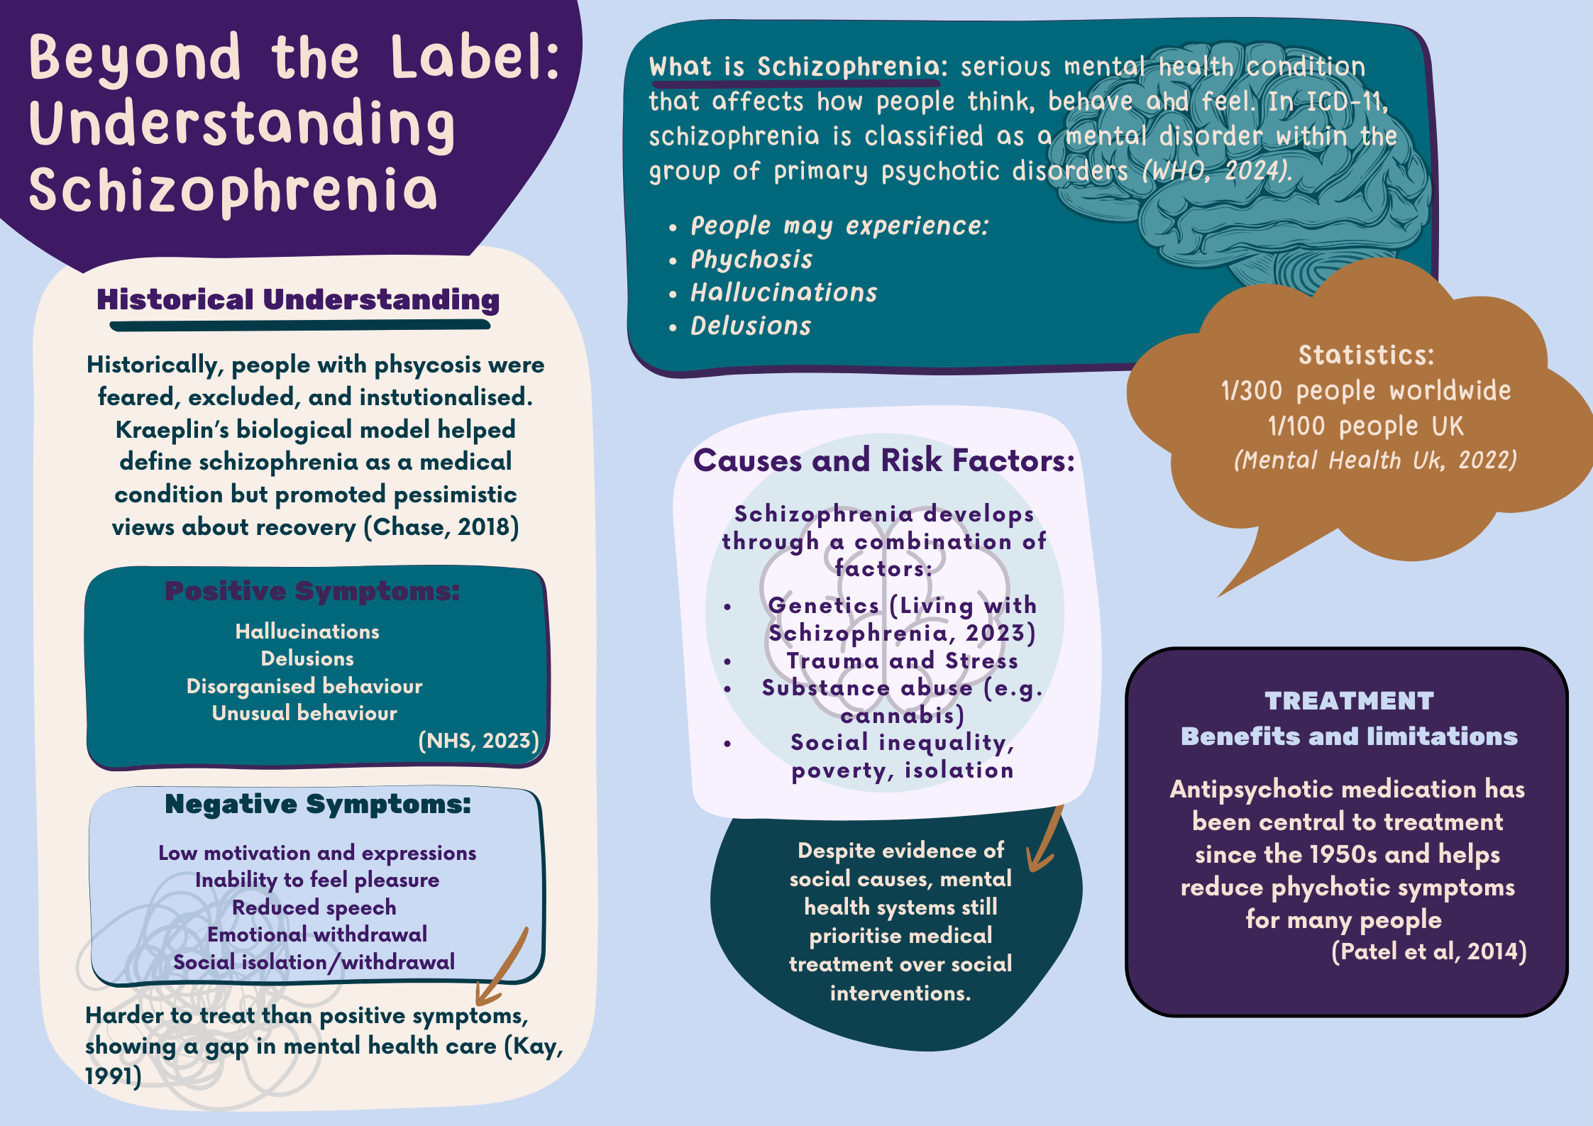
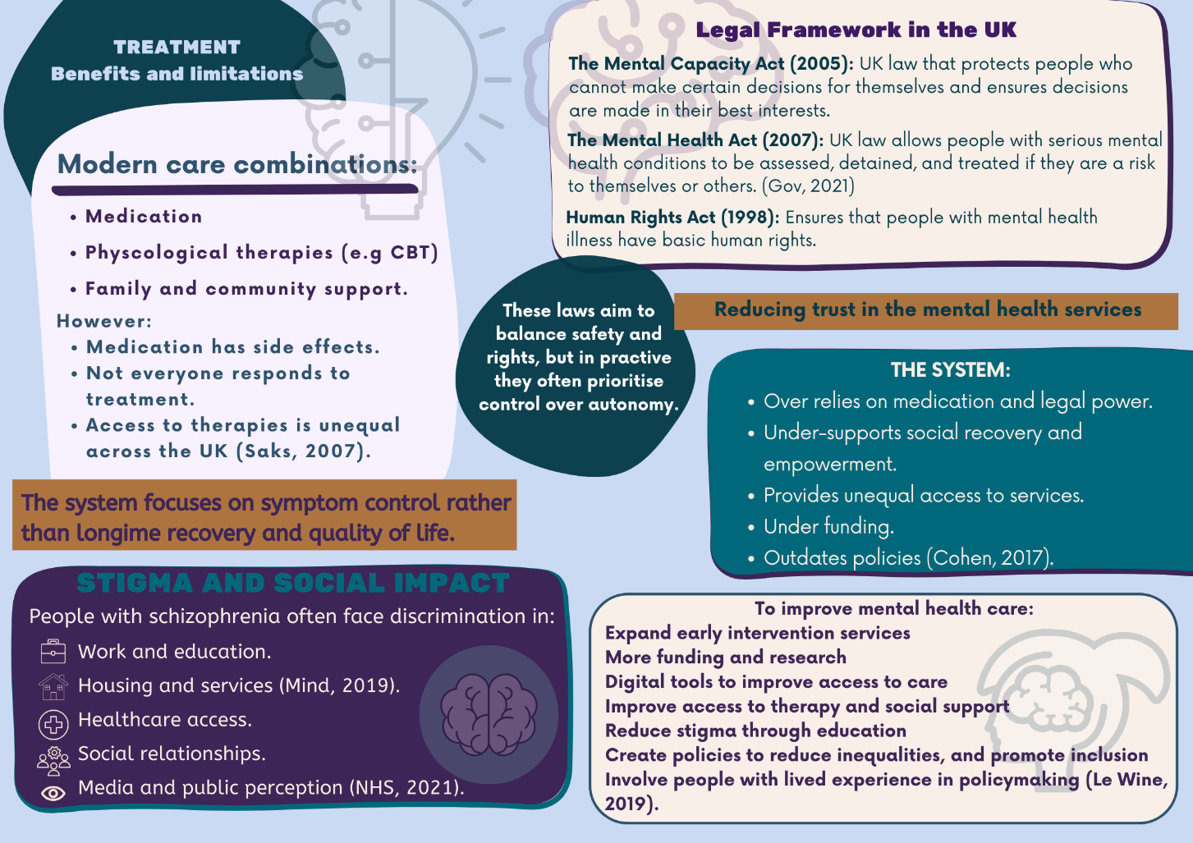

References
- Chase, R. (2018) The making of modern psychiatry. Logos Verlag Berlin.
- Cohen, N.L. (2017) Public health perspectives on depressive disorders. Baltimore Johns Hopkins University Press.
- GOV.UK (2021) Mental Health Act 2007 - Explanatory Notes, Legislation.gov.uk. Available at: https://www.legislation.gov.uk/ukpga/2007/12/notes/division/6/1?view=plain.
- Kay, S.R. (1991) Positive and negative syndromes in schizophrenia : assessment and research. Brunner/Mazel.
- Living with Schizophrenia (2023) Living With Schizophrenia | Information & Support, Living With Schizophrenia. Available at:
https://livingwithschizophreniauk.org/.(Accessed 29.01.2026).
- Le Wine, H.E. (2019) Schizophrenia - Harvard Health, Harvard Health. Available at: https://www.health.harvard.edu/mind-and-mood/schizophrenia-a-to-z.
- Mental Capacity Act (2005) Mental Capacity Act 2005, www.legislation.gov.uk. Available at: https://www.legislation.gov.uk/ukpga/2005/9/part/1
- Mental Health UK. (2022). Schizoaffective Disorder - Mental Health UK. [online] Available at: https://mentalhealth-uk.org/help-and-information/conditions/sch [Accessed 29 Jan. 2026].
- NHS (2021) Living with - Schizophrenia, nhs.uk. Available at: https://www.nhs.uk/mental-health/conditions/schizophrenia/living-with/
- NHS (2023) Symptoms - Schizophrenia, nhs.uk. Available at: https://www.nhs.uk/mental-health/conditions/schizophrenia/symptoms/ (Accessed 27.01.2026).
- Patel, K.R. et al. (2014) ‘Schizophrenia: Overview and Treatment Options’, Pharmacy and Therapeutics, 39(9), p. 638. Available at: https://pmc.ncbi.nlm.nih.gov/articles/PMC4159061/.
- Saks, E.R. (2007) The Center Cannot Hold: My Journey Through Madness. Hachette Books.
- Understanding schizophrenia | Mental health problems | Mind (2019) Mind.org.uk. Available at: https://www.mind.org.uk/information-support/types-of-mental-health-problems/schizophrenia/understanding-schizophrenia/#ProblemsWithDiagnosingSchizophrenia (Accessed: 27 January 2026).
- World Health Organization (2024) International Statistical Classification of Diseases and Related Health Problems (11th ed.), Chapter 06: Mental, Behavioural or Neurodevelopmental disorders. Available at: https://icd.who.int/browse11/l-m/en#/http://id.who.int/icd/entity/1410080352 (Accessed 27.01.2026).

