Key aspects of Commissioning.
Student:
Thomas Hughes.
Student number:
1909575
Teacher:
Dr P Holden.
Course:
Plant Operations and Performance.

Introduction.
The subject of this assignment concentrates on the initial aspects of pre-commissioning, following systematic and professional methodologies to ensure the safe and efficient handover of a fully integrated unit ready for further commissioning activities.
During the assignment I will discuss the planning, mechanical completion and pipe and instrument diagram checking of a key piece of machinery new to the Zimmer Biomet manufacturing plant at Bridgend.
Being a medical device company, cleanliness of products is of the upmost importance. The commissioning of this plant will upgrade our ability to provide clean and quality parts with the sole focus on alleviating pain and improving the quality of life for people around the world.

Planning the project:
At the start of the commissioning of any new Plant it is important to consider many factors; the use of proven methodologies will ensure the new plant is safe to use and efficient when handed over to production.

Scope:
To establish a comprehensive list of items / actions that will occur in order to facilitate the installation of the Solvac S2-1812 Vapour Degreasers in the End of Line Value stream at Zimmer Biomet’s Bridgend site, whilst conforming to CP01100 Operation Project Plan procedure.
The installation of the Solvac S2-1812 Vapour Degreasers are new to the Bridgend site and its purpose is to align with Processes similar to ones used in our Sister plant at Warsaw, Indiana, USA.
The installation of the Solvac S2-1812 Vapour Degreasers will help facilitate the removal of manufacturing residues and microbial contamination, effectively lowering the overall cleaning burden of the Final sterile passivation wash.
This contamination reduction will facilitate alignment to the Global Engineering Specification GES09802 Device Residual Materials and Endotoxin Limits.

The Approach:
Included in the scope of the project.
- Revise the Master Validation plan (MVP). The MVP defines the processes and equipment that require validation and the priority and order for completion. Working in a heavily regulated organization it is important to complete this correctly to remain compliant.
- Create the Operation Project Plan.
- Review all risks.
The most important stage during the commissioning of any new plant, not only that the plant is installed safety but that during the producing phase all risks have been identified, documented and actioned accordingly.

The Hazard and Operability study is a key and important part of commissioning and time and effort must be placed when completing these checks throughout all phases of the commissioning.
Various stages of Hazard and Operability Study are generally undertaken. Summarised in the following table:
HAZOP study | Description
1 | Identify major hazards and check for availability of key hazard data
2 | Coarse HAZOP using flowsheet and block diagram
3 | Full HAZOP on frozen P&I diagram
4 | Check that all intended actions have been implemented, including hardware and software
5 | Pre-commissioning check including statutory requirement
6 | Safety audit after a few months operation

https://www.hse.gov.uk/comah/sragtech/techmeasplantmod.htm

Quality Plan Risk Analyses form to be completed and any control measures actioned immediately.
Review the Vendors Design Risk Assessment EN ISO 12100:2010 to identify risks; this will also help create any future risk assessments.
COSHH assessment for the solvent being used – 3M Novec 72DA.
- Plan and prepare location of the new plant.
- Installation of equipment services. (Any pipes or wires that are required for the plant to run)
- Plan documentation. Generate Installation Qualification, Work Instructions, Standard Operating Procedures, Process specifications and all relevant documents required for the installation and validation of the new plant. Do not underestimate this stage.
- Installation of the Solvac S2-1812 Vapour Degreasers.

- Conduct engineering performance study.
- Resource plan – Identify team members required to support the OPP, (i.e. Process Engineer, Maintenance, H&S, Validation Engineer, Quality etc. and length of time required for commissioning support.
- Scheduling - Identification of high-level project plan / milestones and planned completion dates for which the project can be measured against.
- Communication Plan – Plan for project status meetings with working and steering Committees. Ensure that the status of the plant commissioning is reviewed at the site’s Management Review.
- Plan for testing equipment i.e. Temperature probes and ultrasonic testing equipment.

Mechanical completion
Mechanical Completion is the phase of Commissioning where the new plant is installed in accordance to the drawings and contract, ready for pre-commissioning activities to commence.
It is imperative to consider the contents within the contract and define the responsibility of both the vendor and commissioning team. This is not be underestimated.
The single most important item that must be instigated is to understand exactly what the commissioning team is responsible to deliver with regard to the contract. No early activity in the commissioning phase should be given as much emphasis as allocating the right amount of hours to read through the contract comprehensively and gain a full appreciation of the implications, seeking clarity on potentially questionable areas, so all parties are fully aware of the scope and boundaries of responsibility of the commissioning organization.(Killcross, 2012 p.10)

A detailed punch list compiled to capture all installation activities, some of which are:
Piping installed as per the drawing, pipes are then leak checked, before being cleaned to remove all contaminants.
All electrical equipment installed, tested and verified using calibrated equipment
Verify that the plant is CE marked.
Ensure when installed, enough space is left for maintenance activities.
Verify the installation environments meets the following equipment requirements:
Ambient Temp <26°C
Humidity <70% RH
Check start up and shut down procedures.
Verify all E-Stops work and that the quantity and location are suffice from an Operators point of view.
Any deviations must be documented, and then reviewed by a Quality representative to remain compliant.

Pipe and Instrument Diagram Checking.

What to check:
This phase of commissioning must be taken extremely seriously. Ensuring that the documents provided are not only correct but to the latest revision. The commissioning engineer should sit and understand the P&ID diagram to understand what requires checking. Missing an integral part of the plant could have an adverse effect during the start-up phase.
Creating a detail punch list will ensure that all checks have been completed and passed to the required standard. All checks documented and completed with calibrated tooling.
Quality time invested at the review stage can only help the commissioning team’s total effectiveness throughout the project. (Killcross, 2012 pg.32)

Below are steps to consider when checking the Pipe and Instrument Diagram:
- As always, safety should be the first consideration. Did the vendor install it safely? Can the machine be operated safely?
- Check for damage of housing unit, tanks, access panels and frame work.
- Walk through all pipe work and valves, checking for defects or leaks. Check that fluid containment is available to contain liquid in case of any minor/major leaks.
- Check all cables for damage.
- Check that all services i.e. Electricity and air supply can supply the correct level of voltage and bar.
- All equipment checked thoroughly for damage.
- Ensure all valves are in the correct position prior to start up.
- Repeat start up and shut down procedures.
- Label key valves and equipment.

Once the Machine is started, further checks are required to ensure tanks are capable of performing to the correct parameters.
Temperature of all four sections of the degreaser to be checked with a calibrated probe.
Ultrasonic generators checked and tested to ensure strength is suffice.
Human interface checked for damage and workability.
Check all safety and alarms are visible and working.

Introduction to the Solvac S2-1812 Vapour Degreaser.

Theory of Operation.
The Solvac S2-1812 ultrasonic vapour degreaser is designed and tested for use with non-flammable, EPA approved solvent 3M Novec 73DE. This solvent provides excellent cleaning and drying results.
The vaporisation and condensation of the solvent is the driving force to move solvent throughout the system. This process, known as distillation, ensures that the dirtiest solvent is concentrated in the vapour generator.
The condensed distillate gravity drains into the process sump, which cascades into the vapours generator (boil sump).
As parts are lowered into the cleaner, solvent condenses onto the parts, rinsing them. Ultrasonics create vapour bubbles in the liquid which generate high pressure jets of solvent when they implode, and it is this action which helps remove particulates at a submicron level.
A final rinse takes place in solvent vapours as the parts are removed from the process tank.
Solvent remaining on the parts volatises and drops back into the tank when moved into the Freeboard Zone; located just above the Vapour Zone.

Diagram one: System overview.
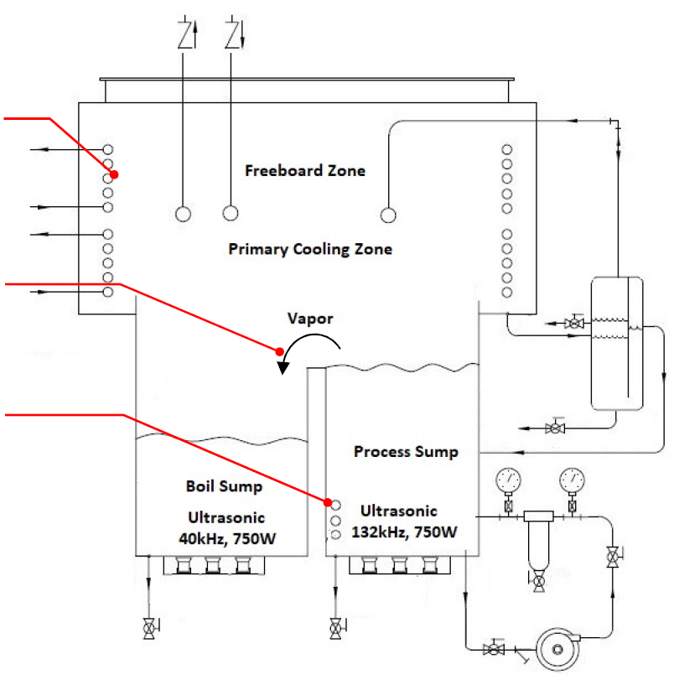
Solvent flows over the weir and into the boil sump.
These Coils condense free solvent above the vapour line reducing the concentration in the upper enclosure.
The cooled vapour condenses and drains back into the process sump as distilled solvent.

Diagram two - Solvac S2 low line plumbing P&ID.
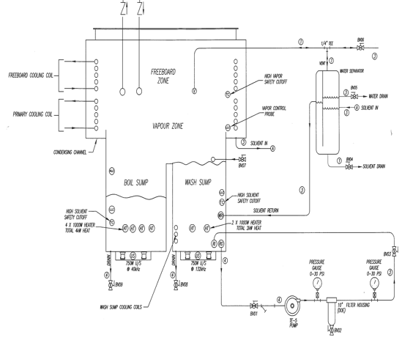

Wash cycle detail. As Per PS No 154. Rev1.
The wash process consists of one fully automated cycle containing three Stages.
- Immersion, 2. Vapour Rinse & 3. Freeboard Dry.

- Immersion: From the load position at the top, the hoist lowers and submerges the parts fully into the ultrasonic cleaning tank (position 1) as shown in diagram 1 above. The ultrasonics are activated for the full duration of the immersion stage.
Parameter | Set point | Lower Tol. | Upper Tol.
Time (s) | 240 | 230 | 250
Power (w) | 750 | 700 | 800
Agitation | None | N/A | N/A
Tank Temperature (ºC) | < 48* | N/A | N/A

- Vapour Rinse: Once the immersion stage is complete, the hoist raises to the vapour zone (position 2). Due to a small difference in part temperature compared to vapour temperature, solvent vapour condenses on the surface of the parts and flows off and back into the tank creating a rinse action, this rinse action continues until the part temperature equals the vapour temperature. The rinse stage is now complete.
Parameter | Set point | Lower Tol. | Upper Tol.
Time (s) | 120 | 110 | 130
Power (w) | 750 (500 + 250) | 700 | 800
Vapour Temperature (ºC) | 38 ** | N/A | N/A

- Freeboard Dry: The parts then move into the freeboard-drying zone (position 3). Here the residual solvent evaporates from the surfaces of the warm parts and is re-condensed when it makes contact with the cool surfaces of the freeboard zone. The re-condensed solvent flows back into channels and is processed through a water separator and filtration system before being returned back into the cleaning tank. Once the drying stage timer has elapsed, the cycle has finished and parts are ready to unload.
Parameter | Set point | Lower Tolerance | Upper Tolerance
Time (s) | 30 | *N/A | *N/A

Services required:
Electricity: The Solvac S2-1812 Vapour Degreasers requires a Supply Voltage ranging from 390 – 420V, Frequency of 50Hz. All of which to be tested with a calibrated Test Meter, and documented within the Installation Qualification.

Air Supply: The Solvac S2-1812 Vapour Degreasers requires 5Bar of dry and regulated air pressure. Air supply is tested using a calibrated pressure gauge and documented within the Installation Qualification.

Before introducing any chemicals to the plant all safety precautions must be considered and any hazards actioned and documented.
Health and Safety precautions:
COSHH
Consideration of the solvent used for the initial fill of the Solvac S2-1812 Vapour Degreaser must be taken in to consideration. It is imperative to read the MSDS sheet and create a COSHH assessment to detail any hazards prior to anyone using the solvent. This will detail all hazards and ensure sufficient control measures are in place.
The solvent used is 3M Novec 72DA Engineered Fluid.
During the assessment, it was identified that the above solvent could cause drowsiness or dizziness if exposed to solvent vapours as well as irritation to skin and eyes if made contact.
The release of vapours from the tank are minimised via two refrigeration systems, which condense any solvent and keep a cap of cold air above the vapour. If the refrigeration fails, pressure switches on the cooling system will switch off power to the heat if pressures exceed set points minimising the escape of solvent.
Strict gowning procedures of the area must be adhered to; anyone who enters the wash is to be gowned as detailed below.
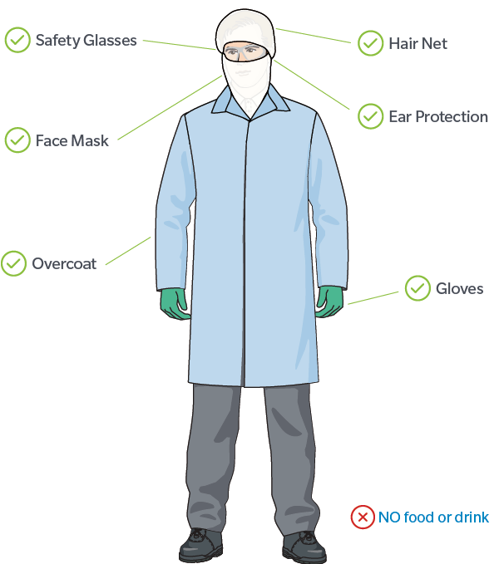

Prior consideration of Plant location is essential, detail of this should be captured during the planning phase. Ensure the degreaser is located within a well-ventilated area to minimise Vapour inhalation.

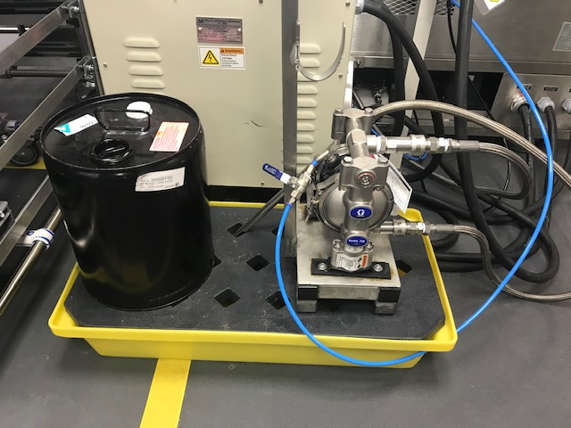
To reduce contact with the solvent, an external pump was fitted to top up and remove solvent when needed.

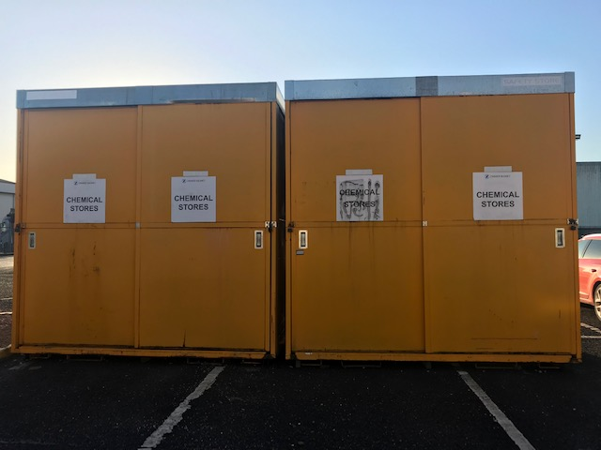
Any stock held of 3M Novec 72DA Engineered Fluid is managed via RM Stores and kept inside the Chemical Storage area.

Manual Handling.
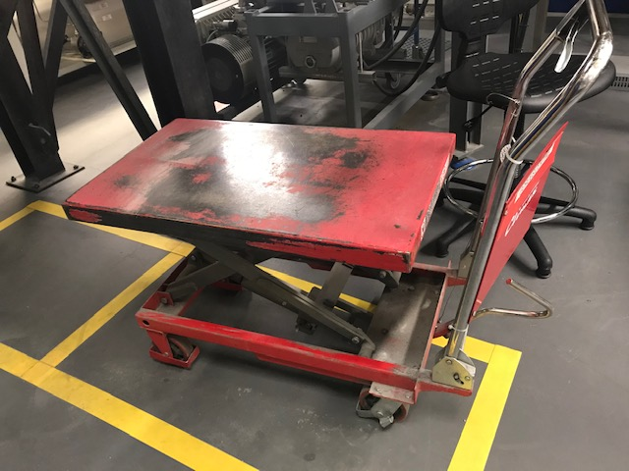
Manual handling is a risk when requesting barrels from RM stores. Each drum weighs approx. 22.7kgs.
To request these drums from RM stores two persons have to be available and use the supplied trolley to transport drums to and from area.

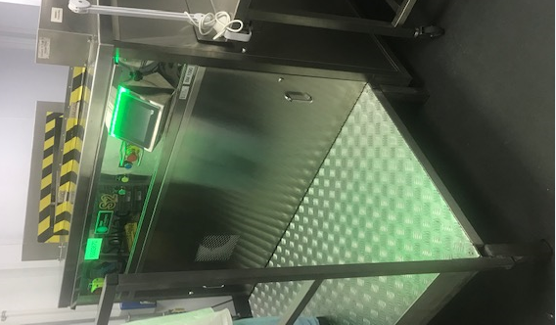
All batches that are put through the wash weigh up to 3kgs. Due to the height of the wash, most Operators are likely to have to lift this weight above shoulder height, due to the frequency of this task throughout any given shift a raised platform was installed to minimise risk so there was no lifting above waist height.(see picture)

Description and purpose of the recirculation filtration System

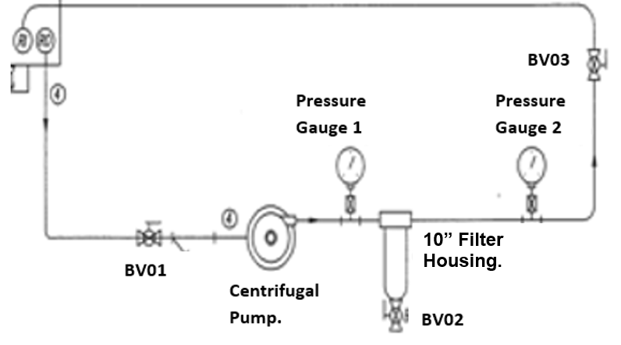
Ball Valve Key:
Item | Size | Function | Status
BV01 | 3/4" | Wash Sump Recirculation Suction | Normally Open
BV02 | 1/4" | Filter Drain | Normally Closed
BV03 | 1/2" | Wash Sump Recirculation Discharge | Adjustable

Critical Equipment:
Centrifugal pump
10“Filter housing.
Pressure Gauges 0-30psi.

Recirculation Filtration system purpose.
A filtered recirculation loop driven by a centrifugal pump provides the process sump with filtered solvent. The recirculation loop has a filter housing containing a 10-micron filter to remove any debris or contaminants that may be apparent from the manufacturing processes.

Impellers within the pump rotate to drive solvent through a ¾” stainless steel pipe, solvent is then pumped passing through pressure gauge 1 then through the filter housing containing a 10-micron filter. Solvent now passes through a smaller ½” pipe and through pressure gauge 2.
The cycle is repeated continuously until filters require changing. If the pressure between gauge 1&2 is greater than 5bar, this is the indication that the filters and blocked and require changing.

Details of how to complete this will be written and documented within the process specification. Ball valves are labelled to aid operators with the change. (See below)

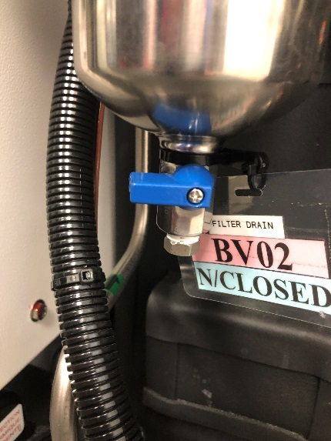
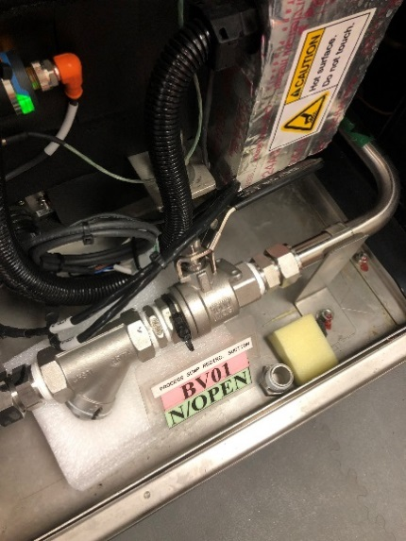
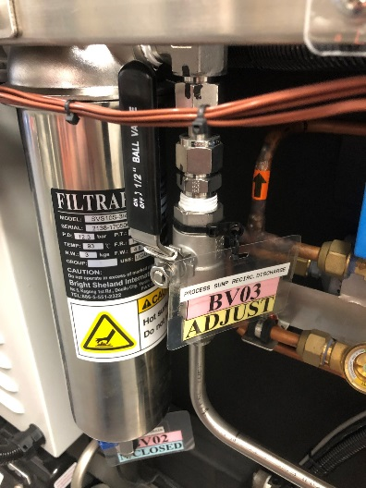

With all the above being stated, I want to stress one vitally important starting position about commissioning; this is to categorically state, that to be a critical factor to the success of a project… Commissioning is NOT just turning up the day after construction is complete and pressing the BIG GREEN BUTTON!
(Kilcross, 2012)

Bibliography.
Zimmer Biomet Documents:
PS no 154, Solvac S2 Degreaser Rev 1. Oct 2019
I001667, Washroom & Box Label Entry, Rev 2. Jan 2020.
I001740, S2 DEGREASER – DETAILED OPERATION MANUAL Rev 1, Oct 2020

Other sources:
Kilcross, M. (2012) Chemical and process plant commissioning handbook 1st ed. Oxford: Elsevier Ltd
Advanced ceramics technology instruction manual 3T2C-IM-0.2, Revision 0.2, 2019.
https://www.commissioningcoach.com
https://www.hse.gov.uk

