

Osvaldas Stanelis

1802408

Data and Information Systems
(Databases and Application Development
ACCA5026)

22.01.2021

The Smile Factory

“The Smile Factory” is a local private dental and orthodontic surgery. The surgery realises it is time to computerise. Our task to make a database to improve surgery system.
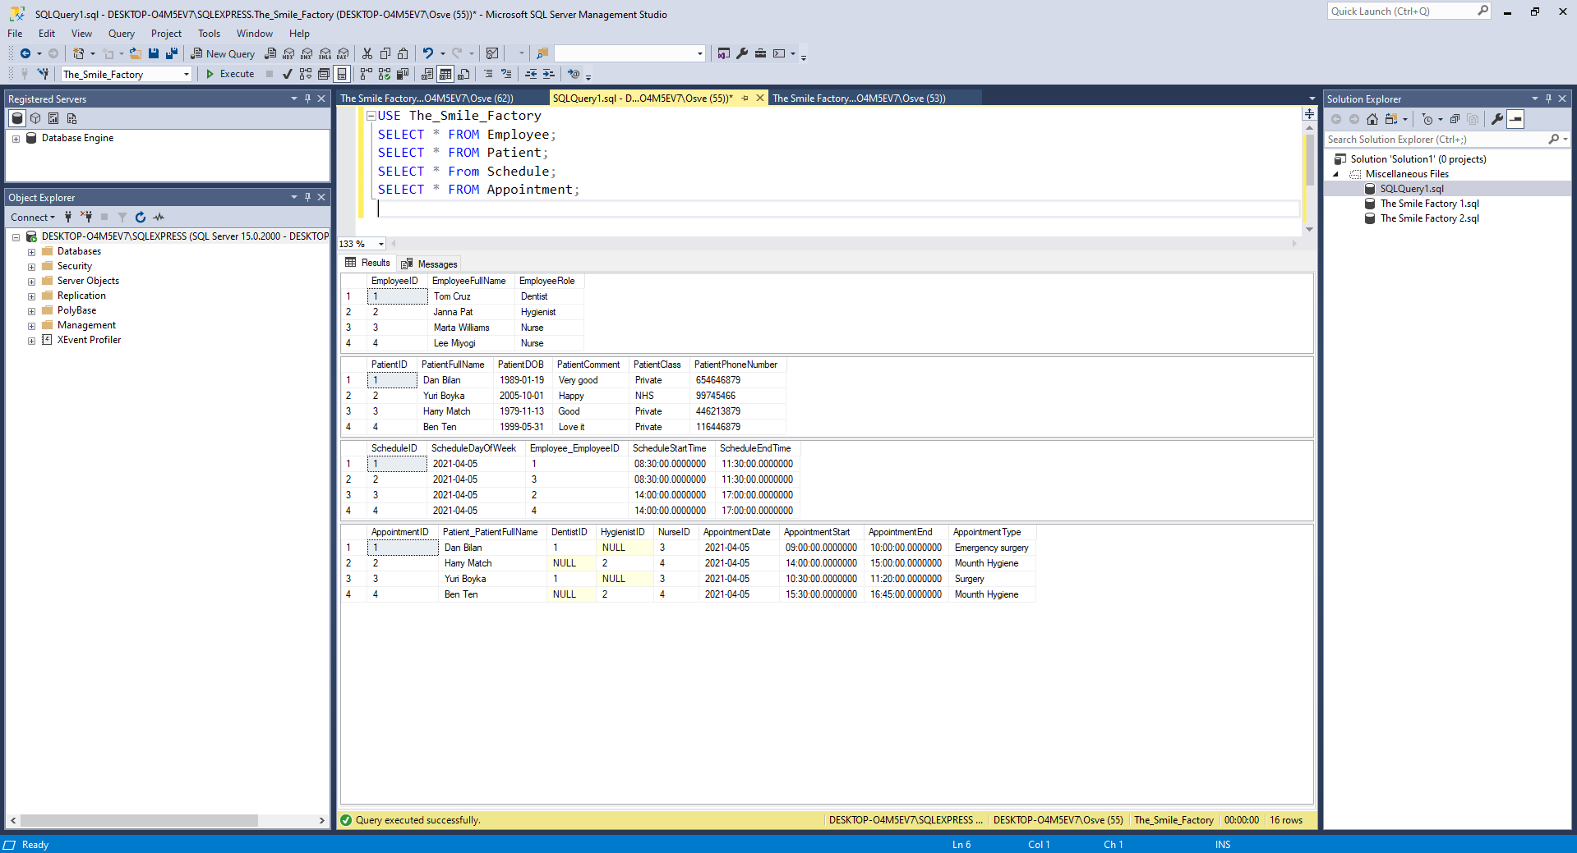
Surgery “The Smile Factory” are using hand-written and over-full diary to collect all data. The time has come to change their old system to new fully computerised. As all system will be fully computerised so it will be much easier for the surgery to fully manage, collect, save, view, data from patients, from employees and see schedules and appointments in one place, so all of this is they will get by using our created database. Benefits: all data in one place, accessible data, easy to edit data, secure data, store data, remotely access to database. The surgery “The Smile Factory” with database will increase job productivity much faster than before. Will avoid some of mistakes for example lost hand-written information.

