13/03/2018
[Web Development]
[Programming 2]
Liam Salter (1702256)
Table of Contents:

- Introduction………………………………………………………………….. 2.
- Part A (Understanding)……………………………………………….… 2.
  - Applying Problem Solving Technique (Subdividing Problems Into Functions) …………………………………………..……………….2.
- Part B (Testing) …….………………………………………………………. 3.
  - Problem 1 …………………………………………………………….3.
  - Problem 2 …………………………………………………………... 4.
  - Problem 3 …………………………………………………………… 6.
- Part C (Implementation)……………………………………..…………. 7.
- Conclusion…………………………………………………………………..… 9.
- Appendix………………………………………………………………………. 10.
- References…………………………………………………………………….. 22.

- Introduction.
This report details the understanding and application of the subdivision of problems into functions, the testing and fixing of an application provided in the assignment brief and practical exercises showing the implementation of the knowledge gained throughout the course.
- Part A (Understanding).
  - Applying problem solving Technique (subdividing problems into functions).
Functions are innately designed to solve problems. A function, by definition is an assortment of tasks, which put together perform a task [1]. Every program within the C/C#/C++ language has at least one function, which is known as the ‘Main’ function. A function takes an existing problem and breaks the problem down into smaller achievable goals.
Functions carry many benefits for the program itself and for the programmer(s) that are creating the program. One of these benefits would be that breaking problems down into smaller, more achievable goals simplifies the thought process, which simplifies the programming process. Another major benefit that functions carry is that they lessen human error in a few ways, one way would be to eliminate or lessen the desire for the use of copy and paste. When subdividing problems into functions, the problems are brief and specific. If the code is broken, one a few changes would be needed, instead of changing multiple of the same bug due to copy and pasted code. Another benefit related to the copy and paste ‘problem’ that functions have is that they can be called multiple times, this saves time for the programmer and also means that the code re usability is an option, as bugs can be easily identified and rectified within functions. As functions are usually relatively brief and solve specific problems, this ensures that the code is more readable for other programmers if the program is being developed within a team, or that the code may be re visited within coming months. Also, the ‘Main’ function by practice, should “tell a story”[Mike Dacey], therefore by calling and using functions within the ‘Main’ function, again, the code becomes easily readable.
Functions are applied by taking a large problem, breaking down the problem into smaller problems, listing and writing the problems down and then turning those smaller problems into functions. Then these functions can be called multiple times within the program to solve the specific problem needed.
As functions solve specific but simple problems, this allows them to be called multiple times and increases code efficiency. Creating a function that solves multiple problems can be useful, but has very limited usage as the problem being solved is to complex. Examples of functions would be :
int AddTwoNumbers(numbers[2]) and int DisplayAnswer(numbers[2])
A function can be used to call itself if a specific condition is not met. This is known as a Recursive Function. An example would be a IsQuitting() function within a while loop [2].
- Part B (Testing)
Code Located Within The Appendix.
  - Problem 1.
1 | Testing If All Options Work [Correct Input]
Description |  | User enters option numbers being 1, 2 or 3
 |  | Test Steps :
1 | Message displayed asking user for input
2 | Enter Number 1
3 | Retry with numbers 2 and 3

Response |  | Program moves on to next expected operation or function.
Status |  |  | Date |  |  | Description
Pass |  |  | 13/08/08  12:14 PM |  |  | Program moved onto expected operation/function.

2 | Testing If Invalid Inputs Display Error Message
Description |  | User enters invalid menu options
 |  | Test Steps :
1 | Message displayed asking for user input
2 | Entered 87, -94, hello1 and 1hello.
3

Response |  | Display invalid input response message
Status |  |  | Date |  |  | Description
Fail |  |  | 13/03/18  12:18 PM |  |  | All inputs provided expected error message, except for '1hello', which the program continued to run option 1.

  - Problem 2.
1 | User Enters Valid 'YES' option
Description |  | User enters valid yes option e.g. "YES"
 |  | Test Steps :
1 | Message displayed asking user to confirm exit
2 | Enter "YES"
3

Response |  | Application closes
Status |  |  | Date |  |  | Description
Fail (Potentially Intentional) |  |  | 13/08/18  12:45 PM |  |  | The application closed, but the console window didn't close.
Pass |  |  | 13/03/18  12:51 PM |  |  | Removed console->Pause(), console window now closes entirely.
Appendix - Figure 1.

2 | User enters other forms of 'yes'
Description |  | User enters other forms of 'yes' e.g. "Yes", "yes" and "y"
 |  | Test Steps :
1 | Message displayed asking user to confirm exit
2 | Entered "Yes", "yes" and "y"
3

Response |  | Application closes
Status |  |  | Date |  |  | Description
Fail |  |  | 13/03/18  12:55 PM |  |  | The application fails to close, and returns to main menu.
Pass |  |  | 13/03/18  01:09 PM |  |  | Application closes successfully.
Appendix - Figure 2.

3 | User enters invalid response at exit prompt
Description |  | User enters invalid response at exit prompt such as "hello"
 |  | Test Steps :
1 | Message displayed asking user to confirm exit
2 | Enter invalid response such as "hello" and "123"
3

Response |  | Message to display invalid input
Status |  |  | Date |  |  | Description
Fail |  |  | 13/03/18  01:11 PM |  |  | User was taken back to main menu.
Pass |  |  | 13/03/18  01:22 PM |  |  | Message was displayed to ask the user to input a valid response.
Appendix - Figure 3.

4 | User enters ‘NO’ at exit prompt
Description |  | User enters ‘NO’ at exit prompt
 |  | Test Steps :
1 | Message displayed asking user to confirm exit
2 | Enter “NO”
3

Response |  | Program returns to main menu
Status |  |  | Date |  |  | Description
Fail |  |  | 13/03/18  01:24 PM |  |  | Message is displayed to ask user for valid input.
Pass |  |  | 13/03/18  01:51 PM |  |  | User is returned to main menu.
Appendix - Figure 4.

  - Problem 3.
1 | Display single digit numbers
Description |  | User entered 1,1,1,1,1, answer displayed whole single digit number
 |  | Test Steps :
1 | Choose option 1 from menu
2 | Message displayed asking user to enter numbers
3

Response |  | Number and outline display correctly
Status |  |  | Date |  |  | Description
Pass |  |  | 13/03/18  02:31 PM |  |  | The numbers were added successfully and outline was displayed properly.

2 | Display negative single digit numbers
Description |  | User entered -1,-1,-1,-1,-1, answer displayed whole single digit negative number, but displayed two characters
 |  | Test Steps :
1 | Choose option 1 from menu
2 | Message displayed asking user to enter numbers
3

Response |  | Number and outline display correctly
Status |  |  | Date |  |  | Description
Fail |  |  | 13/03/18  02:33 PM |  |  | Numbers were added successfully, but outline displayed incorrectly due to multiple characters present.
Pass |  |  | 13/03/18  02:47 PM |  |  | Created DisplayAnswerLine function to display outline border correctly with numbers more than single digit.
Appendix - Figure 5.

3 | Display multiple digit numbers (Negative and Positive numbers used)
Description |  | User entered -100, 40, 50, 30, -200
 |  | Test Steps :
1 | Choose option 1 from menu
2 | Message displayed asking user to enter numbers
3

Response |  | Number and outline display correctly
Status |  |  | Date |  |  | Description
Fail |  |  | 13/03/18  02:51 PM |  |  | Numbers were added successfully, but outline displayed incorrectly due to multiple characters present.
Pass |  |  | 13/03/18  02:55 PM |  |  | Created DisplayAnswerLine function to display outline border correctly with numbers more than single digit.
Appendix - Figure 6.

- Part C (Implementation).
Exercise 1.
This is a comprehensive list of the author’s workings to identify the problems from easiest difficulty to hardest difficulty.
1. Display "You Won" / "You Lost" message.
2. Input a number / Store user guess.
3. Display hint message.
4. Store guess count [MAX 5 GUESSES].
5. Compare number to user guess.
6. Generate random number.
7. Set random number between -20 and +20.

Problems | Knowledge Mapped Solutions
Display outcome messages. | Use printf statement to display messages.
Input number and store guess. | Ask user to input number, and scan guess with into dedicated variable.
Display hint message. | Use printf statement based on distance between guesses.
Store guess count. | Scan guess count into dedicated variable.
Compare number to the guess. | Use ‘if’ statement to compare to number to guess.
Generate a random number. | Use srand for random number generation with ‘time.h’ include.
Set random number between -20 and +20. | Set random number generator parameters between -20 and +20.

Exercise 2.
Attempted Code Test/Fix Located In Appendix.
Located below is a list of the author’s workings to identify the workings of the code.
- Check if the input string is valid.
- Find the separator positions in the array.
- Get every character from the array (apart from the separators), and return and convert them into integers.
- Separate the array into several different numbers, by using the separators.

Program | Knowledge Mapped Solutions
Check if input string is valid. | Check if input falls within expected range using loops to check individual characters.
Identify separator locations in array. | Use ‘if’ statement and loops check each character if they are a separator.
Get every character from the array (apart from the separators), and return and convert them into integers. | Use ‘stoi’ function to convert strings into integers.
Separate array into different numbers | Get numbers in array, differentiate numbers using separators, then place in different dedicated array location.

Exercise 3.
Completed Code Located In Appendix.
Located below is a comprehensive list of the author’s workings to identify the problems of creating the program, from easiest difficulty to hardest difficulty.
1. User input.
2. Create board.
3. Display board.
4. Invalid input message.
5. Multiple user system.
6. Testing for four in a row.
7. User collision detected.

Problems | Knowledge Mapped Solutions
User input. | Use printf statement to display message then scan into variable.
Create the board. | Create array, use for loop to create the board.
Display the board. | Use ‘#’ char to display board.
Display invalid input message. | Use ‘if’ statement to detect valid input, then use printf to display error message if input is invalid.
Multiple user system. | Use ‘if’ statement and modulus operator to switch players each turn.
Test to detect for 4 in a row. | Use ‘if’ statement to increment columns and rows.
Detect user collision. | Check if row and column position is empty, if not, place above.

- Conclusion.
Throughout this task, the author has understood and applied the problem-solving techniques of subdividing problems into functions by identifying, researching and applying the benefits and understanding of functions. Also, through testing an application, the author has identified, tested and fixed bugs throughout the program. Finally, the author has implemented their knowledge through identifying problems and separating them into achievable goals ranked least difficult through most difficult, also programming the exercises outlined in the brief.

- Appendix.
Figure 1.
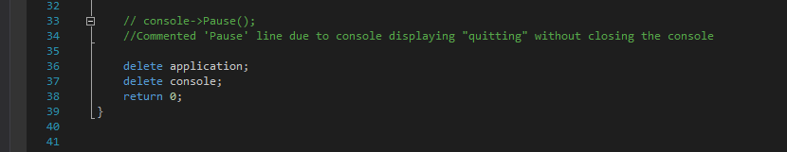
Figure 2.
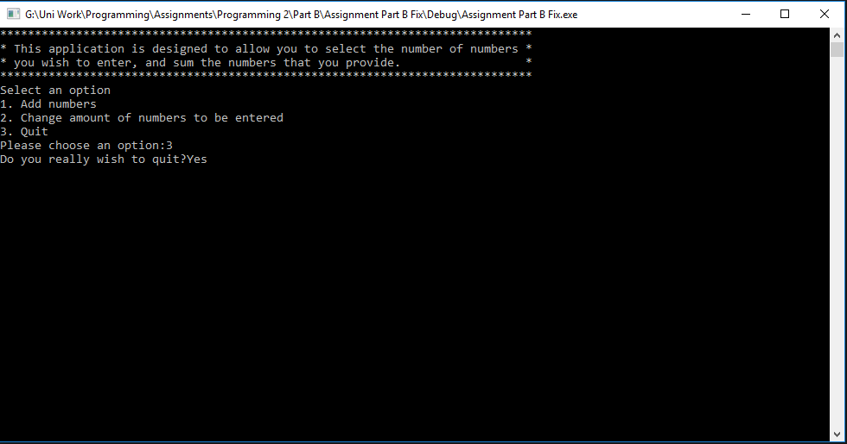
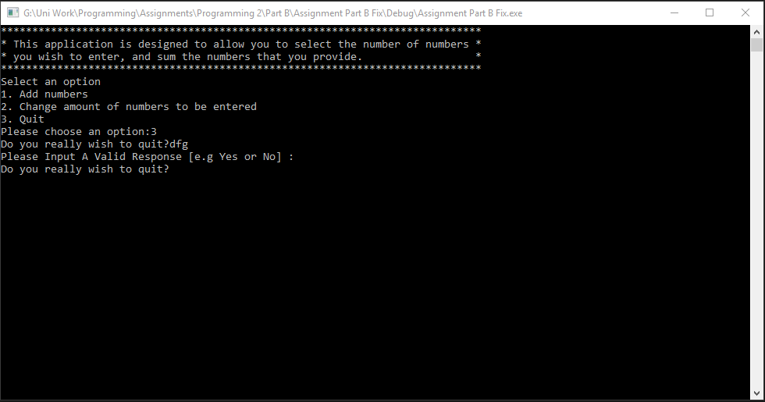
Figure 3.

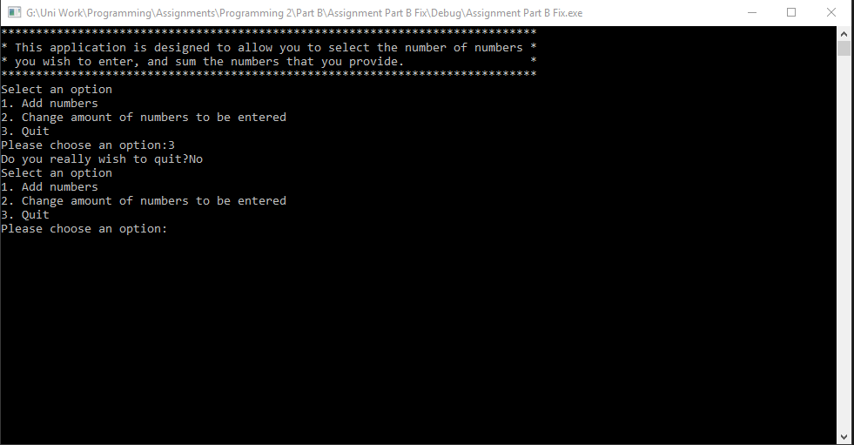
Figure 4.

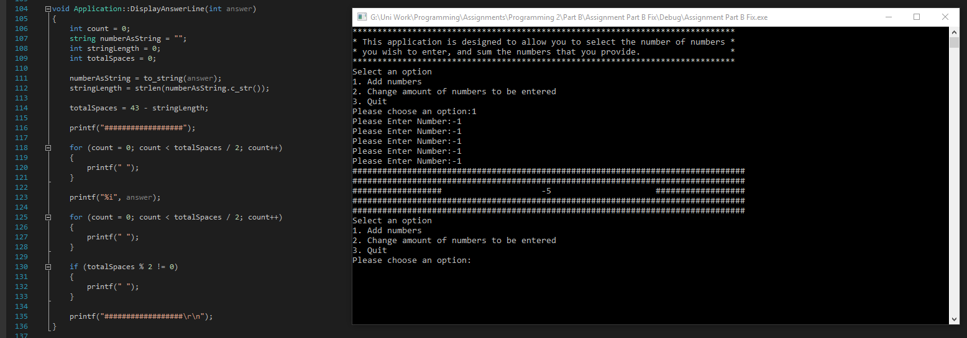
Figure 5.

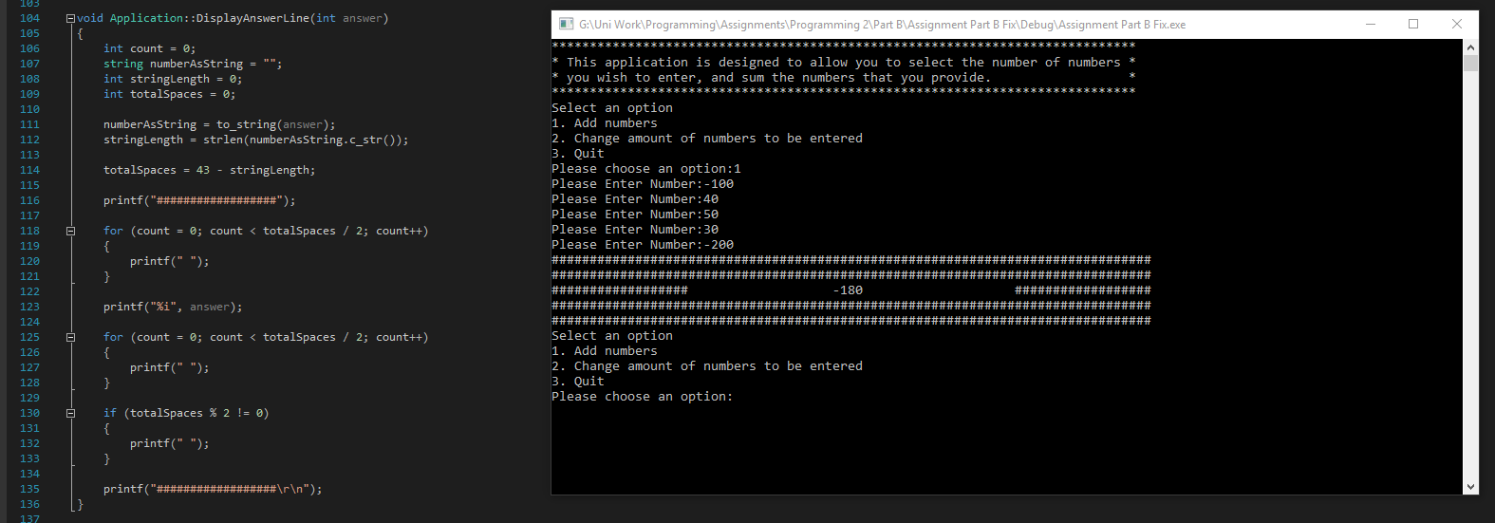
Figure 6.
Part B (Exercise Code).
Main.cpp
#define _CRT_SECURE_NO_WARNINGS
#pragma warning(disable:4996)

#include <string>

#include "Console.h"
#include "Application.h"

using namespace std;

int main(int args, char* argv[])
{
Console* console = new Console();
Application* application = new Application(console);
bool quit = false;

console->PrintLine("*****************************************************************************");
console->PrintLine("* This application is designed to allow you to select the number of numbers *");
console->PrintLine("* you wish to enter, and sum the numbers that you provide. *");
console->PrintLine("*****************************************************************************");

while (quit == false)
{
application->DisplayMenu();
application->ChooseOption();
quit = application->ProcessOption();
}

// console->Pause();
//Commented 'Pause' line due to console displaying "quitting" without closing the console

delete application;
delete console;
return 0;
}

Console.cpp
#include "Console.h"

string Console::ReadString()
{
char text[100];

scanf("%99[^\n]s", text);
ClearInputBuffer();

return (string)text;
}

int Console::ReadInteger()
{
int number;

scanf("%i", &number);
ClearInputBuffer();

return number;
}

double Console::ReadDouble()
{
double number;

scanf("%lf", &number);
ClearInputBuffer();

return number;
}

void Console::ClearInputBuffer()
{
char ch;
while ((ch = getchar()) != '\n' && ch != EOF);
}

void Console::Print(string text)
{
printf("%s", text.c_str());
}

void Console::PrintLine(string line)
{
Print(line + "\r\n");
}

void Console::Pause(void)
{
while (1) { if (_kbhit()) break; } // Pause
_getch();
}

Application.cpp
#include "Application.h"

Application::Application(Console * console)
{
_console = console;
_chosenOption = 0;
_numNumbersReqd = 5;
}

void Application::DisplayMenu()
{
_console->PrintLine("Select an option");
_console->PrintLine("1. Add numbers");
_console->PrintLine("2. Change amount of numbers to be entered");
_console->PrintLine("3. Quit");
}

void Application::ChooseOption()
{
_chosenOption = ReadNumber("Please choose an option:");
}

int Application::ReadNumber(string prompt)
{
_console->Print(prompt);
return _console->ReadInteger();
}

bool Application::ProcessOption()
{
bool quit = false;

switch (_chosenOption)
{
case 1:
int total;
total = GetTotal();
DisplayResult(total);
break;
case 2:
_numNumbersReqd = ReadNumber("Please enter the number of numbers to be entered:");
break;
case 3:
quit = IsQuitting();
break;
default:
_console->PrintLine("Unknown option value entered");
break;
}

return quit;
}

int Application::GetTotal()
{
int total = 0;
int index;

for (index = 0; index < _numNumbersReqd; index++)
{
total = total + ReadNumber("Please Enter Number:");
}

return total;
}

void Application::DisplayResult(int result)
{
_console->PrintLine("###############################################################################");
_console->PrintLine("###############################################################################");
DisplayAnswerLine(result);
_console->PrintLine("###############################################################################");
_console->PrintLine("###############################################################################");
}
bool Application::IsQuitting()
{
string response;
bool quit = false;

_console->Print("Do you really wish to quit?");

response = _console->ReadString();

if (response == "YES" || response == "Yes" || response == "yes" || response == "y") //Added more options
{
_console->PrintLine("Quitting");
quit = true;
}
else if (response == "NO" || response == "No" || response == "no" || response == "n") //Added more options
{
quit = false;
}
else
{
printf("Please Input A Valid Response [e.g Yes or No] : \r\n"); //Added message to prevent invalid responses
quit = IsQuitting(); //Recalled function to insure valid response before exiting
}

return quit;
}

void Application::DisplayAnswerLine(int answer)
{
int count = 0;
string numberAsString = "";
int stringLength = 0;
int totalSpaces = 0;

numberAsString = to_string(answer);
stringLength = strlen(numberAsString.c_str());

totalSpaces = 43 - stringLength;

printf("##################");

for (count = 0; count < totalSpaces / 2; count++)
{
printf(" ");
}

printf("%i", answer);

for (count = 0; count < totalSpaces / 2; count++)
{
printf(" ");
}

if (totalSpaces % 2 != 0)
{
printf(" ");
}

printf("##################\r\n");
}

Console.h
#pragma once
#pragma warning(disable:4996)
#include <conio.h>
#include <string>

using namespace std;

class Console
{
// Attributes
// NONE

// Constructors
// NONE

// Properties
// NONE

// Methods
public:
string ReadString();
int ReadInteger();
double ReadDouble();
void Print(string text);
void PrintLine(string line);
void Pause(void);

private:
void ClearInputBuffer();
};

Application.h
#pragma once
#include "Console.h"

class Application
{
// Attributes
private:
Console * _console;
int _chosenOption;
int _numNumbersReqd;

// Constructors
public:
Application(Console* console);

// Properties
// NONE

// Methods
public:
void DisplayMenu();
void ChooseOption();
bool ProcessOption();
private:
int ReadNumber(string prompt);
int GetTotal();
void DisplayResult(int result);
bool IsQuitting();
void DisplayAnswerLine(int answer); //New Method to display answer line
};
Part C (Exercise 2).
Source.cpp
#include <string>

using namespace std;

bool IsValid(const char str[], int stringLength, char separator)
{
int index;
int dashCount = 0;

for (index = 0; index < stringLength; index++)
{
if (str[index] == separator)
{
if (dashCount > 0)
{
return false;
}
dashCount++;
}
else if (isdigit(str[index]) == 0)
{
return false;
}
else
{
dashCount = 0;
}
}

// Can't start with a separator
if (str[0] == separator)
{
return false;
}

// Can't end with a separator
if (str[stringLength - 1] == separator)
{
return false;
}

return true;
}

int FindChar(const char str[], int stringLength, int startPos, char character)
{
int index;

if (startPos < stringLength)
{
for (index = startPos; index < stringLength; index++)
{
if (str[index] == '-')
{
return index;
}
}
}

return -1; // end of array
}

int ConvertToNumber(const char str[], int startPos, int endPos)
{
int digit;
int number = 0;

for (int i = startPos; i < endPos + 1; i++)
{
digit = (int)str[i] - '0'; // Convert from ASCII
number = (number * 10) + digit;
}

return number;
}
bool SplitIntoNumbers(string digits, int stringLen, int numbers[], int arrayLength)
{
const char *digitArray = digits.c_str();
int startOfNumber = 0;
int dashPosition;
int index = 0;

if (IsValid(digitArray, stringLen, '-') == false)
{
return false;
}

dashPosition = FindChar(digitArray, stringLen, startOfNumber, '-');
while (dashPosition > 0 && index < arrayLength)
{
numbers[index] = ConvertToNumber(digitArray, startOfNumber, dashPosition - 1);
index++;

startOfNumber = dashPosition + 1; // Start of next number
dashPosition = FindChar(digitArray, stringLen, startOfNumber, '-');
}

// Read number at end of string
if (index < arrayLength)
{
numbers[index] = ConvertToNumber(digitArray, startOfNumber, stringLen - 1);
}
index++; // Account for number at end of string even if we don't read it.

// Too few or too many numbers to be read
if (index < arrayLength || index > arrayLength)
{
return false;
}

return true;
}

struct TestValues
{
string value;
int startPos;
int endPos;
int expectedResult;
TestValues(string v, int sp, int ep, int exp);
};

TestValues::TestValues(string v, int sp, int ep, int exp)
{
value = v;
startPos = sp;
endPos = ep;
expectedResult = exp;
}

int main(int argc, char** argv)
{
TestValues **testValues = new TestValues*[4]{
new TestValues("1", 0, 0, 1),
new TestValues("12", 0, 1, 12),
new TestValues("123", 0, 2, 123),
new TestValues("aa123", 2, 4, 123)
};

int number;
for (int i = 0; i < 4; i++)
{
number = ConvertToNumber(testValues[i]->value.c_str(),
testValues[i]->startPos,
testValues[i]->endPos);

if (number == testValues[i]->expectedResult) //Did we get the expected result ? ?
{
// Test passed
}
else
{
// Test failed
}

}

for (int i = 0; i < sizeof(*testValues); i++)
{
delete testValues[i];
}
delete testValues;

}
Part C (Exercise 3).
Source.cpp
#define _CRT_SECURE_NO_WARNINGS
#include <string>
using namespace std;
char ch;

void PlayerInstructions();
void CreateBoard(char board[6][7]); //row 6, column 7
void DisplayBoard(char board[6][7]);
void Input(char board[6][7], int turnCount);
bool WinState(char board[6][7]);

int main(int argc, char** argv)
{
// char text[100];

char board[6][7];
int turnCount = 0;
bool playerWon = false;

PlayerInstructions();
CreateBoard(board);

while (playerWon == false)
{
Input(board, turnCount);
turnCount++;
DisplayBoard(board);
playerWon = WinState(board);
}

return 0;
}

void CreateBoard(char board[6][7])
{
int rowCount = 0;
int columnCount = 0;

for (rowCount = 0; rowCount < 6; rowCount++)
{
for (columnCount = 0; columnCount < 7; columnCount++)
{
board[rowCount][columnCount] = 254;
}
}
}

void DisplayBoard(char board[6][7])
{
int rowCount = 0;
int columnCount = 0;

for (rowCount = 0; rowCount < 6; rowCount++)
{
for (columnCount = 0; columnCount < 7; columnCount++)
{
printf("|%c", board[rowCount][columnCount]);
}
printf("|\r\n");
}
printf("\r\n");
}

void Input(char board[6][7], int turnCount)
{
int rowCount = 0;
int column = 0;

char playerTurn = ' ';

if (turnCount % 2 == 0)
{
playerTurn = '1';
}
else
{
playerTurn = '2';
}

printf("Player %c, Choose A Column (1-7) : ", playerTurn);
scanf("%i", &column);

while ((ch = getchar()) != '\n' && ch != EOF); //code would not wait for user input if input was invalid
//code used from assignment appendix

while (column < 1 || column > 7)
{
printf("Please Input Valid Key! \r\n \r\n");
printf("Player %c, Choose A Column (1-7) : ", playerTurn);
scanf("%i", &column);

while ((ch = getchar()) != '\n' && ch != EOF);
}

printf("\r\n");

for (rowCount = 0; rowCount < 7; rowCount++) //For each row
{
if (board[6 - rowCount - 1][column-1] != '1' && board[6 - rowCount - 1][column - 1] != '2') //if bottom position empty, fill
{
board[6 - rowCount - 1][column-1] = playerTurn;
break;
}
//otherwise, iterate the loop to check row above
}
}

bool WinState(char board[6][7])
{
int row = 0;
int column = 0;

for (row = 0; row < 6; row++)
{
for (column = 0; column < 7; column++)
{
if (board[row][column] == '1' && board[row][column + 1] == '1'
&& board[row][column + 2] == '1' && board[row][column + 3] == '1')
{
printf("Player 1 Wins!");

return true;
}

if (board[row][column] == '2' && board[row][column + 1] == '2'
&& board[row][column + 2] == '2' && board[row][column + 3] == '2')
{
printf("Player 2 Wins!");

return true;
}

/////////////////////////////

if (board[row][column] == '1' && board[row + 1][column] == '1'
&& board[row + 2][column] == '1' && board[row + 3][column] == '1')
{
printf("Player 1 Wins!");

return true;
}

if (board[row][column] == '2' && board[row + 1][column] == '2'
&& board[row + 2][column] == '2' && board[row + 3][column] == '2')
{
printf("Player 2 Wins!");

return true;
}

}
}
return false;
}

void PlayerInstructions()
{
printf("Instructions : Keys 1 - 7 \r\n \r\n");
}

References

[1] | "C - Functions," tutorialsPoint, [Online]. Available: https://www.tutorialspoint.com/cprogramming/c_functions.htm. [Accessed 13 March 2018].
[2] | "Recursive Function," TechTerms, [Online]. Available: https://techterms.com/definition/recursivefunction. [Accessed 13 March 2018].

