Student Name: Ioana Mirela Bumbu
Student Id number: 2227453
Module: Food & Beverage (BMIH4002)
Lecture’s name: Muhammad Cassamo
Word count: 402

Table of Contents
1 PART 1: Restaurant Concept 4
2 PART 2: Menu design 5
3 References 6

PART 1: Restaurant Concept
The concept for the chosen business idea revolves around a family-style dine-in concept. Typically observed in the Mediterranean and Italian settings, the family-style dine-in concept gives rise to social interaction between large groups of people or general families that eventually encourages a sense of an engaged community (Lucas and Sines, 2019). Provided with such background knowledge, the primary emphasis of a family-style catering method entails the serving of food dishes in large bowls or platters, the families and groups of people are permitted to pass around the dish and cater themselves as per their preferences. This catering and restaurant style highlights a relaxed and at-home feeling for the customers, which further enables them to enjoy the meal with a sense of warmth and familiarity (Yusni et al., 2022). Similarly, the family-style concept of the restaurant usually promises a good customer experience because the food dish is catered to the customer in large quantities, unlike in single plates like conventional restaurants (Pfanenștîli, 2022).
The targeted audience for the family-style restaurant may depend directly on its location, its offered cuisines and the atmosphere of the dine-in. However, if observed on general grounds, the target audience for the said restaurant may entail families and children that seek a laid-back dining environment that makes them feel an at-home familiarity with the food. On the other hand, the restaurant may cater to customers who are often appealed by an eating atmosphere that lightly engages with social interaction and builds an interactive community environment. Additionally, the restaurant may seek to cater to business people who find it more comfortable to exchange words of business over a relaxed dinner. Family-style restaurants can also aim to cater their services to large groups of tourists who simply wish to dine-in in a comfortable setting.
With the targeted population being identified, the menu of the restaurant can be formulated. In order to complement its family-style nature, the restaurant seeks to cater large portions of food in platters and bowls. This deed will adhere to the communal environment of the restaurant (Lucas, 2018). The menu seeks to entail mostly comfort food because families in large groups or business people on a trip desire a taste that brings forth the notion of familiarity and a sense of comfort. Given this, the menu seeks to include a variety of dishes that suits every family's culture, whether it be Italian, American, British or Mediterranean (Yamnych, 2020).

PART 2: Menu design

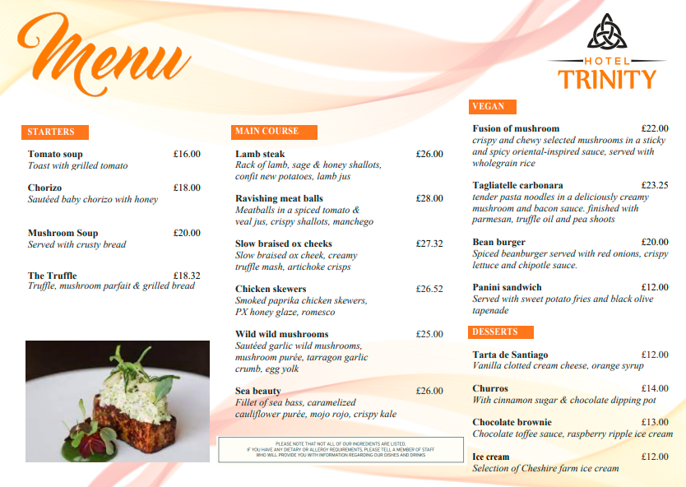

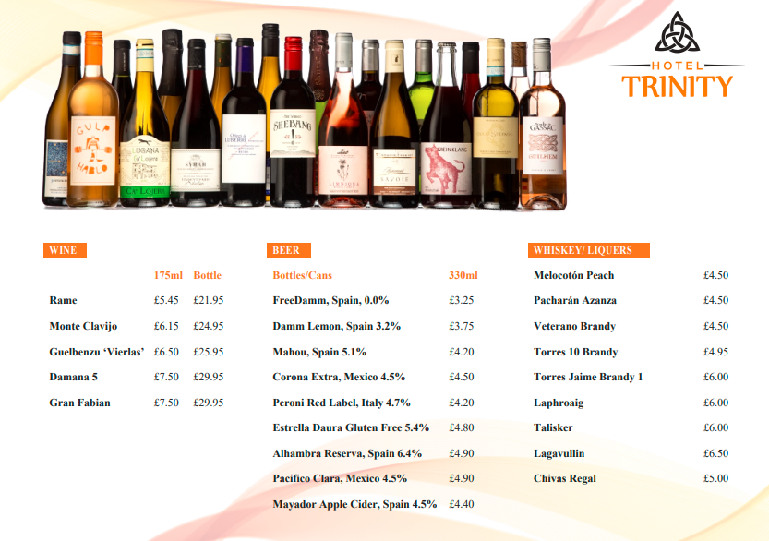

References
Chef sargent 2023. Our menu. [online]. Available at < https://www.edit.london/menuhttps://www.chefsargent.co.uk/example-menus/>. [Accessed on 20 May 2023].
CRANBERRY SWAMP 2023. Our menu [online]. Available at < http://www.cranberryswamp.co.uk/?gclid=CjwKCAjwg-GjBhBnEiwAMUvNW0W7aY8Z3hpJL9WF_Brr6l7lvUngc5CyMcsENDTMIzDbZb_nyr2fNxoC-fAQAvD_BwE>. [Accessed on 20 May 2023].
Edit London 2023. Our menu. [online]. Available at < https://www.edit.london/menu>. [Accessed on 20 May 2023].
Lucas, T. and Sines, C., 2019. Marketing strategies to increase sales in small family-style restaurant businesses. The Journal of Social Media in Society, 8(1), pp.55-66.
Lucas, T., 2018. Marketing Strategies to Increase Sales in Small Family-Style Restaurant Businesses (Doctoral dissertation, Walden University).
Pfanenștîli, G., 2022. How to start your own restaurant business. In Conferinţa tehnico-ştiinţifică a studenţilor, masteranzilor şi doctoranzilor (Vol. 2, pp. 546-549).
Ritz London 2023. Menu[online]. Available at https://www.theritzlondon.com/dine-with-us/the-ritz-restaurant/ritz-restaurant-menus/>. [Accessed on 20 May 2023].
Riva blu 2023. Menu.[online]. Available at https://rivablu.co.uk/menus/>. [Accessed on 20 May 2023].
Yamnych, N., 2020. Catering: Restaurants concepts.
Yusni, A., Ab Rashid, P.D., Isa, M.M., Badiuzaman, A.F., Saliza, N. and Salmi, M.A.A., 2022, December. Customers’ Satisfaction Towards Online Digital Menu Experience and Intention to Revisit Family-Style Restaurants Post COVID-19 Pandemic. In Proceedings of the 2nd International Joint Conference on Hospitality and Tourism, IJCHT 2022, 6-7 October 2022, Singaraja, Bali, Indonesia: IJCHT 2022 (p. 121). European Alliance for Innovation.

