Contexts page

The Photograph of the beach – page 2
Experiencing and exploring the outdoor space – page 3-5
Risk benefit assessment form – page 6-9
How adults support children in the outdoor space – page 10-13
References – page 14

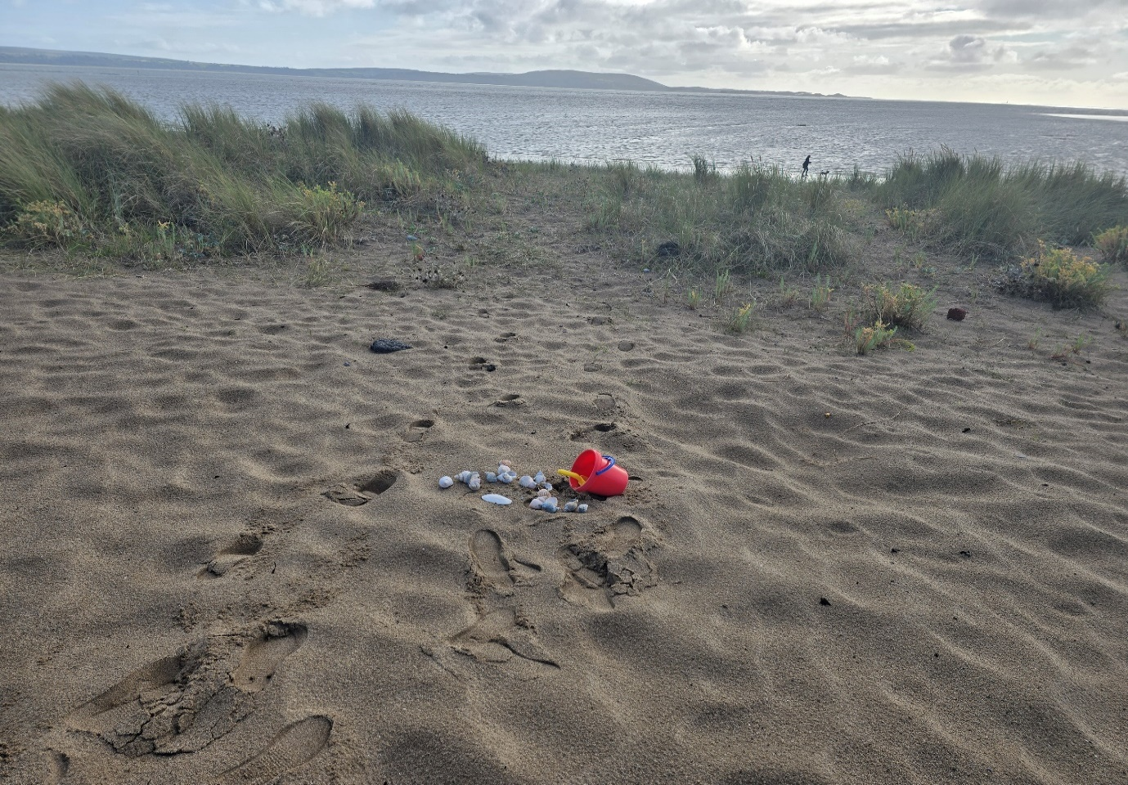
Photo of the beach.
Source: Thornton,2025. Personal photograph

Experiencing and exploring at the beach

As the summer holidays were upon us, the children who previously had been attending the day nursery, were coming back to the setting as school was closed for the holidays. The practitioners have decided to take them to the beach, to help children explore and learn about the outdoor environment, to teach and develop their knowledge about the concepts of mathematics and science, and to have a fun day out. The practitioners have planned to take four children of the ages between four and five. Parents would be given a letter and permission forms, to take the children off the nursery premises with their consent. Parents are asked to provide the appropriate clothing and essentials. The weather for the day is looking to be a nice warm day; therefore, the children would be wearing light causal clothing with appropriate shoes such as jelly shoes or crocs. They would have to wear a hat and apply suncream to protect them in the sun. Parents would be asked to supply wellies and a wetsuit just as a precaution as weather can change on the day. There would be two practitioners going with the children, both are trained first aiders, and will also provide a first aid kit. The practitioners would take some essentials such as buckets, spades, balls, and be providing water bottles and a picnic. Providing towels for children if they want to have a splash with their feet in the water and a blanket for the picnic. Just before leaving to go the beach the children would be dressed for the weather and suncream would be applied and wearing their sunhats. Arriving at the beach all the children and adults would be wearing a Hi vis vest for their safety and there is a path that vehicles and cyclists use, the children would have to cross to get to the beach, the children would hold hands with the adults to cross and be told to be aware of the cars and cyclists that pass, they be taught the road safety and to listen for on coming cars. At the beach the children would benefit from learning about science and mathematical concepts. Children want to explore and use their imagination during play and experiment with objects that they find. The four children are Emma, Darcie, John and Kian, arriving at the beach they are happy and are eager to play and wanting to explore the outdoor space. They say that they have been to the beach with mammy and daddy and with their grandparents, they say they enjoy coming and having lots of fun. The practitioners would give each of them a bucket and spades, Darcie asks to make a sandcastle with Emma, as they are trying to build Darcie turns to say, ‘why wont the sandcastle stay still?’ to which the practitioner says, ‘let’s go and get some water to make the sand wet’. Upon returning they pour water on to sand to make it moist, Emma then says, ‘wow I didn’t realise that would work’. They learned the concept of science in change of texture and consistency, and the changing of the colour of the sand. They continued to build when Darcie decided to knock the castle down and says to Emma ‘that was fun let’s go and play with something else’. So, they wanted to see what they could find along the beach; they saw some shells and stones to which the practitioners say, ‘put the shell close to the ear and what can you hear?’ Darcie replies, ‘I can hear the ocean’. The practitioner replies saying, ‘yes you can, shall we see how many we can collect? To which John replies and says, ‘I can collect ninety-nine of them? So, the children decided to have a race who can collect the most shells and when finished we sat to have a drink and a snack, then we counted together to see how many was collected and who had the most. John then says, ‘aww no I didn’t get to ninety-nine I only had ten’, which Kian replies ‘I had twenty yay more than you’. Darcie then says, ‘aww I only had eight I want more’, but then Emma said, ‘I got ten too like John?’ The practitioner then said that ‘Kian had collected the most, so he is the winner’. Kian asked, ‘can I take these home so that I can paint and make something for my mammy’. The children cheered and wanted to do something else. As they were walking around the beach the practitioners decide to take the children by the water. As they get closer Emma says ‘I can hear seagulls, and I can hear the sea’, John then spotted something he asks, ‘look at that cardboard, can we play with it?’ the practitioner replies saying ‘yes, but what do you think you could make out of it?’ to which, Kian replies ‘can we make a boat and put it in the water to watch it float?’ the practitioner explained that did not have the materials to make a boat but they can still watch and see if the cardboard would float, which it did and then Emma saw a plastic bottle and she wanted to do the same ‘can this bottle float?’ They learned how materials do float in water; this is teaching them that the water holds enough weight for these items to float. They started to watch as the waves were getting closer. Darcie asks, ‘can we jump with the waves?’ and John says, ‘can we get closer to jump higher?’ then realising the water is cold, they all scream and say, ‘why is the water so cold?’. The practitioners explains that water needs the heat from the sun, and it takes longer to heat because the water does not stay long enough to get warm as the sea comes and goes. The children listen as the practitioner explains this all to do with science. The practitioners then ask if the children know what creatures live in the sea? Emma and Kian start naming them, ‘there are jellyfish, crabs, turtles, and sharks’, the practitioner agrees and says ‘shall we count how many creatures that live in the sea? So together started to count how many there are. Then they spotted a jelly fish the practitioner said, ‘oh look at that jellyfish but do not go near it,’ Emma asks, ‘why can’t we go see it?’ which John replies, ‘ooh no it can sting you?’, ‘yes they can’ replied the practitioner. The children were happy just to look from a distant, they looked for other creatures but didn’t see any others. It was time to go home Emma says, ‘I had fun at the beach’, and the others also said they had too. The children enjoyed and experienced at the beach; they learned things about the science and the world around them. They showed that they were interested and asked a lot of questions about their surroundings of the beach. They were more impressed when they watched the tide going out to sea and that they noticed that the water had left the shore muddy. They learned about the concept of science, living things that live in the sea and learning about nature. As stated in the Curriculum of Wales (2019), the progression steps 1-3 in line with the children, they were curious and understanding about the outdoor at the beach. They were asking questions and explored the environment, they showed a lot of interest about the world around them. Learning simple numbers and knowing how to count and who had more than the other. They learned about the world around them of living things in the progression steps 1-3 as they explored the nature and living things, they identified that living creatures can be harmful and know their risks and how to act by keeping distance themselves and others. Overall, the children learned and had the knowledge about the outdoor environment.

RISK BENEFIT ASSESSMENT

Location / Activity: |  | Date:
Assessor: |  | Review date:

The boxes in the table below will expand as you type into them; pre-entered text is simply for illustration. You should delete irrelevant items and replace with text relevant to your circumstances.
Your overall risk rating – Low, medium or high – is based on your judgement about whether the BENEFITS of the activity or opportunity outweigh the RISKS.
Experience exploring outdoor space in photograph | How will young people BENEFIT from this activity? | Hazards and associated risks | Who is at risk? | PRECAUTIONS in place to reduce the risk of injury | Overall risk after precautions  RATING: L/M/H
Sand | This would help in their learning, making sandcastles, experiencing their senses by touch and texture. Teaching the concept of science mixing sand and water. Filling buckets with sand, water or objects, learning the maths of weighing and measuring and counting. | Putting sand in their mouths, digging a hole to deep they could fall in. going to close to the sea where there are mud and quicksand. Jellyfish washed up on the sea could sting if get too close. Heatstroke and sand burn on feet if too hot. | The adult and child | Adult with child always, observe and supervise, when playing in the sand, and when going near the sea. Not to go close to any sea creatures as they could sting as they are washed up on the beach. To wear suitable shoes to protect their feet and suncream to be applied throughout the day. Wear sunhats to protect them from the sun and heat.
Water | It would help them learn about the sea waves, the temperature of the water and learn about the sea creatures that live in the waters. | Seaweed could trap their feet if sea is not in. in hot weather walking to the sea, the feet could burn. | The child | To always supervise and observe the children. Not to go by the sea when the tide is not in, could be muddy and could cause to sink or quicksand. Wear suitable footwear to protect their feet from heat and objects on sand and water. Not to go near the jellyfish or other sea creatures that are dangerous. Not to go into the sea if high winds and high tides.
objects | Collecting shells and pebbles to learn their counting, listening to the shells for science, looking at different insects and creatures that live in and around the sea. | Putting them in their mouths, could be small so can choke. Litter around the areas can be sharp objects laying around. | The child | To always supervise and observe the children. To tell children not to touch any litter, not to put it in their mouths. Tell them they can only pick up shells with the adults. Not to touch any sharp objects and to walk around safest areas of the beach.
Weather | A dry day would benefit experiencing the beach, playing in the sand, water and exploring and playing games.  A cold rainy day can limit what they can play but can still explore the beach. | Too hot could cause heatstroke, dehydration, sunburn and heat exhaustion.  Cold and stormy weather can be windy and sea tide could have strong and high waves. | Adult and child | Always supervise and observe children. Suncream to be applied as instructed. Wearing appropriate clothing and suitable footwear. Drinking plenty of fluids throughout the day. Always wear sunhats.  Wrap up warm, wear suitable clothing and footwear as could be muddy wear wellies. Not to go near the sea because of the high winds and waves.
Busy walkway | Learning how to cross the road, or the walkway. Learning to look and their look left and right and listen to oncoming vehicles. | Getting hit by car or bike. Running and not looking where they are going. | child | Adults to always hold the child’s hand. To explain and teach children about road safety. Children and adults to wear hi vis vest for safety and for visibilities for drivers and others. Children could wear reins for extra guidance when going for a walk and crossing the road.

How adults support children in the outdoor space

Introduction
This assignment is researching how adults working with children, help them develop and encourage their mathematical and science skills, whilst learning in the outdoor environment. Researching different theories who believe that outdoors is the best way of learning for young children. It teaches them skills and gaining confidence outdoors and having fun.

Main Body
The adult’s role to support and encourage children with their mathematical and scientific in the outdoors is that of, according to Jordan (2009, cited Brunton and Thornton, 2010, p.17) is when children and adults work together, they can bring new ideas and experience to any given situations, and together they explore and experiment. The adult would acknowledge and recognise the child’s skills and not interfering and to let the child decide their outcome of their experience. However, Davis and Howe (2009 cited in Brunton and Thornton, 2010, p.17) agree that working this way would help the practitioners to give the children their own independence to do their own exploring with the adult sharing the knowledge of the activity and to help build more opportunities for child led play. According to (Crook and Bilton, 2016, p.15) the role of the adult is important, to be prepared for any kind of different scenarios, some children take naturally to the outdoor play and exploring, where others need more time and support. They need to be motivated and to help build their confidence with time. The adult role is important for children to teach them and guide them in risks that they take each day. According to (crook and Bilton,2016, p.20) the role of the adult is to help children to develop many of strategies to help themselves and even more importantly to trust themselves to make judgements about how to cross the road and to seek help regarding a mathematical problem. The Royal Society (2015, quoted in Crook and Bilton, 2016 p.20) for the prevention of accidents (ROSPA 2015) and the health and safety executive (HSE, 2015) both argue strongly that children need to learn to face and overcome challenges and that risk taking is an important life learning tool. The importance of the adult is to play and engage with the children and to extend their learning. Plan and teach them words with clear meanings and to encourage open-ended questions about learning all aspects of mathematics (Skinner and Stevens 2012, p.131). Bruce (1991, cited Tucker, 2014, p.13-14) argues that free flow play encourages children to play more freely and to let them choose their own play this would teach children to make their own choices, control of their own activity by imagination and what comes next. Experiment by taking risks but in a safe environment, showing their curiosity to what they enjoy playing with, and to help them with their social and behaviour skills. This would also contribute for their mathematical thinking and problem solving. It would gain their understanding of the role of mathematical, recognising the mathematical activity, which can be both to help children socialise and work together and it would be enjoyable during the activities. However, The Early Years Foundation (DFES 2007, cited Waite, 2011, p.51) believes that children learn more about the environment, having a free flow between in and outdoors. This gives children opportunities to make connections within their learning, knowing their difference when using loose parts, and to whether they belong to the outdoor or the indoor area. This helps them to encourage their concepts, of the activities that are set out within the setting. However (Robertson, 2017, p.41-42) believes that the outdoors environment, can create mathematically for children to have the freedom, to investigate, experience and to ask questions during play. They can use their ideas with open-ended and resources that can be used by referring to loose parts. Therefore, Nicholson (1971) which he calls the theory of loose parts is based on the finds of theoretical support and in any other surroundings that can be creative, and he believes that by having more things in the environment that can be used during play, the more the environment can offer. Furthermore, Nicholson’s theory of loose parts is now used both the play work profession (Wilson, 2010) and in other play and child-related (King, 2022, p.4). The outdoor games for children to have the opportunities to run, jump, skip, play with balls, hoops and beanbags. This can be introduced by adults to show children new games as this would develop their maths skills and offering them different shapes and sizes of balls, they can compare the weight large or small, and even how high they can throw (Skinner and Stevens, 2012, p.128). According to (Rekers and Davies, 2021, p.146) Forest schools in Wales in the outdoor play, that teacher’s is to take part in the child’s play and activity which is called The Foundation Phase Framework (FPF) where they are being curious and active in the search for meaning, this will help with their literacy and numeracy skills, it will also help to support and develop their social skills. However (Knight, 2013, p.40) says that Forest schools offer the children when playing outdoors, that the children can play freely and take risks, as the adults have made sure that it is safe for them to play. They believe that children make better choices, and they will be aware of the hazards and to take responsible risks in the near future. According to (Tovey, 2012, p.17) says the Froebel Approach encourages that play brings both adult and child to bond more, and that the adult role is important by supporting and extending play, indoor and the outdoor through observations and interactions. Froebel’s ideas on play of Vygotsky who also argued that play is the leading form of development in young children (1978: 70). According to (Maynard 2014, p.18) the garden described by Froebel was a spiritual place where the children would learn and grow with nature. It encourages their creative and imagination play, by their discovery through songs, stories and games, so that children would be connected in areas of learning. However, Montessori described not a garden but a house, and not a nature but science and argued, that the environment should let children make their own decisions in their own place, to be independent and to organise their own surroundings. By using Froebel’s environment of the garden, she argued that scientific knowledge helps not only to a better knowledge of the plants but can be used to transform them (Montessori 1989:9). Piaget (1958), (cited Tucker, 2014, p. 12-13) says not only has he guided the early years practitioners, in their settings and have encouraged and allow children to make their own decisions, but his work has been leading in commercial maths schemes, that he suggests that the learning progresses in stages when developing mathematics. Therefore, Vygotsky (1978) unlike Piaget, he highlights the understanding and interacting with children and adults through language, in which children can make sense in their own words and meaning as they share experiences. He influences the mathematics to encourage teachers to teach the child about their own experiences and to speak more about mathematics. Like Vygotsky, Bruner (1991) he too shares the same interactions with others. He says that play helps children to socialise, and they learn by rules, roles and friendships. The practitioners are to encourage and support children’s environment, which acts as a ‘scaffold’ for their learning. Brumer has a ‘spiral curriculum’ where children play with the same materials and activities but using them differently each time to strengthen their development. Science in the early years is not a subject that they learn in primary school, in the setting it is in everyday that children experience and explore through play and interactions. Children experience things like blowing bubbles, when playing in the sand and water. Watching plants grow and looking and finding for different insects. Scientific is very important where children learn to ask questions, to observe and explore for themselves (Davies, 2014, p.7). In the outdoors there are so many opportunities for children to develop their mathematical skills. Children can have conversations with the adults to ask to be pushed higher on the swings, if they can climb the frame and to go down the slide. The adult would ask them to put objects in different positions such as above or below, in or out. looking at pictures and books can learn by stories that have counting and have different shapes. Playing games can also encourage and help their mathematical development. All these activities are to learn and extend their mathematical language and to develop in their mathematical thinking (Yelland, Diezmann and Butler-Deborah, 2014, p.34). According to (Sargent, 2015, p.8) he says that it is very important for children to gain learning from experiencing the outdoor environment and to develop their knowledge of science as the learn about the outside world. They learn by investigating and observing a range of humanity and natural things, such as living things and other materials. When children are playing outdoors, they are less restricted, and they have more freedom to play and to make a mess. They can use large equipment’s, use different materials for messy play, understanding and exploring the nature, such as growth of plants, ice melting, wet clay and dry sand. This will help them develop and understanding, observe and discuss their findings about the concept of science. In the UK the outdoors curriculum for children is different in each region. The Scottish curriculum describes that learning outdoors develops the child’s learning in literacy, numeracy, health and wellbeing. This encourages children to connect and a deeper understanding in and between curriculum areas (LTS, 2010). The Welsh Foundation Phase Framework (WFPF) says that children should be able to move freely between the indoors and outdoors, this would help and develop the first-hand experiences of their language, concentration and their skills, this will support their learning in the future (DCELLS, 2008a). Furthermore, The Northern Ireland curriculum Guidance for Pre-School Education they say that outdoor learning is part of the overall education and encourages teachers to give children the opportunities to explore, experiment and to plan and to make their own decisions. This promotes the foundation stage where children learn best when they interact with others and enjoying the practical outdoors. Every curriculum believes that the outdoors teaches children early maths, science and literacy, it helps children develop and learn about the concepts of the subjects (Sargent, 2015, p. 9-11).

Conclusion
Children in the early years are supported and encouraged with mathematical and science with the help of the adults. Everyday they learn something new; they gain confidence in the outdoors as they have so many opportunities than indoors. They take risks as long it is safe to do so and experience the world around them. Some theorists do agree with one another, and others have their own opinions. In the early years children do learn so many things, and they have an understanding about the concept of science and mathematical in the outdoor environment.

Reference List
Brunton, P. and Thornton, L. (2010) Science in the Ealy Years building firm foundations from birth to five. London. Sage publications.
Crook, A. and Bilton, A. (2016) Exploring outdoors ages 3-11: a guide for schools. London (England). New York New York. Routledge.
Curriculum of Wales (2019) Area of learning and experience science and technology Available at: https: //hwb.gov.wales/curriculum-for-wales/science-and-technology/description-of-learning/ (Assessed: 27 September 2025).
Davies, D. (2014) Teaching science and technology in the Early Years (3-7). 2nd edn. New York, New York. Routledge.
King, P. (2022) American journal of play. A Theoretical Expansion of the play cycle, Jakob Van Uexkull’s functional cycle and the perceptual cue.
Knight, S. (2013) Forest school and outdoor learning in the Early Years. Sage Publications.
Maynard, T. and Waters, J. (2014) Exploring outdoor play in the Early Years. Maidenhead. Berkshire. Open University Press.
Rekers, A. and Waters-Davies, J. (2021) Chapter 9 ‘All of the wild’ Cultural formation in Wales through outdoor play at Forest school. Springer.
Robertson, J. (2017) Messy maths: a playful, outdoor approach for early years. Juliet Robertson author. Carmarthen Wales. Independent thinking press.
Sargent, M. (2015) Developing early science skills, outdoors activity ideas and best practice for teaching and learning outside. Mark Allen Group.
Skinner, C. and Stevens, J. (2012) Foundations of Mathematics: An active approach to number, shape and measures in the early years. London. Bloomsbury.
Thornton, G. (2025) Personal photogragh.
Tovey, H. (2013) Bringing the Froebel approach to your early years practice. Taylor and Francis group. London. Routledge.
Tucker, K. (2014) Mathematics through play in the early years. 3rd edn. London. Sage.
Waite, S. (2011) Children learning outside the classroom from birth to eleven. Sue Waite author. London. England. Thousand oaks. California. Sage publications.
Yelland, N., Diezmann, C. and Butler-Deborah, A. (2014) Early mathematical explorations. Port Melbourne vic. Cambridge. University press.

