BMSW4002: Effective Team Work and Communication

Name CRINA CORINA BONT 2115157
DANIEL IOAN BONT 2115207
CARMEN MARTA CRACIUN 2112672
JULIET ANGELA BRYAN 2115262
AMIE SANDERSON 2115467
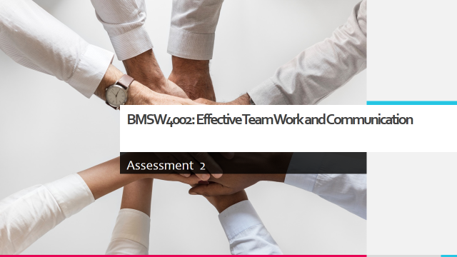
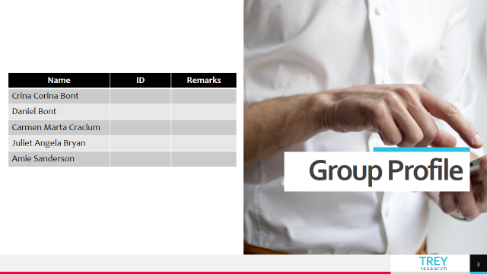

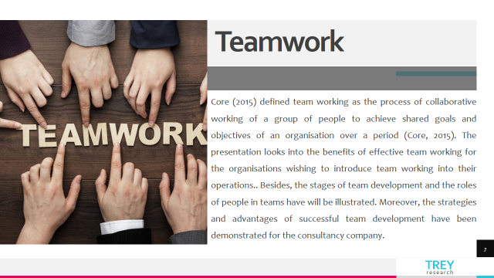
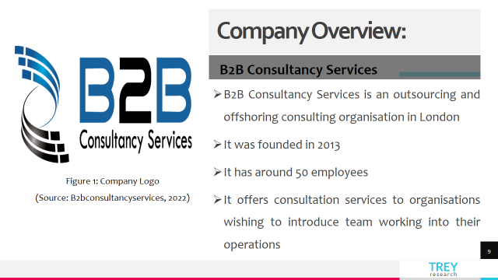

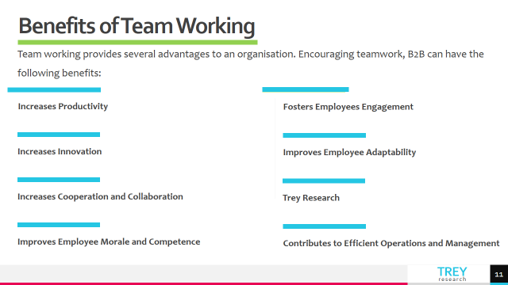
Speaker Notes: Encouraging teamwork, an organisation can have the following benefits:
- The overall productivity of the organisation can be increased as a result of effective teamwork. Teams are formed with a shared vision and objectives (Johnson, 2017). Collaborative working practices make teams more effective than traditional working practices. It improves the organisation.
- Teamwork increases innovation. In a team, there remain different types of employees, who can offer different ideas to achieve the objectives by thinking from different perspectives (Peacock, 2016). An organisation can manage continuous innovation through successful team working.
- Teamwork increases cooperation and collaboration among the team members. As a result, the members can learn from each other (Johnson, 2017). It will improve the processes of communication and help to avoid any types of mistakes in the operations and management of the organisation.
- Teamwork fosters the engagement of the employees. Therefore a strong coalition of the employees can be established in an organisation through team working (Peacock, 2016). Moreover, this can motivate people to help each other in critical situations.
- Team working makes the workplace environment more flexible. This can improve the adaptability of the team members in the organisation. As the team workers know the roles of each other, they become able to face challenges together (Johnson, 2017).
- Teamwork improves the morale and competence of the employees. Therefore, they become an excellent performer for an organisation (Peacock, 2016). It also enhances the skills of team members to overcome obstacles.
- The teams in an organisation can continuously contribute to improving the service levels by delivering efficient operations and management (Johnson, 2017).

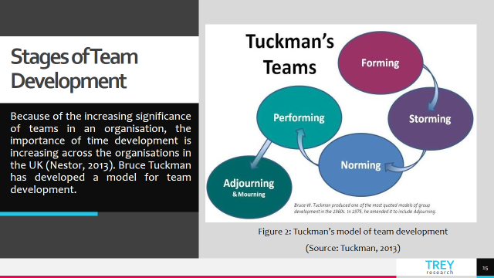
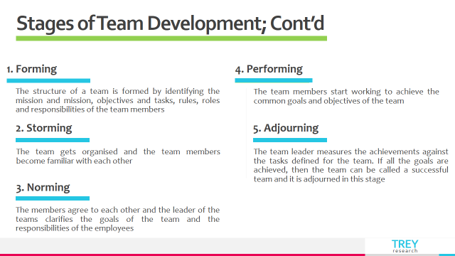
Speaker Notes:
- Forming: In the forming stage, the structure of a team is formed by identifying the mission and mission, objectives and tasks, rules, roles and responsibilities of the team members. In addition, an organisation can prepare guidelines for the team in this stage to direct the team members and involve them in operations. To form a team effectively, an organisation needs to appoint a leader (Tuckman, 2013). Besides, it is necessary to identify the challenges and opportunities to motivate the team members properly according to the standards of the organisation.
- Storming: In the storming stage, the team gets organised. The team members become familiar with each other. However, because of the difference in power and status of the members included in the team, conflicts can arise. Therefore, the leader needs to establish clear roles for all the members included (Tuckman, 2013). Besides, the leader of the teams should have coaching skills to motivate employees to their roles in the team in the second stage of team development.
- Norming: In the 3rd stage of team development, the members agree with each other. The leader of the team will clarify the goals of the team and the responsibilities of the employees to achieve the goals in the norming stage (Tuckman, 2013). The probability of success of a team is dependent on the interdependence and collaboration of team members. So, the leader must play an active role to remove the confusion of the members to achieve a high performance of the teams.
- Performing: In this stage, the employees work to achieve the common goals and objectives of the team focusing on their roles and responsibilities (Tuckman, 2013). Proper delegation of the employees is necessary to achieve maximum outputs from the team. The leader must have to monitor and give necessary guidance to the members to make their jobs easy. In addition, he must have to look for any threat or obstacle that can decrease the performance of the team to improve the accuracy of team working practices in an organisation.
- Adjourning: This is the last stage, where the leader measures the achievements against the tasks defined for the team. If all the goals are achieved, then the team can be called a successful team (Nestor, 2013). However, it is necessary to recognise the contribution of each of the team members to give them good feelings about their achievements.
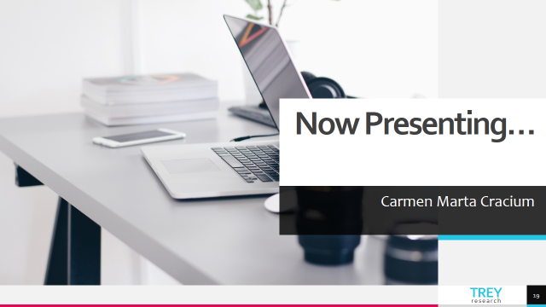
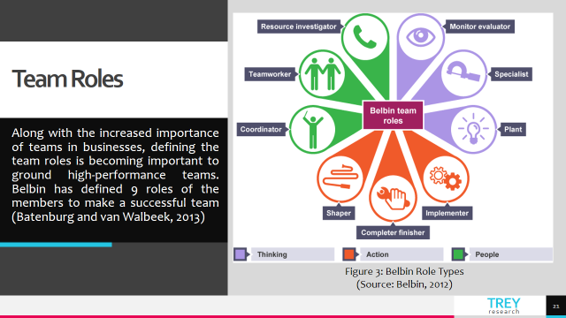
Speaker Notes: An organisation can apply this model to allocate human resources in teams.
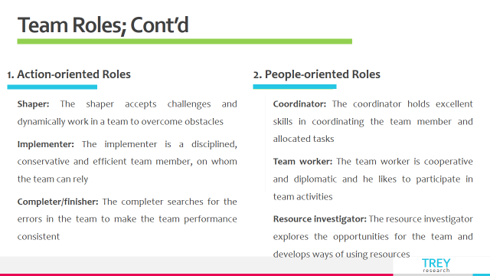
Speaker Notes:
Action-oriented roles
- Shaper: A shaper is a person, who can accept challenges and dynamically work in a team to overcome obstacles (Batenburg and van Walbeek, 2013). But a shaper often offends the feelings of other members.
- Implementer: An implementer is a disciplined, conservative and efficient team member, on whom the team can rely (Belbin, 2012). However, an implementer can be inflexible and slow in responding to new opportunities. But he can turn ideas into practice.
- Completer/finisher: A completer searches for the errors in the team to make the team performance consistent (Batenburg and van Walbeek, 2013). He focuses on finishing the tasks in due time.
People-oriented roles
- Coordinator: A coordinator holds excellent skills in coordinating. Generally, the team leader works as the coordinator according to Belbin’s model (Belbin, 2012). However, the coordinator has to clarify the goals and make effective decisions.
- Teamworker: A team worker is cooperative and diplomatic. He likes to participate in team activities (Batenburg and van Walbeek, 2013). Besides the team worker must have effective listening and execution skills.
- Resource investigator: The resource investigator explores the opportunities for the team and develops ways of using resources (Belbin, 2012). He is always optimistic about the success of the team.
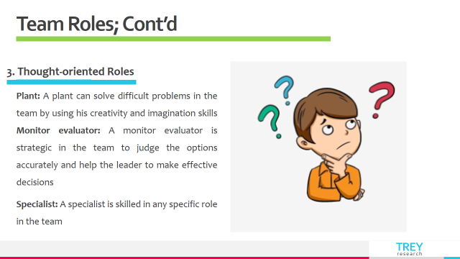

Speaker Notes:
Thought-oriented roles
- Plant: A plant can solve difficult problems in the team by using his creativity and imagination skills (Batenburg and van Walbeek, 2013).
- Monitor evaluator: A monitor evaluator is strategic in the team to judge the options accurately and help the leader to make effective decisions (Belbin, 2012).
- Specialist: A specialist is skilled in any specific role in the team (Batenburg and van Walbeek, 2013). He is dedicated, but he may not have the ability to perform all types of activities in the team.
An organisation can search for those people, who have these types of skills, knowledge and behaviour to form excellent teams.
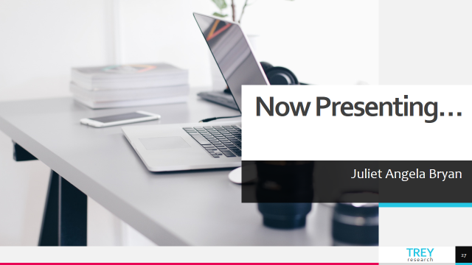
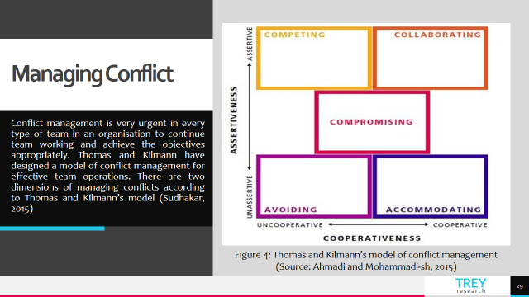
Speaker Notes:
In a team, conflicts can arise among the members from their disagreements to any subject relevant to the teamwork e.g. perceptions of the workers, desires and motivations, personal values or ideas (Abiodun, 2014). Conflict management is very urgent in every type of team in an organisation to continue team working and achieve the objectives appropriately. Thomas and Kilmann have designed a model of conflict management for effective team operations. There are two dimensions of managing conflicts according to Thomas and Kilmann’s model (Sudhakar, 2015). However, there are 5 elements of this model to apply in the dimensions to resolve conflicts; competing, avoiding, accommodating, collaborating and compromising (Ahmadi and Mohammadi-sh, 2015). Everyone involved in the conflict must have to compromise. But the team members can increase or decrease their sense of assertiveness or empathy according to the views of others to solve issues.
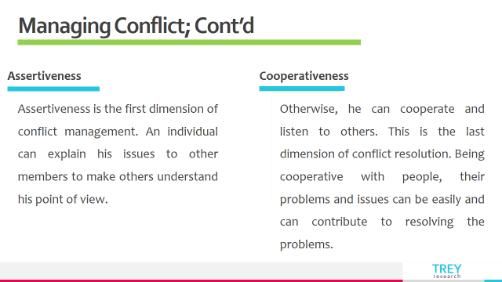
Speaker Notes:
- Assertiveness: Assertiveness is the first dimension of conflict management (Ahmadi and Mohammadi-sh, 2015). An individual can explain his issues to other members to make others understand his point of view.
- Cooperativeness: Otherwise, he can cooperate and listen to others. This is the last dimension of conflict resolution (Sudhakar, 2015). Being cooperative with people, their problems and issues can be easily and can contribute to resolving the problems.
High assertiveness and low cooperativeness maximise negative or positive enforcement of an individual over others (competing). High assertiveness and high cooperativeness enhance the collaboration of the people to come to a solution (collaborating) (Sudhakar, 2015). Low assertiveness and low cooperativeness withdraw the problematic issue from both sides (avoiding) (Ahmadi and Mohammadi-sh, 2015). Low assertiveness and high cooperativeness recognise others' concerns and find a solution to the conflict (accommodating).

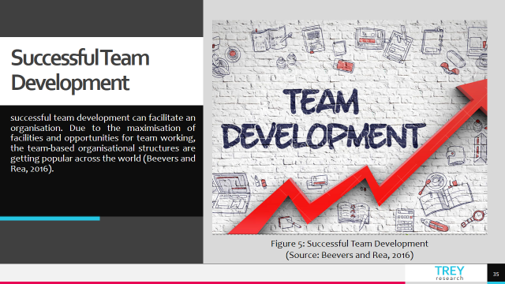
Speaker Notes:
An organisation can ensure successful development by following a few strategies.
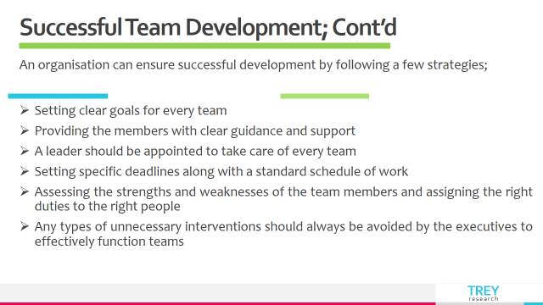
Speaker Notes:
It is mandatory to set clear goals for every team. The members need guidance and support. So, a leader should be appointed to take care of every team. Besides, specific deadlines are necessary to be set along with a standard schedule of work (Woodcock, 2017). Assessment of the strengths and weaknesses of the team members is necessary to assign the right duties to the right people. Any types of unnecessary interventions should always be avoided by the executives to effectively function teams.


