Chapters and other information to include within the dissertation:



A critical evaluation of how the far-right movement has affected Policing in the United Kingdom since 1930

Name: Adam Puddy
Student Number: 2134353
Degree: BSc (Hons) Professional Policing Practice
Word Count: 8,327

Acknowledgements
First, I would like to express the deepest of gratification to my beautiful wife Meghan. Meghan has been the cornerstone of support for me ever since I joined Gwent Police, and without her I would be half the man I am. Meghan has given me the kick I needed to complete this work even when I was feeling very anxious and lonely. Meghan has suffered with terrible illness over the last two years and to see her resolve only inspired me to keep going and she still supported me when I should have been there for her more. I am truly grateful.
Secondly, I would like to express gratitude to Stephanie Brown. I have been emailing Stephanie for 1 to 1 sessions as I did struggle understanding how to structure a dissertation but she had put my mind at ease. I am grateful for her answering my silly questions and doing so in a professional and well-meaning manner. Thank you, Stephanie.
Lastly, I would like to thank my friends and family for putting up with me over the last year of completing this project. My parents Claire and Lyndon, sister Rhian, mother and father in law Chris and Tracey, sister in law Mollie, brothers in law Luke and Tom and extended family have been very supportive and helpful when I was feeling overwhelmed with this project. My wonderful colleagues Abigail, Hannah, Geraint, Lisa and Oliver for being amazing friends and supporting me when I needed it most.

Declaration
This work has not previously been accepted in substance for any degree and is not being concurrently submitted in candidature for any degree.
Signed: Adam Puddy
Date: 03/04/2025

STATEMENT 1
This dissertation is being submitted in partial fulfilment of the requirements for the degree of BA.
Signed: Adam Puddy
Date: 03/04/2025

STATEMENT 2
This dissertation is the result of my own independent work/investigation, except where otherwise stated.
Other sources are acknowledged by footnotes giving explicit references. A bibliography is appended.
Signed: Adam Puddy
Date: 03/04/2025

STATEMENT 3
I hereby give consent for my dissertation, if accepted, to be available for photocopying and for interlibrary loan, and for the title and summary to be made available to outside organisations.
Signed: Adam Puddy
Date: 03/04/2025

STATEMENT 4
I hereby give consent for my dissertation, if accepted, to be available on the university’s IT system to those who have consent to use the system.
Signed: Adam Puddy
Date: 03/04/2025

Abstract
This dissertation examines and critically evaluates the presence of the far-right in society from an historical extent to the present day. The project seeks to use the research to gain a better understanding of the topic and how its long term effects can damage the community. The research for this topic includes historical articles, professors, public documents and official government pages. The findings of this protect will highlight the issues in the UK in regards to race and religion from the past to the present day. The topic will also highlight how the use of the internet is used by far-right affiliations to influence young audiences and garner support for their cause. This dissertation makes recommendations including more training for police officers and rehabilitating offenders.

Chapter One – Introduction
1:1 – Introduction………….5
1:2 Background and Rationale………..5-6
1:3 Aims and Objectives……….6
1:4 Research Structure………7
1:5 Conclusion………7
Chapter Two – Literature Review
2:1 – Introduction……….8
2:2 - Origins of far-right ideologies and it’s influences………8-10
2:3 - Far-right post war and how policing led to more problems……….10-11
2:4 - Modern day far-right and how it is policed………….11-12
2:5 – Conclusion………12
Chapter Three – Methodology
3:1- Introduction…………12-13
3:2 - Primary and Secondary Research Sources……….13
3:3 - Qualitative and Quantitative Data………….14
3:4 – Sampling………….14
3:5 – Ethics…………..14-15
Chapter Four – Analysis of Results
4:1 – Introduction………15
4:2- Demographic Information……….15-17
4:3- Questionnaire Results…………..17-22
4:4- Conclusion………..22
Chapter Five - Conclusion and Recommendations
5:1 – Introduction………22-23
5:2- Findings……….23-24
5:3- Contributions to Theory ……….24
5:4- Limitations………24
5:5- Recommendations………24-25
5:6- Future Research…………25
5:7-Conclusion……………26
Bibliography…….26-29
Appendices
6:1- Appendix One - Copy of Questionnaire……..30-33
6:2 – Appendix Two – Questionnaire Results……..33-37
6:3 Appendix Three – Ethics Form…………37-52

A critical evaluation of how the far-right movement has affected Policing in the United Kingdom since 1930

1:1 Introduction
I have chosen to speak about this topic in my dissertation, because it has been a subject which divides many opinions within communities and is a generational problem for many decades. My own personal interest in history and history of policing will be essential when it comes to studying and researching this topic. I am anxious to learn more about people’s opinions and I want to hear first-hand, the effects this subject has on people who have experienced it such as former police officers, victims and I am interested to hear from people who are on the fence with their opinions. I want to explore the topic from as early as the First and Second World War until the present day. I believe that this topic is worthy for consideration as it is topical to the present day and has multiple examples of historical incidents which will provide an ample amount of reading material and professional research references.
I have surveyed serving police officers as part of my research into examining the Far-Right and I have asked questions which relates to the modern day way of policing this topic. Considering the recent Southport Riots in England I was interested to know, how many officers are trained to deal with such issues as rioting. I wanted to know if officers had the correct training and equipment compared to those who answered the survey who has not received any additional training to tackle the issue of rioting. My research will also outline the drop in numbers of officers over the past few decades and highlight how stretched forces now are in dealing with the high volume of calls and incidents.
I will go into detail regarding the last 9 decades of British Far-Right movements. I will start with its origins and popularity during the Second World War with the British Union of Facists and research how ideologies of the time, motivated young men and women to attend hateful rallies. I will then research its eventual ban by themGovernment and how the party splintered into smaller factions became prevalent. Over the decades, Far-Right ideologies have always haunted the United Kingdom and I want to research and learn whether this is because of multiple reasons. The reasons being that is this a generational issue? Are young children motivated by parents or family members to have these beliefs and as they get older instil these beliefs into their children. Are the reasons being the area these people live in? Are they motivated to believe these ideas through the issue of poverty and upbringing. All of the reasons can be seen as excuses, but I want to research the thought process behind these beliefs.

1:2 Background and Rationale
The far-right movement and politics in the UK has existed from at least the 1930’s springing from the British Union of Fascists, headed by Oswald Mosley and the inspiration taken from Nazi Germany when Fascist leader Adolf Hitler gained power in Germany in 1933 when he became Chancellor. Since the end of the Second World War the UK saw a raise in the 1960’s and 1970’s of white nationalist organisations which opposed non-white and Asian immigration with examples being “Teddy Boys”. Parties such as the British National Party (BNP) were established in 1960. Through the decades, I will be looking into how such groups were policed by local police forces and how these groups were policed pre-Police and Criminal Evidence Act (PACE) in 1984 and post PACE which will lead to the present day such as the English Defence League (EDL) and UK riots against immigration. In England and Wales in 2022/2023 there were a total of 145,214 reported hate crimes to Police (Home Office, 2023).
There is justification to this research as it a very topical subject which is prominent now in the present day as it has been since the 1930’s. I have researched the works by Dr William Allcorn who is a professor at the Centre of Analysis of the Radical Right. I have also read works by Roanna Carleton-Taylor who is an author specialising in the events of the Far-Right movement and it’s politics.

1:3 Aims and Objectives

The aims and objectives of my research are:

Aims:

1) To investigate the impact that far-right politics and ideologies has on communities and the communities’ opinions on how this is policed.
2) To have a thorough understanding of how far-right politics and ideologies started in the UK through statistics.
3) To use statistics and facts to outline Hate Crime in the UK and in accordance with UK Government’s justice system.

Objectives:

1) Examine and research the history of far-right politics and ideologies and how it is still very relevant today as it was in the 1930’s
2) To develop an understanding of the communities who have experienced being targeted by far-right politics and their preferences of how to police the issues, and to understand why people are drawn into the ideologies of far-right politics.
3) To evaluate and equate existing research with the proposed evidence to seek any correlations
4) Analyse the efficiency of UK police forces and how they operate to deal with far-right hate crimes, including protests and riots.
5) To critically evaluate the impacts this topic has on communities, from the past to the present day and how public opinion can influence people’s perspectives.

1:4 Research Structure
The structure of this project will be placed into five chapters. The first chapter will introduce the research topic with the reasons for the intended research. The chapter will also identify the aims and objectives.
The second chapter is the literature review. This chapter will include pre-existing literature and research used to support my findings and find gaps in pre-existing research. To researching the historical beginnings of the topic bringing it to the modern day.
The third chapter consists of the methods and methodology used in the research. This chapter discusses the use of both primary and secondary data and shows the relevant need for this data.
The fourth chapter explains and analyses the results in my primary research. This was conducted using a questionnaire in the form of a survey and the results will be analysed and compared to national statistics.
The fifth and final chapter will explore the findings of the research and conclude with recommendations that have been found throughout the project.

1:5 Conclusion
Before the topic is discussed it is important to understand the impacts that this subject has had throughout the decades, and it is understandable that this may not be a popular topic for a dissertation. I believe that it is important to discuss this topic given how recent events such as the riots in England in 2011 and 2024 have stemmed through far-right ideology. As a serving police officer who deals with hate related crimes daily, I am interested to see how police forces deal with combating the far-right and if any improvement has been made to police it since the 1930’s.
To see the impacts that online social media can have on people and how easy it is for people to be influenced by things they see online. I want to know how communities are affected by this topic and see what can be done to improve the services that the communities received and learn first hand what is taught in police forces.

Chapter Two: Literature Review

2:1 Introduction into far-right movement

For the past 9 decades, far-right politics and ideologies have been a talking point in the UK. The ideologies of the far-right have been implemented within the UK since the founding of the British Union of Fascists in 1932 by Oswald Mosely. Since the party was banned after World War Two, smaller but many far-right became more prevalent. “The radical right has been small, fractious yet persistent in nearly a century of activism” (Feldman, 2024). In a report commissioned by UK Parliament in 2023 regarding response and intelligence into far-right ideologies, it states that it is difficult to pinpoint and find those who are motivated by the ideologies. Understandably the Police or any other force or agency are not going to delve into tactics and intelligence reports on a public document, but it does show that trying to target and fight this ideology is a difficult task, especially in the modern day of internet use and people’s ability to hide their identity to spread their hatred.
As a result of crimes changing and increasing, police forces being stretched on resources and the present-day demand on police officers, it is easy to see how reports of crime can slip through the net or not be investigated to a standard upheld by the public. In a report by the Thames Valley Police Federation, it states that “Police resources are now so stretched that it is putting officer safety at risk” (2025). In another report by Professor Blockley at Leeds Trinity University he states that “Police retention in the UK is now a national issue due to the demand and the rapid change in society, the police are struggling to keep up with the changes as the role is ever more challenging” (2024).
In 2021/2022 there had been 109,843 recorded racially aggravated hate crimes reported to police in England and Wales which was a 19% increase from the previous year. This statistic published by the Home Office shows that racially aggravated offences are on the rise in the UK and due to the modern-day technologies, such as social media, it is easy for people to access media and documentation which can influence their opinions. This chapter will explore the origins of far-right organisations and how influential they can be when targeting certain groups of people. The chapter will delve into racial divide, that was felt in Britain at a time where post war unemployment and stigmas of the time had ignited debates within the country. This would then lead to far-right organisations being influential in stirring up hatred and violent rioting. The chapter will also cover how policing this relatively new form of crime was conducted whilst critically analysing policing failures and lessons learned from mistakes of the past. A look into the modern era of far-right organisations and how technology has advanced the messages and grooming of young male adults online, and the police’s tactics to counter this advance.

2:2 Origins of far-right ideologies and it’s influences

Once the First World War ended in an armistice on 11th November 1918, many of Europe’s countries were left in economic crisis and struggling to rebuild. This struggle had led to many civil wars in Europe with peace not being achieved until 1923. (Imperial War Museum, 2018). The First World War had altered the global balance of power with empires now fallen and monarchies in countries such as Germany, Turkey and Russia either overrun and forced to abdicate and flee to neutral countries or killed and taken over by revolutionary leaders. “World War I had profound and far-reaching economic consequences for Europe.” (Educare, 2025).
The chaos of the First World War and Europe’s economic struggle had allowed small political groups in countries like Italy and Germany to flourish and gain momentum. In Germany, one political party in 1919 was formed by Anton Drexler which was named the German Workers Party. The party worked to promote German national pride with antisemitic tones and strong distaste for the Treaty of Versailles, which was the peace settlement which ended the First World War. “Antisemitism is hostility toward or discrimination against Jews as a religious or racial group.” (Berenbaum, 1998).
The treaty had given Germany harsh conditions in which they had lost land, military personnel and had to pay a large sum of money to the allies for the losses they endured during the war. Adolf Hitler became the leader of the party in 1921 and changed it’s name to National Socialist German Workers Party (Nazi). The Nazi Party struggled to gain support in the beginning of their formation, with many Germans believing them to be thugs and not a respected political party for the country. Hitler was arrested and sentenced to prison in 1923 for his involved in The Beer Hall Putsch in Munich for attempting to overthrow the government in a coup which was a failure. During his imprisonment, Hitler wrote the book “Mein Kampf” which was published in 1925 as a manifesto for his far-right ideologies. The book suggests that Jews and other minorities are to blame for Germany’s downfall, and it was the reason that they had lost the First World War. “The book promoted the key components of Nazism: rabid antisemitism, a racist world view, and an aggressive foreign policy” (USHMM, 2025).
Upon Hitler’s release, the Nazi Party began to gain some political momentum with the success of Hitler’s book and gaining new supporters after the 1929 Wall Street Crash which put the world into a global financial crisis. Germany was forced to repay loans to the United States from which they borrowed to get their economy back on track after the First World War and the Treaty of Versailles. Hitler used this crisis to his advantage by exploiting the anger in Germany with promises that he would be the man to rebuild the country and promised the people that he would create employment and oppose the Treaty. Hitler did all this whilst openly blaming Jews and other minorities for Germany’s downfall and planted the seed into German society which would lead to horrendous treatment of Jews and minorities as the Nazi Party gained more and more power. “The incompetence of the government fuelled German citizen's desire for urgent change”. (Roshni, 2013).
Hitler’s policies and influence had started to make headlines around the world. In Britain, a former labour MP named Oswald Mosley had been inspired by Hitler and the Nazi Party, agreeing with the Party’s stance on Jewish people and other “undesirable” minorities. “Britain’s most notorious fascist, known for his violent anti-Semitic rhetoric and for maintaining friendships with the likes of Adolf Hitler”. (Mason, 2022). In 1932, Mosely formed the British Union of Fascists (BUF), along with other MP’s and several smaller fascist-like groups. The BUF maintained close ties to the Nazi Party and in January 1933, Hitler was made Chancellor, cementing his goal of full control of Germany and its policies. The Nazi Party held multiple rallies and events in 1933, to which members of BUF attended.
In the next few years that had past, Hitler had passed the Nuremburg Laws in 1935, in Germany which were race policies that “protected German blood” and “German honour”. The laws dictated that Jewish people and other minorities such as black people, travellers and disabled people were not allowed to marry German’s and stripped away citizenship from Jewish people. Many minorities were denied basic rights and were forced to flee Germany or be placed in ghettos. “Marriage and relationships between Jewish people and Germans became illegal.” (BBC, 2009). Oswald Mosely, taking inspiration from this, made speeches at his own rallies blaming Jewish and minority immigrants for Britain’s economic and social issues. Mosley, like Hitler, hoped to gain support from the British public by promoting these issues hoping it would work just as it did in Germany. “Mosley’s fascists followed the Nazi’s example of falsely blaming Jewish “immigrants” for society’s problems.” (London Museum, 2025).
On 4th October 1936, the BUF planned to march through the East End of London which was a highly populated area for the Jewish community. More than 2,500 fascist supporters gathered and attempted to march into the East End. However, the movement was met with fierce anti-fascist protesters. An event known as “The Battle of Cable Street” saw violence and multiple arrests made. This was one of the first times that police had dealt with an issue regarding the far-right. Many people believed the police to be siding with the fascists due to the treatment that anti-fascist protesters had compared to the fascists. The police arrested 6 fascists compared to 80 anti-fascists. “The police were met with fierce resistance. Everything from rotten fruit to boiling water rained down on them from windows on all sides.” (Cole, 2022). The Second World War was declared in September 1939 as Britain once again, fought Germany. To counter any German sympathy, the UK Government banned The British Union, who were the BUF before changing their name in 1937, and Oswald Mosely was imprisoned in May 1940. “The government did not want a declared fascist and inciter roaming the streets of the capital”. (Historic Times, 2025).

2:3 Far-right post war and how policing led to more problems

The Second World War ended with an allied victory in Europe in May 1945 and with Nazi Germany and the axis powers of Italy and Japan defeated, the far-right ideologies had taken a massive hit. In 1948 Britain has passed the British Nationality Act, which meant that those born in any of Britain’s colonies were given British citizenship. The act led to a surge of immigrants coming into the United Kingdom, which of course was met with opposition from those affiliated with far-right views. “An increase in immigration over the following four years which would act as a spur for far right opposition.” (Carleton-Taylor, 2022).
Far-right political parties and small fractions of supporters had still been present in society in the following decades with well-known parties such as British National Party (BNP) being formed in the 1960’s. Police were met with heavy criticism during the periods before the Police and Criminal Evidence Act (PACE) of 1984 came into legislation especially from black communities and those of an ethnic background. As stated on the UK Government website, PACE is to establish the powers of the police to combat crimes while protecting the rights of the public.
The police had a reputation of abusing the power of The Vagrancy Act 1824 which gave police the power to stop and search anyone they deemed suspicious of committing a crime instead of believing that an actual crime had been committed. “These powers allowed the police to stop any person found loitering in a public place on suspicion of intent to commit an offence, rather than a belief a crime had been committed.” (Cheadle, 2021).
An example of this, is the Notting Hill riots in 1976 in which police clashed with those who were attending the annual Notting Hill Carnival. Police attempted to arrest a black man over an allegation of pickpocketing, and they were met with groups of black youths protesting the arrest. This had then led to an escalation of disturbances to which many carnival attendees clashed with police which led to riots. It was reported by the BBC that more than 100 police officers required hospital treatment and more than 66 arrests were made. Many people from the local community expressed that this incident had a similar scene to that of the 1958 riots in Notting Hill where members of the far-right group “Teddy Boys” had marched into Notting Hill and demonstrated violence towards the black community. This was in protest of the “Windrush” generation who had come to Britain from the Caribbean ten years earlier as part of the British Nationality Act of 1948. Police were criticised for not having enough officers on duty to help protect the community. Police were also criticised for the majority of arrests being black men instead of the white men who instigated the violence. This was one of the first racial riots to which Britain had not seen prior and it was obvious that police could not handle the incident therefore arrested anyone they could. “racially-charged violence that had broken out in Notting Hill, something that Britain had not witnessed before.” (Staveley-Wadham, 2022).

2:4 Modern day far-right and how it is policed

In the modern era, policing has changed dramatically since the far-right were first formed. “It developed crime-fighting methods, improved the use of technology and became increasingly specialised”. (GSCE History, N.D). Policing tactics such as facial recognition and counter-terrorism presence online are just a couple of many tactics that Police use to identify offenders of far-right, by undercover operations and plain clothed officers attending gatherings. The tactics are of my own knowledge being a Police Constable. An example of recent police tactics being used were from the riots in England in relation to the incident in Stockport where three young females were killed at a themed dance class on 29th July 2024. “More than 90 people were arrested after demonstrations organised by far-right groups descended into riots in UK towns.” (Binley and Johnson, 2024).
Initially, the police had struggled to maintain order due to the lack of resources and low numbers. The police had deployed riot trained officers along with specialist firearm and dog handler officers. Due to the rising chance of order not being maintained, police forces from all around the UK were deployed to assist officers in cities like Liverpool and Manchester so the riots and disturbances could be contained. It was reported by the BBC that more than 30 far-right supporters were planning to protest. To counter act this, Prime Minister Kier Starmer had stated that he would authorise a new national disorder programme. This was to allow national police forces to share intelligence on those who have a far-right affiliation. Another tactic used by police to disrupt and disengage far-right supporters.
Due to modern day technologies such as social media, those who spread far-right ideologies can get their message out quickly and often behind an anonymous means. Having a presence on social media means that audiences can be easily targeted given how accessible the internet has become. “As of January 2024, nearly 98 percent of the UK population used the internet.” (Petrosyan, 2024). Far-right activists such as Tommy Robinson, who was the founder in 2009 of far-right group The English Defence League (EDL) is an example of how using social media as a means to promote ideology and hatred as his social media posts often garner thousands if not millions of engagements in which many people will read and form an opinion whether they agree or disagree.
In an article by NewStatesman, an investigation by the Metropolitan Police states that investigations for far-right content online have increased from 2019 to 2,000 cases annually. The majority of the investigations are for male children under the age of 18. Young males are being influenced online by accessing far-right websites and “influencers” online and are being groomed into believing what these groups are saying. Statistics from the UK Home Office state that those who have been referred to Prevent. As described by BBC Prevent was introduced in 2006 as an anti-terrorism agency. Children aged 11 to 15 accounted for the largest proportion of referrals with approximately 2,729, while those aged between 16 and 17 accounted for the second largest proportion 892 of referrals.
In a report from Sky News, it states that around 70% of those who eventually leave far-right organisations had been recruited online. The far-right use a lot of modern innovations such as patriotism and online games to attract members to their cause. Police counter-terrorism schemes and intelligence are also used to combat the influence of online far-right organisations with monitoring and prevention interventions which can aid young children being targeted by these organisations and disrupt their chances of recruiting. Attempting to police online is becoming a more difficult task, given the drop in numbers of officers being recruited and those that leave the job. Due to the increasing budget cuts and lack of recruitment, officers with specialist skills like computer technology are not being fully supported and this will mean it is more likely that criminal activity like far-right extremism may slip through the net. “Officers stood at 149,164 at the end of September 2023, down 402 from 149,566 at the end of March”. (Thompson, 2024).

2:5 Conclusion

As discussed in this chapter, far-right ideologies have been ingrained in British society since the end of the First World War. The time between the First and the Second World War saw an increase in memberships to far-right affiliated parties such as BUF.
The BUF’s campaigning and support of Nazi Germany in a time where racial prejudice was rising, saw that many far-right political were looking for someone to blame for the post First World War economic crisis and attempting to rile communities into joining their cause. Fascism had taken a massive hit after the conclusion of the Second World War which saw far-right organisations either banned or splintered into small groups which could easily be monitored and policed.
Moving through the decades especially in the 1950’s, 1970’s and 1980’s saw police accused of racism and enabling the far-right activists. As outlined in this chapter through “Windrush” and the Notting Hill riots. PACE had been introduced in 1984 in an effort to justify the police’s use of stop and search in which police had to use belief over suspicion when using this power. Modern day policing of far-right has improved with the use of technology and information sharing between forces but as discussed with the dropping of policing numbers, it is becoming more difficult to give officers the correct training to counteract this. The next chapter will discuss the rationale and research of this topic by justifying the methods used in the research and the relevance to the topic.

Chapter 3 – Methodology

3:1 Introduction
The previous chapter of my chosen topic has achieved the first, second and third objective of the research proposal. This has been achieved by critically analysing and researching existing literature. The purpose of this chapter of the dissertation, I will be looking to achieve the fourth objective which is to evaluate and equate existing research with the proposed evidence to seek any correlations.
In an article by Victor Hu (2023), he describes research as being critically important when evaluating research and its findings. Systematic reviews are very valuable to research. As outlined by Preston (2023), systematic reviews should have a clear research question, which clearly describe methods on how the research has been conducted.
In this chapter, I aim to explore the primary and secondary research data sources. In my dissertation, my research is mostly reliant on secondary sources. I have also taken a pragmatic approach to my research using constructed primary and secondary sources to base my findings on objective and subjective points of view. I have also incorporated critical theory into my findings which has historical values based on real life historical events which tie into the modern day. The methodology will outline the research methods that I have conducted for this dissertation, justifying why I have used these methods.

3:2 Primary and Secondary Research Sources
To begin, it is important to understand the types of methods when conducting research in a methodology. It is also important to realise how this can benefit you when choosing appropriate methods to assist your research project. As described by Rashid (2022) research methods allow for the researcher to gather help in finding a solution to the problem posed in their question. This will also lead to questions of as to why these different methods had been used and what research was conducted to justify the findings.
In a study by Surbhi (2017) there are two types of research, which are primary and secondary. Primary research involves taking data as freshly as possible; therefore, it would be very new and raw data which can be used to gather information on the topic first time by the researcher. This can be conducted by using questionnaires and informal conversations. Primary research is beneficial when gathering data as it can explore the possibilities of producing new findings and knowledge, whilst gathering a new perspective to pre-existing data. “Primary research is carried out by scholars and researchers to gain new information.” (Nicolas, 2024). The processing of primary research is that the researcher will base their research on their findings based on a scientific principal. To do this, researchers will develop the research question and then collect the data, analysis it and present the evidence within the conclusion. “Formulating a hypothesis, designing an experiment to test the hypothesis, and collecting and interpreting data.” (National Academy of Sciences, 2009).
Secondary research is data which has already been collected and studied. Whether this is by published authors or online articles which have been analysed and interpreted as reliable. As published by Qualtrics (2021), when using these methods, researchers will gather the information, analysis it and present it within their findings to help answer the proposed question. Like primary research, secondary is helpful to the researcher as the data which has already been collected, can be formulated and used quickly to assist in the analysis of the data as it has already been collected and is credible. “This saves the researcher a great deal of time and allows for a potentially wider dataset to be gathered.” (Taylor, 2022). In my research, I have used this method for most of my dissertation given the historical background into my topic. I have conducted secondary research in regard to online articles and published works to support my findings and these will be spoken about in depth during the analysis of results chapter.
3:3 Qualitative and Quantitative Data
As described by McLeod (2023) the differences between qualitative and quantitative data for research purposes are as follows. Qualitative data uses the system of gathering data and information through the means of non-numerical means. The method concentrates on using words and images to examine and explore subjects through observation and sometimes, conversation. This system therefore supports the use of primary data as it can gather information first hand as previously explored. It is also important for qualitative data to be used in the use of secondary data. The aims of using this method of using words and research from previously analysed data, is that it can be used to give an accurate outcome once the researcher is ready to conclude their findings. The method can produce detailed analysis and fill in gaps from research which has yet to be found.
Quantitative data uses the system of gathering data and information via numbers or statistical methods. This method is used to show findings and corroborate data using numbers and to make predictions and identify patterns. This method of research is helpful in regards to the primary research as using methods like questionnaires and interviews can be studied by using charts and objectives can be expressed through numerical means. To support the use of secondary data, the method can be used to research previously explored analysis and use this data as part of the research regarding the question of the topic. The aims of this method are to use the numerical research to accurately test theories and identify the patterns of the answers given by those who have participated in the research question posed to them.

3:4 Sampling
Once again, referring to McLeod (2023) sampling is an important part of gathering information on a chosen topic as it opens discussions and opinions, which can assist the researcher to see points of view of the persons taking part. This can also be helpful for supporting arguments and critically evaluating both sides of fence when asking the topic question.
In regard to the sampling of my research, I have taken a different approach to the draft sampling I stated at the beginning of my dissertation. I have decided to use my research to conduct a survey in a questionnaire format. To achieve this, I have asked serving police officers to participate and answer 15 questions relating to their age, gender, role etc. whilst also posing the questions of how many hate crime related calls they have attended are far-right related and if they have received the correct training to deal with incidents.
I will be comparing these findings that I have gathered to other analysed data from secondary research standpoint. I will also be sampling previous research on the topic and examine the similarities between historic far-right policing and the present day, as stated in my literature review. I am interested in comparing these results.

3:5 Ethics
Due to this topic being somewhat sensitive and topical I can understand that some people may be reluctant to speak about their experiences or give their opinions on the topic and may not be open to being honest about their experiences, therefore I have offered the option of anonymously participating. I have used secondary data to gather information on those who are affected by the topic and have used their experiences in my research. I have used primary data to gather information from serving officers to gather information on the topic. I have provided within my questionnaire, helplines and guidance for those affected by the topic in the hopes that if they feel uncomfortable or mentally upset by the topic, they can seek help and advice from these organisations.

Chapter Four – Analysis of Results

4:1 Introduction

To gather primary source data in my studies, a survey was conducted in order to see the extent of which serving police officers attend calls relating to far-right hate crime and if they had received the correct training and equipment to deal with the incident. In the survey, the responses totalled to 28. In this chapter, the questions and answers to the survey will be explored and used to present the results that were gathered.
The survey consists of multiple-choice questions and a free text box so participants could type their answers. Overall, the survey contains a list of 15 questions which include age, gender, ethnicity, police force etc. The survey was conducted by using Microsoft Office Forms website and distributed to officers via Microsoft Teams, email and using Gwent Police’s internal intranet service named The Beat. This method was used in the hope of obtaining as many responses as possible to gather the information and to see the data to analyse the results.

4:2 Demographic Information
To analyse the results, demographic data was collected to see the variety of participants and gather information about their age, gender, police force and length of service as a police officer. The survey garnered 28 responses to the questions.
The responses show that 16 males (57%) compared to 12 females (43%). When asked about the age of the participants, 28 responses stated that 7 of the participants were aged 18-24 (25%), 13 were aged 25-34 (46%), 5 were aged 35-44 (18%), 2 were aged 44-55 (7%) and 1 was aged 55+ (4%). This shows a good variety of ages of the participants.
The participants were then asked about their ethnicity. 28 responses to this question stated that 17 participants (61%) had chosen White British, 1(4%) had chosen White Mixed, 1 (4%) had chosen Caucasian, 1 (4%) had chosen Welsh, 1 (4%) had chosen British and 6 (23%) had chosen White.
The participants were then asked which police force they serve. 28 responses had shown that 26 serve with Gwent Police (93%) and 2 responses were non-Gwent police (7%) these forces being City of London and Greater Manchester.
The participants were then asked to state their length of service as a police officer. 28 responses had shown that 0 participants had been a police officer for 7-12 months (0%), 3 had been serving for 13-23 months (11%), 15 had been serving for 2-5 years (54%) and 10 had a service length of 10+ years (36%). The results are shown in the graphs below.
Graph 1 – Gender - Question 1 of 15
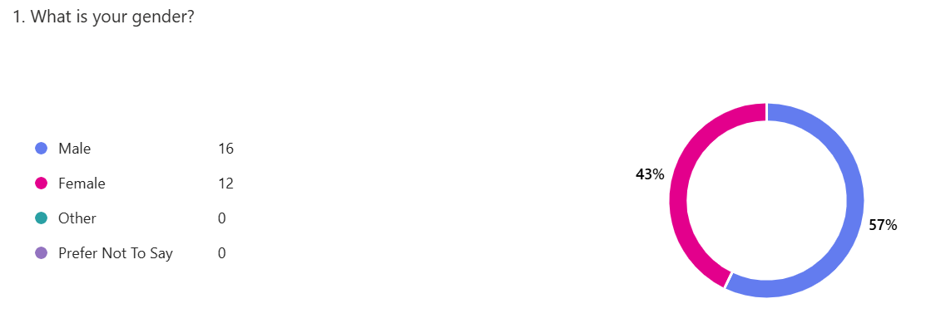

Graph 2 -Age Group – Question 2 of 15
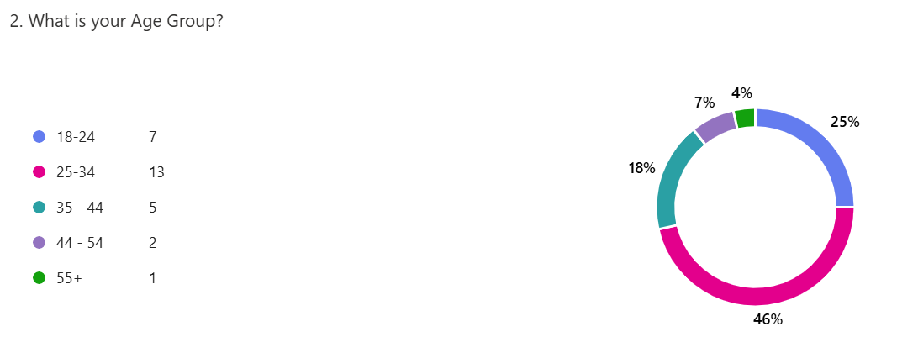

Graph 3 – Ethnicity – Question 3 of 15

Column1 | Column2 | Column3
White British | 17 responses | 61%
White Mixed | 1 response | 4%
Caucasian | 1 response | 4%
Welsh | 1 Response | 4%
British | 1 response | 4%
White | 6 responses | 23%

Graph 4 – Police Force – Question 4 of 15
Column1 | Column2 | Column3
Gwent Police | 26 responses | 93%
Non-Gwent | 2 responses | 7%

Graph 5 – Length of Service – Question 5 of 15

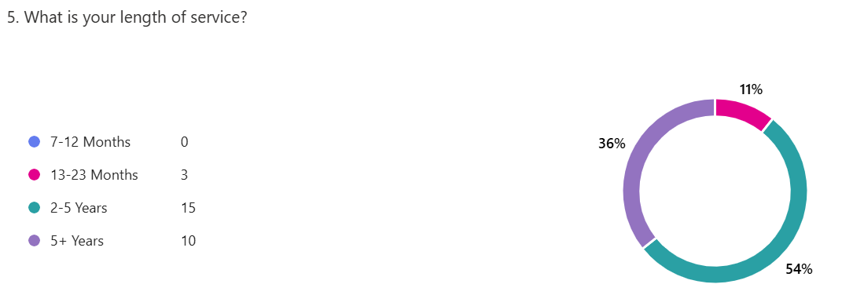
4:3 Questionnaire Results

To answer question number 6 on the survey which is “What Police Support Unit (PSU) level are you?”, it is best to explain exactly what PSU means before advancing forward with the results. As outlined by Eve in an article on SurreyLive (2018), PSU trained officers are those who are deployed to public order events or major incidents. This is relevant given the recent 2024 Stockport riots as mentioned in a previous chapter. From West Yorkshire Police (N.D), PSU comes in three levels. Level three is the lowest form of training where officers are taught how to deal with low-level public order events. Level 2 is the middle tier to which officers are given training to deal with medium to high level public order. Level 1 is the highest level, and officers are trained to deal with high level disorder and major incidents such as natural disasters etc.

Graph 6 – PSU Training - Question 6 of 15
Column1 | Column2 | Column3
PSU L3 | 17 responses | 64%
PSU L2 | 4 responses | 16%
PSU L1 | 0 responses | 0%
Non-PSU | 5 responses | 20%

In the table above, the results show that the majority of officers who completed the survey are PSU L3. Out of 28 responses 17 officers are trained at this level (%). 4 participants are trained in PSU L2 (%), 0 participants are trained at PSU L1 (0%) and 5 participants are non-PSU trained (%).
Question 7 is a follow up to the previous question, which asks participants if they had been deployed to a public order event during their service. For context, as outlined by Wales Safer Communities (N.D) public order can often include rioting, drunken behaviour and violent disorder. This question was designed to see how many officers had attended a public order event.

Graph 7 – Public Order Deployment – Question 7 of 15
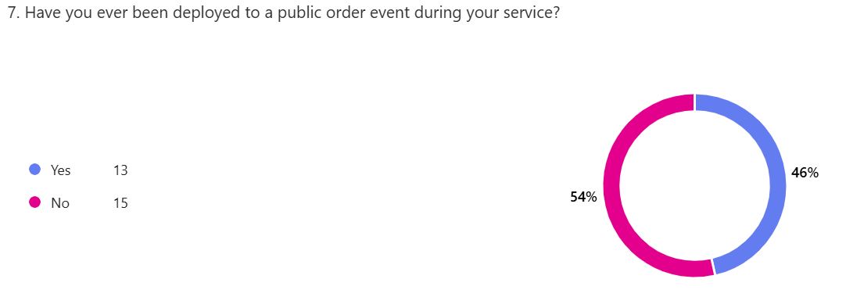
In the graph above, the results show from 28 responses, that 13 officers (46%) had attended a public order event compared to 15 officers (54%) who had not.
Question 8 asks the participant to state what kind of public order event they had attended and responded too. This question was designed to see the variety of public order events police officer had attended.

Graph 8 – Public Order Events – Question 8 of 15
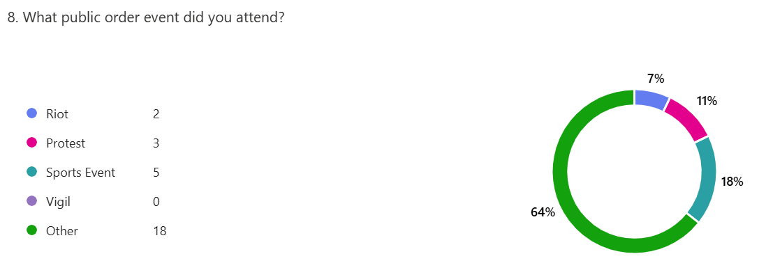
In the graph above, the results show that from 28 responses, 2 participants had attended a riot (7%), 3 participants had attended a protest (11%), 5 participants had attended a sports event (18%), 0 participants had attended a vigil (0%) and 18 participants had attended a different public order event (64%)
Question 9 asks the participants about how common reports of hate related crimes are made in their force area. Hate crime as defined by the Crown Prosecution Service (2022) is a criminal offence that is motivated by hate and prejudice towards persons based on race, sexual orientation, disability, religion and identity.

Graph 9 – Hate Crime Reports – Question 9 of 15
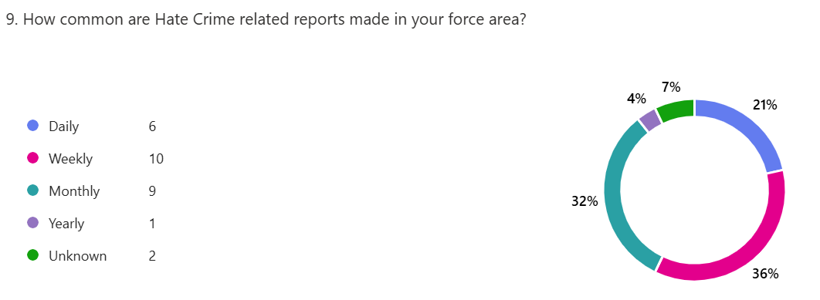
In the graph above, the results show that from 28 responses. 6 participants had said that hate crime is reported daily (21%), 10 participants had said that hate crime is reported on a weekly basis (36%), 9 participants had said that hate crime is reported on a monthly basis (32%), 1 participant had said that hate crime is reported on a yearly basis (4%) and 2 participants had said that they did not know the statistics.
Question 10 asks the participants to state how many hate related crimes have they investigated during their length of service.

Graph 10 – Hate Crime Investigations – Question 10 of 15
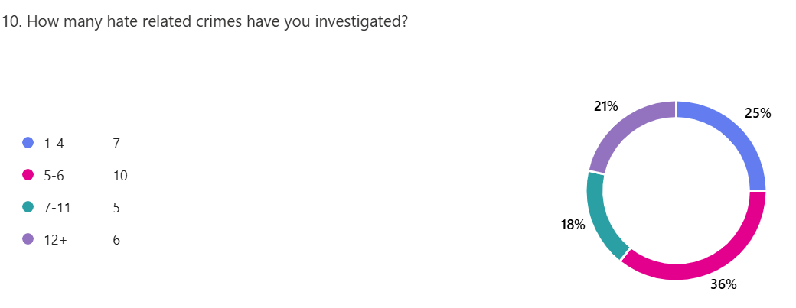
In the graph above, the results show that from 28 responses. 7 participants have investigated between 1-4 hate crime related crimes (25%), 10 participants have investigated between 5-6 hate related crimes (36%), 5 participants had investigated between 7-11 hate related crimes (18%) and 6 participants had investigated more than 12 hate related crimes (21%).
Question 11 asks the participant about the most common form of hate crime that they had investigated during their length of service. This question was not limited to one answer and participants could choose multiple answers.

Graph 11 – Common Form of Hate Crimes Investigated – Question 11 of 15
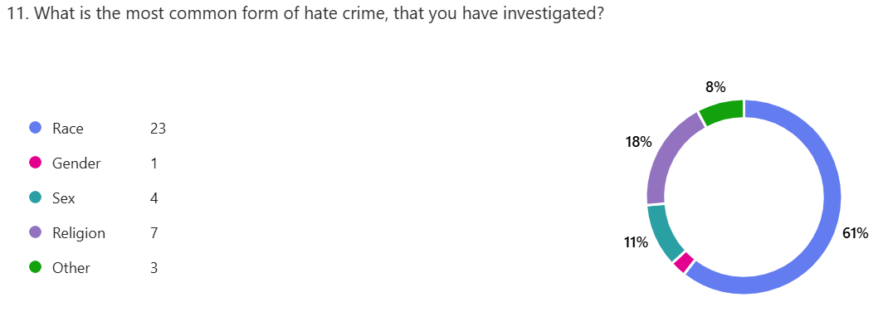
In the graph above, the results show that out of 38 responses (28 participants), 23 incidents of race had been investigated (61%), 1 incident regarding gender (3%), 4 incidents regarding sex (11%), 7 incidents regarding religion (18%).
Question 12 asks the participants if any of the alleged offenders had any ties to a far-right movement or party.

Graph 12 – Any Ties to Far-right Movements or Parties – Question 12 of 15
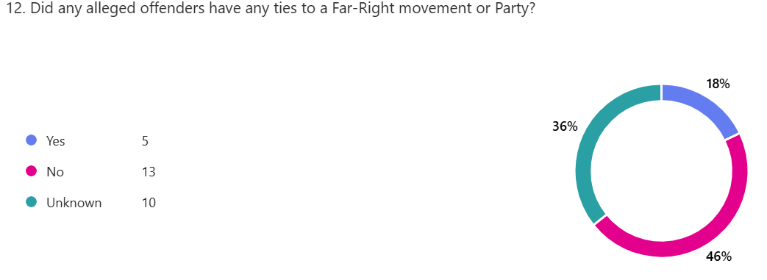
In the graph above, the results show that out of 28 responses. 5 participants had answered yes to offenders being affiliated with the far-right (18%), 13 participants had answered no (46%) and 10 participants answered unknown (36%).
Question 13 asks the participants how the alleged offender had been known to be affiliated to a far-right movement or party.

Graph 13 – How it is known the Offender is Affiliated – Question 13 of 15
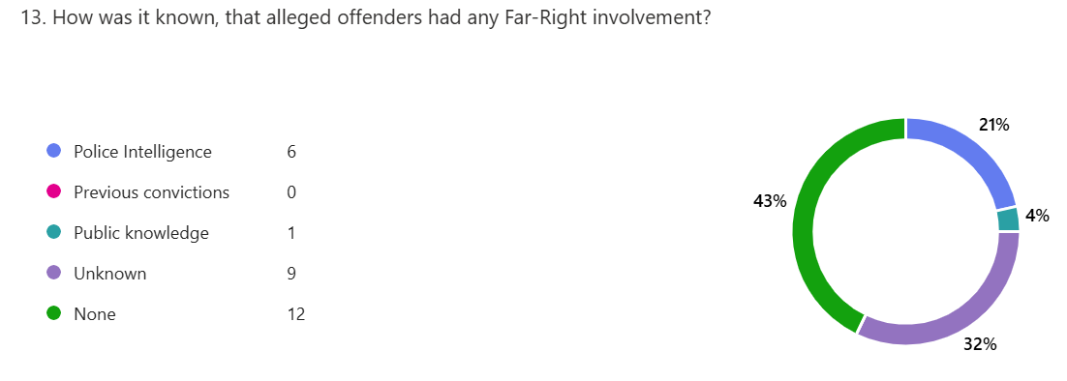
In the graph above, the results show that from 28 responses. 6 participants had knowledge of the affiliation from police intelligence (21%), 0 from previous convictions (0%), 1 from public knowledge (4%), 9 did not know if they were affiliated (32%) and 12 offenders had no affiliations (43%).
Question 14 asks the participant to outline how many positive outcomes had come from the investigation of a hate related crime.

Graph 14 – Positive Outcomes – Question 14 of 15
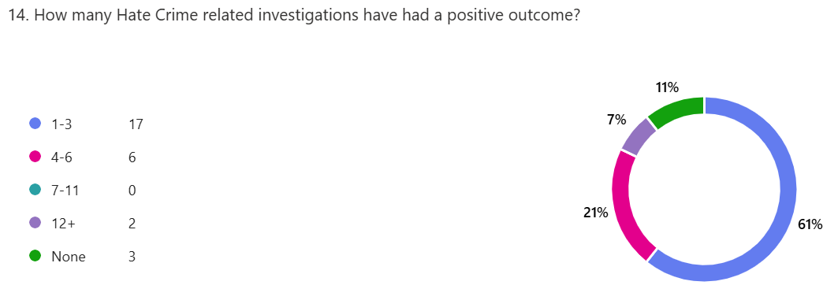
In the graph above, the results show from 28 responses. 17 responded to have between 1-3 positive outcomes (61%), 6 for between 4-6 outcomes (21%), 0 for between 7-11 outcomes, 2 for 12+ (7%) and 3 for no positive outcomes (11%).
Question 15 asks the participant to state the main reasons why hate related crimes do not have a positive outcome in their investigations.

Graph 15 – Negative Outcomes – Question 15 of 15
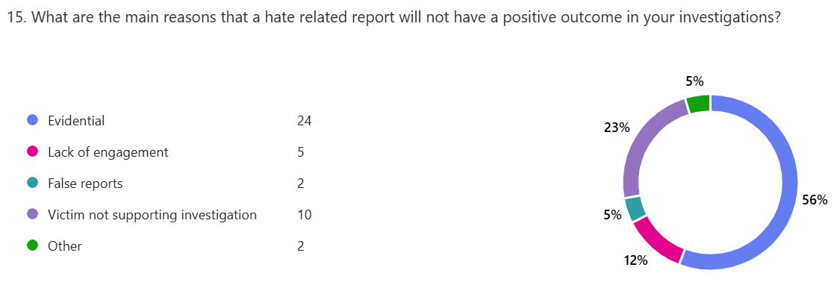
In the graph below, the results show from 28 responses. 24 had answered that evidential difficulties resulted in a negative outcome (56%), 5 from a lack of engagement from the victim (12%), 2 from false reports (5%), 10 from victims not supporting an investigation (23%) and 2 from other means (5%).
4:4 – Conclusion
In conclusion, this chapter has highlighted that from the results of the questionnaire, many officers are not trained to the correct standard of public order (PSU) to deal with incidents. In the recent riots of 2024 in England, this is a worrying statistic as 93% of recorded hate related crime from March 2023 to March 2024 were for public order (Home Office, 2024). The results also show that race and religion are the dominating factors of hate related crimes. When comparing my results to national statistics in England and Wales from the Home Office (2024) reports of hate related crime for their race were at 70% which was a decrease of 5% comparing to 2023. There was an increase of 25% compared to March 2023 for reports of hate related crime to religion. The results also show that gaining a positive outcome for a victim of hate crime is difficult due to evidential difficulties and victims not supporting an investigation. In my conclusion and recommendations chapter, there will be analysis on how this can be improved in future. I believe that this chapter has completed objective 4 and 5 of my research proposal.

Chapter Five – Conclusion and Recommendations

5:1 Introduction
This chapter will aim to deliver the conclusion and the recommendations to my dissertation. In this chapter the findings from my research and investigations into how the far-right movement has affected policing since the 1930’s had been interesting. The chapter will address the information gathered from primary and secondary sources whilst critically evaluating the information and comparing results. The gathered information from this research is intended to explore the past of the far-right movement to the present day and to examine how much or if any change has been made in the past 9 decades.
The study has five main research objectives, which include looking into the history of the topic to understand how far-right ideologies and organisations operate and gather support. To develop an understanding on how communities who are victims of this topic have been affected and if policing has had any profound change from years gone by. To evaluate findings and recent research from local areas to national statistics. Using primary and secondary research to seek any evidence that UK police forces are under equipped to deal with such incidents such as public order etc. To critically evaluate the topic to see what kind of impact it has on local communities and the use of modern technologies such as social media.

5:2 Findings
The main findings of this project are that the UK still have a quite substantial issue with hate related crime reporting. Figures from Statista (2024) show that there has been a significant increase in England and Wales from 2012/2013. The figures show that in 2024 there had been 140,561 reports of hate related crime in 2023/2024 compared to 42,255 reports in 2012/2013. The research shows that since 2012 there has been an increase in reports made to police every year. From the research it shows similar findings in Scotland and Northern Ireland since 2005.
Through the research into the findings, historical impacts from the rise of far-right movements are still relevant today. Racial and religious prejudice are still a highly discussed topic globally with people having opinions on the subject. It is evident that subjects such as the First and Second World War being taught in schools and thousands if not millions of documentaries being made on the subject, reach an unknown amount of people globally. Therefore, there would be a lot of opinion and preferences to this subject.
An example of this is the Holocaust. It is widely renowned and accepted that the Holocaust was the cause of six million Jewish people losing their lives in Europe in the 1930’s and 1940’s. To this day, many people including far-right activists, deny that the Holocaust even happened or did not happen as reported (Mackenzie, 2018). The point of this finding is that although it is having been proven evidential, people will form opinions that outright go against evidence. The reason for this is that the evidence does not suit their narrative or that it is used as propaganda to encourage support or new followers.
From my findings in a survey, 18% of police officers from Gwent Police, had dealt with a hate crime that had a far-right affiliation. This is quite a high percentage for a local police force, and it shows that although the world is changing, it is not necessarily improving. 23% of victims from findings in the survey stated that they did not wish to pursue a complaint or support a police investigation. This statistic is disappointing, but questions must be asked as to why victims feel the need, to not support an investigation. The question to think about is it a policing issue? Or have victims been let down before and do not trust police to get a positive outcome? In a report by the BBC (2020) it states that two thirds of black and ethnic groups feel that police forces in the UK have a racial bias. This statistic should be addressed and will form as part of the recommendations section of the chapter.
The findings have also shown that an online presence on social media can influence people easily. The platforms can be used to spread fake news and instigate hate, often through anonymous means. Far-right affiliated accounts can and will use social media to garner support and often try and recruit new members. As discussed in a previous chapter, social media is used by over 95% of UK residents with many of these being children. Children can be heavily influenced online by looking up to inappropriate role models. As previously stated, young males under 18 are being referred to counterterrorism with approximately 2,729 referrals made. Although this does not prove that it is all far-right affiliated, it is concerning that children are now on terrorism watch lists because of what they can access on social media.
Overall, the findings of this project have been interesting and surprising. It shows that historic events from many years ago are still playing a big role into the modern day far-right organisations. Many of these organisations are still influenced and supportive of the policies and hold a racial prejudice as those like Adolf Hitler and Oswald Mosely. The findings have also shown that the police still struggle to gain trust with ethnic communities and the lack of training shows that police will continue to struggle with this.

5:3 Contributions to Theory
The study that was conducted contributes to the theorical understanding that the UK still has an issue with race and religion and policing has been affected by this throughout the years. As discussed in the literature review, historic events are still impacting on modern society and although weaker than decades ago, it is still an underlining problem in society that people cannot accept people for who they are. It is hard to imagine those who have these ideologies living in society, but it is worrying to think about those who agree with it but do not act on it. This is why there will never be an exact statistic on those who are affiliated with far-right organisations. The study also suggests that police services need to improve the training and trust issues between ethnic communities and the police still need to be addressed.

5:4 Limitations
The studies primary source data was limited due to only receiving 28 responses. Police officers who had answered are from a force area which does not have a big ethnic community, so it is hard to compare this to those who serve in a city or have a large ethnic presence. If the sample size had been larger, there would have been more results and statistics to compare answers instead of heavily relying on national statistics.
The report will also carry self-bias and personal knowledge due to interest in the topic. Not all findings can always be supported from primary or secondary sources, therefore this could either enhance or degrade the findings of the project.
Additionally, relying on many secondary sources can prove difficult if further research in the future debunks or disproves the findings.

5:5 Recommendations
This part of the chapter will include recommendations from professional bodies, studies and personal thoughts.

- Improvement in police training

It is evident, that police are not receiving the correct training or are not being offered training which can assist in dealing with an incident such as public order events. As discussed in a previous chapter, 93% of hate crime related incidents are from public order or violence against a person. If police are not given the correct training, then this statistic, which is worryingly high will continue to rise. This can be improved by training officers at the beginning of their service with refresher courses yearly. A limitation to this would be budgets and adequate training officers.

- Online Educational in Schools

In today’s age, where the internet is used very commonly, children are exposed to a staggering amount of information online. In a report by Ofcom (2024) it states that children as young as infants own a smart phone and 76% of children aged 5-7 own a tablet. 42% of these children have a social media account. There must be further education in schools to protect children from accessing or viewing inappropriate content. As outlined in my literature review young males are being influenced online by accessing far-right websites.

- Rehabilitation through Education

In a report by Novus (2025) those who enter a prison education programme and complete their courses are less likely to offend after 12 months of release. Using this finding, it may be helpful for rehabilitated offenders to enter schools and have an online presence showing the negatives effects of prison and also showing negative effects of joining a far-right group.

- Police Surgeries with Local Communities

Police forces can open surgeries and invite local communities to discuss where they need to improve. This can be an open invite and may encourage those of an ethnic background to attend and air their grievances should they have them in regard to trusting police. This can be achieved by going on patrol so the community can see police face to face and approach them.

5:6 Future Research
Future research should compare national statistics from previous years to see if there has been an improvement in reporting hate-related far-right crimes. A further reach on demographics from national and intercontinental means. Although this research is primarily UK based, it would be interesting to see how other countries deal with the topic and if inspiration can be achieved to improve police services in the UK.
Future research should also involve seeing the long-term effects of this topic to local communities and policing in general. Whilst also researching if rehabilitation and educational have been useful in educating people about the topic. This can be achieved through interviews and surveys gaining primary source data.

5:7 Conclusion
The study of the topic and the research that has gone into it, has significantly broadened the understanding of the far-right and the affects it has on policing. It has been interesting to study the history of the far-right and see how the influences of the past are still playing a role in modern society. It is also intriguing to see the positives and negatives that this topic has on policing.
Those who offend with far-right affiliations will feel the full force of the law, but with the lack of officer numbers and training, there is a chance that more offenders may slip through the net and continue to offend. Using statistics from my own research and nationally, it is safe to say that the UK still has the burden of a racial and religious prejudice and with the lack of support from affected communities, it is likely that this may rise given the influence of social media and distrust in the police from previous incidents.

Bibliography

Reference List
- BBC (2019). Persecution of Jewish people - Nazi control of Germany - National 5 History Revision. [online] BBC Bitesize. Available at: https://www.bbc.co.uk/bitesize/guides/zn8sgk7/revision/5.
- BBC News (2017). Reality Check: What Is the Prevent strategy? BBC News. [online] 4 Jun. Available at: https://www.bbc.co.uk/news/election-2017-40151991.
- BBC (2020). Ethnic minorities feel UK police are racially biased, report says. BBC News. [online] 20 Aug. Available at: https://www.bbc.co.uk/news/uk-53843240.
- Berenbaum, M. (1998). Antisemitism | History, Meaning, Facts, & Examples. [online] Encyclopedia Britannica. Available at: https://www.britannica.com/topic/antisemitism.
- Binley, A. and Johnson, D. (2024). More than 90 arrests made after unrest breaks out at protests. [online] BBC News. Available at: https://www.bbc.co.uk/news/articles/c0jqjqxl3dyo.
- Blockley, T. (n.d.). Police Recruitment and Retention. [online] Leeds Trinity University. Available at: https://www.bing.com/ck/a?!&&p=e03ee1d815af19d9db0ab3456d1c41399410d9a0873301bc4a515c3cfbbf0d1cJmltdHM9MTc0MzEyMDAwMA&ptn=3&ver=2&hsh=4&fclid=1b876a3c-37de-6e15-34a8-7ed336656feb&psq=Professor+Blockley+at+Leeds+Trinity+University+police&u=a1aHR0cHM6Ly9mb3Jtcy5sZWVkc3RyaW5pd
- Carleton-Taylor, R. (2017). History Of The Far Right In Britain. [online] https://resistinghate.org/. Available at: https://resistinghate.org/history-of-the-far-right-in-britain/.
- Cole, M. (2022). The Battle of Cable Street. [online] Historic UK. Available at: https://www.historic-uk.com/HistoryUK/HistoryofBritain/Battle-Of-Cable-Street/.
- Crown Prosecution Service (2022). Hate Crime. [online] www.cps.gov.uk. Available at: https://www.cps.gov.uk/crime-info/hate-crime.
- file:///C:/Users/408574/Downloads/Far-Right%20Mobilisations%20in%20Great%20Britain%202009-2019FRGB-Research-Report-1.pdf - Dr William Allchorn & Andreas Dafnos – Oct 2020
- E.Cheadle, C. (2021). A Critical Assessment of the Police and Criminal Evidence Act 1984. [online] Friedmanomics. Available at: https://www.friedmanomics.co.uk/post/a-critical-assessment-of-the-police-and-criminal-evidence-act-1984.
- Eve, C. (2018). Police codewords revealed - including the more rude abbreviations. [online] Surrey Live. Available at: https://www.getsurrey.co.uk/news/uk-world-news/police-slang-revealed-including-codewords-15262202.
- www.gale.com. (n.d.). The Radical Right in Britain | Matthew Feldman. [online] Available at: https://www.gale.com/intl/essays/matthew-feldman-radical-right-britain.
- www.gcsehistory.com. (n.d.). Trends and Changes to Modern Policing. [online] Available at: https://www.gcsehistory.com/faq/modernpolicing.html.
- G, R. (2013). How did the Great Depression contribute to Hitler’s rise | MyTutor. [online] www.mytutor.co.uk. Available at: https://www.mytutor.co.uk/answers/57800/GCSE/History/How-did-the-Great-Depression-contribute-to-Hitler-s-rise/.
- Historic Times. (2025). Historic Times. [online] Available at: https://historic-times.com/the-rise-and-fall-of-oswald-mosley-from-political-star-to-pariah-of-british-fascism/
- Home Office (2024). Individuals referred to and supported through the Prevent Programme, April 2023 to March 2024. [online] GOV.UK. Available at: https://www.gov.uk/government/statistics/individuals-referred-to-prevent-to-march-2024/individuals-referred-to-and-supported-through-the-prevent-programme-april-2023-to-march-2024.
- Hu, V.H. (2023). Why does research matter? Community Eye Health, [online] 35(117), p.1. Available at: https://pmc.ncbi.nlm.nih.gov/articles/PMC10061254/.
- Imperial War Museums (2018). Continuing Conflict: Europe after the First World War. [online] Imperial War Museums. Available at: https://www.iwm.org.uk/history/continuing-conflict-europe-after-the-first-world-war.
- London Museum. (2025). The Battle of Cable Street. [online] Available at: https://www.londonmuseum.org.uk/collections/london-stories/battle-of-cable-street/.
- Mason, E. (2022). Your guide to Oswald Mosley and the British Union of Fascists (BUF). History Extra. [online] 23 Feb. Available at: https://www.historyextra.com/period/20th-century/oswald-mosley-biography-british-union-fascists-facts-history/.
- Mackenzie, L. (2018). Why Do People Deny the Holocaust? [online] History Hit. Available at: https://www.historyhit.com/why-do-people-deny-the-holocaust/.
- McLeod, S. (2023). Qualitative vs quantitative research methods & data analysis. [online] Simply Psychology. Available at: https://www.simplypsychology.org/qualitative-quantitative.html
- Mcleod, S. (2023). Sampling methods. [online] Simplypsychology.org. Available at: https://www.simplypsychology.org/sampling.html.
- National Academy of Sciences (US), National Academy of Engineering (US) and Institute of Medicine (US) Panel on Scientific Responsibility and the Conduct of Research (2009). Scientific Principles and Research Practices. [online] Nih.gov. Available at: https://www.ncbi.nlm.nih.gov/books/NBK234526/.
- New Statesman. (2021). How the far right is radicalising British children. [online] Available at: https://www.newstatesman.com/politics/uk-politics/2021/06/how-far-right-radicalising-british-children.
- Nicolas, A. (2024). Primary Research Explained | Definition, Types & Examples. [online] ResearchProspect. Available at: https://www.researchprospect.com/primary-research/.
- Novus. (2025). Why prison education is important: A key to transforming lives after release. [online] Available at: https://www.novus.ac.uk/news/why-prison-education-is-important-a-key-to-transforming-lives-after-release/
- Ofcom (2024). A window into young children’s online worlds. [online] www.ofcom.org.uk. Available at: https://www.ofcom.org.uk/media-use-and-attitudes/media-habits-children/a-window-into-young-childrens-online-worlds.
- Office, H. (2024b). Hate crime, England and Wales, year ending March 2024. [online] GOV.UK. Available at: https://www.gov.uk/government/statistics/hate-crime-england-and-wales-year-ending-march-2024/hate-crime-england-and-wales-year-ending-march-2024#section3.
- Petrosyan, A. (2024). Internet penetration in the UK 1990-2018. [online] Statista. Available at: https://www.statista.com/statistics/1124328/internet-penetration-uk/.
- Preston, I. (2023). LibGuides: Systematic reviews: What are systematic reviews? [online] library-guides.ucl.ac.uk. Available at: https://library-guides.ucl.ac.uk/systematic-reviews/what.
- Qualtrics (2021). Secondary Research: Definition, methods, & examples. [online] Qualtrics. Available at: https://www.qualtrics.com/experience-management/research/secondary-research/.
- Rashid, H. (2022). Research methodology | importance & types of research methodology in research. [online] Library & Information Management. Available at: https://limbd.org/research-methodology-importance-types-of-research-methodology-in-research/
- https://resistinghate.org/history-of-the-far-right-in-britain/ - Roanna Carleton-Taylor – 2017
- Scientia Educare (2025). How World War I Affected Europe’s Economy: Historical Overview. [online] Knowledge and Educational Portal. Available at: https://scientiaeducare.com/study-notes-on-the-economic-impacts-of-world-war-i-on-europe/
- Staveley-Wadham, R. (2022). Exploring The Notting Hill Race Riots of 1958. [online] blog.britishnewspaperarchive.co.uk. Available at: https://blog.britishnewspaperarchive.co.uk/2022/05/12/exploring-the-notting-hill-race-riots-of-1958/.
- Statista. (2024.). Hate crime England and Wales 2021. [online] Available at: https://www.statista.com/statistics/536448/police-recorded-hate-crime-in-england-and-wales/.
- Surbhi S (2017). Difference Between Primary and Secondary Research (with Comparison Chart) - Key Differences. [online] Key Differences. Available at: https://keydifferences.com/difference-between-primary-and-secondary-research.html.
- Taylor, E. (2022). Advantages of Secondary Research. [online] www.ivoryresearch.com. Available at: https://www.ivoryresearch.com/library/dissertation-articles/advantages-of-secondary-research/.
- Thames Valley Police Federation. (2025). Survey exposes financial struggles and retention risk in UK police service - Thames Valley Police Federation. [online] Available at: https://tvpfed.org/survey-exposes-financial-struggles-and-retention-risk-in-uk-police-service/
- Thompson, F. (2024). Fall in number of police officers in England and Wales. [online] Evening Standard. Available at: https://www.standard.co.uk/news/uk/home-office-england-wales-yvette-cooper-government-b1134618.html.
- UK Home Office (2022). Hate crime, England and Wales, 2021 to 2022. [online] GOV.UK. Available at: https://www.gov.uk/government/statistics/hate-crime-england-and-wales-2021-to-2022/hate-crime-england-and-wales-2021-to-2022.
- United States Holocaust Memorial Museum (2025). Mein Kampf. [online] United States Holocaust Memorial Museum. Available at: https://encyclopedia.ushmm.org/content/en/article/mein-kampf.
- Vittozzi, K. (2020). Sharp rise in children investigated over far-right links - including youngsters under 10. [online] Sky News. Available at: https://news.sky.com/story/sharp-rise-in-children-investigated-over-far-right-links-including-youngsters-under-10-12131565.
- Wales Safer Communities. (n.d.). Public Order. [online] Available at: https://safercommunities.wales/anti-social-behaviour-disorder/public-order/.
- West Yorkshire Police (N.D) - Officer Safety, Police Support Unit (PSU) Training and Job Related Fitness Testing (Online). Available at: https://www.westyorkshire.police.uk/sites/default/files/2021-04/officer_safety_police_support_unit_psu_training_and_job_related_fitness_testing.pdf
- 1976: Notting Hill Carnival ends in riot. (1976). news.bbc.co.uk. [online] 30 Aug. Available at: http://news.bbc.co.uk/onthisday/hi/dates/stories/august/30/newsid_2511000/2511059.stm.

Appendix Chapter
Appendix:

6:1 Appendix 1 – Copy of Questionnaire
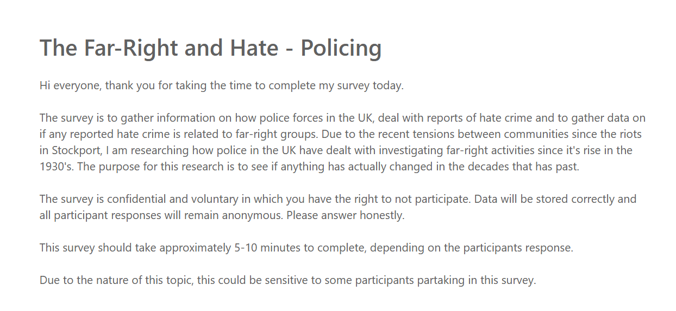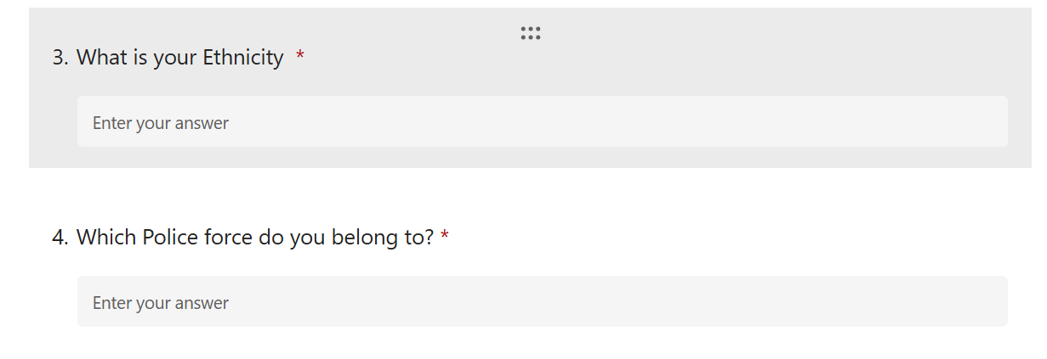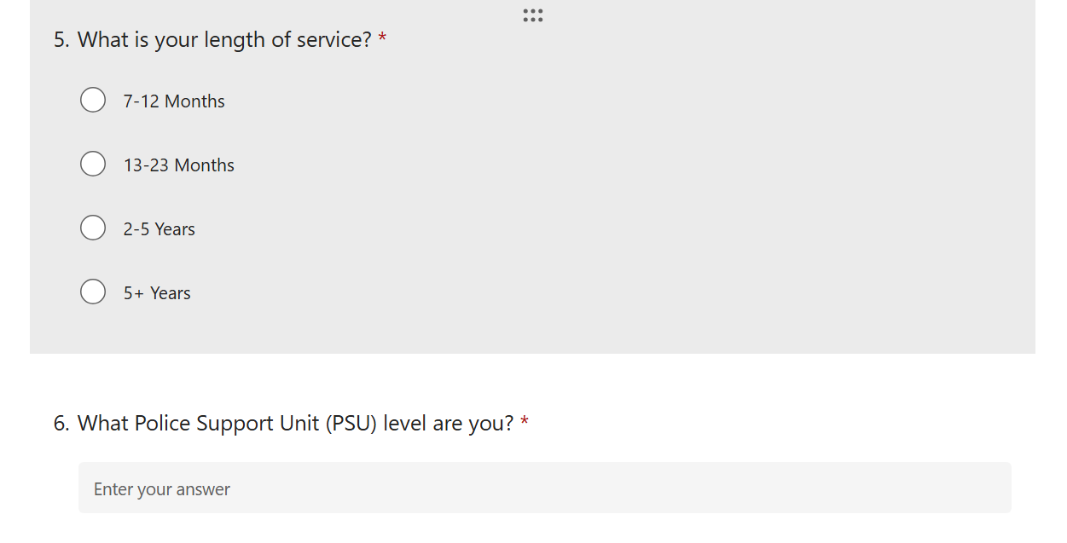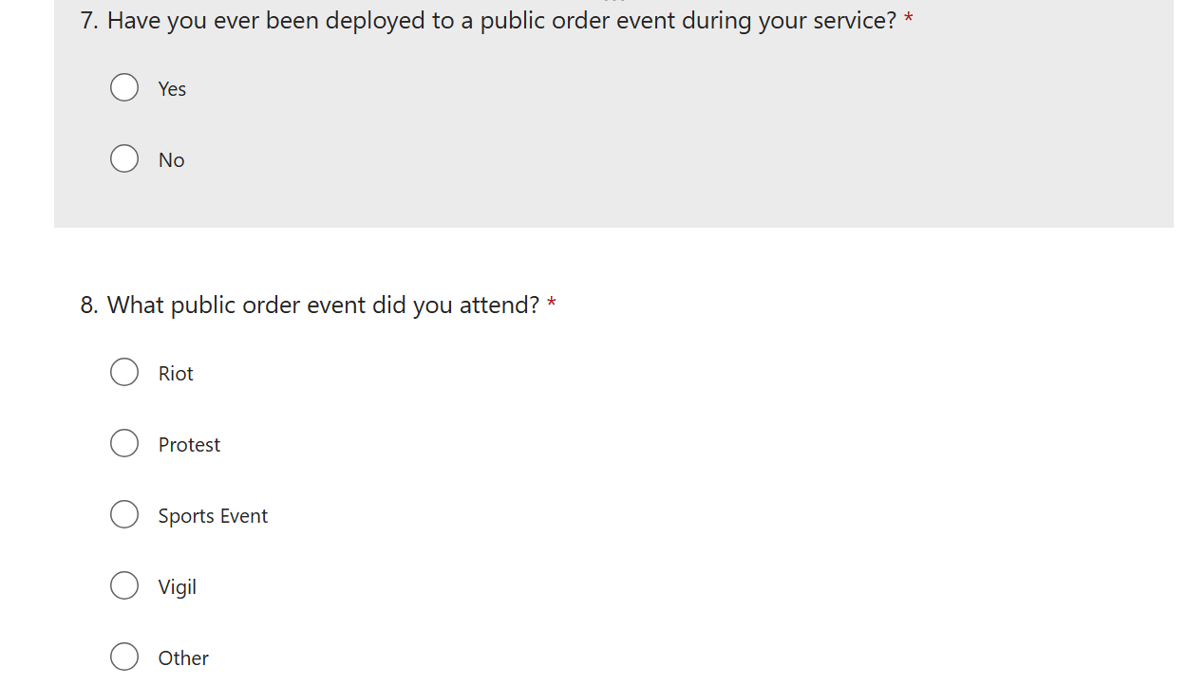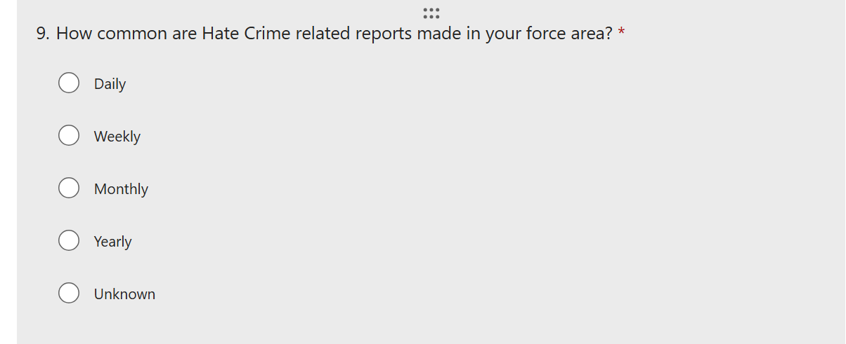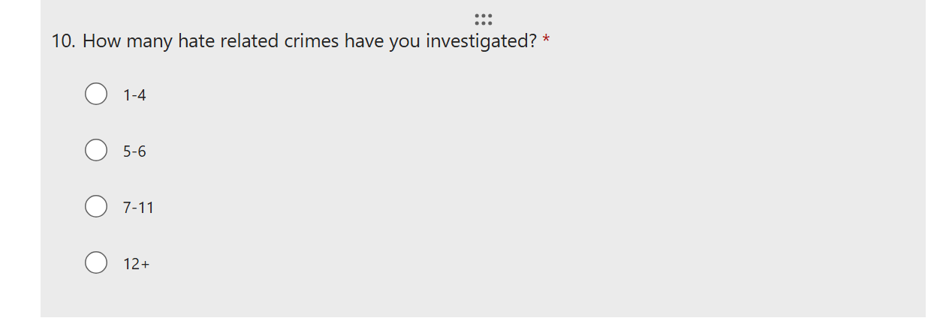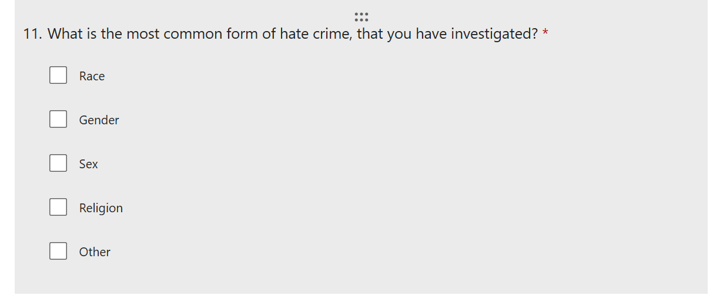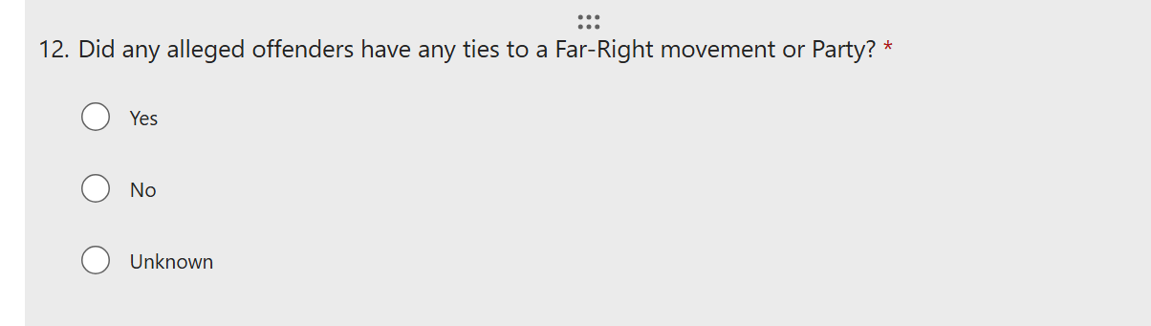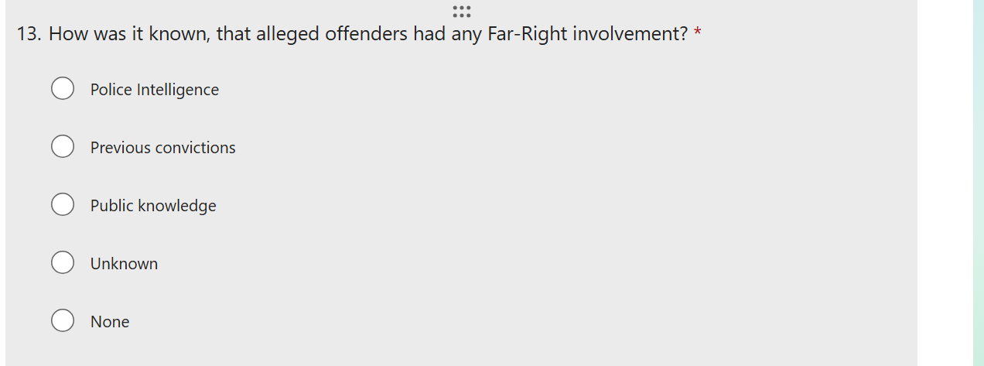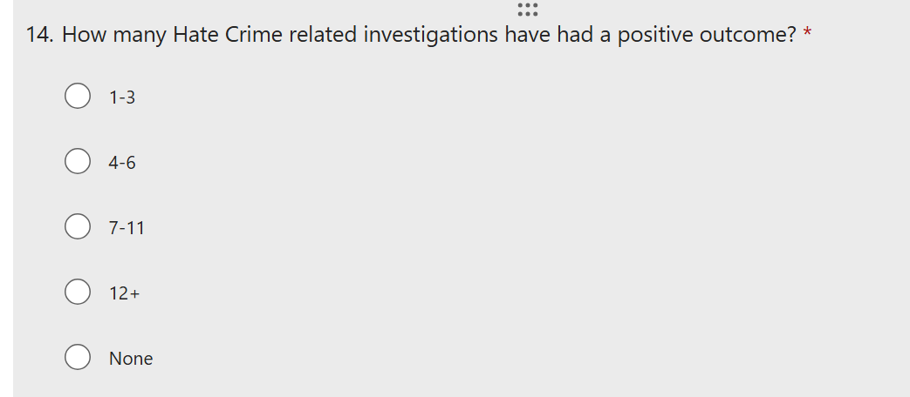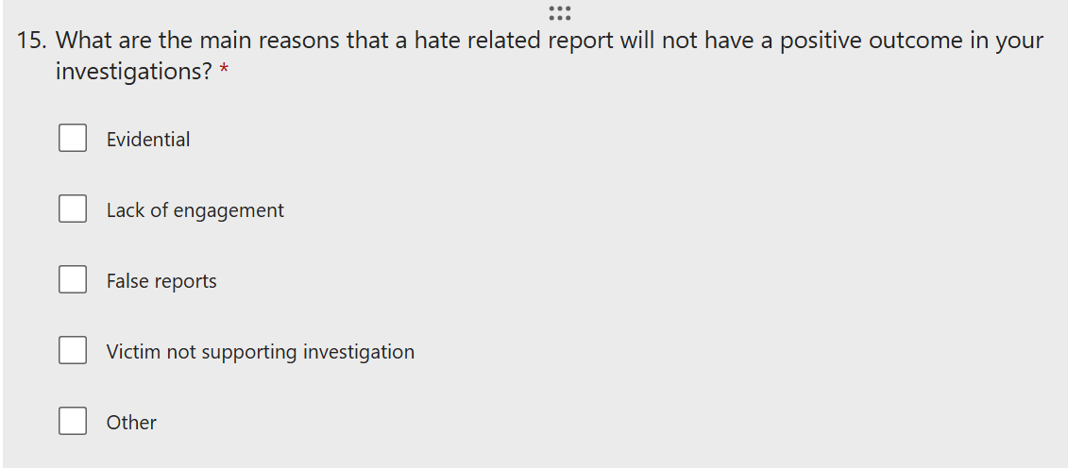

Appendix 2 – Questionnaire Results
Column1 | Column2 | Column3
White British | 17 responses | 61%
White Mixed | 1 response | 4%
Caucasian | 1 response | 4%
Welsh | 1 Response | 4%
British | 1 response | 4%
White | 6 responses | 23%
Column1 | Column2 | Column3
Gwent Police | 26 responses | 93%
Non-Gwent | 2 responses | 7%
Column1 | Column2 | Column3
PSU L3 | 17 responses | 64%
PSU L2 | 4 responses | 16%
PSU L1 | 0 responses | 0%
Non-PSU | 5 responses | 20%

Appendix 4 – Ethics Form

APPLICATION FOR ETHICAL APPROVAL

RESEARCH STUDENTS
This form is to be completed by the student within SIX months for full-time students and TWELVE months for part time students, after the commencement of the research degree or following progression to Part Two of your course.

Once complete, submit this form via the MyTSD Doctoral College Portal at (https://mytsd.uwtsd.ac.uk).

This document is also available in Welsh.

RESEARCH STAFF ONLY
All communications relating to this application during its processing must be in writing and emailed to pgresearch@uwtsd.ac.uk , with the title ‘Ethical Approval’ followed by your name.

STUDENTS ON UNDERGRADUATE OR TAUGHT MASTERS PROGRAMMES should submit this form (and receive the outcome) via systems explained to you by the supervisor/module leader.

In order for research to result in benefit and minimise risk of harm, it must be conducted ethically. A researcher may not be covered by the University’s insurance if ethical approval has not been obtained prior to commencement.

The University follows the OECD Frascati manual definition of research activity: “creative work undertaken on a systematic basis in order to increase the stock of knowledge, including knowledge of man, culture and society, and the use of this stock of knowledge to devise new applications”. As such this covers activities undertaken by members of staff, postgraduate research students, and both taught postgraduate and undergraduate students working on dissertations/projects.

The individual undertaking the research activity is known as the “principal researcher”.

Ethical approval is not required for routine audits, performance reviews, quality assurance studies, testing within normal educational requirements, and literary or artistic criticism.

Please read the notes for guidance before completing ALL sections of the form.

This form must be completed and approved prior to undertaking any research activity. Please see Checklist for details of process for different categories of application.

SECTION A: About You (Principal Researcher)
1 | Full Name: |  | Adam Puddy
2 | Tick all boxes that apply: |  | Member of staff: | ☐ | Honorary research fellow: | ☐
 | Undergraduate Student | ☒ | Taught Postgraduate Student | ☐ | Postgraduate Research Student | ☐

3 | Institute/Academic Discipline/Centre:
4 | Campus:
5 | E-mail address:
6 | Contact Telephone Number:
 | For students:
7 | Student Number: | 2134353
8 | Programme of Study: | BSc(Hons) Professional Police Practice
9 | Director of Studies/Supervisor: | Jane Davies

SECTION B: Approval for Research Activity
1 | Has the research activity received approval in principle?  (please check the Guidance Notes as to the appropriate approval process for different levels of research by different categories of individual) |  | YES | ☐ | NO | ☒
 |  |  |  |  | Date
2 | If Yes, please indicate source of approval (and date where known): Approval in principle must be obtained from the relevant source prior to seeking ethical approval | Research Degrees Committee |  | ☐
2 |  | Institute Research Committee |  | ☐
2 |  | Other (write in) |  | ☐

SECTION C: Internal and External Ethical Guidance Materials
 | Please list the core ethical guidance documents that have been referred to during the completion of this form (including any discipline-specific codes of research ethics, location-specific codes of research ethics, and also any specific ethical guidance relating to the proposed methodology). Please tick to confirm that your research proposal adheres to these codes and guidelines. You may add rows to this table if needed.
1 | UWTSD Research Ethics & Integrity Code of Practice | ☒
2 | UWTSD Research Data Management Policy | ☒
3 | [List any other relevant documents here] | ☐

SECTION D: External Collaborative Research Activity
If there are external collaborators then you should gain consent from the contact persons to share their personal data with the university. If there are no external collaborators then leave this section blank and continue to section E.
1 | Institution
2 | Contact person name
3 | Contact person e-mail address
4 | Is your research externally funded? |  | YES | ☐ | NO |  | ☐
5 | Are you in receipt of a KESS scholarship? |  | YES | ☐ | NO |  | ☐
6 | Are you specifically employed to undertake this research in either a paid or voluntary capacity? | Voluntary | YES | ☐ | NO | ☐
7 |  | Employed | YES | ☐ | NO | ☐
8 | Is the research being undertaken within an existing UWTSD Athrofa Professional Learning Partnership (APLP)? | If YES then the permission question below does not need to be answered. | YES | ☐ | NO |  | ☐
9 | Has permission to undertake the research has been provided by the partner organisation? | (If YES attach copy)  If NO the application cannot continue | YES | ☐ | NO |  | ☐

Where research activity is carried out in collaboration with an external organisation
10 | Does this organisation have its own ethics approval system? | YES | ☐ | NO | ☒
 | If Yes, please attach a copy of any final approval (or interim approval) from the organisation (this may be a copy of an email if appropriate).

SECTION E: Details of Research Activity
1 | Indicative title: | A critical evaluation of how the far-right movement has affected Policing in the United Kingdom since 1930
2 | Proposed start date: | 04/07/2024 | Proposed end date: | 07/04/2025
Introduction to the Research (maximum 300 words per section)
Ensure that you write for a Non-Specialist Audience when outlining your response to the points below:
- Purpose of Research Activity
- Proposed Research Question
- Aims of Research Activity
- Objectives of Research Activity
Demonstrate, briefly, how Existing Research has informed the proposed activity and explain
- What the research activity will add to the body of knowledge
- How it addresses an area of importance.
3 | Purpose of Research Activity  The purpose of the research is to evaluate how far-right movements in the United Kingdom has affected policing over the past 80 years and how police nationwide deal with the movement such as tactics, intelligence and reports. The purpose of the research is to also study how this movement has gained momentum and support throughout the past 8 decades and to examine why people are drawn into the world of far-right politics.  I will be examining evidence from past and current cases such as the far-right movement in the United Kingdom during the Second World War with figures such as Oswald Mosley and the UK Fascist Party and how during the United Kingdom’s fight against Nazi Germany’s fascist ideals did Mosley gain momentum and support, laying the foundations for future members of the British public being involved in far-right views. I will also be examining how post Second World War far-right views on anti-immigration such as the windrush movement and current topical issues such as anti-Islamic protests and riots.  (this box should expand as you type)
4 | Research Question  A critical evaluation of how the far-right movement has affected Policing in the United Kingdom since 1930  (this box should expand as you type)
5 | Aims of Research Activity  The aims of the research activity are to evaluate the far-right movement and look at evidence on how this movement has grown in the United Kingdom throughout the decades during and after the Second World War until the modern day. Through the research I will be looking at previous cases and evaluating the evidence on how this affects policing and on how police deal with investigating and managing offenders who have extreme political views.  (this box should expand as you type)
6 | Objectives of Research Activity  . Examine evidence through researching the most prolific cases of far-right activities and how the movement gains momentum through the decades.  . To examine the origins of modern day far-right views such as the extermination of Jews during the Second World War, anti-immigration rallies and protests and to the present day anti-muslim riots and rallies.  . To examine how policing the far-right movement has changed throughout the decades from intelligence to training and how to identify those who take part in the riots and rallies.  (this box should expand as you type)
Proposed methods (maximum 600 words)
Provide a brief summary of all the methods that may be used in the research activity, making it clear what specific techniques may be used. If methods other than those listed in this section are deemed appropriate later, additional ethical approval for those methods will be needed. You do not need to justify the methods here, but should instead describe how you intend to collect the data necessary for you to complete your project.
7 | The proposed methods to research and to gain evidence of the far-right movement has affected those who have been targeted by their beliefs such as:  Questionnaires to the communities affected by the movement – Some people are not comfortable talking in person and would rather give evidence or experiences anonymously via an online questionnaire.  . Police officers who deal with and have dealt with cases of far-right activity and how it has affected them mentally or physically – Interviewing or questionnaires to be sent to officers who have since retired or still active to gather data on how many far-right related calls they had attended and how it was dealt with. It will be ideal to gather data of how policy has changed from pre-PACE to post-PACE and see how policing this movement has changed throughout the decades. I also want to know how this can affect a police officer mentally and physically.  (this box should expand as you type)
Location of research activity
Identify all locations where research activity will take place.
8 | Multiple UK Police Services  Online forums  (this box should expand as you type)
Research activity outside of the UK
If research activity will take place overseas, you are responsible for ensuring that local ethical considerations are complied with and that the relevant permissions are sought. Specify any local guidelines (e.g. from local professional associations/learned societies/universities) that exist and whether these involve any ethical stipulations beyond those usual in the UK (provide details of any licenses or permissions required). Also specify whether there are any specific ethical issues raised by the local context in which the research activity is taking place, for example, particular cultural and/or legal sensitivities or vulnerabilities of participants. If you live in the country where you will do the research then please state this.
9 | (this box should expand as you type)

10 | Use of documentation not in the public domain: Are any documents NOT publicly available? | NO | ☒
10 |  | YES | ☐
11 | If Yes, please provide details here of how you will gain access to specific documentation that is not in the public domain and that this is in accordance with the current data protection law of the country in question and that of England and Wales.  (this box should expand as you type)

 | Does your research relate to one or more of the seven aims of the Well-being of Future Generations (Wales) Act 2015? | YES | NO
12 | A prosperous Wales | ☐ | ☒
13 | A resilient Wales | ☐ | ☒
14 | A healthier Wales | ☐ | ☒
15 | A more equal Wales | ☐ | ☒
16 | A Wales of cohesive communities | ☐ | ☒
17 | A Wales of vibrant culture and thriving Welsh language | ☐ | ☒
18 | A globally responsible Wales | ☐ | ☒
19 | If YES to any of the above, please give details:
 | (this box should expand as you type)

SECTION F: Scope of Research Activity
 | Will the research activity include: | YES | NO
1 | Use of a questionnaire or similar research instrument? | ☒ | ☐
2 | Use of interviews? | ☐ | ☒
3 | Use of focus groups? | ☐ | ☒
4 | Use of participant diaries? | ☐ | ☒
5 | Use of video or audio recording? | ☐ | ☒
6 | Use of computer-generated log files? | ☐ | ☒
7 | Participant observation with their knowledge? | ☒ | ☐
8 | Participant observation without their knowledge? | ☐ | ☒
9 | Access to personal or confidential information without the participants’ specific consent? | ☐ | ☒
10 | Administration of any questions, test stimuli, presentation that may be experienced as physically, mentally or emotionally harmful / offensive? | ☒ | ☐
11 | Performance of any acts which may cause embarrassment or affect self-esteem? | ☐ | ☒
12 | Investigation of participants involved in illegal activities? | ☐ | ☒
13 | Use of procedures that involve deception? | ☐ | ☒
14 | Administration of any substance, agent or placebo? | ☐ | ☒
15 | Working with live vertebrate animals? | ☐ | ☒
16 | Procedures that may have a negative impact on the environment? | ☐ | ☒
17 | Other primary data collection methods. Please indicate the type of data collection method(s) below. | ☐ | ☒
 | Details of any other primary data collection method:  (this box should expand as you type) | ☐ | ☒
If NO to every question, then the research activity is (ethically) low risk and may be exempt from some of the following sections (please refer to Guidance Notes).

If YES to any question, then no research activity should be undertaken until full ethical approval has been obtained.

SECTION G: Intended Participants
If there are no participants then do not complete this section, but go directly to section H.

 | Who are the intended participants: | YES | NO
1 | Students or staff at the University? | ☐ | ☒
2 | Adults (over the age of 18 and competent to give consent)? | ☒ | ☐
3 | Vulnerable adults? | ☐ | ☒
4 | Children and Young People under the age of 18? (Consent from Parent, Carer or Guardian will be required) | ☐ | ☒
5 | Prisoners? | ☐ | ☒
6 | Young offenders? | ☐ | ☒
7 | Those who could be considered to have a particularly dependent relationship with the investigator or a gatekeeper? | ☐ | ☒
8 | People engaged in illegal activities? | ☐ | ☒
9 | Others. Please indicate the participants below, and specifically any group who may be unable to give consent. | ☐ | ☒
 | Details of any other participant groups:  (this box should expand as you type) | ☐ | ☒

Participant numbers and source
Provide an estimate of the expected number of participants. How will you identify participants and how will they be recruited?
10 | How many participants are expected? | 30 through the use of a survey.  (this box should expand as you type)
11 | Who will the participants be? | Police officers  (this box should expand as you type)
12 | How will you identify the participants? | My participants will be anonymous  (this box should expand as you type)

 | Information for participants: | YES | NO | N/A
13 | Will you describe the main research procedures to participants in advance, so that they are informed about what to expect? | ☒ | ☐ | ☐
14 | Will you tell participants that their participation is voluntary? | ☒ | ☐ | ☐
15 | Will you obtain written consent for participation? | ☐ | ☐ | ☒
16 | Will you explain to participants that refusal to participate in the research will not affect their treatment or education (if relevant)? | ☒ | ☐ | ☐
17 | If the research is observational, will you ask participants for their consent to being observed? | ☒ | ☐ | ☐
18 | Will you tell participants that they may withdraw from the research at any time and for any reason? | ☒ | ☐ | ☐
19 | With questionnaires, will you give participants the option of omitting questions they do not want to answer? | ☒ | ☐ | ☐
20 | Will you tell participants that their data will be treated with full confidentiality and that, if published, it will not be identifiable as theirs? | ☒ | ☐ | ☐
21 | Will you debrief participants at the end of their participation, in a way appropriate to the type of research undertaken? | ☒ | ☐ | ☐
22 | If NO to any of above questions, please give an explanation
 | (this box should expand as you type)

 | Information for participants: | YES | NO | N/A
24 | Will participants be paid? | ☐ | ☒ | ☐
25 | Is specialist electrical or other equipment to be used with participants? | ☐ | ☒ | ☐
26 | Are there any financial or other interests to the investigator or University arising from this study? | ☐ | ☒ | ☐
27 | Will the research activity involve deliberately misleading participants in any way, or the partial or full concealment of the specific study aims? | ☐ | ☒ | ☐
28 | If YES to any question, please provide full details
 | (this box should expand as you type)

SECTION H: Anticipated Risks

Outline any anticipated risks that may adversely affect any of the participants, the researchers and/or the University, and the steps that will be taken to address them.

If you have completed a full risk assessment (for example as required by a laboratory, or external research collaborator) you may append that to this form.
1 | Full risk assessment completed and appended? |  | Yes | ☒
1 |  |  | No | ☐
2 | Risks to participants  For example: sector-specific health & safety, emotional distress, financial disclosure, physical harm, transfer of personal data, sensitive organisational information
 | Risk to participants:  Little risk of above specified information  (this box should expand as you type) | How you will mitigate the risk to participants:  (this box should expand as you type)
3 | If research activity may include sensitive, embarrassing or upsetting topics (e.g. sexual activity, drug use) or issues likely to disclose information requiring further action (e.g. criminal activity), give details of the procedures to deal with these issues, including any support/advice (e.g. helpline numbers) to be offered to participants. Note that where applicable, consent procedures should make it clear that if something potentially or actually illegal is discovered in the course of a project, it may need to be disclosed to the proper authorities
 | (this box should expand as you type)
4 | Risks to the investigator  For example: personal health & safety, physical harm, emotional distress, risk of accusation of harm/impropriety, conflict of interest
 | Risk to the investigator:  Little risk – mostly anonymous participants and those who wish for their identify to be known will be safeguard checked  (this box should expand as you type) | How you will mitigate the risk to the investigator:  (this box should expand as you type)
5 | University/institutional risks  For example: adverse publicity, financial loss, data protection
 | Risk to the University:  Little risk – no participation will happen on campus  (this box should expand as you type) | How you will mitigate the risk to the University:  (this box should expand as you type)
6 | Environmental risks  For example: accidental spillage of pollutants, damage to local ecosystems
 | Risk to the environment:  Little risk – not affected  (this box should expand as you type) | How you will mitigate the risk to environment:  (this box should expand as you type)

 | Disclosure and Barring Service
 | If the research activity involves children or vulnerable adults, a Disclosure and Barring Service (DBS) certificate must be obtained before any contact with such participants. | YES | NO | N/A
7 | Does your research require you to hold a current DBS Certificate? | ☐ | ☒ | ☐
8 | If YES, please give the certificate number. If the certificate number is not available please write “Pending”; in this case any ethical approval will be subject to providing the appropriate certificate number.

SECTION I: Feedback, Consent and Confidentiality

1 | Feedback  What de-briefing and feedback will be provided to participants, how will this be done and when?
 | (this box should expand as you type)
2 | Informed consent  Describe the arrangements to inform potential participants, before providing consent, of what is involved in participating. Describe the arrangements for participants to provide full consent before data collection begins. If gaining consent in this way is inappropriate, explain how consent will be obtained and recorded in accordance with prevailing data protection legislation.
 | (this box should expand as you type)
3 | Confidentiality / Anonymity  Set out how anonymity of participants and confidentiality will be ensured in any outputs. If anonymity is not being offered, explain why this is the case.
 | (this box should expand as you type)

SECTION J: Data Protection and Storage

 | Does the research activity involve personal data (as defined by the General Data Protection Regulation 2016 “GDPR” and the Data Protection Act 2018 “DPA”)? | YES | NO
1 | “Personal data” means any information relating to an identified or identifiable natural person (‘data subject’). An identifiable natural person is one who can be identified, directly or indirectly, in particular by reference to an identifier such as a name, an identification number, location data, an online identifier or to one or more factors specific to the physical, physiological, genetic, mental, economic, cultural or social identity of that natural person. Any video or audio recordings of participants is considered to be personal data. | ☐ | ☐
 | If YES, provide a description of the data and explain why this data needs to be collected:
2 | (this box should expand as you type)
 | Does it involve special category data (as defined by the GDPR)? | YES | NO
3 | “Special category data” means sensitive personal data consisting of information as to the data subjects’ –  (a) racial or ethnic origin,  (b) political opinions,  (c ) religious beliefs or other beliefs of a similar nature,  (d) membership of a trade union (within the meaning of the Trade Union and Labour Relations (Consolidation) Act 1992),  (e) physical or mental health or condition,  (f) sexual life,  (g) genetics,  (h) biometric data (as used for ID purposes), | ☐ | ☐
 | If YES, provide a description of the special category data and explain why this data needs to be collected:
4 | (this box should expand as you type)

 | Will data from the research activity (collected data, drafts of the thesis, or materials for publication) be stored in any of the following ways? | YES | NO
5 | Manual files (i.e. in paper form)? | ☐ | ☒
6 | University computers? | ☐ | ☒
7 | Private company computers? | ☒ | ☐
8 | Home or other personal computers? | ☐ | ☒
9 | Laptop computers/ CDs/ Portable disk-drives/ memory sticks? | ☒ | ☐
10 | “Cloud” storage or websites? | ☐ | ☒
11 | Other – specify: | ☐ | ☒
12 | For all stored data, explain the measures in place to ensure the security of the data collected, data confidentiality, including details of backup procedures, password protection, encryption, anonymisation and pseudonymisation:
 | (this box should expand as you type)

 | Data Protection
 | Will the research activity involve any of the following activities: | YES | NO
13 | Electronic transfer of data in any form? | ☐ | ☒
14 | Sharing of data with others at the University outside of the immediate research team? | ☐ | ☒
15 | Sharing of data with other organisations? | ☐ | ☒
16 | Export of data outside the UK or importing of data from outside the UK? | ☐ | ☒
17 | Use of personal addresses, postcodes, faxes, emails or telephone numbers? | ☐ | ☒
18 | Publication of data that might allow identification of individuals? | ☐ | ☒
19 | Use of data management system? | ☐ | ☒
20 | Data archiving? | ☐ | ☒
21 | If YES to any question, please provide full details, explaining how this will be conducted in accordance with the GDPR and Data Protection Act (2018) (and any international equivalents, where appropriate):
 | (this box should expand as you type)
22 | List all who will have access to the data generated by the research activity:
 | (this box should expand as you type)
23 | List who will have control of, and act as custodian(s) for, data generated by the research activity:
 | (this box should expand as you type)
24 | Give details of data storage arrangements, including security measures in place to protect the data, where data will be stored, how long for, and in what form. Will data be archived – if so how and if not why not.
 | (this box should expand as you type)
25 | Please indicate if your data will be stored in the UWTSD Research Data Repository (see https://researchdata.uwtsd.ac.uk/ ). If so please explain. (Most relevant to academic staff)
 | (this box should expand as you type)
26 | Confirm that you have read the UWTSD guidance on data management (see https://www.uwtsd.ac.uk/library/research-data-management/) | YES | ☒
27 | Confirm that you are aware that you need to keep all data until after your research has completed or the end of your funding | YES | ☒

SECTION K: Declaration
The information which I have provided is correct and complete to the best of my knowledge. I have attempted to identify any risks and issues related to the research activity and acknowledge my obligations and the rights of the participants.

In submitting this application I hereby confirm that I undertake to ensure that the above named research activity will meet the University’s Research Ethics and Integrity Code of Practice which is published on the website: https://www.uwtsd.ac.uk/research/research-ethics/
1 | Signature of applicant: |  | Date:

For STUDENT Submissions:
2 | Director of Studies/Supervisor: |  | Date:
3 | Signature: |  | Date:

For STAFF Submissions:
4 | Academic Director/ Assistant Dean: |  | Date:
5 | Signature: |  | Date:

Checklist: Please complete the checklist below to ensure that you have completed the form according to the guidelines and attached any required documentation:
☐ | I have read the guidance notes supplied before completing the form.
☐ | I have completed ALL RELEVANT sections of the form in full.
☐ | I confirm that the research activity has received approval in principle
☐ | I have attached a copy of final/interim approval from external organisation (where appropriate)
☐ | I have attached a full risk assessment (where appropriate) ONLY TICK IF YOU HAVE ATTACHED A FULL RISK ASSESSMENT
☐ | I understand that it is my responsibility to ensure that the above named research activity will meet the University’s Research Ethics and Integrity Code of Practice.
☐ | I understand that before commencing data collection all documents aimed at respondents (including information sheets, consent forms, questionnaires, interview schedules etc.) must be confirmed by the DoS/Supervisor, module tutor or Academic Director.

RESEARCH STUDENTS ONLY
Once complete, submit this form via the MyTSD Doctoral College Portal at (https://mytsd.uwtsd.ac.uk).

RESEARCH STAFF ONLY
All communications relating to this application during its processing must be in writing and emailed to pgresearch@uwtsd.ac.uk , with the title ‘Ethical Approval’ followed by your name.

STUDENTS ON UNDERGRADUATE OR TAUGHT MASTERS PROGRAMMES should submit this form (and receive the outcome) via systems explained to you by the supervisor/module leader.

