Assignment-Innovation B
ACPA6005 Introduction to Innovation Management
bill mcallister-lovatt
UWTSD.AC.UK

Select one innovation from within the past 10 years, made by your own company, or a company of your choice within your sector of industry. This may be a product, process, business model or marketing innovation.
Innovation, uncertainty and risk • Individual, collective and corporate innovation • Pre-conditions for innovation – corporate culture and innovation • Innovation and business strategy • Leadership styles and change management • Theory of innovation management (including business model canvas) • Scenario planning • Strategies and implementation plans.
My chosen innovation company is Brompton Folding Bikes, a company who refined folding bikes so that commuters could fold their bikes and commute to work, especially to get on to public transport, walking to work easily which made their journey easier & flexible.
“Brompton bikes fold down small and are welcome on rush-hour trains, cars, buses etc”.

Table of Contents
The principal drivers for the innovation 3
The barriers and risks faced by the company in developing this innovation 5
The key determinants in the process of committing to develop the innovation. People, process, Infrastructure. 8
The processes and technologies which the company used to carry this development forward 10
The Innovation Table 10
The extent to which the development relied on resources external to the company and the ways in which the deployment of these resources was managed 11
How management overview of the development was maintained 13
The extent to which you feel this innovation process represents best practice 14
Your report should also provide your own critique of the whole innovation process, and an evaluation (to the extent to which one is possible in the case of vey recent innovations) of the success of your chosen innovation 15

The principal drivers for the innovation.
A new/different way of manufacturing bikes, the market is changing for the way we work & commute, within this remit, there is a measure of uncertainty as to how this will look now & in the future.
In order to facilitate this “New way of working & engaging” to develop a convenient & innovative building and developing process for manufacturing in a completely different way, by using cells for the manufacture & process, building bike for commuting.
Three Horizons of Innovation, Innovation in 3 Horizons successfully manages your core team is a challenge, but in order to borrow you the risks manage the risks, you need to know what your key business aspects are. As you can see from the three Horizons model was to offer a way of thinking that bouncers are competing demands of running existing business and building new ones not eliminate uncertainty, but it will put a business Framework on the 70-20-10 rule is a guideline not as a reference point so basically the core aspect of your business should be free to undertake new forms of innovation.
We are doing this, to see what new markets are available to us and at the same time what will happen in the long term; this is the key to an innovation strategy and one that needs to be looked at and understood carefully from a business and people perspective.
Also, it is indicative of the company and the structure, firms will require a degree of collaboration both from an internal & external structure & capability, this is a crucial factor in any concept or alignment to innovation as the people are the best resources that a company has and at the same time both from an individual & collective perspective for the company to grow thrive & move forward.
It is imperative that the structure which may been in place already, will be recognised not purely from a business perspective but also how an innovation mindset within the company can be grown and nurtured.

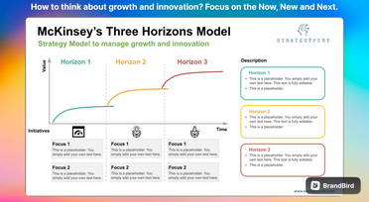

The barriers and risks faced by the company in developing this innovation.

In order for the company to move forward with these innovations, there are major factors involved: - cost, company & workforce structure, market fluctuations and the desire to “do something different”. Meanwhile, the company still has to carry on with its current infrastructure & people, this is no small task in its own right.
Financial constraints & investment both for long & short -term infrastructure, will have a major bearing and outcome on the company. One of the key risks for the company is not to think or act differently, the act of doing nothing, whilst still carrying on with the “normal” way of things; actually it can be a fear of failure and not producing different thinking and or innovation, when not everyone would be “A creative” The company has been going for a number of years over 10, a key aspect was the actual public perception of buying a new form of transport, and although it was a folding bike, would it actually be a market leader, and crucially given the new ways of working a hybrid model at work, does this lead to an asset of actually travelling to work in a different way. Initially it would be an asset to those lived or commuted to larger cities who travelled to work, using car, public transport of various means, whereas the bike would perceptibly give a sense of great freedom to the consumer/purchaser of the bike.

A typology of innovations Trott

Type of innovation | Example
Product innovation | The development of a new or improved product
Process innovation | The development of a new manufacturing process such as
 | Pilkington’s float glass process
Organisational innovation | A new venture division; a new internal communication
 | system; introduction of a new accounting procedure
Management innovation | TQM (total quality management) systems; BPR (business
 | process re-engineering); introduction of SAPR3*
Production innovation | Quality circles; just-in-time (JIT) manufacturing system; new
 | production planning software, e.g., MRP II; new inspection
 | system
Commercial/marketing innovation | New financing arrangements; new sales approach, e.g., direct
 | marketing
Service innovation | Internet-based financial services


- *Note: SAP is a German software firm and R3 is an enterprise resource planning (ERP) product.

The Innovation Matrix below,
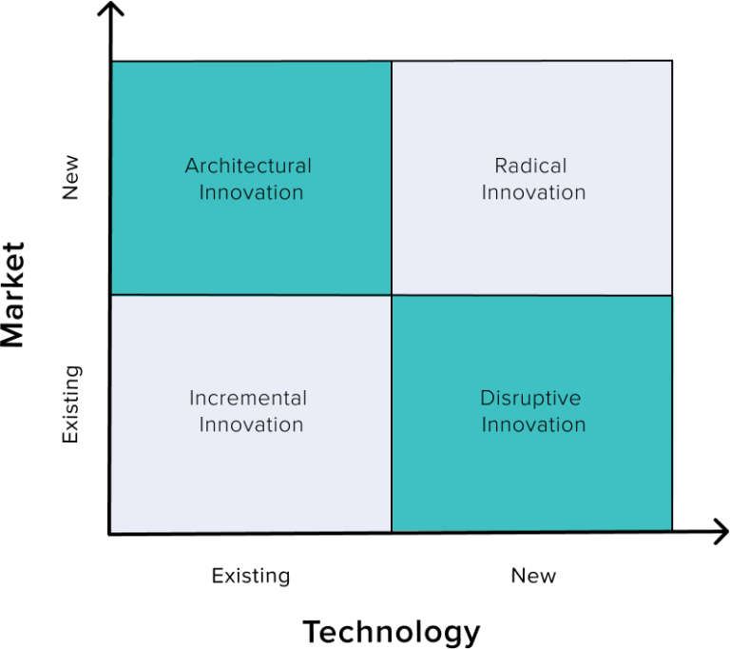

The key determinants in the process of committing to develop the innovation. People, process, Infrastructure.
Innovation can be based on demographics, in particular age distribution. The datum is already available and there is known lead time, all that is missing is the ability to see the future as a result of the present situation (and future projection) and not a result of the past. Identifying changes in the centre of population gravity (the age group that is the largest and the fastest-growing age group in the population) can be exploited by capitalizing on the anticipated needs/wants of that group. (Drucker)
There may be boundaries within the company that have not been fully understood or harnessed, and there can be external factors to look at; these may cover, information, capabilities, Knowledge and crucially that there may be factors that they have not even thought of, or knew that they existed, so a trailing / find out exercise may be of value to the company.
Knowledge-based innovation is the sexiest of entrepreneurship; it is what many think of when they think of the term “innovation.” Peter Drucker suggests that knowledge-based innovations have long lead times (longest of all innovations) and convergence of knowledge. Once the research and synthesis of knowledge are complete thorough analysis followed by practice of entrepreneurial management must ensue. Analysis is necessary to confirm and validate the innovation and entrepreneurial management is needed to manage the risks. (Google may be a good example of a company that is lacking in entrepreneurial management, one that is market-focused and driven.)
Intellectual property protection and proper timing (window of opportunity) are also important aspects of knowledge-based innovation. This innovation seems akin to an “all in” approach given the long lead times and the creativity needed to converge knowledge that leads to the breakthrough.
Changes in Perception
Perception-based innovation occurs when one capitalizes on the perception (not reality) of a group (sector, society, etc.). One example given was the unprecedented advance and improvement in the health of Americans (though I am not sure that is the case today!). Americans, however, had the perception that we were unhealthy and needed to change and this opened up opportunity in health foods, education, exercise facilities, equipment, and attire and so on. Peter Drucker states that spotting inaccurate perceptions and acting on them can be risky, they may not be sustainable. For this reason, he recommends that perception-based innovations start small and specific.

Linear Models of innovation-Trott

Technology push
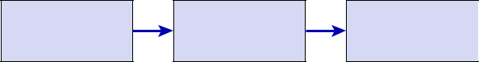

Research and developmnt

Marketing

Manufacturing

Market pull
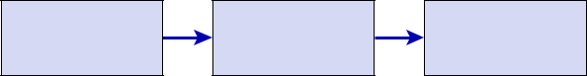

Research and

development

Marketing |  | use

Manufacturing User

The processes and technologies which the company used to carry this development forward.
The Key process can be described as manufacturing, building new teams, logistics, JIT, Stock control, customer orders; technology would be customer ordering, and customers defining their requirements; colour, frame size, etc External technology, people & collaboration, increasing knowledge , capability, capacity; if that is looked at in a different way, and the pooling of factors, this can lead to an insight, a project, new way of working, defing & refining process driven work, new technologies, IOT, in order to redefine & rework the company product to redefine their USP, and at the same time, be mindful of the new reference points that may arise to enhance product & delivery mechanisms, as Brompton would affirm to this aspect of their work.
Skilled Craftmanship
All Brompton bike frames are built by hand. The steel frames are pieced together using a process called brazing. Our brazers are trained in-house for 18-months. Some Master Brazers have been crafting our bikes for over 18 years. A small signature at the bottom of every frame marks the maker.
The titanium framesets are TIG welded in our specialist factory in Sheffield, 300 km north of our London Factory. This process requires a high level of skill and coordination between hand, foot and eye. Like brazing, each craftsperson has a signature style, their welds as unique as handwriting.

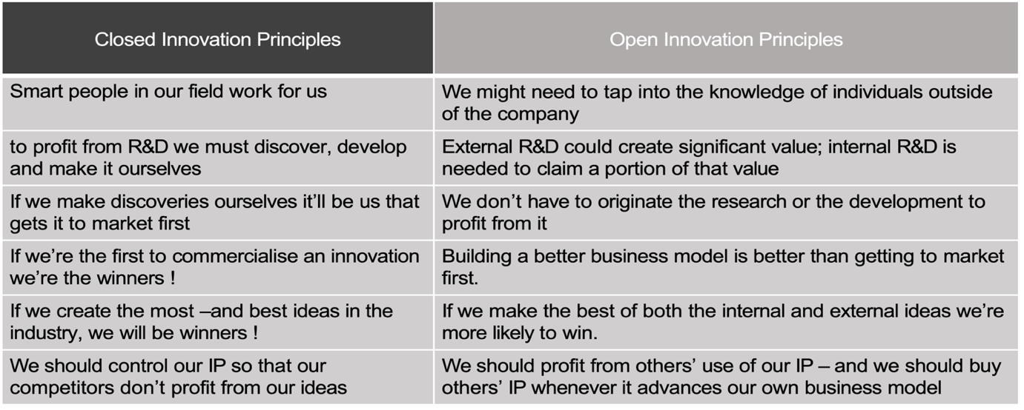
The Innovation Table

The extent to which the development relied on resources external to the company and the ways in which the deployment of these resources was managed.
External factors, the company would have to look at other forms, of manufacture, people skills, Firms that have looked to other areas to establish working relationships with have. done this with a view to cutting costs, utilising companies people outside of your own local workforce. One of the key examples was to build a factory, in Sheffield 200 miles away from London, in our specialist factory for welding TIG; This process requires a high level of skill and coordination between hand, foot and eye. Like brazing, each craftsperson has a signature style, their welds as unique as handwriting.

If an external supplier, business was to be aligned to the company, one of the key aspects that may occur would be, lower productions costs and working with a supplier that understands the complexities of its business; also looking to reduce their R & D infrastructure. After all, R & D can be extremely costly the company if there is no dedicated and or infrastructure within the company structure, which may be an asset or a hindrance dependent on the company goals, values & behaviours.

How management overview of the development was maintained.

The management overview was maintained by building a different structure for the teams, there was a new reporting mechanism to be maintained, and at the team level cells were then reappraised to develop and maintain a different reporting mechanism, the chain of command was developed to be a less hierarchical structure and become more “Flat”; this in turn became an overview of how the company was going to achieve its targets with the new bike developments, however, at the same time it could not risk losing those key people and knowledge that they has accumulated over a considerable period of time.
Due to the new manufacturing processes within the company, it then fell on the management to devise & derive a new way/paradigm of working, this will and was challenging and continues to be so, given the vagaries of the market & customer base.
Again, the management overview was one of innovation, the creativity can be understood for the length of employee engagement & retention, so as to keep a continuous basis for upskilling & learning, which is the basis for the company structure & future.
As previously stated, Drucker says he recommends that perception-based innovations start small and specific, and to that end this can be a paradox of whether to “Think big” and where would that lead the company from a people, process, and financial perspective, to name but a few of the determinants that can be affected. The Overview now has fundamentally changed given the recent changes to work & working practices, allowing the new ways of working to fit into people’s working lives. The key aspect in the next few years will be to ask if people really physically need to commute to work, as the new way of working will have an effect on many businesses. Therefore, will management be able to plan diverse, or carry on with the same model given the changes especially in demographics & working patterns?

The extent to which you feel this innovation process represents best practice.
Best Practice, ultimately needs to be defined in the context of the company & its business model, is the company in itself a “Best Practice model for itself & others to follow?” In that case how is this going to reference & redefine itself within those parameters of BP.
It is a totally subjective aspect to ask this as it would need to be assessed from a BP scenario, yes there are many aspects of this that would be in line with Best Practice, namely, the retraining & redistribution of staff, the financial elements, proof to market, is and the innovation will be ongoing within the product development and upgrading the bike accordingly. It seems that whilst the pursuit of excellence/ innovation form a Brompton perspective has been one of Innovation, I feel that have reached a critical point in their process; they have managed successfully build a product with variations add-ons, and now electric, and whilst they have continued to evolve, they may just now be tweaking their product and not necessarily being innovative.
The Innovation strategy has been an incremental process for Brompton, where it has taken its initial concept to build a folding bike and push the limits of technology & process for a customer driven outcome; I believe that its only rivals in the marketplace would be Moulton Bikes.

Your report should also provide your own critique of the whole innovation process, and an evaluation (to the extent to which one is possible in the case of vey recent innovations) of the success of your chosen innovation.
The whole Brompton innovation process, was brought about by the fact that commuting to work especially from using one’s own transport radically shifted in the past ten years, to that end, Brompton saw a gap in the market, therefore in order to fill that gap with their products, there required an understanding and more importantly a willingness to develop and enhance products that would fill & expand their market.
However, this brought up many factors in their innovation journey, from the initial concept to product out the door; As has been noted previously there are multiple factors that affect & effect the Innovation process, from a people process to business model, financial constraints, and most of all will the product continue to sell and be the right one to market?
As Brompton have stated that their workforce has been successful in delivering and developing a product that seem to fulfil the market requirements at present, given the current market conditions, one of the key factors is the price of the bike which can be upwards of £2,500, so it is then targeted at a very specific audience; and with that it is seen to be a niche market, so much so that it is unfortunately a favourable to product to steal.
It would seem that the bike is certainly innovative and works well, what would it take for Brompton to manufacture a less expensive model so you would create a greater customer base.
Finally, I will mention the Three Horizons model again; is still very useful as a shorthand for prioritizing innovation initiatives, today, some Horizon 3 disruptions do take long periods of development.
However, the trap of the Three Horizon model is not recognizing that today many disruptions can be rapidly implemented by repurposing existing Horizon 1 technologies into new business models — and that speed of deployment is disruptive and asymmetric by itself.
“In the 21st century the attackers have the advantage, as the incumbents are burdened with legacy”. Harvard Business School

Overview of the Innovation Process- Trott
Scientific and |  | Creative | operating
Scientific and |  | individuals | functions and
technological |  | individuals | functions and |  | Firms develop
technological |  |  | activities |  | Firms develop
developments |  |  | activities |  | knowledge,
inevitably lead |  |  |  |  | processes and
to knowledge |  |  |  |  | products
inputs
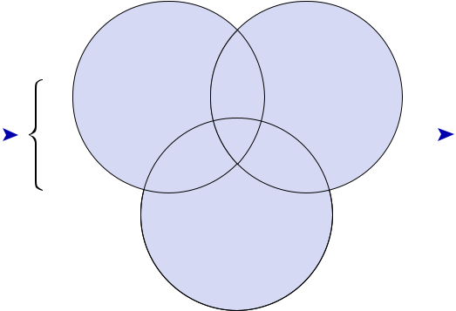

Firms’ architecture

and external linkages
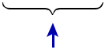

Societal changes and market needs lead to new type of business structure.

References.
Paul Trott (2012), Innovation Management and New Product ☒ Development, 5th edition, London: Prentice Hall.
Peter Drucker (2012) Innovation and Entrepreneurship, ☒ Taylor and Francis.
OECD? Eurostat (2018 Oslo Manual), Oslo Manual; Guidelines for V=Collecting, Reporting & Using Data on Innovation, 4th Edition Paris/ Eurostat/ Luxemburg
Greg Satell (2017) Mapping Innovation, Mc Graw-Hill

Joe Tidd and John Bessant (2013), Managing Innovation: Integrating Technological, Market and Organizational Change, 5th edition Wiley.

