Cloud Based Web Services

ACC6024

Assignment 1: API Creation

  - Sophie Meyrick-Vernon
  - 2221762

Table of Contents
Introduction 3
REST APIs and Alternative Protocols 3
REST APIs 3
Alternative Protocols 3
Web API Implementation 4
Overview of the API 4
Basic Operations 5
Demonstration of GET requests 5
Demonstration of POST requests 5
Demonstration of DELETE requests 6
Editing Operations 7
Workflow Process 7
Software Testing 8
Test Results Table 9
Conclusion 9
References 11

Introduction
Web APIs play a crucial role in modern web applications by facilitating communication between clients and servers. This report explores RESTful APIs and compares them with two alternative protocols, SOAP and GraphQL. It then follows the design and implementation processes of a Pokémon Pack API, developed using Node.js and Express. The API demonstrates GET, POST, DELETE and PATCH operations and models a simple workflow. Tests are provided as documented test cases and as automated unit tests.

REST APIs and Alternative Protocols

REST APIs
REST (Representational State Transfer) is an architectural style introduced by Roy Fielding for building distributed web systems [1]. REST defines a set of constraints and principles that promote interoperability between clients and servers. This makes it one of the most widely adopted paradigms for web API design [2].
A crucial feature of REST is its use of standard HTTP methods to interact with resources. GET is used to retrieve data from the server. POST is used to submit new data to the server. DELETE removes a specified resource from the server. PUT/PATCH are used to update existing resources.
Underlying these operations is REST’s key constraint of statelessness. This means that each request from a client must contain all the information required for the server to understand and process it, without relying on stored session data. The server does not maintain any memory of previous interactions, ensuring that every interaction is independent. Statelessness allows servers to handle large volumes of independent requests efficiently and makes it easier to distribute workloads across multiple server instances [3].
Together, these principles of using standard HTTP methods to interact with resources and maintaining stateless communication provide the fundamental structure of RESTful API design [4].

Alternative Protocols
SOAP (Simple Object Access Protocol) is a messaging protocol created for exchanging information between applications across the internet. It was developed to allow systems running on various operating systems to exchange information reliably. This is done using HTTP as it is universally supported by browsers and servers [5].
SOAP relies on XML as its message format and defines rules for structuring data and handling requests. The XML format includes: an envelope that specifies it’s a SOAP message, a body detailing what the message contains, an optional header that may contain information about the application and a fault that may contain the status of the application [6]. Services built with SOAP commonly use WSDL (Web Services Description Language) to specify communication rules. This acts as a formal contract between the client and server to ensure both sides follow the same structure and interpretation of messages.
SOAP provides several advantages that REST does not. One key strength of SOAP is its extensibility. SOAP is also more flexible in terms of transport protocols, as it is built on top of HTTP which is already installed on most systems. While REST is typically tied to HTTP. SOAP can work over many different protocols including HTTP and SMTP [6]. SOAP also includes built in error handling which makes it easier for different systems to understand and process errors consistently when a request fails [7]. Finally, SOAP provides strong built in security features which help protect messages and ensure they are sent securely [7].
However, SOAP also has several drawbacks. One of the biggest drawbacks is performance. As SOAP messages uses XML formatting the messages can become large and slow to process. This is especially true compared with the more lightweight data formats used by REST [8].
GraphQL is a query language and runtime for APIs which allows clients to request only the specific data that they need to avoid over fetching. Instead of multiple REST endpoints, GraphQL provides a single endpoint to handle various queries [6].

Web API Implementation

Overview of the API
This section focuses on the design and implementation of a Web API developed using Node.js and the Express framework. The API was developed and run locally to provide a simple and effective environment for testing and development.
The purpose of the API is to simulate a Pokémon card pack inventory system that maintains a list of sealed Pokémon packs. It supports basic CRUD operations, including GET, POST, PATCH, and DELETE. This allows users to retrieve, create, update, and remove data. Editing functionality is implemented using the PATCH method which allows partial updates to existing records. The API also includes a simple workflow process based on a status field where packs move through stages such as sealed, reserved, and sold.
Evidence of software testing is provided through an automated test suite using Jest and Supertest, as well as structured test cases to demonstrate correct functionality.

Basic Operations

Demonstration of GET requests
The GET method is used to retrieve data from the API. Two GET endpoints were implemented:
- GET /packs retrieves a list of all Pokémon card packs.
- GET /packs/:id retrieves a single pack based on its unique identifier.
This allows users to view the entire inventory or access detailed information about a specific pack. The implementation of this operation can be found in app.js.
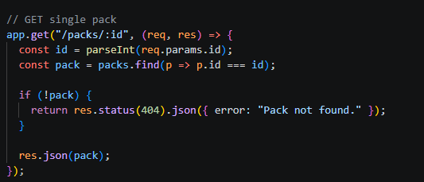

Demonstration of POST requests
The POST method is used to create new resources in the system. The endpoint:
- POST /packs allows users to add a new Pokémon card pack to the inventory.
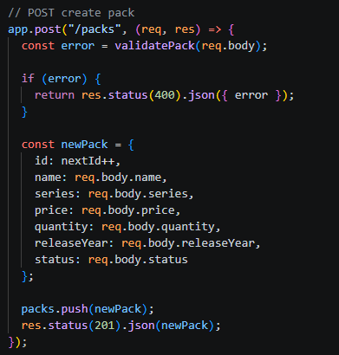
The API validates the input data before adding the new pack to ensure that all required fields are present and correctly formatted. A unique ID is automatically assigned to each new pack.

Demonstration of DELETE requests
The DELETE method is used to remove resources from the system. The endpoint:
- DELETE /packs/:id deletes a pack based on its ID.
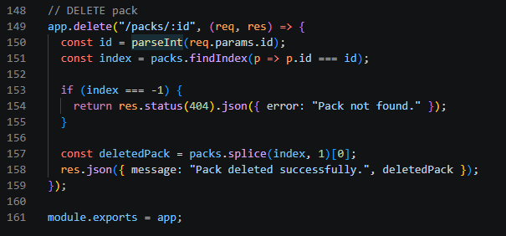
If the specified pack exists it is removed from the inventory. If it does not exist an appropriate error message is returned.

Editing Operations
Editing functionality is implemented using the PATCH method which allows partial updates to existing resources. This approach is more efficient and aligns with RESTful design principles compared to replacing entire objects.
The endpoint:
- PATCH /packs/:id
allows specific fields of a pack to be updated such as price, quantity, status, name or series.
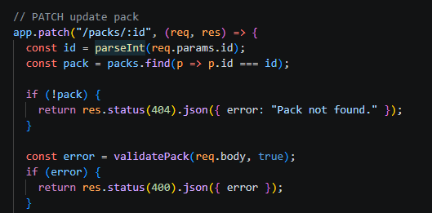

The API includes validation logic to ensure that only valid data is accepted. For example, price must be a positive number and status must be one of the allowed values.
PATCH was chosen over PUT because it allows updating only the fields that have changed rather than requiring the entire object to be sent again. This makes it more efficient and flexible. The use of PATCH satisfies the assignment requirement for additional marks.

Workflow Process
A workflow process has been implemented using the status field of each Pokémon pack. The workflow consists of three stages: sealed, reserved and sold. This represents the lifecycle of a pack within the inventory system.
- All packs are initially created with a status of sealed.
- A pack can be updated to reserved when it is allocated or set aside.
- A pack can then be updated to sold once it has been purchased.
To ensure logical consistency the API enforces valid transitions between states.
For example:
- A pack can move from sealed to reserved or directly to sold.
- A pack can move from reserved to sold.
- A pack cannot move backwards from sold to sealed.
This workflow is implemented in the PATCH route within app.js where the status transitions are validated before applying updates. This demonstrates a multi stage process like real world inventory or order management systems.

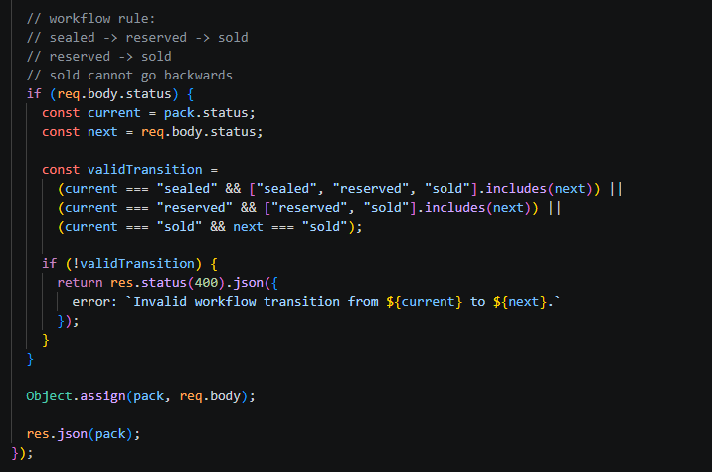

Software Testing
To verify the functionality of the API automated tests were implemented using the Jest and Supertest frameworks. These tests ensure that each endpoint behaves as expected and that invalid operations are handled correctly. Tests are handled in an automated test file: tests/api.test.js
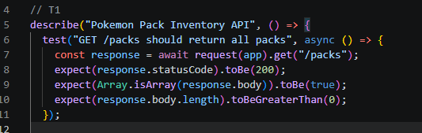
Example Test Case T1:

Test Results Table
Test No | Operation | Description | Expected Result | Outcome
T1 | GET /packs | Retrieve all packs | Returns array of packs | Pass
T2 | Get /packs/:id | Retrieve a single pack | Returns correct pack | Pass
T3 | POST /packs | Create new pack | Pack created with ID | Pass
T4 | PATCH /packs/:id | Update pack status | Status correctly updated | Pass
T5 | DELETE /Packs/:id | Delete pack | Pack removed | Pass
T6 | PATCH invalid | Invalid status change | Error returned | Pass

The successful execution of these tests demonstrates that the API is reliable and behaves as expected under both valid and invalid conditions.

Conclusion
In conclusion, this project helps understand both the theory and practical side of APIs. The investigation of REST and alternative protocols such as SOAP and GraphQL highlighted the strengths and weaknesses of each approach. REST was found to be the most suitable for this project due to its simple use and strong compatibility with JavaScript and AJAX.
The API satisfies the assignment requirements by implementing GET, POST, DELETE and PATCH operations for sealed Pokémon card packs. Editing is handled using PATCH which supports partial updates and provides a more RESTful solution. A workflow process is implemented through the status field with valid transitions between sealed, reserved and sold. Testing is evidenced through an automated Jest and Supertest test suite covering the main operations and validation cases.
Overall this assignment has reinforced key concepts in API design. This includes routing, data validation, workflow management, and testing. It has also demonstrated the importance of choosing the appropriate API architecture, with REST proving to be an effective solution for building scalable and maintainable web services.

References

[1] | L. Gupta, “REST API Tutorial,” restfulapai, 1st April 2025. [Online]. Available: https://restfulapi.net/. [Accessed 9th November 2025].
[2] | K. D. K. F. Rahul Awati, “What is REpresentational State Transfer (REST),” TechTarget, 29 July 2024. [Online]. Available: https://www.techtarget.com/searchapparchitecture/definition/REST-REpresentational-State-Transfer. [Accessed 9th November 2025].
[3] | “What is a REST API?,” redhat, 8th May 2020. [Online]. Available: https://www.redhat.com/en/topics/api/what-is-a-rest-api. [Accessed 9th November 2025].
[4] | “REST API Architectural Constraints,” Geeks for Geeks, 9th Jan 2025. [Online]. Available: https://www.geeksforgeeks.org/javascript/rest-api-architectural-constraints/. [Accessed 22nd November 2025].
[5] | W. Schools, “XML Soap,” W3 Schools, [Online]. Available: https://www.w3schools.com/xml/xml_soap.asp. [Accessed 2025 November 22].
[6] | “Basics of SOAP - Simple Object Access Protocol,” Geeks for Geeks, 12th July 2025. [Online]. Available: https://www.geeksforgeeks.org/computer-networks/basics-of-soap-simple-object-access-protocol/. [Accessed 18th April 2026].
[7] | K. Lane, “What Is a SOAP API?,” Postman, 28th June 2023. [Online]. Available: https://blog.postman.com/soap-api-definition/. [Accessed 18th April 2026].
[8] | A. S. Gillis, “SOAP (Simple Object Access Protocol),” TechTarget, 2nd June 2022. [Online]. Available: https://www.techtarget.com/searchapparchitecture/definition/SOAP-Simple-Object-Access-Protocol. [Accessed 18th April 2026].
[9] | M. Fayard, “GraphQL vs. REST: A Complete Guide,” datacamp, 25th August 2024. [Online]. Available: ACCA3020. [Accessed 22nd November 2025].

