Brittany Wallace
Evaluation
All together I took 8 self portraits and I had to decide on what photographs I wanted to use and what looked better together. I chose 3 photographs that I think worked well together and they were all different which is what I wanted.
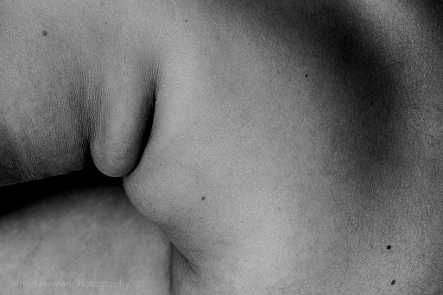
I was influenced by a photographer named Daniel Freeman, he did these amazing abstract human form photographs which were close ups of skin, curves and different angles while taking a photograph of a body. It then made me think more about the curves in some bodies, how everybody is different. I wanted to show curves in my photographs and mostly skin.

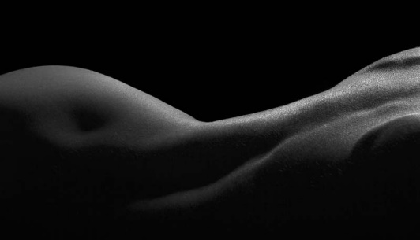
Another photographer that also influenced me was Ted Tahquechi, he is a blind photographer and he captures the landscapes of bodies. I mostly focused on using a lot of skin in my photographs and I tried to show more close ups of curves in my images as I wanted to bring a bit of this artist into my work.

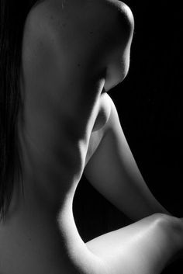
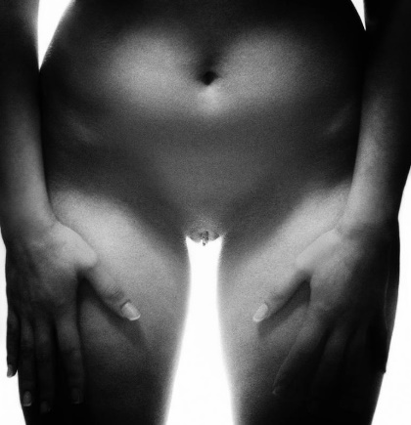
I was also influenced by a bunch of images that I came across while researching and these images were of women bodies that are slightly covered up in a way by their arms or turned at a slight angle. Images like that made me think of another way that I could make a bit sexual, like having my legs open slightly. I also noticed that most of these images weren’t good quality which made me think about the quality that I wanted my photographs to be.

I feel these two photographers that I’ve used in my research and the photos I’ve found really helped me develop on what poses I could do, helped me play around with colours as all of the photos I researched were mostly black and white as it brings out more details. I didn’t want to use black and white in my photographs as I use it quite a lot so I thought I would just leave it with colour. As my photographs are self-portraits, I did find it a bit difficult to take my own photographs and I had to set my camera on a timer to make sure that the images were perfect. While editing the photographs I wanted to make sure that the images simple and tried to mess about with the quality as I tried to make it a little bit pixely as I mostly wanted the figure of the bodies. I wanted to make the photographs small as I wanted people to get up close and personal with my piece as I feel like they would see the curves of the bodies.
Over all I was very happy with the outcome of the images that were chosen and how they looked, I loved how small the images were as they make you get up close with the photographs and having a white boarder made the photographs stand out a bit more. I built up confidence while doing this task as it’s something I’ve not done before and it’s a different path for me. I wanted to show how at every angle on your body you look different and I feel like I’ve shown that through my photographs.

Bibliography
http://danielfreemanphotography.co.uk/abstract-nude/
https://fstoppers.com/spotlight/human-body-blind-photographers-eye-164589
https://www.saatchiart.com/art/Photography-Sunrise-over-bikini/823372/2751387/view
https://www.shutterstock.com/search/body%2Bwoman%2Bblack%2Bbackground?section=1&image_type=photo&people_model_released=true&safe=true&search_source=base_related_searches&saveFiltersLink=true&page=2
https://www.pinterest.co.uk/rochelleluchia7/abstract-bodies/

