Student Name : Alina Smalbergher
Student ID Number : 2114414
Foreign Languages & Cultural Awareness (BMIH5003)
Lecturer : Jinping Li

18 November 2022
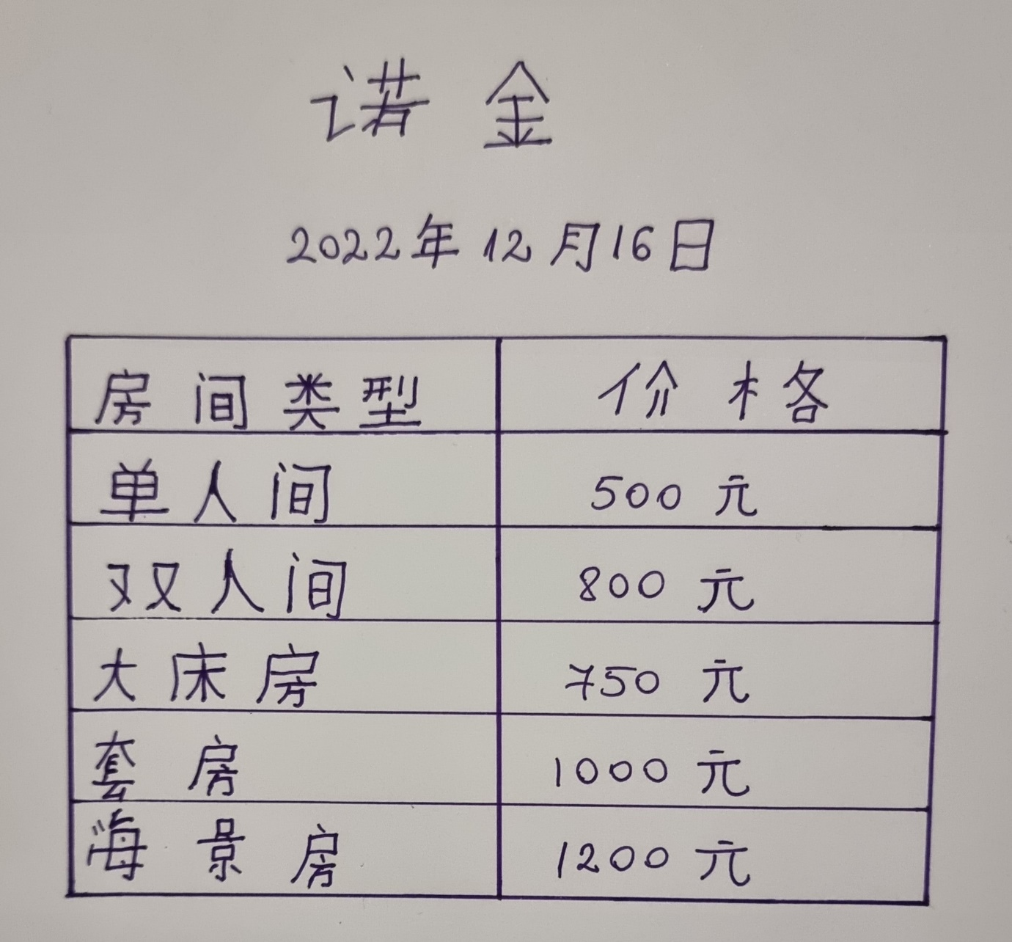
Hotel Display Board

