Matthew John Permintella | Mechanical Engineering HND | 12/12/2020

Fluid Analysis of wind turbine structure

List of figures
Fig(1) geometric parameters of an air foil.
Fig (2) Pressure distribution around a cylinder.
Fig (3) Pressure distribution around an airfoil.
Fig (4) Separation of a boundary layer.
Fig (5) Flow over a 2D airfoil profile.
Fig (6) Boundary layer separation.
Fig (7) Development of a Boundary layer on smooth surface.
Fig(8) Vector changes due to due to blade length (Bhattacharya, n.d.).
Fig(9) Coefficient of lift v Angle of Attack for the aerofoil used.
Fig(10) Coefficient of lift v Angle of Attack for the aerofoil used.
Fig(11) Angle of attack.
Fig (12) Visual of Stall on airfoil blade.

Contents
1.0 Introduction…………………………………………………………………………………………………….…..Page 4
2.0 Objectives…………………………………………………………………………………………………….……..Page 4
3.0 Reynolds Number…………………………………………………………………………………………..……Page 5
4.0 Boundary layer flow around wind turbine ………………………………………………………..…Page 8
4.1 Boundary layer separation……………………………………………………………...………Page 8
4.2 Boundary layer description…………………………………………………….………….…...Page 9
4.3 Relevance of separation/turbulence in airfoil of wind turbine blade …….Page 11
5.0 Flow angle change along length of blade (Task 3)……………………………………………….Page 12
6.0 Pitch angle change along length (Task 4)…………………………………………………………….Page 13
7.0 Conclusion ……………………………….………………………….…………………………………………….Page 14
8.0 References ……………………………………..……………………………………………………….…..…...Page 16
9.0 Bibliography……………………………………………………..….……..........................................Page 17

- Introduction
The report will give a brief explanation of air foil geometry and will discuss the importance of the Reynolds number and how it effects the fluid flow around an airfoil. The Reynolds number for airfoil blade will be estimated. Lastly simple calculations will be done to determine the flow and pitch angle change along the length of the blade.
- Objectives

- Critically analyse and evaluate techniques for structural and fluid problems and CAE results.

- Reynolds number
The geometric parameters of a wind turbine airfoil are below.
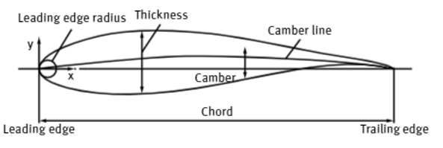
Fig(1) geometric parameters of an air foil (Chen and Wang, 2017).
As seen in the above the description of various aspects of the airfoil are listed.
- Trailing edge: the last point of the mean line for the airfoil.
- Trailing edge angle: the angle between the upper, lower surface of the trailing edge.
- Trailing edge thickness: the thickness for trailing edge of airfoil.
- Chord: the connection made between the leading edge and the trailing edge.
- Thickness: The diameter of the inscribed circle for an airfoil.
- Camber: the maximum vertical distance between the mean line and the chord line.

3.0 Description and important of Reynolds number (Task 1)
In fluid dynamic the most vital fluid factor for airfoil aerodynamic performance is known as the fluid viscosity, viscous fluid generates lift force indirectly, however, drag force is generated directly, although this causes fluid separation. This effect Is known as the Reynold number and is denoted as $Re$. When there is fluid flow the ratio of inertial forces $F_{g}$ to viscous forces $F_{m}$ which is the internal friction known as the Reynolds numbers and is a dimensionless quantity (Schmitz, 2019)
There are several ways to calculate this value, see formula below:
$$Re= \frac{F_{g}}{F_{m}}= \frac{ρV_{0}l}{μ} (1)$$
However, in many cases the viscosity can be expressed as $v= μ/ρ$ this is known as the kinematic viscosity, this is expressed:
$$Re= \frac{V_{0}l}{v} (2)$$
Let,
$V_{0}$ – The average velocity of the flow,
$l$ – Characteristic length of the flow.
$v$ – Kinematic viscosity.
$μ$ – Dynamic viscosity.
$ρ$ – Density of the fluid.
From the above equation, there are three parameters that affect the value of Reynolds number, these are the fluid velocity, characteristic length, and the viscosity. When the Reynolds number is large the effect of the viscous are low, however when Reynolds number is small the viscous effects are high. The Reynolds number is a parameter to highlight fluid motion in a particular state. There are three vital categories: these are known as turbulent, laminar and transitional flow. Firstly, turbulent flow occurs when the Reynolds number is high the flow has chaotic property changes which are known as high momentum convection, rapid variation of the flow field in space and time and low momentum diffusion. Secondly, Laminar flow has a low Reynolds number, layers within the fluid flows parallel within the layers, no disruption occurs. Thus, the stress and velocity field undergo gradual and continuous change within space and time (Tong, 2010).
Within air turbines airfoils this value $Re$ can range dramatically because of the power range requirements. Because of the large $Re$ range airfoils will undergo variations of jet turbulence, roughness of the airfoils surface, and vibration effects this drastically and change the performance of the airfoils. Airfoils lift to drag force characteristics are affected by the Reynolds number. As the Reynolds number increases the lift curve slope increases, the stall angle of attack (AOA) increases, the lift coefficient $C_{L}$ increases, but the minimum drag coefficient $C_{D}$ decreases. But In some cases, airfoils can have reversed properties, with an increase in the Reynolds number the lift slope decreases, minimum drag coefficient $C_{D}$ increases and the maximum lift coefficient $C_{L}$ decreases. (Schmitz, 2019).
Below assumptions have been made to estimate the Reynolds number. From equation (1) in relation to airfoils the characteristic length (L) will be the chord length of an airfoil.
L = Chord length of the air foil = 0.664m
$ρ=$ Density of air = 1.225 Kg/m³
V = Air Velocity = 15 m/s
$μ$ = Dynamic viscosity of air = 1.81 x ${10}^{-5}$ kg/(m.s) at 15 $°$C
Thus,
$$Re= \frac{ρV_{0}l}{μ}= \frac{1.225*15*0.664}{1.81*{10}^{-5}}= 674088.39$$
The airflow around the wind turbine blade is considered turbulent.
4.0 Boundary layer (Task 2)
This section will address boundary flow around an air foil of a wind turbine blade and discuss separation and turbulence around the blade. When the Reynolds number is higher the flow is separated, this is due to a thin boundary layer of slow-moving fluid, which is close to the surface body, inside which the viscous forces predominate, however outside the flow within this layer behaves almost inviscidly, the drag effect on the body is directly caused when the viscosity is quite small, this has a huge effect on the fluid flow pattern as seen in below Fig(2+3).(Chen and Wang, 2017).
Reynolds number with a value > 2000 is laminar.
Reynolds number with a value 2000 > 4000 is classed as the transition phase
Reynolds number with a value > 4000 is turbulent.
4.1 Boundary layer separation
As seen in Fig(2a) the inviscid distribution of flow pressure has the following characteristics around the cylinder; fore and aft the cylinder, the pressure is high, but below and above the pressure is low. Fluid on the downstream side is slowing down, this is due to an adverse pressure gradient, but at the boundary wall fluid flow slows down to standstill at the rear stagnation point. (Schmitz, 2019). However, in real flow the boundary layer has already had the flow reduced by the viscosity, at the stagnation point the flow has been halted well before, the flow begins to flow backwards due the effect of adverse pressure. At this point in question pressure, is low, but the boundary layer separates from the surface body and forms a wake of stagnant fluid which is at low pressure fig (4), thereby the pressure distribution is drastically altered as seen fig(2b+3). There is high pressure around and forward of the stagnation point is no longer equal with the high pressure at rear which exerts drag-wise force pressure. (Tong, 2010)
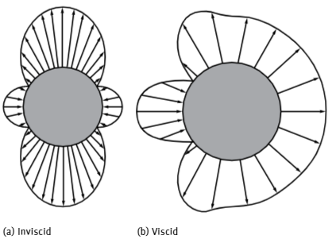

Fig (2) Pressure distribution around a cylinder (Angle of Attack, 2021).
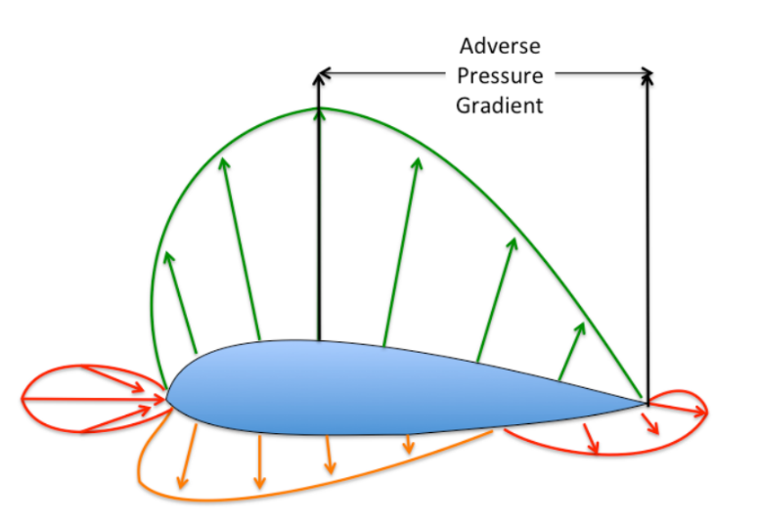
Fig (3) Pressure distribution around an airfoil (Angle of Attack, 2021).

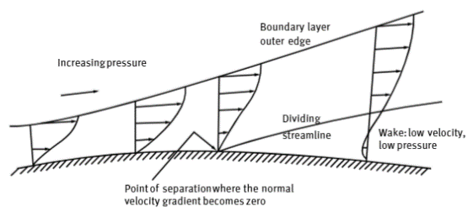

Fig (4) Separation of a boundary layer (Chen and Wang, 2017).

4.2 Boundary layer description
To gain a solution to the Navier-Stokes equation, the Reynolds number needs to be large and consideration of velocity on the surfaces suffers discontinuity. This is when the value of velocity, which is different to zero, however at some point in the flow value is zero this would occur at the airfoil surface profile, due to viscous terms. This region is known as the boundary layer, within this area viscosity has huge impact that causes to velocity to diminish completely. Look at fig (5) boundary layer consists of streamlines as well as the leading stagnation edge point, this is due to adverse pressure gradient the fluid flow finds due to airfoil profiles it approaches (Chen and Wang, 2017).
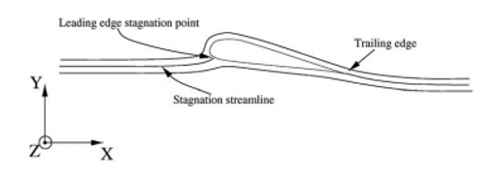

Fig (5) Flow over a 2D airfoil profile. (Chen and Wang, 2017).
The size of the boundary layer on the airfoil profiles is important for estimating the separation point, boundary later thickness where the velocity in the x direction $v_{x}=0.99v_{e}$, see below fig(6) for this boundary layer (Chen and Wang, 2017).
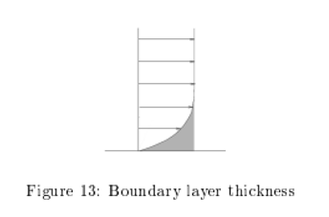

Fig (6) Boundary layer thickness. (Tong, 2010)

Within the upper boundary surface problem, fluid which flows over the profiles of the airfoil accelerates and passes leading edge. However, on the bottom side on the profile, curvature is less and this leas to separation and fluid flow decrease and this is a strange phenomenon. To satisfy Kutta condition pressures on the leading edge from upper and lower profile surfaces must be equal (Tong, 2010).

For airfoils where the boundary layer is laminar which is for the most part attached to upper profile surface of the airfoil, these airfoils have separation and turbulence when $α$ value is greater. However, when $α$ is lower the pressure gradient is negative on upper surface to avoid separation, but the flow accelerates. But the fluid flow needs to slow in order to satisfy Kutta condition, at this point the boundary layer is likely to detach. After this transition, the thickness of the boundary layer is small, this is due to reduce flow at trailing edge, separation is more likely to happen due to positive pressure gradient. As mention controlling this separation point, at which place it will happen is important because once the fluid flow becomes turbulent it is very hard to control and predict behaviour for the remaining profile of the airfoil (Tong, 2010).

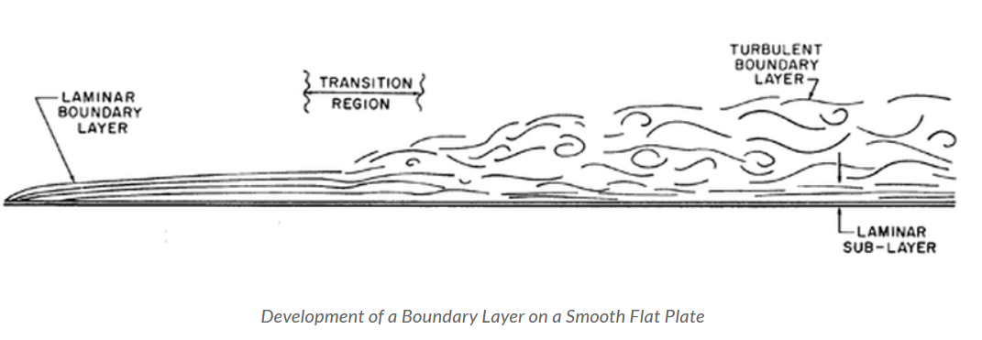
Fig (7) Development of a Boundary layer on smooth surface.
As seen in fig(7) the boundary layer along a flat surface changing along the surface.

4.3 Relevance of separation/turbulence in airfoil of wind turbine blade
As highlighted above delaying boundary layer separation for wind turbine blade profiles is critical. Delaying separation, the coefficient of drag $C_{D}$ is reduced as well as the coefficient of lift $C_{L}$ is greatly improved by delaying the stall. With the coefficient of lift $C_{L}$ increased it has an impact on the turbine losses as well as affecting the aerodynamic efficiency which will also affect the power that the turbine can provide. Ensuring smooth laminar flow over the blade will improve aerodynamic performance and the possibility of getting closer to the Betz’s limit. With ensuring laminar flows will help with structural integrity of blade and motor and ensure smooth operating and stop malfunctions from happening. (Chen and Wang, 2017, Schmitz, 2019)

5.0 Flow angle change along length of blade (Task 3)
Using the given data in task 3, windspeed of 15m/s, a blade length of 10m and a rotational speed of one revolution per second, show how the flow angle along the blade would change along the length. From the data some simple calculations can be made to determine change in flow angle along the length of the blade.
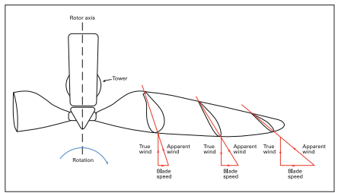
Fig(8) Vector changes due to due to blade length (Bhattacharya, n.d.).
To calculate the two vector components the following equations have been used.
$$arctan⁡(2π* n* \frac{r}{v})$$
Where,
n = rotational speed rpm
v = wind velocity m/s
r = radius m
The relative wind velocity seen by the airfoil blade has two components.
In the direction of the wind, the value is the actual wind speed = v
Perpendicular to wind due to the angular motion of the blade = $ω*r$
The angle along the blade will be tangent = $\tan\left(\frac{ω*r}{v}\right)$

From these simple calculates the below table can be populated.
Radian Position "r" [m] | Wind speed [m/s] | Speed of blade [m/s] | Relative velocity of wind impacting the blade [W] [m²/s²] | Induced Velocity [m/s] | Flow angle Inverse [tan $φ$] | Flow Angle [$φ$ Degrees] | Lift force [N/m²] | Angle of attack [Degrees] | Pitch angle [Degrees]
1 | 15 | 6.284 | 264.489 | -6.284 | 2.387 | 67.27 | 28.950 | 10.5 | 56.77
2 | 15 | 12.568 | 382.955 | -12.568 | 1.194 | 50.04 | 115.800 | 10.5 | 39.54
3 | 15 | 18.852 | 580.398 | -18.852 | 0.796 | 38.51 | 260.551 | 10.5 | 28.01
4 | 15 | 25.136 | 856.818 | -25.136 | 0.597 | 30.83 | 463.202 | 10.5 | 20.33
5 | 15 | 31.420 | 1212.216 | -31.420 | 0.477 | 25.52 | 723.753 | 10.5 | 15.02
6 | 15 | 37.704 | 1646.592 | -37.704 | 0.398 | 21.69 | 1042.204 | 10.5 | 11.19
7 | 15 | 43.988 | 2159.944 | -43.988 | 0.341 | 18.83 | 1418.556 | 10.5 | 8.33
8 | 15 | 50.272 | 2752.274 | -50.272 | 0.298 | 16.61 | 1852.808 | 10.5 | 6.11
9 | 15 | 56.556 | 3423.581 | -56.556 | 0.265 | 14.85 | 2344.960 | 10.5 | 4.35
10 | 15 | 62.840 | 4173.866 | -62.830 | 0.239 | 13.43 | 2895.012 | 10.5 | 2.93
Table 1: Calculation data.

Graph 1: Flow angle change along the length of the blade.
As seen in graph (1) & table (1) the flow angle $φ$ changes along the length of the blade, the closer you get to the tip of the blade the faster the blade is moving, and wind angle increases.

6.0 Pitch angle change along length (Task 4)
Using the given the data in figure 2, show how the pitch of the blade must change along the length so that the blade does not stall. Using the flow angle from task 3 table 1, a calculation can take place in order to detemine pitch angle change along the length of the blade
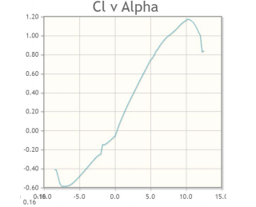
Fig(9) Coefficient of lift v Angle of Attack for the aerofoil used.
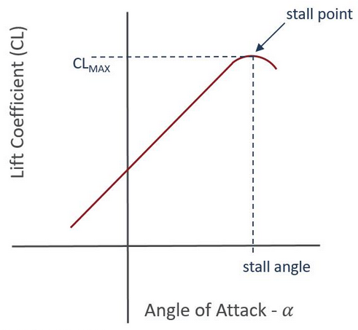
Fig(10) Coefficient of lift v Angle of Attack with stall point(Angle of Attack | AeroToolbox, 2021).
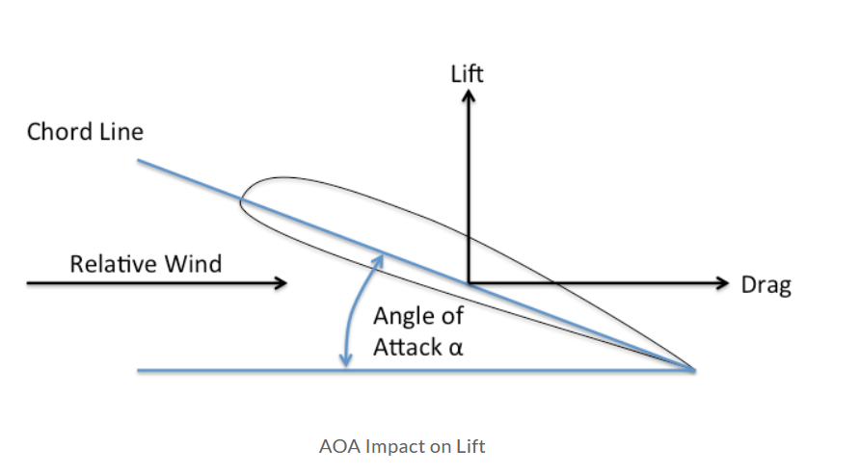
As seen in fig(10) the value in fig(9) was decided due to angle of attack of 10.5 degrees would not cause the blade to stall.

Fig(11) Angle of attack (Aerospaceweb.org | Ask Us - Angle of Attack and Pitch Angle, 2021).

Graph 2: Pitch angle change along the length of the blade.
To determine the pitch, angle the angle of attack assumed to be constant along the length of the blade, the inflow air angle can be used with the angle of attack to calculate the pitch. Looking at the above graph(2) it is clear that the pitch angle changes along the length of the blade and for good reason the optimum pitch angle is found during the design process to have the best angle of attack to maximum the amount of energy that can be extracted out of the wind and to utilise the best fluid flow around the airfoil blade which is all related to Reynolds number and separation. The blade stalls due to rapid increase of air passing over airfoil causing the boundary layer to separate this results in the lift coefficient decreasing and aerodynamic performance lose. Stall occurs when the critical attack of attack is exceeded.
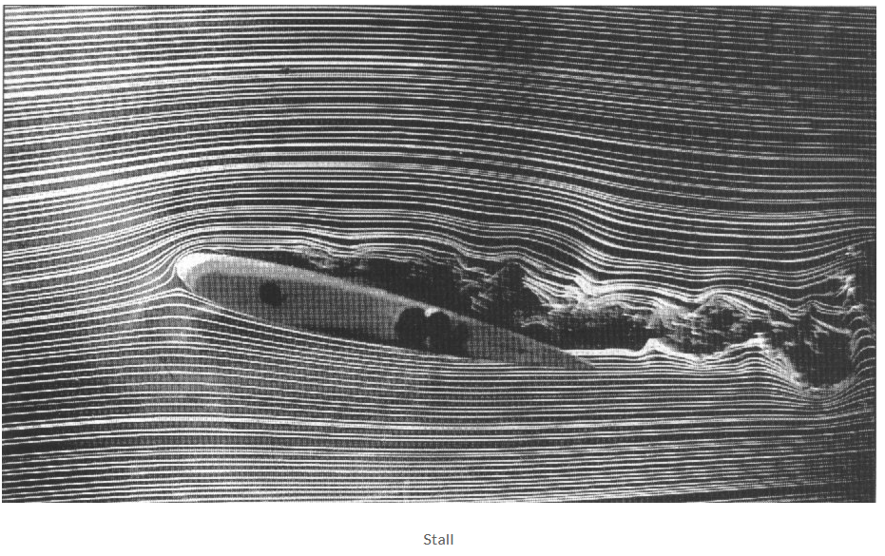

Fig (12) Visual of Stall on airfoil blade (Angle of Attack, 2021).
As seen in fig(12) the fluid flow has separated from the air foil surface body, the flow has become turbulent and chaotic.
7.0 Conclusion
As discussed in the report the Reynolds number has a huge impact on the performance of wind turbine blade due to the effects it has on the fluid flow around the wind turbine airfoil. From graph (1+2) it was determined the pitch angle and in flow air angle changes along the blade length due to the rotational velocity generated by the fluid flow. The implication of stall and separation were discussed as these are important factors to consider when design a wind turbine blade.
8.0 References
AviationChief.Com. 2021. Angle of Attack. [online] Available at: <http://www.aviationchief.com/angle-of-attack.html> [Accessed 9 January 2021].
Bhattacharya, S., n.d. Design of Foundations for Offshore Wind Turbines.
Chen, J. and Wang, Q., 2017. Wind Turbine Airfoils And Blades. 3rd ed. Wuhan, Hubei, People's Republic of China: De Gruyter, pp.9-18.
Schmitz, S., 2019. Aerodynamics of Wind Turbines. 1st ed. US: Wiley.
Tong, W., 2010. Wind Power Generation and Wind Turbine Design. 2nd ed. Southampton: WIT Press.
9.0 Bibliography
Aerospaceweb.org. 2021. Aerospaceweb.Org | Ask Us - Angle Of Attack And Pitch Angle. [online] Available at: <http://www.aerospaceweb.org/question/aerodynamics/q0165.shtml> [Accessed 9 January 2021].
AeroToolbox. 2021. Angle Of Attack | Aerotoolbox. [online] Available at: <https://aerotoolbox.com/angle-of-attack/> [Accessed 9 January 2021].
AviationChief.Com. 2021. Angle of Attack. [online] Available at: <http://www.aviationchief.com/angle-of-attack.html> [Accessed 9 January 2021].
Bhattacharya, S., n.d. Design of Foundations For Offshore Wind Turbines.
Chen, J. and Wang, Q., 2017. Wind Turbine Airfoils And Blades. 3rd ed. Wuhan, Hubei, People's Republic of China: De Gruyter, pp.9-18.
Schmitz, S., 2019. Aerodynamics of Wind Turbines. 1st ed. US: Wiley.
Tong, W., 2010. Wind Power Generation and Wind Turbine Design. 2nd ed. Southampton: WIT Press.
Courses.lumenlearning.com. 2021. Rotation Angle and Angular Velocity | Physics. [online] Available at: <https://courses.lumenlearning.com/physics/chapter/6-1-rotation-angle-and-angular-velocity/> [Accessed 9 January 2021].
AeroToolbox. 2021. Angle Of Attack | Aerotoolbox. [online] Available at: <https://aerotoolbox.com/angle-of-attack/> [Accessed 9 January 2021].
Sciencedirect.com. 2021. Reynolds' Number - An Overview | Sciencedirect Topics. [online] Available at: <https://www.sciencedirect.com/topics/engineering/reynolds-number> [Accessed 9 January 2021].

