Melawin Rai
2nd year Photography arts
Dissertation proposal

Dissertation proposal
Re-find the ‘real’

Context

The subject matter that I would like to explore for this dissertation proposal is about the ‘Real’ in Photography. The age were living in today has many error in image manipulation but we still locate our sense of right in the “real” images. Photography has changed drastically Due to technology advancement and how easy it to view images that are shared which without knowing could be fake or real. This dissertation will use theories and ideas that will discuss the responsibility of photography. Also it will explore how social media plays in the roles of this subject.
My aim for this dissertation proposal is to find out that will we ever re-find the “real”.

Chapter 1

Photography has been an important piece of technology since it was invented 1826. We seem to have uncontrollable need to document our life,nature, family and everything around us. There was a hope to return to more stable and basic of photography but due to advance in technology and developments, modern technology is changing everyday imagery led to our lives and emotions become mediatised.As it advances on it has been easier and easier for anyone to become “photographers” because of smart cameras and the manipulation of images with the use of photoshop.

Photo manipulation has become very common in the age of digital cameras. Photoshop was invented in 1988 which is the most used software for professional use but There are various recent alternative software where you are able to manipulate your image for cheap and easy. Listed down:
- i Affinity Photo.
- Sketch.
- GIMP.
- Pixelmator Pro.
- Pixlr.
- Corel PHOTO-PAINT.

Manipulating an image actually dates back as far as the invention of photography. For the recent years there are countless amount of images which are manipulated but back in the early years not much was done then and those years were the real era of photography. First ever manipulated image of U.S. president abraham lincoln lithograph print from 1860. Few images that was very controversial or notorious from the early ages is the Italian dictator benito mussolini image on his horse.
The original image is on the right but what he wanted was that everyone should be removed from the image except for him so he looked more heroic. It was then noticed that it was three image merged into one.

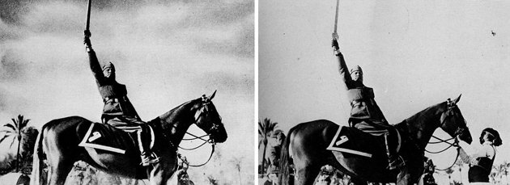
Is photoshop ruining photography? I think that basic photoshop can be and used excessively but i feel that it can ruin landscape photography and fashion photography .there are current arguments over retouching advertisements for example where women who have issues over their appearance due to always seeing retouched models. A comment for Vogue 2018 march Magazine “They went overboard with the photoshop on Bella's face. She is naturally gorgeous there is no need for editing” . It may look visually pleasing and satisfying to see someone that “perfect” but these womens cant look as good as these models simply because the models have been so retouched that it's not even natural anymore.

‘The greater the power, the more dangerous the abuse.’- Edmund Burke

Photographers are also running one of the biggest photography subject, landscape is being manipulated in such ways that makes it some time impossible to even think is that even real.
In 2012 david byrne who lost his 10,000 prize money was a winner disqualified from the landscape photography competition because of excessive digital manipulation in his entry image. The problem is not that the work was manipulated but the problem is that the photographer should have made it clear to the judges that his image was manipulated in the first place.I believe that it wouldn't have been a problem if he had told the judges which would have led to 2 possibilities, keep him in the competition or asked him to look for a different competition.

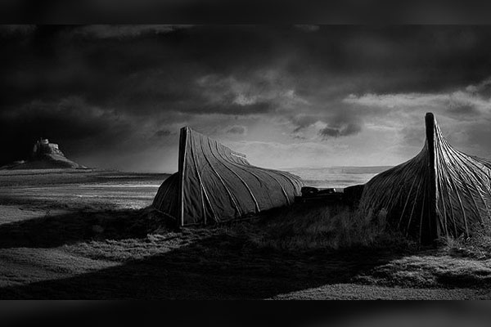

For example Ansel adam considered honestly trying to build a authentic representation of the landscapes he was photographing. Ansel adam demonstrates his scenery at its most authentic and ordinary with no editing of any kind of manipulation. Differently andreas gursky opened with this view but soon began altering his representation with digital editing so that it was no longer a genuine representation.

Chapter 2

Will we ever find the real?
What happened to the times where people are in the darkroom, taking their time processing their images in their chemicals not knowing if their images would come out right or wrong. That's the authentic way of doing photography rather than taking pictures on camera and images would get saved on a sd card. You would then edit you image on a software or so to fix it up. Imagine what photography would be like in 10-20 years, not needing to dslr but phones able to take pictures better than cameras and more smaller.

But are we moving off from capturing the real? A staged photo is not acceptable in the news media because of the real world situations and events. In portraiture,fashion and still lifes are of course planned ahead, directed and produced which should be obvious to viewers. There is a debate in the photojournalistic world is figuring out how much a photographer is allowed to edit their original picture without crossing the line of truth. Can we even trust the world of media anymore of what they show on the news?
Some business are very critical on photographers images because they are drawing extreme lines on putting limits to any alteration on photographer can apply on their images, which is bound to fail.

This debate is a ethical issue and has always been, weather the photographer has their clear intention to mislead and lie. There is a article on about robert capa which talks about one of his iconic photograph of the republican militiaman, Federico borrell garcia, at the moment of death. This is a famous image of his showing a moment where a soldier is shot at moment of death. But did the famous photograph capture the death of the soldier or was it staged? The truth is that Robert capa had no aim to lie or deceive when he had reconstructed the events so he could photograph them to show the world. It was all over before he even got the chance to get there so his intention was to show what had happened on that battle.

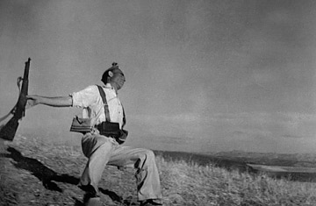
(The Falling Soldier) Cerro Muriano, Cordoba front, Spain. September 5th, 1936)

If a photographers story is wanted to be told as a series of landscapes,so be it. If a photojournalist story wants to be told in a staged form, so be it. If that is how photographers wants their work to be shows then fine, we can give them our opinion and arguments but also respect each other's views.the point if this is the form is clearly unrelated. What is relevant is that how the creator has decided to engage you to their work, the viewer of the image.

Chapter 3

How Social media effects images?

Social media has changed our way of seeing our everyday life, the way we look at things, family, friends, work, going out etc. when people go out for dinner with friends and family, the first thing you generally see is at least one person or all of them taking a picture of their food or drinks and uploading it on social media telling people what they are up to.

“People taking photographs of their food in a restaurant instead of eating it” - Antonio Olmos.

Also when you go somewhere abroad or to visit a famous place or art, “click” they take a photo of it rather than looking at it in detail right there and then. They need it experience it there and then. Then they see it later on their camera and their zooming in to see it properly which is a waste of time in my opinion.

“People taking photographs of mona lisa instead of looking at it. I think the iphone is taking people away from their experiences.

Social media is the latest professional “photography killer”. These platforms have over millions of users which allows more people than ever before to consume and produce imagery on huge scale. Platforms like instagram where anyone can choose, edit and upload their images and get seen by anyone around the world. As well as there is good side to it,It's dangerous for people to see your work because it encourages people to steal photos so they can use it for their account and get paid. I used to get told or hear about when you were warned off putting images on a website because they would be stolen. Sound any familiar?
I believe that people who doesn't even have knowledge of photography are making more than professional photographers in instagram because when you take and edit it on instagram you can choose a filter for you image and those filters have their own settings built into it making your images more professional looking.it looks like they know alot about photography but really the editing software in social media is doing it for them with just a click.

Today many professional photographers can get their sales and commissions without having to put their website up .if you go on instagram you can make your account business or normal account same as twitter or facebook.
The top social medias that are facebook and instagram who are both owned by the same owner who is making billions. Because people are uploading images everyday or seconds of their work or just general day to day stuff they do. They get many followers on their accounts and more the flowers the bigger their profile get and their account gets seen on their developers system. Meaning the developers start paying them for their everyday uploads which turns out like a full time job uploading images on instagram or any other social media. It's very easy these days to get paid for your images on social media because of social media.

Finally i have led to my final question for my dissertation.
“Do we need professional photographers anymore in the future?”
Because of how technology is advancing and how technology can take pictures of sceneries and know what they are taking picture. I can talk about how soon phones will soon take over dslr because it almost does the same thing as dslr but how rapidly its getting smarter than a dslr and how portable it is of its size. I can also talk about how anyone can be a photographer because how smart cameras are becoming and how easily it notices what you're taking a picture of and makes it look professional. Because of that it can ruin the careers of professional photographers sooner of later in the future.

Internet References

dailymail.co.uk/news/article-2107109/Iconic-Abraham-Lincoln-portrait-revealed-TWO-pictures-stitched-together.html

blog.melchersystem.com/in-search-of-real-photography/

content.time.com/time/world/article/0,8599,1912110,00.html

theguardian.com/artanddesign/2013/dec/13/death-of-photography-camera-phones

lightstalking.com/12-hugely-important-moments-in-the-history-of-photography/

nytimes.com/2009/05/28/fashion/28RETOUCH.html

pakistantoday.com.pk/2012/11/03/photography-competition-winner-disqualified-for-too-much-photoshopping/

petapixel.com/2014/03/11/50-photography-quotes-inspire/

weforum.org/agenda/2017/03/most-popular-social-networks-mapped/

washingtonpost.com/news/the-intersect/wp/2015/02/19/how-25-years-of-photoshop-changed-the-way-we-see-reality/?noredirect=on&utm_term=.d60c3cf97629

Book:

Landscape and Urban Planning : Volume 44, Issue 4, 1 September 1999, Pages 177-198

The Atlas of Beauty: Women of the World in 500 Portraits

