Business Management
Dissertation

Research title
How different types of leadership styles can influence the process of an organisation
Perspective from UK

Supervisor: Dr Taye Timothy Osadiya
Student name: Diana Dimova
Student ID: 1818046

University of Wales Trinity Saint David (London Campus)

Abstract
Companies in the UK operate in a highly competitive and complex business environment. In order for them to stay competitive, be profitable, and deliver exceptional customer service, they need to implement the right strategies, operational processes, and favourable leadership styles. The main responsibility for that falls on the management and the leadership team of the organisation. For that reason, company’s leaders must be well prepared and equipped with the right mindset, skills, and competencies. One of the most important steps towards that is to implement the correct leadership style, so that a favourable working environment is achieved, and the company is run adequately. The aim of this research is to evaluate the most common leadership styles and to explore how different types of leadership can influence the process of an organisation, with a perspective from The UK. Among the most favourable leadership styles a company can implement are democratic, visionary, transformational, supportive, and charismatic styles. It is the responsibility of the management to decide on the best leadership style or mixture of several styles to be used, in order to create a favourable working environment and to secure the future success of the organisation.

Table of Contents
Chapter 1. Introduction 4
1.1. Research aims and objectives 4
1.2. Research main question and subquestions 5
Chapter 2. Literature Review 6
2.1. The UK business environment 6
2.2. What is leadership? 6
2.3. Full Range Leadership Model 7
2.4. Leadership styles 8
2.4.1. Democratic 9
2.4.2. Autocratic 10
2.4.3. Visionary 11
2.4.4. Transformational 12
2.4.5. Bureaucratic 13
2.4.6. Supportive 14
2.4.7. Laissez-faire 15
2.4.8. Transactional 16
2.4.9. Charismatic 17
Chapter 3. Methodology 18
3.1. Sampling method 19
3.2. Data analysis 20
3.3. Time prospect 20
Chapter 4. Results, Analysis and Discussion 22
Chapter 5. Conclusion, Recommendations and Reflection 35
5.1. Conclusion 35
5.2. Recommendations 36
5.3. Reflection 37
References 39
Appendices 48
Appendix 1. Survey questions 48

Chapter 1. Introduction
Nowadays, companies in the UK operate in a highly competitive and complex business environment (Guest, et al., 2003). In order for organisations to stay competitive, be profitable, and deliver exceptional customer service, they need to implement the right strategies and operational processes (Guest, et al., 2003). The main responsibility for that falls on the management and the leadership team of the organisation, whose role is to assure adequate working practices and appropriate internal processes.
The proper functioning of each company department depends on the right decisions and actions of the top management, including Human resources, Research & Development, Operations, Finances, Customer service, etc. For that reason company’s leaders must be well prepared and equipped with the right mindset, skills, and competencies, in order to execute the organisation’s processes and manage the workforce in the most appropriate manner (Hersey, et al., 2008).
One of the first and most important steps towards that is to choose and implement the correct leadership style, so that a favourable working environment is achieved, and the company is run adequately. Among the most common leadership styles a business organisation can adopt are Autocratic, Democratic, Visionary, Transformational, and Supportive (Nanjundeswaraswamy and Swamy, 2014). It is up to the top management to evaluate the business sector, the company goals, and the workforce, and to embrace the most appropriate style that will contribute to the future growth and success of the company.

1.1. Research aims and objectives
The aim of the following research is to evaluate the most common leadership styles and to explore how different types of leadership can influence the process of an organisation, with a perspective from The UK. For that reason, the research will examine various aspects of the proposed topic; different leadership styles, including their advantages and disadvantages; challenges related to the use of the different leadership styles, as well as how they can impact the processes within the organisation.

1.2. Research main question and subquestions
The main purpose of the report is to provide answers to the following main question, and the three additional sub-questions:

Main question
How different types of leadership styles can influence the process of an organisation, with a perspective from The UK?

Sub-questions
- What are the different leadership styles an organisation can adopt?
- What are the most favourable leadership styles a management can implement?
- What are the most common challenges associated with the implementation of a specific leadership style?

Chapter 2. Literature Review

2.1. The UK business environment
The business environment in The United Kingdom could be described as safe and favourable (The Global City, 2022). The country scores particularly high on the “Ease of doing business” index, which means that companies can rely on favourable laws and regulations, which are designed to encourage growth and success.
Furthermore, The UK business environment boasts is characterised with a high level of expertise and may enhance the success of business. Along with all the benefits however, due to the large size of the market, the business environment has also been found to be extremely competitive (CMA, 2020). Therefore, companies operating within the UK market must make sure they use all available strategies, practices, and operational processes, in order to thrive, stay competitive, and be profitable. Evidence from literature suggests the success of the UK businesses are influenced by the robust leadership styles that the managers of those organisations have adopted (BIS, 2012).

2.2. Definition of leadership
Leadership could be defined as a transformational process through which a group of followers are motivated to achieve a common goal (Avolio et al., 1999). A leader themselves is a person who possesses a set of special character traits that enable him or her to influence people towards the accomplishment of certain tasks or goals. Leadership in an organisational context often exhibits similarities with management as both leaders and managers work closely with their subordinates influencing them to be productive and complete tasks in a timely manner, towards organisational success (Weiner, 2009). Nevertheless, leadership and management are two different things, due to the fact that managers are mainly concerned with company duties, such as planning, organising, and controlling, by following a strict schedule, whereas leaders tend to be more flexible and open-minded and in most cases are better involved with their followers (Bass, 1990).
On this note Northouse (2015), asserts that leaders tend to influence and inspire big company changes and chase the company's long-term goals. This implies that, organisational leadership is all about looking for innovative opinions, providing support to followers, solving problems, and working together with subordinates towards the company growth and success.To summarise, organisational leadership is a type of company management approach during which leaders assist in setting the firm’s strategic goals while at the same time help motivate employees to stay productive and to successfully accomplish their professional duties. In terms of weaknesses, organisational leadership has been linked with a lack of adequate mentoring, decreased flexibility among staff, over-control, narrow coordination, narcissism, and indifferences to followers (Shaw, et al., 2011). These weaknesses however vary in number and extent among the different leadership styles, making some leadership styles more favourable than others (Nanjundeswaraswamy and Swamy, 2014).

2.3. Full Range Leadership Model
The Full Range Leadership Model is an embodiment of three set of theories covering three distinct leadership styles ranging from low to high engagement leading styles that enhance different leadership effectiveness. The theory was introduced by Bass and Avolio and features the following three leadership styles: 1) transformational; 2) transactional; and 3) laissez-faire leadership (Bass and Riggio, 2006; Avolio et al., 1999; Judge and Piccolo, 2004). In their work ,the authors found laissez-faire leadership to be the least effective and assert that transactional leadership was found to produce average results and transformational leadership was found to be the one that delivers high engagement and strong efficiency(Bass and Riggio,2006;Avolio et al.,1999;Judge and Piccolo,2004).
On this note Vincent-Höper et al. (2012), argued that transformational company leaders are managers who engage, motivate, and advance their staff members by communicating attractive visions, collaborative values, and mutual goals, as well as by outlining a drawing of the requested type of behaviour among staff. The most prominent elements of transformational leadership include influential motivation; idealised influence and behaviour; individualised consideration; and cognitive stimulation (Bass and Riggo, 2006; Bass and Avolio, 1994).
On the other hand, transactional leadership is characterised by exchange processes between leaders and subordinates that result in adherent staff compliance to the demands of the leader, without necessarily creating commitment to the task or the errand objectives (Trottier et al., 2008). The transactional type of leadership style features two sub-styles, namely: a) constructive style, also known as contingent reward style; and b) corrective style, also known as management-by-exception style.
The third leadership style - laissez-faire, is a style of leadership which has been characterised by academics and practitioners as an approach that has the tendency of creating an environment where workers lack of interest, have little to no involvement, indifference, high levels of absenteeism, and missing achievements by the leader. It is a type of leadership style in which leaders provide staff with very little supervision and direction and allow staff members to make company decisions themselves (Bass and Riggio, 2006).

2.4. Leadership styles
Over the years there are various leadership styles that have been developed. Among the most popular ones that are used in today’s business environment are democratic, autocratic, visionary, transformational, bureaucratic, supportive, laissez-faire, transactional, and charismatic. Some of these styles have been proven to be beneficial for the growth and success of organisations, whereas others have been found to be detrimental for companies (Hasan Al Khajeh, 2018). For instance, among the most favourable leadership styles are democratic, visionary, supportive, transformational, transactional, and charismatic. On the other hand, the autocratic, bureaucratic, and laissez-faire, have been proven less favourable.
This division however is relative, as the most appropriate leadership style depends on a lot of factors, such as company type, business sector, and current economic conditions, among others. It is the top management’s responsibility to evaluate the different leadership styles and to decide which one would be most suitable for the given business organisation. It is a common practice for companies to implement several different styles which can be either switched depending on the situation or mixed for best results (Hasan Al Khajeh, 2018).

2.4.1. Democratic
According to Hackman and Johnson (1996), democratic leadership is a type of leadership style which encourages all employees to take part in the company's decision-making processes, and is related to higher staff productivity, increased employee satisfaction, and raised involvement among staff members. This leadership style is associated with better morale and higher respect. Leaders, who have adopted such a style of leading their workforce, are more likely to provide guidance to their subordinates, take higher participation in the company’s group activities, and allow stronger input from staff members (Vigoda-Gadot, 2007). Furthermore, such leaders prefer to delegate tasks and authority to their employees, while at the same time are happy to provide support in challenging situations.
Democratic leadership style is often linked to the establishment of successful, profitable, and sustainable business organisations, boasting a highly satisfied and committed workforce (Bass, 1990). Democratic leaders have been found to exhibit big confidence and high trust in their subordinates. Usually, if a difficult situation or a company issue arises, these leaders involve most of their employees in the discussions and decision-making procedures, in order to find the best possible solution for the firm and its employees.
Leaders who have adopted the democratic leadership style typically act like a coaching body to their subordinates. The leader has the final word but before he or she makes their say they collect all the necessary information and inputs from their employees, so as to make the most favourable decision for the company, its workforce, and its shareholders (Gastil, 1994). This way of leading carries many positive outcomes for the company and its staff, such as increased productivity, however some researchers argue that it can be very time-consuming during the decision-making phase, which is considered as a drawback (Denhardt and Denhardt, 2003).

2.4.2. Autocratic
The autocratic leadership style, also referred to as dictatorship style, is characterised by the presence of a leader who holds all the power within the organisation and regards his or her decisions as final and supreme (Burke et al., 2006). According to the authors (Burke et al., 2006), the staff of a company, which has adopted an autocratic leadership style, performs because of the available rewards and the possible punishment that might follow should the tasks are not completed on time. Furthermore, Northouse (2015) argues that an autocratic leadership style is often imposed on the company, and not necessarily chosen by the top management as a way of leading the firm. For that reason, this style is commonly referred to as a coercive leadership style.
Typically, leaders who have adopted the autocratic leadership style make company’s choices that are based on their personal judgments and ideas, and very rarely take advice from subordinates (Gonos and Gallo, 2013). Furthermore, such leaders do not make compromises and often refuse to provide explanation regarding their behaviour. Such a leadership style implements absolute control over the workforce, dictating all organisational methods, and accepting little, if any, input from employees. Staff members are not trusted with making decisions or undertaking important duties or tasks.
Even though in some instances, an autocratic leadership style can prove effective and beneficial, such as in situations requiring fast decision-making, in most cases, the autocratic leadership style’ disadvantages have been found to outweigh the style’s advantages (Akor, 2014). This is why such a leadership style is not favoured by staff members in the majority of the business organisations. According to the available literature on the topic, the autocratic leadership style has been defined as the opposite of the democratic leadership style.

2.4.3. Visionary
According to Yukl (2006), visionary leadership style is characterised by the utilisation of transformational characteristics and behaviours. Sashkin and Sashkin (2002), describe visionary company leaders as persons who display high confidence, prosocial power traits, and favourable organisational skills, all of which are needed for the success of the company. Typically, a visionary leader would develop his or her own vision and after that they will merge it together with the shared vision of their subordinates.
Furthermore, Heath and Heath (2010) argue that It is the communication of the formed vision that leads to the actual empowerment of staff members to act and give their best towards the success for the company. The authors (Heath and Heath, 2010) continue by stating that if employees do not perform well or act inadequately under a visionary leadership, it is because the leader’s vision has not been communicated in a clear and appropriate manner. Often, during such circumstances staff members are wasting time trying to understand which way to go, thus leading to their decreased productivity and reduced responsiveness.
As argued by Zhu et al. (2005) the visionary leadership style creates a positive work environment that is characterised by high cohesion levels, raised commitment among employees, as well as increased motivation, trust, and performance. Visionary leaders inspire subordinates to act beyond their personal interests and to perform in a way that is most appropriate for the future growth, success, and profitability of the business organisation. With regards to the shortcomings of the visionary leadership style, some researchers argue that these are the easily-getting-bored nature of visionaries, the large number of ideas and unrealistic enthusiasm within the company environment, as well as the low degree of staff ability to suggest different ideas or visions (Westley and Mintzberg, 1989).

2.4.4. Transformational
The transformational leadership style has been characterised by the availability of four core elements, including individualised consideration by the staff; charismatic employees’ role modelling; intellectual workforce stimulation; and highly inspirational motivation among staff members (Gumusluoglu and Ilsev, 2009). Transformational leaders have been found to initiate high regard, loyalty, and respect among their subordinates, and believe in having a common mission with them (Barbuto and Burbach, 2006). Such leaders tend to establish unique relationships with their subordinates, and encourage individual differences, skills, and needs among employees.
Furthermore, organisational leaders are characterised as persons who are able to communicate the company’s vision to the staff in a clear and concise manner, demonstrating to the workforce the best way for staying committed and achieving goals. As a result, staff members feel very motivated and positively stimulated for achieving even better results. (Hayward, et al., 2004). Due to its nature, the efficiency of the transformational leadership style can be well complemented by the partial implementation of the transactional leadership style.
According to Conger (2002) transformational leadership style goes beyond employees’ incentives for high performance, so as to stimulate staff members’ intellectually, to increase their creativity, and to transform workers’ personal concerns into an integral part of the company’s mission and vision. Change is what lies at the base of this leadership style. Additionally, It has been made evident by Para-González, et al. (2018) that the implementation of the transformational leadership style leads to an improved organisational performance and highly motivated workforce. Therefore this type of leadership style could be placed among the styles that express bigger potential for company success, growth, and profitability.

2.4.5. Bureaucratic
According to Sapre (2000) bureaucracy may exhibit negative aspects when it comes to company change or innovation, and that the use of a bureaucratic leadership style leads to a decision-making process that is performed under strict company rules and regulations which often lead to a diminished creativity and motivation among staff members. Furthermore, it has been established that companies which have adopted a bureaucratic leadership style have faced issues on various organisational levels, including planning and decision-making (Langer, et al, 2019).
The bureaucratic organisational structure reveals authority that is centred within the top management hands, thus encouraging a focused and controlled work culture in which employees and working processes are supervised in a conservative manner (Hoy and Sweetland, 2001). Furthermore, it has been made evident that most business organisations with a bureaucratic leadership do not allow the personal growth and development of staff members, as well as lack a novelty and mechanisms that enable the revision of company’s decisions. Such firms exhibit weak staff communication due to the bigger number of hierarchical divisions, and in most cases possess an extrinsic rewarding system which stimulates company conformity instead of company innovation.
Additionally, bureaucratic organisations appear to be highly centralised in terms of the decision-making processes. Typically, such companies encourage staff member’s suggestions, however the final decisions are made by the top management. In that respect, Hoy and Sweetland (2001) argue that there are two main categories of centralisation, namely intense centralisation and less intense centralisation. The former type is characterised by the presence of a top management which makes all decisions, whereas the latter type of bureaucratic centralisation allows for decision-making that is based on a staff participatory method, thus providing employees with a certain degree of judgmental rights.

2.4.6. Supportive
According to Rafferty and Griffin (2004), supportive leadership style is a type of organisational leadership in which the leader helps his or her subordinates by providing them emotional support and is concerned for the workforce’s needs and well-being. Furthermore, Kahn and Byosiere (1992) argue that supportive leadership is positively linked to the employees’ satisfaction and performance, and leads to reduced stress levels on the job, thus forming a positive work environment that facilitates communication and collaboration among staff. This type of leadership style exhibits similarities with the individualised consideration style which is a subdivision of transformational leadership. The reason for that is the fact that both styles of organisational leadership express interest and concern in followers and attend to their individual needs (Rafferty and Griffin (2004).
However, unlike the individualised consideration approach which features developmental elements, like career advice for employees, offering training, and monitoring employee progress, the supportive leadership style focuses exclusively on the social aspects, such as the offering of emotional support, sympathising, listening to subordinates, and caring for their personal needs (House, 1981). According to the published literature on the topic, the supportive leadership style has been associated with positive outcomes on an organisational level (Euwema, et al., 2007). For instance, this style of staff leading has been linked to higher employee satisfaction, improved commitment, better career certainty, and less occupational stress among staff members.
Furthermore, the supportive leader does not strive to accomplish all company goals by delegating them to his or her subordinates, but rather acts as a team member with coaching traits. Such a type of leader is open to recommendations from their followers and is eager to provide constructive feedback to them.

2.4.7. Laissez-faire
According to Bass and Avolio (1990), the laissez-faire leadership style could be best described as an absence of leadership. Often regarded as a “hands-off” approach for influencing employees in the workplace, this type of style is seen as destructive for the organisation since laissez-faire leaders have been found to exhibit no interest in the needs of their subordinates, nor they engage in company’s decisions or provide feedback in a timely manner. Furthermore, Skogstad et al. (2007) argue that such leaders are rarely able to meet the expectations of their subordinates, which often leads to the creation of role conflicts, ambiguities, and disagreements among staff members. Additionally, laissez-faire leaders tend to exert minimal to no effort to get the required company tasks done and show low concern for their subordinates.
These findings are further supported by Einarsen et al. (2007) who argue that the laissez-faire style of leadership falls in violation with the interests of the company and its employees due to the fact that the style undermines organisational vision and objectives, and threatens the well-being of the workforce. Laissez-faire leaders are often found inconsistent to staff members because they fail to fulfil the promised obligations and work duties, and rarely provide any guidance to their subordinates. This, in its turn, could undermine employees’ judgement about their leaders’ integrity and create distrust and breaching of contracts. Ultimately, all of the above could lead to intercompany doubts and uncertainty, and to erosion of staff members’ trust in the management team and the company as a whole.
Nevertheless, due to its nature, the laissez-faire leadership style tends to encourage independent thinking among staff members, which is why it is commonly found in creative organisational settings, such as start-ups, creative studios, and advertising agencies.

2.4.8. Transactional
The transactional leadership style is characterised by a leader who is always willing to deliver something in return to his or her subordinates. This could come in the form of a pay rise, bigger responsibilities, a positive performance review, or any other type of promotion within the organisation. According to Ojokuku, et al. (2012), the transactional style of leadership can be presented as the exchange of demands and rewards between the leader and their followers. This however often can lead to the issue of higher expectations towards the subordinates. Additionally, another issue that could arise during transactional leadership is the building of a workforce that is only motivated when it will get something in return. This could be especially threatening to the company during lean periods when organisational resources are thin and management has little to offer to its employees.
Nevertheless, the transactional style of leadership has been found to have a positive effect on an organisational performance level (Longe, 2014). One of the main reasons behind Longe’s findings (Longe, 2014) is the fact that the transactional style of leadership has been indicated to be particularly helpful in building and sustaining a highly motivated workforce that is capable of achieving positive results towards organisational growth. Furthermore, this type of leadership style leads to the formation of a positive work environment that allows for optimal staff performance (Longe, 2014).
Due to its nature, the transactional leadership style often displays the traits, similarities, or behaviours of the charismatic style of leadership, as it has been found to be quite effective for building a highly motivated workforce.

2.4.9. Charismatic
The charismatic leadership style is yet another style that is considered to bring positive outcomes in terms of organisational performance. Usually, the leaders who have adopted a charismatic approach for managing their subordinates tend to form a vision which should be followed by their employees (De Hoogh, et al., 2004). This type of leadership style embraces creativity, innovation, and prosperity and has been found to be particularly motivational for the workforce. When staff members are presented with a charismatic leader they prefer to follow their leader without questioning his or her decisions.
In terms of negative consequences, the charismatic leadership style has been linked with a workforce who is entirely dependent on its leader, meaning that if the leader resigns from the organisation, employees will lose direction. This problem appears to be further worsened by the fact that charismatic leaders rarely train their employees to become appropriate replacements once the leaders have left the company. This style of leadership typically results in happy and satisfied followers, but very few future company leaders. For that reason, Germano (2010) argues that the charismatic leadership style can have a negative organisational effect in the long run.
This finding is further supported by Ojokuku et al. (2012) who established similar outcomes as part of their quantitative research on bank employees in Nigeria. According to the results of the research, the charismatic leadership style carries negative consequences for organisational performance, due to the fact that this style does not engage and motivate the workforce enough so as to obtain the necessary performances for the future growth and success of the company (Ojokuku, et al., 2012).

Chapter 3. Methodology
Research methodology refers to a set of techniques and methods that are used with the aim of gaining broader knowledge about a certain topic, as well as for the purpose of solving a specific problem (Gorard, 2013). The research methodology covers different procedures and approaches whose major purpose is to help researchers identify, collect, summarise, and evaluate all the necessary data that is directly related to the topic of research.
For the purpose of conducting this research secondary and primary research methodology was used. As part of the secondary research, the available literature, studies, and publicly made knowledge on the subject was researched, collected, and evaluated. For the conduction of the primary research a questionnaire form containing 15 questions was distributed via social media with the aim of obtaining at least 30 respondents.
Based on the aim and objectives of the research, it appeared that a primary data collection method with survey respondents would have been preferred, in order to obtain an in-depth and first-hand understanding of how the different types of leadership styles can influence the process of an organisation in The UK. However, just the primary method alone was not sufficient enough as it was not going to reflect the purpose and the objectives of the research fully. The main reason being the limitations of the primary data collection method which involves only a small number of survey respondents, and it could be time-consuming (Patten and Newhart, 2017). For that reason, this research used a secondary data collection method too, along with the primary method, using a quantitative methodology approach.
According to Patten and Newhart (2017) the quantitative research method involves the gathering and analysis of both statistical and numerical data. This data allows the presentation of distributions, frequencies, as well as relationships. One of main reasons the quantitative research method was chosen for this research is its ability to generalise the research findings. For example, unlike the qualitative research method, the quantitative approach allows researchers to collect data from a bigger sampling size, thus being able to represent the broader views and opinions of the targeted demographic group (Patten and Newhart, 2017).
Furthermore, this research intended to collect the information in the shortest possible time, as well as to analyse the data in a better and easily understandable manner. For that reason, it was more sensible to have used the quantitative research method, since multiple survey respondents could have been added simultaneously, thus further saving precious time.

3.1. Sampling method
In most instances, the volume of available data related to a given research topic is quite large, which could make the process of data evaluation and systematisation very time-consuming. Therefore, it is a common practice for researchers to take advantage of the implementation of adequate sampling methods which helps narrow down the secondary data to a more manageable size (Taherdoost, 2016).
The sampling method that was used in this research paper is probability. The number of articles used for the conduction of the secondary research were narrowed down to 20 and the number of survey respondents used for the conduction of the primary research was set at 30. The ideal respondents were either full or part-time employees, working in the UK. In order to find appropriate participants, the survey form was distributed via Facebook groups with relevant topics. The form was also distributed among students at the University of Wales Trinity Saint David (London Campus), who were under employment.

3.2. Data analysis
When all the necessary primary and secondary information related to the topic is collected, the researcher needs to make an appropriate interpretation of it. The data analysis could be performed with the use of a qualitative, quantitative or mixed interpretational approach (Berg, et al., 2004).
Due to the nature of this research paper, quantitative data interpretation was implemented. The collected data was processed with the use of Microsoft Excel, in order to create graphs and charts and to achieve easier information analysis, and understandable data representation. The raw data was cleaned up by excluding incomplete survey questionnaires. The percentage of the completed survey forms was included in order to present the survey response rate. Because the size of the sample was not large, the survey response rate was expected to be above 75%. The collected data was then decoded with the use of numerical graphs and figures, since it was quantitative research. It was then entered into Microsoft Excel spreadsheet for final analysis. Microsoft Excel allowed easy use, provided the collected raw data was entered adequately. The results were presented using charts, graphs, tables, and text. The text was used mainly for the representation of the secondary data.

3.3. Time prospect
In order to be conducted successfully and in a timely manner, the research project must have a well-defined start and end date, as well as a detailed step-by-step plan. There are various software programs that can aid the planning process, but among the most useful ones is the Gantt chart (Geraldi and Lechter, 2012).
Therefore, this research paper used the Gantt chart, in order to ensure on-time project completion. The conduction of the secondary research was scheduled for weeks 3 and 4 from the start of the project, whereas the primary research questionnaires were distributed via social media in weeks 4 and 5. The respondents were given 2 weeks to return the filled questionnaires. Once all 30 complete forms were collected, it took 1 week to analyse and present the final findings. The detailed timeline can be seen in Table 1 below.

Table 1. Gantt chart: 15 February - 30 April (10 weeks)
 | W-1 | W-2 | W-3 | W-4 | W-5 | W-6 | W-7 | W-8 | W-9 | W-10
Preparation
Research
Questionnaires
Data collection
Analysis
Writing draft
Fishing report

Chapter 4. Results, Analysis and Discussion
The questionnaire that was intended to collect primary data comprised 15 multiple choice questions. It received 31 responses which were gathered over a period of 2 weeks. The questionnaire form was distributed with the help of social media such as Facebook. The post contained a description of the survey and a link leading the participants to the Google questionnaire form.

Question 1: What is your gender?
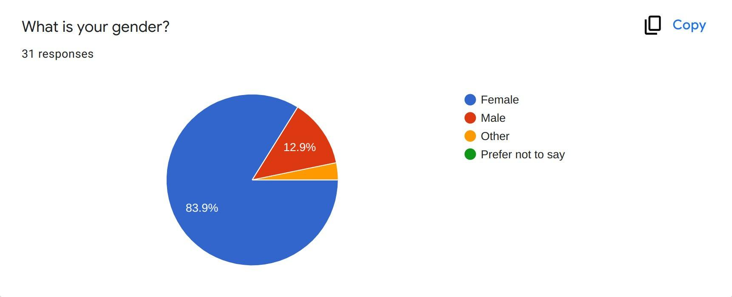
Of the 31 respondents, the majority were female at 83.9%, compared to 12.9% being male, and a small fraction (3.2%) other. (Question 1 above). These results revealed that the female audience engages more with social media which can be a useful insight for future studies that intend to reach respondents via social media. The remaining demographic data that was gathered covered the age and professional occupation of the participants.

Question 2: What is your age?
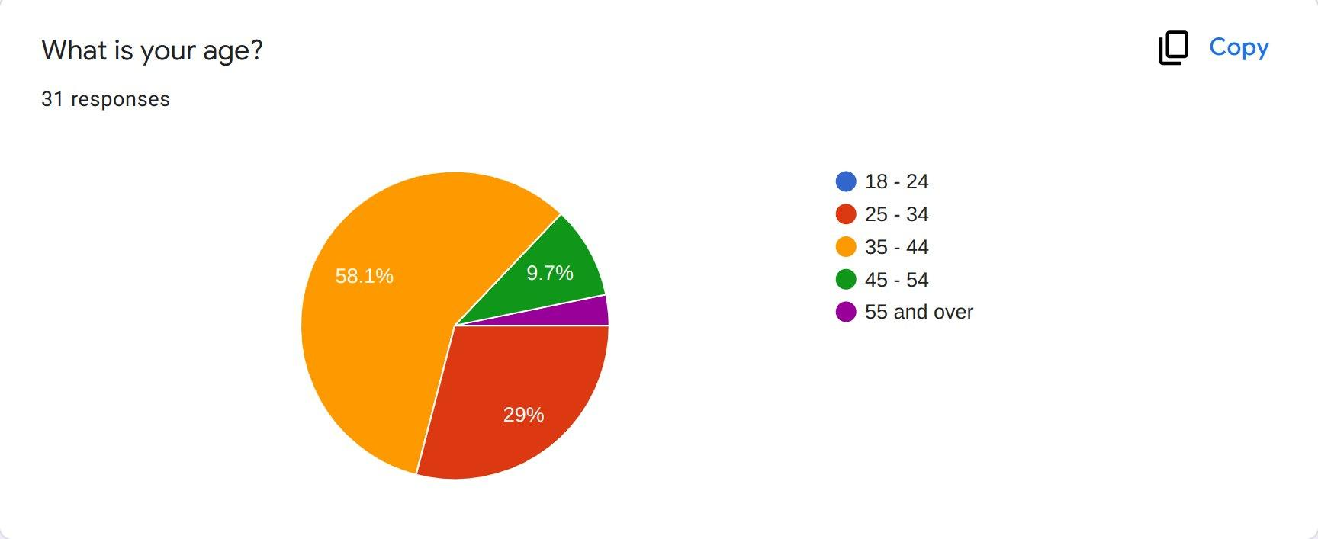
Over half of the respondents (58.1%) were between 35 - 44 years. 29% said they fall within the 25 - 34 age group, and another 9.7% - within the 45 - 54 age group (Question 2 above). Once again, here it becomes evident when it comes to filling out survey forms on social media, the most active age group is 35 - 44.

Question 3: Which one best describes your current occupation?
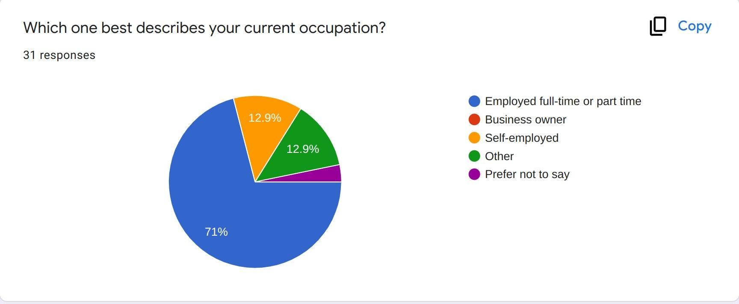
In terms of occupation, the majority of the respondents (71%) stated they were employed full-time or part time, followed by self-employed at 12.9%. Another 12.9% fell into the “Other” group (Question 3 above). This is not a surprise, provided that the survey form clearly expressed that only individuals who are into some form of employment should proceed.

Question 4: Please choose the most appropriate answer according to your personal opinion
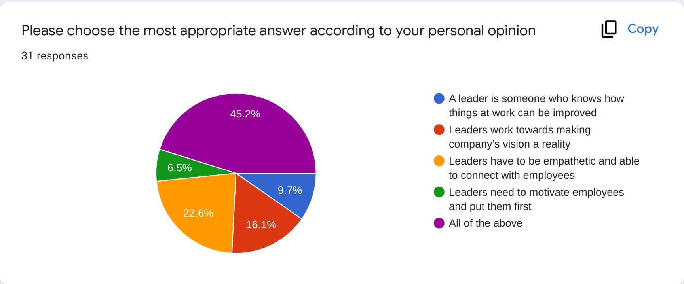
Question 4 was designed in such a way to collect the respondents' opinion about what a leader is. Nearly half of them (45.2%) chose all of the provided options, meaning that for them a leader is someone who knows how things at work can be improved; who works towards making company’s vision a reality; who is empathetic and able to connect with employees; and who needs to motivate employees and put them first (Question 4 above). These answers further support the findings of the secondary research based on the work of Weiner (2009), Bass (1990), and Northouse (2015).

Question 5: Would you say that company leaders play an important role in organisational success
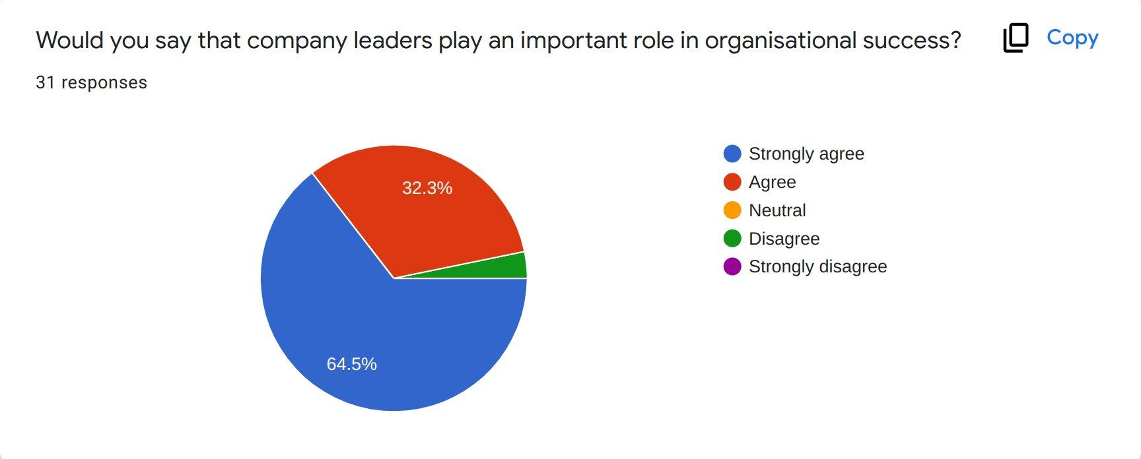
When asked whether company leaders play an important role in organisational success, 64.5% indicated they strongly agree, with another 32.3% saying they agree (Question 5 above). Once again, this question corresponds to the findings of other researchers from the past, such as Hasan Al Khajeh (2018) and Bass (1990) who have observed similar traits regarding organisational leadership.

Question 6: Do you believe that different leadership styles lead to different organisational outcomes?
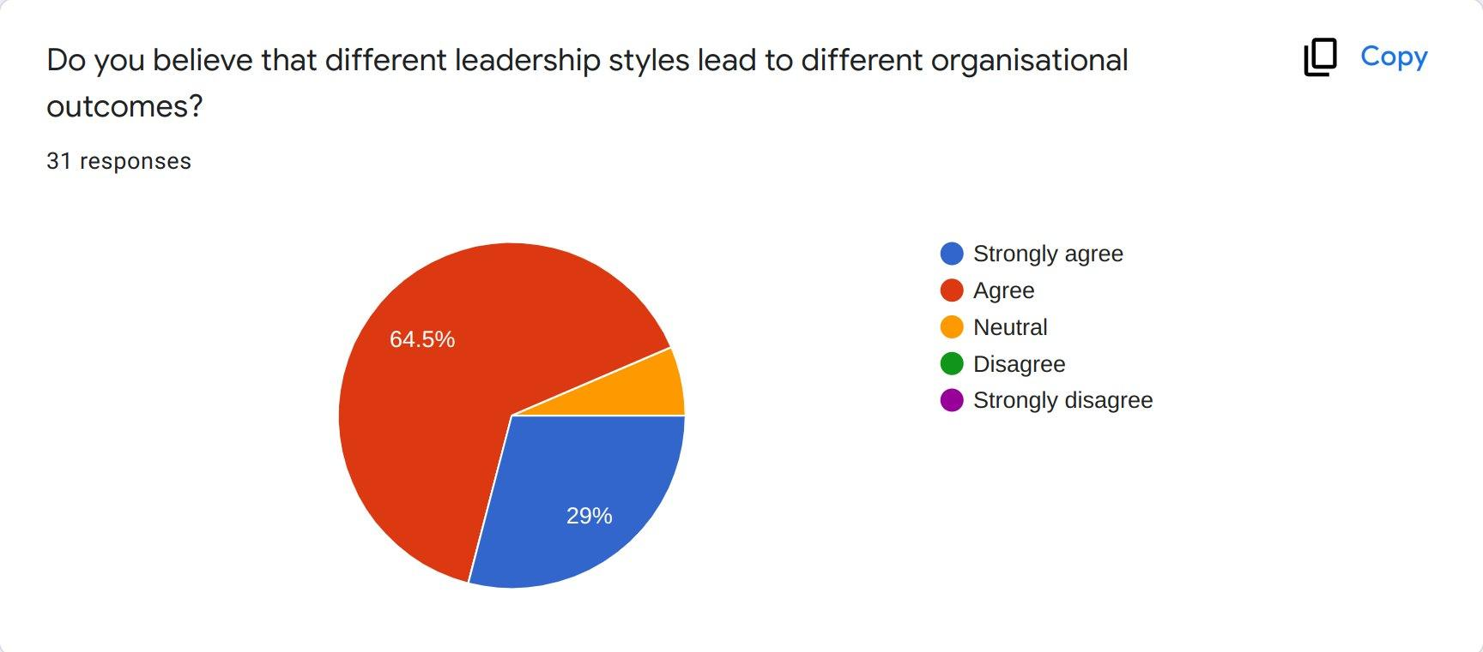
Almost all respondents (64.5% - agree and 29% strongly agree) believe that different leadership styles lead to different organisational outcomes (Question 6 above). The response to this question further proves previous findings by Northouse (2015), Shaw, et al., (2011), and Nanjundeswaraswamy and Swamy (2014), who have observed that some leadership styles are more favourable than others, thus leading to different organisational outcomes.

Question 7: Would you say that democratic leadership is linked to organisational success?
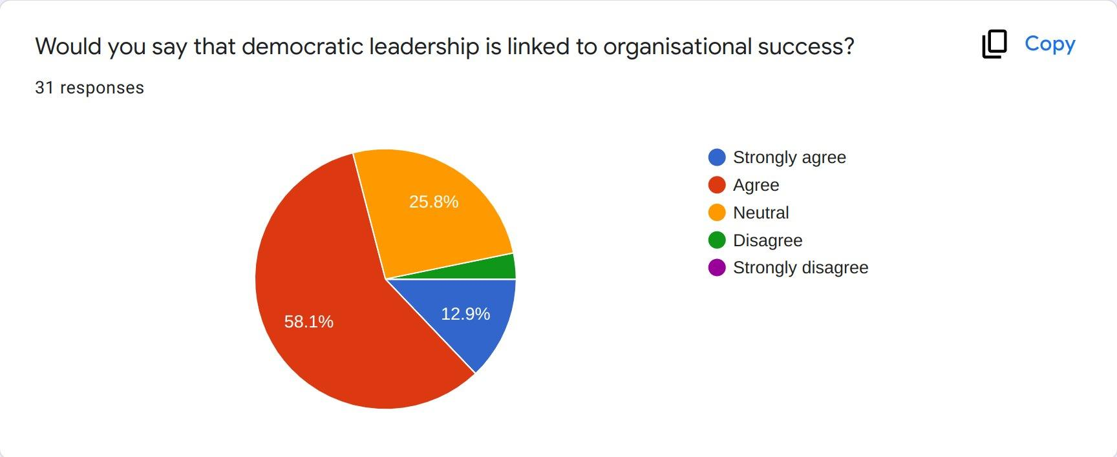
The majority of respondents (58.1% Agree and another 12.9% Strongly agree) placed democratic leadership among the styles that would lead to organisational success the most (Questions 7 above). These results correspond to the findings of Hackman and Johnson (1996), who have observed that democratic leadership encourages employees to take part in the company's decision-making processes, and is related to higher staff productivity, increased employee satisfaction, and raised involvement among staff members.

Question 8: Would you say that visionary leadership is linked to organisational success?
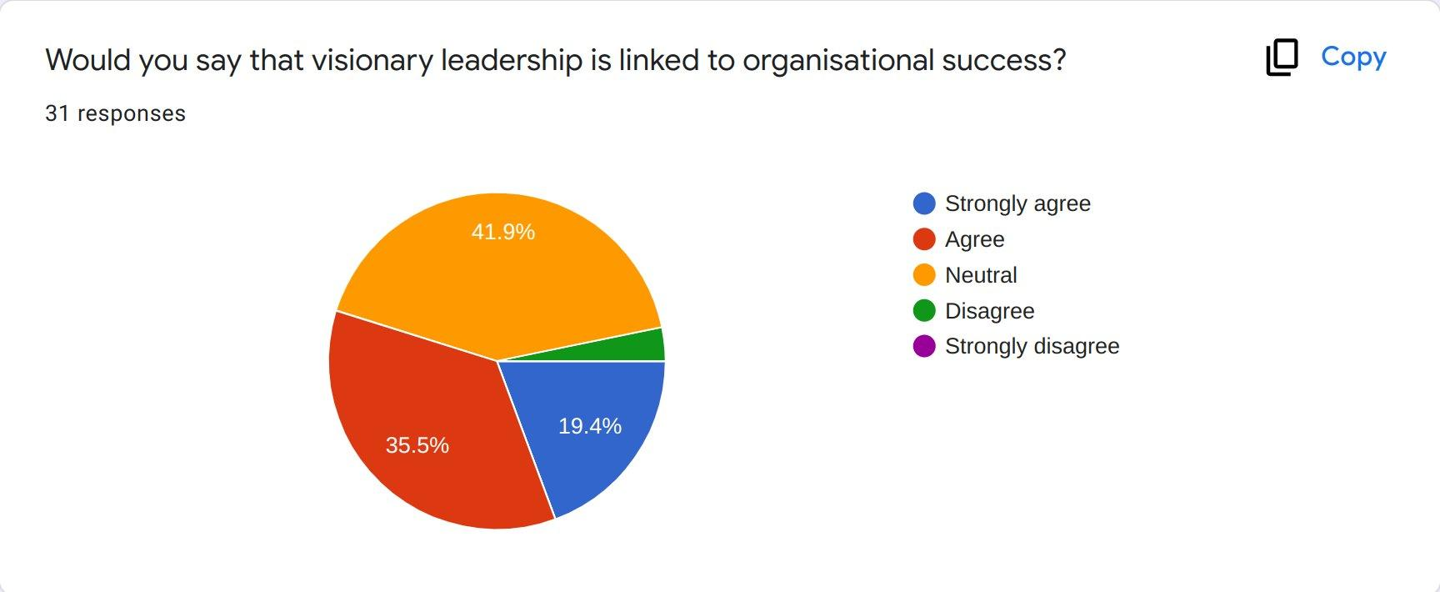
Just over half of the respondents (35.5% Agree; 19.4% Strongly agree) stated that visionary leadership style is among the styles that would lead to organisational success (Question 8 above). However the other half remained neutral (41.9%) meaning that they might not have understood the question or are unsure of the answer. Nevertheless, the answer to this question further supports the findings by other researchers in the field, such as Sashkin and Sashkin (2002) and Heath and Heath (2010).

Question 9: Would you say that bureaucratic leadership is linked to organisational success?
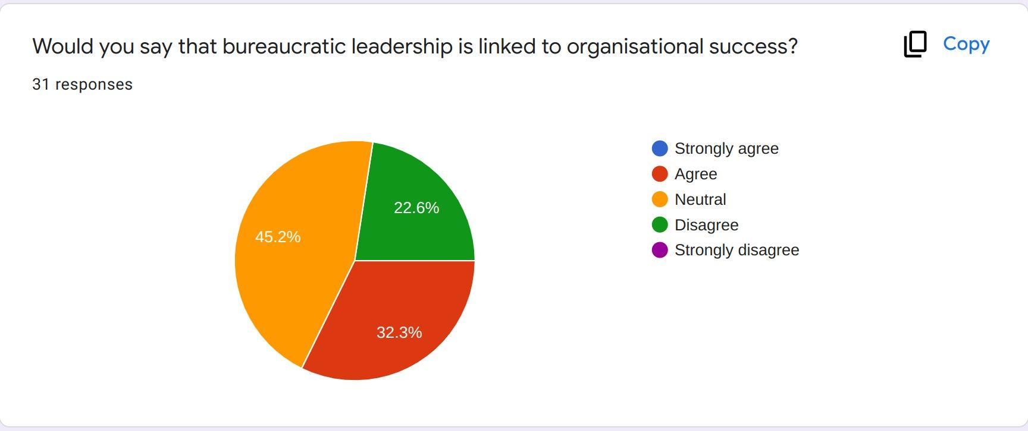
When asked about the link between bureaucratic leadership style and organisational success, nearly half of the participants in the survey remained neutral (45.2%). A third (32.3%) stated they believe it leads to organisational success, but another 22.6% think this style would not lead to organisational success. When cross-referencing this question with the available literature on the topic, it becomes evident that this type of style is indeed related to a diminished creativity and motivation among staff members (Sapre, 2000; Langer, et al, 2019).

Question 10: Would you say that laissez-faire leadership is linked to organisational success?
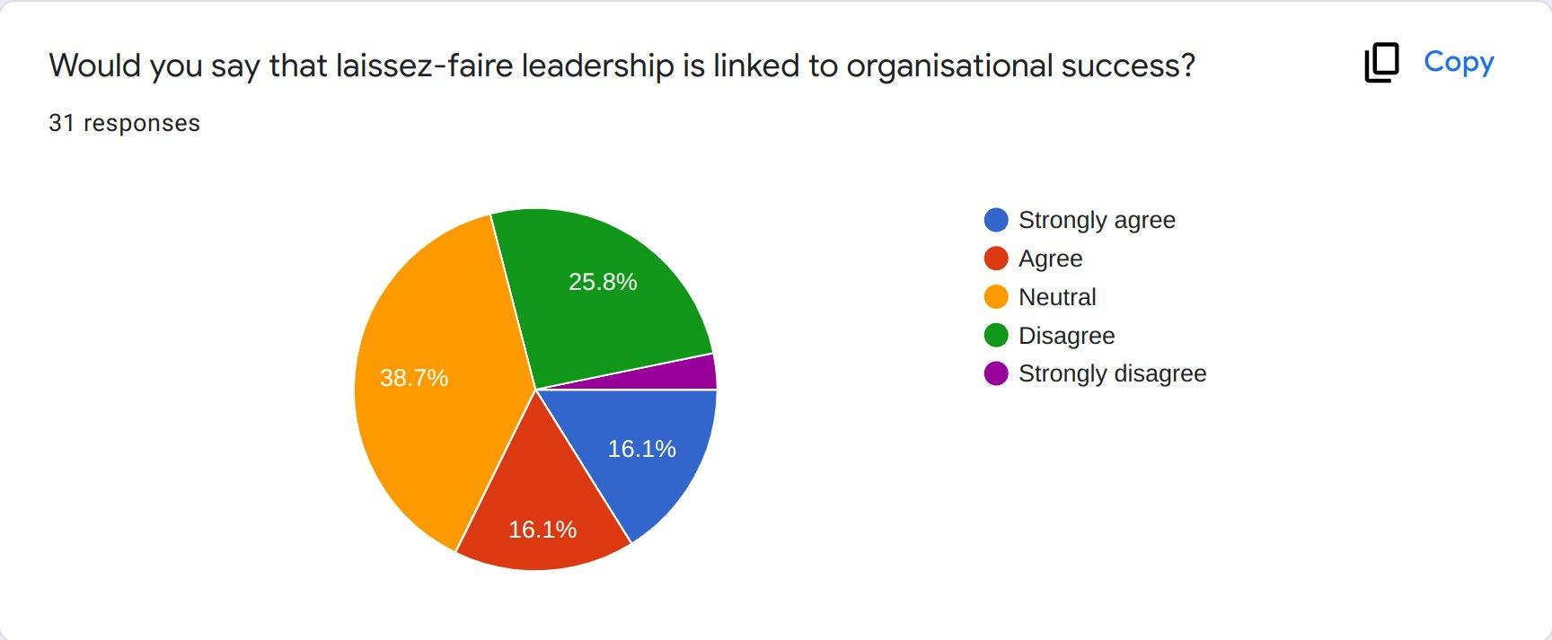
In question 10, the respondents placed the laissez-faire leadership style among the least successful, compared to the rest of the styles in question. Nearly a third stated they agree or strongly agree (16.1% and 16.1% respectively), whereas a quarter of them (25.8%) said they disagree. Having a high percentage of neutral responses (38.7%) may reveal that the participants were either unaware of this type of leadership style, or unsure of the correct answer. Nevertheless, the negative aspects of this type of leadership have been proven by other scholars like Bass and Avolio (1990), Skogstad et al. (2007), and Einarsen et al. (2007), who postulate that the laissez-faire style of leadership falls in violation with the interests of the company and its employees, undermines organisational vision and objectives, and threatens the well-being of the workforce.

Question 11: Which leadership styles do you believe would lead to organisational success? (thick as many as you wish).
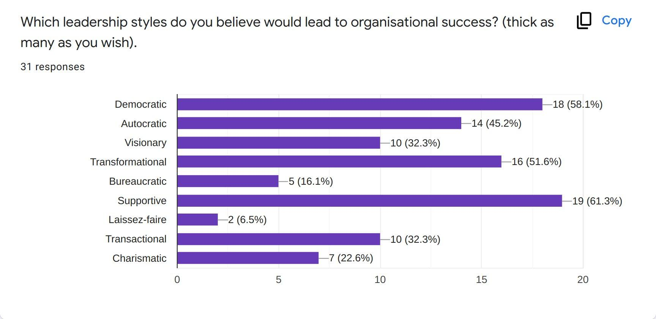
Question 11 which was designed in order to gather the respondents' opinions about the most beneficial leadership style when it comes to organisational success. The majority of the respondents chose the following 3 leadership styles in that matter: Supportive at 61.3%; Democratic at 58.1%; and Transformational at 51.6%. A third of the respondents (32.3%) also stated Transactional and Visionary leadership styles in that category. This does not come as a surprise provided the findings of this research and the available literature on the topic (Rafferty and Griffin, 2004; Kahn and Byosiere, 1992)

Question 12: Which leadership styles do you believe would lead to organisational failure? (please tick as many as you wish).
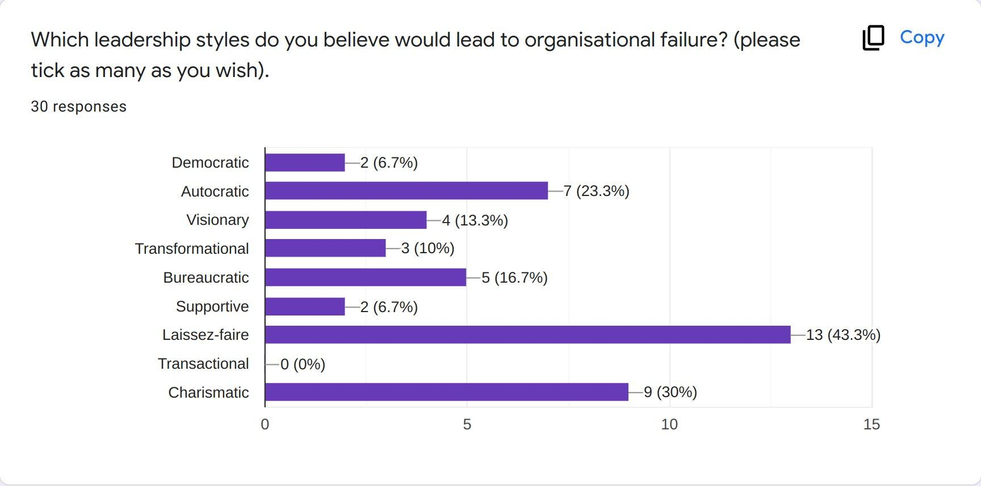
When asked which leadership styles they believe would lead to organisational failure, most of the respondents (43.3%) gave Laissez-faire style as an answer, followed by Charismatic leadership at 30%, and Autocratic at 23.3% (Question 12 above). When comparing the results to the available literature it becomes evident that the answers to this question correspond closely with the findings of other researchers of the leadership subject, such as Burke et al., (2006), Gonos and Gallo (2013), Bass and Avolio (1990), and Germano (2010), all of whom argue that these leadership styles can have a negative organisational impact in the long run.

Question 13: What is the preferred leadership style in the company you are currently working for?
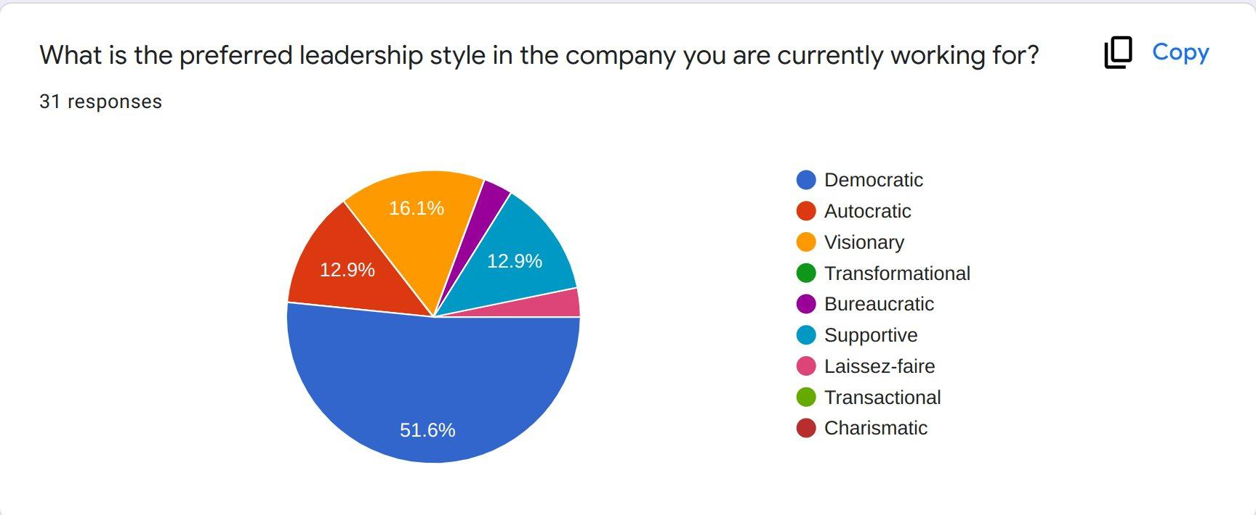
The last 3 questions from the survey were destined to capture the most preferred leadership style in the company the respondents were working for at the time of filling out the questionnaire, as well as the associated benefits and drawbacks of those styles. In terms of the most common leadership style used in companies, over half of the respondents (51.6%) answered Democratic, followed by Visionary (16.1%), Autocratic (12.9%) and Supportive (12.9%) (Question 13 above).

Question 14: What are the biggest benefits of working under this leadership style? (please tick as many as you wish).
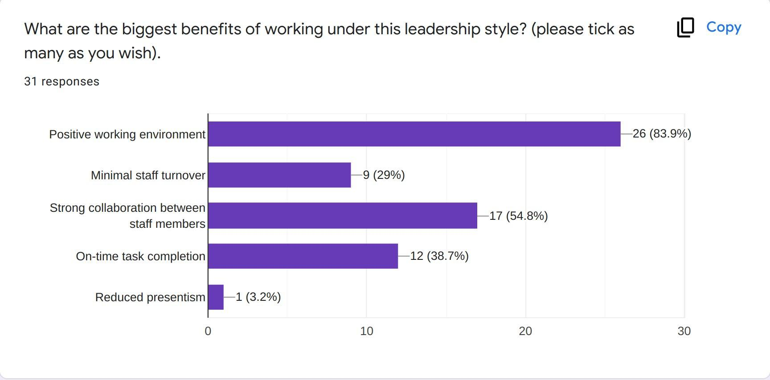
In terms of the biggest benefits of working under the above mentioned leadership styles (Question 13), the majority of the respondents provided a positive working environment (83.9%), strong collaboration between staff members (54.8%), and On-time task completion (38.7%) as top 3 benefits (Question 14 above). Once again, these answers align with the findings of the secondary research of this paper (Hasan Al Khajeh, 2018; Bass and Riggio, 2006; Avolio et al., 1999; Judge and Piccolo, 2004)

Question 15: What are the biggest drawbacks of working under this leadership style? (please tick as many as you wish).
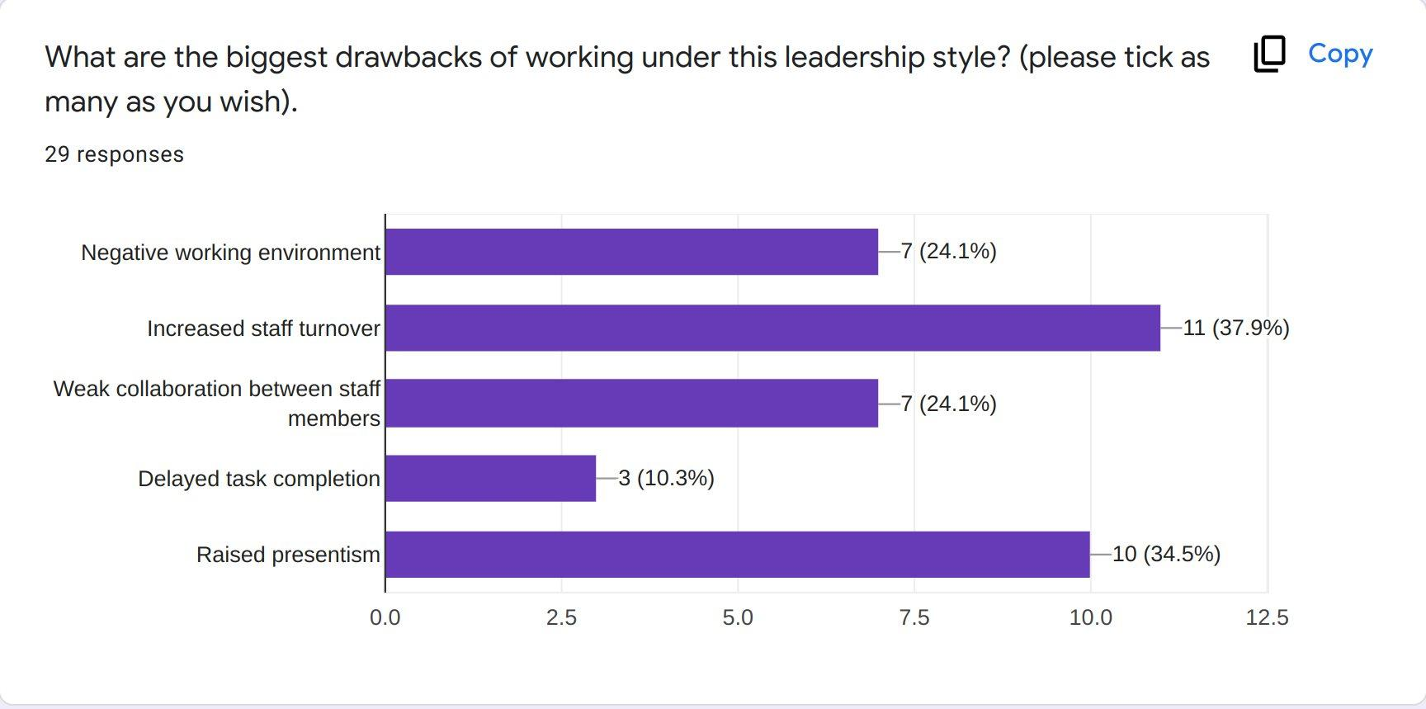
As to the drawbacks, a third of the participants in the survey gave increased staff turnover (37.9%) and raised presentism (34.5%) as answers (Question 15 above). These primary findings are further supported by scholars, such as Hasan Al Khajeh (2018), Burke et al. (2006), Sapre (2000), and Einarsen et al. (2007).

Chapter 5. Conclusion, Recommendations and Reflection

5.1. Conclusion
In order for any given organisation to be competitive, profitable and successful within the complex business environment of the UK, it must make sure it creates a favourable working environment and implements the right business strategies and operational processes in place. In order for that to happen, management needs to adopt adequate leadership styles that are in line with the company’s main objectives and goals.
An evaluation of the available literature on the topic reveals that the use of effective leadership styles can positively impact the processes within the organisation and can contribute significantly towards organisational success. This applies to all sorts of organisations within the UK, regardless of the size and sector the business operates in. Furthermore, according to the literature review, many UK companies seem to be underestimating the importance of leadership styles, many of which even do not realise it.
Among the most favourable leadership styles a company can implement are democratic, visionary, transformational, supportive, and charismatic styles. Depending on the circumstances, the implementation of more than one of these styles might be needed. Nevertheless, it is the responsibility of the management to decide on the best leadership style or mixture of several styles to be used, in order to create a favourable working environment and to secure the future success of the organisation.

5.2. Recommendations
Based on the primary and secondary data findings, the research can provide several recommendations on the most appropriate leadership styles that a company can adopt in order to be prosperous, as well as suggestions on how top management can tackle the associated challenges that may arise during the implementation of a particular leadership style. Business organisations have a broad range of leadership styles to choose from, such as autocratic, democratic, visionary, bureaucratic, transformational, transactional, supportive, laissez-faire, and charismatic. As seen from the findings however, leaders should be cautious when choosing the type of style they want to implement, as some of these leadership styles have been shown to lead to an organisational decline.
For example, autocratic, bureaucratic, charismatic, and laissez-faire leadership styles are among the least favourable, whereas leadership styles, such as visionary, transformational, and supportive have been linked to a positive working environment and potential company success in the long run. Leaders should also be aware that different leadership styles could prove beneficial in different situations or business stages, meaning that they need to adopt a flexible approach and review the current leadership process in the organisation on a regular basis. A mixture of two or more leadership styles is also encouraged should the circumstances require it.
Furthermore, it is highly recommended that leaders listen to their subordinates and provide a positive working environment where employees feel respected, cherished and supported. To be successful, leaders should give regular feedback and be open to receiving feedback from their subordinates in return. Intercompany issues should be addressed in a timely manner and the necessary changes must be made according to the circumstances. According to the findings of this research, the best leaders are those who inspire their followers, look for innovative solutions, provide support to their subordinates, solve problems together with staff members, and work together with their followers towards achieving the company’s goals, thus leading to organisational growth, profitability, and success.

5.3. Reflection
The overall experience related to the production of this dissertation was positive and highly beneficial to my future professional progression. From the very beginning up until the last days prior to submitting the final version I had full support from my supervisor who was guiding me along the process. The successful and on-time delivery of the paper was mainly due to the fact that I had a clear vision of the dissertation structure, created a detailed plan prior to starting the research and followed the plan strictly. The majority of stages went well and I did not encounter any serious obstacles. I had the chance to implement many academic skills that I have acquired during my time at the university, including academic writing, research, time-management, critical thinking, SMART planning, and communication.
In terms of negative experience, I would mention several aspects. Firstly, when I started the secondary research, I was a bit overwhelmed with the vast pool of information on the topic of leadership. I had to use my research and critical thinking skills to the greatest extent, in order to narrow down the available literature and choose the most appropriate studies. Perhaps if I have to do it all over again, I would allocate more time on this stage. Secondly, I encountered some challenges during the collection of the primary data, and more precisely - the data gathering took slightly longer than I was expecting. I have also realised that survey respondents are more likely to complete a survey which contains only multiple-choice questions, and no open-ended ones. Once again, for any similar research in the future, I would allocate more time on this phase and will try to distribute the questionnaire to a larger group of potential respondents.

References
Akor, P. U. (2014). Influence of autocratic leadership style on the job performance of academic librarians in Benue State. Journal of Educational and Social Research, 4(7), pp. 148-152.

Avolio, B.J., Bass, B.M. and Jung, D.I. (1999). Re-examining the components of transformational and transactional leadership using the Multifactor Leadership Questionnaire. Journal of Occupational and Organizational Psychology; 72, pp. 441-462.

Barbuto, J. and Burbach, M. (2006). The emotional intelligence of transformational leaders: a field study of elected officials. Journal of Social Psychology 146 (1), pp. 51-64.

Bass, B. M. (1990). Bass and Stogdill’s handbook of leadership: Theory, research & managerial applications (3rd edition). New York: Free Press.

Bass, B. M. and Avolio, B. J. (1990). Transformational leadership development: Manual for the multifactor leadership questionnaire. Palo Alto, CA: Consulting Psychologists Press.

Bass, B.M. and Avolio, B.J. (1994). Improving Organizational Effectiveness: through Transformational Leadership, Thousand Oaks: Sage Publications Inc.

Bass, B.M. and Riggio, R.E. (2006). Transformational Leadership (2nd edition), London: Lawrence Erlbaum Associates Publishers.

Berg, B. L., Lune, H., and Lune, H. (2004). Qualitative research methods for the social sciences (Vol. 5). Boston, MA: Pearson.

BIS (2012). LEADERSHIP & MANAGEMENT IN THE UK - THE KEY TO SUSTAINABLE GROWTH [Online], Available at: https://assets.publishing.service.gov.uk/government/uploads/system/uploads/attachment_data/file/32327/12-923-leadership-management-key-to-sustainable-growth-evidence.pdf [Accessed on: 21 March 2022].

Burke, C. S., Stagl, K. C., Klein, C., Goodwin, G. F., Salas, E. and Halpin, S. M. (2006). What type of leadership behaviors are functional in teams? A meta analysis. The Leadership Quarterly, 17 (3), pp. 288-307.

CMA (2020). The State of UK Competition [Online], Available at: https://assets.publishing.service.gov.uk/government/uploads/system/uploads/attachment_data/file/939636/State_of_Competition_Report_Nov_2020_Final.pdf [Accessed on: 05 January 2022].

Conger, M. (2002). Leadership learning to share the vision. Organizational Dynamics 19 (3), pp. 45-52.

De Hoogh, A.H.B., D.N. den Hartog, P.L. Koopman, H. Thiery, P.T. van den Berg, J.G. van derWeide, and C.P.M. Wilderon. (2004). Charismatic leadership, environmental dynamism, and performance. European Journal of Work and Organizational Psychology 13(4), pp. 447-71.

Denhardt, J. V. and Denhardt, R. B. (2003). The new public service: Serving, not steering. Armonk, NY: M. E. Sharpe.

Einarsen, S., Aasland, M. S., and Skogstad, A. (2007). Destructive leadership behaviour: A definition and conceptual model. The Leadership Quarterly, Vol.18(3), pp. 207-216.

Euwema, M. C., Wendt, H., and Van Emmerik, H. (2007). Leadership styles and group organizational citizenship behavior across cultures. Journal of Organizational Behavior, 28, pp. 1035-1057.

Gastil, J. (1994). A definition and illustration of democratic leadership. Human Relations, 47, pp. 954-971.

Geraldi, J. and Lechter, T. (2012). Gantt charts revisited: A critical analysis of its roots and implications to the management of projects today. International Journal of Managing Projects in Business. 5(4).

Gonos, J. and Gallo, P. (2013). Model for leadership style evaluation. Management,18(2), pp. 157- 168.

Gorard, S. (2013). Research Design. Creating Robust Approaches for the Social Sciences. Durham University, UK: SAGE Publications Ltd.

Guest, D.E., Michie, J., Conway, N. and Sheehan, M. (2003) Human resource management and corporate performance in the UK. British journal of industrial relations 41(2), pp.291-314.

Gumusluoglu, L. and Ilsev, A. (2009). Transformational leadership, creativity, and organisational innovation. Journal of Business Research, 62 (4), pp. 461-473.

Hackman, M. Z. and Johnson, C. E. (1996). Leadership: A communication perspective (2nd edition). Prospect Heights, IL: Waveland Press.

Hasan Al Khajeh, E. (2018). Impact of Leadership Styles on Organizational Performance. Journal of Human Resources Management Research, pp. 2166-0018.

Hayward, Q., Goss, M. and Tolmay, R. (2004). The relationship between transformational and transactional leadership and employee commitment. Grahamstown: Rhodes University Business Report.

Heath, C. and Heath, D. (2010), Switch: How to Change Things When Change is Hard. New York, NY: Crown Publishing Group.

Hersey, P., Blanchard, K. and Johnson, D. (2008). Management of Organizational Behavior: Leading Human Resources (9th edition). Upper Saddle River, NJ: Pearson Education.

House, J. S. (1981). Work stress and social support. Reading, MA: Addison-Wesley Publishing.

Hoy, W. K. and Sweetland, S. R. (2001). Designing better schools: the meaning and measure of enabling school structures. Educational Administration Quarterly, 37(3), pp. 296-321.

Judge, T.A. and Piccolo, R.F. (2004). Transformational and transactional leadership: a meta-analytic test of their relative validity. Journal of Applied Psychology; 89(5), pp. 755-768.

Kahn, R. L. and Byosiere, P. B. (1992). Stress in organizations. In M. D. Dunnette, & L. M. Hugh (Eds.), Handbook of Industrial and Organizational Psychology, pp. 571-650. Palo Alto, CA: Consulting Psychologists Press.

Langer, J., Feenay, M.K., and Lee, S.E. (2019). Employee Fit and Job Satisfaction in Bureaucratic and Entrepreneurial Work Environments. Review of Public Personnel Administration, 39(1), pp. 135-155.

Longe, O. J. (2014). Leadership style paradigm shift and organisational performance: A case of the Nigerian Cement Industry. African Research Review, 8(4), pp. 68-83.

Nanjundeswaraswamy, D. R. and Swamy, D. R. (2014). Leadership styles. Advances In Management [Online], Available at: https://www.researchgate.net/publication/272509462_Leadership_styles [Accessed on: 04 January 2022].

Northouse, P. G. (2015). Leadership: Theory and practice. Thousand Oaks, CA: Sage publications.

Ojokuku, R. M., Odetayo, T. A. and Sajuyigbe, A. S. (2012). Impact of leadership style on organizational performance: a case study of Nigerian banks. American Journal of Business and Management, 1(4), pp. 202-207.

Para-González, L., Jimenez-Jimenez, D., and Martínez-Lorente, Á.R. (2018). Exploring the mediating effects between transformational leadership and organizational performance. Employee Relations: International Journal.

Patten, M.L. and Newhart, M. (2017). Understanding research methods: An overview of the essentials. Routledge.

Rafferty, A. E. and Griffin, M. A. (2004). Dimensions of transformational leadership: Conceptual and empirical extensions. Leadership Quarterly, 15, pp. 329-354.

Sapre, P. M. (2000). Realizing the potential of management and leadership: toward a synthesis of Western and indigenous perspectives in the modernization of non-Western societies. International Journal of Leadership in Education, 3(3), pp. 293-305.

Sashkin, M. and Sashkin, M.G. (2002), Leadership that Matters: The Critical Factors for Makinga Difference in People’s Lives and Organization’s Success. San Francisco, CA: Berrett-Koehler Publishers Inc..

Shaw, J. B., Erickson, A., and Harvey, M. (2011). A method for measuring destructive leadership and identifying types of destructive leaders in organizations. The Leadership Quarterly, 22(4), pp. 575-590.

Skogstad, A., Einarsen, S., Torsheim, T., Aasland, M. S., and Hetland, H. (2007). The destructiveness of laissez-faire leadership behavior. Journal of Occupational Health Psychology, Vol.12(1), pp. 80-92.

Taherdoost, H. (2016). Sampling Methods in Research Methodology; How to Choose a Sampling Technique for Research. International Journal of Academic Research in Management. 5, pp. 18-27.

The Global City (2022). Reach out and grab success [Online], Available at: https://www.theglobalcity.uk/the-uk-offer/business-environment [Accessed on: 05 January 2022].

Trottier, T., Van Wart, M., and Wang, X. (2008). Examining the nature and significance of leadership in government organizations. Public Administration Review; 68(2), pp. 319-333.

Vigoda-Gadot, E. (2007). Leadership style, organisational politics, and employees' performance: An empirical examination of two competing models. Personnel Review, 36 (5), pp. 661-683.

Vincent-Höper, S., Muser, C., and Janneck, M. (2012). Transformational leadership, work engagement, and occupational success. Career Development International; 17, pp. 663-682.

Weiner, B. J. (2009). A theory of organizational readiness for change. Implementation Science, 4(1), p. 1.

Westley, F. and Mintzberg, H. (1989). Visionary leadership and strategic management. Strategic Management Journal, 10, pp. 17-32.

Yukl, G. (2008). How leaders influence organisational effectiveness. The Leadership Quarterly, 19 (6), pp. 708-722.

Zhu, W., Chew, I.K.H. and Spangler, W.D. (2005). CEO transformational leadership andorganizational outcomes: the mediating role of human-capital-enhancing human resourcemanagement. The Leadership Quarterly, Vol. 16(1), pp. 39-52.

Chapter 7. Appendices

Appendix 1. Survey questions
Question 1
What is your gender?
- Female
- Male
- Other
- Prefer not to say

Question 2
What is your age?
- 18 - 24
- 25 - 34
- 35 - 44
- 45 - 54
- 55 and over

Question 3
Which one best describes your current occupation?
- Employed full-time or part time
- Business owner
- Self-employed
- Other
- Prefer not to say

Question 4
Please choose the most appropriate answer according to your personal opinion
- A leader is someone who knows how things at work can be improved
- Leaders work towards making company’s vision a reality
- Leaders have to be empathetic and able to connect with employees
- Leaders need to motivate employees and put them first
- All of the above

Question 5
Would you say that company leaders play an important role in organisational success
- Strongly agree
- Agree
- Neutral
- Disagree
- Strongly disagree

Question 6
Do you believe that different leadership styles lead to different organisational outcomes?
- Strongly agree
- Agree
- Neutral
- Disagree
- Strongly disagree

Question 7
Would you say that democratic leadership is linked to organisational success?
- Strongly agree
- Agree
- Neutral
- Disagree
- Strongly disagree

Question 8
Would you say that visionary leadership is linked to organisational success?
- Strongly agree
- Agree
- Neutral
- Disagree
- Strongly disagree

Question 9
Would you say that bureaucratic leadership is linked to organisational success?
- Strongly agree
- Agree
- Neutral
- Disagree
- Strongly disagree

Question 10
Would you say that laissez-faire leadership is linked to organisational success?
- Strongly agree
- Agree
- Neutral
- Disagree
- Strongly disagree

Question 11
Which leadership styles do you believe would lead to organisational success? (thick as many as you wish).
- Democratic
- Autocratic
- Visionary
- Transformational
- Bureaucratic
- Supportive
- Laissez-faire
- Transactional
- Charismatic

Question 12
Which leadership styles do you believe would lead to organisational failure? (please tick as many as you wish).
- Democratic
- Autocratic
- Visionary
- Transformational
- Bureaucratic
- Supportive
- Laissez-faire
- Transactional
- Charismatic

Question 13
What is the preferred leadership style in the company you are currently working for?
- Democratic
- Autocratic
- Visionary
- Transformational
- Bureaucratic
- Supportive
- Laissez-faire
- Transactional
- Charismatic

Question 14
What are the biggest benefits of working under this leadership style? (please tick as many as you wish).
- Positive working environment
- Minimal staff turnover
- Strong collaboration between staff members
- On-time task completion
- Reduced presentism

Question 15
What are the biggest drawbacks of working under this leadership style? (please tick as many as you wish).
- Negative working environment
- Increased staff turnover
- Weak collaboration between staff members
- Delayed task completion
- Raised presentism

