Title page should have the following details:

Name: Stefan-Bogdan Panaite

Student ID: 2537232

Module Name: Effective Teamworking and Communication(LCLM4003)

Lecturer’s Name: Ibrahim Rufai

Following are the characters in the video that you must watch before attempting to answer the questions. These characters are a team of students working on a project.

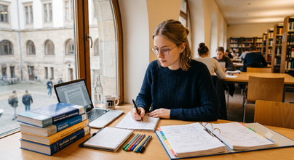 | Lena, a hardworking undergraduate from Germany, approaches her studies with detailed-oriented care and a consistent dedication to quality. Driven by a preference for precision and a reliance on empirical evidence, she consistently delivers exceptionally researched and thoroughly documented work.
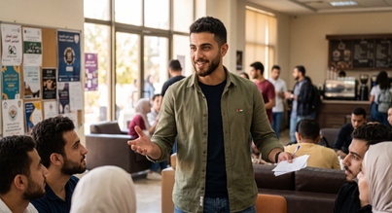 | Omar, an undergraduate student from Jordan whose confidence and persuasive charisma naturally draw others to him. With a natural ability to make quick decisions and a genuine talent for motivating those around him.
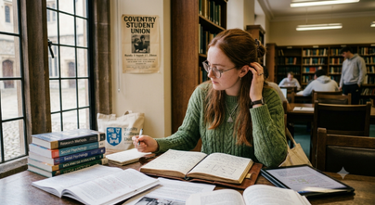 | Hannah, an undergraduate student from Ireland, whose calm manner and sharp intellect are instantly recognisable. Bringing her thoughtful, detail-oriented approach to everything she does, Hannah is a researcher through and through, thriving on evidence and considered evaluation.
 | Kenji, a Japanese undergraduate student known for his calmness, reliability, and strong sense of community. Always prioritising group harmony, Kenji always offers supportive guidance on group projects.
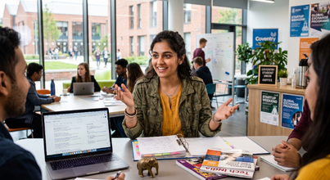 | Priya, an undergraduate student from India whose vibrant energy and dynamic resourcefulness are instantly recognisable. Bringing her unique blend of passion and practicality to the academic world, Priya is a natural networker and problem-solver.
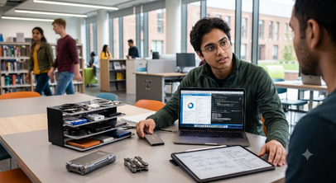 | Alex, a computer science major from Canada. Analytical, tech-savvy, and deeply practical, he approaches every academic challenge with a systematic mindset, always finding ways to streamline work using digital tools. He prefers to organise data for projects and fine-tuning workflows.

Watch the video and then answer the following ten questions within the spaces provided. Each question carries an equal mark. Each answer should be a minimum of 100 words and a maximum of 150 words. Please note that the questions are grouped by topics, instead of following the timeline. You need to watch the whole video before answering the questions. Please make sure that you provide citations and references for all the relevant concepts you use in answering the questions.

Question 1
Explain what teamwork is, give examples from the video.
I believe that in my team we have different people with different abilities; that's why it's teamwork. For instance, Priya is very friendly, talkative and lively. Alex is an effective organiser and analyst. Omar is sure, encouraging the team to make decisions. Hannah is careful and pays attention to details. Kenji is dependable and team-orientated, contributing to effective teamwork. Each member is unique in personality and skills, complementing other members. Some of them bring energy and ideas and others bring motivation, organisation and attention to details. In my opinion a team like them can achieve all the goals without errors.

Question 2
Omar states that the team has been debating for two hours; the team members look worried. Lena intervenes and argues; Omar intervenes again. Hannah looks troubled. (timestamp: 2:00 – 2:56). Identify which of Tuckman's stages of team development this part of the video represents.
I believe that this part is the "Storming" stage of Tuckman's team development model. There appears to be disagreement and tension within the team because team members are divided on the next steps. Omar is trying to make a decision quickly, but Lena is worried about having the required evidence and meeting the assessment requirements. They are not going toward a consensus, but they are posing questions to each other about their ideas. The team members' worried and troubled expressions, including Hannah's, also indicate that there is some tension in the team caused by the disagreement. This is a common problem at the Storming stage when team members have different priorities, communicate quite a bit and are having difficulty finding common ground. This team is not yet at the corporation and understanding stage like that of a Norming stage.

Question 3
Identify & explain which Tuckman's Stages of Team Development is the team in during the last 2 minutes of the video (timestamp 4:00 – 5:58).
In my opinion it represents the performing stage of Tuckman’s team development model. Team working is good, and responsibilities are understood.
Omar asks Lena to look over his work, and she agrees to do so and make the final edits. Hannah has finished the market analysis, and Priya has been looking for more case studies to add to the team's research. They are communicating and supporting one another instead of disagreeing on how to proceed. The team is also organised with their group log up to date, their Trello board set up and digital tools up to date. They have specific tasks to do, and they are all moving towards the same thing – completing the campaign and submission. In general, the team demonstrates good communication, cooperation, trust and productivity, essential elements of the performing stage.

Question 4
Explain what group decision-making is, and provide a relevant example from the video.
Group decision-making occurs when team members brainstorm various ideas, share information and reach consensus on the optimal solution. Instead of a single decision-maker, the team can collaborate on providing their knowledge and opinions before making a final decision. This can help to make better decisions since different viewpoints are taken into account.
For instance, in the video, when they were talking about their campaign strategy and the audience they would be targeting. Interviewing the client, Hannah fills in the market analysis and evaluation matrix, which gives evidence on the behaviour of the target audience. Then Priya locates two recent case studies from other external digital agencies to back up the findings by Hannah. The team makes use of this information to ensure the campaign approach is suitable. This demonstrates group decision-making as the final direction is based on information and contributions from a number of team members, not on one person's opinion.

Question 5
Explain what Nominal Technique is, provide an example from the video.
A technique for decision-making that involves members of the group thinking about ideas themselves first and then bringing the ideas to the group. All get a chance to add their input, and so no one can take over the conversation. Once everyone has contributed their ideas, the team may compare, discuss and evaluate their ideas before determining their best opinion.

A good example from the video is the team members giving their ideas and information in deciding the campaign strategy. Hanahh presented her matrix for market analysis and evaluation, and Priya did so with examples from the latest external agencies. The team next discussed the various suggestions, and based on the information they had, decided what should be done. This demonstrates the nominal technique, as it involves each member of a team contributing their ideas and knowledge prior to making a decision as a team.

Question 6
What (Thomas-Kilmann model) conflict mode does Priya use when she states "We do not have to choose between being brilliant or being thorough.", and she supports Omar’s framework while giving Lena 48 hours to verify the data? (timestamp 3:20 – 3:36)
According to the Thomas-Kilmann model, Priya employed a 'collaborating' conflict mode. This is because she always attempts to find one solution which takes into account all the ideas rather than one person's view over another. Priya tells the team in the video that they don't need to go with either being brilliant or being thorough, indicating that she would like the team to have both factors. She agrees with Omar's plan, and she also allows Lena 48 hours to check the data. This demonstrates that Priya is willing to hear both sides of the issue and come up with a solution that benefits everyone on the team. Rather than bring about further conflict, she supports the team to work together and to make a better decision that is based on creativity and accurate information.
Therefore, her approach is the best described as collaborating.

Question 7
When the debate between Omar and Lena peaks, Hannah responds by "shrinking back slightly in her chair" and softly trailing off as she is spoken over. Using the Thomas-Kilmann Conflict Mode, identify and describe Hannah's conflict mode in this scene. (timestamp 2:00 - 2:45)
Hannah is using the avoiding conflict mode from the Thomas-Kilmann model. In this scene, Hannah does not get involved in the argument between Omar and Lena. If the discussion gets more serious, she reacts by stepping back a bit in the chair and trails off when she's cut off. This is due to the fact that she is not at ease with the conflict and that she does not argue with the others nor does she pursue her opinion further. Rather than attempt to resolve the issue or defend her own point of view, Hannah pulls out of the situation. Her behaviour implies she does not want to escalate/foil the conflict. Sometimes it can be helpful to avoid it in order to relieve tension in the short term, but it can also be the case that ideas or opinions are not heard. Thus, Hannah's response to the situation in this scene can best be characterised as 'avoiding'.

Question 8
Identify which Belbin roles Alex and Priya might be demonstrating (e.g., Plant, Implementer, Coordinator, Specialist, Monitor Evaluator, etc.) and explain them with relevant examples from the video.
Alex demonstrates the traits of the implementer by helping the team complete their work. For example, he sets up the digital tracking system to keep tasks organised and make sure the team stays on schedule.
Priya is a teamworker, as she listens to other people's opinions and helps the team make a decision. A compromise is proposed, such as beginning the campaign quickly and providing proof for it. She offers to start the creative process but gives the team 48 hours to find information to support their process. I'm sure both are very important for me as I think Alex maintains the team, and Priya helps the team to work together and to solve problems as well.

Question 9
Identify which Belbin roles Omar and Lena might be demonstrating (e.g., Plant, Implementer, Coordinator, Specialist, Monitor Evaluator, etc.) and explain them with relevant examples from the video.
Omar shows the role of a plant by using his imagination. One example of this would be a cutting edge digital campaign that incorporates interactive features and AI personalisation. He wants the project to be different and stand out.
Lena exemplifies the monitor evaluator role of critically reviewing ideas and paying attention to facts and evidence. For instance, she says the campaign should be done according to the handbook of the module, and creative decisions should be based on academic evidence. He wants to ensure that the team has a good output of quality work.
Both of them are necessary, I think, because Omar is able to come up with ideas, and Lena is able to make sure that those ideas are feasible and have evidence to back them up. Working together, they can help the team develop a successful campaign.

Question 10
After watching the video, decide which Belbin role you would naturally take in this team and why would you take that role?
I believe I would go for teamworker, as that is a role I enjoy, and I like to work as a team. I would hear everyone's ideas and respect everyone's opinion. In case of disagreement, I would attempt to resolve the issue and arrive at a solution for the team. I think ethereal communication and cooperation are essential to being successful. I would help my teammates when they need help. I believe this position would be a perfect fit for me, as I want to make everyone feel part of something and want to get people together to work for the same objective.

References list

Belbin Team Roles (n.d.). Found at https://www.belbin.com/about/belbin-team-roles
Belbin (n.d.), Social, thinking and action.
The Thinking Social Action file is available at https://www.belbin.com/resources/articles-directory/thinking-social-action.

Principles of Management: Team Development Over Time. (n.d.). Retrieved from OpenStax. The materials are available at https://openstax.org/books/principles-management/pages/15-2-team-development-over-time.

