

Strategic Management (LCMB7003)

Strategic Analysis of DELL


Student name: Meetkumar Jayeshbhai Patel
Student Number: 2210109
Lecturer: Hossein Shokri / Dr. Gladius Kulothungan
Submission Date: 8 September, 2023

Table of Contents
Introduction 2
Background 3
Mission and Objectives 3
Macro-Environment Analysis 4
PESTEL Analysis 5
Micro-Environment Analysis 6
Industry Life Cycle 7
Porter’s Industry Five Forces Analysis 9
Internal Analysis 10
Strategic Resources and Capabilities 10
Value Chain Analysis 11
Primary Activities 12
Secondary Activities 13
VRIO Analysis of Distinctive Resources and Capabilities 14
SWOT Analysis 16
Strategies to Sustain Competitive Advantage 18
Growth Strategies 20
Green Strategy and CSR 22
Recommendations 23
Conclusion 24
References 25

Introduction
In the dynamic and competitive business environment of today, effective strategic management is crucial for organisations pursuing long-term success. Globally renowned technology company Dell Inc. serves as a dazzling example of strategic acumen. This report examines Dell's strategic management practises in great detail, revealing the key factors that have propelled the company to the vanguard of the technology industry.
Innovation and customer-centricity comprise the foundation of Dell's strategic management approach. Dell has been able to create a portfolio of products and services that appeal to both consumers and businesses thanks to its meticulous market analysis and understanding of customer requirements. The report will investigate how Dell's innovative direct-to-consumer business model has enabled the company to strengthen customer relationships, streamline supply chains, and maintain cost efficiency.
In addition, the report will illuminate Dell's strategic adaptability and versatility. Dell has demonstrated the ability to adapt as technology evolves, embracing new trends and technologies while remaining faithful to its core competencies. Through an analysis of Dell's strategic decision-making processes, resource allocation, and long-term vision, this report will provide valuable insights into how Dell has navigated obstacles and capitalised on opportunities. Understanding Dell's strategic management practises will not only provide valuable lessons for businesses in the technology industry, but will also inspire businesses across all sectors to improve their strategic acumen and achieve sustainable development.

Background
Michael Dell founded Dell PLC in 1984, and the company has since become a dominant participant in the global technology market. Dell's ascent to prominence is attributable to its innovative direct-to-consumer business model. The company's headquarters are located in Round Rock, Texas, United States. Customers were able to customise and purchase computers and technology products directly from Dell, bypassing traditional distribution channels. Over the years, Dell's strategic vision and customer-centric focus have driven its expansion into multiple technology segments, allowing it to offer a diverse portfolio of products, solutions, and services to meet the requirements of consumers, businesses, and enterprises worldwide.
Dell reported outstanding financial results for its fiscal year 2023, demonstrating its market significance. With total revenues of $102.3 billion and a net income of $5.56 billion (Statista, 2023a), the company demonstrated its robust financial performance in the intensely competitive technology industry. This financial prowess is evidence of Dell's strong market presence and strategic ability to navigate the industry's complexities.
The workforce at Dell plays a crucial position in the company's operations, and as of 2023, the company has approximately 133,000 employees (Statista, 2023b). These devoted professionals contribute to Dell's culture of innovation, technological expertise, and dedication to providing quality products and services to its global customers.
Despite its dominant market position, Dell confronts intense competition from the industry's leading competitors. Apple Inc., Samsung Electronics Co., Ltd., Lenovo Group Limited, Hewlett-Packard Company (HP), Sony Corporation, and Fujitsu Limited are among its primary competitors. Dell endeavours to differentiate itself and maintain its competitive edge in this highly dynamic and ever-changing market through innovative strategies and customer-centric approaches.

Mission and Objectives
Mission Statement:
Dell's mission is to be a global leader in technology by providing innovative products and services that enable individuals and organisations to reach their maximum potential (Dell UK, 2021). Through a dedication to delivering high-quality products, an exceptional customer experience, and environmentally responsible business practises, Dell seeks to be the world's preferred provider of technology solutions.
Objectives:
Dell strives to continuously innovate and develop cutting-edge technology solutions that meet the diverse requirements of its customers (Dell UK, 2021).. Dell seeks to develop products and services that improve productivity, efficiency, and connectivity by anticipating and analysing customer needs, ultimately enhancing the lives of individuals and fostering the growth of businesses.
As a multinational technology company, Dell aspires to maintain a strong market leadership position across all of its diverse product segments (Dell UK, 2021).. Dell strives to be at the forefront of technological advancements and market trends by leveraging its core competencies and strategic insights, thereby establishing new industry standards and driving sustainable growth.
Dell places a high priority on operational efficiency and excellence. The company continually attempts to optimise its supply chain, manufacturing processes, and distribution channels, thereby reducing costs and expediting product delivery to customers (Dell UK, 2021).. This objective enables Dell to maximise customer value while maximising profits.
With a mission to make technology accessible on a global scale, Dell intends to expand its presence in various geographic regions (Dell UK, 2021).. By establishing robust partnerships and localised operations, Dell aims to meet the specific requirements of various markets while maintaining its global brand identity.

Macro-Environment Analysis
Critical to strategic management, Macro-Environment Analysis examines the external factors and forces that can influence an organization's operations and performance. It enables businesses to acquire a comprehensive understanding of the economic, social, technological, political, legal, and environmental factors that shape the dynamics of their industry and market (Radwan, 2018). By conducting a macroenvironment analysis, companies like Dell are able to identify opportunities and threats originating from the external environment, allowing them to formulate effective strategies and proactively adapt to changing conditions. In the case of Dell, we will employ the PESTLE model to analyse its macroenvironment in greater detail.

PESTEL Analysis
The acronym for the PESTLE model is Political, Economic, Social, Technological, Legal, and Environmental. The purpose of this analysis is to determine how Dell navigates political and regulatory challenges, adapts to economic fluctuations, responds to social and cultural shifts, embraces technological advances, complies with legal requirements, and integrates sustainability practises to address environmental concerns (Wallis, 2017). By conducting a thorough PESTLE analysis, we can gain valuable insight into Dell's strategic decision-making process and its capacity to flourish in a complex macroenvironment.
Political factors refer to the impact of government policies, regulations, and stability on the operations of a business (Johnson et al., 2020). Political factors for Dell may include trade policies, tax regulations, intellectual property laws, and geopolitical stability. Changes in import/export tariffs, for instance, can have an effect on Dell's global supply chain and manufacturing costs. In addition, government initiatives that support technological innovation or sustainability may provide Dell with opportunities to align its strategies with policy objectives.
Economic factors refer to the broader economic conditions that can impact Dell's business performance (Johnson et al., 2020). Economic growth, inflation rates, exchange rates, and consumer spending patterns can have a substantial effect on Dell's sales and revenue. During economic downturns, for instance, consumers and businesses may spend less on technology products, affecting Dell's sales volumes.
Social factors include cultural, demographic, and societal tendencies that impact consumer behaviour and market demand (Johnson et al., 2020). Understanding social factors is essential for Dell in order to tailor its products and marketing strategies to consumer preferences. For instance, Dell must account for the rising demand for eco-friendly products and services, which is a result of rising environmental awareness.
Technological factors represent the impact of technological advancements on a company's operations and the industry landscape (Johnson et al., 2020). For Dell, technological innovation must be at the vanguard in order to remain competitive. Embracing trends such as cloud computing, artificial intelligence, and the Internet of Things (IoT) enables Dell to provide cutting-edge solutions that meet the changing requirements of its customers.
Environmental factors are ecological and sustainability considerations that businesses must resolve (Johnson et al., 2020). Dell acknowledges the significance of environmental responsibility and has adopted eco-friendly product design and supply chain practises. This includes the use of recycled materials, the reduction of energy consumption, and the reduction of e-waste production.
Legal factors include the laws, regulations, and compliance requirements that businesses must comply with (Johnson et al., 2020). Dell operates in numerous countries, each of which has its own legal framework. Dell's global operations require strict compliance with data protection laws, intellectual property rights, and labour regulations.

Micro-Environment Analysis
Microenvironment analysis focuses on investigating the factors that have direct effects on a company's immediate operating environment. It involves a comprehensive analysis of the company's industry, rivals, customers, suppliers, and other stakeholders (Lancaster and Reynolds, 1998).
By comprehending the microenvironment, companies such as Dell are able to identify their competitive strengths and weaknesses, anticipate customer requirements, and devise market positioning strategies. We will utilise the Industry Life Cycle and Porter's Five Forces models of strategic analysis to obtain a deeper understanding of Dell's microenvironment. The following image shows the difference between macro and micro environment of a business:
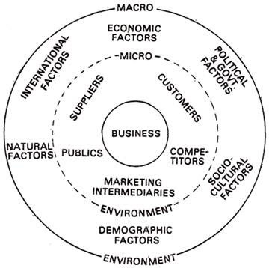
Source: https://www.businessmanagementideas.com/business-environment/environment-of-business-micro-and-macro/10135

Industry Life Cycle
The Industry Life Cycle is a framework that depicts the evolution of an industry from its inception to maturity and, in some cases, eventual decline. It outlines the stages an industry undergoes as it adapts to shifting market conditions, technological advances, and competitive pressures (Lynch, 2021b). The life cycle concept provides valuable insights into the distinct challenges and opportunities that arise during each phase, allowing companies to align their strategies accordingly. The following image shows the various stages in the model:
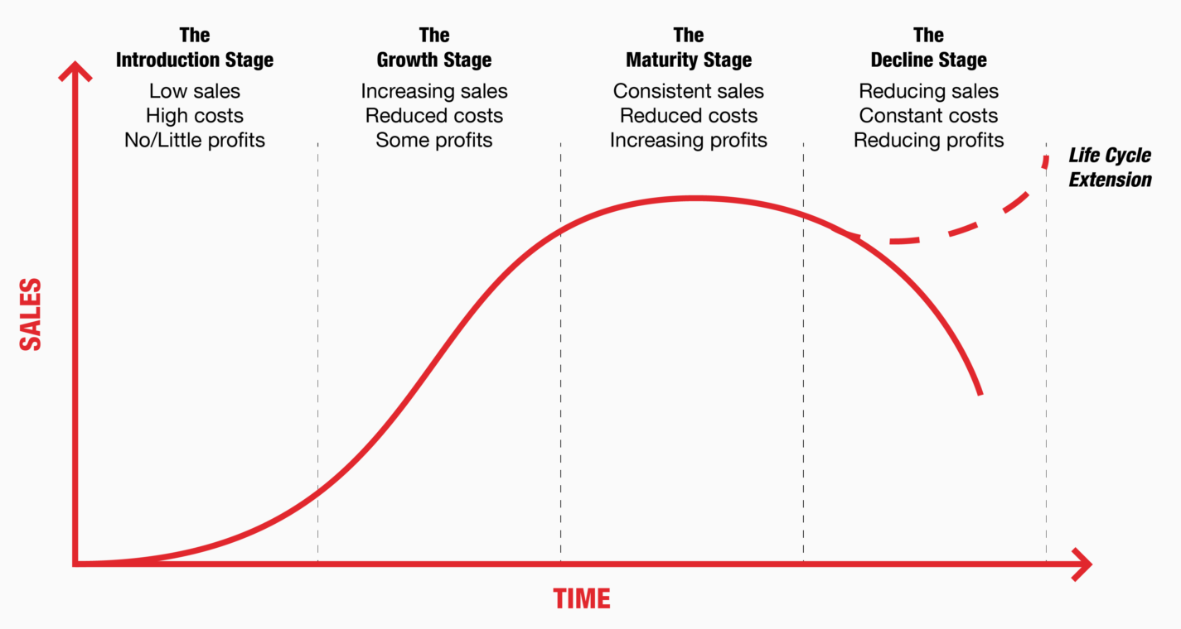
Source: https://www.manrajubhi.com/4-stages-of-a-business-life-cycle/
The Dell Industry Life Cycle Model (Levitt, 2022) is as follows:
During the introduction phase in 1984, Dell arose as a pioneering startup and revolutionised the computer industry with its innovative direct-to-consumer business model. The company, founded by Michael Dell, permitted customers to customise and purchase personal computers directly from Dell (Dell UK, 2021). This disruptive strategy challenged the predominant traditional distribution channels in the industry, paving the way for Dell's rise to industry leadership.
As Dell's direct-to-consumer business model acquired traction, the company quickly entered the growth phase (Dell UK, 2021). The market embraced Dell's innovative concept, resulting in a rapid increase in the company's consumer base and market share. The company's success was propelled by its emphasis on customization, cost-effective production, and responsive customer service, which enabled it to diversify its product offerings and enter new geographic markets.
Dell entered the maturity phase of the industry life cycle during the late 1990s and early 2000s (Dell UK, 2021). The market for personal computers became extremely competitive, and Dell faced difficulties in sustaining its competitive advantage. To remain profitable and sustainable in a mature market, the company prioritised operational efficiency, supply chain optimisation, and cost management during this phase.
The personal computer market experienced a decline in the 2010s as a result of the proliferation of mobile devices and shifting consumer preferences. New technology trends posed increasing competition for Dell, resulting in a decline in its traditional business. Dell, however, recognised the need for renewal and transformation rather than succumbing to the challenges.
In response to the decline phase, Dell initiated a period of transformation and renewal. The company was able to reevaluate its strategies and concentrate on long-term innovation after going private in 2013. Dell positioned itself as a comprehensive provider of technology solutions for modern businesses and individuals by diversifying its offerings to include cloud computing, data storage, cybersecurity, and IT services.

Porter’s Industry Five Forces Analysis
Porter's Five Forces is a strategic framework that provides a structured analysis of the competitive forces within an industry. This model assists businesses in comprehending the factors influencing the attractiveness and competitiveness of their industry (Blokdyk, 2018).

The following diagram illustrates the model:
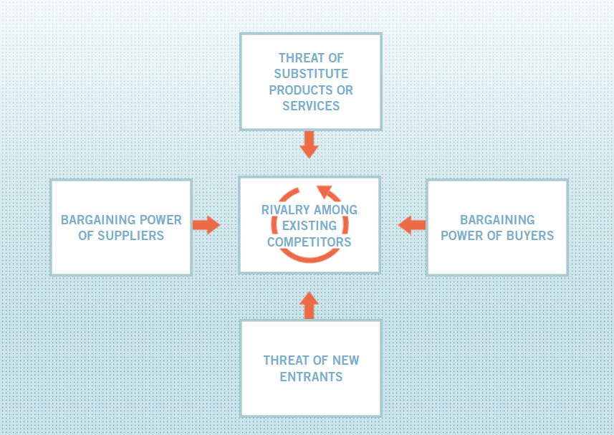
Source: https://www.isc.hbs.edu/strategy/business-strategy/Pages/the-five-forces.aspx

Internal Analysis
An essential component of strategic management, internal analysis evaluates an organization's internal strengths and deficiencies. It entails a thorough analysis of the company's resources, capabilities, and overall performance in order to identify its competitive advantage and areas for improvement (Henry, 2008). Dell will be able to identify its unique resources, primary competencies, and overall competitiveness within the technology industry by conducting an internal analysis. In the following sections, we will conduct an internal analysis of Dell using a variety of strategic tools and frameworks.

Strategic Resources and Capabilities
Strategic resources are the organization's tangible and intangible assets, competencies, and capacities that allow it to attain a competitive advantage and create value for its customers and stakeholders (Indeed Editorial Team, 2022). Physical assets (e.g., manufacturing facilities), intellectual property (e.g., patents and trademarks), human capital (e.g., skilled personnel), and organisational capabilities (e.g., effective supply chain management) are examples of these resources. Strategic capabilities, on the other hand, refer to an organization's capacity to deploy and effectively utilise its resources in pursuit of particular strategic objectives. Typically, the organization's culture, leadership, processes, and systems influence these capabilities. Multiple strategic assets and competencies have contributed to Dell Inc.'s success in the technology industry.
Dell's innovative direct-to-consumer business model has been essential to its success. By selling directly to customers, Dell enjoys higher profit margins, more opportunities for customization, and stronger customer relationships.
Dell has developed a robust global supply chain that enables the company to efficiently source components, assemble products, and distribute them globally. This strategic capability enables Dell to reduce expenses and swiftly respond to market demands.
Over the years, Dell has established a strong brand reputation for quality, dependability, and customer service. This strategic asset gives Dell a competitive edge and fosters customer loyalty.
Dell invests heavily in research and development, fostering technological innovation to maintain its industry leadership. This strategic capability enables Dell to introduce market-leading products and solutions.
Dell places an emphasis on establishing long-lasting relationships with its customers, comprehending their requirements, and providing customised solutions. This customer-centric strategy increases brand loyalty and facilitates customer retention.

Value Chain Analysis
Value Chain Analysis is a strategic framework for identifying and evaluating the primary and secondary activities that contribute to the creation of value for a company's products or services. Michael Porter introduced the value chain concept as a means of comprehending how businesses can gain a competitive advantage by optimising internal processes and operations (De Mozota, 2010). From the acquisition of raw materials to the delivery of the finished product to customers, the value chain consists of a series of interconnected activities that contribute value to the final product.
The following image shows the primary and secondary activities involved in a value chain:
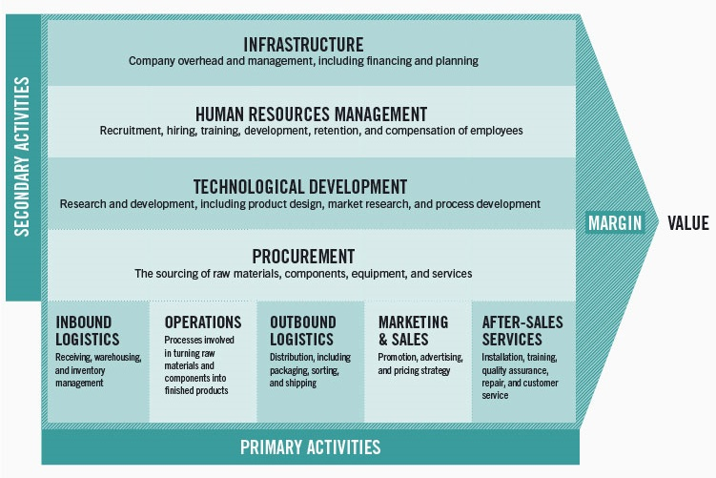
Source: https://online.hbs.edu/blog/post/what-is-value-chain-analysis
By analysing the value chain, a business can identify opportunities for cost reduction, process enhancement, and value creation, thereby enhancing its market competitiveness. The value chain consists of two categories of activities: primary and secondary.

Primary Activities
The primary activities in the value chain are the physical creation, marketing, sale, and delivery of a product or service to the consumer (De Mozota, 2010). These activities are essential to a company's primary operations and play a crucial role in generating customer value. Inbound logistics, operations, outbound logistics, marketing and sales, and customer service are the primary activities that comprise the value chain. The following are the primary activities in Dell's value chain:
- Inbound Logistics: Dell's inbound logistics include the sourcing, procurement, and receipt of basic materials and components required for the production of its technology products. The company's global supplier relationships are robust, allowing it to efficiently acquire high-quality components. Dell's efficient inbound logistics contribute to cost savings and on-time material accessibility.
- Operations: The build-to-order manufacturing process is at the heart of Dell's operations. After receiving consumer orders, Dell assembles the products according to the configurations specified. This method reduces inventory costs and minimises the risk of products becoming obsolete. Dell's responsiveness to fluctuating consumer demands and market trends is enabled by its efficient operations.
- Outbound Logistics: Dell's outbound logistics entail the distribution of finished products from its manufacturing facilities to the locations of its customers. Using a direct-to-consumer business model, the company eliminates the need for intermediaries. The well-structured outbound logistics system of Dell ensures the prompt and effective dispatch of products to customers around the globe.
- Marketing and Sales: The marketing and sales activities of Dell are centred on reaching target customers and promoting its customised technology solutions. The company utilises a variety of marketing strategies to promote its product offerings and customer-centric orientation. Dell's direct sales model enables the company to interact directly with consumers, ensuring the delivery of personalised service and the development of strong relationships.
- Customer Service: Dell places a strong emphasis on customer service in order to increase customer satisfaction and retention. The company offers warranty services, technical assistance, and after-sales support. consumer service activities are indispensable for preserving long-term consumer loyalty and generating positive word-of-mouth referrals.

Secondary Activities
Secondary activities in the value chain are functions that contribute indirectly to the creation of value in a company's products or services. These activities provide the necessary support and infrastructure for the primary activities to function effectively. Procurement, human resource management, technology development, and firm infrastructure are examples of the secondary activities within the value chain (De Mozota, 2010). These are the secondary activities in Dell's value chain:
- Procurement: Dell's procurement activities are centred on procuring and acquiring the required materials, components, and services for its manufacturing process. To ensure the timely and cost-effective availability of basic materials and components, the company maintains strong relationships with its suppliers. Effective procurement practises aid Dell in optimising production costs and preserving product quality.
- Human Resource Management: Dell's human resource management plays a crucial role in the acquisition, development, and retention of qualified talent. The company invests in training and development programmes for the purpose of enhancing employee capabilities and fostering innovation. Dell's devoted personnel is essential to operational excellence and technological progress.
- Technology Development: As a technology company, Dell places a heavy emphasis on technological research and development. The company invests in R&D to introduce new products, enhance existing technologies, and remain ahead of market trends. Dell is able to offer cutting-edge solutions to its consumers as a result of its dedication to technology development.
- Firm Infrastructure: Firm infrastructure refers to Dell's overarching management, administration, and support functions. This includes financial, accounting, legal, and general management functions. The streamlined coordination of Dell's various departments, which supports the company's overall operations and strategic decision-making, is made possible by the company's efficient infrastructure.

VRIO Analysis of Distinctive Resources and Capabilities
The VRIO framework is used to evaluate a company's capabilities and resources based on their Value, Rarity, Imitability, and Organised implementation (Barney and Hesterly, 2010). The application of VRIO analysis to Dell's core competencies yields information regarding the company's competitive advantage and its ability to maintain it in the technology industry.The following flowchart illustrates the framework:
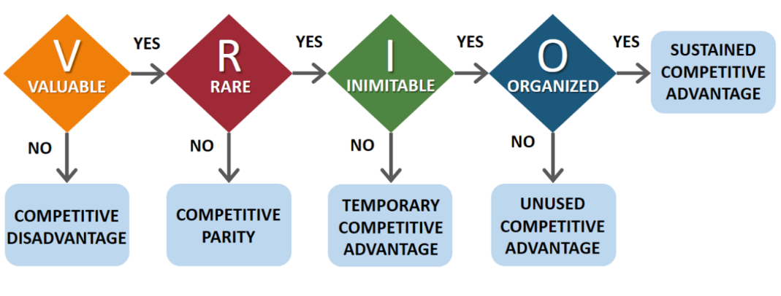
Source: https://www.seadogproductions.co.uk/creative/vrio-framework/
The VRIO analysis of Dell can be implemeted with respect to the following factors (Cheng, 2022):
Direct-Sales Model
- Value: Dell's direct-sales model is valuable as it reduces retailer/dealer costs and some storage costs. Selling products directly to customers allows Dell to maintain control over pricing, customization, and customer relationships.
- Rarity: The direct-sales model is rare in the computer industry, giving Dell a unique selling proposition. Competitors rely on traditional retail networks, making Dell stand out as a company with a strong reputation for quality and personalized offerings.
- Inimitability: Imitating Dell's direct-sales model would require competitors to reorganize their entire processes and supply chains, making it challenging and costly to replicate.
- Organization: The direct-sales model is well-organized and deeply embedded in Dell's business strategy. It cannot be easily replaced by an equivalent strategic capability.
Just-in-Time Inventories
- Value: Dell's just-in-time inventories save costs by minimizing storage and inventory holding expenses. They allow Dell to purchase only what is needed, reducing the risk of overstocking and obsolete components.
- Rarity: Just-in-time inventories are uncommon in the computer industry, stemming from the way Dell was founded. Competitors often use traditional stock management models.
- Inimitability: Replicating Dell's just-in-time inventory system would necessitate significant capital investments and process reorganization, making it difficult for competitors to imitate.
- Organization: The just-in-time inventory process is well-organized within Dell's supply chain, providing a sustainable advantage.
Customer Relationship Management (CRM)
- Value: Maintaining strong customer relationships and reputation adds value by providing Dell with invaluable market information and insights.
- Rarity: Comparable Customer Relationship Management capabilities are lacking in Dell's competitors, making this skill uncommon in the industry.
- Inimitability: Competitors would face high costs in imitating Dell's CRM competency, involving the reorganization of customer-related functions and processes.
- Organization: While good reputation management can partially replace this competency, replicating Dell's well-organized CRM system would be challenging.
Good Market Segmentation
- Value: Dell's ability to adapt its acquisitions and offerings based on market segments adds value as it allows the company to participate in various market segments and cater to diverse customer needs.
- Rarity: While Dell competes in a wide range of fields, other rivals also offer a diverse portfolio of products. This competency is not unique to Dell.
- Inimitability: Developing new product lines and acquisitions come with high costs, both in R&D and business expansion, making it challenging for competitors to replicate.
- Organization: The rapid advancement of technology poses a risk to all products in the computer industry, making market segmentation an ongoing challenge for Dell.
Strategic Partnerships within the Industry
- Value: Dell's strong partnerships within the computing industry reduce product costs and enable co-creation of solutions, contributing to competitive advantage.
- Rarity: While Dell's partnerships are valuable, competitors like Apple also have extensive partner networks.
- Inimitability: Establishing strategic alliances in the oligopolistic industry is challenging, and many suppliers already have partnerships with computer manufacturers.
- Organization: This competency can be replaced by influencing component suppliers or establishing a strong supply chain to enforce favorable terms with suppliers.

SWOT Analysis
SWOT analysis is a strategic management instrument used to evaluate a company's internal strengths and weaknesses, as well as its external opportunities and threats. The analysis enables organisations to formulate effective strategies and make well-informed decisions by providing them with a comprehensive comprehension of their current position. The Dell SWOT analysis is as follows (Balasingham, 2021):
Strengths
- Direct Sales Business Model and Online Sales: Dell's direct sales model and strong online presence enable the company to reach customers directly, thereby reducing costs and enhancing customer engagement.
- Customization of Products: Dell's ability to offer customised products enables customers to tailor their technology solutions, resulting in increased customer satisfaction and loyalty.
- Effective Supply Chain Management Process: Dell's efficient supply chain management contributes to cost savings, on-time delivery, and a rapid response to consumer demands.
- Inorganic Growth Structure: Dell's strategic acquisitions have facilitated inorganic growth, enabling the company to expand its product portfolio and enter new markets.
- Business to Business (B2B) Sales: Dell's emphasis on B2B sales enables the company to penetrate the corporate market and form long-term partnerships.
Weaknesses
- Low R&D Spending in PCs: Dell's relatively low investment in research and development for personal computers has led to a lack of competitive advantage and delayed product innovation.
- Leadership and Management: Some leadership and management flaws have been identified, influencing strategic decision-making and execution.
- Financial Debt: The financial debt of Dell poses a threat to the company's financial health and its ability to pursue development opportunities.
- Reliance on Educational Sales: Dell's reliance on educational and university sales, which account for only 5% of total PC sales, leaves the company vulnerable to fluctuations in the education market.
- Limited Retailers: Dell's limited presence in brick-and-mortar retail stores restricts consumer access, potentially limiting its market penetration.
Opportunities
- Entering Developing Economies Dell can utilise its brand reputation and customization capabilities to enter or further develop markets in developing economies.
- 2.Integration of Customization: Dell can extend its ability to customise to all conceivable products, capitalising on consumer preferences for individualised solutions.
- Product Portfolio Development: Dell's strong brand recognition and global presence present opportunities for expanding into new technological markets and expanding its product portfolio.
- Growth in Online Sales: The increasing popularity of online sales provides Dell with an opportunity to strengthen its e-commerce presence and acquire a larger market share.
- Technological Advancements: Dell can capitalise on the development of new technologies such as cloud storage, tablets, mobile phones, and business servers to expand its offerings and maintain a competitive advantage.
Threats
- Intellectual Property Concerns: Dell may face difficulties relating to patents, copyrights, and design rights, which could result in legal disputes and product offering restrictions.
- Financial Recession: Economic downturns, such as the Dot-Com Crash, can have an effect on consumer expenditure and business investment, thereby affecting Dell's revenue and profitability.
- Online Dependence: Dell's excessive reliance on online sales channels exposes the company to potential disruptions, cyber threats, and shifting consumer preferences.
- Industry Life Cycle: The fast-paced and dynamic nature of the technology industry may result in product obsolescence and shortened product life cycles, affecting Dell's competitiveness.
- Rivalry: Dell operates in a market with intense competition from key technology companies, which could affect market share and pricing dynamics.

Strategies to Sustain Competitive Advantage
In order to maintain their market position, profitability, and growth over the long term, businesses must implement strategies to sustain their competitive advantage (Barney and Hesterly, 2018). Competitive advantage is the distinct set of strengths and competencies that distinguishes a company from its rivals and enables it to outperform and remain at the top of its industry.
Dell can maintain its competitive advantage by implementing Porter's generic strategies (Porter, 1998), such as cost leadership, differentiation, and concentration. The following diagram illustrates the different factors in Porter’s Generic Strategy:
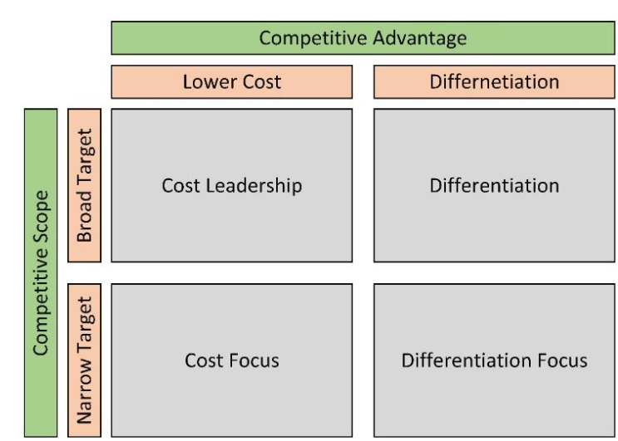Source: https://www.researchgate.net/publication/353014481_Strategic_Analysis_of_Dell_Inc
Each of the strategies can be tailored to Dell's unique capabilities and market position:
- Cost Leadership: Dell can achieve cost leadership by perpetually optimising its supply chain and production processes to reduce expenses. By leveraging its direct-sales model and online sales platform, Dell is able to eliminate middlemen and reduce distribution costs. Additionally, the business can negotiate favourable terms with suppliers to reduce input costs. Offering competitive prices can help Dell acquire a substantial market share by attracting price-sensitive customers. Dell can maintain its cost leadership position and fend off competitors by continuously innovating to increase cost efficiencies.
- Differentiation: Dell's competitive advantage can be maintained through product differentiation. By investing in R&D, the company can introduce innovative features and design elements that set its products apart from the competition. Expanding customization options to meet the specific requirements of each customer promotes a one-of-a-kind, personalised experience. Additionally, emphasising exceptional customer service and support can contribute to product differentiation by enhancing the overall customer experience. Focusing on quality, dependability, and after-sales service can generate brand loyalty, thereby making Dell the preferred option for discriminating consumers seeking differentiated products.
- Focus: Targeting specific customer segments or niche markets where its strengths align with customer requirements, Dell can implement a focus strategy. For example, Dell can focus on providing customised solutions to corporate clients, educational institutions, and small- to medium-sized enterprises. By understanding the specific demands of these target segments, Dell is able to provide them with specialised products and services. Through this strategy, Dell is able to cultivate strong relationships with its target consumers, fostering loyalty and increasing entry barriers for rivals.

Growth Strategies
A company's growth strategies are the plans and actions it takes to increase its market share, broaden its customer base, and increase its revenues and profitability. These strategies are necessary for businesses to flourish in a competitive market and sustain their success over time (Patel, 2023). The Ansoff Matrix is a strategic planning tool that assists companies in analysing growth opportunities based on two important dimensions: existing products and existing markets (Loredana, 2017). It provides a framework for identifying and evaluating various development strategies, thereby guiding businesses in their strategic decision-making.
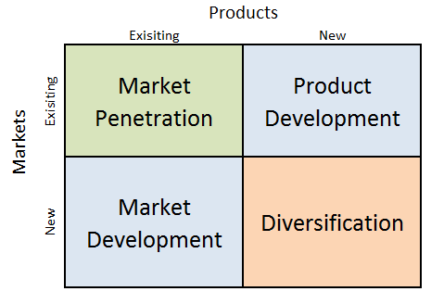
Source: https://research-methodology.net/xiaomi-ansoff-matrix-2/
The following describes how Dell can implement the Ansoff Matrix:
- Market Penetration: The process of selling existing products in existing markets in order to expand market share. Intensifying its marketing efforts to increase brand awareness and customer visibility, Dell can implement market penetration strategies. To reach a larger audience, this could involve targeted advertising campaigns, digital marketing initiatives, and social media engagement. Additionally, Dell can offer special promotions, discounts, and loyalty programmes to encourage customer retention and repeat purchases.
- Market Development: Market development involves introducing existing products to new markets. This strategy targets new customer segments and regions. Dell can investigate opportunities for market development by expanding its operations into new geographies or untapped customer segments. For instance, the company can enter emerging markets with high growth potential where technology products are in high demand. By gaining a comprehension of the specific requirements and preferences of these new markets, Dell can adapt its offerings accordingly.
- Product Development: Product development entails the introduction of new products or product variants into existing markets. Dell is able to concentrate on product development in order to innovate and expand its product portfolio. This could involve investing in research and development to introduce innovative new products or variants. For instance, Dell can develop cutting-edge technologies in areas such as artificial intelligence, cloud computing, and Internet of Things (IoT) devices in order to satisfy the changing needs of the tech-savvy market.
- Diversification: This involves introducing new products to new markets. This strategy carries a greater degree of risk for businesses, as it involves venturing into uncharted territory. Dell can pursue diversification strategies by introducing new products to new markets or industries. As a complement to its existing hardware business, for example, the company can investigate opportunities in software development, cybersecurity solutions, and IT services. Diversification may also entail strategic acquisitions or partnerships to enter markets in which Dell's presence is limited.

Green Strategy and CSR
Green strategy, also known as a sustainable or environmentally-friendly strategy, is an approach adopted by businesses to reduce their negative impact on the environment and promote ecological sustainability. A green strategy aims to integrate environmentally responsible practises into an organization's operations, supply chain, and products (Olson, 2008). By implementing a green strategy, businesses strive to reduce their carbon footprint, conserve natural resources, and positively contribute to the preservation of the environment.
Corporate Social Responsibility is an organization's commitment to conduct business ethically and contribute to societal and environmental well-being. Integrating social and environmental concerns into corporate operations and practises constitutes CSR (Carroll, 1999). Companies engaged in CSR initiatives go above and beyond ordinary profit maximisation to actively address social issues, promote community development, and support environmentally sustainable practises.
Implementing Dell's Green Strategy and CSR:
- Green Initiatives in Operations: Dell can implement a green strategy by emphasising sustainability within its operations. This includes implementing energy-efficient practises, reducing waste, and powering its facilities with renewable energy sources. Dell can minimise its environmental impact by establishing aggressive carbon reduction goals and instituting eco-friendly processes.
- Eco-Friendly Products: Dell can demonstrate its commitment to sustainability by designing and manufacturing environmentally favourable products. This may involve using recycled materials in product packaging, reducing the use of harmful substances, and ensuring that products are readily recyclable or upgradable in order to increase their lifespan.
- Circular Economy: Dell can adopt a circular economy strategy by promoting product recycling and refurbishment. This involves collecting used products and components, refurbishing them, and reintroducing them to the market in order to reduce electronic pollution.
- Supply Chain Sustainability: Dell can collaborate closely with its suppliers to promote sustainable business practises throughout its supply chain. Dell's operations can be made more sustainable by encouraging its suppliers to adhere to environmental standards and ethical labour practises.
- Employee Engagement: Dell is able to engage its employees in ecological initiatives and CSR activities. Encourage employee participation in community service programmes, environmental awareness campaigns, and volunteer opportunities to cultivate a sense of purpose and commitment to sustainability.

Recommendations
Dell can implement the following strategies to improve its strategic capabilities (McKinsey & Company, 2007):
- Focus on Strategic Issues: To improve the quality of the planning process, Dell should employ an issues-based approach that identifies and discusses the most significant strategic issues affecting future business performance. This strategy ensures that management allocates time and resources to the most essential issues, thereby preventing efforts from being wasted on less important matters.
- Include Relevant Participants: Dell should guarantee that the appropriate individuals are involved in strategic discussions. This includes involving essential corporate decision-makers, business unit leaders, and experts in the discussions. A diverse group of participants stimulates critical thought, promotes open dialogue, and facilitates a deeper understanding of the entire organisation.
- Adapt Planning Cycles: To relieve business divisions of the obligation to conduct rigorous strategic planning annually, Dell can consider a customised planning cycle. By alternating the business units undergoing a complete strategic-planning process every two or three years, Dell's senior-management team is able to focus on the most critical issues influencing the entire organisation and make ad hoc strategic decisions as necessary.
- Implement a Strategic-Performance-Management System: Dell should implement a strategic performance management system to effectively measure and monitor the progress of strategic initiatives. This system should incorporate a combination of financial and non-financial metrics to evaluate the success of key initiatives. Regular reviews should be conducted in order to provide early warnings of prospective issues and permit prompt corrective actions.
- Integrate Human Resource Systems Dell should integrate its strategic plan with its human resource processes in order to align the evaluation and compensation of managers with the success of its new strategic initiatives. By tying performance objectives to specific strategic goals, Dell can motivate managers to prioritise the success of these initiatives and resolve any obstacles as soon as possible.

Conclusion
In conclusion, Dell Inc. is a leading player in the technology industry, with fundamental competencies including its direct-sales model, just-in-time inventory management, and strong customer relationship management. By leveraging these assets and adopting growth strategies that align with Porter's generic strategies, Dell will be able to maintain its competitive advantage and achieve future success.
Its reputation as a socially responsible company is enhanced by Dell's commitment to ecological strategies and corporate social responsibility. Dell is able to positively affect the environment and society by emphasising sustainability in its operations and product development. Dell's strategic management practises and commitment to sustainability position the company for continued growth and relevance in the rapidly evolving technology industry. By remaining adaptable, innovative, and socially conscious, Dell is able to navigate obstacles and capitalise on opportunities in order to maintain its industry leadership position.

References
- Balasingham, R. (2021) “Strategic Analysis of Dell Inc,” ResearchGate [Preprint]. Available at: https://www.researchgate.net/publication/353014481_Strategic_Analysis_of_Dell_Inc.
- Barney, J.B. and Hesterly, W.S. (2010) Strategic management and competitive advantage: Concepts. Pearson Education.
- Barney, J.B.. H. and Hesterly, W.S. (2018) Strategic management and competitive advantage: Concepts and Cases, Global Edition.
- Blokdyk, G. (2018) Porter’s Five Forces analysis: A Complete Guide. Createspace Independent Publishing Platform.
- Carroll, A.B. (1999) “Corporate social responsibility,” Business & Society, 38(3), pp. 268–295. Available at: https://doi.org/10.1177/000765039903800303.
- Cheng, J. (2022) “Sustainable Competitive Advantage Analysis and Recommendations for Dell Company to Achieve Success,” Open Journal of Social Sciences, 10(12), pp. 486–497. Available at: https://doi.org/10.4236/jss.2022.1012033.
- De Mozota, B.B. (2010) “Structuring Strategic Design management: Michael Porter’s value chain,” Design Management Journal, 9(2), pp. 26–31. Available at: https://doi.org/10.1111/j.1948-7169.1998.tb00201.x.
- Dell UK (2021) Who we Are. Available at: https://www.dell.com/en-uk/dt/corporate/about-us/who-we-are.htm#.
- Henry, A. (2008) Understanding Strategic Management. Oxford University Press, USA.
- Indeed Editorial Team (2022) “What Are Strategic Resources? (And Other FAQs),” Indeed.com [Preprint]. Available at: https://www.indeed.com/career-advice/career-development/what-are-strategic-resources.
- Johnson, G. et al. (2020) Exploring strategy. Pearson UK.
- Lancaster, G. and Reynolds, P.N. (1998) “Marketing and the Organisation’s Micro- and Macro-environments,” in Marketing. Available at: https://doi.org/10.1007/978-1-349-14039-8_2.
- Levitt, T. (2022) Exploit the product life cycle. Available at: https://hbr.org/1965/11/exploit-the-product-life-cycle.
- Loredana, E.M. (2017). THE USE OF ANSOFF MATRIX IN THE FIELD OF BUSINESS. Annals - Economy Series, 141-149.
- Lynch, R. (2021) Strategic Management. SAGE.
- McKinsey & Company (2007) How to improve strategic planning. Available at: https://www.mckinsey.com/capabilities/strategy-and-corporate-finance/our-insights/how-to-improve-strategic-planning.
- Olson, E.N. (2008) “Creating an enterprise‐level ‘green’ strategy,” Journal of Business Strategy, 29(2), pp. 22–30. Available at: https://doi.org/10.1108/02756660810858125.
- Patel, S. (2023) “Company Growth Strategy: 7 Key Steps for Business Growth & Expansion,” Hubspot, 17 April. Available at: https://blog.hubspot.com/sales/growth-strategy.
- Porter, M.E. (1998) Competitive advantage: Creating and Sustaining Superior Performance. Free Press.
- Radwan, M. (2018) Strategic Marketing Case Study Chick-Fil-A. GRIN Verlag.
- Statista (2023a) Dell Technologies revenue 2023. Available at: https://www.statista.com/statistics/264911/dells-net-revenue-since-1996/.
- Statista (2023b) Dell Technologies number of employees 2023. Available at: https://www.statista.com/statistics/264917/number-of-employees-at-dell-since-1996/.
- Wallis, G. (2017) Pestle Analysis jump start.

