Research Project Proposal

Topic: Analyse the impacts of socio-economic force on employees’ performance management and monitoring in different work modes: Hospitality HR’s perspectives
Hotel: Radisson Hotel

Student Name: Adam Maria-Monica
Student ID: 2241338
Module Code: BMIH5005
Module Lecturer: Scott James

Table of Contents
1. Introduction and Background 3
2. Discussion 4
2.1 PESTLE Analysis of Radisson Hotel 6
1. Political 6
2. Economic 7
3. Social 7
4. Technological 7
5. Legal 8
6. Environmental 8
3. Employment Modes 9
4. Evaluation and conclusion 10
5. References 12

Introduction and background
This research seeks to determine how socio-economic forces affect employee effectiveness in performance management and monitoring in different work modes. The hotel that was selected for this research is the Radisson Hotel. Francois Koukpaki et al., (2020) stated that, Currently, Radisson Hotel in the UK has grown to the next level and serves as an honorable chain in its hospitality sector. They have expanded their presence over the years and now have both leisure and business travelers given the strategic nature of locations owned. Their commitment the offering good accommodation and value-added services is well rewarded with constant clientele. (Yusoff et al., 2020). Currently, the Radisson Hotel has a great reputation among people and is widely known that it offers the best conditions to the guests with modern facilities and careful attitude. These positive attitudes have assisted them in developing a positive image and reputation for the formation of their company and the hotel industry in general.
Competitors in the UK hotel market are also giant chains, such as Hilton, Marriott, and InterContinental Hotels Group (IHG). The Radisson Hotel Group, for instance, has revealed an understanding of how to differentiate by focusing on specific propositions in the hotel services sector while executing clear and focused marketing tactics despite the threats posed by the hotel industry (Úbeda-García et al., 2021). The Radisson Hotel maintains its competitive advantage and relevance in a changing market through creative initiatives and strategic alliances. Their dedication to quality and client happiness makes them a strong force in the hospitality sector in the United Kingdom.
However, Increases in market share, improvements, expansions, and the launch of additional locations could be important markers of Radisson Hotel's growth in the UK. Furthermore, metrics like vacancy rates, revenue per available room (RevPAR), and guest satisfaction ratings can shed light on the operations and expansion of Radisson Hotels in the United Kingdom. However, the hospitality industry supports essential services with £39 billion in tax revenue for the Government and £130 billion in spending. 10% of occupations in the UK, 6% of businesses, and 5% of GDP are related to hospitality.
The Radisson's external stakeholders namely, customers, government, community groups, NGOs, and Suppliers. The assessment aims to identify the factors, current issues, and challenges that Radisson is facing. Radisson Hotel Group is an international base with more than 1320 hotels, around 221,150 rooms with all the luxuries concerned. By the year 2018, Radisson Hotel was conjoint with Jin Jiang International. This assessment aims to identify the Pestle analysis to know about the market position and which factors are hindering the prosperity of Radisson Hotel. This assessment also focuses on the employment modes, and the role of the Human resource department in the hospitality industry, in the UK context (Francois Koukpaki et al., 2020).
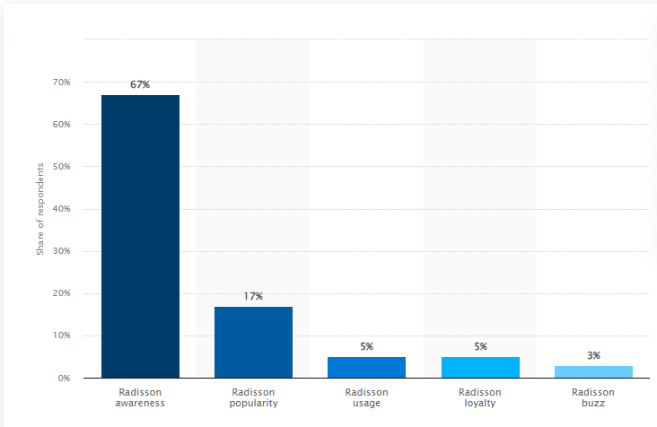
Figure# 1: Radisson brand awareness
Source: (Statista, 2024)

Discussion
According to Úbeda-García et al., (2021), the current challenges and issues faced by the Radisson hotel during the pandemic period were the health and safety measures, third party, shortages of labor, and sustainability. Moreover, social networking has enabled hotels to connect with more clients via campaigns. It can have an impact on the hotel's reputation, both positive as well as negative (Islam et al., 2022). The shortage of labor is the biggest challenge for the hotel, as employees and workers are the main assets of the organization (Padave and Kanekar, 2023). Travel websites enable travelers to provide feedback, helping promote lodgings even more affordable. In contrast, the shortage of labor in the hotel can hinder on providing the authentic services to the customers. Furthermore, the cost of living crises become a challenge in terms of raw materials, energy consumption, staff salaries, rent, etc. The increase in the prices of reservations, accommodations, and other facilities can increase the risk that consumers will not take services from the Radisson hotel (Ahmed et al., 2021).
Moreover, the increase in operating cost leads up to 55.2%. The ingredient cost and supply chain also increase due to economic uncertainty. This can cost more as they consume the revenue and profit. Socio-economic factors play a significant role in shaping the structure of the economy. However, the factors may include income, social class, occupation, employment, education, wealth, geography, race, ethnicity, family background etc. Moreover, the economic conditions directly impact consumer purchasing intention, and economic uncertainty, affecting business revenues (Khan et al., 2021). Subsequently, during economic deflation or shrinkage such as the pandemic period, this tends to decrease the traveling budget and reduce the expenditure expenses on hospitality services and accommodation. Perhaps, those with higher incomes will frequently have more discretionary cash to spend on extravagant hotels and exquisite restaurant meals, however, those with low incomes could place a higher value on price, looking for more affordable solutions for their vacations. The other factor of the unemployment rate will hurt the hospitality industry. However, changes in consumer preferences, and shifting demands of the guests (Ahmed et al., 2021).

PESTLE Analysis

Political
- Changes in government policies, visa regulations, licensing laws, environmental regulations, hospitality policies, employment laws, taxation, and health and safety regulations.
- The employment law involves the employee's working hours, employee rights, wages, and other performance metrics of the employees.
- However, equality measures must be implemented in the hotel industry.
- Furthermore, the safety measures include hygiene in food and cleanliness of the hotel.
- Taxation policy and its impact on the consumer purchasing intention may vary on the services and quality through which the consumers are attracted.
- The hospitality industry saves the amount by taxes and can invest in their security and other infrastructure needs.

Economic
- An economic downturn or recession can lead to a decrease in spending on traveling, which directly affects the revenue of the hospitality industry.
- Economic uncertainty and fluctuation in prices lead to a negative impact on international travel.

Social
- The social factors include demographics, cultural norms and values, lifestyle, trends, geographic conflicts, and other economic crises.
- The demographics include the UK population, household, and their demand for availing of the services from the hospitality industry.
- Consumer Lifestyle may vary on their preferences, services, and experiences they received from hotels
- Radisson Hotel emphasizes overall wellness and long-term viability.
- To accommodate these shifting customer tastes, hotels may need to modify their menus and booking packages.
- When booking a hotel, millennials would rather weigh the facilities against the price.
- A lot of guests base their hotel choices on services such as SPA, Fitness Centre, Parking area, pooling area, playing area, and so on.
- Another reason why so many tourists pick the hotels is their attractive atmosphere.
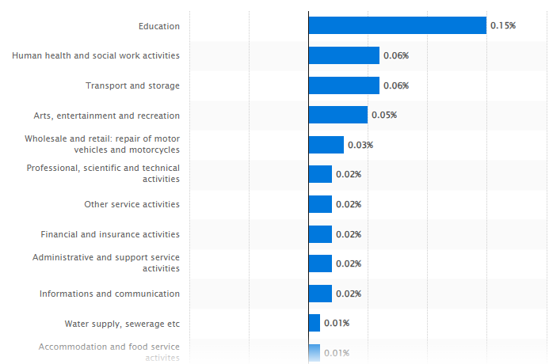
Figure#1: GDP growth in the UK
Source: (Statista, 2024)

Technological
- Technological factors may include the data privacy of consumers.
- With digitization, the hospitality industry must make sure that data safety and visitor data are protected to uphold regulatory compliance and preserve customer confidence.
- Cyber security
- Digital technology can impact significantly on consumer purchasing intention.
- The consumers can book their slots as per their preferences, needs, and wants without facing any hurdle in booking their slots physically by going to the hotel and then booking their reservations.

Legal
- Compliance including the labor law, and environmental and safety measures, must implemented to avoid such legal issues that damage the brand image of the hospitality industry.
- Contractual and legal documents must be adhered to by the vendors, suppliers, and key partners, of the hospitality industry.

Environmental
  - Implementing eco-friendly practices and creating awareness about the sustainability of the overall hotel.
  - Uncertainty in weather, the climate change can hinder traveling trends and patterns (Tanvee et al., 2024).

Employment Modes
In the hospitality industry, different modes of employment have been encountered. However, modes of employment may include contractual, full-time, and part-time. However, the hotel industry includes front desk officers, housekeeping, food and beverages, and maintenance departments are part of the hotel industry. The role of HR in the hotel industry reflects the hiring firing, and giving notice period to employees. However, activities and training programs are the main concern with HR practices. In the hotel industry, all departments must be provided with training and workshops to accelerate their skills. However, the key responsibility of HR is to cater to and resolve all the conflicts between the employees (Tulsi, and JI, 2020). For instance, a conflict involving the front desk officer and housekeeping department in cleaning can interrupt hotel operations and reduce customer satisfaction. However, miscommunication about room status, housekeeping requirements, or schedule difficulties may occur. Quick resolution through open communication channels and cooperation is critical to maintaining a successful operation and providing guests with the service they expect. Collaboration, empathy, and commitment to established standards can help resolve issues and develop a pleasant work atmosphere that promotes excellent visitor experiences (Alananzeh et al., 2018).
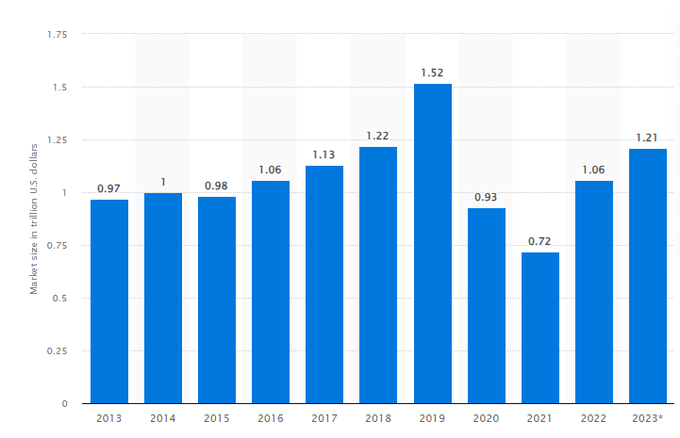
Figure#3: Market Size
Source: (Statista, 2024)
Every type of employment has various advantages and problems for both employers and employees, and the best combination is determined by the hospitality industry's demands and circumstances (Alipour et al., 2019). The hospitality industry may successfully manage staffing requirements, adjust to changing demand, and provide great guest experiences by using a diversified workforce ( Meira et al., 2019).
HR specialists are in charge of hiring and choosing the best people for various positions inside the hotel. By selecting personnel with the requisite abilities, expertise, and cultural fit, HR lays the foundation for outstanding achievement.
However, HR encourages a positive work environment that increases employee engagement and happiness. This includes addressing complaints, enabling interaction between supervisors and staff members, and coordinating staff involvement efforts such as collaboration occurrences. HR can evaluate the performance of their employees by KPI metrics, in which sustainable measures are aligned with the organizational goals. In contrast, 360-degree feedback includes constructive feedback, from the sub-ordinates, supervisors, and team lead ( Yang et al., 2021).
Over the last 5 years growth of the hotel industry, and the pandemic have completely changed the way of consumers' preferences and choices. However, within this 5-year era, consumers' preferences are more into booking their slot online, as the hotel grand overall permission to select their reservation, check-in and check-out authority, and other facilities are included. However, the virtual assistance technology Radisson implementing provides further flexibility to the customers as they can watch the overall hotel, rooms, and other areas virtually and then choose whether to book the reservation or not. Thus, from an HR perspective technology involvement reduces over workload of employees such as front desk officers, housekeeping, and other departments by integrating technological advancement ( Tanvee et al., 2024).

Evaluation and conclusion
In evaluating the role of HR in the hotel industry HR encourages a positive work environment that increases employee engagement and happiness. This includes addressing complaints, enabling interaction between supervisors and staff members, and coordinating staff involvement efforts such as collaboration occurrences.
In the conclusion of this research, this study was based on the evaluation of the impacts of socio-economic force on employees' performance management and monitoring in different work modes: Hospitality HR's perspectives. However, this research aims to identify the factors affecting the hotel industry. The Radisson hotel within prime locations, has increased its footprint over time and is now able to accommodate both leisure and business guests. However, their dedication to providing pleasant lodging and high-quality service has resulted in loyal customers.
The Radisson Hotel enjoys a strong reputation in the industry for providing guests with a unique combination of contemporary amenities and attentive service. Positive evaluations and ratings have helped them build a great reputation for themselves in the hotel industry. Furthermore, Radisson has faced challenges in terms of labor shortage, and price variation which affects consumer preferences and lifestyle, and so on. Thus, the Environment appears as a major problem. As consumers become more conscious of environmental issues, they demand more environmentally responsible practices from hospitality organizations. To be competitive and socially responsible, firms must implement sustainable efforts such as waste reduction, energy conservation, and local product procurement.

References

Ahmed, M., Guo, Q., Qureshi, M.A., Raza, S.A., Khan, K.A. and Salam, J., 2021. Do green HR practices enhance green motivation and proactive environmental management maturity in the hotel industry? International Journal of Hospitality Management, 94, p.102852.
Alananzeh, O.A., Ra'ed, M.D., JAWABREH, O., Al MAHMOUD, A. and HAMADA, R., 2018. The impact of customer relationship management on tourist satisfaction: The case of Radisson Blue Resort in Aqaba city. Journal of Environmental Management and Tourism, 9(2), pp.227-240.
Alipour, H., Safaeimanesh, F. and Soosan, A., 2019. Investigating sustainable practices in hotel industry-from employees’ perspective: Evidence from a Mediterranean Island. Sustainability, 11(23), p.6556.
Francois Koukpaki, A.S., Adams, K. and Oyedijo, A., 2020. The contribution of human resource development managers to organizational branding in the hotel industry in India and South East Asia (ISEA): a dynamic capabilities perspective. Employee Relations: The International Journal, 43(1), pp.131-153.
Islam, M.A., Hack‐Polay, D., Haque, A., Rahman, M. and Hossain, M.S., 2022. The moderating role of psychological empowerment on the relationship between green HRM practices and millennial employee retention in the hotel industry of Bangladesh. Business Strategy & Development, 5(1), pp.17-29.
Khan, A.N., Khan, N.A. and Bodla, A.A., 2021. The after-shock effects of high-performers turnover in the hotel industry: a multi-level study. International Journal of Contemporary Hospitality Management, 33(10), pp.3277-3295.
Meira, J.V.D.S., Dos Anjos, S.J.G. and Falaster, C.D., 2019. Innovation and performance in the hotel industry. Journal of Quality Assurance in Hospitality & Tourism, 20(2), pp.185-205.
Padave, P. and Kanekar, R., 2023. An empirical study on organizational commitment of employees in Indian Hotel Industry. Materials Today: Proceedings, 80, pp.1946-1950.
Radisson, 2024. https://www.radissonhotels.com/en-us/corporate/media/press-releases/RHG-leads-growth-in-Q1-2024-with-focus-on-APAC-and-new-markets. Accessible on 3rd, June, 2024
Radisson, 2024.https://www.radissonhotels.com/en-us/. Accessible on 3rd, June, 2024
Radisson, 2024.https://www.radissonhotels.com/en-us/corporate/about-us/our-presence. Accessible on 3rd, June, 2024
Statista, 2024.https://www.statista.com/forecasts/1335570/radisson-hotels-brand-profile-in-the-uk#:~:text=All%20in%20all%2C%205%25%20of,likely%20to%20use%20Radisson%20again. Accessible on 3rd, June, 2024.
Tanveer, M.I., Yusliza, M.Y. and Fawehinmi, O., 2024. Green HRM and hospitality industry: challenges and barriers in adopting environmentally friendly practices. Journal of Hospitality and Tourism Insights, 7(1), pp.121-141.
Tulsi, P. and JI, Y., 2020. A conceptual approach to green human resource management and corporate environmental responsibility in the hospitality industry. Journal of Asian Finance, Economics and Business, 7(1), pp.195-203.
Úbeda-García, M., Claver-Cortés, E., Marco-Lajara, B. and Zaragoza-Sáez, P., 2021. Corporate social responsibility and firm performance in the hotel industry. The mediating role of green human resource management and environmental outcomes. Journal of Business Research, 123, pp.57-69.
Yang, J., Kim, Y. and Kim, P.B., 2021. Pushing forward high-performance work systems in the hotel industry: A procedural-justice climate to promote higher unit-level outcomes. Tourism Management, 87, p.104385.
Yusoff, Y.M., Nejati, M., Kee, D.M.H. and Amran, A., 2020. Linking green human resource management practices to environmental performance in the hotel industry. Global Business Review, 21(3), pp.663-680.

