

Graduate Diploma Professional Police Practice

LEVEL 6 - 40 Credits

Workbook title: Competency Based Workbook 6 (PCDA) - BMPP 6006D

12 Elements 10,000 words

(SOUTH WALES POLICE, GWENT POLICE AND UWTSD)

Learner name: Michael Reid______________________________

Learner’s University Registration Number:
1910650_______________________________

FACULTY OF BUSINESS AND MANAGEMENT
PUBLIC SERVICE PROGRAMME

Module title: Policing in the Workplace 3 (PCDA) - BMPP6006D

Workbook Guidance

Please read these notes carefully. They provide essential information. The documents you will use in developing your workbook are on the following pages.

What is the workbook for?

The purpose of this workbook is to enable learners to demonstrate and provide evidence of how they meet the learning outcomes set by the College of Policing, for the BSc programme. Essentially, you are being asked to outline your experiential learning based upon your theoretical understanding in a range of operational situations.

This workbook differs from those that you have already completed in that Task 3 -it has an options section giving you the opportunity to answer on an 'advanced learning' area.

Complete the question relevant to the area that has been agreed with the force to study in year 3.

You are expected to answer only 1 of the 5 options below:

- Response Policing.
- Policing Communities.
- Road Policing.
- Information and Intelligence.
- Conducting Investigations.

You may wish to use the same incidents as you’ve outlined in the Occupational Competence Portfolio. Wherever possible we are looking for you to reflect on your personal experience. However, if for any reason there are areas that you feel that you can only answer from a 'hypothetical' perspective, then make this clear within your answer.

How should the workbook be presented?

Blank electronic copies can be found on Moodle of this workbook. You must submit this document electronically therefore it is important that you save your work regularly and upload the final typed version through Turnitin on Moodle.

Word count policy can be found in chapter 7 of the Academic Quality under section 7.7 (this applies to presenting work above and under the specified word count).
(https://www.uwtsd.ac.uk/media/uwtsd-website/content-assets/documents/academic-office/aqh-chapters/chapters---en/Chapter_07_Assessment_Taught_Programmes_Pages_72-79-UPDATED-05-11-2019.pdf)

Reflective practice is a core aspect for your workbooks and although there is a variety of useful resources on Moodle, there is one particular book, that is specifically based on reflective practice in policing, here is a link to one chapter from Selina Copley’s Reflective Practice for Policing Students:
https://moodle.uwtsd.ac.uk/pluginfile.php/298870/mod_resource/content/1/Reflective%20Practice%20for%20Policing%20Students%20-%20Selina%20Copley%20Chapter5.pdf

How is the workbook assessed?

Advice and support about the completion of this workbook will be provided by university staff as part of your initial training day. Your tutor constable and in-force training staff will not be involved in assessing or marking your workbook after it has been submitted.

Dates of workbook submission will be made available during the initial training day and posted on Moodle.

Once submitted your workbook will be assessed and marked independently.

Confidentiality

It is important that no individual can be identified either directly or indirectly from the information in the workbook. However, you must:

- adhere to guidance in the Candidate Handbook about confidentiality;
- not identify individuals including witnesses, victims or offenders by name;
- not write information that enables any individual to be identified indirectly through the description you provide. This includes references to names, colleagues, places (including hospitals, schools, town, villages, streets) specific incidents which were high profile and could be identified due to past publicity, other professionals or any other personal information including medical or other conditions;
- take personal responsibility for adhering to confidentiality rules.
- not include any dates of any incidents or anything that specifically identifies an actual incident.

Please be aware that any content that is deemed to be inappropriate, disrespectful, or abusive will not be tolerated. Following review of any content of this nature the information will be shared with the employer of the student responsible.

Should any health and wellbeing concerns be raised because of disclosures made by the student within this workbook, the employer of the student will be informed.

NOTE

Your workbook will be submitted electronically via Turnitin on Moodle. Guidance on this is in the Candidate Handbook.

Remember that the workbook is YOUR responsibility you must not rely on the assessor or anyone else to pick up any confidentiality breaches, as this is your work and you must accept full responsibility for confidentiality. Meeting all the confidentiality requirements is very important.

Dyslexia and other special circumstances

If you have any condition that you feel may affect your ability to deal with any part of the programme, please see the Candidate Handbook for further guidance. The University has a Student Services Unit that may be able to help but it is the learner’s individual responsibility to contact them.

Competency Based Workbook 6 - Learner Workbook

Guidance:

- Your workbook must contain tasks 1 - 4 below (in the order given);
- You should use the pro-forma to insert your text within each section;
- Note that this module has 4 compulsory tasks with Task three being a choice of 'advanced learning area’ relevant to the area that has been agreed with the force to study in year 3.. Choose only 1 of the 5 options; as only one of these options will be considered for marking.
- You should upload your completed document as a saved pdf file of this workbook; if this is not possible then a Word Doc file is acceptable. Do not send a scanned file from a photocopier, an apple.dot file, or a Microsoft publisher file as Turnitin will not be able to assess them, despite you being able to upload them.

Contents

 | Area of Professional Practice | Word count
TASK 1 | Learning Plan / Personal Development Plan | 2000 equivalent
TASK 2 | Occupational Competency Portfolio (OCP) | 2000 equivalent
TASK 3 OPTIONS SECTION | CHOOSE ONLY 1 OF THESE 'ADVANCED LEARNING AREA’ OPTIONS. IT SHOULD BE ONE THAT HAS BEEN AGREED WITH THE FORCE TO STUDY IN YEAR 3. | All options are  6000 words
Option 1  Option 2  Option 3  Option 4  Option 5 | Response Policing  Policing Communities  Road Policing  Information and Intelligence  Conducting Investigations
TASK 4 | Bibliography

Task 1
Personal Study programme / Individual Learning Plan

One of the learning outcomes identified in the accompanying module descriptor (BMPP 6006D) asks that you formulate and implement a personal study programme to further enhance the development of your professional police practice. A template has been added for an ‘Individual Learning Plan’ that you can use for this task.

This task builds upon the last personal study programme/Individual learning plan completed in a previous workbook. Again this learning plan allows you to assess what level you believe you are in key knowledge, skills and experience against where you believe you (and the force) consider you should be – now and in the coming 6 to 12 months. Some elements within it will be the same or similar to those identified before, however the ratings and your development needs would have changed.

2000 words equivalent. Please note that this is not the actual number of words used in completing the table, the count reflects the thought and research behind it.

ANSWER - please complete the template on the next page:

Knowledge, Skills and Experience Assessment

 | REQUIRED |  |  | RATING |  |  | DEVELOPMENT NEED
KNOWLEDGE | Low  1-4 | Med  5-7  X | High  8-10 | Low  1-4 | Med  5-7  X | High  8-10 | With my personal knowledge, I have a good solid base of the common offences that Police deal with on a daily basis. I am able to identify and consider alternative offences with limited support to identify the correct offence from the onset. If I am unsure on my legislation or processes, I know the procedure to look these up, and I will be able to bookmark or remember for next time how specific things would be completed. I have given myself a medium rather than a high, because the law is vast, and there is a lot of knowledge to learn with regards to not only legislation, but also processes of how to write certain aspects of the job up, or simply being efficient with my time management and dealing with a casefile build.
SKILLS | Low  1-4 | Med  5-7  X | High  8-10 | Low  1-4 | Med  5-7 | High  8-10  X | I’ve graded myself a high with regards to skills, as I have received adequate training through my force to allow for me to skill up with regards to blue light, taser, and stinger being the three main ones that pop to mind. I would also reflect that I can speak with people and de-escalate, as the amount of conflict I have seen during my time as a Police Officer is markedly less than that of some other colleagues, which I attribute to my de-escalation and verbal reasoning skills. I feel that there is still some improvement left within this area however, this would be in relation to improving my efficiency with specific aspects of the job, which is all built from experience. I would not say that I am a 10, but more of a low 8 in this area.
EXPERIENCE | Low  1-4 | Med  5-7  X | High  8-10 | Low  1-4 | Med  5-7  X | High  8-10 | I work in a busy station. This station captures a variety of different calls, from domestic incidents, to road traffic collisions, to public order scenarios, to prolific burglars. This has allowed me to gain exposure to a variety of incidents, much more than those who work a much quieter station with less demand. On the flip side, I also work more and harder for the same pay as another colleague, but I digress. This exposure has allowed me to work on this varied workload, learning and gaining experience from these incidents, becoming more efficient when dealing with the incident the next time. I would say that needle spikings were initially, difficult for me to deal with, however, after dealing with a couple in a short timeframe, I am now able to confidently identify this offence, and to identify whether it has occurred or not, within force policy and guidelines, without supervisory oversight. In some areas of the job, I know more than my own supervisor or more experienced colleagues, as we all have been exposed to different types of incidents.

TASK 2
Recognition and confirmation of progress on the Occupational Competency Portfolio (OCP).

By signing the section below, you are acknowledging your continuing progress on O.C.P.
This is recognised by the university as work that is fully supporting this module BMPP 6006D; Policing in the Workplace 3 and in signing it will be equivalent to 2000 words towards the 10000 words total.

Confirmation of the progress on the Occupational Competency Portfolio (OCP).

I confirm that I am progressing with the Occupational Competency Portfolio (OCP) in accordance with the regulations.

Signed: Michael Reid (Learner – electronic signature accepted,
or type name in.)

Date: 13/06/2022

TASK 3

This is a reminder that this TASK 3 section is an opportunity for you to answer a question on an 'advanced learning' area - RELEVANT TO THE AREA THAT HAS BEEN AGREED WITH THE FORCE TO STUDY IN YEAR 3.

You are expected to answer only 1 of these 5 options:

Response Policing.
Policing Communities.
Road Policing.
Information and Intelligence.
Conducting Investigations.

You may wish to use the same incidents as you’ve outlined in the Occupational Competence Portfolio.

Wherever possible we are looking for you to reflect on your personal experience. However, if for any reason there are areas of your essay that you feel that you can only answer from a 'hypothetical' perspective, then make this clear within your answer.

In your answer to this task, you may also wish to consider how this links into your final year 3 project.

Were there any practical solutions that you were able to derive from an incident, an investigation, or a case that you attended in year 2/3?

Did this play any part in your choice of the topic area you have agreed and intend to study in your final year 3 project?

There will undoubtedly be areas of common research and learning opportunities that you can utilise for this task and for your final year 3 project.

Whatever option you study for your task 3 it is will be beneficial for you to use a recognised reflective model.

Within your answer you should consider ‘what went well’, ‘what not so well’ and ‘what you would do differently next time’; consider both your performance and the performance of others around you.

TASK 3 Option 1

Relevant areas of the National Policing Curriculum:

Response Policing

You should choose a policing incident from year 2/3 that was of a complex nature, in which you played a significant role in providing a response.

Critically analyse the social/political/strategic drivers that impact upon the response to this incident.

You could consider the strategic priorities of your Force; for example, victim led crime, harassment, racially motivated crime, or domestic violence.

Consider how strategies are evolved for those involved in response policing can remain effective in an increasingly challenging environment.

6000 words (+/- 10%: include your actual word count at the end of each section)

ANSWER:

TASK 3 Option 2

Relevant areas of the National Policing Curriculum:

Policing Communities

You should choose a policing problem relating to policing communities from year 2/3 that was of a complex nature, in which you played a significant role in providing a response.

Critically analyse the key emerging issues and potential challenges faced to ‘problem solve’ a solution.

Consider how this could then help to reduce community tension and promote community cohesion.

Consider the competing priorities, any cost/financial constraints and availability of resources. Also consider community expectations against the capability of your force to respond

6000 words (+/- 10%: include your actual word count at the end of each section)

ANSWER:

TASK 3 Option 3

Relevant areas of the National Policing Curriculum:

Road Policing

You should choose a serious collision that you have been involved from year 2/3 that was of a complex nature, in which you played a significant role in providing a response.

Critically reflect upon the management of a serious collision in which you played a significant role in. What were the causes and what strategies, and initiatives could be implemented to reduce the likelihood of it reoccurring?

6000 words (+/- 10%: include your actual word count at the end of each section)

ANSWER:

Roads Policing is a complex area to policing. This is because this is an area to policing where a lot of sudden and unexpected deaths or serious and life changing injuries can occur, where sometimes, no individual person is found to be at fault. Within for example, Response Policing, usually serious injuries or deaths are either committed with intent by another person, or happen as a result of illnesses, or accidents involving no other third party. This makes policing this area much more simple with usually, a lot less questions to answer. Within Roads Policing however, Road Traffic Collisions (RTC’s) are quite commonplace, with most RTC’s being quite minor in nature. There are many RTC’s which do not require Police involvement due to the insurance process picking up the liability and reimbursing damages or losses to other third parties. An RTC is defined by the Road Traffic Act 1988, specifically, section 170. This shows an RTC to be defined as:

“(1)This section applies in a case where, owing to the presence of a [mechanically propelled vehicle] on a road [or other public place], an accident occurs by which—
(a)personal injury is caused to a person other than the driver of that [mechanically propelled vehicle], or
(b)damage is caused—
(i)to a vehicle other than that [mechanically propelled vehicle] or a trailer drawn by that [mechanically propelled vehicle], or
(ii)to an animal other than an animal in or on that [mechanically propelled vehicle] or a trailer drawn by that [mechanically propelled vehicle], or
(iii)to any other property constructed on, fixed to, growing in or otherwise forming part of the land on which the road [or place] in question is situated or land adjacent to such land.”

(Road Traffic Act 1988, 2022)

As we can see, a one vehicle RTC where the driver of that vehicle is injured and no other damage or injury has been caused, is not, within the definition of this legislation, an RTC. This means that scenarios such as a motorcyclist falling off their motorbike, do not meet the threshold to be recorded as an RTC within the UK. If this motorcyclist was injured in this event, this should not be recorded within the national data on this matter.

Now we understand what an RTC is, lets begin to look at data surrounding RTC’s including injuries and the impact that this may have on road users.

Lets take a look at data published by the UK Government based on information provided to them by Police Forces within the UK, covering the period from 2020 to 2021. This was published in November 2021, and on the graph shown below, highlights the periods where a national lockdown was implemented, and we can begin to examine the impact a national lockdown had on RTC statistics. This national lockdown had nothing to do with RTC’s or road users, and was a product of the Covid-19 pandemic, where people were required to remain indoors to prevent the spread of a virus. This resulted in less road users, less traffic on the roads, as people had much less reason to head out of the house during these periods.

Chart 4: Estimated road casualties by month and road user type, Great Britain, 2020 to 2021

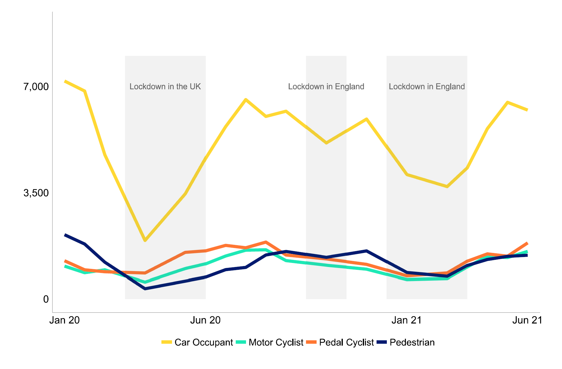
(Road Safety Statistics, UK Government, 2022)

When we look at this graph above, we can see four categories of road user documented below. We can clearly see from the graph that before the first national lockdown, in January 2020, Car Occupants were by far the highest category receiving casualties as a result of RTC’s, showing at around 7,000 casualties We can see a massive decline shortly following the first lockdown period, where it drops to around 2500-3000 casualties instead of 7000. This is more than a 50% reduction during this period. We see a similar reduction to the Pedestrian casualty category, however, pedal cyclist appears to increase during this period, with motor cyclist dipping initially, but coming out with higher casualties than before. Looking further ahead with the data, we can clearly see that the following two lockdowns did have an effect on the data, generally lowering the casualties, however, to a much lesser extent than the original period of lockdown. However, looking at the graph holistically, it appears that there is a small increase in casualties among all road user groups from the start of the data, towards the end. This indicates that road safety in general looks to be improving, however the main focus would be on trying to explain why this improvement is taking place.

To further reinforce the point that our roads are safer now than they were a few years ago, lets look at this chart from the same article.
Chart 3: Percentage change of casualties compared to 2017 to 2019 average, by month and severity, Great Britain, 2020 to 2021

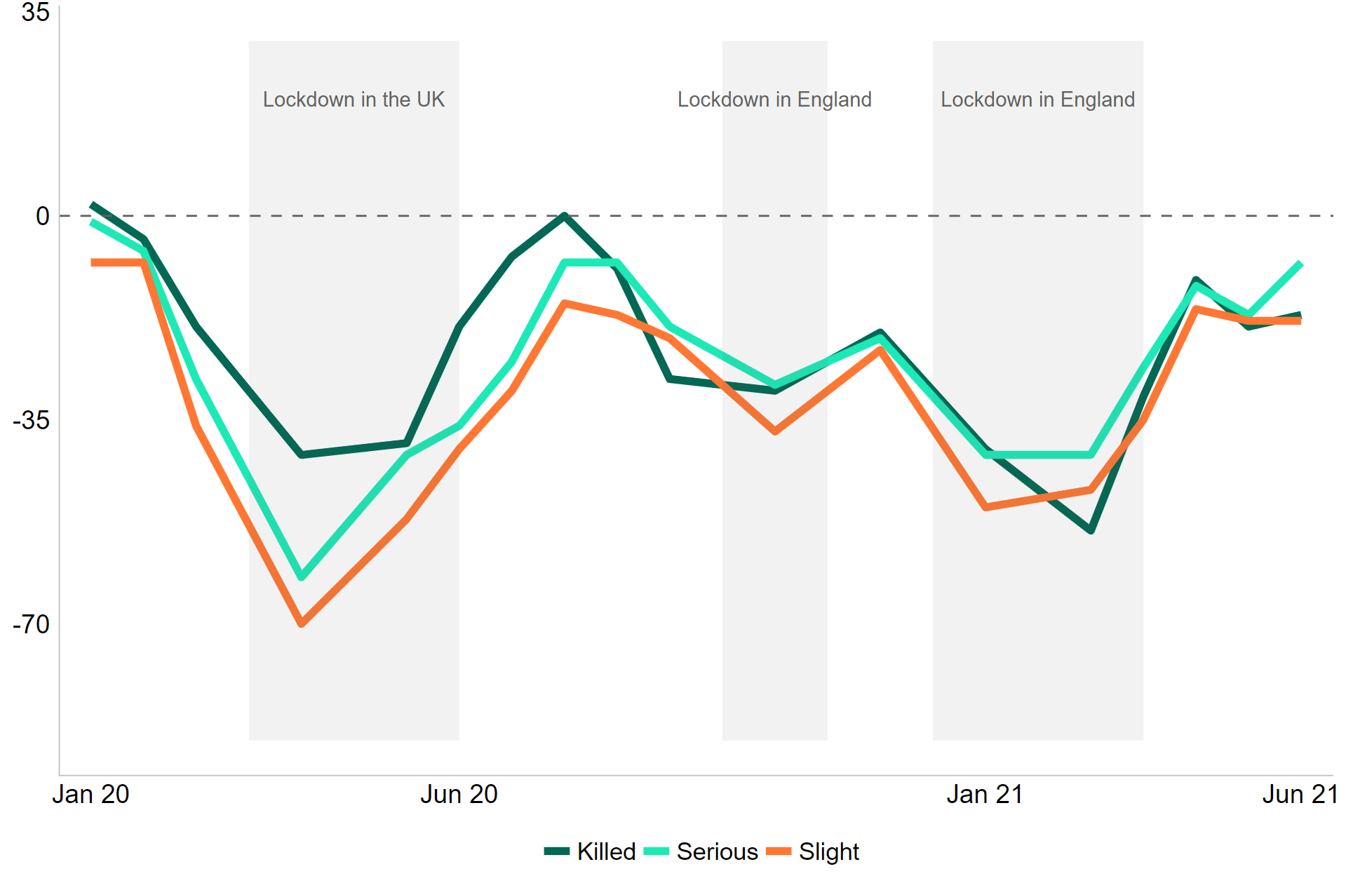

(Road Safety Statistics, UK Government, 2022)

From this data above, we can clearly see that level of injuries, and deaths, drastically fell during the initial lockdown. Over a 35% reduction in people killed on the roads during this lockdown period. As we look across the graph, towards June 2021, we can see that at the end of the graph, the numbers for killed and slight injuries appear to be stable with roughly a 10% reduction in these outcomes to RTC’s as compared to the 2017 to 2019 averages, however the serious injury level appears to be increasing towards the end of the data. As the data ends on June 2021, we cannot see if this increased above the before mentioned averages, or if it stabilised or decreased after the graph cut off.

When we look at the following table:
Table 2: Estimated road casualties, by severity, Great Britain, January to June 2021
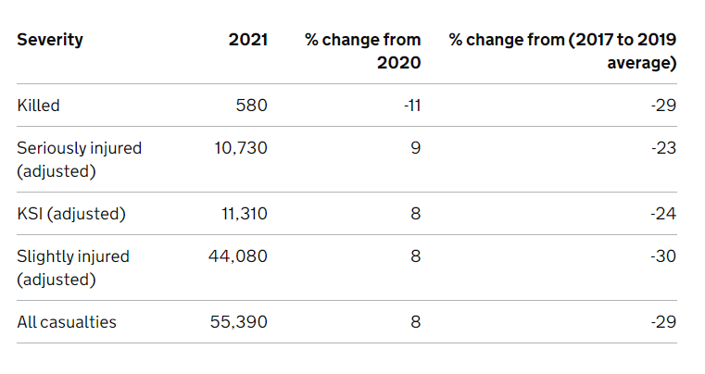
(Road Safety Statistics, UK Government, 2022)

We can clearly see from the data that the data is trending down in relation to casualties across the board. KSI in this data set, is explained to be “Killed or Seriously Injured.” Compared to the 2017 to 2019 averages in all categories, in 2021, we are running at up to 30% less injuries across the board. We must be mindful however, that the impact of the national lockdowns would have heavily influenced this data, and the current work from home dynamic with regards to our workplace adaptations of managing the Covid-19 pandemic within the UK. Less people in the workplace generates less traffic, which means there are less road users. Collisions can happen for a variety of reasons, which I will discuss later in this answer to the question. This data does beg the question, will we fall into a false sense of security with regards to our road safety in light of this data, or be more holistic and understand that this decrease is likely to be down to the national lockdowns due to covid, and that work still needs to continue within this field to improve road safety.

“Compared to January to June 2020:

motor traffic levels increased by 10%
the fatality rate per billion vehicle miles decreased by 19%
the overall casualty rate per billion vehicle miles remained consistent
Compared to the January to June average for 2017 to 2019:

motor traffic levels decreased by 18%
the fatality rate per billion vehicle miles decreased by 13%
the overall casualty rate per billion vehicle miles decreased by 14%”
(Road Safety Statistics, UK Government, 2022)

When we look at the above statistics, we can see that in some categories, such as fatals, and casualties to miles driven, we are making some good progress within 2020. However, we need to be mindful that in June 2020, we were still with 18% less traffic than back in the 2017 to 2019 average.

So why do road traffic collisions happen? There are a variety of reasons. The Department for Transport released a road safety statement in 2019. This covers numerous reasons for why road traffic collisions may take place. Specifically, when speaking about the 7-16 age group, the statement says:
“The Department's THINK! team analysed the Great Britain 2016 reported road
casualties to understand the main contributory factors for child pedestrian casualties.
The top contributory factor for agers 7-16 was that they 'failed to look (e.g. mobile
phones and listening to music)' and in fifth position for both groups 'dangerous action
in the carriageway (e.g. playing)'” (Department for Transport, 2019).

This suggests that the motor vehicle in the majority of cases, may not actually be at fault, and it may be down to the pedestrians inattentiveness. Drawing from my personal experience as a Police trained blue light driver, I am scanning my surroundings for pedestrians all the time, especially far in advance of my current position, however I expect that these pedestrians are aware of the carriageway, and aware that traffic is moving along it, therefore I expect them to remain clear of the carriageway unless they are looking to cross. One of the signs I use to look if someone is expecting to cross, is usually to watch for their head to move, possibly even look behind them towards the other lane of traffic, before stepping towards the roadway. Once I spot this glance, I immediately make note of it, and class this specific pedestrian as a hazard that I now need to deal with. Most drivers, should also be looking for these signs, however, they would not be trained to the same level as myself, making it entirely possible they miss these signs. If however, as the exerpt above states, these pedestrians are not looking, or are not aware, then these signs aren’t present to begin with, and if they step into the carriageway without warning, this is where completely avoidable, and not at fault accidents can occur. This is likely the reason for the recent push to lower the speed limits near schools or in busy town centres to 20mph instead of 30mph. Injuries at 20mph will be less than at 30mph, helping increase the survival rate of the collisions, and also to contribute to causing less injuries, or less severe injuries.

“As a result of this analysis the THINK! team added 'Stop, Look, Listen, Think' and
'Dangerous Habits (distraction)' to their suite of educational resources and these
have been promoted over the last year to teachers and local road safety officers. An
evaluation of the impact of these resources is currently under way and expected to
report in the summer. Interim success measures have indicated that there has been
a 93% increase in teachers claiming safer road safety behaviour among children and
young people (June 2017 to June 2018)” (Department for Transport, 2019).

This looks like the measures taken to educate road users helps to reduce the likelihood of an incident taking place. 93% is a significantly large margin and even though it’s stated to be preliminary data, should not be ignored. Education in this context, appears to have worked.

So what about when it comes to motor vehicle drivers? From the second you pass your test in the UK, you can hop into a car, with limited experience, and drive on your own, independently. It’s an overwhelming responsibility, and many people feel a false sense of security as they’ve passed their test, they must be good enough to tackle what the roads have to throw at them. To help tackle the issue of a lack of knowledge and experience, the statement says:

“2.21 In parallel, DVSA are developing a behavioural change campaign designed to
encourage learners to broaden the range of roads they practice and learn on. The
overarching objective for this campaign is to Increase the amount of practice learners
have on rural roads, driving independently and driving in the dark before they take
their test for the first time.
2.22 DVSA plan to support this with a series of more specific objectives. These will be developed using insight and will look to increase the amount of practice learners
have in the areas they face the biggest risk once they’ve passed their test. DVSA
have used insight from the road casualty statistics and the new driving test research
to identify the main areas in which improving novice drivers' knowledge, skills and
experience will help to improve road safety. These include increasing learner drivers
practice on:
• driving on rural roads - increase the number of learner drivers who have spent 2
or more hours practising on country roads before they take their test from 70.3%
to 74.3% by 30 September 2020.
• driving independently - increase the number of learner drivers who have spent
more than 4 hours practice driving independently before they take their test from
55.3% to TBC% by 30 September 2020.
• driving in the dark - increase the number of learner drivers who have spent
some time practicing in the dark before they take their test by 9% by 30
September 2020 from 82.5% to 91.5%” (Department for Transport 2019).

We need to especially look at the driving on rural roads, drivign independently, and driving in the dark. Rural roads are often quicker, with no defined sides of the road. Hazards can approach quickly and suddently, and a driver must be prepared to stop, or find a place to safely place their vehicle to avoid the hazard. This is a skill set that is simply not possible to build from driving around a city environment, and one that can help identify hazards in all environments, as it requires the driver to be more critically aware of the hazards that surround them. Independent driving is important. This statement does mention the Graduated Driving Licensing, which are schemes which do not exist within the UK. This scheme proposes that drivers can only undertake specific types of driving before gaining a certain amount of experience at driving. For example, a driver may not be able to drive in the dark until they have accrued a specific time period of holding their licence (for example, 6 months), and if caught, may have to risk re-taking their test and having a fine imposed against them. This would force the driver to gain a certain amount of independent experience before tackling a more challenging driving environment. From the exerpt above, it looks like the DVSA have attempted to introduce elements of the Graduated Driving Licence scheme, without actually imposing restrictions on new licence holders, by implementing this level of experience into their driver training curriculum. This will mean that new drivers won’t be restricted upon passing their test, resulting in a wider public acceptance of the potential changes to the regime.

With regards to drink driving, the statement says:
“Over the years drink-driving has become socially unacceptable for the vast majority
of the population, but there is still a minority of people that believe it is acceptable to
drive under the influence of alcohol and drugs.
Enforcement by the Police has been a key factor in tackling drink-driving, and last
summer we launched a competition, run by the Parliamentary Advisory Council for
Transport Safety (PACTS), for manufacturers to develop a Mobile Evidential Breath
Test Instrument (MEBTI) - a device that enables the Police to obtain a breath sample
of suitable accuracy that it can be used in court. This will free up vital Police
resources for other enforcement activity. In December we were pleased to announce
that two manufacturers submitted suitable bids and intend to submit devices for type
approval to the Defence Science and Technology Laboratory (DSTL) later this year” (Department for Transport, 2019).
Public attitudes towards unsafe driving have changed. The fact that drink driving is not socially acceptable helps the Police take enforcement action much more often. With this, it means that councils licencing teams on pubs and bars will be able to be more stringent on landlords and landlady’s of these venues to report suspected drink driving behaviour. From my personal experience as a Police Officer, both members of the public, and members of staff from bars and clubs will report suspected drink driving and provide enough necessary detail to allow for the Police to make efforts to take enforcment action against these individuals.

Speeding is a large contributing factor towards road casualties as-well.
“A study by the University of the West of England entitled The Bristol Twenty Miles Per Hour Limit Evaluation found that the roll-out of 20mph speed limits across the city of Bristol was linked to:
- statistically significant reductions in average traffic speeds of 2.7mph across the city.
- Lower annual rates of fatal, serious, and slight injuries following the introduction of the 20mph speed limits compared to the respective pre-20mph limit rate, thus showing a reduction in the number of injuries.
- An estimated total number of injuries avoided across the city each year is 4.53 fatal, 11.3 serious, and 159.3 slight injuries.
- The number of residents who walk for 10 minutes or more in their local area most days has generally increased in every area.
The Council’s review of the impact of the introduction of 20mph limits across Calderdale in West Yorkshire found:
- A 30% casualty reduction over a 3-year period (and later schemes indicate a 40% reduction).
- A 1.9mph mean reduction in speed (taken from 3.5 million+ readings with variations in some areas).
- A rate of return of £3.65 for every £1 spent (with future benefits for a minimal ongoing cost).

Overall, therefore, it appears reasonable to assert that:

Where speeds are reduced to a maximum of 20mph in built-up areas a decline in casualties of more than 40% will occur.
In built-up areas, on non-arterial roads, where the speed limit is reduced from 30mph to 20mph there is typically an average decline in casualties of at least 20%”

This data shows significantly, that decreasing the speed limit from just 30 to 20mph, has significant road safety implications. The 30% reduction in West Yorkshire is huge, and should not be ignored. This is even more significant in the context of Bristol, where 4.53 fatal accidents are avoided each year simply because of this speed limit decrease. This is furthered by the 11.3 statistic for serious injuries, and a very significant 159.3 slight injuiries avoided.

So why are the above studies significant within the UK’s roads and explaining accidents? Many police forces and emergency services have identified that there are five main causes for road traffic collisions. These have become to be known as the fatal five.

“More than twice the number of people died on Cheshire’s roads in 2018 in comparison to the previous year – and the majority of those deaths could have been avoided.

46 people lost their lives in road traffic collisions in 2018 and already, in 2019, there have been 23 fatalities on our roads – that’s more than one per week.

Investigations into these collisions show that some of the fatalities could have been prevented and that there are five main contributory factors that cause serious road traffic collisions. These are known as the 'Fatal Five'.

The Fatal Five
- Careless driving
- Drink and drug driving
- Not wearing a seatbelt
- Using a mobile phone
- Speeding
Road users who commit one of the Fatal Five offences are far more likely to be involved in a fatal collision than those who do not.

People are dying on our roads as a result of motorists’ poor driving, reckless decisions and momentary lapses in concentration. Fatal collisions are heart-breaking – for the family, for the community, and for the responding emergency services staff who have to witness the tragedy and subsequent aftermath. Stopping any more deaths from occurring as a result of something unnecessary and totally avoidable is a top priority for us.” (Cheshire Police, 2019)

Speed has been covered earlier in my answer, and using a mobile phone was only touched upon with regards to school children pedestrian road users. I haven’t covered any data on seatbelts yet, and drink and drug driving only briefly touched upon. Careless driving hasn’t been discussed much, so far. Some more background on each of the Fatal 5 can be found from South Wales Fire and Rescue Service.
“Get to know the Fatal 5
Don’t Drink/Drug Drive – Don’t risk being one of the 100,000 drink or drug drivers caught each year. You could face a minimum 12 month ban, a large fine, a criminal record or even imprisonment.

Kill Your Speed – You are twice as likely to kill someone you hit at 35mph than you are at 30mph. Just a 1mph cut in average speed can result in a 5% reduction in the collision rate.

Don’t Get Careless – A vehicle can become a lethal weapon when driven carelessly. Getting a fixed penalty will result in a £100 fine and three points on your licence. Causing death by dangerous driving can mean a prison sentence of up to 14 years.

Belt Up – You are twice as likely to die if you don’t belt up. Not wearing a seatbelt can be a fatal decision, even on short, familiar journeys and at low speed. As a driver you are responsible for ensuring that passengers under the age of 14 are wearing a seatbelt (or using the correct child restraint for their height and age.) On the spot fines are £100, but if prosecuted, the maximum is £500.

Switch It Off – You are four times more likely to crash if you use a mobile phone whilst driving, whatever you’re doing with it. The consequences for using your phone behind the wheel are a £200 fine and 6 points on your licence. And if you cause a death, you could face up to 14 years imprisonment.”
(South Wales Fire and Rescue Service, 2022)

This shows that seatbelts for example, are vital to improving road safety and survival rates for “fatal” collisions. Many of the fatals or serious injury statistics discussed above could well be down to lack of a seatbelt. As the full data with reasons for why a specific RTC was a fatal, or a serious are not known or available to the public, we need to take measures to improve road safety across the board. Double the risk of an RTC becoming a fatal by wearing one item that can be found on every modern car, means that the issue here is education and enforcement of this particular issue. This data also hammers home the concept of speeding kills. 35 compared to 30 isn’t a massive increase, however, doubles the fatal rate again. Therefore, wearing a seatbelt, and lowering the speed to 30, immediately has a significant impact on whether an RTC is going to be a fatal, or not.

With this in mind, I will reflect upon a serious collision that I played a part in managing at an initial stage, and also helped to identify lines of enquiry and ultimately identified the correct reason for the collision at an early stage.

This is a busy main road in what would be described as the suburbs of a city. Not quite city centre, but one of the main routes for people who live local to the area, running parralel to a route that’s used for those not local. The main road running along this area is a 30MPH posted limit, with two speed cameras located along the length of the road, a fair distance apart. This collision took place within both of these cameras, and the stretch between these cameras is not monitored for speed enforcement. Two vehicles were involved, and three persons. One of those involved was a young baby, the other two were drivers of each involved vehicle. There were two vehicles involved. This collision took place on one of the T style junctions along the road, with the side road meeting the main road at a 90 degree angle. There was a secondary road, which met both the main road and the side road at a 45 degree angle, but was primarily used for the left turn from the side road to the main road, or access to around 3 houses. Vehicle 1 is going to be the vehicle on the side road, and Vehicle 2 will be the vehicle on the main road. This collision occurred when Vehicle 1 came down the side road, and approached the junction to the main road. Vehicle 2 was travelling along the main road, when Vehicle 1 pulled out from the junction and emerged. Vehicle 2 was forced to swerve right, into the oncoming traffic lane, but due to the amount of space vehicle 1 had emerged, struck this vehicle at a 90 degree solid angle along the front quarter of the vehicle. This caused front end damage to vehicle 2, on the passenger side. Vehicle 1, as it was struck at such an angle, was undriveable. Furthermore, the driver complained of back and neck pain, which are initial preliminary signs of a serious injury. As a result, every caution had to be taken. On initial arrival, my priority is to secure and treat any casualties, therefore, quickly identifying occupants of all the vehicles, and speaking to them, assessing their injuries or potential for injuries is paramount, as ensuring the road to recovery is undertaken in a timely manner is of the utmost importance in these incidents. Due to the report of injuries, it was determined that a tri agency response was required. Therefore, Police, Ambulance and Fire all attended, with the Ambulance Service determining that the individual, due to the potential for a serious injury, had to be cut from the vehicle. This included the roof of the vehicle being cut away, and the car rendered uneconomical to repair. The occupants of Vehicle 2 were all safe and well, including the young child who was strapped into a suitable child seat at the time of the incident.

When we reflect on this, we can look at the seatbelt data from above. If this child seat hadn’t been fitted correctly, or the child strapped in properly, we could be looking at potentially a fatal RTC here, due to the fact that the child would be susceptible to quite harsh forces within the vehicle, and could even be thrown from the seat, striking any number of the interior elements of the car, causing any serious injuries up to death. From the investigation, it was identified that priority should have been given to vehicle 2. Vehicle 2 was travelling along the major road, with vehicle 1 at a junction from a minor to a major. Vehicle 1 had emerged from the junction, and potentially has done this, to get better sight around a parked van close to the junction to their right. This van would cause issues for any other road users emerging from this junciton, as it blocks the view of traffic on the major road, to what is emerging from the junction, and also blocks the view from the minor road, as to what is coming on the major road. It was suspected that our vehicle 1 was travelling at excessive speed on the approach to the junction, and although it did come to a stop, this may perhaps inform us to the fact the driver may have been impatient, in a hurry, and as a result, there is potential for them to have committed careless driving by not fully checking it was safe before proceeding.

So how did this collision occur? Unfortunately, that was not something that I was able to determine at scene, and it’s not something I was involved with following this attendance. From the information given however, it’s clear that the fatal five is relevant to this incident, as we have the correct usage of seatbelts, successfully working and potentially saving at least one if not two lives in this incident. The aspect of careless driving also comes into play here, as that is a likely outcome for the vehicle 1 driver. Speed may also have been a factor, however due to the lack of evidence in this area, we are unable to determine if this was a factor or not, but it’s definitely something that we need to be aware of, as investigators to these incidents.

What can we do to help reduce collisions? Firstly, we could look at educating the public. Schemes such as the fatal five have helped to increase compliance with regards to seatbelts. Drink Driving being socially unacceptable also contributes towards lowering these types of collisions, massively. Legislation supports the Police by allowing us to breathalyse those involved in road traffic collisions, to eliminate the factor of drink from causing that accident, and also discourage people from drink driving, as they know if they are involved in a collision, the Police will find out that they had been drink driving. We need to look at schemes to raise awareness of the fatal five more than they are currently. People need to be aware that not wearing a seatbelt can kill, that drink driving kills. Currently, there are limited and optional schemes for improving your skills as an experienced driver. Most people will go off and pass their tests at 17 or 18 years old, and never see a driver trainer again after this until they retire and hand their licence back in. This is a massive 50-60 year gap between passing their test, and finishing driving. A lot of skills can erode in this time, and not only that, road laws, the highway code, and other things can develop and change during this time. Road Safety is not just a topic unique to the UK. It’s something that is a global issue, and something that countries across the globe need to tackle.

“1. Basing your Strategy on Good Data
Any effective strategy needs to be built on reliable data. This ensures that activities are targeted at those factors most contributing to road traffic fatalities. All high performing countries have good quality data systems (with high accuracy and integrity) on which to base policies, regulations, and initiatives. The Safety Net project, a study undertaken by a consortium of key European Road Safety Research Institutes on behalf of the European Commission, found that data should be collected using a consistent, transparent and independent framework with no interference from stakeholders. It is also crucial to train investigators on how to investigate traffic collisions and accurately collect reliable data.

2. Engineering for a Safer System
Effective engineering plans take into consideration both infrastructure and technology. A well designed infrastructure reduces road hazards and promotes the safety of road users. Moreover, vehicle and infrastructure related technologies increase road and vehicle safety while reducing fatal accidents.

3. Education for Safer People
Evidence based studies have shown that education is crucial to developing safer people and safer communities; therefore, road safety must be taught in schools as well as through driver trainings and safety campaigns.

4. Enforcing Road Safety Laws
Effective enforcement includes written laws and sanctioned schemes that are well thought out and contextualised, but still based on proven leading practice. Enforcement also includes physical enforcement mechanisms both through police and technology (e.g. radars, cameras, etc.). Enforcement is critical in putting education and engineering efforts into effect, in
order to achieve a complete Safer System.

5. Delivering through Partnerships
Partnerships that include a range of expertise relating to the human, vehicle, environment and legal aspects of road accidents, are an extremely positive asset to a road safety strategy. Those partnerships involve a collaboration between different organisations that can leverage a diverse range of skills and work together towards the common goal of casualty reduction. Partnerships are effectively the back-bone for successful road safety achievements” (PwC, 2017)

This guidance above, helps to identify just how important education is with regards to improving road safety, and also with reducing road traffic collision incidents. Drivers have full control of their actions on the road, and bad habits are often carried out through choice. Road users must choose to speed, must choose not to wear their seatbelts, must choose to drink or take drugs before driving, and choose to check their phone while driving. Careless driving could be both a combination of driver choice, and a lack of the drivers skills. This could be down to many factors, including skill fade which can take place over a number of years.

What we could do to help reduce collisions on a national level, is to hold national campaigns, targeting not just the fatal five as a whole, but target one of the fatal five each week. To have a 5 week long campaign, once a year, or once every two years, where drivers are routinely subjected to stops, or checkpoints to advise, educate, and enforce surrounding these fatal five. Enforcement action contributes to road safety. As we’ve discussed earlier, lowering the speed limit from 30mph to 20mph helped to reduce the fatality rate significantly.

“For the year zcolorred spanning October 2015 to September 2016 the UK DfT recorded a total of 182,747 causalities on British roads of which 25,420 were classified as killed or seriously injured (KSIs) and 1,800 as fatalities. Since 2010 the annual numbers of fatalities and KSIs have not changed significantly, following several years in which road safety was improving. The average number of fatal road traffic incidents over the period 2010 to 2016 is approximately 1,800. Since the volume of road traffic has continued to grow over this period, however, the number of fatalities per vehicle mile driven has been falling.
The DfT argue that there is good evidence to suggest that while the absolute number of fatalities on British roads now appears to be relatively static, overall absolute casualty numbers are continuing to fall. In short, levels of safety appear to be improving in relative terms and not deteriorating in absolute terms. Given the changes that have occurred in vehicle technology, medical care, and road safety interventions, however, the DfT also note that a comprehensive causal understanding of the factors underpinning casualty trends is currently out of reach” (Graham, Naik, McCoy and Li, 2019).

“There are thus two important implications of our study that could ultimately improve highway safety. First, is that such inference could be employed to achieve a more effective assignment of SCs and consequent reduction of RTCs. Second, the approach outlined above could
be used to continually monitor SC effectiveness as baseline conditions (e.g. related to road traffic and wider demographic and social characteristics) change, thus providing a mean of monitoring the effectiveness of road safety interventions dynamically” (Graham, Naik, McCoy and Li, 2019).

More research needs to be conducted in the area of road traffic collisions. However it is clear that more education needs to take place surrounding the causes for these collisions, and that drivers need to take steps to improve their own knowledge, and their own skills. Enforcement action is a good way to encourage people to be well informed, and well trained, as many people take being able to drive for granted, and we have the advantage in the UK that possession of a drivers licence is a privilige, not a guaranteed right.

(5834 words)

Bibliography

Assets.publishing.service.gov.uk. 2022. The Road Safety Statement 2019. [online] Available at: <https://assets.publishing.service.gov.uk/government/uploads/system/uploads/attachment_data/file/817695/road-safety-statement-2019.pdf> [Accessed 2 June 2022].

Cheshire Police. 2022. The Fatal Five. [online] Available at: <https://www.cheshire.police.uk/police-forces/cheshire-constabulary/areas/cheshire/campaigns/campaigns/2019/fatal-5/> [Accessed 2 June 2022].

Graham, D., Naik, C., McCoy, E. and Li, H., 2019. Do speed cameras reduce road traffic collisions?. PLOS ONE, 14(9), p.e0221267.

GOV.UK. 2022. Reported road casualties in Great Britain, provisional estimates: year ending June 2021. [online] Available at: <https://www.gov.uk/government/statistics/reported-road-casualties-in-great-britain-provisional-estimates-year-ending-june-2021/reported-road-casualties-in-great-britain-provisional-estimates-year-ending-june-2021> [Accessed 1 June 2022].

King, R., 2018. Reducing speed limits from 30mph to 20mph typically results in more than 20% fewer casualties. [online] 20's Plenty for Us. Available at: <https://www.20splenty.org/20mph_casualty_reduction> [Accessed 2 June 2022].

Legislation.gov.uk. 2022. Road Traffic Act 1988. [online] Available at: <https://www.legislation.gov.uk/ukpga/1988/52/section/170> [Accessed 13 June 2022].

pwc. 2022. A Guide for Policy Makers: On Reducing Road Fatalities. [online] Available at: <https://www.pwc.com/m1/en/publications/guide-on-reducing-road-fatalities.html> [Accessed 4 June 2022].

South Wales Fire and Rescue Service. 2022. Stay aware - South Wales Fire and Rescue Service. [online] Available at: <https://www.southwales-fire.gov.uk/your-safety-wellbeing/road-safety/stay-aware/> [Accessed 2 June 2022].

TASK 3 Option 4

Relevant areas of the National Policing Curriculum:

Information and Intelligence

You should choose an investigation that you have been involved in during year 2/3 that was of a complex nature, in which you played a significant role.

Critically evaluate and reflect upon how information and intelligence was used to progress a given policing operation.

Consider the role of the National Intelligence Model and reflect on how information and intelligence was critical to the outcome of the situation and analyse how the role of NIM as a business process is used to shape a wider force policing objective.

Examples of policing operations could be relating to cannabis factory, organised crime groups, or handling of stolen goods.

6000 words (+/- 10%: include your actual word count at the end of each section)

ANSWER:

TASK3 Option 5

Relevant areas of the National Policing Curriculum:

Conducting Investigations

You should choose an investigation that you have been involved in during year 2/3 that was of a complex nature, in which you played a significant role.

Critically evaluate the role of the victim, or the witness in the investigation and the strategies employed to manage their journey through the criminal justice system. Consider the role of specialists in relation to complex live (or cold) cases.

Critically reflect on how you have ensured the wellbeing and resilience of the investigative team and self during the investigation.

Consider the professional support involved for victims and witnesses and how you maximise the evidential opportunities they present.

6000 words (+/- 10%: include your actual word count at the end of each section)

ANSWER:

TASK4 Bibliography
The bibliography should only include sources referenced within the workbook using the Harvard referencing system. Information about referencing in written assignments and how to avoid plagiarism can be found on Moodle. It is important that you are aware of the importance of ensuring that the work submitted is your original work.

Assets.publishing.service.gov.uk. 2022. The Road Safety Statement 2019. [online] Available at: <https://assets.publishing.service.gov.uk/government/uploads/system/uploads/attachment_data/file/817695/road-safety-statement-2019.pdf> [Accessed 2 June 2022].

Cheshire Police. 2022. The Fatal Five. [online] Available at: <https://www.cheshire.police.uk/police-forces/cheshire-constabulary/areas/cheshire/campaigns/campaigns/2019/fatal-5/> [Accessed 2 June 2022].

Graham, D., Naik, C., McCoy, E. and Li, H., 2019. Do speed cameras reduce road traffic collisions?. PLOS ONE, 14(9), p.e0221267.

GOV.UK. 2022. Reported road casualties in Great Britain, provisional estimates: year ending June 2021. [online] Available at: <https://www.gov.uk/government/statistics/reported-road-casualties-in-great-britain-provisional-estimates-year-ending-june-2021/reported-road-casualties-in-great-britain-provisional-estimates-year-ending-june-2021> [Accessed 1 June 2022].

King, R., 2018. Reducing speed limits from 30mph to 20mph typically results in more than 20% fewer casualties. [online] 20's Plenty for Us. Available at: <https://www.20splenty.org/20mph_casualty_reduction> [Accessed 2 June 2022].

Legislation.gov.uk. 2022. Road Traffic Act 1988. [online] Available at: <https://www.legislation.gov.uk/ukpga/1988/52/section/170> [Accessed 13 June 2022].

pwc. 2022. A Guide for Policy Makers: On Reducing Road Fatalities. [online] Available at: <https://www.pwc.com/m1/en/publications/guide-on-reducing-road-fatalities.html> [Accessed 4 June 2022].

South Wales Fire and Rescue Service. 2022. Stay aware - South Wales Fire and Rescue Service. [online] Available at: <https://www.southwales-fire.gov.uk/your-safety-wellbeing/road-safety/stay-aware/> [Accessed 2 June 2022].

