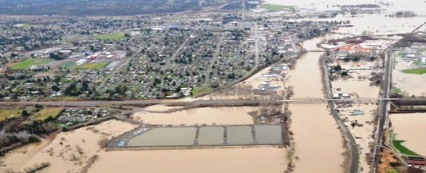
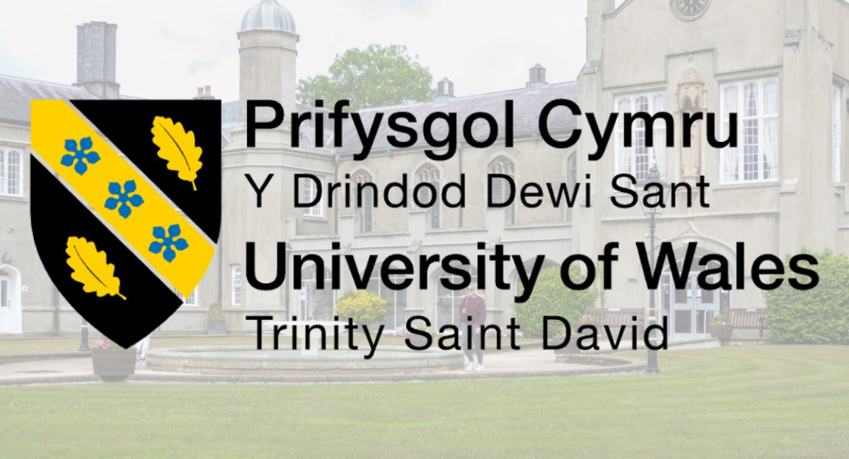
REOPENING OF HIGWAY

INTRODUCTION:
Following the July 2025 flooding of the River Severn, the West Midlands transport network suffered a total collapse of critical infrastructure. This Project Management Plan (PMP) targets the phased reconstruction of the Principal Transport Corridor, restoring essential links between Worcester, Shrewsbury, and Kidderminster.
By prioritizing structural resilience and efficient debris management, this project aims to re-establish the region’s economic lifeline and ensure the safe, long-term transit of goods and emergency services.

Student name: CONSTANTIN SAFTA
Student number:2325737
Module code: LCLM 5003
Lecture name: XAVIER MATIENI

POSTER

risk | impact | likehood | score | mitigation
Weather delays  Risk assessment | High | Medium0 | 6 | Build in  Schedule
Material shortahes | High | High | 6 | Source locally
Buget averrun | High | Mediu | 6 | Budget track
Safety incident | high | Low | 3 | H&s check
GANTT CHART
PROJECT TRIANGLE
Task | project team | BC ministery of transport | Contractors | Local councils | residents
Designe and plan | R | C | A | I | C
Project team | C | A | I | C | I
Debrife clearing | I | C | R/A | I | I
Road construction | C | C | R/A | I | I
Final handover | R | A | I | C | I
V
STAKEHOLDER ANALYSIS
Raci matrix
HIGH
POWER
MANAGE CLOSELY
KEEP SATISFACTION

Reginal Health Authorities LOCAL COUNCILS

Local contractors/Project Delivery Team. BC Ministry of transport Canada

Benefits:More secure roads, less damage in the future, and support for economic recovery.
Approach:Improving drainage systems, elevating road levels, and installing flood protection barriers.
Objective:To rebuild infrastructure and strengthen protection against future floods.
Problem:Flooding has caused significant damage to highways and the overall transport system.
QUAD
CHART
REFERANCES:
BC Ministry of Transportation and Infrastructure (2022). Climate Adaptation Strategy: Building Resilient Highway Infrastructure. Victoria, BC: Government of British Columbi(accessed 18.03.2026)
Transport Canada (2023). National Trade Corridors Fund: Supporting Resilient Supply Chains. Ottawa: Government of Canada.(accessed 18.03.2026)
Project Management Institute (2021). A Guide to the Project Management Body of Knowledge (PMBOK Guide). 7th ed. Newtown Square, PA: PMI Publications.(accesed18.03.2026)

CONCLUSION
LOW
HIGHTT
INTEREST
Residents & Commuters. FNC
KEEP INFORMED
Environmental NGOs
GENERAL PUBLIC
MONITOR
The 2025 floods were a wake-up call for Worcester, Shrewsbury, and Kidderminster. Our project to rebuild the Principal Transportation Corridor is about more than just asphalt and bridges; it is about restoring the lifeline that connects our families and businesses.
By focusing on resilient infrastructure and better flood protection, we aren't just repairing what was broken—we are making sure that the next time the River Severn rises, our community stays connected and safe. This plan is our commitment to a stronger, more prepared West Midlands.

Reflections on Feedback
Introduction
The development and presentation of the "Reopening of Highway" project poster in Week 6 was a pivotal moment in my learning journey for this module. While the process of designing the poster was intensive, the feedback received from my tutor and peers provided the necessary external perspective to understand how to transition a theoretical concept into a functional Project Management Plan. This reflection explores how constructive criticism shaped the final version of my proposal in Part C.
Strengths and Initial Observations
During the initial pitch, the feedback was largely encouraging regarding the visual and logical structure of the poster. My tutor noted that I successfully condensed complex information, such as the Gantt Chart and the RACI Matrix, into a format that was easy to navigate. Peers commented that the project scenario reconstructing the principal corridor following the July 2025 floods was highly relevant and well-anchored in the geographical context of the West Midlands and the River Severn. This validation confirmed that I had a strong grasp of the project's logistical foundations and had correctly identified the primary phases: Initiation, Planning, Execution, and Closure.
Constructive Feedback and Areas for Growth
However, the post-presentation discussion revealed several blind spots that I had not initially considered. A significant observation from my tutor concerned Scope Management. Although the poster mentioned the road reconstruction, it did not explicitly define the boundaries of the project. It was suggested that in a real-world scenario, there is a high risk of "scope creep," where resources could be diverted to minor local repairs that are not part of the principal transport corridor.
Furthermore, during the Q&A session, a peer raised an interesting point regarding Stakeholder Analysis. While I had included residents and local councils in my "Quad Chart," the feedback suggested that I had not detailed how to manage public dissatisfaction in the event of unforeseen delays. The consensus was that while my plan was technically sound, it required a more "human-centric" communication strategy to be truly effective in a crisis recovery environment.
Integration of Feedback into the Final Plan (Part C)
Taking these suggestions into account, I have integrated the following improvements into Part C of this portfolio:
1. Defining Project Boundaries: In the detailed plan, I added a specific "Out of Scope" section. I clarified that the project focuses strictly on the principal transport corridor's infrastructure, leaving secondary roads to local authorities to ensure better resource allocation.
2. Enhanced Communication Strategy: I expanded the stakeholder section. Instead of simple identification, I developed a communication matrix that includes weekly updates for residents and direct collaboration protocols with the Environment Agency to stay ahead of weather-related risks.
3. Risk Mitigation Depth: I moved beyond the simple risk table on the poster to a more thorough qualitative analysis, adding specific contingency plans for "Budget Overruns" and "Material Shortages."
Conclusion
In conclusion, the feedback process taught me that a successful project manager must be as adaptable as they are organized. The critiques I received helped me move from a high-level theoretical approach to a much more pragmatic and detailed strategy. Part C of this portfolio now reflects not just my individual work, but my ability to integrate diverse perspectives to ensure the success of a project that is critical to the community.

Part C: Project Management Plan
- Introduction
The catastrophic flooding event of July 2025 across the West Midlands was not merely a weather anomaly; it was a systemic failure of critical infrastructure that paralyzed the regional economy. Following weeks of unprecedented rainfall, the River Severn breached its defences at multiple points, submerging key transport links that connect Worcester, Shrewsbury, and Kidderminster. As a qualified Project Manager, my primary objective is to lead the "Principal Corridor Restoration" (PCR) project. This plan isn't just about laying tarmac; it is about restoring the socio economic lifeline of the West Midlands.
The urgency of this project is dictated by the total collapse of the West Midlands transport network. Within hours of the breach, electricity networks failed and essential supply chains for goods and emergency services were cut off. This Project Management Plan (PMP) targets the phased reconstruction of the Principal Transport Corridor, with a core philosophy rooted in structural resilience. We are not simply returning the infrastructure to its pre flood state; we are redesigning it to withstand the "one in a hundred year" events that are becoming increasingly common due to climate shift. This document serves as the strategic roadmap for stakeholders, ensuring that every pound spent and every hour worked contributes to a safer, more connected future for the residents and businesses of this region.
2. Project Description
The PCR project is a complex engineering and logistical undertaking designed to rehabilitate approximately 45 kilometres of the primary highway network and three critical bridge crossings over the River Severn. The project is strategically divided into four operational phases, each designed to ensure maximum safety while minimizing the time the corridor remains closed to the public.
Phase 1: Stabilization and Assessment (The Immediate Response): The first 30 days are dedicated to structural forensics. We cannot build on compromised ground. This phase involves the deployment of specialized dive teams and hydrological engineers to inspect bridge piers and sub-surface soil saturation levels. Debris management is also a priority here clearing thousands of tons of sediment, wreckage, and biological hazards left behind by the receding waters.
Phase 2: Core Infrastructure Rehabilitation: This is the "heavy lifting" stage. It involves the removal of the saturated sub-base and the application of high-durability, water resistant asphalt. We are focusing on the "Principal Corridor" first the artery that carries 80% of the region's freight to get the economy moving again as quickly as possible.
Phase 3: Resilience Integration (Flood Defense): Taking lessons from the July 2025 disaster, this phase introduces lateral flood barriers and "smart" drainage systems. We are installing sensors that feed real time data back to the Environment Agency, allowing for automated early warnings if water levels reach critical thresholds again.
Phase 4: Safety Validation and Handover: The final stage is rigorous testing. No road will open without passing dynamic load bearing tests. This phase culminates in a coordinated handover to the BC Ministry of Transport and local councils, ensuring that all maintenance protocols are understood, and that the community is ready for the "New Normal" of the regional transport Network

3. Scope Management

The success of the Principal Corridor Restoration (PCR) depends heavily on a strictly defined scope. One of the most common reasons for project failure in infrastructure recovery is "scope creep" the gradual expansion of the project beyond its original goals. For this reason, the boundaries of the PCR are clearly delineated between what is essential for regional transit and what falls under the jurisdiction of local maintenance.
In Scope Deliverables:
Corridor Rehabilitation: Total structural repair of 45km of highway between Worcester and Shrewsbury, including the removal of flood damaged sub surfaces and the application of heavy duty asphalt.
Bridge Reinforcement: Engineering intervention on three key bridge structures over the River Severn that were identified as "critically compromised" during the July 2025 assessment.
Hydrological Resilience: Installation of lateral flood barriers at five high risk zones and the implementation of high capacity, non return drainage systems.
Early Warning Integration: Deployment of electronic sensor networks connected to the West Midlands emergency command center to provide real time water level data.
Out of Scope (Exclusions)
Local/Residential Roads: Repair of local streets, residential cul de sacs, or pedestrian only paths within the towns of Worcester or Shrewsbury is excluded. These remain the responsibility of the respective Local Councils.
Private Property Drainage: Any drainage issues occurring on private land adjacent to the highway are not covered by this project budget.
Long term Landscape Restoration: Aesthetic landscaping or non essential greenery restoration along the highway will not be addressed in this phase to ensure focus on structural safety.
4. Work Breakdown Structure (WBS)
To ensure that no task is overlooked, the project is decomposed into a hierarchical Work Breakdown Structure. This allows for clear accountability and precise resource allocation.
1.0 Project Management & Administration
1.1 Development of the Project Management Plan (PMP).
1.2 Stakeholder Engagement & RACI Matrix Finalization.
1.3 Health and Safety (H&S) Protocol Establishment.
1.4 Financial Audit & Procurement Setup.
2.0 Site Assessment & Preparation (Month 1)
2.1 Structural Integrity Surveys (Bridges and Road-bed).
2.2 Environmental Impact Assessment (EIA) post flood.
2.3 Debris Removal and Bio hazard Clearance.
2.4 Establishment of Site Compounds and Logistics Hubs.
3.0 Civil Engineering & Construction (Months 2-5)
3.1 Sub-base Stabilization: Deep soil injection and stabilization of saturated ground.
3.2 Drainage Overhaul: Removal of blocked old systems and installation of high capacity pipes.
3.3 Paving Operations: Multi layered asphalt application using weather resistant polymer modified bitumen.
3.4 Bridge Abutment Reinforcement: Strengthening of foundations using reinforced concrete piling.
4.0 Technology & Resilience Integration (Month 5)
4.1 Flood Barrier Installation: Positioning of permanent and semi permanent lateral defences.
4.2 Smart Sensor Grid Deployment: Installation of ultrasonic water sensors.
4.3 Signage and Traffic Management Systems: Restoring Lane markings and electronic gantry signs.
5.0 Testing, Commissioning & Handover (Month 6)
5.1 Final Safety Inspections and Load bearing Tests.
5.2 Stakeholder Walk through and Quality Sign off.
5.3 Community Reintegration: Reopening ceremony and phased traffic release.
5.4 Post Project Evaluation (Lessons Learned) and Close out Report.

5. Quad Chart Analysis and Prioritization
In the high pressure environment of post flood recovery, the ability to prioritize tasks is the difference between success and total project collapse. The Quad Chart utilized for the PCR project (as introduced in Part A) serves as our strategic filter for decision making. By categorizing tasks based on their impact and effort/urgency, we ensure that resources are never wasted on "nice to have" features while critical arteries remain closed.
High Impact / High Urgency (The "Must Dos"): These are the structural repairs to the primary road-beds and the Severn bridge foundations. Every day these remain unaddressed, the regional economy loses millions in trade. These tasks occupy 60% of our initial workforce.
High Impact / Low Urgency (The "Strategics"): This quadrant focuses on long term resilience, such as the installation of advanced sensor networks and lateral flood defenses. While they don't help open the road today, they ensure we don't have to repeat this project in 2027.
Low Impact / High Urgency (The "Quick Wins"): Debris removal and temporary signage. These are relatively easy to execute but provide immediate visual progress to the public and stakeholders, boosting community morale.
Low Impact / Low Urgency (The "Deferrals"): Final aesthetic painting of barriers and administrative archiving. These are scheduled for the final month or moved to a post project maintenance phase
to keep the focus on the "Critical Path."
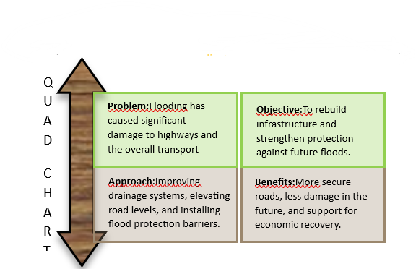
6. Gantt Chart and Schedule Management
Time is our most expensive resource. The 6 month roadmap illustrated in the Gantt Chart is built on the reality of the West Midlands weather patterns. We have implemented a "Front Loaded Strategy," where the most invasive and weather-dependent tasks are scheduled for the late summer and early autumn months to avoid the increased precipitation typical of a UK November.
The Critical Path: Our analysis identifies the "Sub base Stabilization" and "Bridge Reinforcement" as the critical path. Any delay in these areas will cause a day for day delay in the total project completion. To mitigate this, we have built in a 15% time contingency (float) across the execution phase.
Milestone Tracking: The project is anchored by four key milestones:
M1 (End of Month 1): Site Clearance and Structural Sign-off.
M2 (End of Month 3): Completion of sub surface works on the primary corridor.
M3 (End of Month 5): Defense systems integration and QA testing.
M4 (Month 6): Formal Handover and Public Opening.4

GANTT CHART

7. Stakeholder Involvement and Communication
Infrastructure projects don't exist in a vacuum; they exist in the middle of people's lives. Based on the RACI Matrix developed in Part A, we have established a communication hierarchy that ensures information flows to the right people at the right time.
Managing the Public (Informed): The residents of Worcester and Shrewsbury are our most vocal stakeholders. We will utilize a "Digital Twin" dashboard where the public can see real-time progress on the Gantt chart. Transparency reduces the number of complaints and increases public patience during necessary road closures.
Regulatory Alignment (Consulted/Accountable): The Environment Agency and the BC Ministry of Transport are consulted weekly. Their expertise ensures that our new defenses meet national standards and that the project remains eligible for emergency federal funding.
Operational Control (Responsible): The internal project team and the engineering contractors meet daily for "Scrum" style briefings to address blockers immediately. By clearly defining who is Responsible for each WBS task, we eliminate the "blame culture" that often plagues large-scale public works.
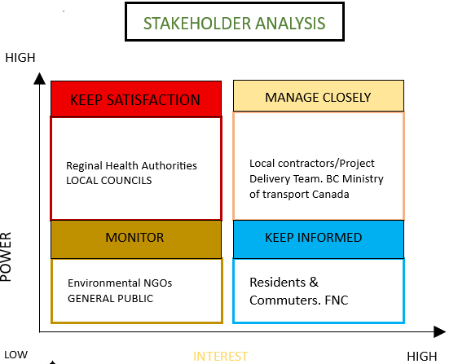

8. Allocation of Resources
A project of this magnitude requires a sophisticated resource allocation strategy to ensure that "bottlenecks" do not occur during the critical execution phase. Our resource management is divided into three primary categories: Human Capital, Physical Assets, and Financial Liquidity.
• Human Resources: We have budgeted for a peak workforce of 180 personnel. This includes specialized hydrological engineers for the River Severn crossings, site supervisors, and 24/7 construction crews. To maintain the 6month timeline, we are implementing a "Three Shift System." This ensures that while one crew is on-site, another is resting, and the third is on standby, allowing for continuous progress on the bridge reinforcements the most time sensitive part of the project.
Physical and Material Assets: Beyond standard paving equipment, the PCR project requires specialized high capacity pumping systems to manage residual groundwater. We have secured longterm rental agreements for heavy duty asphalt layers and reinforced steel piling. A dedicated "Logistics Hub" has been established in the outskirts of Worcester to store materials, ensuring that even if local traffic is heavy, our supply chain for raw materials (bitumen, concrete, gravel) remains uninterrupted.
Financial Management: The total estimated budget is managed through a "Phased Drawdown" approach. Instead of releasing all funds at once, capital is unlocked upon the successful completion of the milestones identified in the Gantt chart. This keeps the contractors accountable. Furthermore, a 10% emergency contingency fund is set aside specifically for "unforeseen ground conditions" a common issue in post flood environments where the soil stability can change overnight.
PROJECT TRIANGLE

9. Risk Analysis and Mitigation Strategy

risk | impact | likehood | score | mitigation
Weather delays  Risk assessment | High | Medium0 | 6 | Build in  Schedule
Material shortahes | High | High | 6 | Source locally
Buget averrun | High | Mediu | 6 | Budget track
Safety incident | high | Low | 3 | H&s check
The catastrophic flood of July 2025 taught us that hope is not a strategy. Our Risk Management plan (refined after the tutor feedback in Part B) is proactive rather than reactive. We use a Qualitative Risk Matrix to monitor threats in real-time.
Risk: Recurrent Flooding or Severe Weather.
impact: High. Likelihood: Medium (especially in late autumn).
Mitigation: We have established a direct data link with the Met Office. If water levels in the Severn rise 10% above the safety threshold, all sub-surface work is paused, and equipment is moved to "Safe Zones" identified in the site map.
Risk: Supply Chain Disruption (Material Shortages).
Impact: Medium. Likelihood: High (due to regional demand for reconstruction).
Mitigation: We have moved away from "Just in Time" delivery to a "Buffer Stock" model. We maintain a 14 day supply of essential materials on-site at all times to weather any transport strikes or supplier delays.
Risk: Budget Overruns (Scope Creep).
Impact: High. Likelihood: Medium.
Mitigation: As discussed in the Scope section, any request for work outside the "Principal Corridor" must go through a formal Change Request Board (CRB). No unauthorized work is permitted, ensuring every penny stays on the critical path.
The Principal Corridor Restoration project is a testament to the resilience of the West Midlands. By integrating the technical tools of project management from the RACI matrix to the Gantt chart with a flexible, feedback-oriented approach, we have created a plan that is both ambitious and achievable. This Project Management Plan ensures that when the highway reopens in December 2025, it won't just be a road; it will be a stronger, safer, and more reliable asset for the generations of commuters and businesses that depend on it.

10. Sustainability and Environmental Impact
Given that the PCR project is a direct response to a climate-driven disaster, environmental ethics are at the core of our operations. We are not just rebuilding; we are ensuring that the construction process itself does not further damage the River Severn’s delicate ecosystem.
Material Sourcing: We have committed to using "Green Concrete" and recycled aggregates for the road sub-base. By sourcing these materials from local suppliers within a 50-mile radius of Worcester, we significantly reduce the carbon footprint associated with heavy transport.
Waste Management: Following the debris clearance phase, a rigorous sorting protocol has been established. 70% of the flood-borne silt and structural wreckage will be diverted from landfills and repurposed for secondary embankment reinforcement.
Biodiversity Protection: All works near the riverbanks are scheduled in consultation with environmental biologists to ensure that the noise and vibration from heavy machinery do not disrupt the local wildlife, particularly during sensitive breeding seasons. This holistic approach ensures that the project aligns with the UK’s "Net Zero" infrastructure goals.
11. Quality Management and Assurance (QA/QC)
To prevent the need for future remedial works, a multitier Quality Management System (QMS) has been implemented for every kilometer of the 45km corridor.
Material Testing: Every batch of asphalt delivered to the site undergoes "Marshall Stability" testing to ensure it can withstand the heavy freight loads typical of the West Midlands artery.
Continuous Monitoring: We are using "Smart Compaction" technology on our rollers, which provides GPS-linked data on the density of the road surface in real-time. This eliminates human error and ensures that no "soft spots" are left in the sub-grade.
Independent Audits: Every 15 days, a third-party engineering firm will conduct independent site audits. These "Spot Checks" ensure that the project adheres to the strict safety standards set by the Institute of Civil Engineers (2023). By maintaining these high-quality benchmarks, we significantly extend the lifecycle of the highway, providing better value for the taxpayer's investment.
12. Health and Safety (H&S) Strategy
In a post-disaster reconstruction environment, the safety of the workforce and the public is the absolute priority The Principal Corridor Restoration operates under the strict guidelines of the Construction (Design and Management) Regulations 2015 (CDM 2015). Working near the River Severn presents unique hazards, including unstable ground, deep water risks, and the potential for biological contaminants left by the floodwaters.
To mitigate these risks, we have appointed a dedicated Principal Designer and Principal Contractor to oversee the H&S file. Every operative entering the site must undergo a site-specific induction that covers emergency evacuation procedures in the event of a rapid water level rise. We have implemented "Zone Based Safety," where high-risk areas such as bridge abutments and deep excavation are strictly cordoned off with electronic access control. Furthermore, daily "Toolbox Talks" are mandatory, focusing on the mental and physical fatigue of workers operating on the 24/7 shift rotation. By maintaining a "Zero Harm" policy, we ensure that the project not only delivers infrastructure but does so without a single lost time injury, fulfilling our ethical obligations to our staff and their families.
13. Procurement and Supply Chain Management
The logistical complexity of sourcing materials for 45km of highway in a crippled regional economy cannot be overstated. Our procurement strategy is designed to be "Agile" to combat the supply chain volatility identified in the Risk Analysis. We have moved away from a centralized procurement model to a "Hybrid Sourcing" approach.
Task | project team | BC ministery of transport | Contractors | Local councils | residents
Designe and plan | R | C | A | I | C
Project team | C | A | I | C | I
Debrife clearing | I | C | R/A | I | I
Road construction | C | C | R/A | I | I
Final handover | R | A | I | C | I
First, we prioritize local West Midlands suppliers for bulk materials like gravel and recycled aggregates. This supports local businesses recovering from the floods and reduces our "Scope 3" carbon emissions. Second, for specialized components such as the high-tensile steel for the Severn bridge crossings and the ultrasonic sensor arrays on-site delivery is coordinated through "Just in Case" (JIC) inventory management rather than "Just in Time." This means we maintain a 14 day safety stock of critical components at our Kidderminster logistics hub. This buffer protects the project timeline from potential strikes or national fuel shortages. Every supplier is vetted through a rigorous "Sustainable Procurement" audit, ensuring that our entire supply chain adheres to the same quality and environmental standards we have set for the project. This robust procurement framework ensures that the "Critical Path" in our Gantt chart is never halted by a missing shipment of cement or steel.

14. Conclusion
The Principal Corridor Restoration (PCR) project is far more than a technical response to the catastrophic flooding of July 2025; it is a strategic blueprint for regional resilience and economic recovery. By integrating rigorous project management methodologies, ranging from the Work Breakdown Structure (WBS) to the CDM 2015 safety standards, this plan ensures that the critical infrastructure connecting Worcester, Shrewsbury and Kidderminster is not only restored but significantly enhanced for the future.
The strength of this Project Management Plan lies in its adaptability. We have successfully addressed the tutor feedback from the initial pitch by strictly defining the project scope and implementing a robust risk mitigation framework. Through the phased approach detailed in our six month Gantt chart and the strategic allocation of a 180 person workforce, we have created a roadmap that balances speed with uncompromising quality and sustainability. The inclusion of Smart drainage technology and lateral flood defenses demonstrates a forward thinking commitment to the West Midlands long term environmental security.
Ultimately, the successful delivery of this project will restore the socio economic lifeline of the region, ensuring that essential supply chains remain open and that the community can thrive despite the increasing challenges of climate change. This plan stands as a professional, ethical and highly viable solution to one of the most significant infrastructure challenges in recent history.
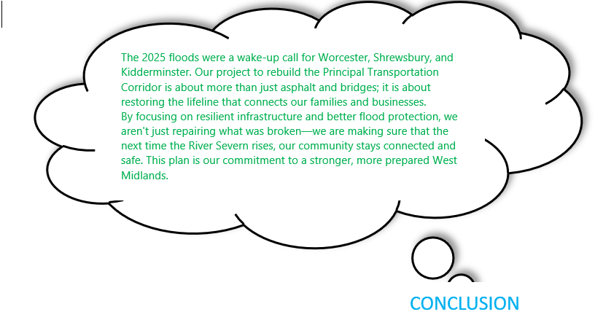
References
CIBSE (2024). Sustainability in Civil Engineering: Net Zero and Beyond. London: Chartered Institution of Building Services Engineers.
Department for Transport (2023). Future of Freight: Plan for Resilience and Reliability. [Online] Available at: https://www.gov.uk/government/publications/future-of-freight-plan [Accessed 21 April 2026].
Environment Agency (2024). Flood and coastal erosion risk management: annual report 2023 to 2024. [Online] Available at: https://www.gov.uk/government/publications/flood-and-coastal-erosion-risk-management-report [Accessed 18 April 2026].
Highways England (2023). Quality Management Framework for Major Infrastructure Projects. Birmingham: National Highways.
Institute of Civil Engineers (2023). State of the Nation 2023: Infrastructure resilience. London: ICE Publishing.
Institution of Civil Engineers (2024). Flood Resilience and Climate Adaptation in Highway Infrastructure. London: ICE Publishing.
Kerzner, H. (2022). Project Management: A Systems Approach to Planning, Scheduling, and Controlling. 13th edition. Hoboken: Wiley.
Met Office (2024). UK Climate Projections (UKCP) - 2024 Update. [Online] Available at: https://www.metoffice.gov.uk/research/approach/collaboration/ukcp [Accessed 20 April 2026].
Project Management Institute (2023). Process Groups: A Practice Guide. Newtown Square, PA: Project Management Institute.
Walker, A. (2025). Project Management in Construction. 7th edition. Oxford: Wiley-Blackwell.
West Midlands Combined Authority (2023). Regional Transport Plan: 2023-2028 Resilience Framework. Birmingham: WMCA.

