

Student Name: Shubhamsingh Satyendrasingh
Bhadauriya

Student ID:2510990

Module Name: Strategic Management

Module Code: LCMB7003

Lecturer’s Name: Amare Desta

Term 2

Section – 1
Introduction –
This report analyses the strategic position of Reliance retail Limited, one of India’s largest retail chains. It shows how the company operates in Indian and how external factors affect the business, and how it maintains competitive advantage in a dynamic business environment. The study includes both internal and external factors via using strategic tools like PESTLE, VRIO, Balanced Scorecard, and Ansoff’s Matrix. It also explores Reliance’s business and corporate strategies, including cost leadership and diversification. Additionally, how CSR activity improve company reputation and provides recommendations for future growth and improved global competitiveness.

1.Organisational Context and Overview
Reliance Industries Limited is one of the largest and most diversified companies in India. It was founded in 1966 by Dhirubhai Ambani, with earlier beginnings in yarn trading in Mumbai in 1957. Initially, it focused on textiles, which helped establish its presence in the Indian market (Reliance Industries Limited, n.d.).
In the early 1980s, the company diversified into petrochemicals and set up a polyester filament yarn plant in Patalganga. This marked the beginning of major expansion into sectors such as oil refining, natural gas, and energy. In 2000, it built the world’s largest refinery at Jamnagar and later discovered natural gas in the Krishna-Godavari basin. It also entered the telecommunications sector in 2002 (Reliance Industries Limited, n.d.).
Under Mukesh Ambani’s leadership, Reliance expanded further into retail and digital services. The launch of Jio Platforms in 2016 transformed India’s telecom industry by offering low-cost internet services and gaining millions of users. Today, Reliance operates across oil and chemicals, retail, digital services, financial services, and green energy, making it one of India’s most valuable companies (Reliance Industries Limited, n.d.).
Mission -
To invest in businesses of the future that contribute to the growth and development of the nation while creating value for stakeholders (Board Infinity, 2025).
Vision –
To lead India’s journey towards a digital and sustainable future through continuous innovation and strategic partnerships (Board Infinity, 2025).
Reliance’s industry use diversification where it earns money from traditional businesses such as oil refining and petrochemicals, and reinvests the profits into new businesses like telecom, Jio Finance, and digital services, which helps it maintain sustainable growth (Shastri, 2025).
Reliance has different competitors in different industries. For Energy & Petrochemicals, it has Indian Oil Corporation (IOC), Bharat Petroleum (BPCL), ONGC, Nayara Energy. In Retail, it has Tata Group (Trent), Aditya Birla Group (ABFRL, More Retail), Amazon India, Walmart-owned Flipkart (online). In Telecom & Digital Services, there are Bharti Airtel and Vodafone Idea (Board Infinity, 2025).
Reliance is at top ranked in retail stores in India where they sell multiple formats including grocery, fashion, electronics, and pharmacy, by having 19,340 stores (Reliance Industries Limited, 2025) and more than 300 million registered customers. Reliance is dominant in the sector and currently operates in 4,290 pin codes. Also, it has JioMart subsidiary which is a quick retail delivery company (The Economic Times, 2025).
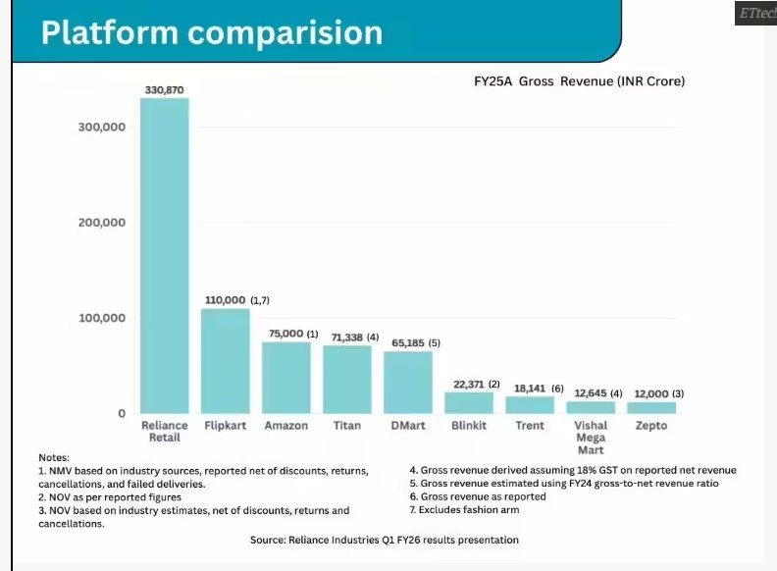
(The Economic Times, 2025)

2.External and Internal Environment Analysis
2.1 PESTLE –
PESTEL analysis is a strategic tool for examining external factors such as Political, Economic, Social, Technological, Environmental and Legal factors, which provide information about opportunities and threats for the company and help the company make decisions accordingly(Marinović-Matović and Arsić, 2020).
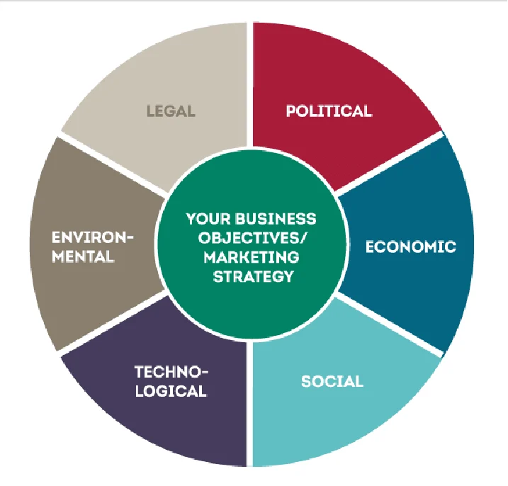
(Pinnegar et al., 2019)

Political Factors –
In India, the government allows only 51% FDI (Foreign Direct Investment) in multi-brand retail stores with government approval, which makes market entry difficult for global retailers and gives an advantage to domestic companies in competition (Kundgir, 2024), but MNCs still have a chance to enter the market with approval. Also, the Make in India scheme is boosting local manufacturing, which reduces the price of products by improving production and supply chains (IndianRetailer, 2024), and GST implication has made the tax system simpler by replacing many different taxes with one single tax, which helps companies reduce compliance burden (IndiaFilings, 2025). All these elements work for Reliance Retail and provide benefits in their retail business.

Economic Factors –
India is the world’s 3rd-largest retail market and the market is expected to grow from US$ 952 billion (2024) to US$ 1.6 trillion (2030) (India Brand Equity Foundation, 2025). Also, rising disposable incomes, and increasing middle class expenditures with increasing urbanization, and strong economic growth in India, along with controlled inflation, create demand for food and other services, which increases the retail business (India Brand Equity Foundation, 2025). Also, increasing internet infrastructure helps people buy products easily with a click, and all of these factors work in favour of the retail business. However, government allow 100% FDI in online business (India Brand Equity Foundation, 2025) Increasing digital adoption, strong FDI-backed global competition, and aggressive pricing strategies are creating intense competition among Amazon, Flipkart, and Reliance in India’s online retail market.

Social Factors –
Rising education level in India and changes in attitude in shopping create a demand for smart shopping options. Instead of buying products from older stores, people now prefer to buy products from trustful and branded stores which follow all the rules and regulations (Hingad et al., 2022) . Also the cultural celebrations and religious festivals increase the demand of new clothes, grocery and different products, where retail stores are the place people can buy everything at a single space and also get good discounts and create opportunity for retail business. (Valliyammai and Prashanthi, 2024).
Hofstede's Cultural Dimensions –

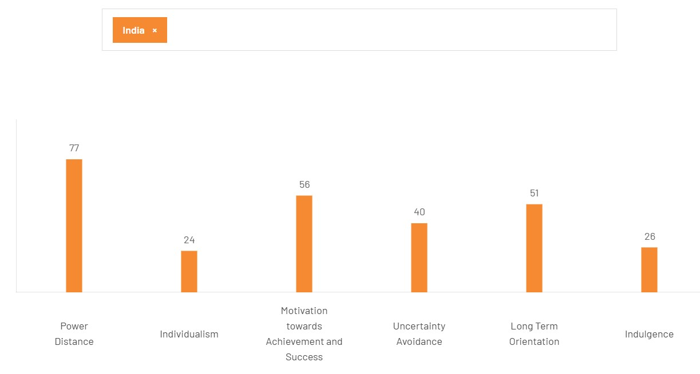
(The Culture Factor Group, 2025)

Hofstede’s Cultural Dimensions Theory helps explain how cultural characteristics in India influence retail business strategy. India’s Power Distance score is 77, which indicates that people accept hierarchical structures. Individualism score is 24, which shows that in India people usually take decisions according to group and family, so companies should design advertisements, offers, and schemes by considering this factor. Motivation towards Achievement and Success is 56, which shows India is a moderately masculine society. Uncertainty Avoidance is 40, which means customers tend to avoid risk and prefer branded and reliable products. Long-Term Orientation is 51, which indicates people think about future outcomes and make decisions accordingly. Finally, Indulgence is 26, which shows that people are very careful with spending.
- This model says how changes in culture differences influence the action of customers in terms of buying behavior and decisions, which helps retail companies like Reliance Retail design better marketing strategies and customer offerings.

Technological Factors –
India is a growing economy, and it has a well-organized IT infrastructure. India has the world’s cheapest internet, where 1 GB data cost around Rs. 7.38, and the government is also supporting it through Digital India by increasing connectivity and improving affordability (India Brand Equity Foundation, 2026).
Therefore, almost all businesses are using advanced technology and AI tools in the business and India is leading AI and technology hub where all the business are using AI and application in their business to make it easy for the customers people now prefer to buy product online instead of stores, which allow them to compare product and price online (Meta, 2026). In this scenario, retail store needs to sell product in both places like online and in store where Reliance dominant by using low price strategy and quick delivery application, which gives it a competitive advantage in the retail industry.

Environmental Factors –
Environmental Factors affect production and the social value of the company in the market. In India, companies must follow all the rules and regulation by The Central Pollution Control Board (CPCB) including Environmental permits for operations (India Briefing, 2024). Also, growing consumer awareness about environmental protection companies use recycled plastic content instead of single use plastic and also all of these factors affect the retail companies like Reliance Retail in business and pressure it to use eco-friendly packaging.

Legal factors –
According to the Ministry of Labour & Employment (Government of India, n.d.), all businesses must follow the rules and regulations according to their applicability. Companies follow employment law to ensure that all employees are treated equally and receive the same benefits according to the law. Also, they have to make sure that health and safety law is followed to ensure safety of staff and customers in the venue. Additionally, India has a well-organized data protection act which makes sure that data is safe. If any company breaches that law and is found guilty, it has to face legal consequences. To avoid all of these, companies ensure legal factors before entering the business in the country (India Briefing, 2024). Moreover, consumer protection act 2019 allow consumers to protect their interests against unfair trade practices (Legal Veda, n.d.). Companies must follow these legal factors and they must understand the consumer right and law before entering in business.

2.2 The critical success factors and strategic challenges

success factors –
- On the basis of the PESTEL analysis, Reliance has understanding of the social factor of India and it uses in their retail business during the festival times and it has culture advantages, by understanding mindset of Indian people Reliance compare its prices with rivals and use a price sensitivity strategy in its stores. Also, the retail business is very competitive, and by making products affordable and low cost, Reliance is leading its retail business.
- It has technological advantage and has good supply chain with many small subsidiaries like Reliance Fresh, Reliance Digital and online platforms like AJIO which help to compete with competitors. Also, Reliance has a strong supply chain and its products available online and offline which supports its retail business.

Challenges factors –
- On online Platform, 100% FDI can be a challenge for it because of availability of rival like Amazon and Flipkart can beat it in online retail business.
- Maintain profitability while using low – price strategy is a challenge for the company but it also gives a competitive advantage in its industry.

2.3 - Internal environment Resources, capabilities, and core competencies.

Resources
- Financial Resources
Reliance Retail is a part of Reliance Industries, which is holding $125 billion revenue (Forbes, 2026), and Reliance Retail has recorded a gross revenue of $39.9 billion (Reliance Industries Limited, 2025). which shows the company is financially very strong.
- Physical Resources
Reliance Retail has 19,340 stores (The Economic Times, 2025), which makes it India’s largest retail chain and also it has a wide network of kirana (small and local stores) partners to provide excellent service to end consumers.

- Supply Chain Resources
It has a good supply chain, According to Logistics Outlook (2022), Reliance Retail invested ₹30,000 crore in FY22 to strengthen its supply chain capabilities. and it has doubled its capacity from 11.1 million sqft to 22.7 million sqft in a year(Logistics Outlook, 2022).

- Product and Diversification Resources
It has diversification in its stores, where Reliance also sells its own manufacturing products in different segments such as Consumer Electronics, Grocery, Consumer Brands, and Fashion and Lifestyle (Reliance Industries Limited, 2025).
These financial resources give it an advantage and help the company easily survive in economic, financial, or pandemic situations.

Capabilities
- It has doubled its warehouse space capacity from 11.1 million sq. ft. to 22.7 million sq. ft. within a year (Logistics Outlook, 2022). It has online platforms like JioMart which allow it to sell products online, and it has more than 600 dark stores to support faster deliveries. Also, it has provided cost advantages to customers by waiving platform and delivery fees (Reliance Retail, 2025).
With having large warehouse capacity and having an online platform, it gives it an advantage of multiple platform business.

Core competency
Reliance has a strong supply chain and a wide range of network, which gives it a core competency. Also, Reliance is a domestic company and it has a well-established reputation. With that, Reliance makes products cost-effective and targets more and more customers by using cost-effective advantages, and that makes it different from others(Reliance Retail, 2025).

2.4 - VRIO (Value, Rarity, Imitability, Organization) framework
VRIO analysis is a tool used in strategic management to evaluate a company’s internal resources and capabilities. In this framework, companies use four factors: Value, Rarity, Inimitability, and Organization, and based on these, they analyse long-term competitive advantage (Knott, 2015).
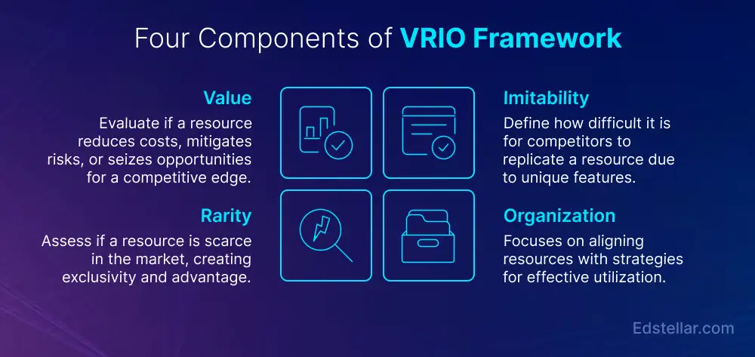
(Edstellar, 2026)

Capability | Value | Rarity | Imitability | Organization | Impact
Financial Strength | YES | YES | YES | YES | Sustain competitive advantage
Supply Chain & Logistics | YES | YES | YES | YES | Sustain competitive advantage
Physical Store Network | YES | YES | YES | YES | Sustain competitive advantage
Digital Capability | YES | NO | NO | YES | Competitive Parity
Brand Reputation | YES | YES | YES | YES | Sustain competitive advantage
(Self-Create)

- Reliance has strong financial backing with Reliance Group and also, Reliance Retail is India’s number one retail company with $39.9 billion revenue in 2024–25. It has shown profit growth of 8.6% year on year, showing it has a sustained competitive advantage in the retail business (Reliance Retail, 2025). Also, it has invested ₹30,000 crore in FY22 for supply chain and has the biggest physical store network in India. Also, the brand reputation is very high due to customer satisfaction (Reliance Retail, 2025). Also, Reliance’s business model is difficult for other companies to copy, making it rare in the market, and it also presents strong organisational support behind it.

- However, the digital capability of Reliance Retail is valuable and well organised, but not rare, and many other rivals like Zepto, Blinkit, and Swiggy Instamart also have the same capability, and any new company can also copy it.

3. CSR and Sustainability –
CSR means Corporate Social Responsibility. Companies do CSR activities to show their responsibility toward society. Reliance Retail does all its CSR activity under Reliance Foundation, which is focusing on inclusive and sustainable development across India (Reliance Foundation, n.d.).
Reliance Foundation is involved in many development activities in India, and Mrs. Nita Mukesh Ambani is the Chairperson of it. It has a rural development programme where it uplifts rural people by improving water, nutrition, and jobs in villages so that people can earn better livelihoods (Reliance Foundation, n.d.). It also has a healthcare programme where it runs Community Medical Centres and the ASMAN Project: Alliance for Saving Mothers and Newborns, which provides free medical facilities (Reliance Foundation, n.d.).
In addition, education, art and culture, sports development, environment and animal welfare, disaster management, and women empowerment programmes are the main parts of its CSR activities (Reliance Foundation, n.d.), where it connects with 86 million lives and spends around $252.2 million in FY 2024–25 (Reliance Industries Limited, n.d.).
By doing these activities, the company creates value in the market and increases trust among people toward the company. Also, Reliance has a wide range of products and services, and CSR indirectly works as a marketing campaign for the company, where the company uses its banner and name to promote its brand, which helps the company create demand for its products and services through these activities.
Reliance understands growth and development, and by developing rural areas and educating people, it helps the nation build a bright future, which ultimately supports India’s economic progress and creates a more sustainable future workforce for the country and the business environment.

4. Comprehensive and holistic view of the organization - Balanced scorecard
The Balanced Scorecard is a strategic management tool that was introduced by Robert S. Kaplan and David P. Norton in 1992 to evaluate organizational performance by analyzing financial, customer, internal processes, and learning and growth perspectives (Madsen, 2025).

Financial Prospective –
Objectives:
The Financial Prospective provide information of finance achievement of the company by analysis its year-on-year revenue growth and compare it with industry growth, operation cost, and overall financial performance.
Key performance indicators (KPIs):
- Year-on-year gross profit growth, where Reliance Retail has recorded 8.6% year-on-year (Reliance Industries Limited, n.d.).
- Year-on-year gross revenue growth, where its gross revenue growth recorded 7.9% year-on-year (Reliance Industries Limited, n.d.).
- EBITDA margin increased by 10 bps (Reliance Industries Limited, n.d.).
Targets:
Reliance retail maintains steady growth and continues improving its financial performance by improve profit growth and it has strong and close to the industry growth rate. Also continue increasing EBITDA FY 2023–24 it showed EBITDA of INR 23,108 crore and current FY 2024–25 it has recorded INR 25,094 crore (Reliance Industries Limited, n.d.).
Initiatives:
Reliance retail focuses on expanding its business to increase its profit by increasing retail stores in country (Reliance Industries Limited, n.d.).
Overall, the company is growing and improving its operations. Profit growth is strong but slightly below the industry, showing a strong position in retain business.

Customers –
Objectives:
In term Customers prospective, it presents the value and trust of the company in the market and to analyses it management consider product satisfaction, product quality, service reliability, pricing, brand loyalty and feedback.
Key performance indicators (KPIs):
- Reliance Retail has strong customer base of 349 million registered customers (Reliance Retail Limited, n.d.).
- Easy Return , replacement and refund policy (Reliance Retail Limited, n.d.).
- 4 times increment in its orders JioMar (The Economic Times, 2026).
- Some research comparing Reliance Trends and Pantaloons found that customers preferred Reliance Trends, indicating stronger customer preference and perceived value (Bansal and Kaur, 2021).
Targets:
Reliance maintains strong customer trust and value by improving product satisfaction and service reliability, and increasing the customer by using JioMart, and strengthen brand loyalty and perceived value in the market.
Initiatives:
Use the easy return and replacement policy to build trust and encourage repeat purchases, promote JioMart and improve online experience to support continued order growth, and focus on product quality, pricing, and customer feedback to increase customer satisfaction and brand loyalty.
Overall, customer satisfaction score is not directly disclosed, but increasing JioMart orders show a good reputation among people. It has a large number of registered customers, showing a strong customer base for the company.
Internal Business Processes –
Objectives:
The internal business processes perspective focuses on how effectively an organization manages its operations and deliver value to customers. Internal Business Processes evaluates supply chain efficiency, inventory management, and service delivery.
Key performance indicators (KPIs):
- Well-established and strong retail chain connections with its suppliers and using advance technology and warehouse software which help it manage inventory by sharing product information with warehouses (Economic Times, 2023).
- By using Omnichannel, partnerships with local stores for a fast delivery network (Economic Times, 2023).
Targets:
Reliance aim to well-established retail chain and strong connections to ensure smooth operations and uses advanced technology for inventory management and enhance delivery speed through partnerships with local stores, which provides a fast delivery network.
Initiatives:
The company uses advanced technology and warehouse systems to manage inventory and share real-time product information across locations. It also strengthens its omnichannel model by partnering with local stores to enable faster delivery. In addition, it follows dynamic assortment optimization by regularly updating store product space based on performance and customer demand.
Overall, Reliance uses automation in its supply chain and adds or removes products based on their performance.
Learning and Growth –
Objectives:
Organizational capacity indicates the survival and growth capacity of an organization by analyzing employees, research and development, and adaptation capacity.
Key performance indicators (KPIs):
- Equal Opportunity Policy (Reliance Industries Limited, n.d.).
- Investment in training and development (Reliance Industries Limited, n.d.).
- Adoption of advanced technology, and implementing AI, which gives it a competitive advantage (The Economic Times, 2025).
- New brand and product development (Reuters, 2022).
Targets:
Strengthen organizational capacity by improving employee development and trust, continue adopting advanced technologies such as AI, and keep developing new brands and products to sustain business growth and competitive advantage.
Initiatives:
- Support equal opportunity and fair treatment through the Equal Opportunity Policy and invest in employee training to make workers more competent.
- Move from computers to implementing AI and advanced technologies across the business to improve efficiency and competitiveness.
- Develop new brands and products and launch new business formats like Azorte in the mid-premium fashion segment to secure long-term growth.
Overall, the company has strong organizational capacity through employee development, technological advancement, and developing new products, which provide it with a competitive advantage in its segment.

5.Strategic Choices and Implementation –

Business Level Strategy - Cost leadership strategy
- Reliance Retail mainly follows a cost leadership strategy, where the company focuses on offering products at lower prices using its strong supply and price negotiation strategy where reliance takes big discount on bulk buying and making product affordable in the store (Times of India, 2014). This helps the company attract price-sensitive customers in India. Also, with the wide retail network and digital platform like JioMart support low-cost operations and efficient distribution. Also, reliance has good supply chain where its Omni-channel strategy helps it to give fast deliver network.
- To make products affordable, Reliance directly buys products from manufacturers, reducing commission costs and passing the savings on to customers in the form of lower prices. Additionally, Reliance promotes agricultural products and provides benefits to farmers by buying vegetables and food items directly from them (Markhub24, n.d.).
- Reliance Retail follows a backward integration model , where instead on depend on the suppler reliance developed its own supply chain and manufacturing like Campa and Sosyo, alongside in-house brands like Enzo (home care) and Good Life (staples) (Tandon, 2025).with that it has also require retail and wholesale business and the logistics and warehousing business from Future Group to make its product affordability To make products affordable, Reliance directly buys products from manufacturers, reducing commission costs and passing the savings on to customers in the form of lower prices. Additionally, Reliance promotes agricultural products and provides benefits to farmers by buying vegetables and food items directly from them (Markhub24, n.d.).

Corporate Level Strategy - Diversification strategy
- At the corporate level, Reliance Retail follows a diversification strategy. The company operates in multiple segments like grocery, fashion, electronics, and digital retail, and it has many brands and products in its segments. In grocery, it has Reliance Fresh, which provides fresh products; in fashion, it has Reliance Trends; and for electronics, it has Reliance Digital, which makes it a one-stop shopping place and reduces risk in its business (Markhub24, n.d.).
- Also, Reliance has multiple platforms like Reliance stores and online platforms like JioMart and Ajio, where the company wants to shift its focus from aggressive expansion to product growth and allow convenience to customers in shopping (Markhub24, n.d.).
- However, the company has limited international expansion and has no retail stores outside India.

Recommended Strategy
- The most suitable strategy for Reliance Retail is a combination of cost leadership. Cost leadership should remain the core strategy because Indian consumers are highly price sensitive.
- One of the biggest opportunities which company has to expand its business outside of the country. Reliance have well stablished and good management and they have understanding of the retail business.
- In the retail business market and via using its online platform , reliance can expand it business in European country and give competition to local retail store.
Analysis –
Reliance has wide range product availability with strong management and supply chain, also India’s price sensitivity environment gives it an edge to gain competitive advantage over its rivals like Dmart, TATA, and V-Mart. Additionally, Reliance Retail needs to explore new markets by expanding its business in other countries.

6.Strategic Evaluation and Recommendations
Ansoff’s Matrix –
Ansoff’s Matrix is a strategic management tool developed by Harry Igor Ansoff which helps organizations visualize their current product offerings and markets, enabling them to consider future growth strategies systematically.
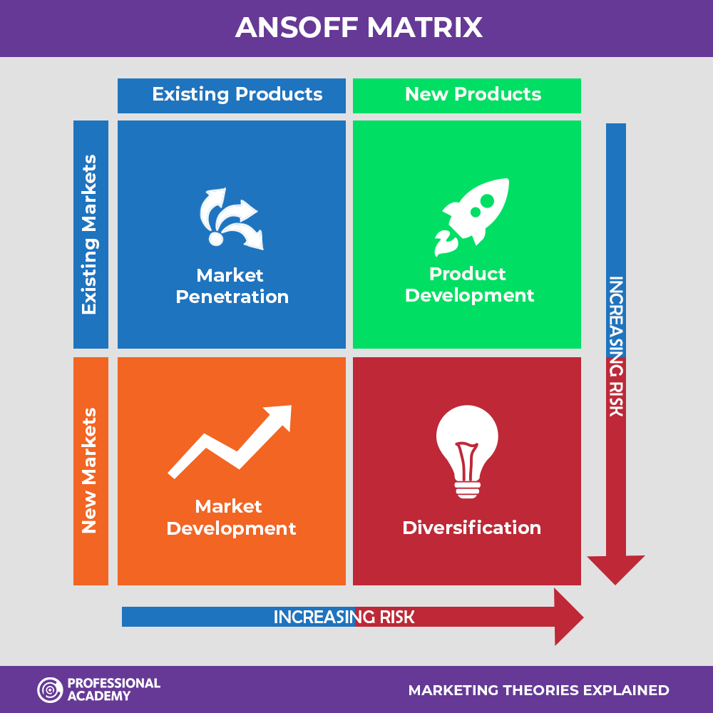
(Professional Academy, n.d.)

Market penetration –
In this strategy, the company expands its business within the market with the same products and services. According to Business Standard (2025), Reliance Retail has a plan to open 500–550 new stores a year, which helps it to cover more market. Also, company is increasing its reliance fresh store in local areas and increase it market share in retail business. However, heavy reliance on store expansion and low pricing may reduce profit margins and create long-term sustainability challenges.

Market Development –
In this strategy, company sells its product in new market. Most of the people in India live in rural areas, and Reliance is aggressively increasing its store in Tier-2, Tier-3 cities and rural areas (Reliance Retail to Launch Fashion World by Trends Stores in Rural and Small Towns, 2023). Additionally, this strategy gives Reliance a competitive advantage over smaller retailers by building a strong first-mover presence in emerging markets. However, focusing only on domestic rural markets limit it global growth opportunities and company should expand it business out side of the country help it to grow market.

Product Development –
In this strategy company develop new product for its existing market, For Reliance retails , it has it own manufacturing product Enzo in home care and Campa in FMCG, which gives it better control over pricing and improves profit margins However, most diversification remains related, which may limit exposure to new growth opportunities. However, company need to fucus on product development which help them to reduce suppler dependency.

Diversification –
In this strategy, a company enters into new markets with new products or services. Reliance Retail use a related diversification strategy by integrating digital platforms with its retail business platforms like JioMart and using online and offline retail services, allowing the company to expand its reach and improve customer convenience. This integration of technology with retail helps Reliance create a strong omnichannel presence in the market., Also, reliance is developing new business segment like reliance fresh, reliance mart, reliance store, reliance digital to expand its retail business.

Recommendations -

- Reliance Retail should improve its current store and profit instead of increasing the number of stores which increases cost for the business. Reliance retail business is growing because of its low-cost product strategy, while rapid expansion supports scale, it can also create cost pressure to maintain profit margin. Additionally reliance should review the store performance and according to it should reduce underperforming stores and improve inventory management(Business Standard, 2025).
For example, Sainsbury's reduces the store to make make our business more efficient and effective (ITV News, 2025).
- Reliance Retail should diversify geographically by entering in international markets. Currently, its growth only depends on India and in India competition is increasing for retail business, which increases exposure to domestic economic fluctuations. supports it long-term growth.
For example, IKEA expanded its business globally and reduced its dependency on its parent country, Sweden (Jonsson and Foss, 2011).

Conclusion
Reliance Retail is a largest retail business chain in India with having strong financial capacity, and an efficient supply chain. It uses a low-price strategy and offers many products, which helps it attract a large number of customers. External factors like India’s economic growth and technology support its expansion, but competition and FDI rules create challenges. Overall, the company is performing well, but future growth depends on improving profits, strengthening digital services, and expanding into international markets for long-term success.

Section 2
Gibbs reflective cycle –
Gibbs Reflective Cycle is used for reflection and learning, which includes six stages: description, feelings, evaluation, analysis, conclusion, and action plan. This strategy helps people to think about a situation, learn from it, and understand what they should do if they face the same situation again in life (Gibbs’ Reflective Cycle, Simply Psychology, 2025).
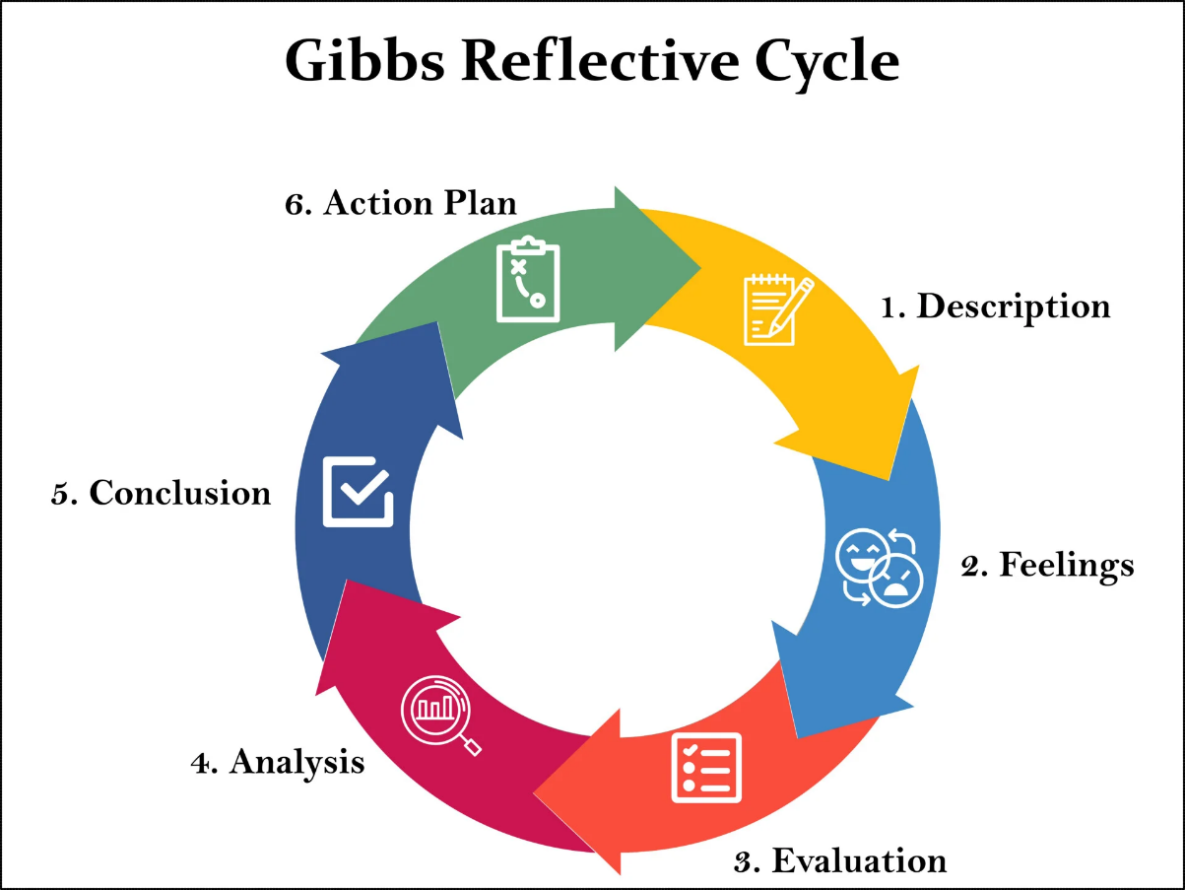
(Gibbs’ Reflective Cycle, Simply Psychology, 2025)

1.Description –
In my first semester, it was my first time when I was writing a report and that time, I learned so many things about report writing and all of these things I utilised while I was writing this report. For this, I have chosen a company and I have to write 5000 words which includes its strategy to gain competitive advantage in the market. First of all, all of my classmates needed to find a company and write it in the list which is given by the professor, and then we have to write assignment. I searched so many companies and made my mind for Reliance because I was interested in Reliance Industry and it has multiple businesses.

2. Feeling -
At the first, the task looks very easy and I thought it very easy because in my last semester and in this semester, I have done all my assignment where I did almost same task and analysis framework. I started to find information about the company and I found that some simple and common information like mission statement was not available and it took so much effort to find this. Also, this task includes almost same framework and finding differences from it is very hard and in this task I have to do critical analysis where I want to avoid repetitive information for the task. It was very hard for me and all single framework what I have done last time become very hard for me.

3.Evalution -
Reliance Industry is one of India’s leading business groups and, as per the task, I had to choose only one company, not the group. I started writing about it but I made a mistake because I was writing about Reliance Industry. Then, according to the guidance and with the help of my professor, I changed my company and chose Reliance Retail, which is a part of Reliance Industry.
The hardest part of this task was that I changed the company a couple of weeks before submitting the assignment. The good part of this task was that I found most of the information in the same link where I was doing research on Reliance Industry. Because of this task, I learned that always take full information before starting any work.

4.Analysis -
At the beginning, I made mistakes due to a lack of understanding of the task and confusion about the requirements. I started writing the assignment before fully understanding it, and finding data related to Reliance Retail in India was not easy. I also had to use reliable sources to support my arguments and perform critical analysis. For this purpose, I used the university library, but because most of the data from India was limited, it was difficult to find sufficient information. Writing the Balanced Scorecard took a lot of time as it includes several frameworks, making it complex and challenging.
Through this process, I learned a lot about Reliance and the retail industry. I also had to organise the information in a proper flow and ensure that only relevant data was included in my report.

5. Conclusion -

Overall, this task helped to improve my knowledge and understanding of the concepts. I learned how to do PESTLE analysis, how to write a Balanced Scorecard, CSR, VRIO, and Ansoff’s Matrix, as well as Strategic Choices and Implementation in this task. Some topics I had done before, but some analysis tools were completely new for me, which helped to increase my overall understanding.

6.Action Plan -

Next time, I will read and understand the task requirements carefully and then I will start to it. I will organize my work and divide the task into small steps so I can compete it and I will make small target and achieve it and for all of these I need to improve my time management.

Final Reflection -
Overall, this assignment improved my understanding of different frameworks. It taught me where I was making mistakes and what strategy I should use next time. This strategy allows me to do self-realization of my work, which improves my analytical skill and learning skills.

