A COMPARISON OF THE MARKETING METHODS OF TWO MULTINATIONAL HOTEL BRANDS

Name: Adriana-Isabela Trefas
Student ID number: 2242075
Module: Marketing Essentials BMIH4005
Lecturer: Gayathri Mudiyanselage
Word count: 1637
Submission Date: 19/05/2023

This essay is to compare Six Senses and Holiday Inn using marketing methods, getting sources from books, journals, newspaper articles, websites. Outline statement of the main points situational internal/external analysis SWOT and PASTLE, marketing mix, segmentation targeting and positioning, Similar Web analysis tool will be used to comparison Six Senses and Holiday Inn. Marketing can be defined as being “the process of identifying, anticipating, and satisfying customer requirements productively”. (CIM, 2007). Marketing management is engaging profitable customers and attract new customers by promising superior value. (Kotler et al 2019, p.5).
Six Senses is an international hotel, having locations in over 20 some of the world’s most unique places, is a luxurious, expensive, and exotic hotel. Through the principles of wellness and sustainability makes the hotel luxurious. Holiday Inn is in UK, located in centres of the cities, is accessible and affordable to anyone who wants to travel in UK, closer to public transports and touristic attractions. Holiday Inn provides leisure guests, business customers and families.
According to appendices 05 Fig.01, Frig 02 and appendices 06 the SWOT and PESTLE analysis internal and external factors which contributes to analysing the comparisons hotels. According to Six Senses (2023) they characterise themselves being in treed with the entire world, having an authentic unique style, local, personal, and sustainable. “We’re here to help you reconnect and focus on what’s really matters,” in unforgettable locations of a natural beauty that will fascinate everyone, and “an uncompromising level of service that will stay with you long after you’ve left.”
According to Six Senses (May 2023) Thru the process of water and energy consumption, their own cultural process is protecting and restoring endangered species. Six Senses goal is to eliminate plastic from their own hotel and spa. According to Holiday Inn (2023) kids stay and eat free. If you register to be a member at Holiday Inn, you get rewards in points, night discounts, welcome amenity, milestone rewards and more.
Six Senses weakness is that they are expensive, this can be improved by offering membership to attract customers, making offers like 10% off 2nd time when they check in, or offer rewards in points. According to Trustpilot (2023) in appendices 07, customers were extremely disappointed about Holiday Inn quality of customer services, they complaint about cleanliness and poor customer service. Holiday Inn weakness could be improved by building a stronger team, increase the number of the employees and train them to satisfy all customers. According to Kotler et al (2020, p.29) the marketing process is researching what are the customers' needs and creating value for them afterwards designing a “customer-driven marketing strategy” (Kotler et al, 2020, p29). An opportunity for both hotels could be to invest in technology, technology can bring an enormous on opportunities. According to Dadwal (2020) the use of technology has begun to be very important for companies, the information and communication technology (ICT) have a massive growth; the businesses understood the importance of using technology and it adopted it very quickly. The use of technology added value to the chain, network, and made the business model of the company. (Dadwal, 2020)
To be successful, they should improve their marketing knowledge, trying new things “Most successful entrepreneurs would not be where they are today if they did not take a chance and try new things.” Holiday Inn could employ high-quality people, the most principal factors that represents quality is sincerity and credibility, who will represent the hotel should be friendly, well dressed, well-mannered people. Six Senses could make a multiple plan policy- selective discounting suitable for “different type of people, groups, off-season rates could be lower in weekdays, compare with weekend, wholesales rates” (Feiertag 2019, pp. 46-47).
Traditional marketing helps the company to reach customers by advertising thru any offline source placing advertisements in public places often visited by many people. The emergency of Covid-19 created an opportunity for existed businesses, to adapt the technology and transforming the businesses more technological. Digital marketing is any online source marketing, through the Internet companies can attract people from all categories. Traditional marketing uses advertising in old way such as newspapers, magazine, radio, and television. In comparison with digital marketing, the advantage of using online sources is that companies can target customers using search engines and lower the price. Businesses can target their customers very easily using technology like social media, email, online and mobile marketing (Bajrami, et al, Pp. 327-328, 2022).
Threats are defined as unfavourable external elements in the business environment that hurt the company and present a challenge to performance (Kotler et al 2020 p. 57). Competition can be a threat for both comparisons hotel. A company should find out as many strategies as possible about their competitors. They should constantly compare the competitors marketing strategies with their own strategies; what products, prices, channels, and promotions they use. In this way, the company can find out what advantages and disadvantages are and what can be done to be on top of their competitors (Kotler, and Hongwai,2020 p.553). According to Kotler et al (2020 p.73) to be successful, a company must provide greater customer value and satisfaction than its competitors do.
“The weak oil and global terrorism threat created some lump in the mattress over at Holiday Inn owner InterContinental Hotel Groups” (IHG) (Gerrard., 2016). According to McCallum (2022) the Holiday Inn owner “has confirmed that the company has been hit by a cyber-attack" therefore if they would have improved their technology system, it would not have happened this.
According to Potters (2023) the Brexit had a significant impact on inflation increased, because of the currency market change with a fall in pound and as a destination country, UK appeal to be less attractive country as a destination. Because of UK’s dependence internationally on import of gas, oil, electricity, cereals, the fluctuation because of Brexit has affected all consumers (Pollitt, 2022).
According to Steinbach (2023) the war between Russia and Ukraine had an immediate and dramatic effect on global markets, through increased regular prices. The consumers and the firm suffered enormously because of the energy growth price. Therefore, Six Senses and Holiday Inn, have been affected by the energy growth price.
Segmentation is to identify who are the ideal customer base. Companies divide large to find out what groups of customers they have. Customers' needs can be reach more easily, efficiently, and effectively in smaller groups, offering them satisfaction thru products and services that match their needs (Kotler et al 2020 p.200).
Customers are principal factors in the company's microenvironment, they drive revenues and without them the company would not exist. The fact of delivery network is to engage customers and create strong relationships with them. (Kotler et al, 2020 p.74)
According to appendices 1, Fig.1 Holiday Inn was most visited in United State with 80,6%, and Six Senses was most visited in France with 83,4%. According to appendices 1, Fig.2 Holiday Inn was visited by 1,438M people. According to appendices F.3 Geography shows that Holiday Inn was most visited in United States 79,1%, and Six Sense was most visited in Turkey 70%. According to appendices 2, the demography shows that Holiday Inn was the most visited by women with 52,58% and Six Senses was the most visited by men with 49,33%. According to appendices 2, Six Senses and Holiday Inn has been most visited by customers aged between 25-34. According to Similar web Holiday Inn engagement monthly visits is 479,422 comparing with Six Senses monthly visits 421,785. The most used social traffic it was Facebook and YouTube, accessed mostly from mobile phone, Holiday Inn is in the lead with 12.34% referrals traffic (appendices 3). According with appendices 08, Instagram (2023) in comparison with Holiday Inn social media audience for Six Senses in higher. But on Twitter (2023) according to appendices 09, Holiday Inn audience is higher in comparison with Six Senses.
To reach the top, a company should maximize the benefits for customers and the level of involvement must be better than its competitors. Marketers not only have to adapt to the customers' target needs, but their offerings must also be better than its competitors, in the mind of customers (Kotler, et al,2019 p.73). After identifying and analysing its competitors, a company should decide on a competitive strategy (Kotler, 2009 pp. 312). Not all the competitive strategies are good for all companies, depending by the size and the industry position. Large firms with a superior position in industry can use some kind of strategies that other smaller firms do not have the budget. Some losing strategies for larger firms, can bring enough success for smaller firms (Kotler, et al, 2019 p. 73).
Considering a target group’s needs, the company must bring a unique and appropriate position for its products. Positioning should be what makes the company unique, making the customers feel that the products or services received are exclusively for themselves. ( Pelsmacker 2017, pp. 127-130). According to appendices 4, Fig.01 the perceptual positioning map elaborates the high quality and services offered by Six Senses and Holiday Inn. According to appendices 4, Fig.02 Bowman’s Strategy clock Six Senses is a model used in marketing to analyse the competitive position in comparison to the offerings of competitors.
Analysing Holiday Inn and Six Senses using situational internal/external analysis SWOT and PASTLE, marketing mix, segmentation targeting and positioning, Similar Web analysis tool; We found out what strategies and what targets have both comparisons. In conclusion Six Senses stands for luxury, situated in unforgettable places. Holiday Inn stands for the affordable, easy access to bus station. Six Senses targets are middle generation to older generations ages between 25-44 years old. Six Senses goal is to go plastic free; Holiday Inn could use this as a strategy to target more customers. The use of Digital Marketing should be used by both hotels to target more customers.
REFERENCES

About us (2023) [Facebook] Available at: http://www.facebook.com/SixSenses/about (Accessed on: 7th May 2023)
Analysis between Six Sense and Holiday Inn, [Similar Web] Available at: https://pro.similarweb.com/#/digitalsuite/websiteanalysis/overview/website-performance/*/999/3mwebSource=Total&key=sixsenses.com, holidayinn.com (Accessed on: 06/05/2023)
Dadwal, S. (2020) Handbook of research on innovation technology and marketing for the connect consumer. Hersley, Pennsylvania: IGI Global
GERRARD, BRADLEY, (2 Aug 2016). Holiday Inn owner IHG disrupted by oil and terrorism. Investors Chronicle, London. Available at: https://www.proquest.com/docview/1818684079?accountid=130472&parentSessionId=UP8FDjmIQ%2Bsk3%2FQAV%2BUlTxz0c5n5DivfK1hsQIyPkE4%3D&pq-origsite=primo (Accessed on: 8th May 2023)
Holiday Inn Fallowers (2023) [Instagram] Available at: https://www.instagram.com/holidayinn/?hl=en Accessed on: (17th May 2023)
Holiday Inn Fallowers (2023) [Twitter] Available at: https://twitter.com/holidayinn?lang=en Accessed on: (17th May 2023)
Holiday Inn hotel hit by cyber-attack (2022) Shiona McCallum, Technology reporter, BBC NEWS 6th September. Available at: https://www.bbc.co.uk/news/technology-62814943 , Accessed on: (17th May 2023)
Howard Feiertag (2019) Hospitality sales and marketing: through a period of evolutions. Apple Academy Press.
Jonathan Portes, Immigration and the UK economy after Brexit, Oxford Review of Economic Policy, Volume 30, Issue 1, Spring 2022, PP. 82-69. Available at: https://academic.oup.com/oxrep/article/38/1/82/6514758 Accessed on: (15th May 2023)
Matthew Housden, (2008-2009) Marketing Research and Information, The Official CIM Coursebook, Butterworth-Heinemann, Elsevier. Burlington.
Michael G. Pollitt. The future economic consequences after Brexit: energy, Oxford Review of Economic Policy, Volume 38, Issue 1, Spring 2022, Pp 165-178 Available at: https://academic.oup.com/oxrep/article/38/1/165/6514749 (Accessed on: 15th May 2023)
Patrick De Pelsmacker, Maggie Geuens, Joeri Van den Bergh, (2017) Marketing communications: a European Perspective, ed. 6th Pearson Education Limited.
Philip Kotler, Kevin Lane Keller, Mairead Brady, Malcolm Goodman, Torben Hansen (2009) Marketing Management. Pearson Practice Hall.
Philip T. Kotler, Gary Armstrong, Lloyd C. Harris, and Hongwei He (2019) Principles of Marketing, ed.8^{th,} Pearson Education Limited.
Six Senses Fallowers (2023) [Instagram] Available at: https://www.instagram.com/sixsenses/
Accessed on: (17 May 2023)
Six Senses Fallowers (2023) [Twitter] Available at: https://twitter.com/sixsenses?ref_src=twsrc%5Egoogle%7Ctwcamp%5Eserp%7Ctwgr%5Eauthor Accessed on: 17th May 2023)
Six Senses (2023) Six Senses Doesn’t Just Talk the Talk, it Walks the Walk When it Comes to Sustainability. Available at: https://www.sixsenses.com/en/corporate/media-center/press-releases/2023/six-senses-sustainability-2022 (Accessed on: 8th May 2023)
Shpresa Mehmeti-Bajrami, Fidan Qerimi and Arbëresha Qerimi (2022) ‘The Impact of Digital Marketing vs. Traditional Marketing on Consumer Buying Behaviour’, HighTech and Innovation Journal, 3(3), pp. 326–340. Available at: https://doi.org/10.28991/HIJ-2022-03-03-08.
Steinbach. (2023) The Russia-Ukraine war and global trade reallocations. Economics letters,226. Https://doi.org/10.1016/j.econlet.2023.111075
Trustpilot (2023) Holidayinn reviews. Available at: https://uk.trustpilot.com/review/www.holidayinn.com (Accessed on: 8th May 2023)

APPENDICES 01.
Fig.1
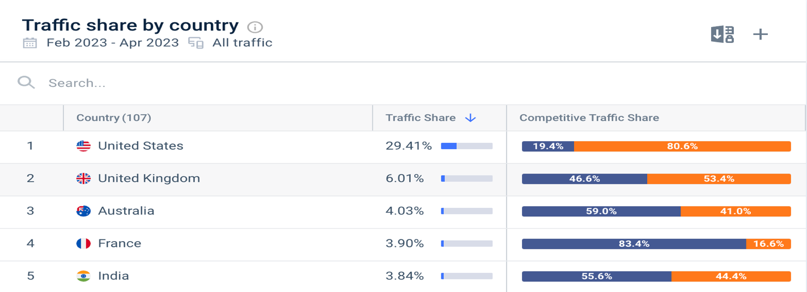Fig.2
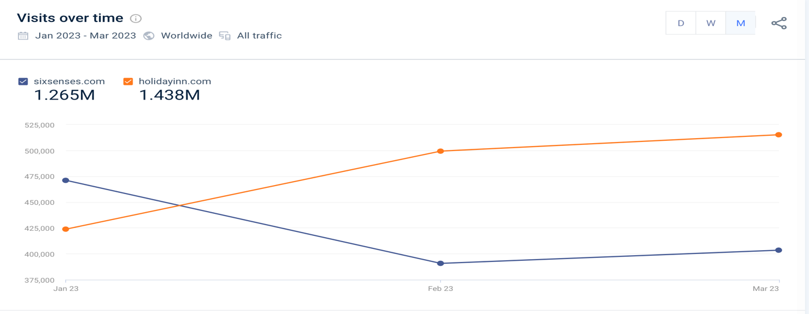
Fig.3

APPENDICES 02.

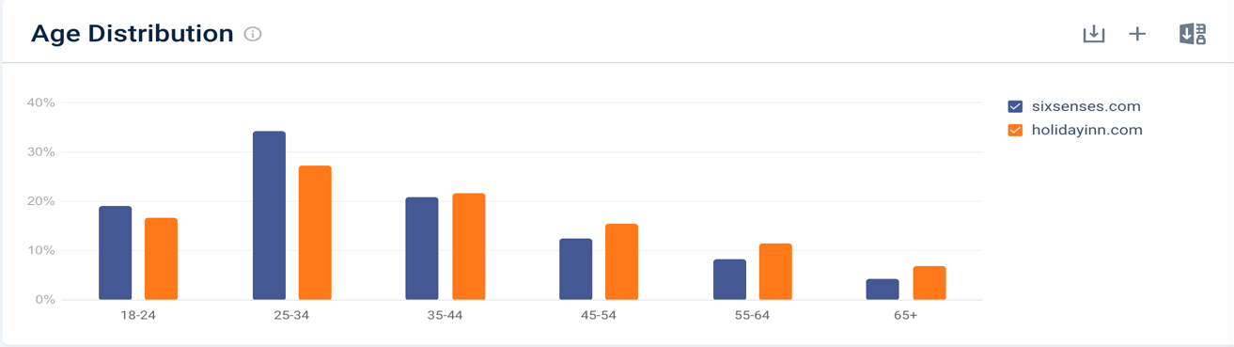

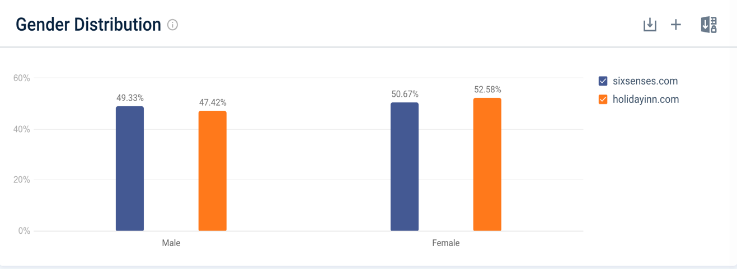
APPENDICES 03.

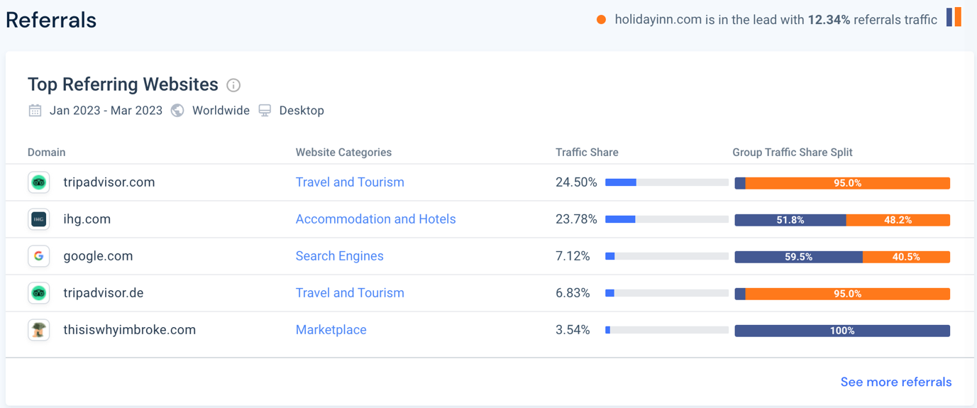

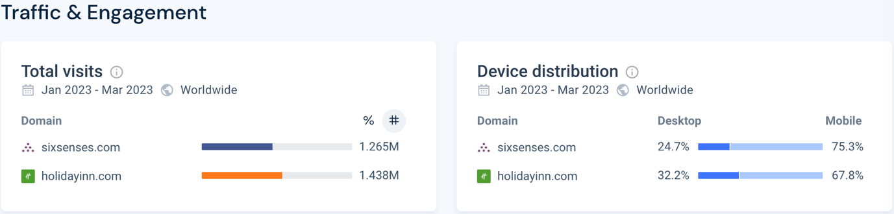

APPENDICES 04.

Fig. 01 PERCEPTUAL POSITIONING MAP

Fig.02 Bowman’s strategy clock

Appendices 05 Fig 01. SWOT Analysis for Six Senses

Fig. 02 SWOT Analysis for Holiday Inn

Appendices 06 PESTLE Analisys

Appendices 07 Customers Review showing their feelings about Holiday Inn accommodation and customer services received.

Appendices 08 Instagram Six Senses and Holiday Inn

Appendices 09 Twitter Six Senses and Holiday Inn

