Note: How to display the volume fraction for the copper liner:
Choose the results that you want to show:
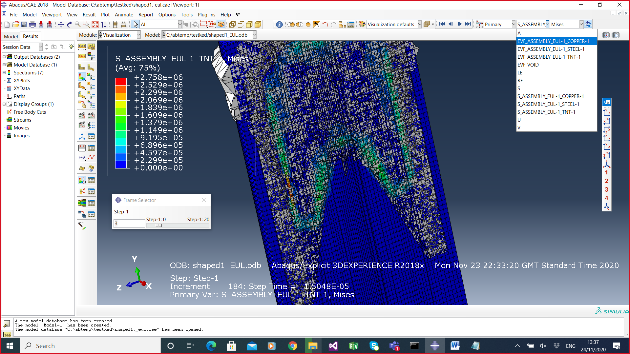
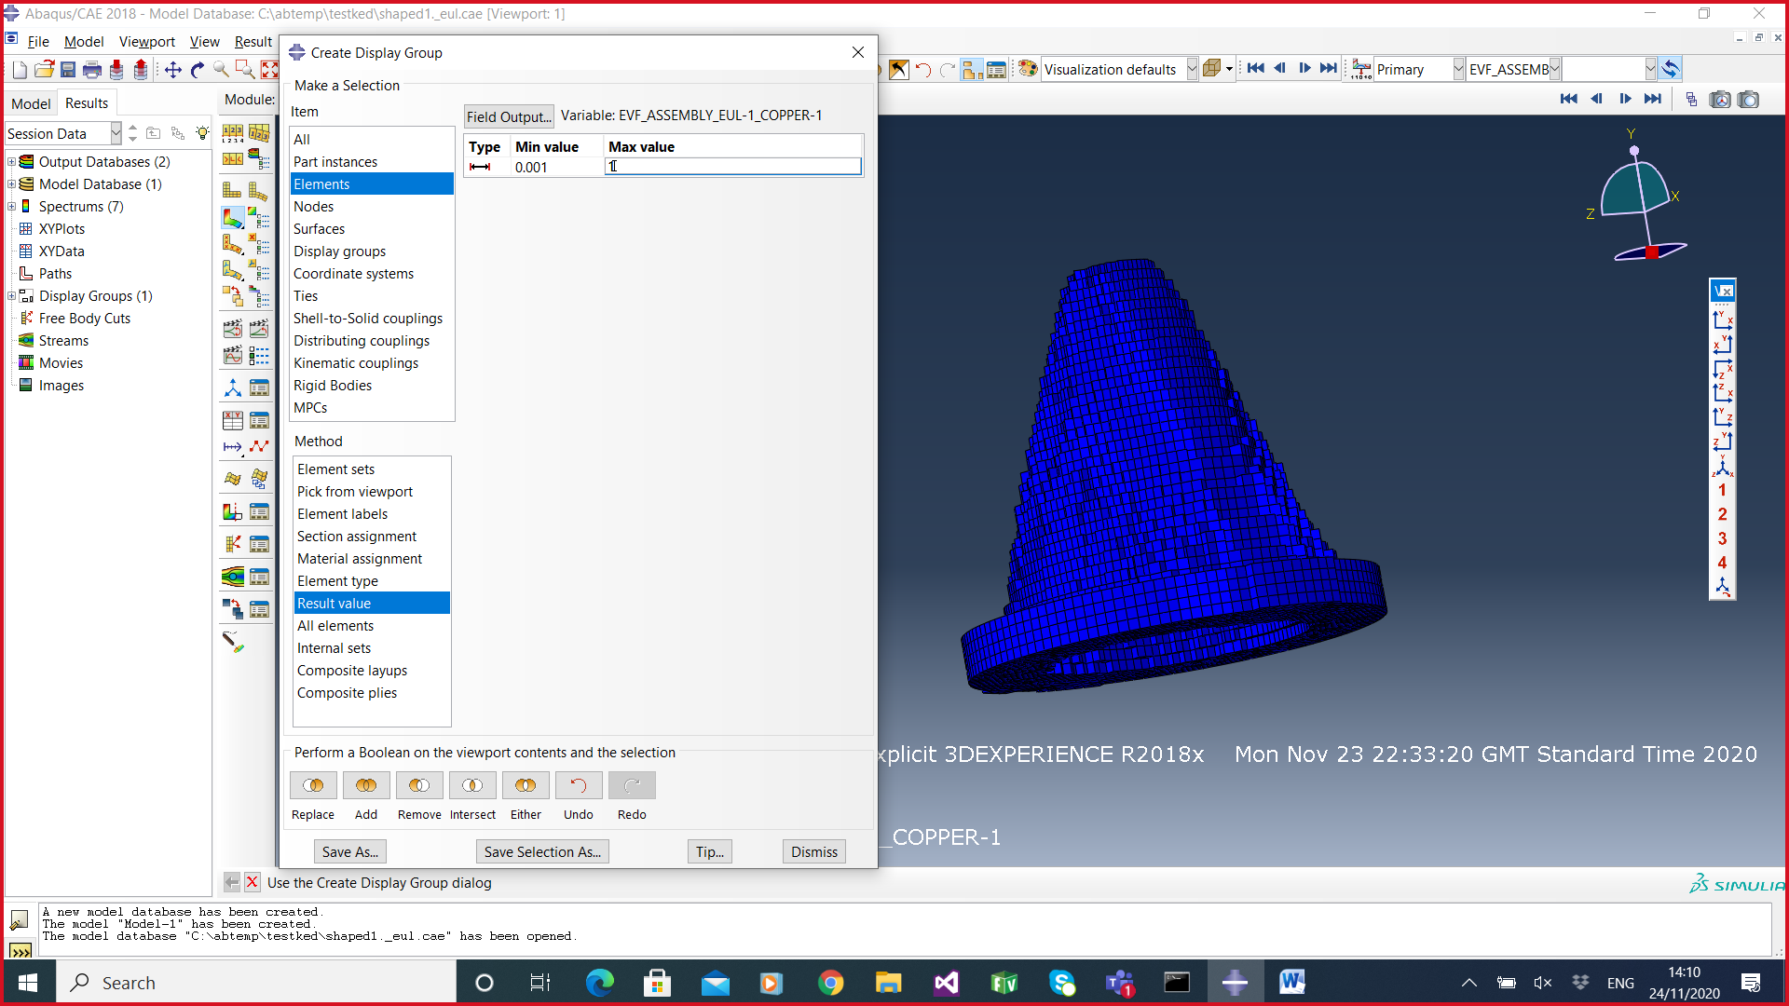

Next: Create a DISPLAY GROUP , to filter only the range you want to see on the viewport: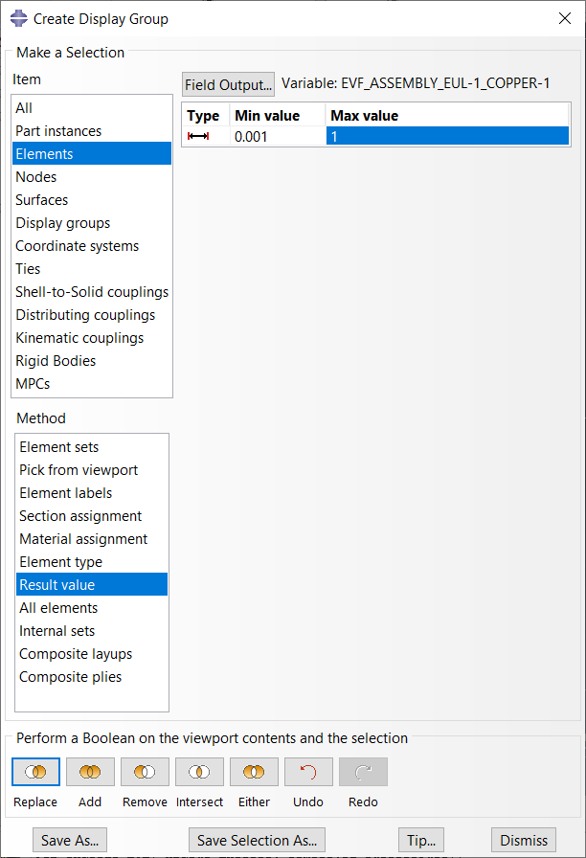

Don’t forget to click on REPLACE
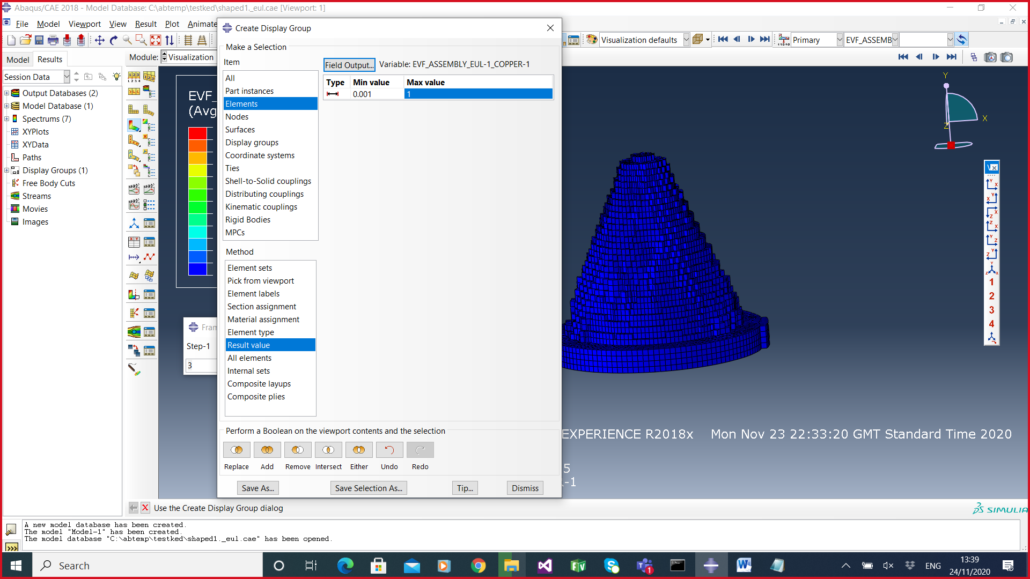

Under CONTOUR OPTIONS:
You can choose to plot ISOSURFACES instead of BANDED Contour plots if it helps.
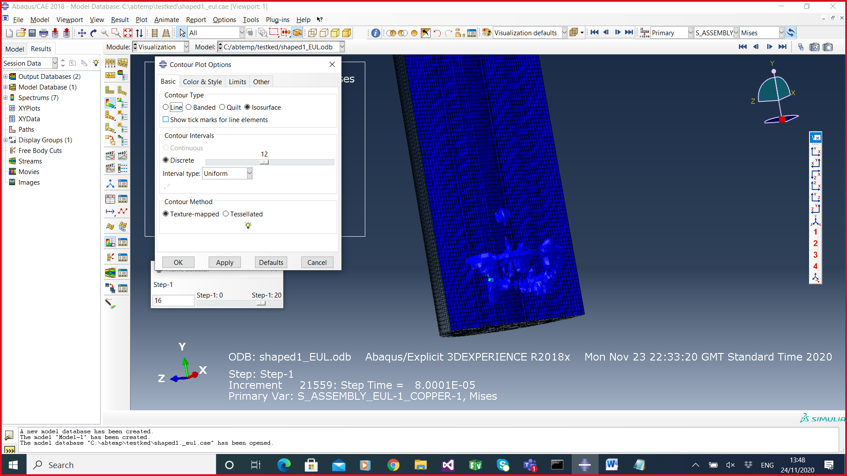

GENERAL POINTS that apply to both Lagrangian and Eulerian :

How to change the tmax simulation time and the output frequency of results:
In STEP Module: Choose the step manager and edit the tmax setting :
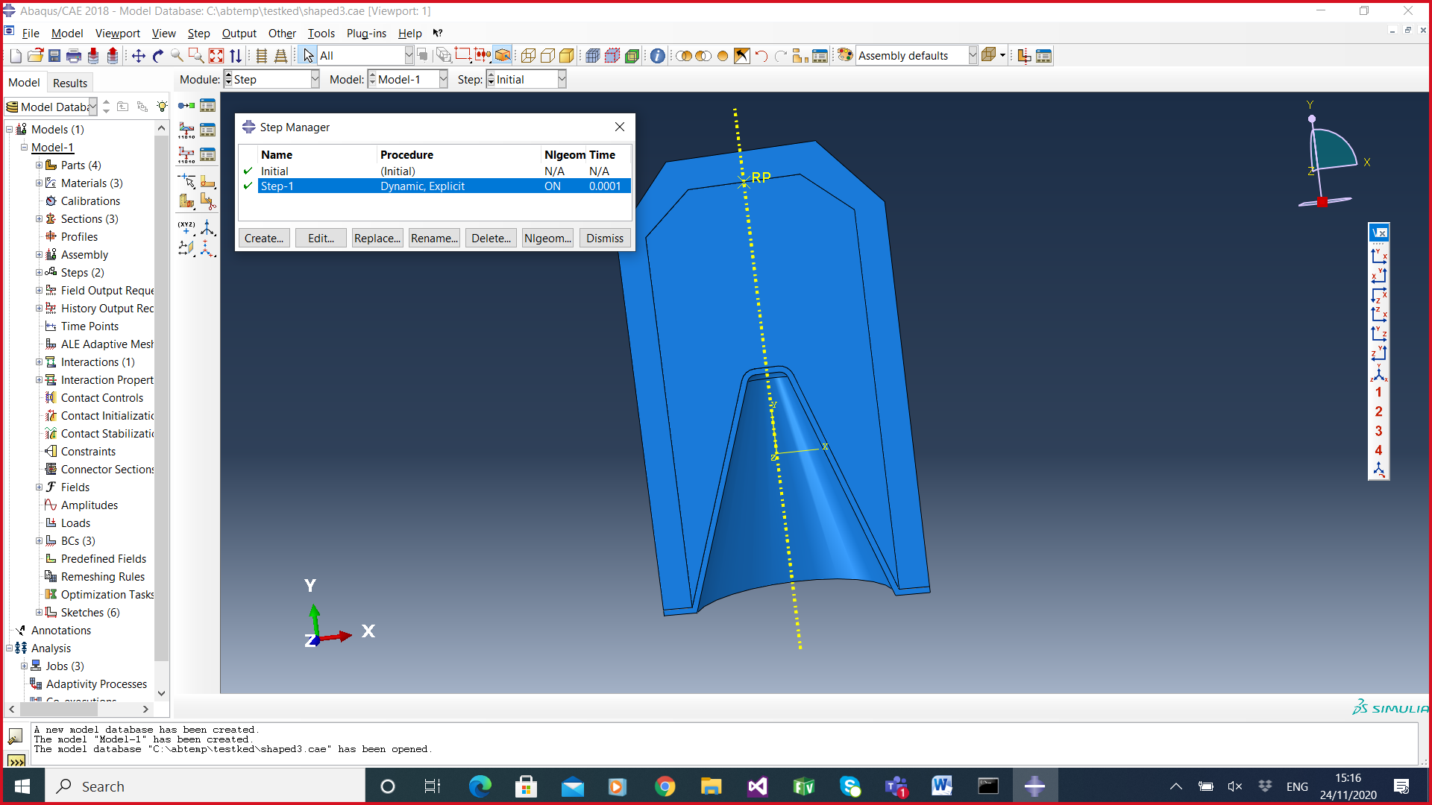

To change the frequency of results output:

In the STEP Module:
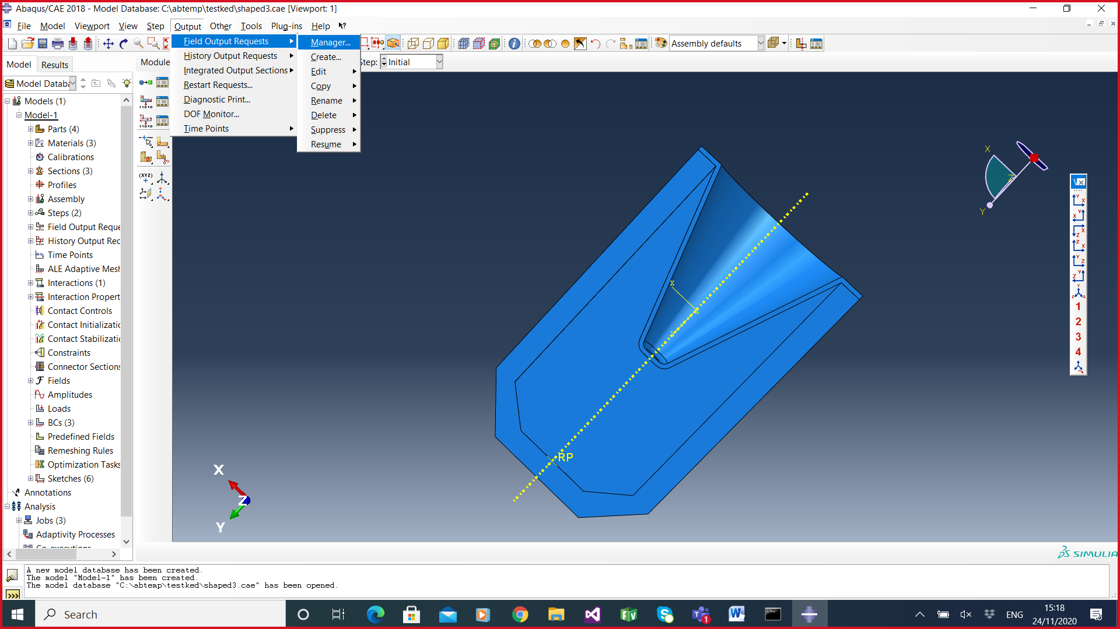

Edit the existing field output:
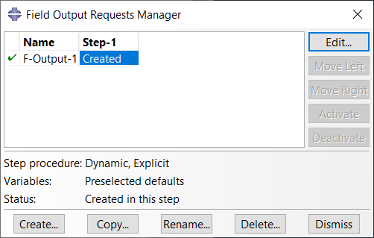

And here you can change the number of outputs from 200 to any sensible number.

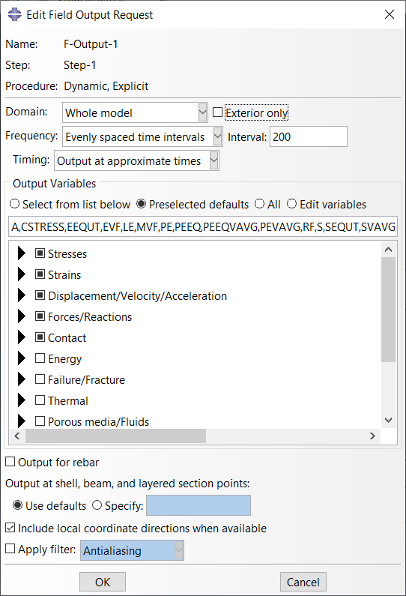

Or if you want to output at particular times:
Here I have decided to output every 10 microseconds (1E-05) .
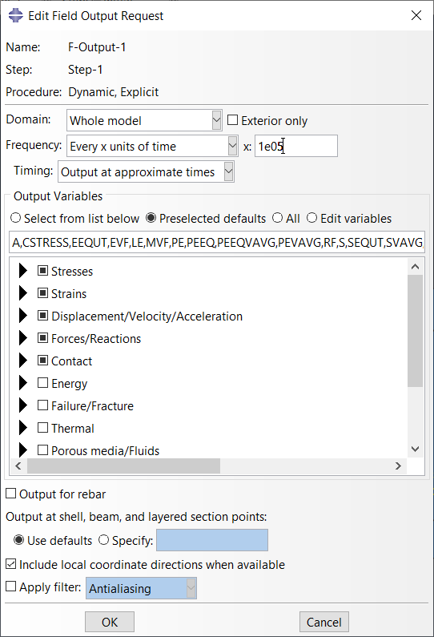

To change the max and min limits of the stress display - to highlight regions of interest for example, you can manually enter the limits under CONTOUR OPTIONS

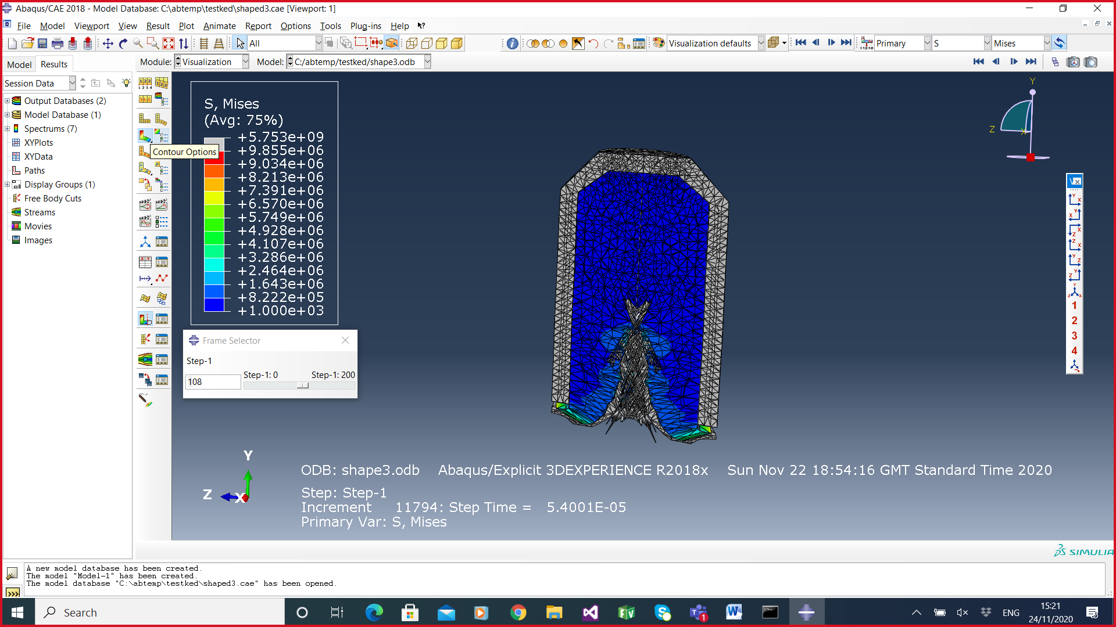

IN this example below, I have reduced the max value manually to highlight the detonation waves in the TNT:



