ADFM4017

Visual Studies



MODULE HANDBOOK
2018-2019

Visual Studies

Overview
How to record the world and interpret our observations.

Highlights

- Colour theory, typography, perspective and grids.
- Digital Matte Painting, background imaging and digital set extensions
- Formal aspects e.g. rhythm, proportion, temporality, line and texture.
- Observational analysis, timing through drawing, photography and motion tracking.

Level 4 – 20 credits

Assessment – 40% Presentation, 60% Portfolio

Teaching is by lecture, seminar and hands-on workshop.

Module Tutor
John Hill john.hill@uwtsd.ac.uk

Tech Dem Artist
Adam Shailer adam.shailer@uwtsd.ac.uk

Please make an appointment with your tutor for a tutorial if you have additional questions not covered in the sessions. If you need to consult the course team urgently, please email the staff member concerned. Additional support times / production surgery will be indicated on your timetable. The room will be available at this time and there will be a member of staff available for support and to answer questions.

Module Outline

AIM(S)

- To locate practice in the relationship between observation, technique, process and ideas creation.

- To predict how the results of visual studies can help to solve design problems whilst recognising them as objects in their own right.

LEARNING OUTCOMES

Upon successful completion of this module, a student should be able to demonstrate the ability to:

- Summarise, locate and defend the practices of visual studies.

- Independently reform and extend stylistic methods in the creation of visual work.

CONTENT
There will be a visual portfolio, covering all aspects of your work on the module and a formal presentation lasting ten minutes – this will also be marked.

Indicative content
- Composition and visual conventions.
- Formal aspects e.g. rhythm, proportion, temporality, line and texture.
- Colour theory, typography, perspective and grids.
- Exploration of impression as an interpretive response to stimuli.
- Affordance, accessibility and Golden Ratio.
- Movement, motion, character exercises.
- Storyboarding.
- Digital Matte Painting, background imaging and digital set extensions
- Observational analysis, timing through drawing, photography and motion tracking.

The following software/hardware may be used on this module:

Adobe InDesign, Adobe Photoshop, Adobe Illustrator, Google Sketchup, Adobe fter Effects.

ASSIGNMENT OUTLINE
[See Assignment Brief for full details]

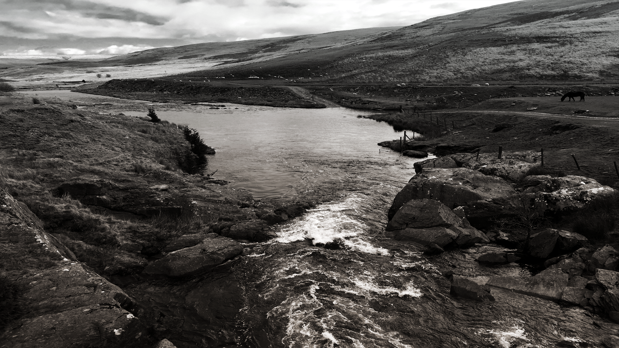

PORTFOLIO

Assignment [60% of overall mark] Presentation [40% of overall mark]

Assessment will be comprised of two components. Each student will produce a body of work evidencing engagement with the practice and principles of visual studies. By the end of the module a student should have a portfolio of exploratory research and design work for presentation in a visual portfolio. The presentation of the portfolio will be to a mixed audience both known and unknown to them. This will determine a student’s engagement with the selection of appropriate visual processes and their ability to explain it to others.

Feedback

Feedback Date 20 days after the date of assessment

Feedback is an essential part of all education and training programmes. It helps learners to maximise their potential at different stages of training, raise their awareness of strengths and areas for improvement, and identify actions to be taken to improve performance. Feedback can be seen as informal (for example in day-to-day encounters between teachers and students or trainees, between peers or between colleagues) or formal (for example as part of written or clinical assessment). However, there is no sharp dividing line between assessment and teaching in the area of giving feedback on learning. Feedback is part of the overall dialogue or interaction between teacher and learner, not a one-way communication.

During your studies you will therefore receive feedback in many ways, including the following:

- Dialogue between lecturers and students in formal classes.
- Direct questions and responses from teachers inside and outside formal classes.
- Email correspondence between teachers and students.
- Interactions between students and teachers using the module message board on Moodle.
- Informal comments and responses to pitches and presentations in classes.
- Comments and annotations added to written submissions, such as essays and reflective journals.
- Formal written feedback in response to assignments recorded on the summative
- Assessment module feedback forms.
- You will have an opportunity to discuss your feedback with your tutor.
- Feedback will be returned on assessed work within 20 working days of submission.

MODULE TIMETABLE

** You will be expected to conduct non-assessed tasks as part of your development on this module. This will include filming outside of the classroom environment. **

Module Evaluation

At the end of this module, you will be asked to complete a module evaluation form. Please refer to the anticipated learning outcomes when making your evaluation.

SCHEME OF WORK

 | Indicative Content | Time | Date | Room
1 | - Visual Studies – Overview – Assignment Brief  - Composition and visual conventions. | 1000-1300 | 26/11/2018  30/11/2018 | Studio
2 | - Formal aspects e.g. rhythm, proportion, temporality, line and texture. | 1000-1300 | 03/12/2018  07/12/2018 | Studio
3 | - Observational analysis, timing through drawing, photography and motion tracking.  - Exploration of impression as an interpretive response to stimuli. | 1000-1300 | 10/11/2018  14/12/2018 | Studio
4 | - Digital Matte Painting, background imaging and digital set extensions | 1400-1700 | 07/01/2019  11/01/2019 | Studio
Portfolio Submission Deadline and Presentation: Monday 14th January. 2019
9 | - Feedback on Portfolio submissions | Feedback tutorials week commencing 14/01/2019

This scheme of work is indicative and subject to change

MODULE RESOURCES

Reading List:

Module Code | ADFM4017
Module Title | Visual Studies for Set Design
Classification | Reading List entry | Electronic*
Essential | Publishing, 3., ed., 2016. Digital Painting Techniques: Volume 8. 1st ed. London: 3DTotal Publishing. | ☐
Essential | Rizzo, M., 2014. The Art Direction Handbook for Film & Television. 2nd ed. London: Focal Press. | ☐
Essential | Meirelles, I., 2013. Design for Information: An Introduction to the Histories, Theories, and Best Practices Behind Effective Information Visualizations. 1st ed. Rockport. | ☐
Further | Barnard, M., 1998. Art, Design and Visual Culture: An Introduction. 1st ed. London: Palgrave. | ☐
Further | Publishing, 3., ed., 2016. Beginner's Guide to Digital Painting in Photoshop: Sci-Fi and Fantasy. 1st ed. 3DTotal Publishing. | ☐

Note: Students will also be directed to project-specific resources during the course of the module when they are available and appropriate.

