Introduction to Web Development
  - Lecture 5 Lab Tutorial Exercise

Creating a Slideshow with CSS3 Animations

Objectives
The aim of this lab exercise is to give you some experience of using CSS3 Transitions, Transformations and Animations.
To assist you in this exercise, please refer to the following references available on the W3Schools website (explanation of all CSS styles and selectors) – of course I am also here to assist :
- CSS Styling Properties: http://www.w3schools.com/cssref/default.asp
- CSS Selectors: http://www.w3schools.com/cssref/css_selectors.asp.

Exercise 1: Getting Started
- Note: This exercise requires you to have completed last week’s exercise.
- Open up the website project from last week in Visual Studio or your preferred development environment (e.g. NotePad++, Sublime).

Exercise 2: CSS Transitions and CSS Transformations
- You will use CSS transitions to enlarge the images shown on the gallery page as the user hovers over each image. You will use CSS3 Transformation styles for this.
- Open up your gallery.html page from last week. You will notice that the images are all contained inside the <section id=”gallery”> element.
- Go to your styles.css stylesheet and locate the previous styles you created for #gallery img { … }
- To enlarge the images, you will apply a transformation, but you will also make this change occur gradually using transitions.
Copy and paste the following CSS style definition into https://autoprefixer.github.io/ to get the right browser prefix codes needed – the definition is saying that if any transforms occur on elements matching this selector, they should occur gradually over 2s. Feel free to use a different time.
- Paste the definitions from autoprefixer inside the #gallery img { … } definitions.

- Next, add the following style definitions for the hover effect. Feel free to use another scale size.
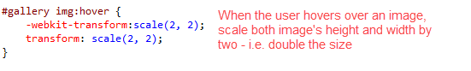
- Save your changes and preview the gallery page. Hover over the images.
- Hmmm, do you spot the problem? Some of the images are positioned out of view when enlarged. You need to change (translate) the position of some of the images when enlarged. Unfortunately, you cannot do the same thing for every image.
- Okay go back to your CSS file and make the following changes:
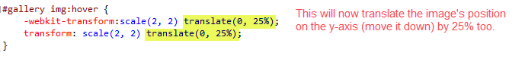
- Save your changes and preview the gallery page. Hover over the images.
- It should be a bit better until you get to the last set of images.
- Go back to your CSS file. Now, for the next step, I am assuming you have 12 images as I do. I am going to introduce a new CSS selector (read more), which is going to select the last 6 images (images 7 – 12).
- Create a new set of styles as shown below (make sure you add these styles after the previous ones).
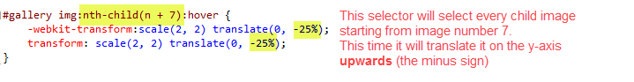
- Save your changes and preview the gallery page. Hover over the images.
- Much better. But if like me you like things to be perfect, you will notice the annoying scroll bars when you hover over the images towards the bottom. You will make changes to the HTML and CSS to fix this.
- You will make the gallery page a flex box too (last week). Open up the your Christmas page from last week and add the new class shown below to the opening <body> element.
- Save your HTML page.
- Now open the gallery HTML page and make the following change to the opening <body> element.
- Save your changes.
- Now, go back to your CSS file. Add the following set of styles:

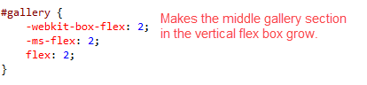
- Next, locate the previous styles added for #festive-page. The gallery page will use the same styles, so add change the selector name as shown below:
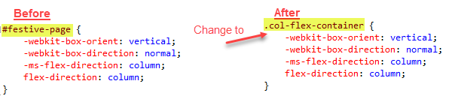
- Save your changes and have a look.
- That should all work fine now.

Exercise 3: Creating an Image Slideshow
- Make a copy of the current home page, that is, the index.html page. You can call the new page index-slideshow.html
- Open up the newly copied page, index-slideshow, in Visual Studio.
- The image slides will work as follows:
  - Each image in the slideshow will occupy 100% of the width.
  - The 3 images will be positioned side by side (using floats ) to occupy a total width of 300% (3 * 100%)
  - Only one image will be displaying at a time, the rest will be positioned outside the viewable area. They will slide into view (shift left by -100%) one at a time – see image below.

Left: 300%
Left: 100%
Left: 0%

Current Image Displaying

The HTML
- You should have a <section> element with an id=banner. Rename this id to banner-slideshow (it is important you rename this to something different) and delete everything in the highlighted box area. I have pasted before and after images below.
Before
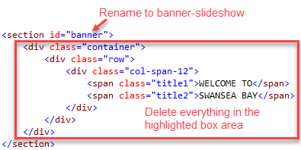

After
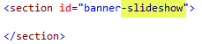
- Next add an empty <div> … </div> element to the <section> element as shown below. This <div> element will contain all the images for the slideshow and it will be used to define animation styles.
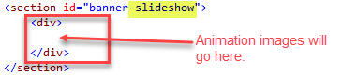
- Download the zipped images document from Moodle. Unzip and copy the images to the images folder of your website project.
- Each image will be created using the HTML5 <figure> element. It is a container element for an image and also allows you to specify caption <figcaption> for the image.
- Add the images and captions as shown below.
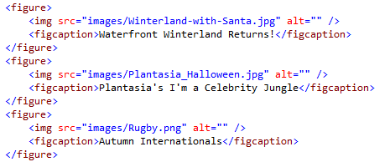
- Save your changes. If you preview your page, you probably just have the images displayed vertically and quite untidily too.

The CSS
- The following diagram shows you what the HTML looks like and the CSS selectors for each of the elements that you are going to use.
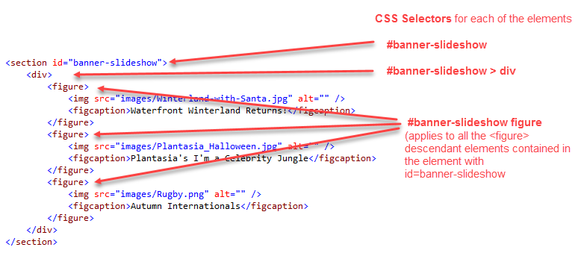
- Open up your styles.css file.
- Make note of the id attribute value added to the <section> element representing the slideshow added in step 2. Mine is called banner-slideshow. Add the following id selector for this element and the specified styles. Setting overflow to hidden will hide any content outside the browser viewable area. You can also try a different height if you want the animation area to be longer.
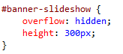
- Next, you want to style the child <div> element in the banner-slideshow element. Add the following styles. Add the comment too, because you will need to return to this point later.
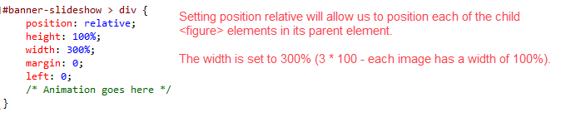
- Next you will style the descendant <figure> elements.
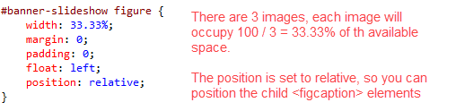
- Finally, you need to style the descendant <img> elements.
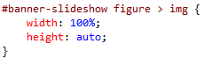
- Save your changes. If you preview your page, you should now have just the first image showing. The other images are currently hidden from view.

The Slideshow Animation
- For the slide show effect, you will create an animation that will change the left position to bring the next image into focus.
  - You will use percentage (%) key frames to specify when the change should occur and what the new left value should be.
  - To create a smooth slideshow that displays the image for a few seconds, then gradually slides in the next image:
    - There are 3 images, so each image needs to be displayed for 33.33% (100/3) of the total duration. So for three images: 33.33%, 66.67%, 100%
    - However, you need to account for the time it will take the next image to come into view (decrease left by 100%) and subtract this from each of the main percentages. Let’s give a duration of 3.33% for each image change.
    - Therefore your percentage increments will be:
0% | Start at 0%
30% (33.33 – 3.33%) | Display 1st image for 30% of time
33.33% | Slide next image into view, shift by -100%
63.33% | Display 2nd image
66.67% | Slide next image into view, shift by -200%
96.67% | Display 3rd image for 30% of time.
100% | End back to beginning again, slide 1st image back into view, shift by -300%

- The key frames for the CSS animation are shown below – add them to your stylesheet The animation has been given the name slideshow.
Important: because animations are part of CSS3, you will need prefix codes. You need a webkit version as shown.
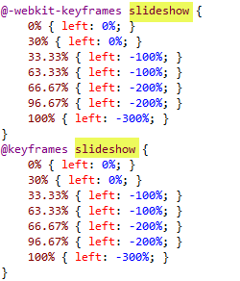
- Now look for the comment you added earlier to remind where you need to add the animation.
- Copy and paste the following CSS style definition into https://autoprefixer.github.io/ to get the right browser prefix codes needed and then paste these styles where the comment is. Note: you can change the duration to whatever you prefer – the example shown is 30s.
- Save your changes. Is your slideshow working? If not, call for help.
- Have you noticed the problem? After the last image, there is a blank white space that appears for a second and then the animation starts again.
- You will fix the problem in the next steps.

Changes to HTML
- Return to your HTML document.
- Locate the set of three <figure> images. You need to repeat the first <figure> at the end, so that it fills the gap as shown below. Copy the first <figure> … </figure> element and paste it after the last one as shown below.
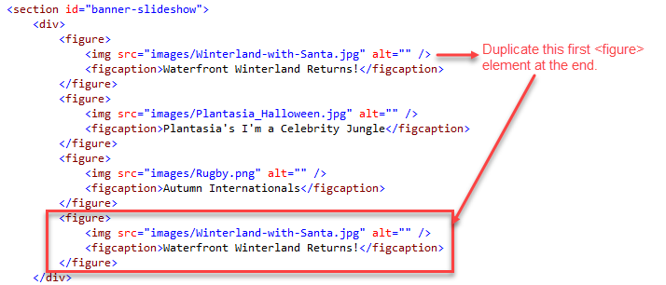
- Save your changes.

Changes to CSS
- Now go back to your CSS document and locate the following style definitions and make the highlighted changes.
  - We now have 4 figure elements, so need to increase total width to 400% (4 * 100%)
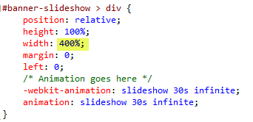
  - But it means each <figure> element will now occupy 25% (100% /4) of the available space.
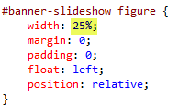
- Save your changes and have a look. The problem should be fixed.

The Figure Captions
- Finally, the figure captions need to be positioned absolutely within the <figure> element, as they are currently not visible. Add the following styles to the style sheet to do this. The example shows the captions as being positioned absolutely from the top, right corner,
Feel free to use your own preferred fonts, colours, sizes, etc.
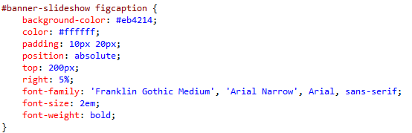
- Save your changes and preview.
- That’s all for today!

