

Student Name: Malavraj Nareshbhai Ratnu
Student ID: 2435245
Programme: Master of Business Administration
Module Name: Strategic Management
Module Code: LCMB7003
Lecturer Name: Jia Miao
Assignment Title: Strategic Management

Executive Summary
Kohl’s Corporation is a renowned retailer in the US market, which was founded by Maxwell Kohl in 1962. This report has discussed the strategic management of the retailer Kohl’s Corporation that aims to expand its business by entering into a new economy to gain a competitive advantage. This report has highlighted Kohl’s business expansion in the Japanese market due to the availability of probable opportunities. This report has illustrated a brief introduction of the company and the target market, Japan, by offering proper justification through Porter’s Diamond Framework and BCG Matrix. This report has also evaluated the macroeconomic business environment of the company by integrating frameworks like PESTLE, Porter’s Five Forces, and Competitive Rivalry. The economic factor through PESTLE analysis can emerge as an opportunity for Kohl’s, whereas the political factor can impose a threat. Also, the bargaining power of the buyers is quite high due to the presence of competitors' brands like AEON, Seiyu in the Japanese market. The report also showcased strategy development and formulation by discussing the joint venture as a market entry strategy that the brand can use with the help of Porter’s Generic Strategies. Also, a performance evaluation framework has been used showed showing the Balanced Scorecard Framework and Triple Bottom Line Approach.

Table of Contents
Introduction 4
1. Selection of Organisation and Target Market 4
2. Comprehensive Strategic Analysis 8
3. Strategy Development and Formulation 17
4. Performance Evaluation Framework 20
Conclusion 23
References 24

Introduction
The report will discuss strategic management in light of the supermarket retail chain named Kohl's Corporation for its Japan expansion. The chosen company and the chosen market for expansion will be justified in this report using Porter's Diamond model and BCG framework, along with the macro environment and competitive landscape analysis of Japan using PESTLE analysis, Porter's Five Forces analysis, and competitor analysis. Strategic development and formulation will also be discussed using Porter's Generic Strategies, and the performance evaluation framework will also be analysed using the balanced scorecard framework and KPIs.

1. Selection of Organisation and Target Market
For this particular report, a supermarket chain named Kohl’s Corporation is selected for business expansion in the country called Japan. Kohl's Corporation is a widely renowned retail chain, which is headquartered in Wisconsin, US, and was founded in 1962 by Maxwell Kohl (kohls.com, 2025). The supermarket retail chain primarily operates in the US with more than 1100 physical stores (bloomberg.com, 2025). However, the present condition of the US market is significantly volatile and uncertain, which often impacts the supermarket chain negatively in terms of profitability. Thus, the brand is required to expand its business operations in other countries, such as Japan. Porter's Diamond framework and BCG Matrix are discussed below to justify the choice of the brand and the country.
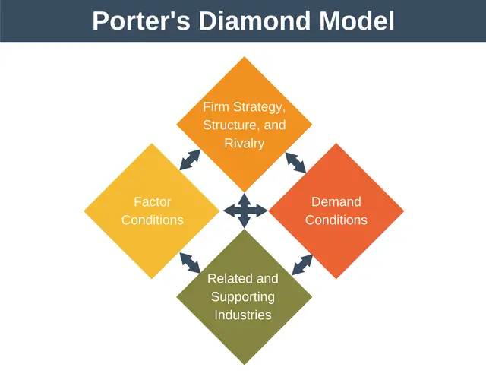
Figure 1: Porter’s Diamond Framework
(Source: expertprogrammanagement, 2024)
Factor conditions
Japan is highly recognised for its educated workforce due to a strong focus on digital literacy. It has been analysed that the internet penetration reached 84.9% in Japan, showing the user rate of 104.4 million in 2024 (datareportal.com, 2024). Thus, it is quite evident that residents of Japan are highly aware of digital technologies, which further results in an efficient and educated workforce of the country with the knowledge of logistics and IT infrastructure. Additionally, a significant focus of Japan on retail tech as well as transportation efficiency enhances its overall retail infrastructure. Based on this, it can be stated that Kohl's Corporation can explore huge benefits regarding skilled workforce as well as efficient digital infrastructure in retail by choosing Japan for its business expansion.
Demand conditions
Consumers of Japan significantly prioritise quality and excellence in retail services (Fukunaga et al. 2024). This further helps retailers to constantly innovate their product lines with premium quality and unique designs, as well as high value. Thus, Kohl's Corporation can find it extremely beneficial to expand its business in Japan due to the organisation's high-quality retail and household items. Also, the Japanese consumers’ preferences regarding unique designs will further push Kohl's to differentiate its business from rivals by producing unique and trendy retail items.
Related and supporting industries
Japan is highly appreciated for its strong retail ecosystem due to world-class fashion suppliers as well as logistic providers (Zeng et al. 2025). Kohl's Corporation can gain access to explore world-class fashion suppliers in Japan after expanding its business in this country, which can help to enhance the product line and uniqueness of the brand. Moreover, retail technology and innovation hubs of Japan can also support Kohl's to improve its operational efficiency and establishment of the brand in this country, which can further result in high profitability of the brand.
Firm strategy, structure, rivalry
Kohl's Corporation’s US model represents the focus on value and unique, fashionable items (Islam et al. 2025). Thus, the business model of the supermarket chain can align with the Japanese preferences for unique casual wear and other exceptionally designed items. This can further differentiate the brand and contribute to the increase in its overall profit margin. However, established players like AEON, Seiyu Group, and Don Quijote in Japan can create intense rivalry for Kohl's Corporation after expanding its business in the country.
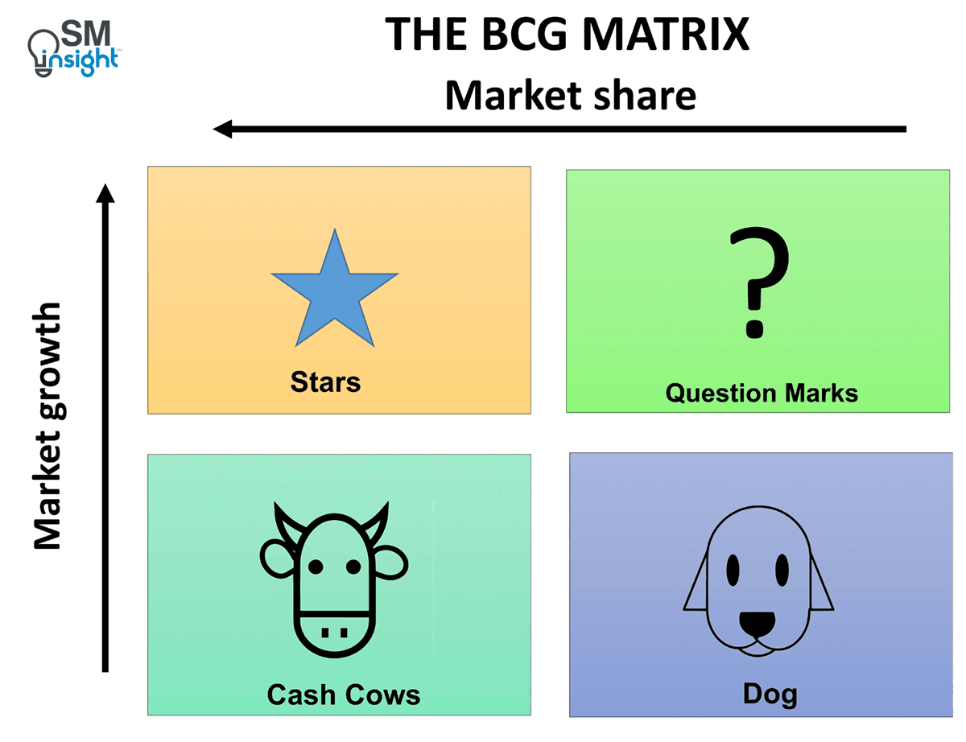
Figure 2: BCG Matrix
(Source: strategicmanagementinsight, 2025)
Stars
Kohl's Corporation can consider localisation of its product and marketing strategies, along with brand building, as a star in the Japanese market to gain significant share and growth. Thus, the supermarket retail chain needs to focus on investing in these aspects to make a successful expansion in the Japanese market.
Question marks
In the Japanese market, the core apparel of Kohl's Corporation, along with its Sephora partnership, will be considered in the quadrant of question mark, as these aspects can provide a high market share to the brand despite having a low growth in the Japanese market.
Cash Cows
Kohl's Corporation’s US departmental store model is considered a cash cow, which can help the brand to share in the Japanese market, despite having low growth.
Dog
Kohl's needs to focus on minimising the low-performing product categories in the Japanese market to ensure successful research allocation for stars and strong question marks.
Based on the analysis of the BCG Matrix, it can be considered that Kohl's Corporation can invest in its stars and question marks to increase market share as well as growth in Japan, which will further enable the brand to acquire a high profit margin after expanding its business in the country.

2. Comprehensive Strategic Analysis
The US-based supermarket retail chain Kohl’s Corporation is planning to expand its business in Japan to maintain and increase its profitability in a volatile and complex marketplace. Thus, to enter the Japanese market, Kohl's Corporation needs to analyse the macro environment of Japan to adopt strategies and optimise its expansion planning accordingly. PESTLE analysis is used below to analyse the macro-environmental factors of Japan.
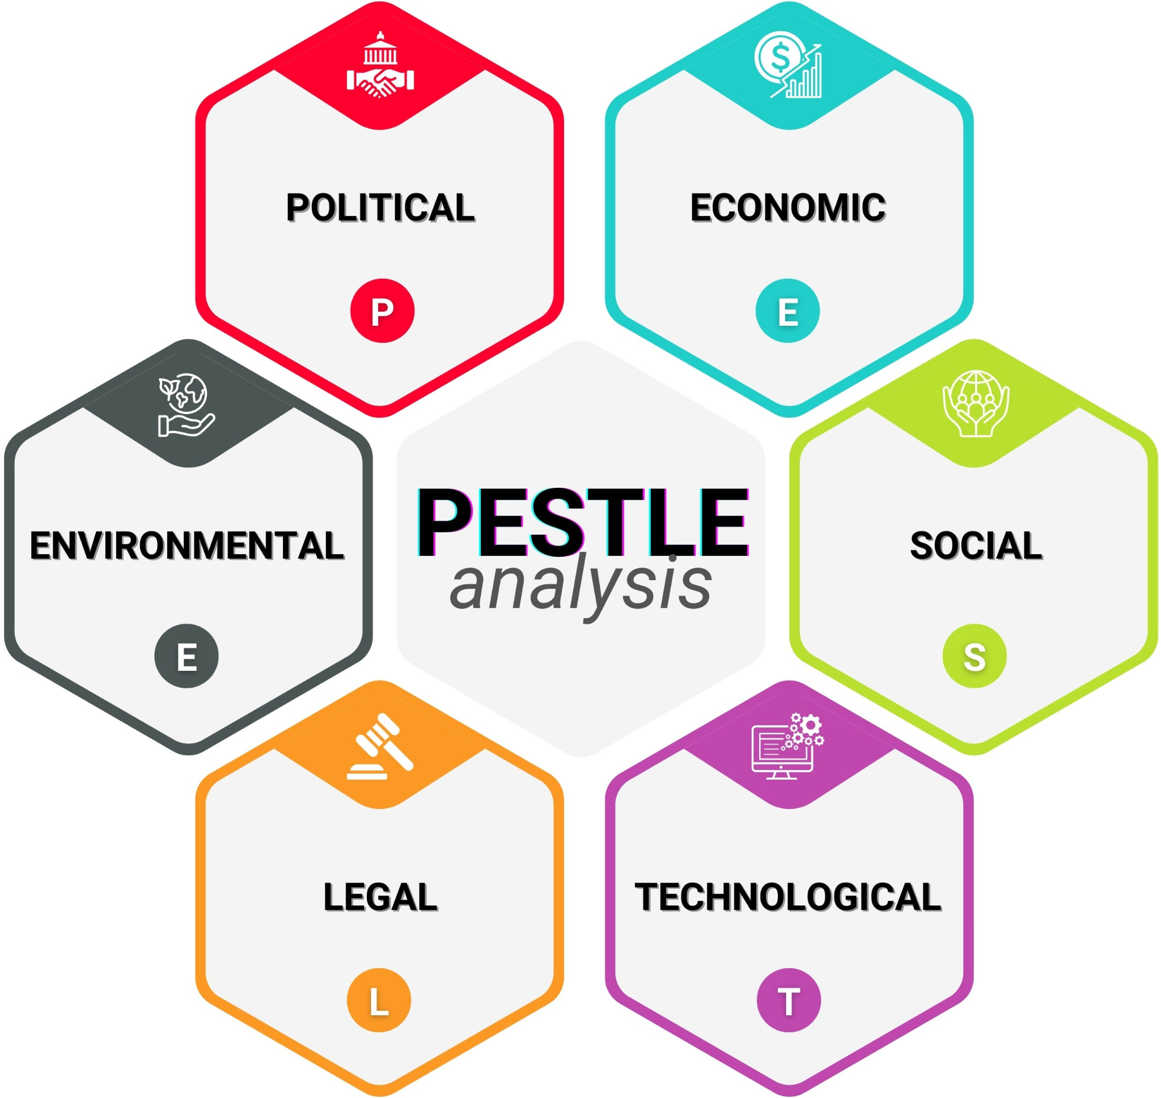
Figure 3: PESTLE analysis
(Source: medium, 2025)
Political
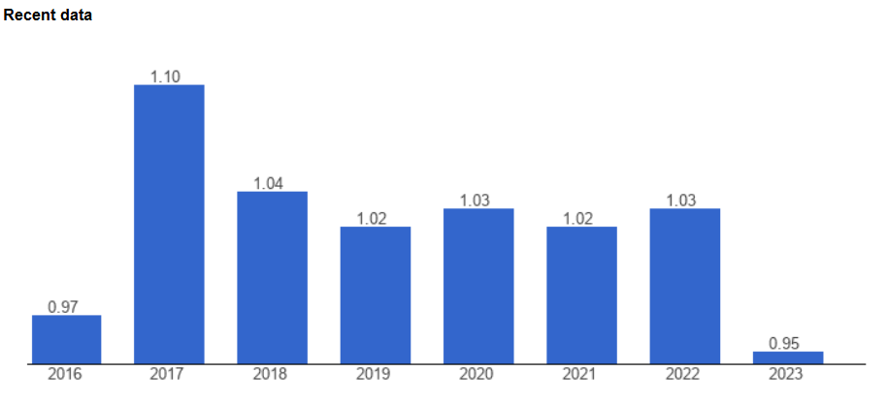
Figure 4: Political Stability Index value of Japan
(Source: theglobaleconomy, 2023)
Despite having a strong political scenario in Japan, the country is currently facing severe turmoil in its political climate. Based on the above-mentioned graph, the political stability index value of Japan is depicted with a reduction. In 2023, the political stability index value of the country decreased to 0.95, compared to 1.03 in 2022 (theglobaleconomy.com, 2023). This reflects a significant disruption in the political stability of the country, driven by factors like internal leadership challenges as well as the fragmentation of parliamentary activities. Due to the internal struggles of the ruling liberal democratic party of the country, the leadership practices have shifted frequently, disrupting the entire political environment. Apart from that, Indo-Pacific regional security concerns, as well as US politics, hamper the political stability of Japan by creating severe complexities. Based on these disruptive political conditions of Japan, it is quite evident that the supermarket chain Kohl's Corporation can face potential difficulties in managing its operations while entering Japan due to the unstable political scenario.
Economic
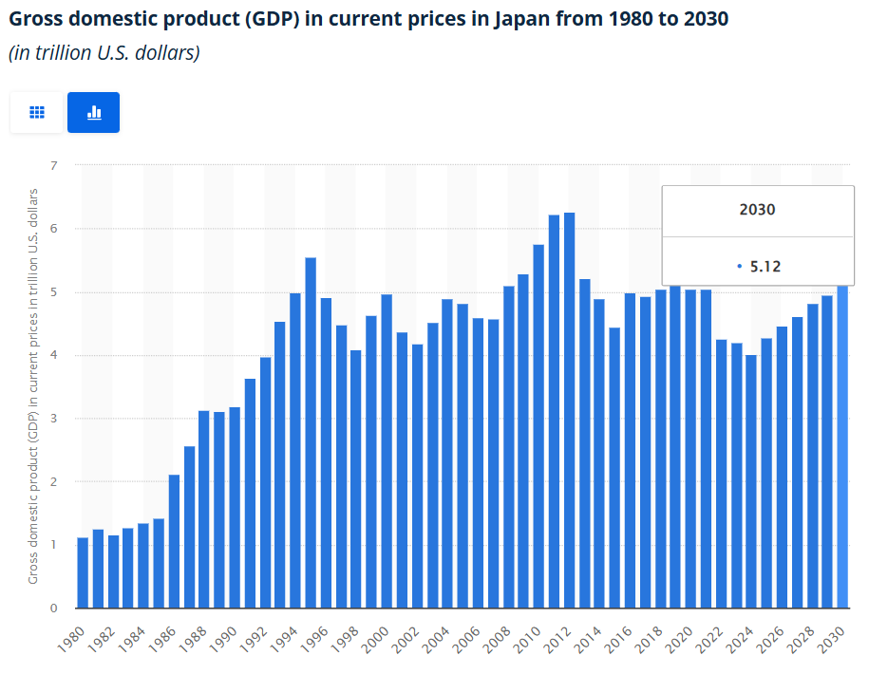
Figure 5: GDP of Japan
(Source: statista, 2025)
Japan is highly recognised for its strong economic factors, which are considered highly beneficial for the businesses of this country. Based on the graph of Japan’s GDP, it is quite evident that the country has a strong hold in terms of GDP. In 2024, the GDP of Japan was reported at $4.02 trillion, which is forecasted to increase to $5.12 trillion by 2030 (statista.com, 2025). As per the growth forecast, it is highly evident that Japan is quite significant as well as strong due to its highly developed economic system. Additionally, the inflation rate of Japan in August 2024 was analysed at 2.7% representing a significant decline compared to 3% in the same period of 2024 (tradingeconomics.com, 2025). Thus, it can be considered that the moderate inflation and high focus on industrial growth significantly contribute to the GDP growth of the country. Based on this, it can be stated that the expansion of Kohl's Corporation in this country can be proven highly beneficial due to the strong economic conditions. Thus, Kohl's Corporation can explore various economic opportunities while establishing its business in this particular country.
Social
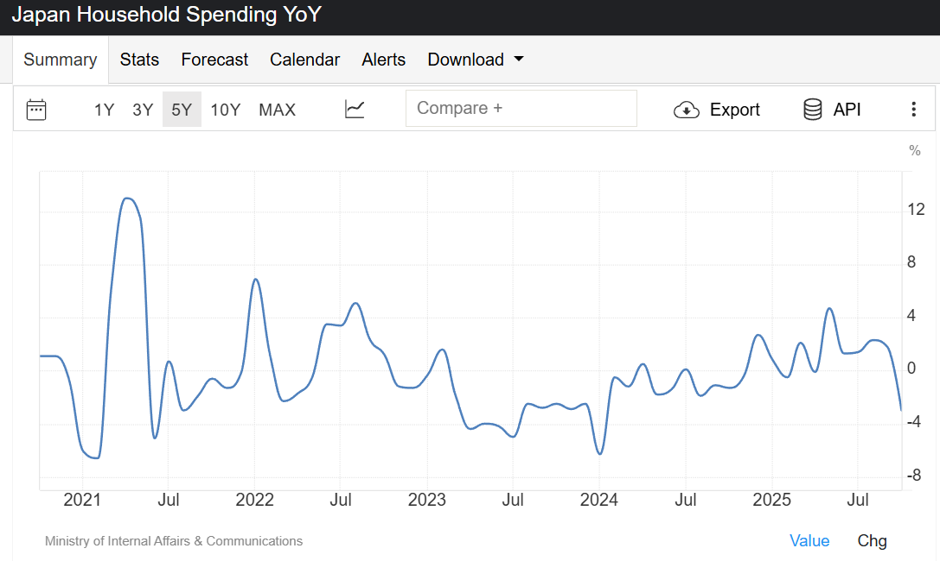
Figure 6: Household spending in Japan
(Source: tradingeconomics, 2025)
Japan is currently going through various social challenges, which are consequently affecting the business organisations as well. The country is currently experiencing low fertility rates and a decreasing birth rate, contributing to the decreasing population of the country. This consequently results in a labour shortage for business organisations in the country. In addition to this, declining pensions as well as a strained healthcare system also impact the affordability of Japanese consumers. Thus, the household spending of consumers also decreased in a significant manner, affecting the overall growth of the retail industry. As stated in the graph, the household spending rate of Japan decreased by 3% in October 2025 compared to the growth of 2.7% in December 2024 (tradingeconomics.com, 2025). This consequently results in the lower revenue growth of the retail organisations in the country. Apart from that, the ageing population of Japan also causes workforce challenges for business organisations. Thus, it is quite evident that the disruptive social condition of Japan can cause disturbance for Kohl's Corporation while expanding its business in this country.
Technological
In terms of technology, Japan is highly reported due to its strong focus on constant technological advancements.
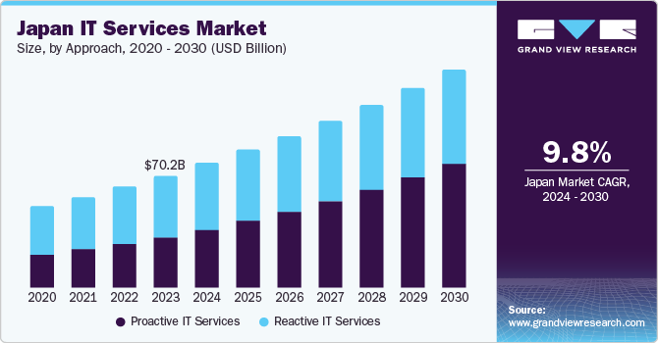
Figure 7: Japan IT market
(Source: grandviewresearch, 2025)
As per the graph above, Japan is currently experiencing a significant growth in its IT service market. In 2023, the IT service market of Japan reached $70.2 billion, along with a further increase to $77.90 billion in 2024. Moreover, the IT service market of the country is estimated to grow to $136.81 billion by 2030 at a CAGR of 9.8% between 2024 to 2030 (grandviewresearch.com, 2025). The technology market growth of the country is driven by the constant integration of advanced robotics, AI, and leading digital technologies for constant innovation. The country has also achieved a strong global position in the deployment of 5G to ensure a successful digital infrastructure.
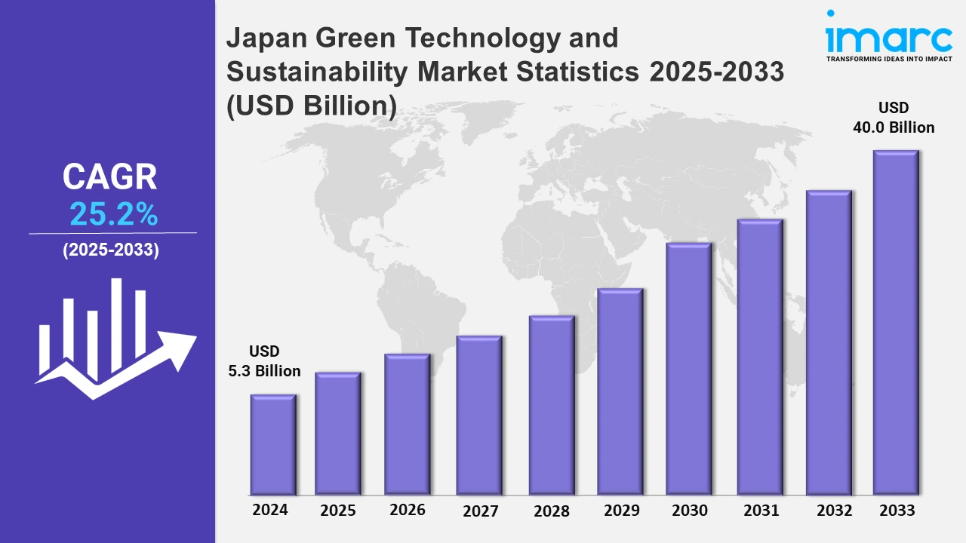
Figure 8: Green technology and sustainability market of Japan
(Source: imarcgroup, 2025)
Furthermore, green technology and the sustainable market in Japan also increased to $5.3 billion in 2024, and are also forecasted to increase to $40 billion by 2033 at a CAGR of 25.2% between 2025 to 2033 (imarcgroup.com, 2025). It is quite evident that the country also focuses on the constant integration of green and energy-efficient technologies to enhance sustainability. Thus, Kohl's Corporation’s plan to expand its business to the Japanese market can be highly beneficial in terms of technological factors due to the strong hold of Japan in technological advancements.
Legal
The unique hybrid legal system of Japan is quite efficient for business organisations. The “Labour Standards Act” of Japan is proven quite effective for the workforce of businesses due to the setting of fair wages and safety, along with working hours (leglobal.law, 2024). Also, the corporate regulations and guidelines of Japan are beneficial for organisations. The country’s Labour law and workforce guidelines represent high job security along with equal opportunity. Thus, Kohl's Corporation can explore various benefits associated with legal factors of Japan while expanding its business in this country.
Environmental
Japan has a strong focus on environmentally friendly business practices, as the country has opted for significant initiatives such as the achievement of net zero emissions by 2050 (japan.go.jp, 2024). Moreover, a significant focus on green transformation by making investments in clean and green energy represents the focus on a circular economy. Thus, Kohl's Corporation can achieve a sustainable reputation after expanding its business in this country.
Kohl's Corporation also needs to analyse the competitive landscape of Japan to assess the effectiveness of its business expansion in this country. Thus, to analyse the competitive landscape of the country, Porter's Five Forces analysis and a competitor analysis using a positioning map are discussed below:
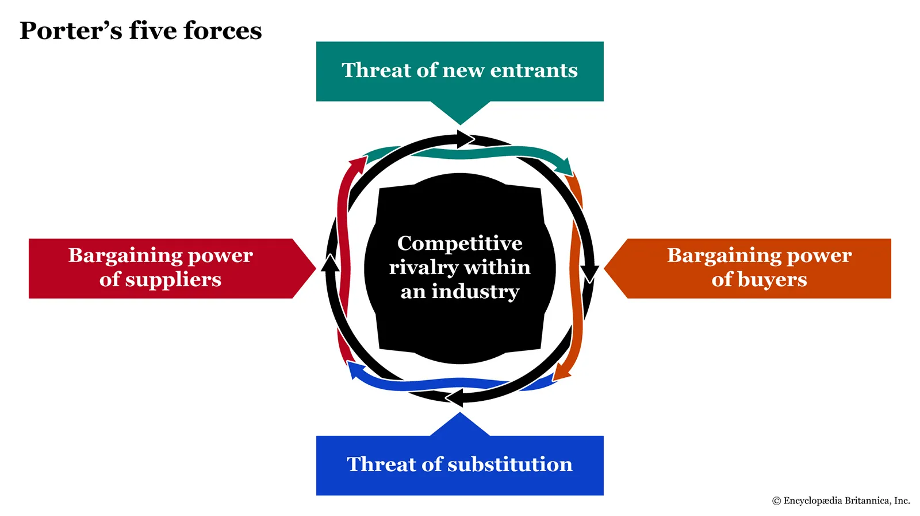
Figure 9: Porter’s Five Forces analysis
(Source: britannica, 2025)
Threat of new entrants
The threat of new businesses for Kohl's Corporation in Japan will be moderate to high, as the rapidly growing e-commerce can help new organisations to make an easier entry. However, the establishment of a new business in the retail industry of Japan requires a significant capital investment along with an extensive distribution network (Ndzabukelwako et al. 2024). This can be difficult for new businesses to match these requirements easily, which can create a moderate threat for Kohl's.
Threat of substitutes
The threat of substitutes can be high for Kohl's Corporation in the Japanese market. There is a huge availability of alternative items, as well as the availability of online retailers to offer a large number of alternatives to customers (Pangarkar and Prabhudesai, 2024). This can create threats for Kohl's Corporation’s consumers in Japan after expanding its business in the country.
Bargaining force of buyers
The bargaining force of the buyer will be significant for Kohl's Corporation while entering the Japanese market due to the availability of established companies. Customers have the power to switch brands based on their convenience and affordability (Sumba-Bustamante et al. 2024). Thus, Kohl's Corporation can face challenges regarding the high bargaining power of customers while establishing its business in Japan.
Bargaining force of suppliers
The bargaining power of suppliers for Kohl's Corporation will be quite low while expanding its business in the country. A large availability of retail suppliers in Japan helps brands to reduce the bargaining power of suppliers (Waworuntu et al. 2024). Thus, Kohl's Corporation can explore the benefits of an effective relationship with suppliers and their low bargaining power on the brand.
Competitive rivalry
Competitive rivalry for Kohl's Corporation will be extreme in Japan after expanding its business. Japan has global giants and local supermarket chains along with luxury brands, which can create a huge threat associated with competitive rivalry for Kohl's Corporation after entering the country.
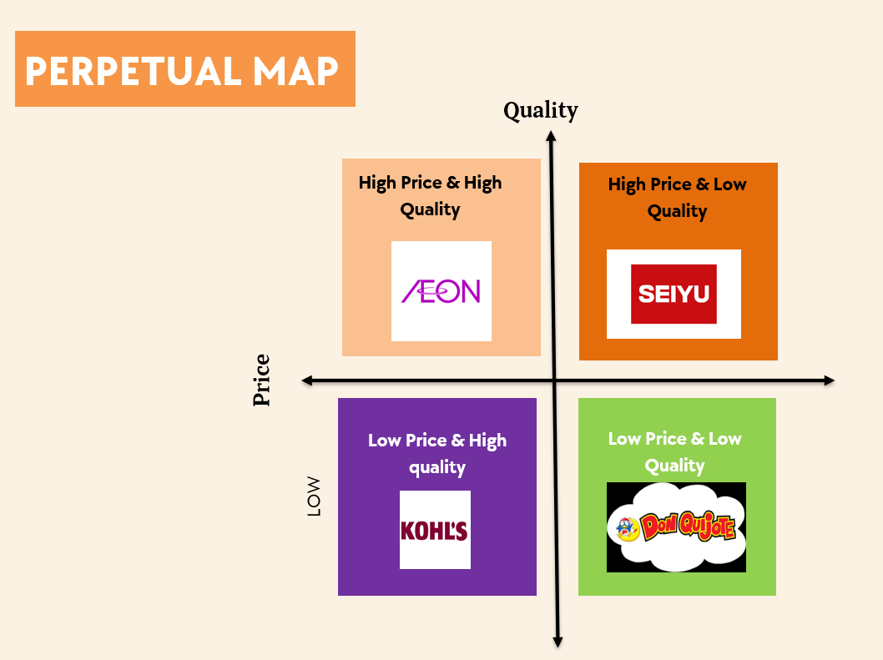

Figure 10: Positioning map
(Source: Self-created)
Based on the positioning map, AEON will be one of the major competitors of Kohl's Corporation while entering the Japanese market. AEON is considered one of the largest supermarket chains in Japan, providing premium quality retail products at a premium range. However, the strong focus of Kohl's in providing affordable retail items with a premium quality can be an opportunity to establish its business in Japan. However, Seiyu Group and Don Quijote will also be major competitors of Kohl's in Japan; among which Seiyu Group belongs to the category of high price, low quality in the positioning map, and Don Quijote belongs to the category of low price and low quality. Thus, the high-quality household and other retail items of Kohl's can help the business to compete with these rivals and establish its business in the country.
The analytical models are proven quite effective in determining the macro environmental factors and competitive landscape of Japan for the business expansion of Kohl's Corporation, as it explores diverse factors, such as political, economic, social, technological, legal, and environmental. However, cultural factors are not discussed, creating a limitation. Along with this, micro environmental analysis is also not given, which creates potential limitations.

3. Strategy Development and Formulation
Market entry strategy, in the opinion of Guercini and Milanesi, (2022), is a plan that is followed by the firms to enter into a new market internationally and expand their businesses with the product or services. Entering a new market by the firms provides more growth opportunities by acquiring more customers from the international economy, which in turn facilitates generating more revenue for the business. Integrating Porter’s Generic Strategies, in this context, can help the business of Kohl’s Corporation to enter and expand its business in Japan, gaining a competitive advantage in the market.
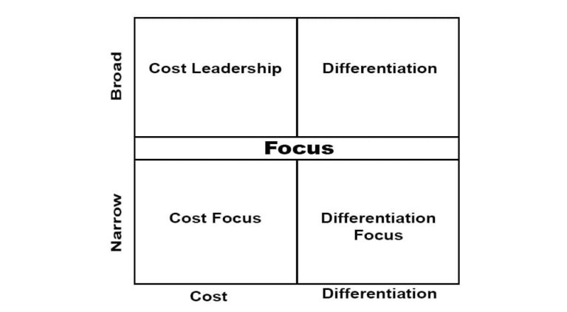
Figure 11: Porter’s Generic Strategies
(Source: parsadi, 2024)
Porter’s Generic Strategies is a framework which allows business entities to gain a competitive advantage in the market by using certain tactics. The firms utilising the strategies of Porter’s Generic basically emphasise the components like cost leadership, differentiation, cost focus, and differentiation focus (Ali and Anwar, 2021). The use of these strategies allows the business entities to offer distinctive products to the customers at a lower cost, which in turn facilitates the organisation to get the loyalty of the customers and a competitive advantage due to increased satisfaction among them.
Integrating Porter’s Generic Strategies framework into the business of Kohl’s Corporation, the company can focus on joint ventures to enter the Japanese market of Japan. Opting for a joint venture as a market entry strategy will allow the company to establish a competitive advantage in the market by utilising the firm’s resources optimally, which in turn will help to achieve the organisational goals and objectives. Joint ventures, as per the idea of Seibert, (2025), are an alliance formed between two organisations to run a business mutually and share the profits generated. Considering Kohl’s Corporation, the use of joint ventures for business operations will allow the company to explore different opportunities and risks in the Japanese market.
Integrating the Ansoff Matrix, in this context, Kohl’s Corporation can use the diversification strategy through a joint venture in the market of Japan. As per Zugay and Zakaria, (2023), diversification strategy in the aspect of the Ansoff matrix allows organisations to enter new markets through business expansion and acquire new customers by offering them new products and services. The market size of the Japanese retail market in 2024 was $1,779.7 billion, which is expected to grow to $2,006.9 billion by 2033, at a CAGR of 1.3% (imarcgroup.com, 2025). The constant growth of the retail market of Japan will offer potential opportunities to the business of Kohl’s Corporation.
Due to the increased retail market size of Japan, through a joint venture, Kohl’s Corporation can acquire several opportunities in the economy while expanding its business. The rising retail market size of Japan will allow Kohl’s to acquire new customers in the market and generate effective sales and revenue due to more satisfaction due to the firm’s emphasis on joint ventures. The use of the joint venture will allow Kohl’s to give more emphasis on differentiation and offer distinctive products to the customers due to better access to resources in the Japanese market. Offering distinctive products to customers gives them satisfaction, which in turn allows them to purchase more, and aids the business to compete effectively in the market and gain a competitive advantage (Agustian et al. 2023).
Besides these, opting for a joint venture by Kohl’s Corporation will help the business to avail the opportunity of knowledge sharing by the partnered firm and get acceptance from the local customers due to the development of products and selling them in the Japanese market as per their choices and preferences. Joint venture will allow Kohl’s to get the advice and expertise of the partnered firm, which will allow the business to make optimal use of resources and show cost leadership, and get a competitive advantage in the business by generating more profit. The local firms that are operating in Japan know the culture and taste, and preferences of the customers and opting for a joint venture will enable Kohl’s Corporation to avail the opportunity of cultural acceptance in the market, helping the business to flourish more and get a competitive advantage in the business.
Although it is known that using the joint venture as a market entry strategy by Kohl’s Corporation will help the firm to acquire different opportunities in the Japanese market, but at the same time, it can face certain risks due to opting for the strategy. In the Japanese market, the business of Kohl’s Corporation can face the risks of trade barriers due to government intervention in the market, which can affect the investment and partnership made by the firm negatively in the economy. Also, due to the joint venture strategy, the business of Kohl’s Corporation can face the risk of cultural clashes within the organisation due to differences of opinion, which can affect the productivity of the firm. The employee engagement rate in Japan is only 7% which is 21% when compared to all over the world (hrleader.com.au, 2025). Thus, while opting for a joint venture, in the economy, Kohl’s Corporation can face the risk of employee or labour shortage in the market, due to which it can go through the problem of low productivity.
Besides these, due to opting for a joint venture strategy to enter the Japanese market, the Kohl’s Corporation can face the risk of shared control from the business with which the company will partner. Joint venture, in the opinion of Hu et al. (2022), allows businesses to share the risks, but sometimes it can lead to conflicts due to a mismatch of ideas between the partnering firms, which ultimately hampers business productivity. Considering corporate social responsibility into account, and integrating the UN Global Compact, the firm that Kohl’s will opt for partnership might fail to work with transparency and accountability, which can restrict the business from achieving its sustainability goals, restricting the company from developing its brand image in the market of Japan. Thus, shared control emerges as a significant risk for the business of Kohl’s Corporation while opting for a joint venture strategy to enter the Japanese market.

4. Performance Evaluation Framework
The balanced scorecard, in the opinion of Bahri and Al Faruqy, (2023), is a framework that allows organisations to convert business strategy in terms of measurable performance. The firm measures the performance of the organisation in terms of four key aspects, which include internal processes, customer, finance, and learning and growth.
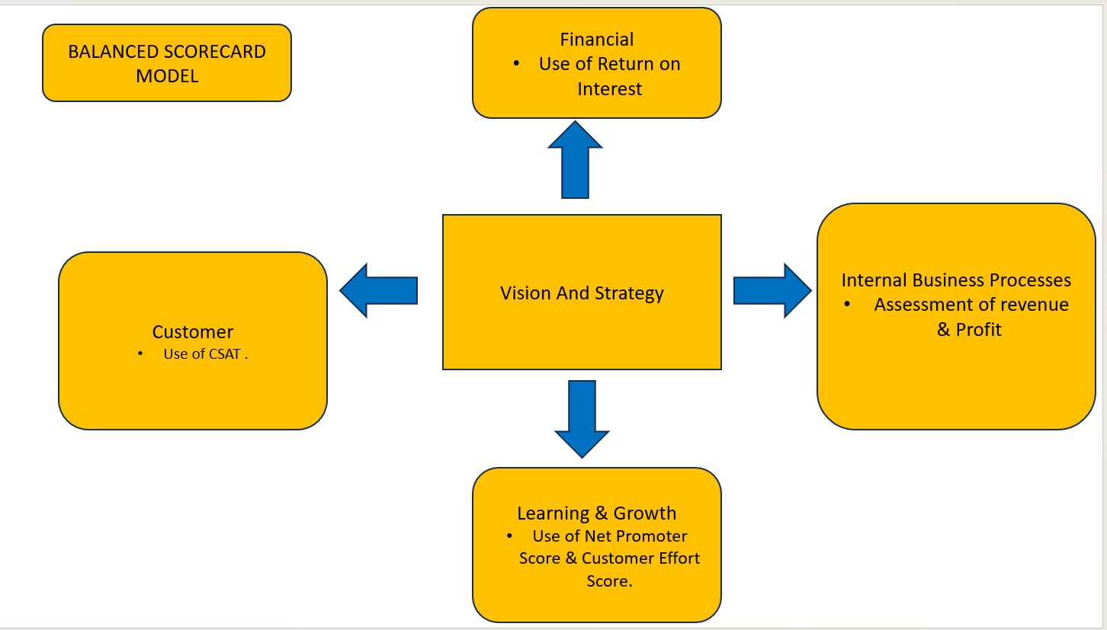
Figure 12: Balanced Scorecard Framework
(Source: Self-developed)
Internal Processes: Internal processes are the operations of an organisation which help businesses to achieve the goals of the firm (Mio et al. 2022). The expansion initiative of Kohl’s Corporation to enter the Japanese market through a joint venture can enable the business to attain success. The smooth operations of the firm, leading to increased productivity of the business in the Japanese market, can enable Kohl’s Corporation to assess the impact and progress of the expansion initiative. When the company finds that it is able to generate better revenue and profits, which are also the key performance indicators, it will enable Kohl’s Corporation to understand that the market entry initiative through a joint venture is successful in entering the market of Japan. Revenue and profits play a key role in enhancing the liquidity position of an organisation in the market and also offer financial stability to the business (Anoop, 2024). Thus, internal processes in the Japanese market will enable Kohl’s Corporation to identify the key performance indicators, like an increase in revenue and profit by reducing the operational expenses of the business.
Customer: Customers are pivotal for the growth of the business as they are responsible for generating sales for the firm in the market. In the context of Kohl’s Corporation, the firm aims to expand its business in Japan due to the availability of potential opportunities in the market. The retail market of Japan is constantly growing in the economy due to a growing population and a huge customer base. Japan made retail sales worth $1.78 trillion in the FY2024, which is expected to reach $2.01 trillion by 2033 (dgc-co.com, 2025). The increased retail sales indicate high buying potential of the customers in the market, providing an opportunity for Kohl’s Corporation to enter the market and expand its business. Thus, based on the purchases of the customers or the retail sales of the businesses, can help Kohl’s Corporation to identify the satisfaction level of the customers or the key performance indicator CSAT. In the opinion of Majka, (2024), CSAT is the KPI that measures the satisfaction level of customers by using the products or services of a brand. Thus, an increased rate of customer satisfaction can enable Kohl’s Corporation to identify the success level of its market entry strategy.
Finance: Finance plays a crucial role for business entities as it enables firms to flourish their business in the market (Gallagher, 2022). A good financial position enhances the brand equity of the firm, which in turn also facilitates acquiring the interest of the investors. In the context of Kohl’s Corporation, the firm aims to enter the market through a joint venture, which will also enhance the financial position in the market due to the sharing of risks and profits among the partnering firms with each other. Thus, the expansion initiative of Kohl’s Corporation will help the business to identify the key performance indicators like return on interest (ROI), due to the joint venture initiative of the firm to expand its business in the Japanese economy.
Learning and Growth: Learning and growth play a significant role as they allow organisations to assess the business environment and work with innovation to achieve success through organisational goals (Brunner et al. 2024). In the context of Kohl’s Corporation, the market entry strategy of acquiring a joint venture to enter the Japanese market will help the business to learn about the culture of the nation and work mutually by incorporating shared ideas. This will enable the business to work with innovation, which will facilitate growth for the business as the customers will get distinctive products, giving them a unique experience, enabling them to purchase products from the brand more. Thus, the expansion initiative of Kohl’s Corporation will help the business to identify the key performance indicators, like net promoter score (NPS) and customer effort score (CES), helping the business to check progress due to the improvements made. The use of these metrics by the company will allow the business to check its progress, as NPS will allow Kohl’s to determine the word of mouth that will be made by the customers, and CES will help to determine the efforts made by the consumers to interact with the business.
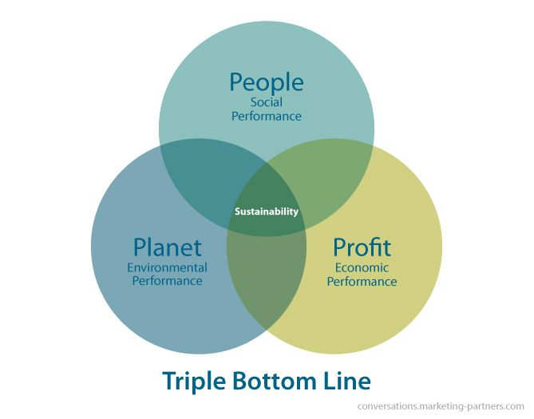
Figure 13: Triple Bottom Line
(Source: inchainge, 2025)
The Triple Bottom Line Framework is an approach where organisations work to earn profit by fulfilling their responsibilities towards people and planet (Nogueira et al. 2023). In the context of Kohl’s Corporation, the initiative by the brand to work with transparency and ethics will enable the business to earn the trust of its customers, enabling them to purchase more from the organisation, while the business opts for a joint venture in the Japanese market. The ability of the business to work with transparency and ethics will help Kohl’s to fulfil its responsibility towards the people. Through the purchase of the customers, the company will be able to measure the KPI of store traffic, enabling the business to assess the impact and progress of the expansion initiative.
Besides these, the company will promote sustainability while making a joint venture, which will help the business to gain the trust of the customers, enabling the firm to fulfil its responsibility towards the planet. The increased trust of the customers will enable the brand to gain their loyalty, which in turn will facilitate the business to assess the KPI of customer lifetime value (CLV), enabling the firm to know about the revenue it can generate from the entire lifetime purchasing journey, helping the business to earn profit too.

Conclusion
The report elaborates on the strategic management of Kohl's Corporation in light of its business expansion in Japan. The chosen company and the market are justified with the help of Porter's Diamond framework and BCG Matrix. Japan’s macro environmental factors and competitive landscape are also analysed using the PESTLE framework, Porter's Five Forces analysis, and competitor analysis. AEON is considered to be one of the major competitors of Kohl's after expanding its business in Japan. Also, strategy development and formulation are discussed using Porter's Generic Strategies, and also include market entry modes. Lastly, the performance evaluation framework is explored with the help of the balanced scorecard framework and KPIs.

References
Agustian, K., Mubarok, E.S., Zen, A., Wiwin, W. and Malik, A.J., (2023). The impact of digital transformation on business models and competitive advantage. Technology and Society Perspectives (TACIT), 1(2), pp.79-93. [Available at: https://journal.literasisainsnusantara.com/index.php/tacit/article/view/55]
Ali, B.J. and Anwar, G., (2021). Porter’s Generic Competitive Strategies and their influence on the Competitive Advantage. International Journal of Advanced Engineering, Management and Science, 7(6), pp.42-51. [Available at: https://www.academia.edu/download/67574092/g28.pdf]
Anoop, M.R., (2024). Cash is King: The Strategic Importance of Liquidity in Financial Management-a review. Multidisciplinary Research in Arts, Science & Commerce (Volume-7), p.26. [Available at: https://books.google.com/books?hl=en&lr=&id=ngMlEQAAQBAJ&oi=fnd&pg=PA26&dq=Revenue+and+profits+play+a+key+role+in+enhancing+the+liquidity+position&ots=D80iwB8tWW&sig=L3FCbLz_fuIG-qMM6sTH84uOyco]
Bahri, E.S. and Al Faruqy, M.Z., (2023). The Measurement Model of Business Entity Performance with Balanced Scorecard Approach. Journal of Multi-Disciplines Science (Icecomb), 1(1), pp.9-15. [Available at:https://www.researchgate.net/profile/Efri-Syamsul-Bahri/publication/368473098_The_Measurement_Model_of_Business_Entity_Performance_with_Balanced_Scorecard_Approach/links/63eaeec8bd7860764364569f/The-Measurement-Model-of-Business-Entity-Performance-with-Balanced-Scorecard-Approach.pdf]
bloomberg.com, (2025), about the operation of Kohl’s. [Available at: https://www.bloomberg.com/profile/company/K1SS34:BZ]. [Accessed on: 03.12.2025].
britannica.com, (2025), about Porter’s Five Forces Analysis. [Available at: https://www.britannica.com/money/porters-five-forces-explained]. [Accessed on: 03.12.2025].
Brunner, C., Fasca, C., Heinze, J., Honey, M., Light, D., Mandinach, E. and Wexler, D., (2024). Linking data and learning: The grow network study. In Transforming Data Into Knowledge (pp. 241-267). Routledge. [Available at: https://www.taylorfrancis.com/chapters/edit/10.4324/9781315045764-1/linking-data-learning-grow-network-study-cornelia-brunner-chad-fasca-juliette-heinze-margaret-honey-daniel-light-ellen-mandinach-dara-wexler]
datareportal.com, (2024), about Japanese internet users. [Available at: https://datareportal.com/reports/digital-2024-japan#:~:text=There%20were%20104.4%20million%20internet%20users%20in,percent)%20between%20January%202023%20and%20January%202024]. [Accessed on: 03.12.2025].
dgc-co.com, (2025), about the retail sales of Japan [Available at: https://www.dgc-co.com/cracking-japans-retail-landscape-in-2025/#:~:text=Japan's%20retail%20market%20remains%20one,of%20USD%2077%20billion%20annually.] [Accessed On: 03.12.2025]
expertprogrammanagement.com, (2024), about Porter’s Diamond Model. [Available at: https://expertprogrammanagement.com/2018/04/porter-diamond-model/]. [Accessed on: 03.12.2025].
Fukunaga, I., Hogen, Y., Ito, Y., Kanai, K. and Tsuchida, S., (2024). Potential Growth in Japan: Issues on Its Relationship with Prices and Wages (No. 24-E-16). [Available at: https://www.boj.or.jp/en/research/wps_rev/wps_2024/data/wp24e16].
Gallagher, T.J., (2022). Financial management: principles and practice. SAGE Publications: UK
grandviewresearch.com, (2025), about Japan’s IT market. [Available at: https://www.grandviewresearch.com/industry-analysis/japan-it-services-market-report]. [Accessed on: 03.12.2025].
Guercini, S. and Milanesi, M., (2022). Foreign market entry decision-making and heuristics: a mapping of the literature and future avenues. Management Research Review, 45(9), pp.1229-1246. [Available at: https://www.emerald.com/insight/content/doi/10.1108/mrr-11-2021-0806/full/html]
hrleader.com.au, (2025), about the workforce engagement of Japan [Available at: https://www.hrleader.com.au/business/27379-lessons-from-japan-s-low-workforce-engagement]. [Accessed on: 03.12.2025].
Hu, S., Gu, Q. and Xia, J., (2022). Problemistic search of the embedded firm: The joint effects of performance feedback and network positions on venture capital firms’ risk taking. Organization Science, 33(5), pp.1889-1908. [Available at: https://pubsonline.informs.org/doi/abs/10.1287/orsc.2021.1513]
imarcgroup.com, (2025), about Japan’s green technology and sustainability market. [Available at: https://www.imarcgroup.com/japan-green-technology-sustainability-market-statistics]. [Accessed on: 03.12.2025].
imarcgroup.com, (2025), about the retail market size of Japan [Available at: https://www.imarcgroup.com/japan-retail-market]. [Accessed on: 03.12.2025].
inchainge.com, (2025), about the Triple Bottom Line [Available at: https://inchainge.com/knowledge/sustainability/what-do-we-know-about-the-triple-bottom-line/] [Accessed On: 03.12.2025]
Islam, N., Khawar, M.T., Hussain, M. and Ramzan, M.B., (2025). Sustainable business model: Feasibility study for a clothing library to promote responsible consumption. Journal of Engineered Fibers and Fabrics, 20, p.15589250251346274. [Available at: https://www.researchgate.net/publication/393003470_Sustainable_business_model_Feasibility_study_for_a_clothing_library_to_promote_responsible_consumption].
japan.go.jp, (2024), about Japan’s sustainability focus. [Available at: https://www.japan.go.jp/kizuna/2024/01/together_for_action_japan_initiatives.html#:~:text=Achieving%20the%20global%20goal%20of,first%20leaders%20meeting%20this%20month.]. [Accessed on: 03.12.2025].
kohls.com, (2025), about Kohl’s. [Available at: https://www.kohls.com/]. [Accessed on: 03.12.2025].
leglobal.law, (2024), about Japan’s Labour law. [Available at: https://leglobal.law/countries/japan/employment-law/employment-law-overview-japan/#:~:text=Legal%20framework,employment%20contracts.]. [Accessed on: 03.12.2025].
Majka, M., (2024). Understanding Customer Satisfaction Score [online] [Available at: https://www.researchgate.net/profile/Marcin-Majka-2/publication/381401905_Understanding_Customer_Satisfaction_Score/links/666b6351de777205a32c2a71/Understanding-Customer-Satisfaction-Score.pdf]
medium.com, (2025), about PESTLE analysis. [Available at: https://medium.com/techno-preneurship/pestle-analysis-the-ceos-guide-to-future-proofing-a-business-877e6c4e20ea]. [Accessed on: 03.12.2025].
Mio, C., Costantini, A. and Panfilo, S., (2022). Performance measurement tools for sustainable business: A systematic literature review on the sustainability balanced scorecard use. Corporate social responsibility and environmental management, 29(2), pp.367-384. [Available at: https://onlinelibrary.wiley.com/doi/abs/10.1002/csr.2206]
Ndzabukelwako, Z., Mereko, O., Sambo, T. and Thango, B., (2024). The impact of Porter's five forces model on smes performance: A systematic review. Available at SSRN 4999059. [Available at: https://papers.ssrn.com/sol3/papers.cfm?abstract_id=4999059].
Nogueira, E., Gomes, S. and Lopes, J.M., (2023). Triple bottom line, sustainability, and economic development: What binds them together? A bibliometric approach. Sustainability, 15(8), p.6706. [Available at: https://www.mdpi.com/2071-1050/15/8/6706]
Pangarkar, N. and Prabhudesai, R., (2024). Using Porter's Five Forces analysis to drive strategy. Global Business and Organizational Excellence, 43(5), pp.24-34. [Available at: https://www.researchgate.net/publication/377578243_Using_Porter's_Five_Forces_analysis_to_drive_strategy].
parsadi.com, (2024), about the Porter’s Generic Strategies [Available at: https://parsadi.com/porters-generic-strategies/]. [Accessed on: 03.12.2025].
Seibert, K., (2025). Joint Ventures als strategisches Instrument im internationalen Marketing (Vol. 23). Duncker & Humblot: Germany
statista.com, (2025), about Japan’s GDP. [Available at: https://www.statista.com/statistics/263578/gross-domestic-product-gdp-of-japan/?srsltid=AfmBOoo5SSrwKDYxMusXQqP9yWHxwJkAm3I9IgPUAXyPrBQ_kMTMT0WP]. [Accessed on: 03.12.2025].
strategicmanagementinsight.com, (2025), about BCG Matrix. [Available at: https://strategicmanagementinsight.com/tools/bcg-matrix-growth-share/]. [Accessed on: 03.12.2025].
Sumba-Bustamante, R.Y., Cantos-Figueroa, M.D.L., Santistevan-Villacreses, K.L., Soledispa-Rodríguez, X.E., Nieves-Lizárraga, D.O., Cervantes-Martínez, L., Ultreras-Rodríguez, A., Olguín-Martínez, C.M., Triana-Garcia, R.W., Delgado, D.R. and Valencia-Ortiz, D., (2024). Strategic model for strengthening smes: An empirical study based on porter’s five forces. Journal Of Infrastructure, Policy And Development, 8(10), pp.1-22. [Available at: https://www.scribd.com/document/814809452/Assignment-2].
theglobaleconomy.com, (2023), about the political stability index value of Japan. [Available at: https://www.theglobaleconomy.com/Japan/wb_political_stability/]. [Accessed on: 03.12.2025].
tradingeconomics.com, (2025), about Japan’s household spending rate. [Available at: https://tradingeconomics.com/japan/household-spending]. [Accessed on: 03.12.2025].
tradingeconomics.com, (2025), about Japan’s inflation rate. [Available at: https://tradingeconomics.com/japan/inflation-cpi]. [Accessed on: 03.12.2025].
Waworuntu, E.C., Yasuwito, M. and Sumanti, E., (2024). Analyzing global industry dynamics using Porter’s five forces and ratio analysis model. Jurnal Ekonomi, 13(02), pp.745-760. [Available at: https://ejournal.seaninstitute.or.id/index.php/Ekonomi/article/view/4391].
Zeng, Y., Katsumata, S., Li, X. and Zhang, Q., (2025). Supplier–buyer (in) congruence in environmental management accounting for sustainable development in the context of Japan. Sustainable Development, 33(1), pp.84-99. [Available at: https://onlinelibrary.wiley.com/doi/abs/10.1002/sd.3085].
Zugay, B. and Zakaria, R., (2023). Ansoff matrix. SAGE Publications, Inc.: UK

