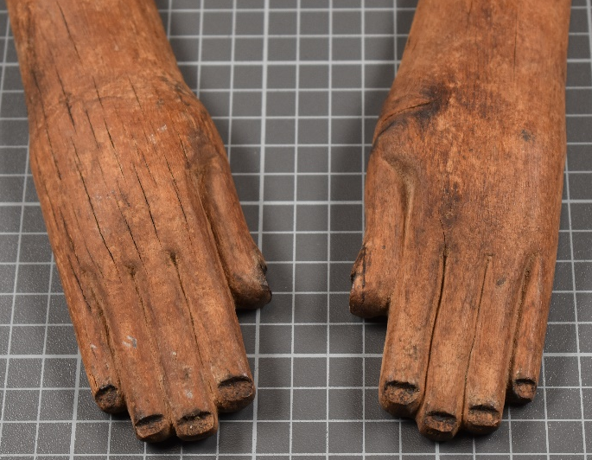
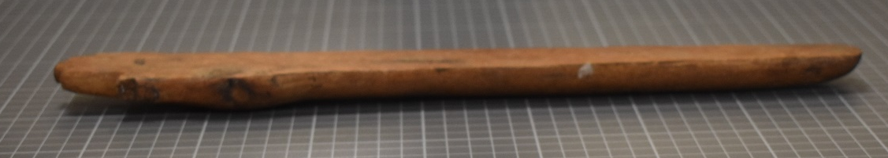
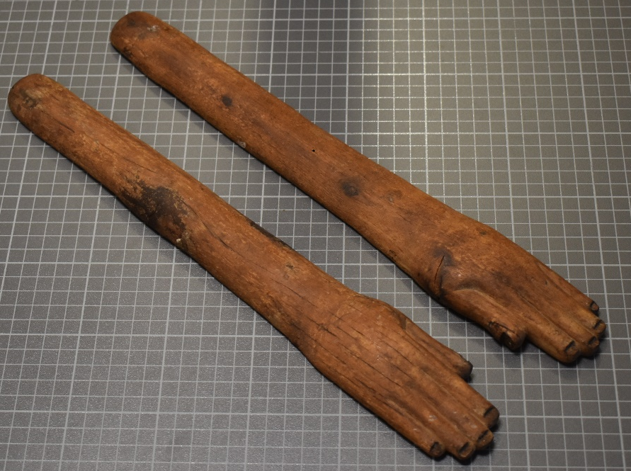

Clappers
Cyfarthfa Castle, Merthyr Tydfil CCM- 2018.994
Object type: Musical instrument (percussion)
Material: wood
Period: possibly Middle Kingdom
Provence: Egypt, likely close to Memphite region
Dimensions: Left; length-39.5cm, width (widest point)-5.5cm, circumference-9.6cm Right; length- 40cm, width (widest point)- 5.5cm, circumference- 9.5cm
Object analysis by Sofie Keddie
Description

The ancient Egyptian wooden clappers from Cyfarthfa are of simplistic design but is nevertheless intriguing in its purpose and meaning in ancient Egyptian religion and culture. The clappers are two mid-brown straight baton-like objects with a hand carved at one end while the other end is merely a slightly rounded edge. Each individual clapper measures to approximately the same length, with only half a centimetre’s difference distinguishing the left clapper’s length from the right. The width of the clappers softly increases from the rounded end toward the carved hand at the other. Engravings at the wider end of the baton which distinguishes it as a hand, the fingers and thumb are shown by soft indented lines. As well as this, the wood has been sanded to rounded ends at, with the fingers being differing lengths, representing the fingers and thumb. The underside of the objects has been smoothed down completely, the flat surface being essential to produce the intended sound. Whereas, the upper portion is just slightly rounded, giving the appearance of a human arm lying flat on a solid surface. The most extensive decoration on the clappers is small rectangular grooves at the end of each finger, deeper than the lines separating each finger, representing the fingernails. The objects are well preserved with little damage, however, there is minor imperfections. There are some shallow vertical cracks running down the left clapper and some spots of discolouration on the wood, possibly moisture damage. As well as this, the right thumb is slightly damaged, with there being a small chip in addition to the fingernail groove.
Clappers like the ones at Cyfarthfa are classified as an ancient form of percussion called an idiophone, which have been around as early as the predynastic times though physical evidence is not established until slightly later, during the 4th millennium BCE. When they are played their “entire body vibrates”. In the case of clappers, this would happen when the separate objects are hit together, making a ‘clap’ sound. The shape being a hand and forearm indicates that their purpose was to imitate ‘clapping’, possibly to keep the beat and rhythm in a piece of music. This could either mean that they were used to completely replace the hands of an individual, which is logical, as physically clapping can be uncomfortable after an extended period. Alternatively, it could have been a mixture of using human hands and clappers. The length of the clappers shows that one would have been held in each hand when played, however, smaller examples could also have been held together and played ‘like bones’ which would produce a different sound. In addition to clappers there were other instruments such as flutes, which appeared at a similar time and followed by string instruments such as harps in the next millennium.
It is not certain what role clappers would have had for the Egyptians. But if how music is used today is anything to go by then it can be assumed that it is used in all areas of life, both regular and special. The earlies depictions of the clappers are shown in art a very early pre-dynastic example of this is the stick figure on the vase (figure 1), many Old Kingdom depictions of clappers are tomb paintings, “where dancers and singers are shown performing during the funeral procession or at the entrance of the tomb.

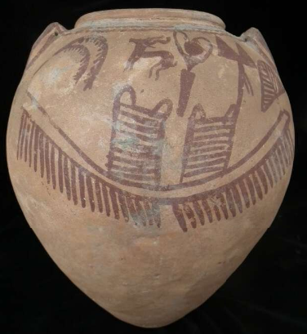
The dancers and singers of this time were predominately female, although male involvement is indicated, especially from the middle kingdom onwards. Funeral dances could be expressing grief or ritual through the movements of the body. The dancers and musicians would likely have been part of professional troupes who were employed for special occasions, like they would today. This means that the original owner of the Cyfarthfa clappers could have been a woman who performed music regularly for entertainment or religious purposes.
Fig.1. pre-dynastic painted pot depicting use of clappers. (British Museum EA36327)
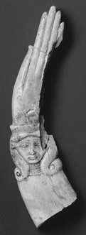
A religious cult that is linked to clappers is that of Hathor, who is closely associated with women, fertility and childbirth. In ancient Egypt, birth and death were both viewed with the same importance, with birth being the beginning of the journey into life and death the beginning of the afterlife. The ritualistic activities of Hathors cult would have included ensuring ‘safe passage’ of a person in both birth and rebirth. Clappers depicting Hathor in her form of a lady with the ears and horns of a cow on the handle (like in Fig.2) have been discovered in both tombs and cultic temples, located mainly in the memphite region and Dendera. These clappers may been used in magical rituals or spells. Noises that clappers would have made could ‘frighten away evil spirits’ or they may have been an ‘offering’ for the deceased without intention to be played. The image of deities such as Hathor would have held its own power because her image would have provided protection.
Fig.2 Curved ivory Egyptian clapper depicting the goddess Hathor. (Brooklyn Museum 14.614)

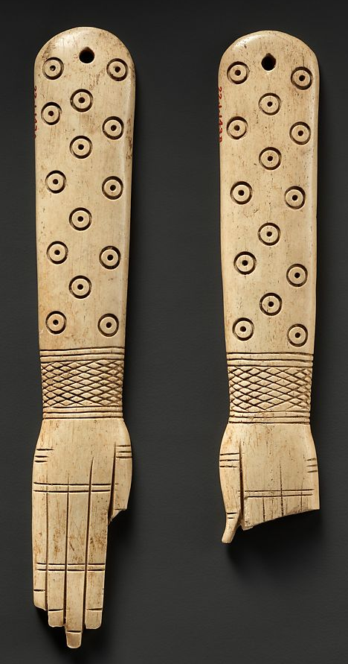
The material and design of the clappers could indicate when it was produced, and it is possible use. The most common materials used is wood, bone and ivory, ones made of bone and ivory (see fig.2 and 3) would likely have been more expensive and trickier to carve, so it can be inferred that they would have belonged to the elite. This is backed up by most of these clappers being buried at sites close to royalty or provincial powers. Middle kingdom members of the cult of Hathor, held titles of priestess as well as administrative titles, which gave them elite status. Wooden clappers seem to be found less in similar contexts; this may be due to them being less desirable, or simply because wood decays faster and therefore the evidence has been destroyed. Clappers can also be straight, or have a slight curve, which may be a mere cosmetic difference or a ritualistic one. The fact that the clappers in figures 2 and 3 have detailed decoration compared to the lack on the Cyfarthfa pair may mean that the wooden clappers were owned by a non-elite person who likely close enough to the Memphite region where cults involving clappers were centralised, possibly in one of the local provinces. Although this cannot be confirmed, it is also essential to consider the possibility that, considering the condition and decoration, that it could be a later imitation.
Figure 3. Pair of straight Ivory Egyptian clappers with circle and bracelet decoration. (MET 22.1.143a, b)

Bibliography:
Images:
Cyfarthfa castle clapper Catalogue photos: Zinn, Katharina (photographer), UWTSD <https://moodle.uwtsd.ac.uk/mod/folder/view.php?id=314714>[Accessed:30/01/2021].
Figure 1: trustees of British Museum photograph, ‘Large Vase, Predynastic’, EA36327 (British Museum, London) https://www.britishmuseum.org/collection/image/154272001 [Accessed: 01/02/2021]
Figure 2: Brooklyn Museum photograph (2018), ‘Fragment of a Magic Wand or Clapper’ 14.614 (Brooklyn Museum, New York) https://www.brooklynmuseum.org/opencollection/objects/3109 [Accessed: 28/01/2021]
Figure 3: MET Photograph, ‘Pair of Clappers’,22.1.143a, b (Metropolitan Museum of Art, New York) https://www.metmuseum.org/art/collection/search/546840 [Accessed:28/01/2021]
Scholarship:
Brewer, Douglas J and Teeter, Emily, Egypt and the Egyptians (Cambridge: Cambridge University Press, 2000)
Heidi Köpp-Junk. ‘The Earliest Music in Ancient Egypt.’ Friends of Asor, VI, no.1 (Jan 2018).URL: http://www.asor.org/anetoday/2018/01/earliest-music-egypt [Accessed:22/01/2012]
Hussein, Angela Murock, ‘A Match for the ages. (Egyptian Musical Instruments)’, Calliope (Peterborough, N.H.), 24.1 (2013), 4 (4)
Spencer, Patricia, "Dance in Ancient Egypt." Near Eastern Archaeology 66, no. 3 (2003): 111
Selene-Sayell, Lou. "SERVANTS OF HEKET: Midwifery and Birth in Ancient Egypt." Ancient Egypt Magazine 13, no. 3 (2012): 10-16.
van Ryneveld, Magda, ‘Frogs in Ancient Egyptian Art.’, Ancient Egypt Magazine, 11.6, (2011):28–30
Mark, Joshua J. ‘Music and Dance in Ancient Egypt’, Ancient History Encyclopaedia, (17/05/2017), https://www.ancient.eu/article/1075/music--dance-in-ancient-egypt/ [Accessed: 22/01/2021]
Gillam, Robyn A. ‘Priestesses of Hathor: Their Function, Decline and Disappearance’, Journal of the American Research Centre in Egypt, 32 (1995), 221-237
Smith, Mark. ‘Democratization of the afterlife’, UCLA Encyclopaedia of Egyptology, 1(1) (2009)
Morris Ellen. ‘Middle Kingdom clappers, dancers, birth magic, and the reinvention of ritual’, in company of images Modelling the Imaginary World of Middle Kingdom Egypt (2000-1500 BC) Proceedings of the International Conference of the EPOCHS Project, ed. Gianluca miniaci, marilina betrò and Stephen Quirke (London, UCL,2014)

Kopp-Junk, H (2018)
Kopp-Junk, H (2018)
Murok Hussein, A (2013)
Morris, E. (2014)
Kopp-Junk, H (2018) and Brewer, D J and Teeter, E (2000)
Spencer, P. (2003)
Spencer, P (2003)
Morris, E. (2014) and Spencer, P (2003)
Mark, J J. (2017)
Van Ryneveld, M. (2011)
Selene-Sayell, L. (2012)
Gillam R A. (1995)
Selene-Sayell, L (2012)
Murock-Hussein, A (2013)
Smith. (2009) and Gillam R A (1995)
Morris, E (2014)
Gillam, R A. (1995)

