Robert Hughes
P146886
University of Wales Trinity St David
Lecturer Dr Owen Williams
(M7X00436)
02/02/2020

LAND SPEED RECORD
ELECTRIC MOTORCYCLE
SUSPENSION SETUP

Contents
Introduction 3
Preliminaries 4
Sag setting 4
Tyre pressure 4
Suspension calculations 4
Simulation 8
Conclusion 10
References 12
Appendix 1 13

Figure 1, land speed bike c/w rider 6
Figure 2, land speed bike profile c/w cog measurements. 7
Figure 3, steady state response graph (chegg, 2020). 7
Figure 4, modified 2D model. 9
Figure 5, mass displacement in Solidworks. 10
Figure 6, frame angular displacement. 10
Figure 7, Matlab results. 11

Table 1, calculations for spring/dampers. 8

Introduction
The ‘so-called’ black art of motorcycle suspension setup is much less a black art but more the understanding of what a rider wants or needs from the bike’s suspension.
The rider is the underlying driver to how the suspension needs to be set up, not just the physical parameters of weight and height but how the bike feels for them to ride.
These unmeasurable quantities of feeling and emotion are as much of the equation as the physical measurements and adjustments that can be made. This unfortunately means that the perfect setup for one rider will only be for the one rider (Prof. D. K. Chavan, 2013).
The machine, if used for road riding will be set up in a particular way that affords the rider a degree of comfort, such as touring bikes but more aggressive styles of bike would have harder springs to give more of the feel of the road to the rider; motorcycles for racing are set up with only one thing in mind, to achieve ultimate grip at the fastest speeds possible, no need for comfort on these machines.
The setup will differ too with environmental conditions, when adjusting for a wet surface changes made may include softer springs and lighter damping, this would be to bias the weight more forward on the bike under braking to keep more heat in the front brakes and tyre; again the adjustments for one rider would not be suitable for a different rider, it is a very personal thing (boxrepsol, 2019).
Motorcycle racers must converse with the technicians intensely to achieve the optimal setup for the conditions and the track, this will change from track to track and day to day because of external variables such as temperature and moisture, even barometric pressure (B. A. Shannak, 2002).
The settings for a professional rider are so precise that if they are applied to a different bike the rider would need them to be refined before being competitive on the new bike.

Preliminaries

Sag setting
The sag setting is a measurement of the height of the suspension appertaining to the optimal operating point, this should be one third of the way up the travel of the shock absorber.
The process to set the sag is as follows: fully back off any preload then bike must be lifted off the ground and the measurements of the front and rear wheels are made; the front wheel is measured in line with the forks from the axle to the lower triple clamp, the rear is measured vertically from the axle to a chosen point on the bodywork on the rear of the bike, , and repeat the measurements with the suspension fully compressed.
The measurements are then taken from each other to give the total length of travel; the preload should then be adjusted to sit at 33% up the travel of the shock absorber with the rider on the bike (mcn, 2019).

Tyre pressure
Another often neglected setting, but very important, is tyre pressure. Again, a very personal setting which is very easy to adjust, a guide front pressure to start from would be 32 PSI or 2.2 bar and rear of 30 PSI or 2 bar; little adjustments at a time and always note what effects result. Pressure should be checked before each ride as it can be affected by barometric pressure and temperature; racing motorcycles will need to be checked when the tyres are at operating temperature.

Suspension calculations
The supporting member in a motorcycle’s suspension setup is the spring, what regulates the spring is the shock absorber or what should be correctly called the damper,
If there were no damper the spring would be free to oscillate, this would lead to serious handling difficulties.
For a brief period when motor powered wheeled transport was in its infancy suspension was a luxury, speeds were limited and solid rubber tyres were enough; as speed increased there became a need to keep tyres in contact with the road and so the spring damper arrangement was devised (daimler, 2020).
The spring in the first instance should be of a stiffness capable of supporting the weight of the machine and rider at a suitable position in its travel (see sag setting above).
The calculation of the spring’s rate is dependent not only on the mass that is supported by it but also on the ride frequency,
Vibration comes not only from the road/track surface but from other parts of the bike itself, the engine’s rotating parts and the wheels rotating for instance have their own vibrations. The engine is generally at a range too high to have effect on the body but if an engine is low revving or not well balanced such as Harley-Davidson engines, they may have a bearing on comfort and feel.
All parts of the human body have frequencies that if acted on the body are very uncomfortable and in some cases dangerous; if the hand is subjected to a vibration of frequency of 12-16 Hz for a short period it will be uncomfortable but for longer term exposure numbness and temporary loss of function can occur (HSE, 2020).
The motorcycle is the same, long term exposure to certain frequencies of vibration can be damaging to the fabric of the motorcycle.
This electric motorcycle has in essence a more simple setup as electric motors are inherently more balanced and create little to no vibration in themselves, as the motors and other moving parts are also as un-sprung mass the rider will feel none of the vibration directly but only through the suspension itself.
The front of the electric bike under design shares similarities with its road going counterparts, it has the same wheel and tyre but has a far from similar un-sprung mass, the rear has striking differences; the wheel is a considerable amount bigger in diameter and width, as is the tyre; Being specifically designed for use on the drag strip; the rear un-sprung mass also includes the weight of the two electric motors and the ancillaries that go along with them.
The calculations for working out the spring and damper characteristics are the same for any two wheeled vehicles, it is seen in Vittore Cossalter’s book, Motorcycle Dynamics, the starting point for any calculations has to be a ride frequency, in examples, Cossalter’s preliminary consideration intimates that a ride frequency of 2Hz is a reasonable starting point for a road going vehicle, but as this motorcycle will only be used on a straight and even surface a higher frequency will be used (Cossalter, 2006).
A ride frequency of 2.1Hz is only marginally higher but is a reasonable starting point to see the outcome of the calculations, as this will be calculated in Microsoft’s Excel program and will be driven from this frequency and mass it is easy to change and the outcome will propagate throughout the results.
The center of gravity of the bike is required to distribute the mass appropriately to the front and rear suspension; this is difficult as the motorcycle is only in the design phase of development and does not physically exist for testing, a reliance has to be put onto computer aided design software to output a reasonable approximation of the center of gravity.
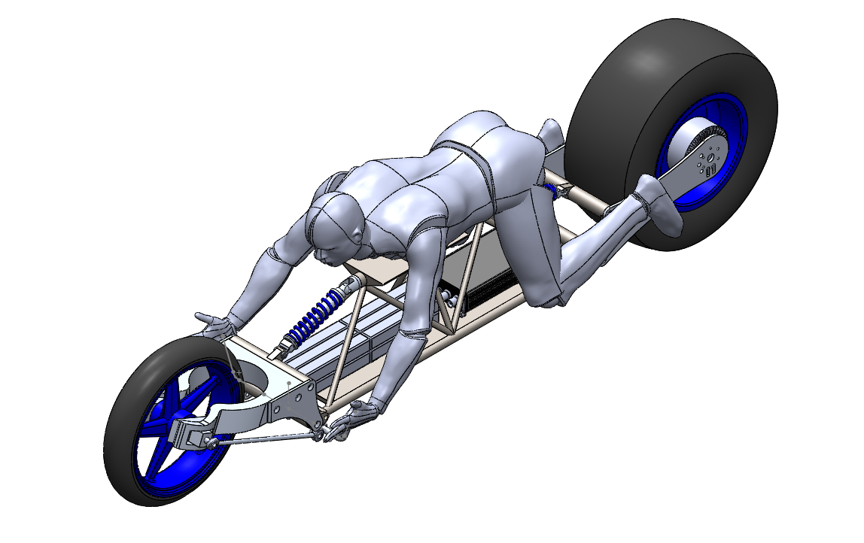
Figure 1, land speed bike c/w rider
The motorcycle has been modelled in Solidworks, see figure 1 and 2, the model includes all major components with the correct weights applied, included is an anatomically correct human figure also with an appropriate weight figure applied, the center of gravity can be seen in figure # as a set of pink arrows; the position of the center of gravity when compared to other motorcycles appears reasonable, it is above the centreline of the wheels and a little back from the center of the frame.
The sprung mass distribution is based on the split between the figures, when applied to the Excel sheet with the equation:- ${\left(2*π*ride frequency\right)}^{2}*sprung mass$, achieves a result for the spring stiffness required for the front and rear suspensions.

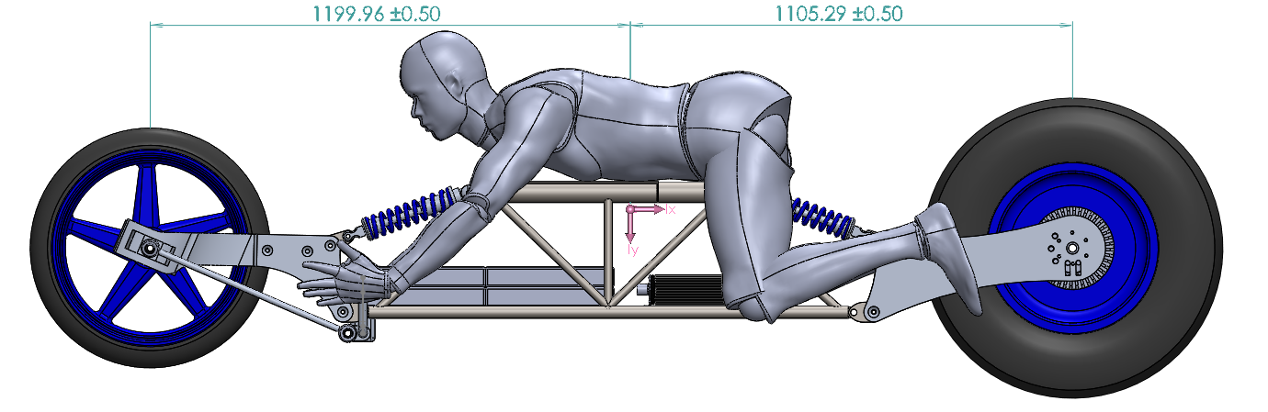
Figure 2, land speed bike profile c/w cog measurements.
The critical damping figure can be acquired by multiplying two times the square root of the vertical stiffness at the wheel times the sprung mass; this is then utilised to achieve the critical damping at the damper itself by multiplying the vertical critical damping by the link ratio squared, this must then be multiplied by a response value determined from the graph in figure 3.
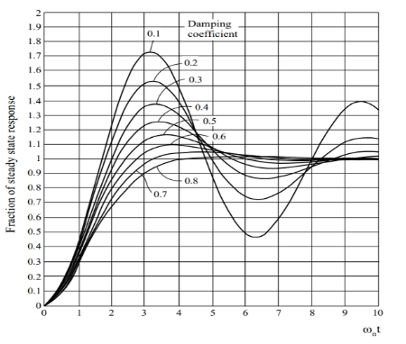
Figure 3, steady state response graph (chegg, 2020).
The figures in table 1 show the mass inputs deduced from real world data and Solidworks (in yellow), the parts in Solidworks when the correct material is applied gives a very accurate mass output.
Other results shown in table 1 are the result of the previously discussed calculations, in green are the link ratios and spring stiffnesses, in blue are the critical and actual damping figures and in brown are the tyre stiffness and damping values.
Table 1, calculations for spring/dampers.

Simulation
The simulation of this suspension setup has been done in Solidworks and attempted in Matlab.
The Solidworks program is a great platform to design with, but the simulation algorithms that are available struggle with more complex structures, it is amazing at static study such as stress and displacement but where degrees of motion are required it struggles.
The design as seen in fig 1 was found to be so complex that the programme would constantly error.
An attempt to simplify the model but keep its major components was attempted but failure still occurred, attempts with no wheels, no onboard loads and just constraints instead of spring/damper units were attempted but with no success.
A breakthrough occurred with trying to make the model more two dimensional, see figure 4; this uses a flat frame and swingarms, the spring damper units are just piston like parts onto which spring/damper mates could be applied; these were used to simulate the main suspension and the suspension effect of the tyres, the long base parts are required to input signals to the lower tyre simulating pistons; to simulate a hump in the road/track/beach.
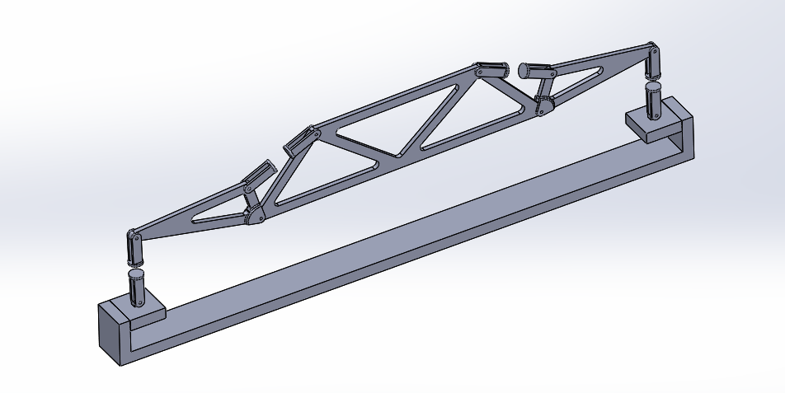
Figure 4, modified 2D model.
Matlab, in this instance is used as a modelling tool, for this application no existing code could be found so an adaption of a supplied code was required, the initial code, supplied by Dr Owen Williams of the University of Wales Trinity St David gave an insight into what was required as the suspension setup is the same as the rear of a motorcycle on both front and rear and the method to induce a road effect to the model.
The code was adapted by taking out the front suspension code which utilised fork rake angle and the existing code for the rear was re-inserted but referencing the front constraints of the model (see appendix 1).

Conclusion
The results from Solidworks were surprisingly close to the results that would be expected from the real suspension; the graph in figure 5 shows two distinct phases of the suspension, it must be noted at this stage that Solidworks requires time for a model in the simulation to achieve its relaxed or stable equilibrium point before the test can begin.
It can be noted that the first two and a half seconds of the graph is its settling phase then the road bump is introduced, the bump is introduced to the front wheel simulation block at the two and a half second mark and a tenth of a second later to the rear block.
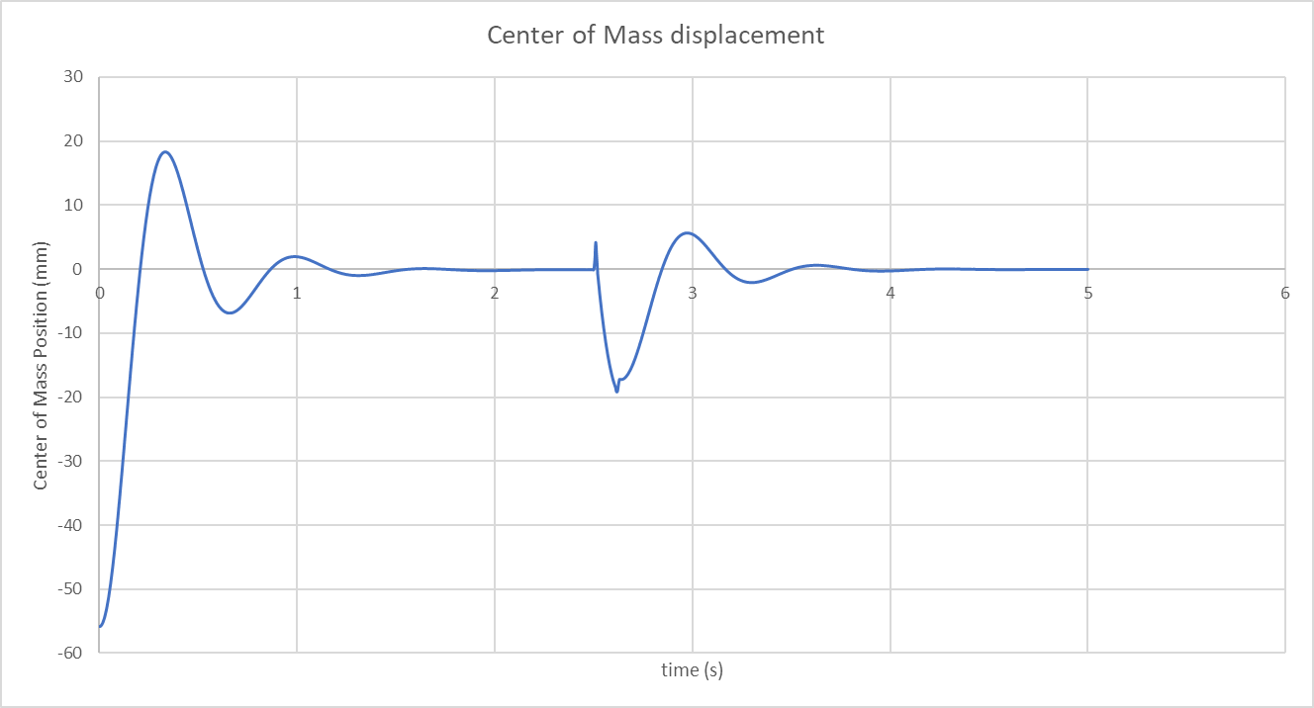
Figure 5, mass displacement in Solidworks.
The graph clearly shows an appropriate spring damping effect, it returns to its equilibrium point and overshoots a few times, this would be a comfortable ride.
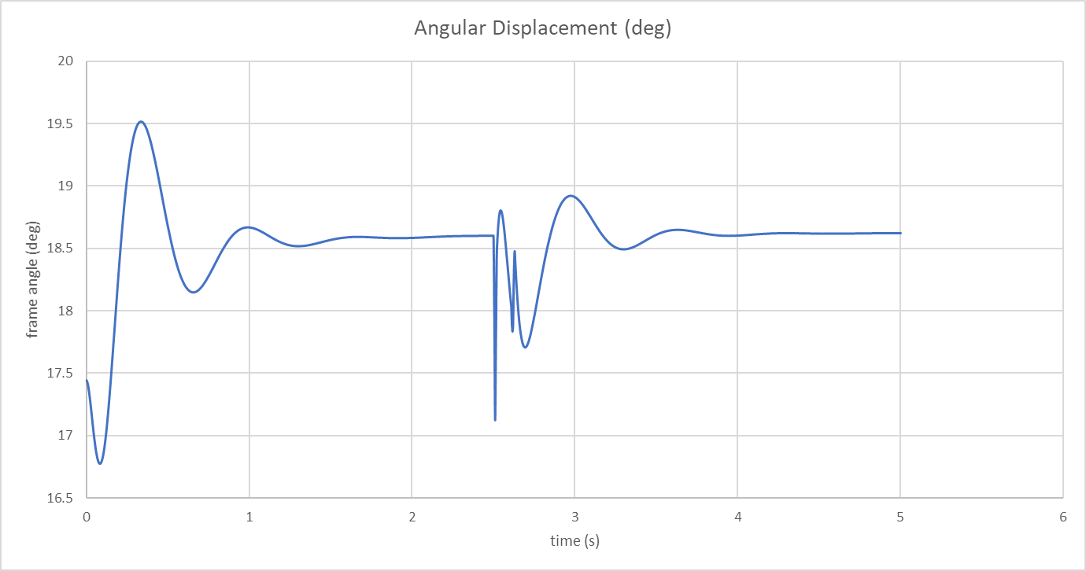
Figure 6, frame angular displacement.
Figure 6 displays the angular change found on the frame during the test, again the first two and a half seconds are the settling phase, the bump inputs would be strongly felt as expected. The angle displacement on the graph is initially down but this displays that the front of the bike rises; the upward movement is the back rising; this graph shows a reasonable return to the equilibrium point.
There were found to be limiting factors in the Matlab code, the results of running this code can be seen in figure 7
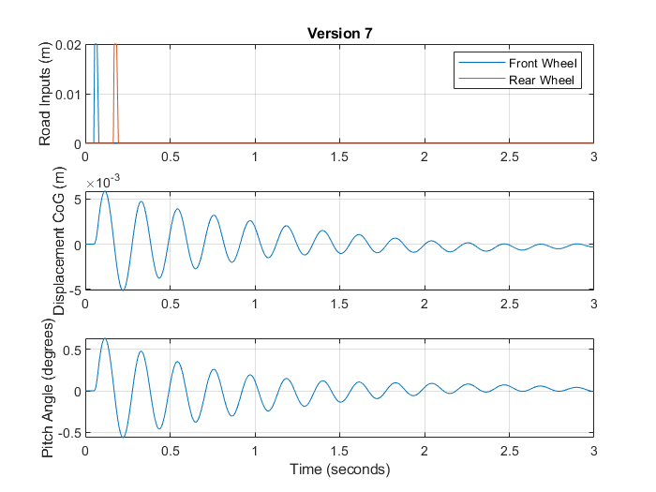
Figure 7, Matlab results.
The output from Matlab shows an under damped situation, it takes a long time to settle to its equilibrium position; the limitation found in the code is that the link ratio cannot be entered if it is greater than 2.4 this requires further investigation.
The overall result of this study using Solidworks and Matlab is encouraging, it goes someway to showing that the mathematics behind the suspension setup is correct and that the setup will function as required on the real bike when built.

References
B. A. Shannak, M. A. (2002). Effect of atmospheric altitude on engine performance. Forschung im Ingenieurwesen , 157 – 160.
boxrepsol. (2019, 08 21). setups-for-dry-and-wet-conditions-getting-the-bike-ready-for-all-weather-conditions/. Retrieved from www.boxrepsol.com: https://www.boxrepsol.com/en/motogp-en/setups-for-dry-and-wet-conditions-getting-the-bike-ready-for-all-weather-conditions/
chegg. (2020, 02 01). accelerometer-natural-angular-frequency-50-rad-s-damping-ratio-06-static-sensitivity. Retrieved from chegg: https://www.chegg.com/homework-help/questions-and-answers/b-accelerometer-natural-angular-frequency-50-rad-s-damping-ratio-06-static-sensitivity-k-5-q29009253
Cossalter, V. (2006). Motorcycle dynamics. usa: Lulu.
daimler. (2020, 01 25). History of suspension: from independent to active suspension. Retrieved from media.daimler.com: https://media.daimler.com/marsMediaSite/en/instance/ko/History-of-suspension-from-independent-to-active-suspension.xhtml?oid=9361881
Firestone, D. F. (1940). USA, Michigan Patent No. 2,280,226.
HSE. (2020, 01 25). hand-arm vibration at work. Retrieved from www.hse.gov.uk: https://www.hse.gov.uk/vibration/hav/index.htm#
mcn. (2019, 07 31). Shock therapy: How to set up your motorbike’s suspension. Retrieved from www.motorcyclenews.com: https://www.motorcyclenews.com/advice/maintenance/suspension-set-up-sag-rebound-compression/
Prof. D. K. Chavan, S. V. (2013). Suspension in Bikes Considering Preload, Damping Parameters and Employment of Mono Suspension in Recent Bikes. International Journal of Engineering Trends and Technology, 212-218.

Appendix 1
Matlab code (amended)
% State Space Half Car Model
% Dr Owen Williams
% University of Wales TSD

%Simulation takes into account front and rear linkage ratio;
%Calculates displacement of sprung and unsprung at front and rear;
%Calculates Ycog and pitch angle

%--------------------Geometry---------------------
TotalMass=257.55; %Total mass of motorcycle(kg)
FrontWheelMass=23.34; %Mass of front wheel(unsprung)(kg)
RearWheelMass=47.27; %Mass of rear wheel (unsprung) (kg)
WeightDistribution=47.95; %percentage at front
Wheelbase=2.30525; %Distance between front and rear contact patch(m)

%--------------------Spring and Dampers------------
Cfspring=8666; %Damping front shock(Ns/m)
Crspring=6634; %Damping rear shock(Ns/m)
Kfspring=142939; %front spring stiffness
Krspring=109415; %rear spring stiffness
LinkageRatiof=2.4; %front linkage ratio
LinkageRatior=2.4; %rear linkage ratio
TyreStiffnessf=98000; %Tyre stiffness front(N/m)
TyreStiffnessr=49000; %Tyre stiffness rear(N/m)
TyreDampingf=126; %Tyre damping coefficient front(Ns/m)
TyreDampingr=63; %Tyre damping coefficient rear(Ns/m)

%--------------------------Variables---------------------
V=20; %Vehicle Velocity(m/s)
g=9.81; %Local Gravity(m/s/s)
T=3; %Simulation Time(s)

%---------------------Road Inputs---------------
x=[0 1.0 1.1 1.4 1.6 3.0 4.0 5.0 6 6.5 10.0]; %road displacement horizontally(m)
y=[0 0 0.02 0.02 0 0 0 0 0 0 0]; %road displacement vertically(m)

%---------------No More Inputs Required--------

%-----------------Calculated System Parameters-----

%---------------------Geometry---------------------
p=Wheelbase; %Wheelbase
a=p*(WeightDistribution/100); %Distance front contact to CoG
b=p-a; %Distance rear contact to CoG
Lf=a; %Distance front sprung to CoG
ms=TotalMass-FrontWheelMass-RearWheelMass; %sprung mass
mfs=ms*WeightDistribution/100; %front sprung mass
mrs=ms*WeightDistribution; %rear sprung mass
mfus=FrontWheelMass; %front unsprung mass
mrus=RearWheelMass; %rear unsprung mass
%-----------------------Springs and Dampers--------------
%kfs=(2*pi*NaturalFrequency)^2*mfs; %Stiffness front suspension(N/m)
%krs=(2*pi*NaturalFrequency)^2*mrs; %Stiffness rear suspension(N/m)
Frqfront=sqrt(Kfspring)/2*LinkageRatiof*sqrt(mfs)*pi;
Frqrear=sqrt(Krspring)/2*LinkageRatiof*sqrt(mrs)*pi;
Kfs=Kfspring*(LinkageRatiof^2); %Front Spring Stiffness(1)(N/m)(old code)0.5*kfs*(cosd(Rake)*cosd(Rake));
Krs=Krspring*(LinkageRatior^2); %Rear Spring Stiffness(N/m)
cfs=Cfspring*(LinkageRatiof^2); %Actual front damping due to rake,(old code)Cfspring*2/(cosd(Rake)*cosd(Rake));
crs=Crspring*(LinkageRatior^2); %Actual rear damping due to linkage ratio
kft=TyreStiffnessf; %front tyre stiffness
krt=TyreStiffnessr; %rear tyre stiffness
cft=TyreDampingf; %front tyre damping
crt=TyreDampingr; %rear tyre damping
%------------------------Road Inputs---------------------
%road profile for rear calculated from wheelbase and road profile

xr=x+p; %rear wheel is wheelbase length behind front
yr=y; %road vertical measurement

%--------------------------------------------------------
%------------------------State Space Matrices------------
%--------------------------------------------------------

%Specify State Space Front
A=[0 1 0 0;-kft/mfus -(cft+cfs)/mfus Kfspring/mfus cfs/mfus;0 -1 0 1;0 cfs/mfs -(Kfspring/mfs) -(cfs/mfs)];
B=[-1 0;cft/mfus -1;0 0;0 -1];
C=[0 1 0 0;0 0 0 1];
D=[0 0;0 0];
X0 = -inv(A)*B*[0 g]';

%Specify State Space Rear
Ar=[0 1 0 0;-krt/mrus -(crt+crs)/mrus Krspring/mrus crs/mrus;0 -1 0 1;0 crs/mrs -(Krspring/mrs) -(crs/mrs)];
Br=[-1 0;crt/mrus -1;0 0;0 -1];
Cr=[0 1 0 0;0 0 0 1];
Dr=[0 0;0 0];
Xr0 = -inv(Ar)*Br*[0 g]';

%--------------------------------------------------------
%------------------------Simulation with Simulink--------
%--------------------------------------------------------
[T,X,Y]=sim('version_7_ss',T); %Runs simulation

%------------------------Selecting Outputs---------------------------------
y_froad=Y(:,1); %displacement road(front)
v_ft=Y(:,2); %velocity front tyre
y_ft=Y(:,3); %displacement front tyre
v_fs=Y(:,4); %velocity front sprung
y_fs=Y(:,5); %displacement front sprung
y_rroad=Y(:,6) ; %displacement road(rear)
v_rt=Y(:,7); %velocity rear tyre
y_rt=Y(:,8); %displacement rear tyre
v_rs=Y(:,9); %velocity rear sprung
y_rs=Y(:,10); %displacement rear sprung

%--------------------------------------------------------%------------------Calculated Outputs--------------
%--------------------------------------------------------
y_cog=(Lf/p*y_fs)+(b/p*y_rs); %find CoG displacement from front and rear
%calculate pitch angle from rise in y_fs & y_rs
thetarad=sin(y_fs/Lf)-sin(y_rs/b); %pitch in radians
theta=thetarad/pi*180; %converts pitch to degrees
y_fsus=y_fs; %front Suspension Travel (m)(old code)/sind(Rake)

%--------------------------------------------------------
%--------------------------Plotting Results--------------
%--------------------------------------------------------
%Mass Displacements
figure(1)
subplot(3,1,1)
plot(T,y_froad,T,y_rroad); grid
title('Version 7')
legend('Front Wheel','Rear Wheel')
ylabel('Road Inputs (m)');
subplot(3,1,2)
plot(T,y_fs); grid
ylabel('Displacement Front End');
subplot(3,1,3)
plot(T,y_rs);
ylabel('Displacement Rear End'); grid
xlabel('Time (seconds)');
%CoG Displacement
figure(2)
subplot(2,1,1)
plot(T,y_froad,T,y_rroad); grid
title('Version 7')
legend('Front Wheel','Rear Wheel')
ylabel('Road Inputs (m)');
subplot(2,1,2)
plot(T,y_cog); grid
ylabel('Displacement CoG (m)');
xlabel('Time (seconds)');
% Tyre Displacements
figure(3)
subplot(2,1,1)
plot(T,y_froad,T,y_rroad); grid
title('Version 7')
legend('Front Wheel','Rear Wheel')
ylabel('Road Inputs (m)');
subplot(2,1,2)
plot(T,y_ft,T,y_rt); grid
ylabel('Tire Displacements (m)');
xlabel('Time (seconds)');
legend('Front Tyre','Rear Tyre');
%Front Suspension and Mass Displacement
figure(4)
subplot(2,1,1)
plot(T,y_froad); grid
title('Version 7')
legend('Front Wheel')
ylabel('Road Inputs (m)');
subplot(2,1,2)
plot(T,y_fs,'r',T,y_fsus,'b'); grid
legend('Sprung Mass Displacement','Suspension Travel')
ylabel('Displacement(m)');
xlabel('Time (seconds)');
% Pitch angle
figure(5)
subplot(3,1,1)
plot(T,y_froad,T,y_rroad); grid
title('Version 7')
legend('Front Wheel','Rear Wheel')
ylabel('Road Inputs (m)');
subplot(3,1,2);
plot(T,y_cog);
ylabel('Displacement CoG (m)');grid
subplot(3,1,3);
plot(T,theta); grid
ylabel('Pitch Angle (degrees)');
xlabel('Time (seconds)');

%--------------------------------------------------------
%--------------------Display frequencies-----------------
%--------------------------------------------------------
disp('NaturalFrequencyfront = (Hz)')
disp(Frqfront) %Shows front frequency
disp('NaturalFrequencyrear = (Hz)')
disp(Frqrear) %Shows rear frequency

