
Applied Leadership and Management in the Workplace
Module Assignment Submission
Student Name: | Rosemarie Bennett
Student Number: | 231780
Module No: | BMSK4014
Module Title: | Problem Solving and Decision Making

Statement of Confirmation of Authenticity
By the act of making this submission, the student declares that this is the work of the student named above. The work has not, in whole or in part, been knowingly presented elsewhere for assessment, or where assessment has been built on a previous assessment, this has been identified. Where materials have been used from other sources it has been properly acknowledged. If this statement is untrue, the student acknowledges that an assessment offence has been committed.
Attention is drawn to the plagiarism and unfair practice policies of both the University and of ILM.

Table of Contents
Table of Contents
Introduction 3
1.1 3
Define a complex problem in the workplace, including its scope and impact 3
1.2 Analyse information on the identified problem, to help inform the decision-making process 3
The Five Whys 3
1 Why isn’t there enough seating in the café? 3
Because the café is too small 3
Brainstorming 4
Fishbone diagram 7
1.3 Propose a range of alternative solutions to the problem 8
1.4 Using a decision-making technique, evaluate a range of solutions to identify the most appropriate option 8
Cost benefit analysis 9
1.5 Develop a detailed plan for implementing the solution 9
1.6 Communicate the plan to relevant stakeholders 11
1.7 Assess appropriate monitoring and reviewing techniques to ensure successful implementation of solution 11
Scope and Impact of the Problem 12
Conclusion 12
References 13
Appendix 13

Introduction
A small café in a rural town is facing a complex challenge that threats its long-term sustainability. Despite being a beloved local spot, the café has seen a steady decline in customers over the past few years and covid hasn’t helped the situation. the interior decor, needs upgrading, which is failing to attract new customers, the population is a small so the café needs to find a way to appeal to new and existing customers and new visitors, newer establishments nearby towns have the new modern deco and would invite new and existing customers and, also foot traffic customers so it’s in desperate need of change to survive the market.

Define a complex problem in the workplace, including its scope and impact
The problem is that the café is to small if faces immediate challenges related to space that leaves customers with very little seating this could lead to customers frustration and could lose customers and a loss for the business, some of the regulars might feel claustrophobic as we don’t have much space, it can get very busy in the mornings and at weekends as many people meet up to work ,meet friends and to relax, and if we can’t deliver extra seating this could lead to an decline in customers.

Analyse information on the identified problem, to help inform the decision-making process

The Five Whys

1 Why isn’t there enough seating in the café?

Because the café is too small
- Why is the café to small?
Because it was only built with a small space
- Why was it built so small?
Because the council had a budget and wasn’t much land available
- Why council on a budget and why was there limited land?
Because they expected less customers and assumed a small village didn’t require a larger café.
- Why did the council expect that the village population to be small?
Because at the time of the building plans the village population was low, over the years changes happen, population of the village have led to higher customers.

The root cause of my problem is the café is too small, this is because this was built as a takeaway coffee shop back in 2004.

Brainstorming

After identifying viable remedies that can mitigate the issue as much as feasible, we must use the data at hand to identify the underlying source of our problem. After that, it will be clear how to address problem and the most practical, affordable solution. I'll walk through a few more resources that may be used to collect this data and how to use them properly in order to support my conclusions.

Yes, list to all possible solutions to help fix the problem.

Outdoor seating covering
More seating
Making the place look more inviting
Getting customers into the café

Open longer hours

After identifying viable remedies that can mitigate the issue as much as feasible, we must use the data at hand to identify the underlying source of our problem. After that, it will be clear how to address problem and the most practical, affordable solution. I'll walk through a few more resources that may be used to collect this data and how to use them properly in order to support my conclusions.

Mind mapping

Add an outdoor gazebo
Add new menu

Redecorate change colour

Add more seating outside
More seating
Make the café more appealing

Getting customer into the café

More staff
Would have to purchase more tables

Over the lunch time period

Outdoor seating
Would need new tables and chairs
Open longer hours

Order more food from wholesalers
Heaters outside

This approach outlines the necessary steps for improving each area that contributes to the primary issue. There is no avoiding some of the arguments raised,

Fishbone diagram

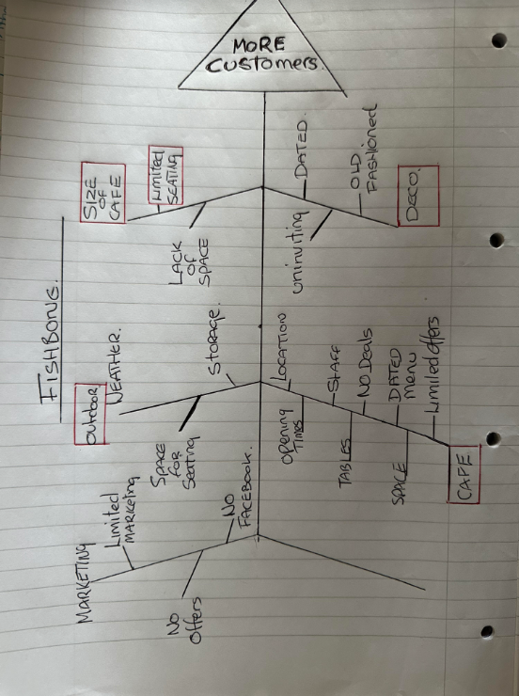

The problem is the size of the café it was originally built by the local authority as a takeaway coffee shop, which going back to 2004, the problem with this is that they didn’t have as many people living in the village then and not many people would wall passed the café so it, closed for a few years as it wasn’t making money. Then in 2006 it was decided that they would open it as a café offering take aways and seating area for mostly breakfasts, they could only fit in four tables which gives a total of 18 seats this has worked up until the present day.

The list of my possible solutions to my problem relating to all the information I have gathered so far is,
- More seating
- Open longer hours
- Expand outside
- Make the establishment more appealing

1.3 Propose a range of alternative solutions to the problem

The possible solution is opening longer hours, having more tables, or invest in furniture such as benches with storage underneath or tables that can be folder when not in use offer a booking system during peak hours to better manage customers this can reduce time and space more affectively, adding a new menu, redecorating the café, also having different offers on different days. With an option for children’s menu. And dog friendly. Which could be important because the café is in a small village.

Opening times – extending

Increase seating inside

1.4 Using a decision-making technique, evaluate a range of solutions to identify the most appropriate option

Grid analysis

 | Cost 1 | Resources 2 | Time 3 | Space 4 | Staff 5
Outdoor seating | 4 | 4 | 2 | 2 | 1 | 13
Opening times | 4 | 1 | 3 | 1 | 5 | 13
Increasing inside seating | 4 | 2 | 1 | 4 | 1 | 12

Weighted Grid

 | Cost | Staff | time | space | resolve
weighting | 5 | 4 | 3 | 2 | 2
Outdoor seating | 4  20 | 1  4 | 2  6 | 2  4 | 4  8 | 42
Opening times | 4  20 | 5  20 | 3  9 | 1  2 | 1  2 | 53
Increase inside space | 4  20 | 1  4 | 1  3 | 4  8 | 2  4 | 39

After doing a weight grid analysis it shows that by opening longer hours it would be visible.

Cost benefit analysis

Staff -- £50 Cost of two members of staff at £12.50 x 4= £50 for two hours.
Utilities -- £10 additional utility would cost £10
Food -- £72 food cost would be £72 this is based on 36 additional meals for the two hours
By opening two extra hours the café would benefit and gain £120 in one day,

Benefits 36 additional meals @ £7 average would benefit the sum of = £252 after all deductions the café would gain £120 per day.

This calculation is on a day rate. With the café open 6 days a week.
So for a week,
Staff - £ 300
Utilities - £60
Food £432

Total extra profit would be £720 per week extra, this is all based on the extra seating in the café to accommodate the customers.

This would take the years costs to.

Staff £15,600
Utilities £3120
Food £22,464

Total years profits would be £37,440.

Again, this is based on having all the extra seats filled, some things cant be controlled i.e weather, footfall, this is all to try and get the extra people into the café by having the space to accommodate for them.

1.5 Develop a detailed plan for implementing the solution

Gantt Chart
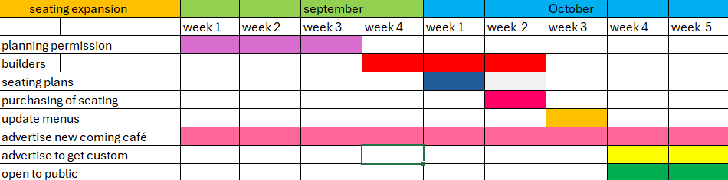

Influence – interest matrix

Level of influence
Level of interest

Owner and customers
staff

Local authority
community

The customers have the highest interest and the highest influence because they are they heart of the establishment, without them there would not be a café in the village and the people working there would not have jobs. The community would not have a place to go to have a sit-down breakfast in the area if this was to happen as there is nothing around for miles. The owner is also one of the highest priorities as they need to know how the business is doing as this would be their livelihood.

1.6 Communicate the plan to relevant stakeholders

Who | what | how
Staff | updates | Verbal, email
customers | updates | Facebook, flyers
suppliers | information | email

to communicate this plan effectively, all staff need to be kept up to date with the forthcoming plans of changing the café as this will implement them as they café will be closed for a short period of time for the renovation to take place. This can be done via email and a face-to-face meeting. The staff would also need to be made aware of how important it is to share the news of the changes and events to entice new custom. Customers and suppliers will have to be aware of the short-term closure not to disappoint them of to make believe suppliers have lost a customer. This can be done to the customers vis notice board in the café, staff word of mouth and social media announcing the closure and upcoming changes. The supplier would need to be emailed with notice as they would expect or potentially try and make a delivery to you if on a monthly order plan.

1.7 Assess appropriate monitoring and reviewing techniques to ensure successful implementation of solution

Monitoring of this change would be somewhat difficult as there are some factors that cant be helped for example weather. However, we can monitor how many meals we have sold in the day compared to last years sales. This can they be evaluated to see if this change has been beneficial to the establishment and profitable. If there is a decrease we can look into advertising in other areas , shops, newspaper etc to try and reach out to all ages of the community who do not have the access to social media, we can also implement offers for certain age groups,

Scope and Impact of the Problem
The café’s small size is a significant issue rooted in its original design as a takeaway coffee shop, built by the local authority in 2004. At that time, the village population was smaller, and there was little foot traffic near the café, leading to its closure for several years due to lack of business. When it reopened in 2006 as a café with a small seating area, it could only accommodate four tables, providing a total of 18 seats. This setup worked for a time but has become increasingly inadequate as the village population has grown.
The limited seating now hampers the café’s ability to serve more customers, particularly during busy periods, resulting in overcrowding and customer frustration. This issue not only affects the café’s ability to attract and retain customers but also constrains its revenue growth. With newer, more appealing establishments in nearby towns drawing foot traffic away, the café risks losing its competitive edge and long-term viability if this problem is not addressed.

Conclusion

The small café in the rural town is grappling with challenges related to limited space and outdated décor, which have led to declining customer satisfaction and potential business loss. After carefully analyzing the issue using methods like the Five Whys, brainstorming, and decision-making tools such as Grid and Cost-Benefit Analysis, extending the café's opening hours has been identified as the most effective solution.
Extending the hours will help distribute customer visits more evenly, reducing overcrowding during peak times and making better use of the available seating. Financial projections indicate that this approach could yield an additional annual profit of £37,440, provided customer demand remains steady. Complementing this with layout reconfiguration, décor updates, and menu enhancements will further attract both loyal customers and new patrons.
A comprehensive plan has been outlined to implement these changes, with clear communication strategies for stakeholders and ongoing monitoring to track progress. By executing this plan, the café can improve its competitive standing, ensuring long-term sustainability and continued value to the local community.

References
Clegg, B., Birch, P. (2007). Instant Creativity: Simple Techniques to Ignite Innovation & Problem Solving. London: Kogan Page Ltd.
Higgins, J. M. (1994). 101 Creative Problem Solving Techniques: The Handbook of New Ideas for Business. Winter Park, Fla: New Management Pub. Co.
Williams, K. (2006). Introducing Management a Development Guide. 3rd ed. Oxford: Butterworth-Heinemann.
Mitchell, R.K., Agle, B. R., and Wood, D.J., (1997). "Toward a Theory of Stakeholder Identification and Salience: Defining the Principle of Who and What really Counts." , Academy of Management Review 22(4)
Mendelow, A. (1991) ‘Stakeholder Mapping’, Proceedings of the 2nd International Conference on Information Systems, Cambridge, MA
(certificate in higher education:skills for the workplace student yearbook , 2017)

Appendix

