5CDPP: Developing Professional Practice in Human Resources
Activity 6

Name: Laura Daniel

CIPD Membership Number: 42646234

Date: 25th March 2022

By signing below, I confirm that the work/evidence presented is my own, unaided work. I understand the regulations pertaining to candidate malpractice and the action that may be taken as a result.

Signed: 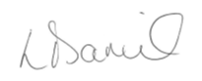
Date: 21st March 2022

Development plan

NAME: | Laura Daniel | MEMBERSHIP NUMBER: | 42646234
COVERING THE PERIOD FROM: | December 2020 | TO: | May 2022

Planned outcome

Where do I want to be by the end of this period? What do I want to be doing? (This may be evolutionary or “more of the same”.)

 | What do I want/need to learn? | What will I do to achieve this? | What resources or support will I need? | What will my success criteria be? | Target dates for review and completion | Evidence of Achievement and Reflection
 | Build relationships with colleagues outside the business to broaden my HR knowledge | Attend networking events or CIPD on-line communities to get involved in discussions and share knowledge | Access to CIPD forums via the internet and keep up to date and attend networking events | Having attended several events and have gained some networking contacts | December 2021 and ongoing whilst in this role | Unfortunately due to Covid and Work constraints, I couldn’t attend any in person events with CIPD. I attended an online event i.e. JCP solicitors’ online employment law seminar on 19th May 2021.  Reflection – I am not great at meeting new people, however I found that on-line isn’t the best way to network with colleagues, hopefully I can pick this up this year now that Covid is on the decrease. I have an in-person event in April 22 with JCP, so hopefully this will help with my confidence
 | Evaluate the impact of pending HR programmes and projects. What is the feedback given? | Undertake a training session on Equality in the workplace with supervisors and managers and evaluate any outcomes | Supervisors time to undergo this training session. Online course on equality and diversity or reading material on equality | Employee engagement and feedback from the training. Catch up with managers a few weeks after the initial training to see if they understand what was discussed and any questions | March 2021 | Instead of equality in the workplace training, I put together a coaching and mentoring presentation in June 2021 due to us having a lot of changes within the organisation. Engagement from staff at the time was ok, however there were a few supervisors who didn’t turn up. I spoke to their managers as I was very unhappy and have since run the training session with them.  Reflection – It took a lot of work to put the presentation together and I was very disappointed that some didn’t turn up. I think next time, I would only have 4 people at a time as 8 people made me very nervous. However feedback was good, I spoke to individuals on the Friday after the training and they were positive on how it went. Unfortunately I saw little change with the supervisors afterwards so was feeling a little deflated. After speaking to my boss Rob, he made me feel much better as he said the training was good.
 | Increase my CPD by carrying out a CIPD self-assessment | Assess myself on the New CIPD Professional Map to find ways to increase my Core knowledge and core behaviours | Access CIPD factsheet’s  Access the CIPD Course on Employee Wellbeing  Assess the CIPD Ethical practice course on GDPR  Access the CIPD Core behaviour course on Valuing People | Having a greater understanding of engagement and motivation to enhance the organisation. This is a core knowledge area on the CIPD map.  Greater understanding on the impact of employee wellbeing at work which is a core knowledge on the map  Greater understanding of GDPR regulations in the UK which is a core behaviour on the map  Greater understanding on how Mono can value its employees more effectively that we are currently | Completed March 2022 and ongoing  Completed 16th March 2022 and ongoing  To be completed April 2022  To be completed May/June 2022 | I completed an assessment on the culture and behaviour core value on the New Professional Map and one outcome was reading the engagement and motivation factsheet.  Reflection – I understand that employee voice will assist with the feeling of motivation and engagement, however, Engaging the workforce at Mono is difficult due to management not wanting to try new things, I will need to speak to my manager about putting an employee suggestion box in the factory. Previous attempt with the MD has failed.  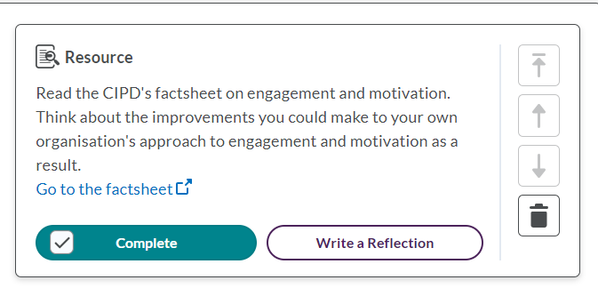  I completed this course from the CIPD website as it was part of my self-assessment. This course was helpful with my personal reflection around wellbeing at work and helped me get some thoughts down on paper on what we can do as a company to improve wellbeing. To start with, we will create a wellbeing policy.  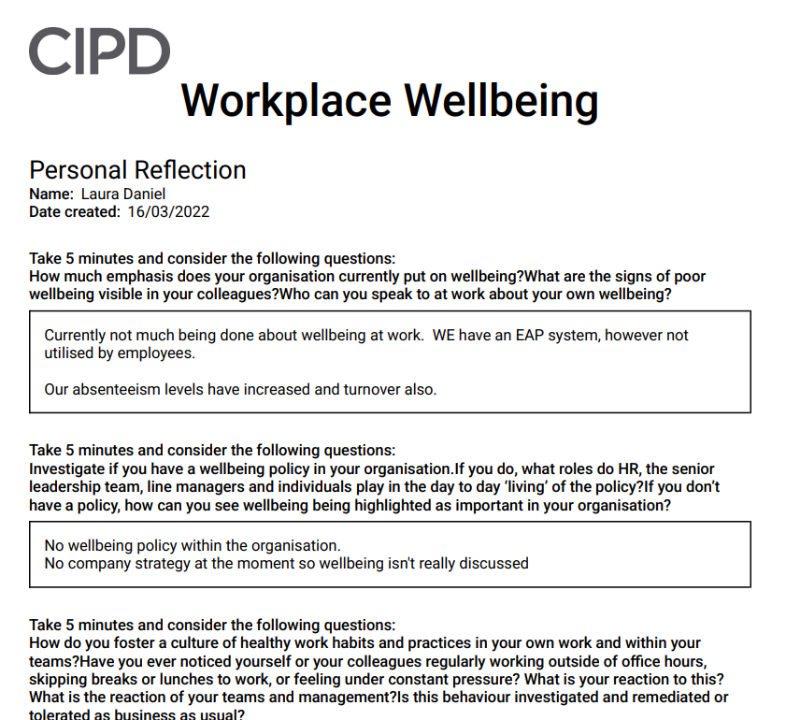  As part of a Core behaviour on the Map I will need to increase my ethical knowledge by completing a GDPR course. I already know a little bit about GDPR, however will be starting to audit the finance/payroll and HR departments after year end (April) so hopefully this course will be helpful for this.  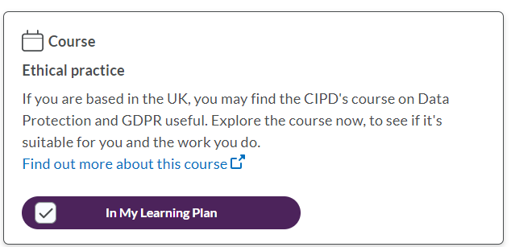  Another Core behaviour recommendation from the map is to complete the valuing people course. I am looking forward to this course, hopefully it will give me more of an insight on how to make a better culture for our employees.  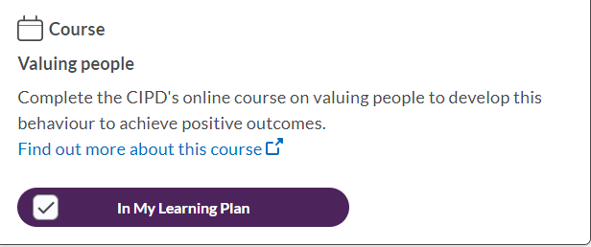
 | Understand the organisations performance | Spend time with the Finance Director and Managing Director to understand the business. | Attend managers meetings and review business plans and annual review documents | Greater understanding on the business plans of the business and ability to put HR plans in place to meet the business criteria | April 2021 and ongoing | I met with the Finance Director as planned. He gave me the minutes of the last management meeting and went through them with me. I have been invited by the Managing Director to sit on these meetings going forward and to present some HR information to the team.  Reflection – Very nervous for the meeting in December, however, I will be fully prepared.  I attended the December meeting and it went well, I put a lot of pressure on myself to begin with, however once I started speaking, my presentation flowed, I needed more confidence in myself.
 | Increase my wider business knowledge. Not just at Mono Equipment but business in general | Read current information to ensure that my business knowledge is relevant | Business and financial publications.  Benchmark activities to find out more information from other local companies | More all -round knowledge which will assist in the future with promotions | December 2021 and ongoing | The finance director has the Financial Times delivered, so I read it after him. I feel this publication doesn’t benefit me and was not what I was looking for, so I only read it a couple of times.  I often read the CIPD factsheets and research journals to gain information and background information. I also read ACAS publications and There is also a group set up by Swansea Council for local businesses to get together on our Industrial Estate, I have asked for the next invite for this.  Reflection – My business knowledge has increased, however feel that there is much more to learn so I have asked our Purchasing and Sales managers if I can go out on the road for a few days with them visiting suppliers and customers to gain more insight.
 | Understand the risks and priorities of the business and HR | Undertake a SWOT analysis of the organisation’s processes, structures and systems | Other departments within the business to give input on their strengths and weaknesses | A greater understanding of the risks within the business and an idea on what can be done to lower the risk | December 2021 and reviewed periodically | I have completed a SWOT and PESTLE analysis and used it for our latest BSI audit.  Reflection – I really enjoyed completing these, I felt that it gave me more of an insight into the business which helps with my role. The auditor was really pleased with the detail that was used on the analysis and has praised me for how thorough it was. We are using this template going forward.
 | Learn how to Increase and promote employee wellbeing at Mono | Complete the CIPD workplace wellbeing online course.  Speak to management about a wellbeing policy | Management and line managers assistance.  Create a training session or get an organisation involved such as Mind. | When wellbeing has become a priority and not an afterthought.  Employees feel as though their wellbeing is important | March 2022 and ongoing | I have completed the CIPD workplace wellbeing course, it was informative and will help me to put a wellbeing policy together going forward.  Reflection – Lots of work is needed in this area of HR, it’s a little overwhelming. I think I will have to chip away in little sections and start firstly with reviewing how many employees make use of our existing EAP system and see if we need to remind employees of what it is.  I would like to learn more about wellbeing at work, so will ask my manager if I can enrol on a managing mental health at work course (run by Mind).
 | Improve my own job performance | Keep up with technology, systems and processes | System support from IT. Attend workshops, seek systems that will assist the HR process. Currently Mono are very paper based | Having attended some workshops, find a HR system to assist with reporting and assisting the HR role | April/May 2022 | I have spoken to the Group HR managers about what systems they are currently using and am awaiting their feedback
 | Increase duties and responsibilities such as taking on a new challenge/project within the business | Take on working my own HR budget. Currently I assist the Finance Director but not take full responsibility | Support from the finance director to prepare and discuss how it is to be presented | HR budget submitted to the Finance Director with his assistance in the first year and fully independent in the second year | Start preparing in July 2022 for submission in August 2022 | This has been agreed with Rob. I am feeling a little nervous about it, however, it will be good for my job profile and further roles.

Development Record

NAME: | Laura Daniel | MEMBERSHIP NUMBER: | 42646234
COVERING THE PERIOD FROM: | December 2020 | TO: | May 2022

Planned outcome

Where do I want to be by the end of this period? What do I want to be doing? (This may be evolutionary or “more of the same”.)

Key Dates | What did you do? | Why? | What did you learn from this? | How have/will you use this? Any further action?
17th May 2020 | Attended a Coronavirus safety zoom meeting in conjunction with the HSE. | To learn more about the virus and ensure that Mono are compliant with the regulations, and our employees safe whilst at work.  I have taken charge of the Coronavirus at site and the Companies polices, sickness procedures, Furlough, employee communications etc. | There are some extra things that Mono need to put in place i.e. wearing of masks, however they are short in supply now within the UK.  As the Coronavirus is new, procedures are evolving and I need to keep up to date with what is going on to be able to inform the workforce. | This information will be used going forward to keep up to date with Covid-19 and will be on-going.
19th March 2021  23rd March 2021 | Attended an on-line HR update seminar with JCP solicitors  Attended a Group HR meeting on-line | To share knowledge on HR updates and to keep up to date with ongoing issues. To build relationships with those outside my business | Employment Law updates for 2021 e.g. Living Wage, Gender pay and tribunal cases  HR issues within the Group such as absenteeism and what different sites are doing to reduce the rates. | I utilised these meetings to ensure that Mono are compliant with Employment Law and practices. Also to ensure that Mono’s procedures are in line with the rest of the HR Group.  Attend further group meetings and JCP seminars each year
February 2021 + December 2021 (audit) | Completed a SWOT and PESTLE Analysis of Mono Equipment | To understand in more detail Mono Equipment’s risks, Strengths, weaknesses, opportunities and strengths and what environmental factors are hindering the business both internally and externally and how any risks can be lowered | There are several good things that Mono is currently doing, however both Coronavirus and Brexit has caused many difficulties for the organisation over the past 2 years and there are not many opportunities available for the business currently. | The SWOT and PESTLE analysis has been used in a recent BSI audit and is now being used as a template for the wider organisation.  I will be updating it again before our next management meeting in June to see if there are any changes.
May 2021 | Completed a skills analysis on current employees. | To identify any skills gaps currently and in the future when employees retire and to fill the gaps before it becomes problematic | There are several areas where we will be exposed in the coming years where employees have worked in the same role for the past 40-45 years. There is currently no succession planning for these roles. | Continue with this analysis each year and update management as to where further gaps are problematic.  Keep in close contact with supervisors to see if there are any signs from their employees of early retirement or resignation.  Contacted local colleges to see about getting some apprentices and Graduates
September 2021 | Completed ACAS courses i.e. Change Management, Bullying and Harassment, Managing Conflict,  Equality and Diversity, Managing People, Performance management | To keep my knowledge up to date and relevant | How to ensure that both myself and Mono are equipped with the correct information to manage employees effectively | I will complete these courses every few years as refreshers.  I want to learn more on how to manage conflict and get better at it. I will ask management if I can attend a course
September 2021 | Attended a senior management meeting to help with my wider business knowledge.  Meeting with Rob Davies (finance director) to discuss budgeting and targets | To assist with my wider business/commercial knowledge | I learnt more about how management budget and talk about what opportunities are coming up | I will be taking charge of the HR budget and am taking part in the quarterly management meetings
29th March 2022 | Transgender Rights in the Workplace on-line seminar with Birkett’s solicitors | To increase employee awareness of Gender Reassignment and to help me understand the Legal rights of employees who are transitioning. | The seminar will be looking at current case law relating to Gender Reassignment and used to assist our employee currently going through gender reassignment | I will use this seminar to do a short training session for our managers.
2nd April 2022 | CIPD online student conference | To build my confidence and connect with other students. | I am looking forward to learning more about how I can positively impact employee’s health and wellbeing at work | Hopefully use what I learn to help with my future career.

Reflection

Continuing Professional Development (CPD) is the term used when people participate in activities to continually improve/enhance their own capabilities (CPD 2020) and is important to ensure individuals remain competent in their roles (Kloosterman 2014).

There are 6 stages to a CPD Cycle: - Identify and plan, Act, Reflect, Apply, Share and Impact (CIPD 2022)

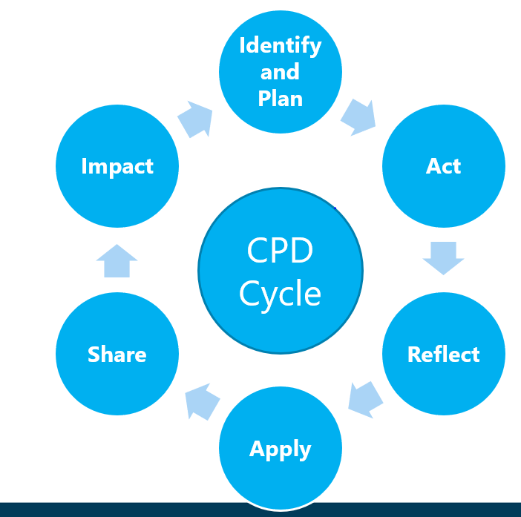

Part of the CPD cycle is reflective practice, which according to Taylor (2016) is an individual’s ability to reflect on what they have learnt or experienced to assist with further learning. Taylor also says that without this practice, an individual’s development could be hindered.

The Gibbs Reflective Cycle 1988 (below) is a model that can be used to help employees reflect and understand what they did well at work and what they need to do to make improvements in the future (Mindtools 2020).
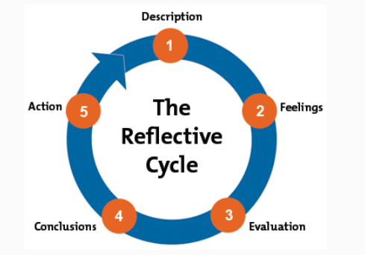

I have used this model when reflecting on my own development plan e.g.
Step 1 Description – Understanding the business performance by asking Rob Davies (Finance Director) to explain the management meeting minutes with me.
Step 2 Feelings – Before the meeting, I felt a little nervous in-case I didn’t understand what I was being told. However as the meting commenced, I really enjoyed it and knew more than I thought.
Step 3 Evaluation – This session was helpful; I am now going to sit in these meetings going forward and talk about HR at Mono Equipment. In December I completed my first management meeting presentation, I was nervous, however was told that my information was informative and insightful by the rest of the team.
Step 4 Conclusion – I would like to develop my presentation skills in the hope that I don’t become so nervous and can handle the situation better.
Step 5 Action – It has been agreed that I will attend a PTLLS (Preparing to Teach in the Lifelong Learning Sector) course to help with my presentation skills.

The Gibbs Model has helped me to think about what has gone well, what skills I need to improve on for the future and what feelings I had at the time.

The CIPD have created a reflection tool to help professionals reflect on their learning by answering several questions to help understand what has been learned and how they have changed from completing their training. I used this reflection tool after the CIPD Profession Map identified a Wellbeing course to assist with my CPD and as a development option (see below). This course made me think about 2 things: -
1 – there is lots that Mono can be doing to help with employee wellbeing
2 - I also would like to know more on how I can improve employee wellbeing by attending a Managing Mental Health course run by Mind. I am very interested in this side of the HR role and think that this course will help both personally and professionally.

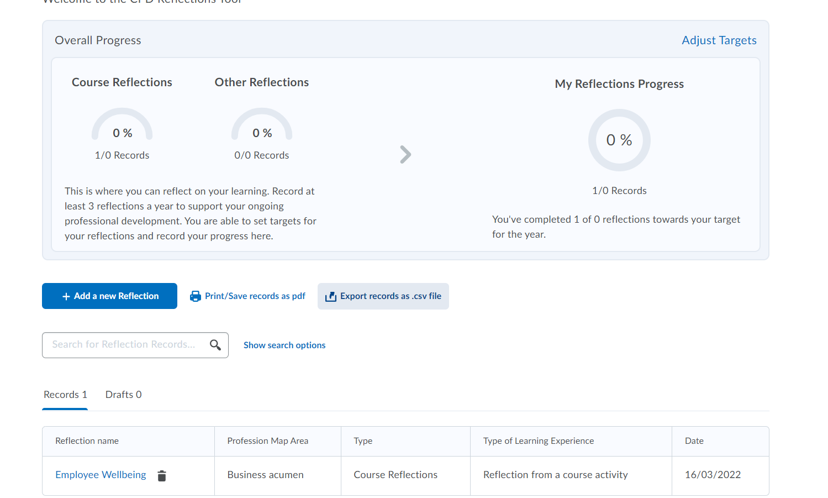

CPD has helped me greatly over the past 2 years of this course and has contributed towards my development and career. What I have learned has been shared with my manager and colleagues and some things have been successfully implemented within Mono e.g. managing Coronavirus, implementing change and employment Law updates. I am looking forward to continuing with my CPD and learning more in the future. I have achieved most of my learning outcomes, however due to the Coronavirus some networking activities have been difficult to attend.

I find reflection a difficult task to do, it makes me feel a little vulnerable and doubt some things I do, however the more I do it, I’m sure the easier it will become. To reflect on the Level 5 CIPD course, at times it has been very challenging juggling work, college assignments and a family, however I am glad I continued as it has been very rewarding. I feel as though my generalist knowledge and confidence has grown and that all the modules have assisted with my current HR role. I don’t want to progress with the level 7 at this stage due to being where I want to be both personally and with my career.

I have reflected on my learning technique and have found that I learn best through attending face to face classes and according to the Belbin Team Questionnaire, I am a Team worker and Specialist so enjoy working with others both in class and at work. I think that Covid-19 has hindered the learning experience slightly as not all classes have been face to face, however the pandemic has taught us all to adapt, which is what we had to do and I think I did it well. I have more learning needs since starting the level 5 course, employee wellbeing being one of them which will be looked at soon.

References

CIPD (2022) Explore the Profession Map. Available at: https://peopleprofession.cipd.org/profession-map Accessed (18.03.2022)

CIPD (2022) The CPD Cycle. Available at: https://www.cipd.co.uk/learn/cpd/cycle Accessed (20.03.2022)

CPD (2020) What is Continuing Professional Development (CPD)? Available at: https://cpduk.co.uk/explained. Accessed (18.03.2022)

KLOOSTERMAN V (2014) The Importance of Continuing Professional Development. Available at: https://continuingprofessionaldevelopment.org/why-is-cpd-important/ (Accessed 18.03.2022)

MINDTOOLS (2020) Gibbs Reflective Cycle, Helping People Learn from Experience Available at: https://www.mindtools.com/pages/article/reflective-cycle.htm Accessed (21.03.2022)

TAYLOR S and WOODHAMS C (2016) Studying Human Resource Management, 2nd Edition: London: CIPD page 114

