
Skills for the Workplace
Module Assignment Submission
Student Name: | Michael Thomas
Student Number: | 2109032
Module No: | BMSK5012
Module Title: | UNDERSTANDING AND ENGAGING IN THE CUSTOMER EXPERIENCE

Statement of Confirmation of Authenticity
By the act of making this submission, the student declares that this is the work of the student named above. The work has not, in whole or in part, been knowingly presented elsewhere for assessment, or where assessment has been built on a previous assessment, this has been identified. Where materials have been used from other sources it has been properly acknowledged. If this statement is untrue, the student acknowledges that an assessment offence has been committed.
Attention is drawn to the plagiarism and unfair practice policies of both the University and of ILM.

Table of Contents
Background 3
Customer Base 3
Quality Management System 3
Customer Service 3
Complaints Procedure 3
Regulatory Complaint Assessment 3
Customer Engagement Value (CEV) 5
Customer brand value (CBV) 6
Customer lifetime value (CLV) 6
Business reference value (BRV) 6
Customer influence value (CIV) 7
Customer knowledge value (CKV) 7
Calculation for a CAS score 8
CAS Dashboard 8
Quality 8
Deming 14 Principles for Transformation 10
Poor Quality 13
Lean Thinking 14
5S 15
Wastes 15
Continuous Improvement 16
Kaizen 16
Kanban 16
Conclusion 16
References 18

Background

Customer Base
Due to the nature of the laboratory products produced, the customers of ThermoFisher are laboratories, schools, National Health Service (NHS), private research establishments, food, and beverage manufacturers together with hospitals worldwide.

Quality Management System
To ensure the quality of the products produced and services provided, ThermoFisher affiliate themselves with the International Organisation for Standardisation (ISO). The company operates within a sector specific quality management system of the ISO9001 group, ThermoFisher operates ISO13485:2016 for medical devices (ISO, 2023). This satisfies regulatory requirements, gives the customer confidence, and ensures a well-maintained quality management system. Regularly audited against stringent prescribed standards.

Customer Service

Complaints Procedure
If the customer identifies an issue with any product supplied to them or ThermoFisher has identified a defective product delivered to them, the initially contact is made to a site senior quality engineer verbally so that containment action is immediately put into place. This is then followed up with detailed information, including documentation for traceability and photographs showing the fault.
These details are entered onto a program called Track Wise, a problem record is generated with detailed information documented, these will include material disposition, root cause analysis, Corrective and Preventative Actions (CAPA) and any regulatory consequences. With every complaint internal or external seven questions are asked, the answers given will direct the pace and path of investigation.

Regulatory Complaint Assessment
- Is this incident the result of mis-labelling?
- Was medical intervention required?
- Was there a death or was there the potential for death or serious injury to occur?
- Is this incident the result of a mis-formulation?
- Was there a product malfunction or performance issue which may affect customers/client’s product or performance?
- Was there permanent impairment or damage to body structure?
- Was there a delay in treatment due to this error?
If the answer to any of the above questions was yes, then the Medicines and Healthcare Products Regulatory Agency (MHRA) and US Food and Drug Administration (FDA) would need to be contacted and the investigation handed over to the agency. The regulatory authority would be the lead and ThermoFisher would support. All information regarding the journey of this product, from raw material to the delivery would be released to the authority, this would include the names of all personnel involved which had a hand in its manufacture.
A worldwide recall of the product would be automatic to stop the potential of a re-occurrence.
The Quality department employs over 30 individuals ranging from Quality Auditors, Quality Engineers, Senior Quality Engineers, Document Engineers, and Regulatory Engineers who oversee compliance.
ThermoFisher aims to complete complaints within 30 days but due to the nature of the business corrective actions may take up to 160 days although some have to be extended beyond this.
The table below is sent out daily, this indicates where the company stands with the various stages of customer complaints. The table shows that three customer complaints have been received in the last 24 hours, 57 open problem records which are internal issues to resolve. There are 9 reworks being carried out with a sales value of £39,000 and 35 containment actions and preventative actions to complete.
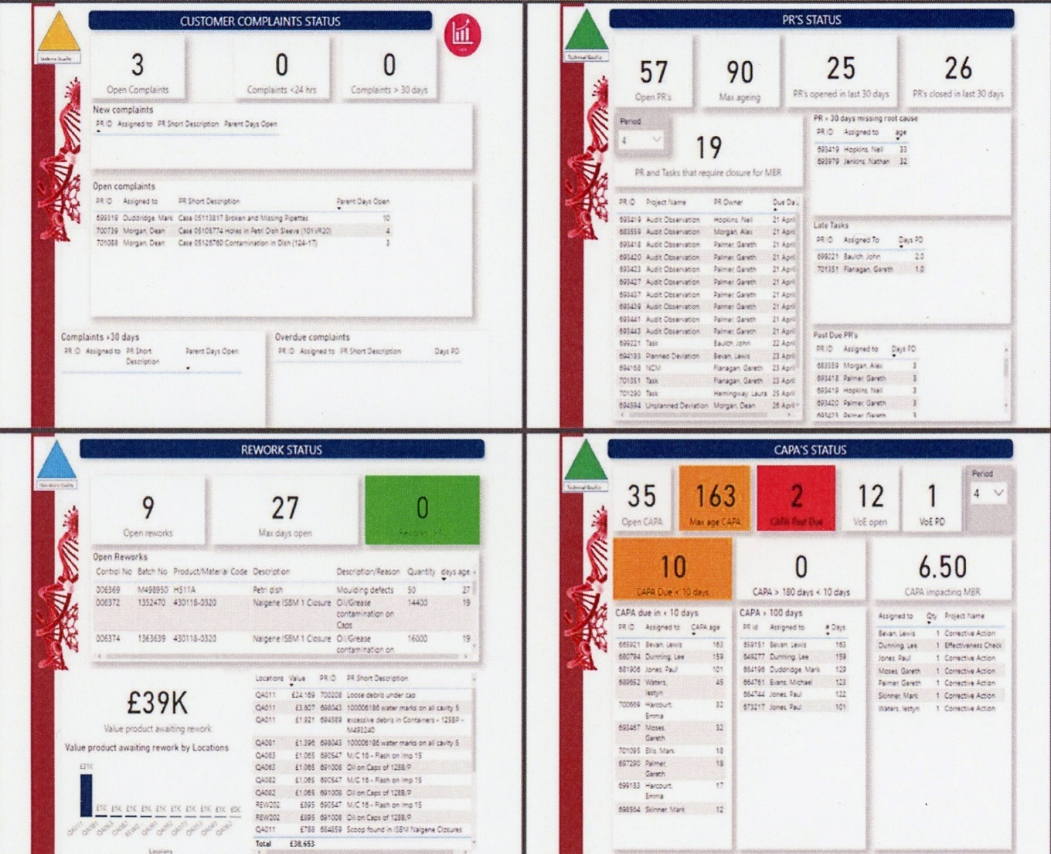

(B. Hooper, personal communication, March 25, 2023).
ThermoFisher currently has an issue with contamination on vaccine bottle closures which are imported from America, some 240,000 have been checked and segregated on site and a further 1 million are on route via sea freight.

Customer Engagement Value (CEV)

ThermoFisher takes CEV seriously and is an advocate of Kumar 5 core dimensions of CEV framework (Kumar, 2018, pp. 203-263). They use the 5 core values for business to business (B2B) as they only sell to business customers. If they pursued a business to consumer model (B2C), then the customer referral value (CRV) would be employed instead of BRV.

Customer brand value (CBV)
ThermoFisher has a long-standing relationship with its customers, the oldest being the NHS. A great deal of effort is made in cultivating relationships, some of the very important customers are invited for factory tours with the senior management team. There will be corporate days when sporting events will be made available to a select few. Customers are made to feel special so that contracts can be renewed or won.
ThermoFisher is also known as ThermoFisher Scientific or Sterilin which has a strong presence on social media and has its own website and University. Facebook is mainly used as an overview at the company’s activities and will echo concerns and strategies regarding world events, Covid 19, Earth Day 2023, it promotes itself as a caring organisation. News is released on this site but not in great depth. (Facebook, 2023).
LinkedIn is used extensively by the company for the release of new products, recent acquisitions and company updates on products and services, the information carefully targets its 1 million followers. The employees use it for networking around the world and job vacancies. (LinkedIn, 2023).
Customer lifetime value (CLV)
One of the results obtained from ThermoFisher’s Customer Allegiance Score (CAS) score is information on customer needs, investment can then be targeted towards their needs. An example of this was information fed back that end users with dexterity issues found difficulty in opening up our urine sample containers as the cap had to be rotated 3 complete revolutions for removal. On examination the lifetime spends from this customer the company had a new bottle and cap manufactured which used a triple thread design, this means that the cap can now be removed in a third of one rotation.

Business reference value (BRV)
It is understood that selling to businesses is more complex than direct selling to end users, business references are essential to this operation. Testimonials can be viewed on a wide range of products which gives potential customers confidence in the brand. These testimonials include interviews by eminent scientists, YouTube links to various articles and specific information to targeted groups. (ThermoFisher, 2023).

Customer influence value (CIV)

This is important to ThermoFisher, the company regularly askes eminent scientists and doctors to discuss their products, this is then recorded and uploaded onto social media sites and ThermoFisher’s own website. This generates revenue from this word of mouth.

Customer knowledge value (CKV)
Information gained through discussions, CAS surveys, seminars and events are fed back to the sites, this has influenced products and packaging. This gave rise to the three-start capped bottle, packaging options are bespoke depending on the customer. Industrial customers want a quantity in a box, hospitals want items packed into trays and then shrink wrapped for ease of distribution. GP surgeries require the same product tumble packed into bags of 50 bottles.

These key metrics are captured in ThermoFisher (CAS), this is based on the Net Promoter Score Methodology (Reichheld, 2022). This is a customer loyalty and satisfaction metric employed across all sites. Amongst other metrics this measures ThermoFisher’s performance and customers perceptions and identifies areas for improvements (ThermoFisher, 2023).
Once a customer makes an initial inquiry with ThermoFisher the customer will be sent a survey of approximately 10 questions, two of which will always be.
- Overall satisfaction (OSAT).
- Likelihood to recommend (LTR).
The other questions may vary depending on the type of enquiry, sales, customer service, technical support, or training. This survey will only take 2 – 3 minutes to complete and will be immediately reviewed and reissued throughout the different stages of the transaction.
After review customers are placed into one of three categories.
- Promoters – Loyal enthusiastic customers who will quite happily promote the brand through word of mouth.
- Passive - customers are unenthusiastic but satisfied customers who could easily buy from the competition.
- Detractors – Customers who are unhappy and will tell anyone who listens to them.

From the survey ThermoFisher knows how to react through timely feedback, the aim is to increase the promoters which in turn increases business. Customer feedback will highlight where resources need to be focused, what is important to the customer and how the company is performing. It also conveys to the customer that the company is listening to them.

Calculation for a CAS score
- CAS = % of promoters - % of detractors.

CAS Dashboard
Below is a screenshot showing the CAS activity of the writers manufacturing group, information has not been filtered down to site level due to confidentiality. From the screen it can be seen the number of contacts/alerts made, the immediate classification made, these being promoters, passive and detractors, what the contact is about and progress.
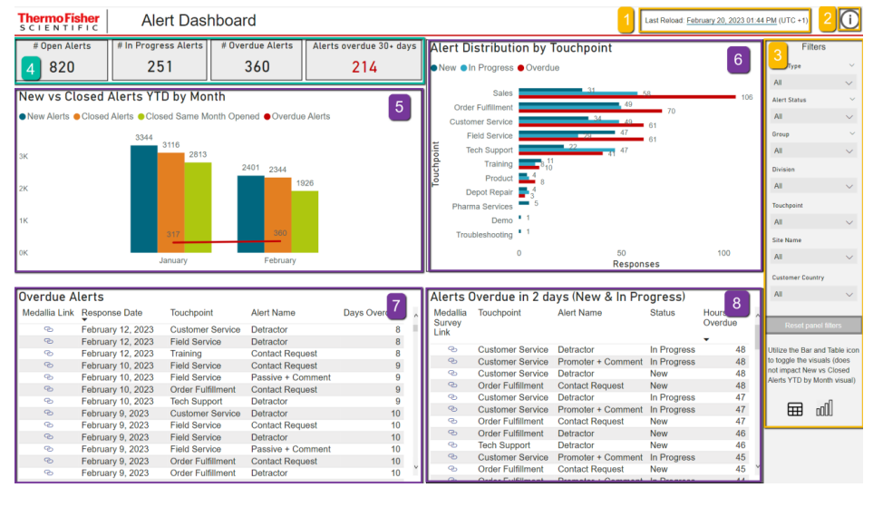(ThermoFisher, 2023)

Quality
Quality is an important part of an organisation; poor quality will make customers look at other options whereby good quality will increase the customer base and grow a company. In 1987 David A Garvin developed a framework of quality as a business approach, this is known as Garvin’s 8 dimensions to quality. (Garvin, 1987).
Performance, ThermoFisher is widely considered to manufacture gold standard products, the consumables perform in the way expected. The container will transport a liquid without spillage, it will hold the desired volume and will meet the requirement of ISO13485:2016.
Features, all screw tops on ThermoFisher sample bottles will have a serrated edge to aid grip, the caps will denote the bottles contents. A white cap will indicate urine, a red cap will indicate the addition of Boric acid (a preservative) and a blue cap will indicate a stool sample bottle. The bottle caps assist laboratories in identifying the contents of the bottle for processing.
Reliability, product must be extremely reliable in accordance with the MHRA requirements. An issue with manufacturing or labelling could lead to a misdiagnosis that could lead to life threatening/life limiting condition or even death.
Conformance, products are manufactured and packed to established standards, every bottle is printed with a batch number for traceability. From raw material to delivery, each step is documented so that in the event of a problem ThermoFisher know who did what to their product.
Durability, products produced have a shelf life of 3 years from manufacture, after that point they should be destroyed. This is due to aging; the plastic is affected by sunlight and goes brittle. Some products have to be irradiated, this make the product sterile, after 3 years this product is outside any guarantees and again must be destroyed.
Serviceability, staff are well trained for each of the manufacturing/packing process, to inspect and pack a 96 well plate ThermoFisher trains and expects their packer/inspector to be familiar with a 14-page document, this explains the defect to look out for, how to hold the plate for inspection, how many plates per bag and then how to seal the bag, the seal must meet specification. When a complaint is received, this is an immediate response from our quality team to segregate suspect product, once the customer provides evidence then a full investigation is carried out with a conclusion required with 30 days for minor issues. For more serious issues there is a longer time frame as regulatory bodies may need to be involved, in the United Kingdom this would be the MHRA or in the United States of America it would be the FDA. ThermoFisher have employees trained for such interactions.
Aesthetics, this is a difficult area as it is subjective, ThermoFisher spends millions of pounds in making sure that the product reaches its customers in optimum condition, no contamination, scuffing, cracking, or deformation is allowed. The products should be as clear as glass.
Perceived Quality, the products manufactured are functional, they are not seen as aspirational, they are of the highest quality. ThermoFisher is seen as being the best in their business, during the Covid19 pandemic they were one of the leading company’s leading the fight back (ThermoFisher, 2020). They are very protective with their reputation and have strict rules for their employees on use of social media. Millions is spent annually on marketing, and they always respond positively to any medical crisis.

Deming 14 Principles for Transformation
This is the core of Total Quality Management (TQM), ThermoFisher does implement many of Demings principles (Beckford, 2010, p. 75).
- Create constancy of purpose, ThermoFisher try and reduce variation in its processes, to drive this a Practical Process Improvement Manger (PPI) is employed. Fortnightly meetings with department managers to identify areas of opportunity, teams set up to gather information and report back, once all the information is available tasks are allocated to each team member. PPI training is available online through the ThermoFisher University (TFU) with Teams face to face training also available.
- Adopt the new philosophy, previous to the PPI initiative some issues were accepted as being the norm, one such fault was flash on components, this is a component with excessive plastic protruding around its outer edge. Now with PPI, costs are allocated to this, cost of rejected components against the cost of repair. On most occasions it is cheaper to instigate a repair, a faulty component is manufactured so this cost is lost, additional inspection is required at a cost. The rejected component must be disposed of at a cost, being a medical supplier ThermoFisher is not allowed to use recycled material, it must be first grade material. A few of the machines produce 5,236 assembled components an hour so defects and costs mount up quickly.
- Stop depending on inspection to achieve quality, to reduce the frequency of inspections and reduce rejects, ThermoFisher now uses Statistical Process Controls (SPC) on its products. Weights are checked and logged, the rule of seven is applied, if seven weights show a trend whereby it is trending towards an upper control limit (UCL) or a lower control limit (LCL) then this is classed as an out-of-control process and an adjustment is required. Machines are also set up to track for process controls, here upper and lower parameter limits are set, if you set a temperature at 280 degrees Celsius with a 5-degree tolerance. If the temperature goes outside the tolerance, then the machine will stop thus stopping potential rejects from being made.
- Focus on total cost and not just the price tag, ThermoFisher to a degree have worked with a single supplier when it comes to spare parts for machinery repair. The company now uses Eriks Industrial Supplies for over 60% of their spare parts. Eriks supply vending machines and keep them stocked up, they do add a premium to the cost of the part, but this is offset by time taken to source, quotations, purchase requisitions, authorisations, and stock outs. The downside is that they are not always as efficient as they quote and some of our machine manufacturers will not sell to third party vendors.
- Aim for continuous improvement, as already discussed a PPI manager is employed with teams set up to improve the process while reducing costs.
- Institute on the job training, all new employees to ThermoFisher spend two weeks in the classroom training and then are shadowed for another two weeks by a competent person. This training is documented and signed off; this information is then transferred onto the departments training matrix. Each employee needs to complete four training modules from ThermoFisher University. The employee can choose their own course relative to their job function, the University has approximately 2500 courses. Additionally, employees have to complete four courses from the National Examination Board for Safety and Health (NEBOSH), these will include fire safety, slip - trips and falls to mention two.
- Institute leadership, unfortunately targets are set, the production machines have a set cycle time, and the assembly halls have a set number of packed boxes per hour. Gradually barriers are being removed due to people being moved around departments which is giving a better understanding of what is done elsewhere.
- Drive out fear, here again the company falls short of its ambition, there is a blame culture amongst some of the managers, it is always somebody’s fault, it is never seen as a bad process.
- Break down barriers, information is improving, every morning at 8.00am we attend a Tier 1 Toolroom meeting, we discuss tooling issues, requirement for the day and what task each toolmaker is working on. At 9.00am the writer attends a Tier 2 Engineering meeting, here discussions are around machinery, factory facilities, breakdowns, and priorities. At 10.00am there is a Tier 3 meeting, here all the departments report to senior management, Quality, Production, Engineering, Finance, plus others. An overview of the previous days KPI’s is given with explanations of why targets have been missed. Departments now work closer together and barriers are starting to come down with cross functional teams.
- Eliminate slogans, being an American company, they use numerous slogans, some might be seen as inappropriate, Homer Simpson might not be the best poster boy.
- Eliminate management by objectives, ThermoFisher does have targets but do invest heavily in training, many of the management team have joined the company and have not come through ThermoFisher training.
- Remove barriers to work pride, if an employee thinks that something is unsafe or know that a process is incorrect, then they are given the authority to stop production. Posters around the company says that nothing is too urgent where corners have to be cut or unsafe acts need to be taken.
- Institute a vigorous education and self-improvement program, ThermoFisher believes strongly in self-development, it actively encourages this, regular training courses are held and a prescribed number of TFU courses need to be accessed. Personal Development Plans are set out at the beginning of the year with quarterly progress updates, all employees are expected to set targets and goals, with one-to-one meetings each fortnight. At the end of the year each employee is graded in eight areas and are awarded either a requires improvement, at standard or clear strength.
- Make transformation everyone’s job, with PPI teams set up and running, incremental changes are being achieved, plan, do, check, act (PDCA) (Mindtools, 2023) is a part of the training. Recognise opportunities available, test the changes made to see if they work, analysis the data available to see impact and act from lessons learnt, did it work or what needs to be done to make it work?

Poor Quality

Back in 1989 R.J. Mortiboys had a booklet published about 8 routes to poor quality (Mortiboys, 1989).
ThermoFisher has invested heavily in its Quality processes and procedures but does fall into some of Mortiboys definitions.
- Previously ThermoFisher did seek short term profitability but over the past few years this is changing. Products produced on site are classed as long-term consumables. Some of the tooling is over 30 years old, standards have changed but the desire to improve these is becoming more difficult.
- Costs will always be a cause of concern, there has to be a premium to both customer and manufacturer. One way of controlling this is by scrap reduction, ThermoFisher has a goal for site scrap of 4.5%, this is then shared out between the departments. Pipette manufacture will be 6.8% due to its dimensional complexity, Petri dish manufacture has to contend with a scrap rate of 3%.
- ThermoFisher does not have a take it or leave it attitude with its customers, every customer is treated the same as they are very protective of their reputation, this is reflected in the price charged.
- A down fall to this environment is that they expect all employees to give 110% regardless of what their job role is, and sickness is actively discouraged. You are expected to come to work even if you have Covid19.
- ThermoFisher does compete on quality, this is why they are classed as the gold standard in life science, cost is determined centrally and is not dictated by the site.
- Buying at the lowest price possible is ingrained in the company as with every other manufacturer.
- Anti-change is a big issue on site, many of the employees transferred from an old site that was closed down, this new factory has improved standards but some struggle with this change. You always hear a conversation with we have always done it this way.
- ThermoFisher is no different to other companies with Macho-Managers, there are a few confrontational ones who would easily fit into 1980/90 culture, but with education and training some are beginning to turn a corner.

Lean Thinking

The house of Lean is a series of activities which are built on a solid foundation of stability and standardisation, Lean thinking is about streamlining the manufacturing process, reducing waste, and removing nonvalue added steps. (Krafcik, 1988) This is a part of ThermoFisher’s work ethic. Each member of the management team is taught value stream mapping how to map a process, this begins by mentally going to supermarket to purchase a tin of baked beans. The manager then records all the steps needed to complete the task, these steps are then divided into activities, action, waiting, inspection, and transport: they then need to work out which ones do not add any value to the outcome. (Womack & Jones, 2003).
This will aid in improving a process by removing unnecessary steps, Lean Thinking helps the employee, process, customer, and business by removing wastes. This way of working introduces a suite of tools which are invaluable for efficiency. Lean thinking is a complex series of activities which are intertwined as shown in the diagram below.

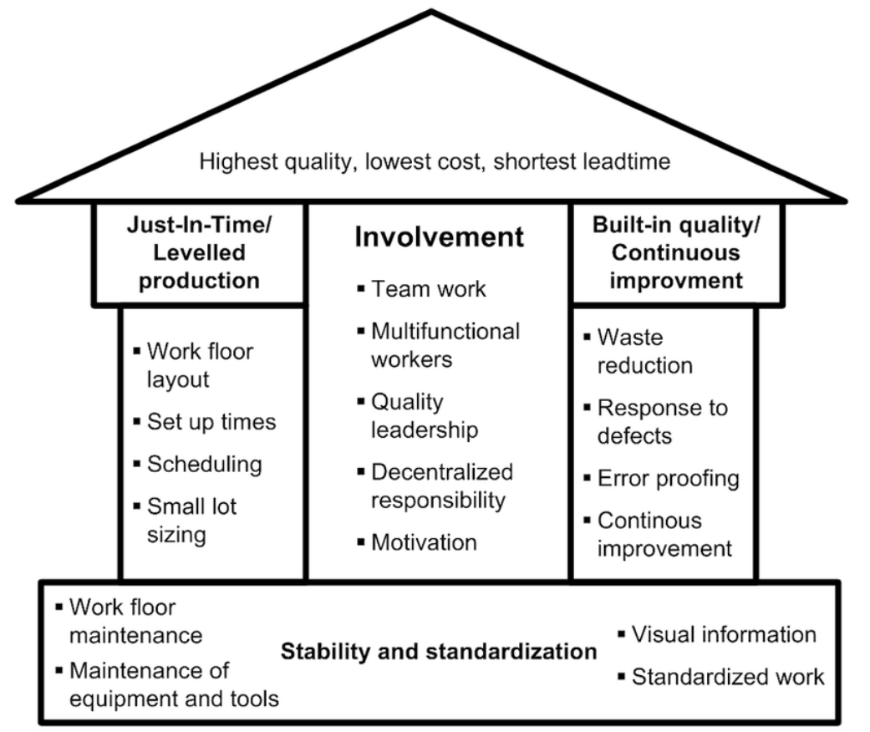
(Researchgate, 2023)
5S (Hirano, 1995) sort, set, shine, standardise, sustain, this is regularly carried out at ThermoFisher, any unused items which are not required for the task is removed from the area, everything should have a place, and everything returned to its place. If there is no place for the item, it is then placed into a 5S holding area and is red tagged. After 30 days a review of the red tag area is made, if the item is not required then it is disposed of.
Wastes, posters are strategically placed around the site asking if anyone has seen TIM WOOD’S, (Creative Safety Supply, 2023) as ThermoFisher now recognises 8 wastes and not the standard 7 wastes.
T – Transport, moving materials unnecessarily.
I – Inventory, too much stock.
M – Motion, too much walking.
O – Over production, too many materials for the job.
O – Over processing, excessive steps to get the job done.
D – Defects, too many rejects.
S- Skills, not fully utilising the skills in the workplace.
Continuous Improvement, ThermoFisher uses the PPI system as already covered.
Kaizen, this has already been discussed as it is encompassed in the PPI process which drives continuous improvement. Kaizen is the building block of lean. (Lean Enterprise Institute, 2023).
Kanban, this is a pull system, only make what is being pulled out of the warehouse by the customer. (Ohno, 1988)

Conclusion
Having critically analysed ThermoFisher by using the theories of Kumar, Garvin, Reichheld, Deming, Mortiboys and Lean Thinking. It can be seen that ThermoFisher is at an advantage due to its size and standing. The company has the financial backing and corporate drive to push through these systems, many smaller companies would fail due to the resources required.
Customers are treated with the respect they deserve, the CAS questioner is immediately sent out after initial enquiry for feedback, analysed to see the customer type and acted upon.
Being a life sciences company strict rules are in place to prevent failures, traceability of product is dictated by the MHRA or FDA associations, this prevents a slap dash attitude from creeping in. The staff are well trained, regular training is carried out and personal development is actively encouraged.
The machinery is well maintained with monthly preventative maintenance programs and standard operating procedures (SOP) in place to cover all aspects steps of manufacture.
Customer complaints, internal and external is processed through a well-documented process with a target completion of 30 days, again this is enforced due to the potential to cause harm or even death.
On the negative side the company does have high targets for production output for each machine and assembly activity. If something does go off plan the immediate thought is to find someone to blame, ThermoFisher is of the opinion that the process is efficient even when it is not, they can not show weakness.
Managers do get rotated around the group, they start activities but do not always see the benefits or negative effects as they’ve moved to another site.
Elements of lean manufacturing are in place, but it hasn’t been embraced whole heartedly, managers are only concerned with their own KPI’s and not the greater good which may impact their department short time.
Although ThermoFisher has excellent employee benefits which should elevate employee experience, the company falls short due to site rules. Warnings are common when associated with sick leave, the employee is expected to turn up to work even when having Covid19. Documentation can also be an issue as good document control is essential but some of the employees are Polish and their English not clear.
ThermoFisher could look to improve the customer experience, by providing personal customer experience based on their purchases and viewing data, by creating recommendations and sending out samples.
Improved marketing, most end users have never heard of ThermoFisher but are regular users of their products.
Look to improve employee involvement, sending representatives to other ThermoFisher sites to understand how the sites products are used and how defects disrupt their production.
Sales Team is remote and never interact with production employees. When making a site visit, they are chaperoned around by senior management and employees kept at an arms distance.
Redesign website, everything is static, single dimension, add links to video clips show a relatively small glimpse at our processes and products. Introducing the brand to a wider audience.
Although ThermoFisher have good standards of quality and customer service is given high priority, there are areas where improvements could be made. The company is making a gradual change from being led by profits to being led by quality. This should see the company grow in the future.

References
Beckford, J. L. (2010). W Edwards Deming. In John. L. W. Beckford (Ed). Quality: A Critical Introduction (pp. 65-85). Routledge.
Creative Safety Supply. (2023, April 30). TIMWOOD. CreativeSafetySupply. TIMWOOD [Definition of the 7 Wastes] | Creative Safety Supply
Garvin, D. A. (1987). Competing on the Eight Dimensions of Quality. Harvard Business Review, Competing on the Eight Dimensions of Quality (hbr.org)
Hirano, H. (1995). 5 Pillars of Visual Workplace: The Sourcebook for 5S Implementation. Productivity Press.
International Organisation for Standardization. (2023, April 23). ISO13485:2016. ISO.ORG. ISO 13485:2016 - Medical devices — Quality management systems — Requirements for regulatory purposes
Krafcik, J. F. (1988) Triumph of The Lean Production System. Sloan Management Review, Volume (30). Page 41.
Kumar, V. (2012). Metrics for Engaging Customers. In Andrew Maund (Ed.), BS in Leadership and Management Skills for the Workplace Yearbook, 1st Year: Metrics for Engaging Customers (pp.203-263). Sage Publications Limited.
Lean Enterprise Institute. (2023, April 30). Kaizen. Lean Enterprise Institute. Kaizen — A Resource Guide | Lean Enterprise Institute
Mind Tools. (2023, April 27). PDCA (Plan Do Check Act). MindTools. PDCA (Plan Do Check Act) - Continually Improving, in a Methodical Way (mindtools.com)
Mortiboys, R. J. (1989). Leadership & Quality Management: A Guide for Chief Executives. Department of Trade and Industry.
Ohno, T. (1988). Toyota Production System: Beyond Large-Scale Production. CRC Press.
Researchgate. (2023, April 27). The House of Lean Production in the Context of the Literature. Researchgate.net. The house of lean production in the context of the literature review,... | Download Scientific Diagram (researchgate.net)
Reichheld, F. [Sarder TV]. (2022, May 04). Full Episode – Fred Reichheld [Video]. YouTube. (123) Full Episode - Fred Reichheld - YouTube
Seaholm, V. [The K S Experience]. (2021, June 8). Garvin’s 8 Dimensions of Quality [Video]. YouTube. (130) Garvin's 8 Dimensions of Quality - YouTube
Thermo Fisher Scientific. (2020, March 14). Thermo Fisher Working with Trump Administration to help ensure availability of testing for COVID-19. [Video]. YouTube. (130) Thermo Fisher Working with Trump Administration to help ensure availability of testing for COVID-19 - YouTube
Thermo Fisher Scientific. (2023, April 26). Customer Experience. Tthermofisher.sharepoint.com.https://thermofisher.sharepoint.com/sites/Customer-Experience/SitePages/CAS/CASSurveyProgram.aspx
Thermo Fisher Scientific. (2023, April 26). Agrigenomics Customer Testimonials. Thermo Fisher.com. Agrigenomics Customer Testimonials | Thermo Fisher Scientific - UK
Thermo Fisher Scientific. (n.d.) Home [Facebook page]. Facebook. Retrieved April 26, 2023, from Thermo Fisher Scientific | Facebook
Thermo Fisher Scientific. (2023, April 26). Thermo Fisher Scientific. LinkedIn. https://www.linkedin.com/search/results/all/?heroEntityKey=&keywords=thermo%20fisher%20scientific&origin=RICH_QUERY_SEARCH_HOME_HISTORY&sid=ZY%3
ThermoFisher. (2023, April 23). Customer Experience. ThermoFisher.Sharepoint.com. https://thermofisher.sharepoint.com/sites/CustomerExperience/SitePages/CAS/CASSurveyProgram.aspx
Womack, J. P., & Jones, D. T. (2003). Lean Thinking: Banish Waste and Create Wealth in Your Corporation. Simon & Schuster.

