University of Wales Trinity Saint David

Design of shaped charges
ACDB 5015: Advanced Physics of OME

Name - Luke Brown (ID-2309075)
Course – Ordnance, Munitions and Explosives (OME)
Lecturer – Kelvin Donne
Submission Deadline – 6th January 2026

Abstract:

This report investigates the influence of liner geometry, material behaviour and numerical modelling techniques on shaped charge jet formation, with the aim of assessing the capability and limitations of finite element methods for modelling high strain-rate OME systems. Using Abaqus/Explicit, two shaped charge configurations were initially developed in a two-dimensional axisymmetric framework to evaluate how variations in liner thickness distribution affect detonation wave propagation, liner collapse, jet tip velocity and jet length. The primary design variable was the liner geometry, where the upper liner thickness was reduced from 1.6mm to 1.2mm while maintaining a constant 1.6mm thickness at the liner base.

Realistic material models were employed, including a copper liner, steel casing and TNT explosive fill. The explosive behaviour was modelled using a detonation-based equation of state, while the liner response incorporated elastic-plastic behaviour with the Mie-Grüneisen equation of state to capture shock-driven hydrodynamic effects. Comparisons were made between simulations with and without Mie-Grüneisen parameters, alongside variations in system viscosity, to evaluate their influence on jet formation and numerical stability. The thinner upper liner configuration produced higher jet tip velocities and increased jet length and was therefore selected for further three-dimensional analysis.

The 3D model consistently employed Mie-Grüneisen parameters with altered viscosity values but suffered from severe mesh distortion, motivating the investigation of adaptive meshing and smoothed particle hydrodynamics (SPH) techniques. A strain-based SPH conversion criterion provided the most stable response, enabling qualitative comparison with 2D results. Overall, the report demonstrates the sensitivity of shaped charge performance to liner geometry and material modelling assumptions, while critically evaluating the strengths and limitations of 2D and 3D numerical approaches for shaped charge analysis.

Table of contents:

Section 1 – Introduction

  - Background on shaped charges ……………………………………………………………………. (Page 1)
  - Problem statement ………….………………………………………………………………………….. (Page 1)
  - Aims and objectives …………………………………………………………………………………….. (Page 2)
  - Scope and limitations …………………………………………………………………………………… (Page 2)
  - Report structure ………………………………………………………………………………………….. (Page 2)

Section 2 – Literature review

  - Jet formation, shockwaves and high-pressure thermodynamics ………………….. (Page 3)
  - Influence of liner geometry ………….…………………………………………………………. (Pages 3-4)
  - Material properties and high strain-rate behaviour ……………………………………… (Page 4)
  - Equations of state (EOS) ………………………………………………………………………………. (Page 4)
  - Numerical methods for shaped charge modelling ……………………………………….. (Page 5)

Section 3 – Methodology

  - Modelling overview ……………………………………………………………………………………… (Page 5)
  - Geometry definition and design variants ………….…………………………………….. (Pages 5-6)
  - Material models and EOS ………………………………………………………………………… (Pages 6-7)
  - Meshing strategy …………………………………………………………………………………………. (Page 7)
  - Boundary and initial conditions ……………………………………………………………………. (Page 8)
  - Solver settings and numerical control ………………………………………………………….. (Page 8)
  - Parametric variations …………………………………………………………………………………… (Page 8)
  - Verification strategy……………………………………………………………………………………… (Page 9)

Section 4 – 2D axisymmetric simulation results and analysis

  - Model setup summary …………………………………………………………………………………. (Page 9)
  - Detonation wave propagation and liner collapse ………….………………………. (Pages 9-11)
  - Jet tip velocity, jet length and energy results ………………………………………. (Pages 11-13)
  - Comparison between liner design variants ………………………………………………… (Page 13)
  - Interpretation of 2D results ……………………………………………………………………….. (Page 13)

Section 5 – 3D model development and analysis

  - Transition from 2D to 3D modelling …………………………………………………………… (Page 14)
  - Numerical stability and mesh distortion issues ……….…………………………………. (Page 14)
  - Adaptive meshing assessment …………………………………………………………….. (Pages 14-15)
  - Smoothed particle hydrodynamics (SPH) implementation …………………………. (Page 15)
  - Final 3D jet formation results ……………………………………………………………… (Pages 16-18)
  - Comparison between 2D and 3D results ……………………………………………………. (Page 18)

Section 6 – Discussion and evaluation

  - Influence of liner geometry on jet performance ………………………………………… (Page 19)
  - Effects of material models and EOS ………….……………………………………………….. (Page 19)
  - Numerical limitations and modelling assumptions …………………………………….. (Page 19)
  - Verification and validation considerations …………………………………………………. (Page 19)
  - Implications for shaped charge modelling …………………………………………………. (Page 20)

Section 7 – Conclusions and recommendations

  - Summary of results ……………………………………………………………………………………. (Page 20)
  - Assessment of model capability …………………………………………………………………. (Page 20)
  - Recommendations for future work ……………………………………………………………. (Page 20)

Section 8 – References

All referenced citations ……………………………………………………………………….. (Pages 21-22)

Section 9 – Appendices

Appendix A- 2D additional simulation data and results ………………………………………. (Page 23)
Appendix B- 3D additional simulation data and results ………………………………… (Pages 23-25)

Table of Figures:

Figure 1 – Conical liner shaped charge configuration [2] …………………………………………. (Page 1)
Figure 2 – 2D 1.6mm liner model …………………………………………………………………………….. (Page 6)
Figure 3 – 2D 1.2mm liner model …………………………………………………………………………….. (Page 6)
Figure 4 – 3D 1.2mm liner model …………………………………………………………………………….. (Page 6)
Figure 5 – 2D 1.6mm liner mesh ……………………………………………………………………………… (Page 7)
Figure 6 – 2D 1.2mm liner mesh ……………………………………………………………………………… (Page 7)
Figure 7 – 3D 1.2mm liner mesh ……………………………………………………………………………… (Page 7)
Figure 8 – 2D 1.6mm liner MG with visco detonation wave propagation ………………… (Page 9)
Figure 9 – 2D 1.6mm final liner collapse ………………………………………………………………… (Page 10)
Figure 10 – 2D 1.6mm MG final liner collapse ……………………………………………………….. (Page 10)
Figure 11 – 2D 1.6mm liner MG with visco liner collapse ………………………………………. (Page 10)
Figure 12 – 2D 1.6mm liner jet tip velocity history ………………………………………………… (Page 11)
Figure 13 – 2D 1.6mm liner MG with visco jet tip velocity history …………………………. (Page 11)
Figure 14 – 2D 1.2mm liner MG with visco jet tip velocity history …………………………. (Page 12)
Figure 15 – 2D 1.2mm liner MG with visco total energy balance …………………………… (Page 13)
Figure 16 – 3D ALE adaptive meshing overclosure …………………………………………………. (Page 15)
Figure 17 – 3D SPH (liner and casing) detonation wave propagation …………………….. (Page 16)
Figure 18 – 3D SPH (liner and casing) liner collapse ………………………………………………. (Page 16)
Figure 19 – 3D SPH (liner and casing) jet tip velocity history ………………………………….. (Page 17)
Figure 20 – 3D SPH (liner and casing) total energy balance ……………………………………. (Page 18)
Figure A.1 – 2D 1.2mm liner MG with visco detonation wave propagation ……………. (Page 23)
Figure A.2 – 2D 1.2mm liner MG with visco liner collapse ……………………………………… (Page 23)
Figure B.1 – 3D SPH (liner) applied at start of simulation liner collapse …………………. (Page 23)
Figure B.2 – 3D SPH (liner) applied after time delay liner collapse …………………………. (Page 24)
Figure B.3 – 3D SPH (liner) applied at strain 3.5 liner collapse ……………………………….. (Page 24)
Figure B.4 – 3D SPH (liner) applied at start of simulation jet tip velocity history…….. (Page 24)
Figure B.5 – 3D SPH (liner) applied after time delay jet tip velocity history…………….. (Page 25)
Table of Tables:

Table 1 – TNT material properties …………………………………………………………………………… (Page 6)
Table 2 – Copper material properties ………………………………………………………………………. (Page 7)
Table 3 – Steel material properties ………………………………………………………………………….. (Page 7)
Table 3 – Jet lengths ……………………………………………………………………………………………… (Page 12)

Section 1 - Introduction:

1.1- Background on shaped charges:

A shaped charge is an explosive device with a hollow cavity, usually lined with metal, designed to focus detonation energy into a high-velocity jet. When initiated, the explosive wave collapses the liner towards the axis, forcing a portion of the liner to form a slender jet and the remainder into a slower-moving slug. Jet tip velocities can exceed 10 km/s, enabling deep penetration of metallic targets. Under these conditions, “the liner behaves approximately as an inviscid, incompressible fluid,” highlighting the extreme pressures and strain rates involved [1, pp. 1-8]. Shaped charges are widely applied in defence for armour defeat and in civil engineering for controlled cutting and perforation. An example of a conical shaped charge configuration is shown in Figure 1 [2].

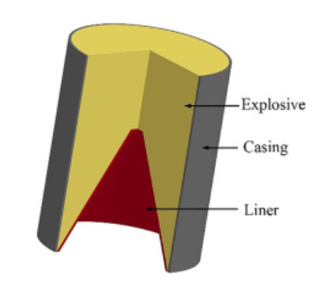
Figure 1 – Conical liner shaped charge configuration [2]

1.2- Problem statement:

Understanding how liner geometry and material response influence jet formation is critical for optimising shaped charge performance. Small geometric variations, such as changes in liner thickness or contour, can significantly alter jet velocity, stability and overall penetration capability. Likewise, material behaviour under high strain rates and pressures determines how efficiently the liner collapses and stretches into a jet [3]. Investigating these effects through numerical modelling provides insight into the physical mechanisms governing jet formation and supports improved design of efficient, predictable and safe OME systems.

1.3- Aims and objectives:

The aim of this project is to investigate shaped charge jet formation using finite element modelling in Abaqus/Explicit, through the development of two-dimensional axisymmetric models and the subsequent extension of a selected design to three dimensions. The report focuses on assessing how liner geometry, material modelling assumptions and numerical techniques influence jet formation behaviour in high strain-rate explosive-metal interactions, while also evaluating the capability and limitations of numerical methods commonly used in OME analysis.

1.4- Scope and limitations:

This report is confined to numerical modelling of shaped charge jet formation using Abaqus/Explicit, with emphasis on the influence of liner thickness, material equations of state, artificial viscosity and meshing strategies. Detonation behaviour is simplified using the Jones-Wilkins-Lee (JWL) equation of state, which provides an empirical approximation of detonation pressure and expansion behaviour but does not explicitly resolve the chemical reaction front [4]. The analysis considers detonation wave propagation, liner collapse, jet velocity and jet length, but excludes target interaction and penetration modelling. Adaptive meshing and smoothed particle hydrodynamics (SPH) are employed to improve numerical stability, though these techniques introduce additional numerical artefacts and modelling uncertainties [5]. Thermal effects are not explicitly modelled, except as represented within the Johnson-Cook model. Results may also be sensitive to mesh resolution and material parameter selection. Furthermore, computational constraints limit assessment of late-time jet evolution.

1.5- Report structure:

This report is organised to guide the reader from fundamental concepts through to detailed numerical analysis and evaluation. It begins by defining the problem context, aims and report boundaries, followed by a review of shaped charge physics, material behaviour, equations of state and relevant numerical techniques. The modelling approach is then described, including geometry definition, material models, meshing and verification. Results from the two-dimensional and three-dimensional simulations are subsequently presented and analysed. The report concludes with a critical discussion of the findings and recommendations for future work.

Section 2 - Literature review:

2.1- Jet formation, shockwaves and high-pressure thermodynamics:

Shaped charge jetting arises from the interaction between the detonation wave and the metallic liner, where extreme pressures cause the liner to undergo hydrodynamic collapse. As the detonation front reaches the liner, shock loading drives the material inward, producing a characteristic velocity gradient along the liner thickness. This gradient results in the forward portion of the liner accelerating into a high-speed jet, while the rear portion forms a slower-moving slug. The process is governed by conservation of momentum and is commonly referred to as the Munroe effect [1, pp. 12-13].

The detonation and collapse process is commonly interpreted using the Euler equations for compressible flow and the Rankine-Hugoniot relations, which describe the jump in pressure, density and internal energy across a shock. At these pressures, the liner behaves in a fluid-like manner despite remaining a solid, allowing hydrodynamic theory to provide useful approximation to its motion. Jet tip velocities may reach several kilometres per second, meaning inertial and shock-driven effects dominate over material strength [6].

At the pressures generated during detonation, the behaviour of both the explosive gases and the liner material can be interpreted using the basic ideas of high-pressure thermodynamics. The detonation wave produces an almost instantaneous rise in pressure, density and temperature, meaning large amounts of internal energy are stored in the system. Gas-law concepts such as the relationship between pressure, volume and temperature help describe how the rapidly expanding detonation products drive the liner motion [7]. Under these conditions the metal responds in a near-fluid manner and the combined thermal and mechanical loading occurs at extremely high strain rates, which strongly influences deformation and jet formation.

Understanding these shockwave and thermodynamic effects is essential because they ultimately control jet velocity, coherence and stability, which govern penetration performance. Small changes in pressure history or material response can significantly alter jet formation, meaning accurate modelling is critical when designing shaped charges for reliable and predictable performance.

2.2- Influence of liner geometry:

The geometry of the liner plays a decisive role in determining shaped charge jet formation and performance. Parameters such as cone angle, curvature and wall-thickness distribution influence the collapse velocity and therefore the velocity gradient along the liner [1, p. 35].
Thinner regions generally accelerate more rapidly under detonation loading, producing higher jet tip velocities, although excessively thin sections may promote early breakup and reduce jet coherence. Conversely, thicker liners provide greater robustness but typically result in lower jet speeds and reduced penetration capability, meaning an inherent trade-off exists between peak velocity and jet stability [1, p. 7]. Cone angle and curvature further affect how uniformly the liner collapses, influencing jet stretching, fragmentation and ultimate penetration behaviour. In this report, the upper region of the liner is varied in thickness while the base thickness is kept constant, allowing the specific influence of local thickness changes on jet formation to be assessed. Understanding this geometric sensitivity is essential for optimising shaped charge designs in ordnance and munitions engineering applications.

2.3- Material properties and high strain-rate behaviour:

Metals used as shaped charge liners are subjected to extremely high strain rates, typically between 10⁴ and 10⁷$s^{-1}$, far exceeding conventional mechanical loading [1, p. 2]. Under these conditions material properties such as yield strength, strain hardening, strain-rate sensitivity and thermal softening have a major influence on how the liner deforms and whether a stable jet is formed. Constitutive models such as Johnson-Cook are commonly used to represent these behaviours, allowing strength to evolve with plastic strain, strain-rate and temperature [8]. Material response also governs failure mechanisms, including ductile damage, necking and jet breakup, which directly affect penetration performance. However, uncertainties in material characterisation at extreme strain rates introduce modelling limitations, meaning accurate property data is essential for reliable simulation outcomes.

2.4- Equations of state (EOS):

An equation of state describes the relationship between ‘pressure, density and internal energy’ for a material subjected to extreme loading [9]. EOS models are essential in shaped charge simulation because both the explosive products and the metallic liner experience very high pressures and shock loading during detonation. In this report the detonation products are represented using the Jones-Wilkins-Lee (JWL) equation of state, which provides an empirical description of pressure as the explosive gases expand. Although widely used, JWL is calibrated from experimental data and does not explicitly resolve the underlying reaction chemistry [4]. The Mie-Grüneisen EOS is applied to the copper liner to describe its response under shock compression [10]. This EOS was introduced for the liner in the 2D analysis to assess whether it improved the physical representation of the shocked metal and was then applied consistently in the 3D models together with modified artificial viscosity to enhance stability. The selected EOS definitions influence the predicted pressure field and therefore the resulting jet velocity and coherence.

2.5- Numerical methods for shaped charge modelling:

Numerical modelling is essential in shaped charge research because the extreme pressures, very high velocities and severe plastic deformation make controlled experiments difficult, dangerous and expensive. Finite element methods (FEM) using explicit solvers such as Abaqus/Explicit are widely used to simulate liner collapse and jet formation. Different kinematic descriptions are available. Lagrangian formulations follow the material mesh but can suffer severe mesh distortion. Eulerian formulations fix the mesh in space and allow material to flow through it, although fine detail may become smeared. Arbitrary Lagrangian-Eulerian (ALE) and coupled Eulerian-Lagrangian (CEL) methods combine features of both to manage large deformation more effectively [11]. To reduce mesh tangling in large deformation regions, techniques such as adaptive meshing and smoothed particle hydrodynamics (SPH) are often introduced. These approaches enable jet breakup and large strains to be represented but may introduce numerical diffusion and reduced spatial accuracy [5]. All models depend on constitutive laws and equations of state, so predictions inevitably reflect modelling assumptions and validation remains challenging.

Section 3 - Methodology:

3.1- Modelling overview:

This report uses numerical simulation to investigate the jet formation process in a shaped charge and to evaluate how liner geometry and material modelling influence performance. All simulations were carried out in Abaqus/Explicit, which is well suited to high strain-rate and shock-dominated problems. A primary Lagrangian formulation was adopted, with additional numerical controls introduced where required to address large deformation. The workflow involved defining the geometry, assigning material models and equations of state, applying detonation loading, generating the mesh and post-processing key outputs. Two-dimensional axisymmetric models were first developed before extending the preferred design to a full three-dimensional simulation for comparison. Key outputs included jet velocity, jet length and liner collapse behaviour, recognising that idealised geometry and detonation modelling introduce simplifications.

3.2- Geometry definition and design variants:

The shaped charge consisted of a TNT fill with a 40mm diameter and a 60° conical copper liner [12, p. 4], [13, p. 242]. The charge height was 60mm, equal to 1.5 times the diameter [14, p. 3]. A steel casing of 2mm thickness surrounded the explosive, except at the base where a 1.6mm square lip was included to support the liner. Two axisymmetric models were created that differed only in the upper liner thickness, which was reduced from 1.6mm to 1.2mm, while the lower section remained at 1.6mm to isolate the geometric influences on jet formation. The selected 1.2mm configuration was subsequently extended into a full 3D model. Figures 2 and 3 show the 2D models with 1.6mm and 1.2mm liners respectively, while Figure 4 shows the 3D geometry based on the 1.2mm design.
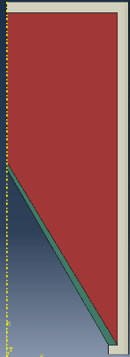
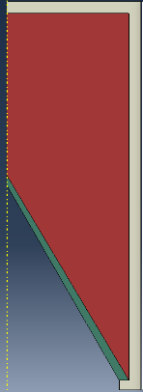
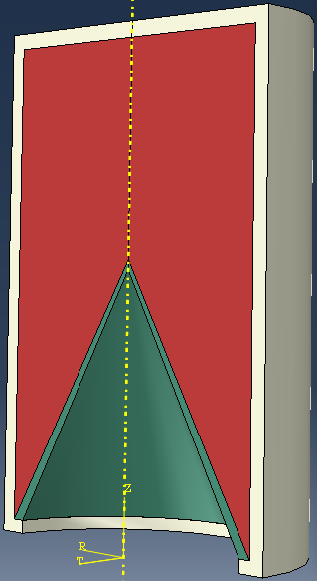
2mm
2mm
2mm
44mm
20mm
22mm
20mm
22mm
Steel
Steel
Figure 3 - 2D 1.2mm liner model
Figure 2 - 2D 1.6mm liner model
Figure 4 - 3D 1.2mm liner model
40mm

TNT
TNT
TNT
60mm
60mm
60mm
1.6mm
1.2mm
1.2mm
30°
30°
60°
Steel

Copper
Copper
Copper

1.6mm
1.6mm
1.6mm

3.3- Materials models and EOS:

Material models and associated equations of state were assigned to the TNT fill, copper liner and steel casing to account for the very high strain rates generated during detonation. Johnson-Cook plasticity and damage parameters were used for the metals to represent strain-rate and temperature-dependent behaviour, as discussed previously. The TNT was defined using a JWL equation of state, with detonation coordinates and timing specified through the detonation point sub-option. Where the Mie-Grüneisen EOS was applied, the shear modulus was used in place of elastic constants such as Young’s modulus and Poisson’s ratio. The TNT material parameters are summarised in Table 1 [15, p. 5], [16, p. 428], while the copper liner data is listed in Table 2 [17], [18, p. 4], [19, p. 3] and the steel casing properties are presented in Table 3 [20], [21, p. 11].

Table 1 - TNT material properties
Mass Density | $${1630kg/m}^{3}$$ | Detonation Wave Speed (JWL) | $$6930m/s$$ | A (JWL) | $$3.766×{10}^{11}Pa$$
B (JWL) | $$4.011×{10}^{9}Pa$$ | omega (JWL) | $$0.36$$ | R1 (JWL) | $$4.17$$
R2 (JWL) | $$0.92$$ | Detonation Energy Dens (JWL) | $${4.294×10}^{6}J/kg$$ | Pre-deton Bulk Modulus (JWL) | $$6.0×{10}^{9}Pa$$
X (JWL) | $$0$$ | Y (JWL) | $$0.19$$ | Z (JWL) | $$0$$
Detonation Delay Time (JWL) | $$0s$$

Table 2 - Copper material properties
Mass Density | $${8960kg/m}^{3}$$ | Young’s Modulus (No MG) | $$1.298×{10}^{11}Pa$$ | Poisson’s Ratio (No MG) | $$0.343$$
Shear Modulus (MG) | $$4.83×{10}^{10}Pa$$ | c0 (MG) | $$3910m/s$$ | s (MG) | $$1.51$$
Gamma0 (MG) | $$2.12$$ | A (JC) | $$9.0×{10}^{7}Pa$$ | B (JC) | $$2.92×{10}^{8}Pa$$
n (JC) | $$0.31$$ | m (JC) | $$1.09$$ | Melting Temp (JC) | $$1356K$$
Transition Temp (JC) | $$293K$$ | C (JC) | $$0.025$$ | Epsilon dot zero (JC) | $$1$$

Table 3 - Steel material properties
Mass Density | $${7850kg/m}^{3}$$ | Young’s Modulus | $$2.1×{10}^{11}Pa$$ | Poisson’s Ratio | $$0.3$$
A (JC) | $$3.74×{10}^{8}Pa$$ | B (JC) | $$5.1×{10}^{8}Pa$$ | n (JC) | $$0.41$$
m (JC) | $$0.679$$ | Melting Temp (JC (D)) | $$1803K$$ | Transition Temp (JC (D)) | $$293K$$
C (JC) | $$0.052$$ | Epsilon dot zero (JC) | $$1$$ | d1 (JC D) | $$0.028$$
d2 (JC D) | $$1$$ | d3 (JC D) | $$-0.916$$ | d4 (JC D) | $$-0.006$$
d5 (JC D) | $$-0.644$$ | Reference Strain Rate (JC D) | $$1s^{-1}$$ | Fracture Energy (JC D) | $$1000J/m^{2}$$

3.4- Meshing strategy:

A very fine mesh was required in the liner and detonation region to accurately capture collapse, jet formation and the development of a velocity gradient. The mesh was refined most heavily near the liner apex and the liner-TNT interface, where deformation and strain-rate demand were highest. Coarser elements were used further from the collapse zone to limit computational cost. Severe element distortion occurred during jet stretching, meaning mesh density had a direct influence on predicted jet velocity, breakup behaviour and numerical stability. Adaptive meshing was introduced to delay mesh collapse although this can introduce numerical artefacts, while SPH was finally applied once conventional meshed behaviour began to break down. Figure 5 shows the meshed 1.6mm 2D model, Figure 6 the meshed 1.2mm 2D model and Figure 7 the meshed 1.2mm 3D model.
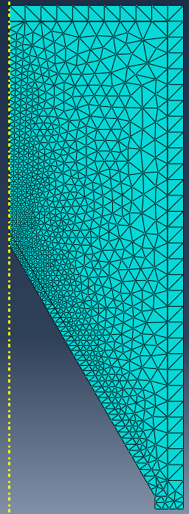
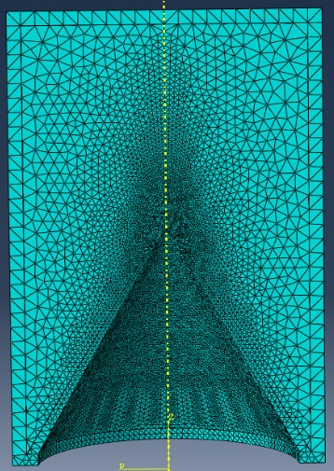
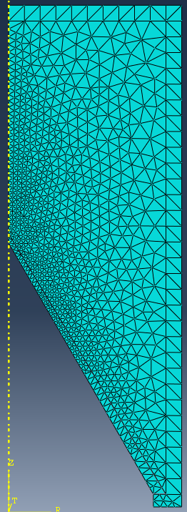

Figure 6 - 2D 1.2mm liner mesh
Figure 7 - 3D 1.2mm liner mesh
Figure 5 - 2D 1.6mm liner mesh
3.5- Boundary and initial conditions:

Boundary and initial conditions were defined to represent an unconfined shaped charge detonation. Symmetry and encastre constraints were applied along the model symmetry planes in both the 2D and 3D analyses. Detonation was initiated using a defined detonation point within the JWL explosive model, with zero initial stress and strain and ambient pressure assumed negligible. General contact was used with frictionless tangential behaviour and hard normal contact between the liner, explosive and casing, while the outer casing was otherwise unconstrained to represent a free charge. These conditions approximate ideal shaped charge operation, although effects such as external confinement, gravity and non-reflecting boundaries were neglected for simplicity.

3.6- Solver settings and numerical control:

Time-step control and numerical stabilisation were important due to the very high strain rates and shock loading. The analysis was run over a total simulation time of $1×{10}^{-4}s$, with field outputs written every $1×{10}^{-7}s$ to capture the rapid liner collapse and jet development. Artificial bulk viscosity was applied to control shock oscillations, with a higher linear viscosity value of 1.0 used when the Mie-Grüneisen EOS was enabled and a lower value of 0.06 otherwise. Damage initiation and erosion within the material models allowed failed elements to be removed where necessary, helping to prevent excessive element distortion while maintaining numerical stability throughout the simulation.

3.7- Parametric variations:

Parametric studies were carried out to assess the sensitivity of jet formation to both geometry and material modelling assumptions. The primary geometric variable was the upper liner thickness, which was reduced from 1.6mm to 1.2mm while all other dimensions remained constant. In parallel, the influence of the Mie-Grüneisen EOS was examined in the 2D models by comparing runs with no Mie-Grüneisen terms, with the EOS applied and with modified bulk viscosity settings to improve numerical stability. The same variations were applied to both liner designs, with jet velocity, jet length and collapse behaviour used as comparison metrics. The preferred 1.2mm configuration was then extended to 3D, where additional parametric testing explored adaptive meshing and SPH activation criteria (time and strain-based) to manage severe deformation. These variations allowed the effects of geometry, EOS selection and numerical methods to be evaluated independently against a consistent baseline model.

3.8- Verification strategy:

A structured verification strategy was applied to ensure confidence in the simulation results. Mesh convergence was assessed by progressively refining the mesh and confirming that key response metrics showed negligible change. Energy balance was also monitored, verifying that total energy remained stable. As full experimental validation was not possible, results were instead compared with established trends in the literature. The inherent modelling assumptions and associated limitations were explicitly acknowledged.

Section 4 – 2D axisymmetric simulation results and analysis:

4.1- Model setup summary:

The two-dimensional axisymmetric models were constructed as outlined in the methodology to investigate how design and material-modelling choices influence shaped charge jet formation. Two liner configurations were analysed, differing only in the reduced thickness at the upper section of the liner (1.6mm and 1.2mm), while all other dimensions remained constant. For each configuration, three simulations were completed: one without Mie-Grüneisen applied, one with Mie-Grüneisen employed and one with both the Mie-Grüneisen terms and increased bulk viscosity. Key response measures included detonation wave development, liner collapse behaviour, jet tip velocity, jet length and total system energy. These results enabled a direct comparison of the relative influence of liner geometry and EOS implementation on jet formation behaviour.

4.2- Detonation wave propagation and liner collapse:

Detonation wave behaviour followed the same overall trend across all Mie-Grüneisen cases and for both the 1.6mm and 1.2mm liner designs. The most notable difference arose when increased bulk viscosity was applied, where casing distortion and element deletion were significantly reduced. Figure 8 presents the pressure field for the 1.6mm configuration with modified viscosity, illustrating the shockwave propagating through the explosive towards the liner. The 2D model was subsequently revolved to produce a three-dimensional visualisation.
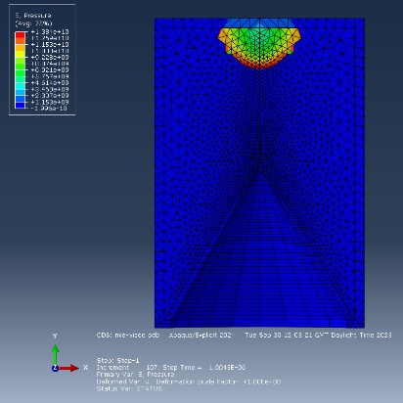
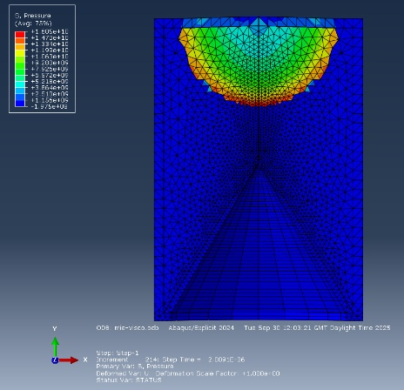
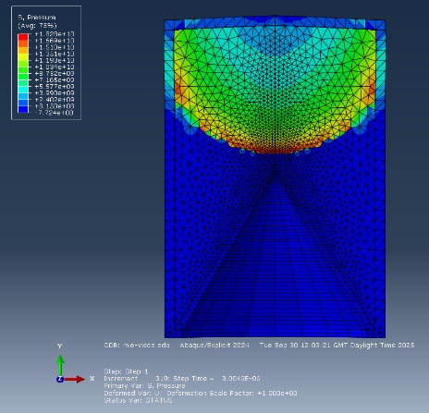
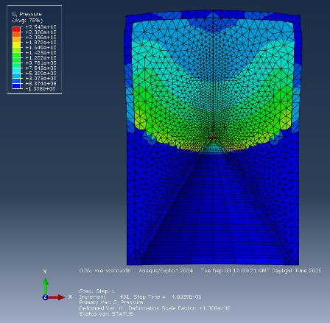
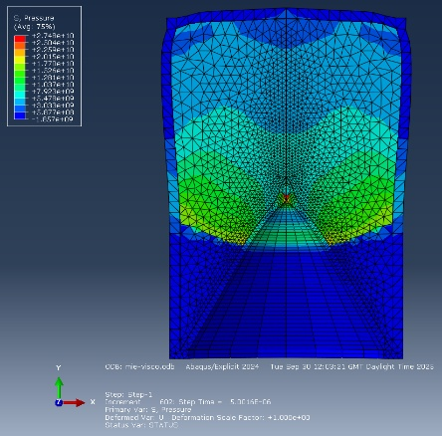
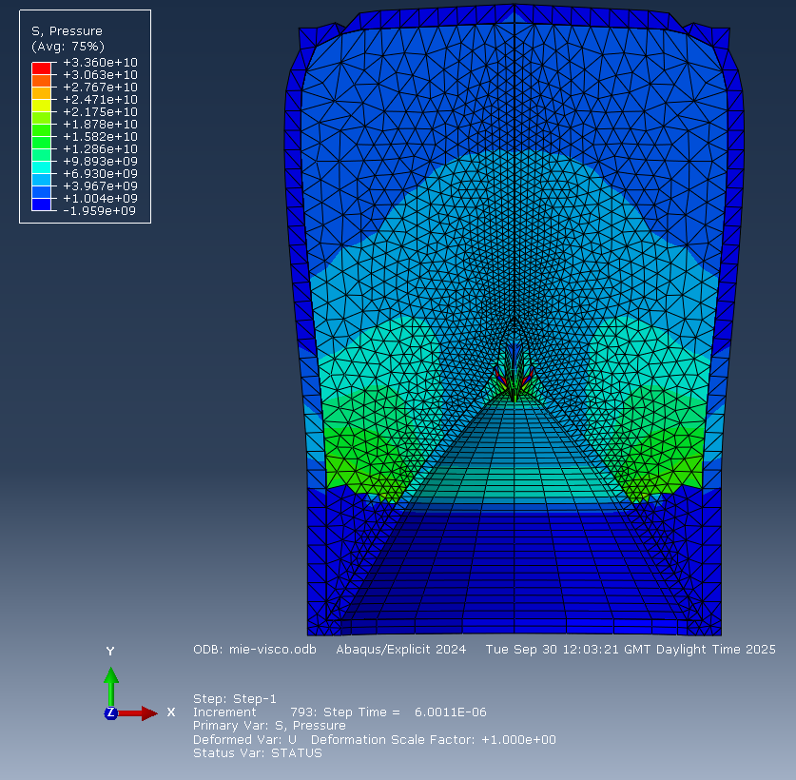

Figure 8 - 2D 1.6mm liner MG with visco detonation wave propagation
The detonation front is seen to converge towards the liner, with the greatest pressures observed at the shock front until it impinges on the liner, transferring energy and initiating jet formation. Additional pressure reflections are visible as the wave interacts with the casing and returns into the explosive, slightly modifying the overall shock pattern.

Liner collapse behaviour showed clear dependency on both the liner geometry and the form of the Mie-Grüneisen implementation. For both the 1.6mm and 1.2mm liners, simulations without the Mie-Grüneisen EOS produced the longest and most continuous jet. When the Mie-Grüneisen model was applied without modifying viscosity, the analysis became numerically unstable and terminated before completion due to excessive deformation. Introducing increased bulk viscosity stabilised the solution and allowed full jet formation to occur, although the resulting jet length was noticeably shorter than in the non-Mie case. Figure 9 presents the final recorded jet shape for the 1.6mm case without Mie-Grüneisen, while Figure 10 shows the corresponding result when Mie-Grüneisen was applied using the default viscosity. Figure 11 illustrates the full liner collapse history for the 1.6mm configuration with increased viscosity. As before, the 2D axisymmetric model was revolved to provide a three-dimensional visualisation of the jet development.
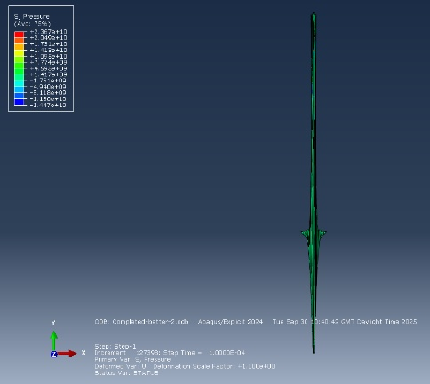
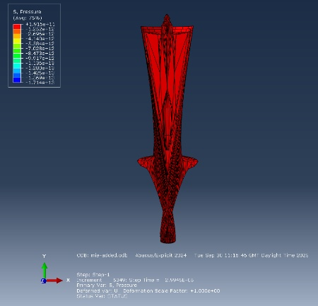

Figure 9 - 2D 1.6mm final liner collapse
Figure 10 - 2D 1.6mm MG final liner collapse
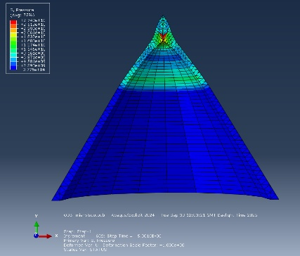
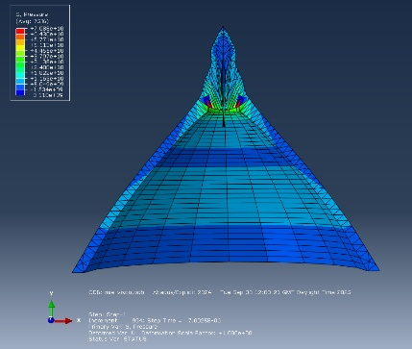
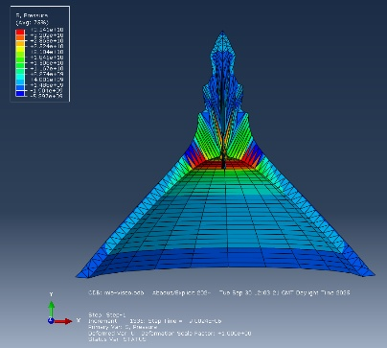
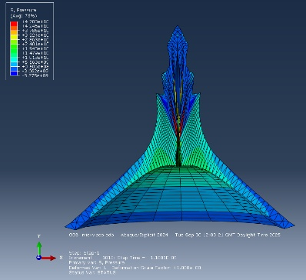
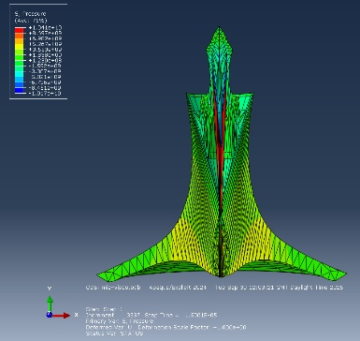
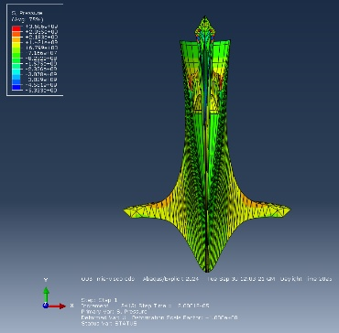
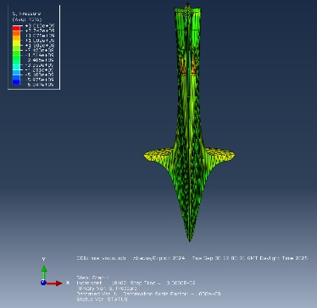
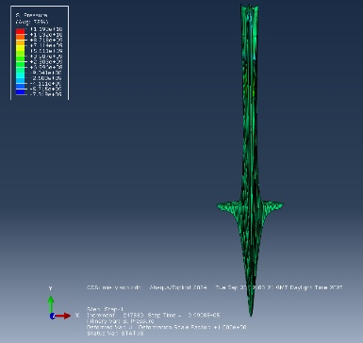
Figure 11 - 2D 1.6mm liner MG with visco liner collapse

As seen after approximately $5×{10}^{-6}$s, the detonation wave reaches the copper liner. The rapidly rising shock pressure drives the liner material radially inward towards the charge axis. This produces a progressive collapse of the liner surface, with the collapse angle controlling how material flows forward to form the jet. The inner surface accelerates more rapidly than the outer surface, causing the liner to stretch and invert, which results in the formation of a high-velocity jet at the front and a slower-moving slug behind. The greatest deformation occurs near the apex region, where pressures and strain rates are highest. The slug consists of the thicker, less-accelerated portion of the liner, while the jet originates from the thinner, more highly accelerated region. The sequence of collapse, jet formation and subsequent stretching is illustrated in Figure 11, showing the progressive development of the jet shape over time.

4.3- Jet tip velocity, jet length and energy results:

Jet tip velocity was obtained by plotting the end nodes of the jet for each liner configuration and Mie-Grüneisen modelling case. Little difference in peak jet velocity was observed between the simulations with and without the Mie-Grüneisen EOS. However, both introducing increased bulk viscosity and increasing liner thickness produced a noticeable reduction in tip velocity. Figure 12 presents the jet tip velocity history for the 1.6mm liner without Mie-Grüneisen, while Figure 13 shows the equivalent case with the EOS applied and modified viscosity. Figure 14 displays the corresponding result for the 1.2mm liner with Mie-Grüneisen and increased viscosity.

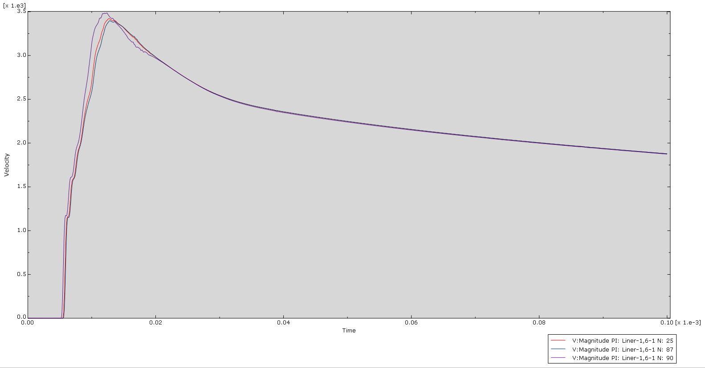
Figure 12 - 2D 1.6mm liner jet tip velocity history
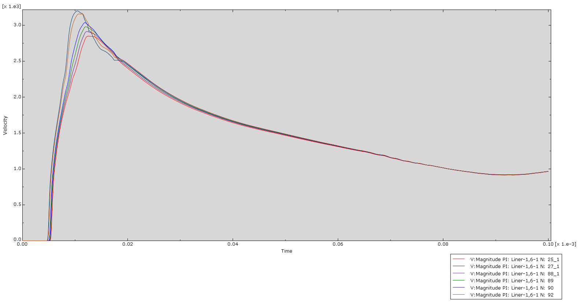
Figure 13 - 2D 1.6mm liner MG with visco jet tip velocity history

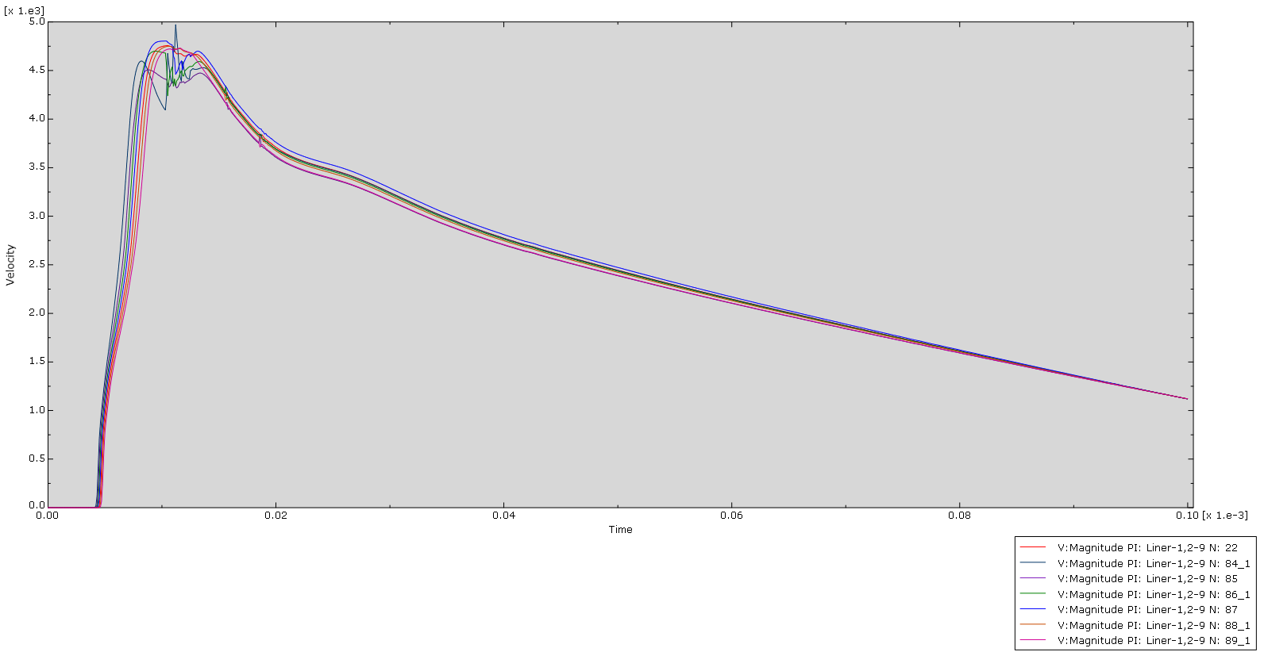
Figure 14 - 2D 1.2mm liner MG with visco jet tip velocity history

Increasing the bulk viscosity reduced the peak jet tip velocity in both liner configurations by approximately $0.25×{10}^{3}m/s$. It also caused the velocity to decay more rapidly with time, leading to a noticeably lower jet speed towards the end of the simulation. The effect of liner geometry was also significant. The 1.2mm liner consistently generated higher jet tip velocities, reaching around $5×{10}^{3}m/s$, compared with approximately $3.5×{10}^{3}m/s$ for the 1.6mm case. This reflects the greater acceleration of the thinner liner section under detonation loading.

Jet length was determined by measuring the distance between two nodes, one located at the jet tip and the other at the rear of the jet. This procedure was repeated for each liner configuration and for every Mie-Grüneisen modelling case, excluding the case with Mie-Grüneisen and no viscosity modification, as these simulations did not complete. The inclusion of Mie-Grüneisen and viscosity parameters resulted in a significant reduction in jet length for both liner models. In all cases, the thinner liner produced the longer jet. The jet lengths obtained from each simulation run are presented in Table 4.

Table 4 - Jet lengths
 | Liner 1.6mm: | Liner 1.2mm:
No MG and visco (0.06): | 0.225m | 0.413m
MG and visco (1.0): | 0.116m | 0.248m

Total energy balance was monitored throughout the simulations to assess numerical stability. In all models that successfully completed, the total system energy remained approximately constant at around $3.62×{10}^{5}\text{J}$, with only small fluctuations observed during detonation and liner collapse. This indicates that artificial energy gain or loss within the model was minimal and that the solution remained numerically stable over the simulated time period. An example energy history plot for the 1.2mm liner with the Mie-Grüneisen model and increased bulk viscosity is shown in Figure 15.

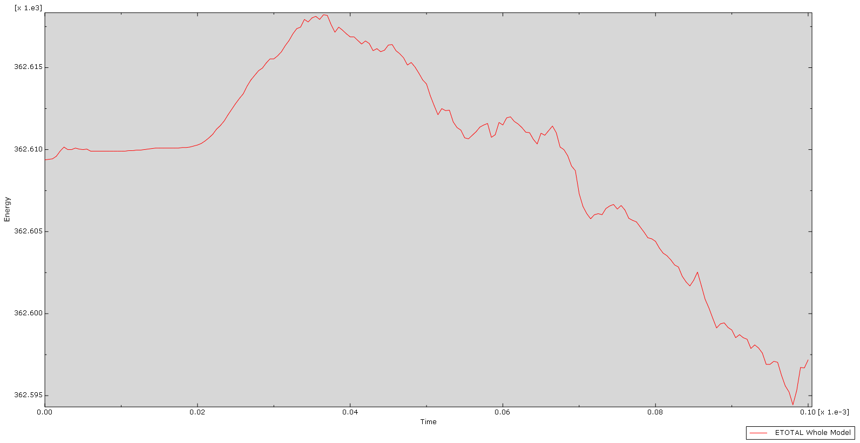
Figure 15 - 2D 1.2mm liner MG with visco total energy balance

4.4- Comparison between liner design variants:

For the two liner-thickness configurations, the detonation wave behaviour was essentially identical, as the liner does not significantly influence wave propagation and all other materials and dimensions were unchanged. The collapse mechanism was also consistent between cases, although the thinner liner produced a longer, higher-velocity jet with a smaller trailing slug compared to the thicker design. Both final simulations using the Mie-Grüneisen EOS with increased viscosity were numerically stable. Neither jet exhibited noticeable breakup within the simulated time, although this may occur for the 1.2mm liner (or thinner designs) as the liner undergoes greater stretching. Additional supporting plots are provided in Appendix A - 2D additional simulation data and results. Overall, this behaviour aligns with the theoretical expectations summarised in the literature review.

4.5- Interpretation of 2D results:

It was determined that including the Mie-Grüneisen terms provided a more realistic representation of the high-pressure liner response, although increasing the viscosity value was necessary for the analysis to remain numerically stable. However, axisymmetric modelling cannot fully capture three-dimensional jet breakup, instability or asymmetry, so a full 3D model was subsequently developed to address these limitations. The thinner liner was utilised as it produced a faster and longer jet in 2D, making it the more critical and performance-driving configuration to study in greater detail.

Section 5 – 3D model development and analysis:

5.1- Transition from 2D to 3D modelling:

The higher performing 1.2mm liner configuration was selected for 3D analysis. Extending the model to 3D allows asymmetric collapse, jet instability, yaw and potential breakup behaviour to develop, which cannot occur in an axisymmetric simulation. The 3D model required a finer mesh in the collapse region, significantly greater computational effort and longer runtimes. While this improves physical realism, the results remain sensitive to mesh density and numerical controls.

In all 3D simulations the Mie-Grüneisen EOS was applied to the liner, together with increased bulk viscosity. This combination was required for numerical stability, so the same settings were used consistently across all 3D runs.

5.2- Numerical stability and mesh distortion issues:

The 3D simulations proved far more difficult to run to completion than the 2D models. Although large deformation also occurred in 2D, the added degrees of freedom in 3D led to far greater mesh distortion and repeated solver termination. In several runs the elements became excessively stretched or produced unrealistic jet shapes, indicating numerical failure rather than physical behaviour. These challenges, which are common in shaped charge jet modelling, motivated the introduction of adaptive meshing and SPH to improve stability and maintain a usable solution.

5.3- Adaptive meshing assessment:

ALE adaptive meshing was introduced to control excessive distortion in the liner during jet formation. In this approach, the mesh is periodically smoothed and repositioned relative to the deforming material, helping to maintain element quality under large strains while retaining a largely Lagrangian description. Adaptive meshing was activated on the liner shortly after the detonation wave reached it, to prevent severe stretching that would otherwise trigger solver failure. However, this strategy did not stabilise the model. Instead, over-closure occurred as explosive material penetrated through gaps in the deforming liner, causing the mesh to remap incorrectly and producing large, unrealistic protrusions from the liner surface, as shown in Figure 16.

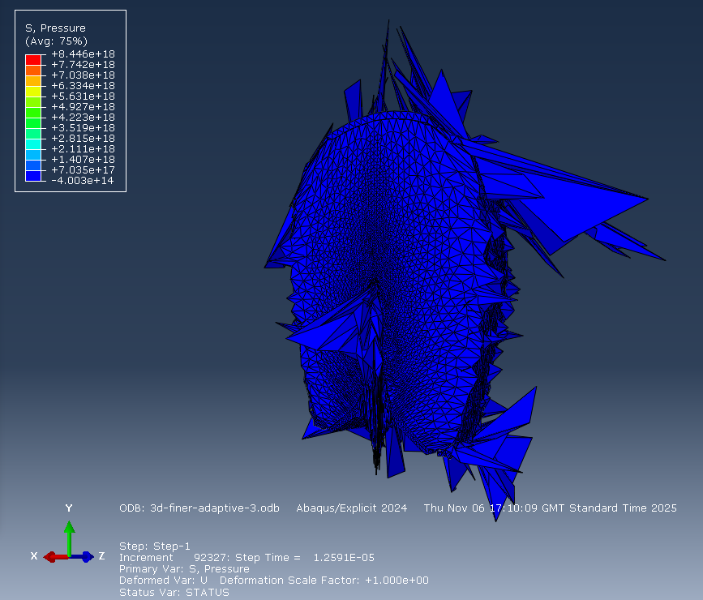
Figure 16 – 3D ALE adaptive meshing overclosure

5.4- Smoothed particle hydrodynamics (SPH) implementation:

After adaptive meshing proved unsuccessful, smoothed particle hydrodynamics (SPH) was trialled as an alternative way to manage the extreme liner deformation. SPH replaces finite elements with particles, allowing very large strains without mesh failure. Several implementation strategies were explored. When SPH was applied to the liner from the start of the simulation, the structure collapsed asymmetrically out of plane, likely due to the explosive products forcing the liner without the constraint of a solid mesh. This behaviour was similar to the earlier over-closure effects observed when adaptive meshing. SPH was then activated after a specified time delay, which helped limit TNT penetration, but the model still failed once casing distortion became severe.

A strain-based activation threshold was also examined using values of 10, 5, 3.5, 3, 1.5 and 0.8. A value of 3.5 provided the most stable behaviour, larger thresholds generated too few SPH particles, while lower values converted excessive mesh regions and again caused out of axis deformation. The model still became unstable during casing collapse, so the casing was finally converted to SPH shortly before failure. This allowed the simulation to continue up to $5.355×{10}^{-5}s$, representing the longest stable runtime and forming the basis for comparison with the 2D results. Full failed SPH liner collapse models are presented in Appendix B - 3D additional simulation data and results. It should be noted, however, that SPH introduces known limitations including numerical noise, reduced spatial accuracy and potential energy conservation issues, which should be considered when interpreting the results.

5.5- Final 3D jet formation results:

Detonation wave behaviour in the 3D simulations followed a broadly consistent pattern across all runs, as no changes were made to the geometry, material properties or detonation model. Figure 17 presents the resulting pressure field for the case in which SPH was applied to both the liner and casing.

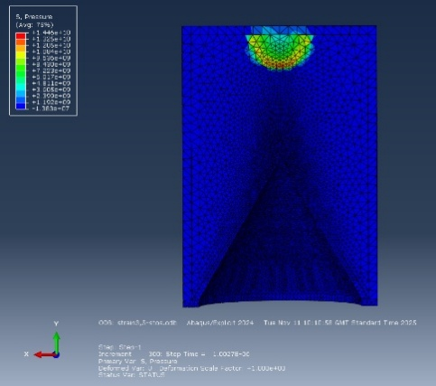
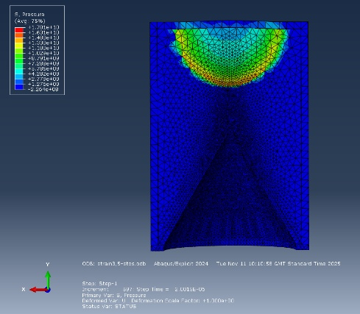
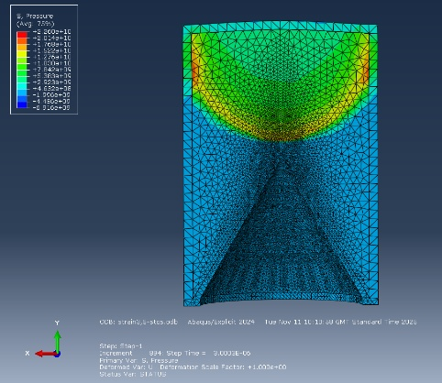
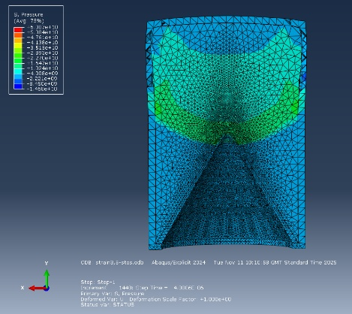
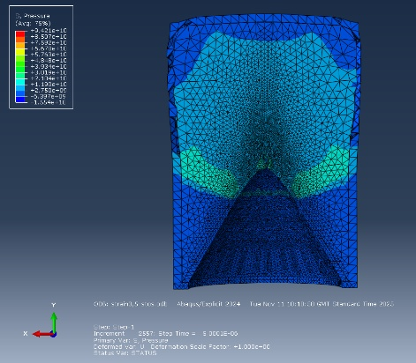
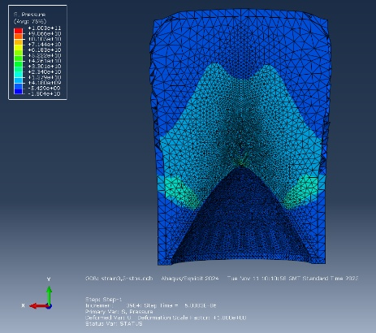
Figure 17 – 3D SPH (liner and casing) detonation wave propagation

Liner collapse behaviour varied significantly depending on whether and how adaptive meshing or SPH was applied, as previously discussed. The most stable configuration was the SPH model applied to both the liner and casing, which achieved the longest simulation runtime. The resulting liner collapse and jet formation for this case are shown in Figure 18.
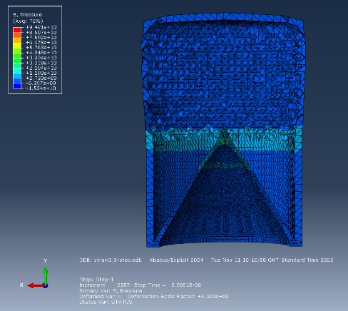
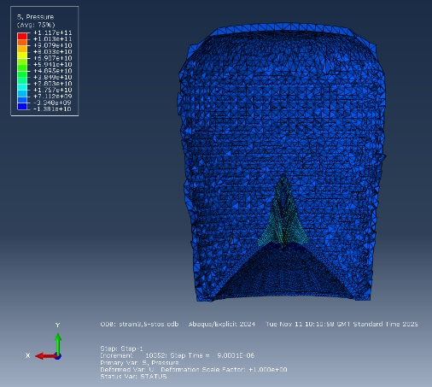
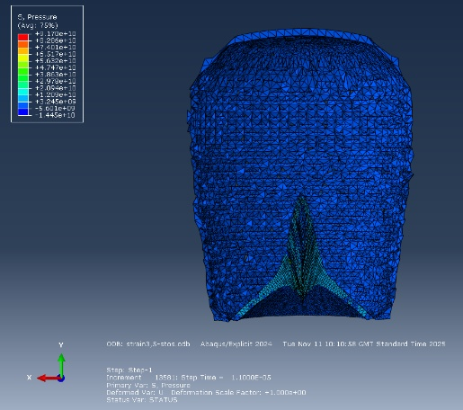
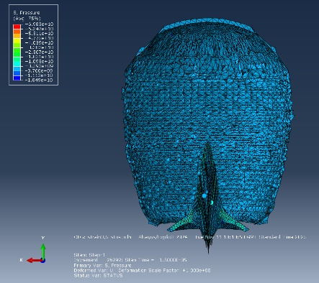
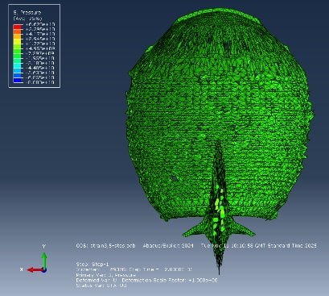
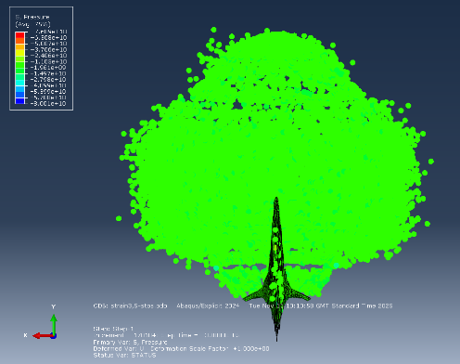
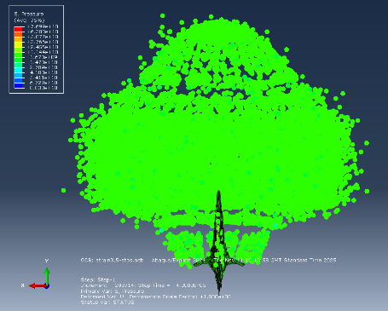
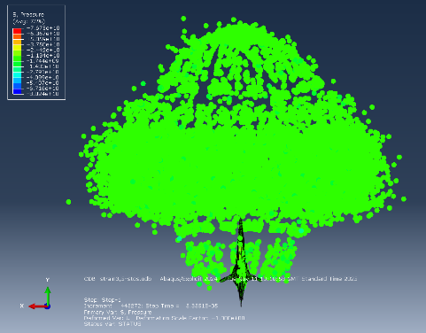
Figure 18 - 3D SPH (liner and casing) liner collapse

After approximately $5×{10}^{-6}$s the detonation wave reaches the copper liner, initiating radial collapse toward the charge axis and the onset of jet formation. The liner continues to accelerate and elongate until around $2.0×{10}^{-5}s$, at which point jet stretching effectively ceases. This behaviour is likely associated with developing numerical instabilities and progressive loss of mesh integrity, meaning the later stages of jet formation are no longer physically reliable.

Some variation in jet tip velocity was observed between the different SPH activation strategies. When SPH was applied from the start of the simulation, the peak velocity was lower, although the velocity remained relatively steady throughout. In contrast, applying SPH after a defined time delay produced two distinct velocity peaks, with the second occurring immediately after SPH activation. The corresponding velocity histories are presented in Appendix B - 3D additional simulation data and results. The velocity response for the SPH model applied to both the liner and casing is shown in Figure 19.

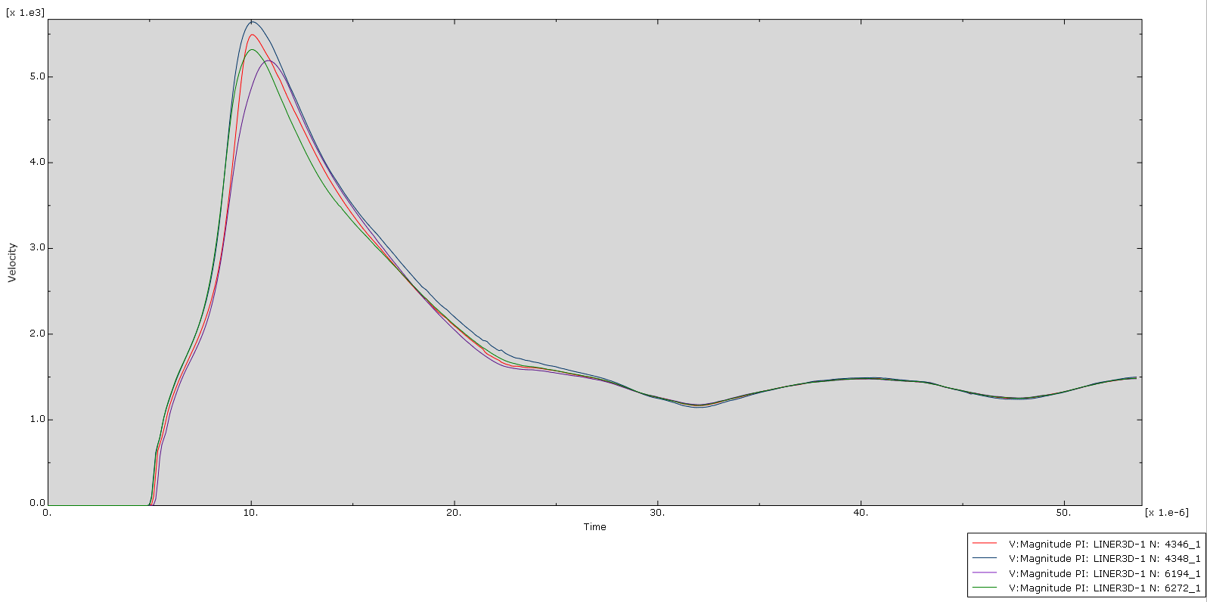
Figure 19 - 3D SPH (liner and casing) jet tip velocity history

A peak jet tip velocity of approximately $5.5×{10}^{3}m/$s is observed, followed by a gradual reduction in velocity as the jet continues to elongate and loses momentum. All monitored nodes near the jet tip exhibit the same overall trend with only minor variation, indicating a consistent and stable velocity field in the jet tip region.

The Jet length measured at $5.355×{10}^{-5}s$ for the SPH model applied to both the liner and casing was 0.0668m. However, this result should be interpreted with caution, as the simulation did not run to completion and the jet did not fully elongate. The recorded length is therefore likely to underestimate the true final jet length.

Across all 3D simulations the initial total energy was approximately $1.81×{10}^{5}\text{J}$. Runs without SPH and those with SPH applied from the start, showed only very small variations in total energy over time. When SPH was introduced after a defined time delay, or triggered by just strain in the liner, the total energy reduced to around $1.77×{10}^{5}\text{J}$. In the final configuration, where SPH was applied to both the liner and casing, the total energy decreased further to approximately $1.60×{10}^{5}\text{J}$, as illustrated in Figure 20. This gradual reduction in total energy indicates increasing levels of numerical dissipation within the model, meaning that although SPH improved stability by preventing catastrophic failure, it also introduced greater artificial loss.

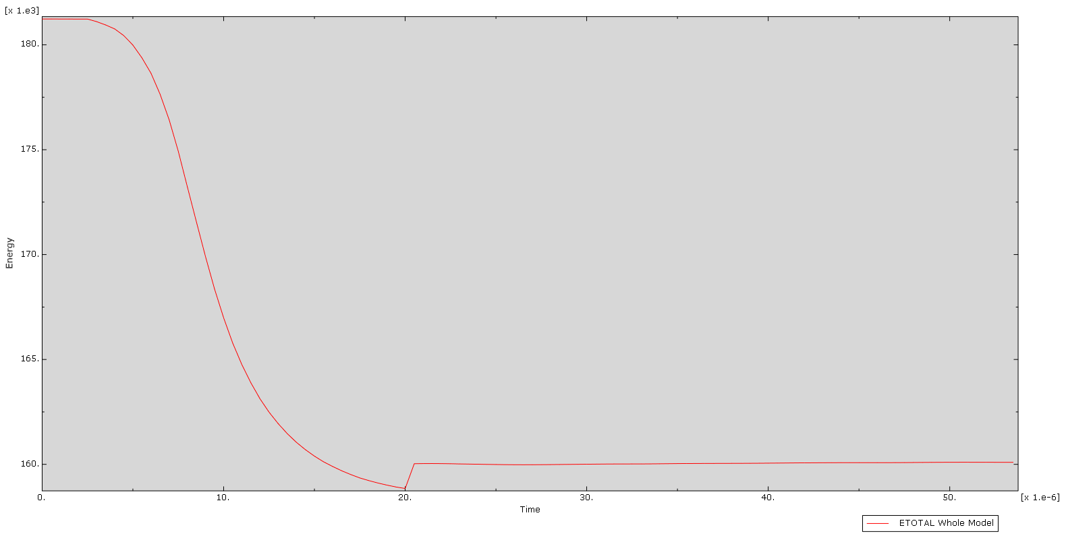
Figure 20 - 3D SPH (liner and casing) total energy balance

5.6- Comparison between 2D and 3D results:

Detonation wave behaviour in 3D followed the same general pattern as in the 2D model, including the presence of minor reflected pressure waves. Liner collapse also initiated in a similar manner, with jet formation beginning at approximately the same time. However, unlike the 2D case where the jet continued to elongate throughout the simulation, the 3D model stopped stretching after around $2.0×{10}^{-5}s$, indicating the onset of numerical instability. Jet tip velocities were broadly comparable, although the 3D model produced a slightly higher peak (by around $0.5×{10}^{3}\text{m/s}$), while the 2D model exhibited a smoother decay in velocity. Jet length in 3D was significantly shorter because the simulation did not reach full collapse completion and had stunted elongation. Total energy balance was also poorer in 3D due to the additional numerical controls required. Overall, while 3D modelling captures more realistic behaviour and potential asymmetry, it introduces greater computational cost and instability risk, meaning 2D remains useful for controller parametric assessment.

Section 6 – Discussion and evaluation:

6.1- Influence of liner geometry on jet performance:

Reducing the upper liner thickness from 1.6mm to 1.2mm increased jet tip velocity and produced a longer, more coherent jet, consistent with published shaped charge theory that thinner liners collapse faster and accelerate more efficiently. However, this also reduced stability and increased sensitivity to numerical and physical disturbances. From an engineering perspective, liner thickness selection therefore represents a trade-off between maximising jet performance and maintaining robustness, highlighting the need to optimise geometry rather than simply minimise thickness.

6.2- Effects of material models and EOS:

The use of the JWL explosive model combined with the Mie-Grüneisen EOS strongly influenced the predicted detonation pressures and resulting jet behaviour. Results were particularly sensitive to the choice of bulk viscosity settings, which affected numerical stability and jet coherence. Since both EOS forms rely on empirically fitted parameters, some uncertainty remains in how accurately they represent real explosive behaviour, especially under extreme strain rates. This sensitivity is consistent with previous studies that report EOS selection as a key source of modelling variability.

6.3- Numerical limitations and modelling assumptions:

The modelling approach involved several simplifications, including axisymmetric assumptions in 2D, no target penetration modelling and reliance on finite element mesh constraints. In 3D, adaptive meshing and SPH were required to manage severe distortion, but these methods can introduce numerical artefacts, smoothing effects and reduced spatial accuracy. Stability issues and energy imbalance further limit confidence in the absolute values produced. As a results, the findings should be interpreted primarily as qualitative trends rather than precise quantitative predictions.

6.4- Verification and validation considerations:

Model verification was based on mesh sensitivity checks and monitoring total energy balance, which remained broadly stable across completed simulations. The predicted behaviour matched expected physical trends from literature, increasing confidence in results. However, the absence of experimental validation means confidence remains moderate and findings should be interpreted with appropriate cautions.

6.5- Implications for shaped charge modelling:

This work demonstrates that shaped charge jet modelling is feasible but highly sensitive to EOS selection, mesh refinement and numerical stabilisation methods. Three-dimensional modelling becomes necessary when asymmetric behaviour is of interest. Future research should prioritise validation against experiments and improved stability techniques for large strain jet simulation.

Section 7 – Conclusions and recommendations:

7.1- Summary of results:

The 2D simulations demonstrated that liner geometry has a strong influence on jet behaviour, with the 1.2mm liner producing a higher jet tip velocity and longer, more finely stretched jet due to its reduced collapse mass. The 3D analyses broadly confirmed these trends but were more numerically challenging, meaning the jet stopped stretching earlier and the final jet length was reduced. Jet velocities between 2D and 3D were generally consistent, although stability was noticeably poorer in 3D. Increasing viscosity within the Mie-Grüneisen model improved stability but reduced peak velocity and length. Overall, thinner liners improved performance but increased sensitivity to modelling choices and numerical control.

7.2- Assessment of model capability:

Abaqus/Explicit proved well suited to modelling high-rate explosive loading, with the JWL and Mie-Grüneisen EOS providing a reasonable representation of detonation behaviour. The use of numerical stabilisation techniques such as SPH helped delay model failure but also introduced artefacts and uncertainty, meaning the results should still be viewed as approximate rather than fully predictive.

7.3- Recommendations for future work:

Future work could include penetration modelling, finer mesh refinement and improved treatment of fracture and thermal effects. Incorporating more detailed reaction modelling and experimental validation would strengthen confidence in the results. Alternative 3D numerical strategies should also be explored to improve stability. Further studies could investigate different liner materials, cone angles and thickness distributions to optimise shaped charge performance.

Section 8 – References:

8.1- All referenced citations:

[1] | W. P. Walters and J. A. Zukas, Fundamentals of Shaped Charges, New York: Wiley, 1989. [Online]. Available: Link. [Accessed 6th December 2025}.
[2] | X. Zhang and W. Xiong, Shock Compression and Chemical Reaction of Multifunctional Energetic Structural Materials, Nanjing: Elsevier, 2022. [Online]. Available: Link. [Accessed 6th December 2025}.
[3] | Z. Hao, Z. Wang, Y. Wang, C. Duan and Q. Ji, “The effect of three-layer liner on the jet formation and penetration capability of shaped charge jet,” Scientific Reports, Taiyuan, 2023. [Online]. Available: Link. [Accessed 6th December 2025}.
[4] | G. Baudin and R. Serradeill, “Review of Jones-Wilkins-Lee equation of state,” EPJ Web of Conferences, Gramat, 2010. [Online]. Available: Link. [Accessed 7th December 2025}.
[5] | S. Sommavilla, “Smoothed Particle Hydrodynamics - A Guided Journey into the Basics of the SPH Method,” Dive CAE, December 2020. [Online]. Available: Link. [Accessed 7th December 2025].
[6] | D. S. Stewart, “Lectures on Detonation Physics: Introduction to the Theory of Detonation Shock Dynamics,” The University of Illinois, Urbana, 1993. [Online]. Available: Link. [Accessed 8th December 2025].
[7] | Y. B. Zel'dovich and Y. P. Rayzer, “PHYSICS OF SHOCK WAVES AND HIGH-TEMPERATURE HYDRODYNAMIC PHENOMENA,” National technical information service, Springfield, 1965. [Online]. Available: Link. [Accessed 8th December 2025].
[8] | V. K. R. Sirigiri, V. Y. Gudiga, U. S. Gattu, G. Suneesh and K. M. Buddaraju, “A review on Johnson Cook material model,” Materials Today: Proceedings, vol. 62, no. 6, pp. 3450-3456, 2022. [Online]. Available: Link. [Accessed 8th December 2025].
[9] | Dassault Systèmes SIMULIA, “ABAQUS Analysis User's Manual - Equation of state,” WashU McKelvey School of Engineering. [Online]. Available: Link. [Accessed 8th December 2025].
[10] | R. Menikoff, “Complete Mie-Gruneisen Equation of State,” Los Alamos National Laboratory, 2012. [Online]. Available: Link. [Accessed 8th December 2025].
[11] | G. S. Yeom, “Numerical Simulation of Conical and Linear-Shaped Charges Using an Eulerian Elasto-Plastic Multi-Material Multi-Phase Flow Model with Detonation,” Kunsan National University, Gunsan, 2022. [Online]. Available: Link. [Accessed 8th December 2025].
[12] | Y. Dou, Z. Liang and J. Dou, “Numerical simulation study on the influence of the variation rate of the liner thickness on the damage performance of shaped charge,” Journal of Physics: Conference Series, pp. 1-8, 2025. [Online]. Available: Link. [Accessed 12th December 2025].
[13] | X. Zhang and Q. Liang, “Studies on jet formation and penetration for a double-layer shaped charge,” Combustion, Explosion and Shock Waves, vol. 47, no. 2, pp. 241-248, 2011. [Online]. Available: Link. [Accessed 12th December 2025].
[14] | J. Park and S. Kwon, “Study on the Penetration Performance of a Double-Angle Linear Shaped Charge: Performance Improvement and Miniaturization,” Aerospace, vol. 11, no. 310, pp. 1-13, 2024. [Online]. Available: Link. [Accessed 12th December 2025].
[15] | R. Liu, L. Tang, X. Jia, X. Jiao, R. Yan and X. Jiang, “JWL equation of state parameters for ideal detonation: A comparative study of literature reports, theoretical derivation, and artificial neural network prediction,” FirePhysChem, pp. 1-10, 2025. [Online]. Available: Link. [Accessed 12th December 2025].
[16] | S. E. Rigby and P. W. Sielicki, “An Investigation of TNT Equivalence of Hemispherical PE4 Charges,” Engineering transactions, vol. 62, pp. 423-435, 2014. [Online]. Available: Link. [Accessed 12th December 2025].
[17] | Matmake, “Properties of Copper (Cu),” [Online]. Available: Link. [Accessed 13 December 2025].
[18] | F. Wang, J. Wang, Z. Qi, X. Wu, X. Zeng and X. Yang, “Evaluation of copper spall response using Mie-Grüneisen equation-of-state parameters determined from molecular dynamics,” Computational Materials Science, vol. 216, pp. 1-11, 2023. [Online]. Available: Link. [Accessed 13 December 2025].
[19] | D. M. Iordache, E. R. Oprescu, C. I. Malea, E. L. Niţu, M. O. Crăcănel and C. Bădulescu, “Determination of Johnson-Cook material constants for Copper using traction tests and inverse identification,” IOP Conference Series: Materials Science and Engineering, pp. 1-11, 2021. [Online]. Available: Link. [Accessed 13 December 2025].
[20] | Geocentrix, “Structural Steels,” 2004. [Online]. Available: Link. [Accessed 13 December 2025].
[21] | F. Hu, X. Liu, B. Wang and Y. Xiang, “Investigations on the Johnson-Cook Constitutive and Damage-Fracture Model Parameters of a Q345C Steel,” Metals, vol. 14, pp. 1-14, 2024. [Online]. Available: Link. [Accessed 13 December 2025].

Section 9 – Appendices:

Appendix A- 2D additional simulation data and results:

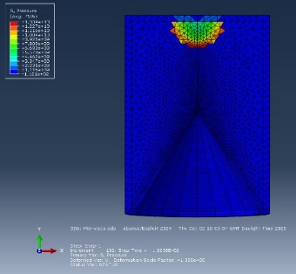
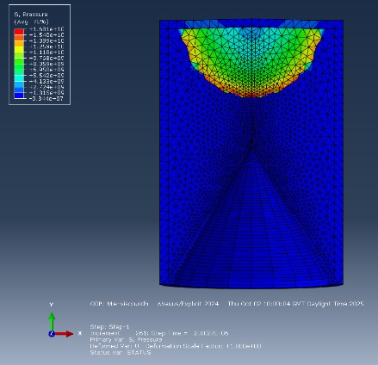
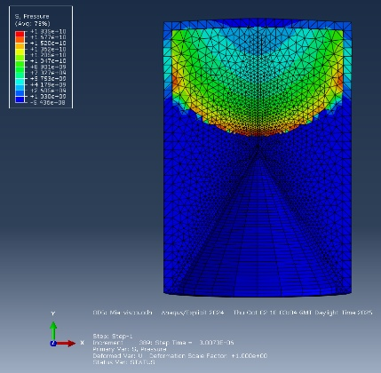
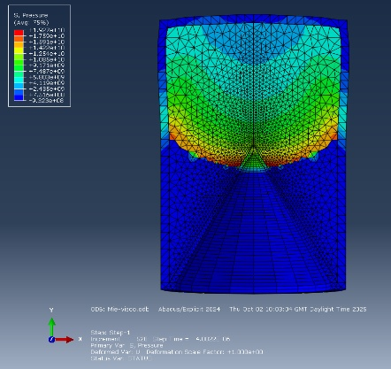
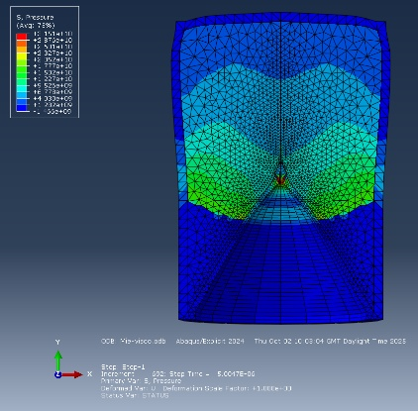
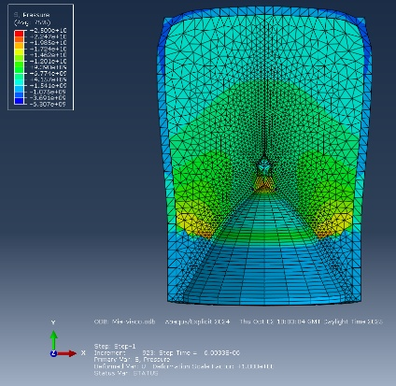

Figure A.1 - 2D 1.2mm liner MG with visco detonation wave propagation
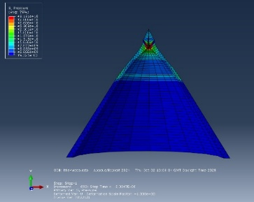
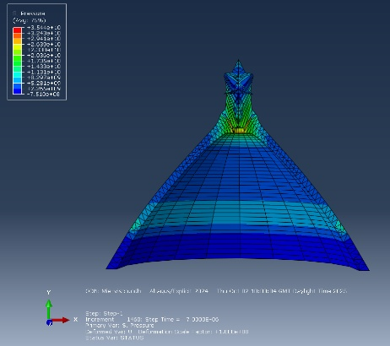
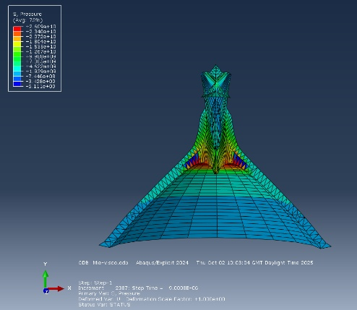
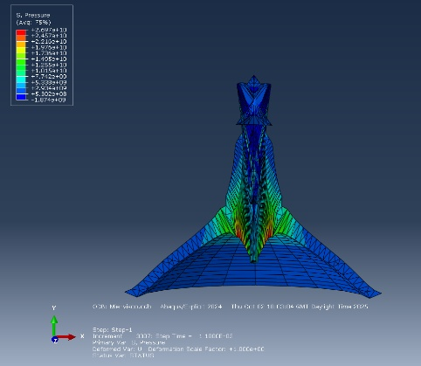
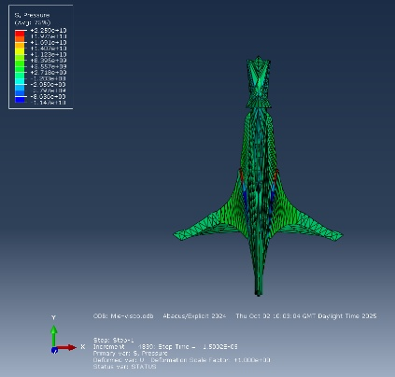
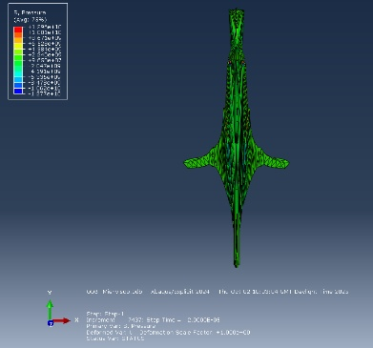
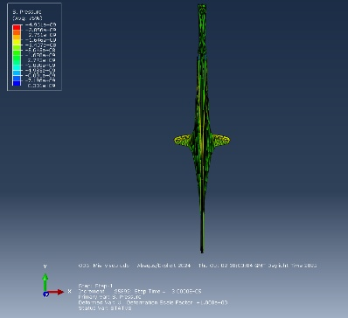
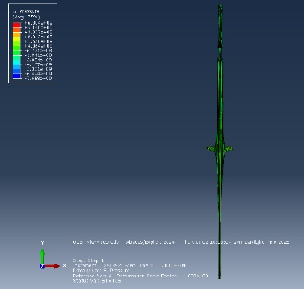

Figure A.2 - 2D 1.2mm liner MG with visco liner collapse

Appendix B- 3D additional simulation data and results:

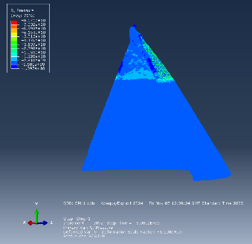
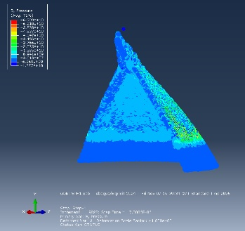
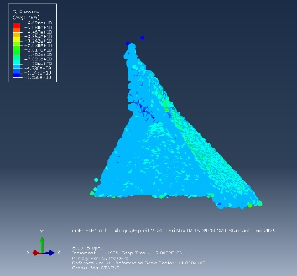
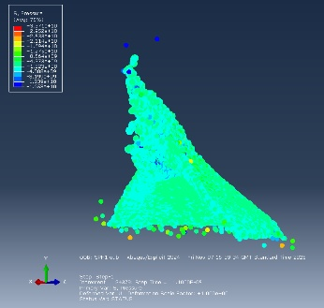
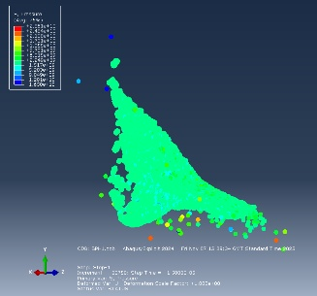
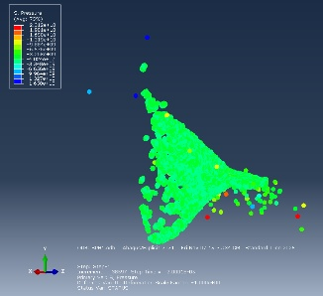
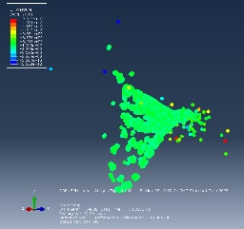
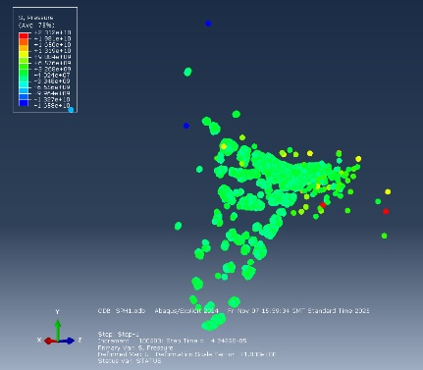

Figure B.1 – 3D SPH (liner) applied at start of simulation liner collapse

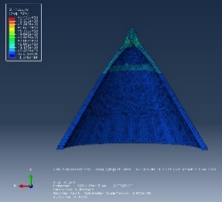
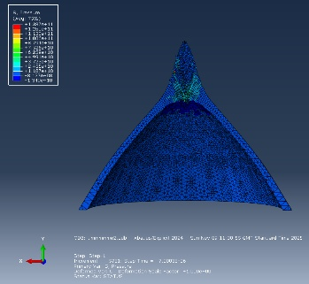
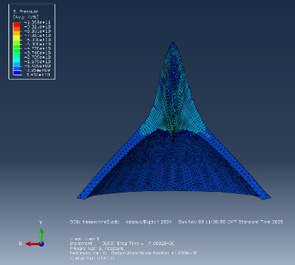
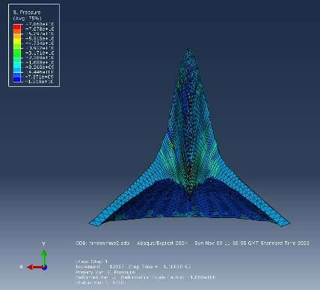
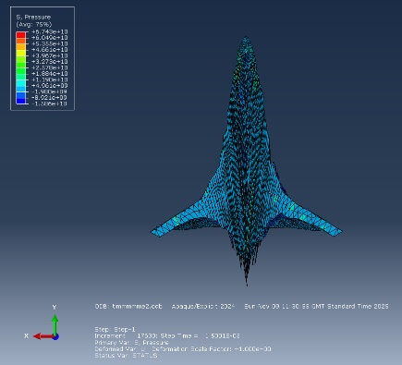
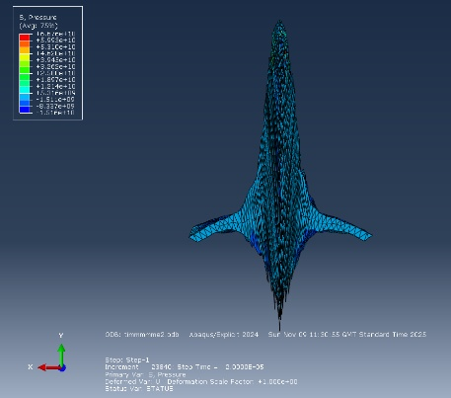
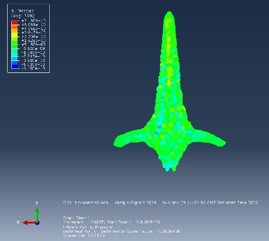
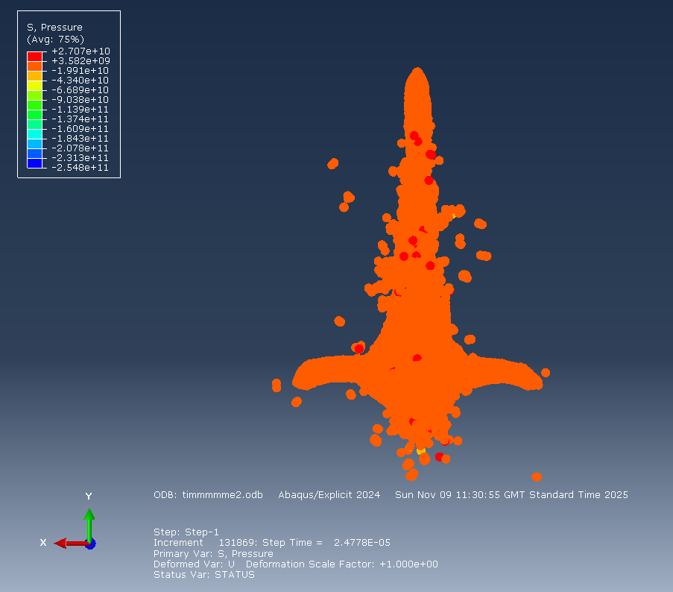

Figure B.2 – 3D SPH (liner) applied after time delay liner collapse
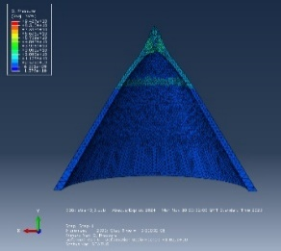
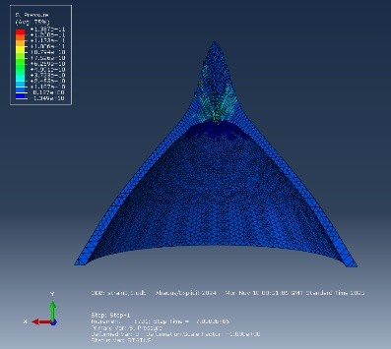
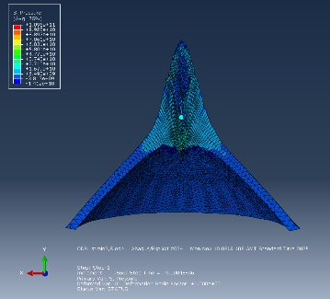
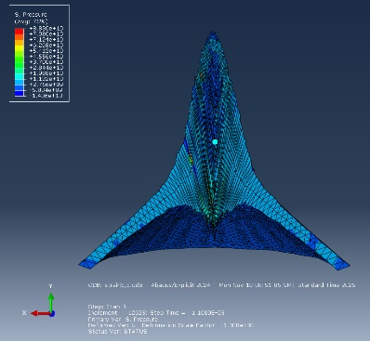
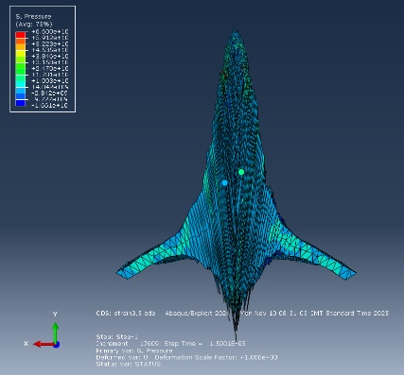
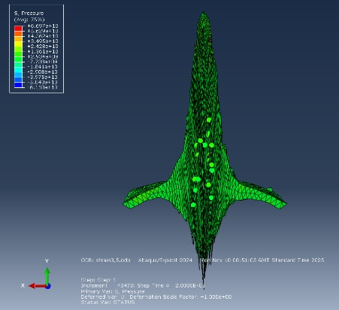
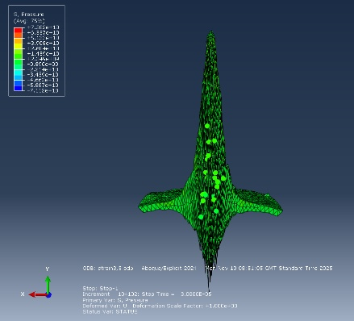
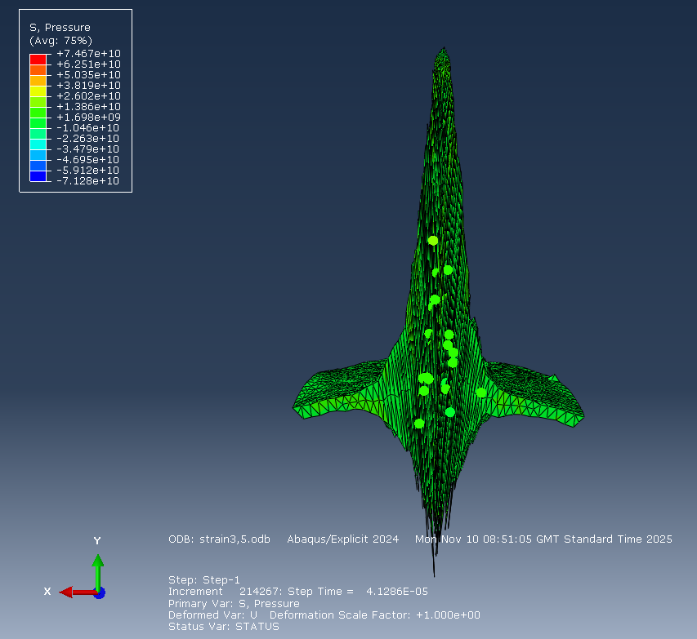

Figure B.3 – 3D SPH (liner) applied at strain 3.5 liner collapse

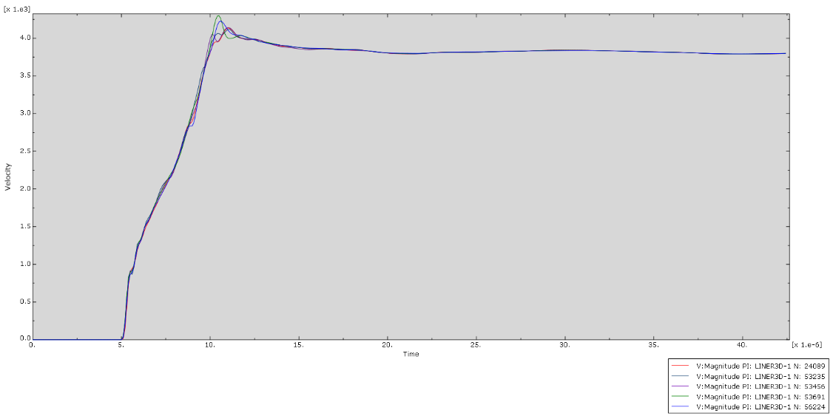

Figure B.4 - 3D SPH (liner) applied at start of simulation jet tip velocity history

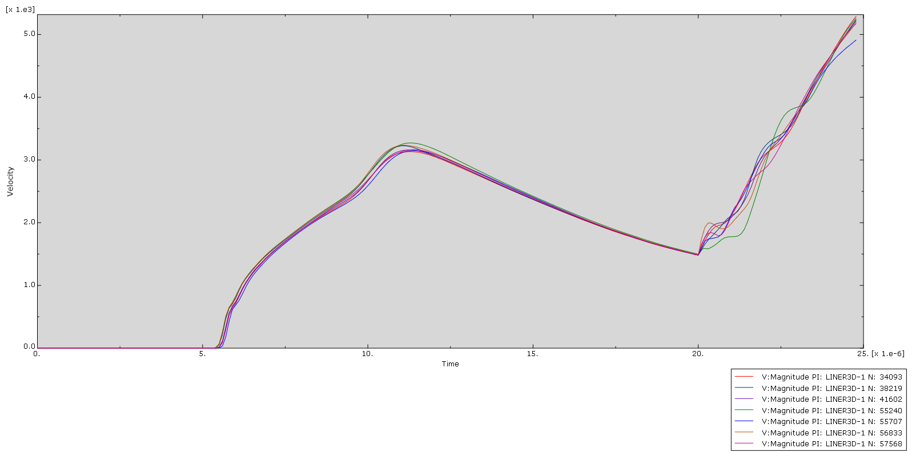
Figure B.5 - 3D SPH (liner) applied after time delay jet tip velocity history

