  LOCATION Swansea | LLEOLIAD abertawe
LEVEL 6 | LEFEL 6
EXAMINATION PERIOD | CYFNOD ARHOLIADAU
May 2018 | Mai 2018

MODULE CODE: M3X8529
Embedded Microcontrollers
TIME: 2 Hours
answer all four questions

Equipment or materials required – None
The Candidates are not permitted to bring calculators, dictionaries; text books/case studies or any other reference materials into the exam room.

ANSWER ALL FOUR QUESTIONS

QUESTION ONE (20 marks total)

- ‘Jitter’ can be an undesirable characteristic in a Real Time System.
Explain why this can be the case, while also producing a timing diagram and some brief, annotated pseudocode to help explain the principle of what Jitter actually is. (7 marks)
- A key trait of an RTOS is that it is deterministic. Explain what this means.
Use the example of a microcontroller that actuates an automotive airbag as an example of why determinism can be vital. (7 marks)
- Real time systems are generally classified into three distinct types depending on how they react to events. Name the three types, and explain their characteristics. (6 marks)

QUESTION TWO (30 marks total)

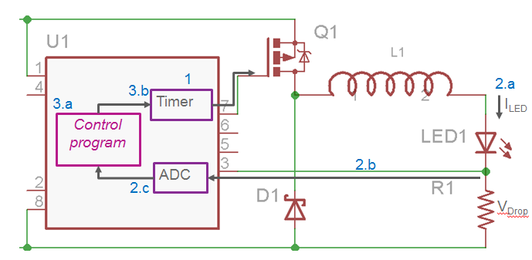

The diagram above depicts an embedded microcontroller (U1) that is being used to control a high power LED in a flashlight.
- Provide a detailed description of the function and purpose of each component, as well as a comprehensive explanation of the overall system operation. (15 marks)
- What advantages does using an embedded system as shown give over a dumb/passive implementation where an LED is simply driven via a current limiting resistor? (7 marks)
- Pins 2 and 4 of the Micro are currently unused. If these were configurable as digital inputs, suggest four additional useful features that could be incorporated to the flashlight system if some additional hardware was used and briefly describe how the features would be implemented. (8 marks)

QUESTION THREE (25 marks total)

When designing embedded electronic systems, you often have five general categories of solution to choose from:
Use an Embedded PC
Design a custom Microcontroller based system
Design a custom ASIC
Use generic programmable devices such as FPGA or PLD
Design using discrete logic

For each of the five options, provide:
One significant advantage of that method
One significant disadvantage
One real life scenario where that option might be the best choice
Justify your answers.

QUESTION FOUR (25 marks total)

You have been tasked with designing an embedded system that requires significant computing power, hence you have decided on a PC104 based approach. Your design also requires some custom electronics to be directly interfaced to a standard 8 bit ISA bus structure.
Provide a block/circuit diagram and explain a typical methodology that could be used to interface the custom electronics to the PC104 ISA busses.

Your interface circuitry goes in here
(Also ensure you define all the busses/signals on the left)
Custom Circuitry
PC104
ISA busses

