Knowledge and Information Management Skills for the Workplace
BMSW5106
Student name: Albena Dimitrova
Lecture name: Md Kalam

Introduction

Knowledge management proves to be a discipline through which an integrated approach is endorsed to the usage, access, organization, capture and creation of informational assets of a corporation. Textual information in which procedural documents and policy are included, structured database and most significantly the expertise resident within staff members heads and tacit knowledge are included in these assets. Knowledge management confirms that the available information can be gained through simple format by the members of staff when objectives have to be gained by them that organization actually required, after this, an experience can be formed which can be utilized when decisions have to be made more effective. Improvement and success of management is represented through this relying on quality or capability related to the applied science or utilized in major activities of management by any organization. when the system of knowledge management has to be developed numerous support systems are there that are required to be considered in which information storage system, information gathering system and information retrieval system are involved. Science can be elaborated as useful information through which any potential value related to the organization is improved.

Concept
Knowledge management is actually a term that is utilized to elaborate a manner in which knowledge is analyzed, shared and gathered comprehensively and consciously by an organization such as in terms of skills of people, documents and resources.
Data is considered to be specific figure or a fact, information is that particular data which is organized for making it a sensible data. Information is on what knowledge is actually built and a context is provided by it so that actions can be taken. Such as, if the quantity is acknowledge of parts that are being made per hour and the utilized processes prove to be the useful in a greater extent as knowledge, when the sector is known in which we are, by whom the items are being made, where are they, who are the suppliers and what price is being charged by the competitors for every single item (Dalkir, 2017).
Scope
The manner in which the word “knowledge” is interpreted by an organization actually varies and dissimilar views are there of dissimilar operation sector which are covered by it:
- Technologies and methodologies.
- Channels of learning and the people such as where information flows.
- Techniques, methodologies and procedures
- Administering knowledge assets involved what is known by the individuals because of the experience of them (Hislop, Bosua and Helms, 2018).
Importance
Definition of KM can be as having an impact on:
- Protecting income streams because it is known by the corporation that how they can protect, secure and fine business interests.
- Enhancing rates of retention.
- Boosting output level
- Endorsing innovation
Knowledge management and organizational learning are interlinked because both of these prove to be supportive for any business. Knowledge does not prove to be a homogeneous resource. Rather, it is related with accurate information and data.
Two distinct forms are there of knowledge which specifically work for e-business in which tacit knowledge and explicit knowledge are involved (Becerra and Sabherwal, 2014).
•Explicit knowledge: In this form, easy transformation of knowledge becomes possible and it further proves to be factual and declarative. Written documents are used when knowledge has to be transferred along with codified media and verbal communication.
Explicit knowledge is spread by Tesco specifically to its members of staff when production analysis has to be done of the production line. This procedure is followed on monthly basis and it is followed by the corporation for every member of staff. Moreover, documentation has to be presented by it for through which the explicit knowledge is explained regarding the work which has been performed throughout the month (Donate and Pablo, 2015).
•Tacit Knowledge: Tacit knowledge is actually the knowledge regarding procedures. When this form of knowledge has to be acquired, experience of several years has to be gained by an individual.
Tesco works in a dissimilar manner with the factors of tacit knowledge management and it is implemented by it within a systemized manner. When new members for staff are recruited by them, training process is initiated by them for a longer term for those members.
The relationship between data, information and knowledge.
Data:
Data is specifically acknowledged as gathering of discrete events, facts and objects out of context. Any sort of reference is not there of the data with time or space. It can be further elaborate as that information which is not processed. Within excel spread sheet, data is stored within every cell any sort of information is not given by it. When any corporation’s sales figures are stored within a spread sheet it is referred to as the data. Some categorization might be done regarding the data so that meaningful output can be gained from it (Omotayo, 2015).
Information:
That data which is processed is referred to as information. Meaningful information can be derived from collected data. It cannot be called information if any sort of result is not being gained from the data. Figure is sales that is stored within a spread sheet does not gives any sort of conclusion on its own rather through any statistical tool or any observation it can be realized that sales of the northern region prove to be better than that of the southern region. This information has been ultimately gained from the data of sales (Dalkir, 2017).
Knowledge
After information knowledge and data proves to be the upcoming step of evolution. When experiences are applied in any judgment or jurisdiction then knowledge is ultimately gained. In data of sale it can be concluded at last that endorsements and marketing have to be done in a greater extent within the south region apart from the northern one if the sales have to be boosted within the southern region. Separation of knowledge is done in two forms; explicit knowledge and tacit knowledge. Organizational learning specifically relies on process cycle of knowledge creation.
The key towards acknowledging the relationship that is intricate between knowledge, information and data lies specifically on the source of information and data. Sources of both are considered to be twofold in which situations and activities are involved. Information is generated through the situations and activities.
Examples related to the activities where data along with information is generated can be gathered include activities of business in which advertising campaigns, sales transactions and production are involved. Situations are related to fluctuations within the atmosphere that might not or might be related with activities of humans in which fluctuation in climate is involved. Human activities that will be impacted because of fluctuations in the climate involve several economic activities, agriculture and so on. Situation is actually a context because of which the decisions are impacted. For instance, production might be impacted due to a factory being deteriorated. In short, information is generated through situations and activities that feed within the process of making the decisions. Relationship has been illustrated in the diagram below that is between information and data (Hislop, Bosua and Helms, 2018).
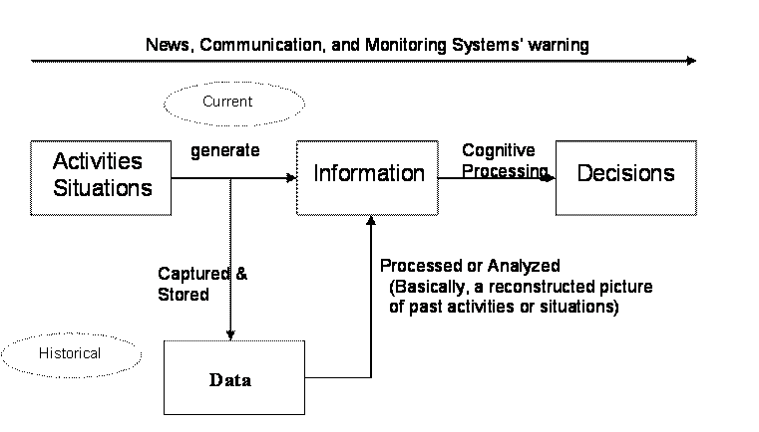
Once they are stored and captured, processing can be done of the data back into information with the help of analysis and compilation. Picture related to the situations and activities of the past can be reconstructed ultimately. Two fundamental aspects are there which are related to analysis, compilation and processing:
- Data to data
- Data to context
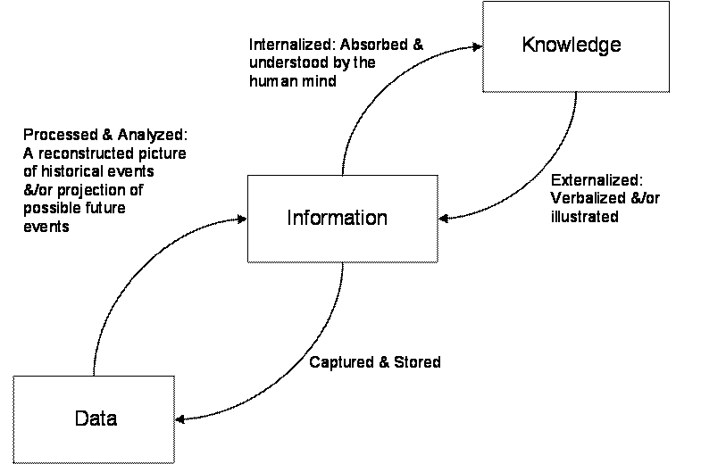

The relationship between individual knowledge and organizational knowledge
Knowledge of individuals that is ultimately paired with other individual’s knowledge within an organization. Organizational knowledge proves to be an asset for the corporation but any sort of value cannot be named to it. When knowledge is pooled by the individuals within an organization, advantages can be gained by the organization because of that specific knowledge such as over others prevailing within same field. Organizational knowledge is actually the sum of knowledge on a whole that is contained within organizations and through which business value is provided. It can be obtained through client’s communications, conferences, and lessons regarding success or failure, product knowledge, intellectual property so that a few sources can be named. Knowledge is always transmitted, preserved and learned from people; therefore, it proves to be a specific role of HR to provide support when knowledge has to be managed (Becerra and Sabherwal, 2014).
Sources of Knowledge
Knowledge takes place in all places within the corporation and it is generated in several intangible and tangible forms such as:
- Individual—Customer queries, files, loose documents, person’s notebooks or memory of any individual. Resources like these related to the tacit knowledge prove to be effective.
- Group/Community—Mentorship programs, training groups, internal teams, project teams, communities of excellence and communities of practice are effective resources that are related to tacit, implicit and explicit knowledge
- Structural—Suppliers, IT systems, traditional ways in which things are done, culture, procedures and routines are implicit knowledge sources (Donate and Pablo, 2015).
- Organizational memory—Knowledge of the organization on a whole. It can be confined in data, records, market research, reports, regulations and guideline. Such sources prove to be effective of a combination of explicit and tacit knowledge.
Apply analysis and modelling techniques to identify knowledge assets.
The approach of business intelligence aims towards making those decisions for the business which are better with the help of utilizing management information systems within a wider range so that data can be managed. Business intelligence is related with practices, applications, technologies and skills that are utilized to prove to be helpful for the business when better understanding has to be acquired regarding commercial context. Business intelligence is further elaborated as information that is collected by it and it also proves to be supportive when better decisions have to be made related to the business and therefore, it can also be referred to as decision support system. Accurate and timely information is utilized by business intelligence when decisions have to be made. With the system of business intelligence, enhanced turnaround times can be found by the corporation on gathering the data, thoughts related to innovative initiatives of the business, a picture that is more precise regarding desires and needs of clients, and strong acknowledgement regarding the way in which top competitors can be competed. Enhancement in agility of business that is gained through business intelligence proves to be significant in several of the cases and because of this, better advantages can be taken by the corporation of consistently evolving conditions of the market (Omotayo, 2015). Application of business intelligence specifically comprises of the systems of profiling, analysis, reporting, gathering information and checking. Key characteristics related to the system of business intelligence involve:
• General overview and interdepartmental concentration towards performance of the business.
• Enhanced techniques so that data can be gathered.
• Discovering the data in optimal way.
• Business enhancements that are of numerous forms are tied together so that easy and quick communication can be enabled between dissimilar departments.
Those businesses which are operating as per the approach of business intelligence are considered to transform the gathered information as a specific portion of the program of business intelligence that is healthy. Atos Origin, which is a universal IT service corporation specifically, elaborates the essentialness along with necessity of information for the corporation’s administration because of the reason that information is considered to be the lifeblood through which creativity is ultimately fueled. Information related to the external universe, information regarding the prevailing performance and information regarding rivalry of personal organization. a policy has to be elaborated, translated and deployed into executable actions and mid-term plans. Confirmation must be done of such plans and adjustment as well through rolling forecasts. Measurement must also be done of the real performance which is to be compared later on which progress related to the plans (Wang, Noe and Wang, 2014).
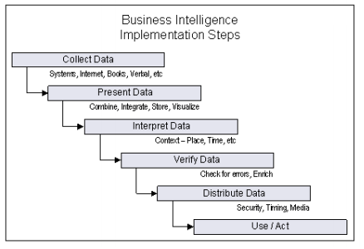
The approach of business intelligence is depicted by the figure such as for information flow within a knowledge developing corporation. If closely realized, the approach of business intelligence proves to be an unrolled version related to PDCA cycle. Data that is collected corresponds towards interpreting data, presenting it and planning it, data verification corresponds to distribute and check the data in order to act accurately at PDCA cycle’s Act stage. PDCA cycle in this context can be considered as an effective approach as opportunities are brought through the loopback such as of knowledge refinement. Because of this, advantages are depicted of spiral approach over waterfall type approach (Abualoush et al., 2018).
Evaluate actual and potential knowledge assets.
Knowledge asset is actually related with the economic view of knowledge of any organization. Knowledge assets are specifically developed through investments with the anticipation that potential income earning will be boosted of the organization. Examples related to knowledge assets involve intellectual property, codified explicit knowledge and best practices. Knowledge of the organization prevails within the individuals, knowledge assets overlap inevitably with human assets along with involving individual organizational member’s knowledge (Jennex, 2015).
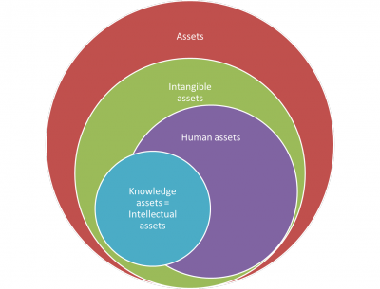
Nonaka et al elaborated knowledge assets as those particular resources of a corporation which prove to be indispensable when value has to be created for the corporation. Knowledge assets are separated by them into 3 categories and experimental knowledge assets is the first one of them in which know-how regarding the individuals is involved whereas, tacit knowledge or routine knowledge assets take place in organization’s daily routine. Codified explicit knowledge is included in the systematic knowledge assets such as those of the organization are stored such as in databases or documents. At last, explicit/conceptual knowledge is the one that is represented in symbolic form in which brands and designs are included. The below table can be referred for excessive details. Development related to such knowledge assets has been connected by Nonaka into the approach of SECI of knowledge conversion. Practical guidance is not offered by the SECI approach such as regarding knowledge assets management (Lim et al., 2017).

Experiential knowledge assets  Know-how and tacit knowledge regarding the individuals | Conceptual knowledge assets  Articulation of explicit knowledge is done through symbols such as the designs.
Routine knowledge assets  Routines of the organization  Culture of the organization | Systemic knowledge assets  Documents  Databases  Intellectual property

While the description of human assets can be given as assets which ultimately walk out when a day ends, documented and codified assets are involved in the knowledge assets. Therefore, knowledge management assets prove to be versatile in a greater extent. Management of knowledge and related tools of KM and processes of knowledge offer methods to the organization through which knowledge assets can be managed.
What is required to create, store, apply and integrate knowledge.
Consider the importance of Intellectual Property rights.
Explicit knowledge within a corporation can be ultimately found within books and databases, details are included in it that are available in a greater extent and which can be read specifically through manuals.
Knowledge management is actually the discipline through which the overall organization, teams and individuals are allowed to systematically and collectively apply, share and create knowledge so that objectives can be effectively obtained. Because of such knowledge, intellectual property is formed of the organization (Wang, Noe and Wang, 2014).
Intellectual property is actually a collection of concepts and thoughts regarding any invention, any brand, a song or any design that can be sold, bought or owned.
For forms of rights are there that can be protected as per the laws and they are:
Patents: Patent is actually an exclusive right related to any invention. Actually, the patent owner is offered the right by the patent to decide regarding whether or how utilization can be done of the invention by others. In this rights exchange, technical information is made by the patent owner regarding publicly available invention such as within published patent report.
Trademarks: Trademark is actually a sign through which services and goods are distinguished of one particular corporation from another (Abualoush et al., 2018).
Designs: Industrial design specifically constitutes the aesthetic or ornamental aspect related to an article. Three dimensions features are contained by any design in which surface or shape of the article is included, or on other side, a two-dimensional feature in which color, lines and patterns are involved.
Copyright: Copyright proves to be a legal term that is utilized when rights have to be elaborated that is contained by the creators over their artistic work and literary.
KEY FEATURES
Several major features are there of digital knowledge repositories that are effective:
Centralization: Digital course wear in a broader range, content that is gained through numerous sources, can be ultimately housed within a major location such as where it can be commented, shared and tagged upon universal inside one interface (Jennex, 2015).
Content management: The extensiveness of acknowledging content ultimately involves contact information, monitoring capabilities, best practices guidance, YouTube videos, blogs, and articles, learning modules, simulations and audio-visual files. With the help of learning outcomes, key words and several other vehicles, the content can be searched
Cost savings. Because of repositories, cost related to education and training can be ultimately declined such as through confirming the accessibility of affordable course materials, lowering the necessity for training within the classrooms and stimulating informal and productive learning (Lim et al., 2017).
Access control: Through restricting separate portions of the content with the help of password authentication along with several other security functionalities so that numerous goals can be accomplished by the curators. Access controls specifically includes protecting intellectual property and safeguarding proprietary information.
Record management: Integration can be done by the repositories with the systems of learning management in order to be seamlessly blended within the talent and learning management programs.
Explain the contribution knowledge assets on an organization.
Knowledge proves to be an essential element behind success of any organization. Even throughout an era that is contemporary, knowledge proves to be the competitive benefit that supports in business growth. For client’s retention, implementing a management process of competitive knowledge proves to be vital. An economy that relies on knowledge proves to be helpful for businesses so that they can sustain within the marketplaces for longer term. Therefore, market research is considered to be compulsory for every organization.
Acquiring knowledge regarding behavior of the clients and prices within the market of dissimilar items must be considered as a consistent procedure and it must be religiously performed. Prices within the marketplaces and behavior of clients fluctuate consistently. Elements like these must be kept updated by the organizations on a whole to confirm that sustainable growth is contained by the business (Shokri and Chileshe, 2014).
Speaking regarding Tesco and E-business, it is realized that acknowledging behavior of clients prove to be challenge because of the reason that numerous rivals are prevailing, by whom expectations of the clients are being met and therefore, making this possible proves to be a difficult task for the corporation. When the element of knowledge management has to be considered, based of knowledge economy is ultimately confirmed by the corporation for its business.

Evaluate the knowledge requirements for the organization.
Two dissimilar categories are there of knowledge in which tacit and explicit knowledge are involved. This particular dissimilarity amid both the knowledge’s is considered to be vital. Codification of explicit knowledge can be done in tangible form and on other side; tacit knowledge proves to be inexpressible and is possessed by individuals. Codification of knowledge is done when it is transmitted or recorded as symbols or within a tangible form. Tacit knowledge on other side proves to be non-codified and through informal learning it is actually acquired (Barão et al., 2017).
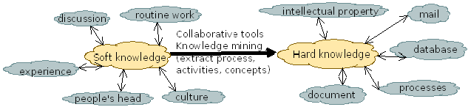

Explicit Knowledge | Tacit Knowledge
- Relies on information’s realization, free from individual bias and independent of people.  - Unprejudiced  - Relies on the context  - Codified within a form that is tangible  - Transmitted or recorded as symbols  - Prevails in dissimilar shapes like diagrams, documents, reports, designs and formulas.  - Transferred comfortably.  - Comfortable to store, convey and acquire. | - Inexpressible, practice and observation, linked with thoughts, relies on people.  - Independent  - Rooted within a cultural and social environment  - Intangible know-how and non-codified.  - Gained through learning by doing and informal learning  - Entrenched in practice & proves to be meaningful in particular conditions, relies on experience and practice  - Cannot be transferred easily  - Difficult for storing, conveying and gaining.

Evaluate the organization’s framework for enabling knowledge sharing.
Primary driver for the strategy of knowledge management in Tesco is that, when the curve of value is climbed by the corporation, effective mechanism is required by it so that expertise can be consolidated efficiently and speedily. Bigger consulting organizations prove to be enthusiastic users of knowledge management and as the business profile of this corporation evolves towards mirroring closely the profiles of organizations like there, knowledge management ultimately becomes essential for it (Archer and Kietzmann, 2018).
The objective behind management of knowledge within this corporation’s context is to leverage the organizational learning on a whole when business related benefits have to be transferred to the clients. The aim is to ultimately lower the efforts towards redoing learning such as the one which has already taken place elsewhere and confirming that clients that are in contact with the staff members of the corporation contain overall knowledge related to the organization.
Implementation and conception of the approach of knowledge management is anchored specifically be a central group of knowledge management, by whom a part if formed of E&R development. For members in staff that are for full time are contained within this group, and sanctioned strength is contained by them of eight. When in full strength that are ramped up, three sub-groups will be there of the group and every one of them would oversee knowledge management’s management of the content and research, maintenance and development of technological architecture, management of the brand and internal endorsements. Efforts are also made so that practice champions can be identified (Liebowitz and Frank, 2016).
THE TESCO KM FRAMEWORK
Knowledge management offering service of this corporation has been designed to support the consumers in:
- Formulating an approach of knowledge so that creation of knowledge can be sustained and reutilized within the organization.
- Arranging in a line the strategy of knowledge towards goals of the business and its priorities so that value creation can be boosted.
- Developing a process framework that is collaborative so that knowledge can be shared, captured and organized.
- Developing technical architecture and content taxonomy for the program of knowledge management
- Deploying and establishing appropriate tools of technology so that the program can be implemented in a greater extent within the organization.
- Instituting a system that relies on balance scorecard so that strategic impacts can be consistently evaluated related to the efforts of knowledge management (Lqbal et al., 2019).
Recommend improvements to the current framework.
Efforts of the corporation related to management of knowledge have ultimately come out of early stages, but still proves to be hard to be implemented on Youngers. Several major inroads are ultimately being made regarding that front which is hard of putting in place the system. However, a long way still has to be passed on that front which is soft so that awareness can be created on a larger scale and quarters on a whole utilize the systems such as those within the organization specifically for business leverage (Barão et al., 2017).
Implications of Knowledge Management
Management of knowledge within this corporation has ultimately moved beyond the stage when information was only shared by the staff members with the help of knowledge documents. It is strongly believed by this corporation that a knowledge sharing culture to be developed that can be reutilized proves to be of greater significance apart from developing a technological infrastructure. On this behalf, numerous initiatives have been ultimately taken by this corporation that is specifically aimed towards developing a culture in which knowledge gets shared in a greater extent (Shokri and Chileshe, 2014).
- Tesco thinks of itself as an organization in which knowledge is shared;
- Where actions are allowed to be taken through relying on power of knowledge.
- By whom leveraging the knowledge is truly believed for innovations.
- Where power is given to every member of staff on behalf of other members knowledge.
- Which is a universally respected leader of knowledge

Conclusion
Knowledge management and organizational learning are considered to be most vital aspects for confirming that sustainable progress is being acquired by the business. If unrestricted flow is there of knowledge, then it might prove to be helpful in organizational learning. Business on a whole strives for incorporating accurate approach of management of knowledge so that market can be held and revenues can be boosted. In addition to this, it further proves to be helpful when members of staff have to be retained along with individual learning and several other essentials that must be considered by the business to confirm the survival of it within a scenario that is competitive in a greater extent.

References
Abualoush, S., Masa’deh, R.E., Bataineh, K. and Alrowwad, A. (2018). The Role of Knowledge Management Process and Intellectual Capital as Intermediary Variables between Knowledge Management Infrastructure and Organization Performance. Interdisciplinary Journal of Information, Knowledge, and Management, vol.13, pp.279-309.
Archer-Brown, C. and Kietzmann, J. (2018). Strategic knowledge management and enterprise social media. Journal of Knowledge Management.
Barão, A., de Vasconcelos, J.B., Rocha, Á. and Pereira, R. (2017). A knowledge management approach to capture organizational learning networks. International Journal of Information Management, 37(6), pp.735-740.
Becerra-Fernandez, I. and Sabherwal, R. (2014). Knowledge management: Systems and processes. Routledge.
Dalkir, K. (2017). Knowledge Management in Theory and Practice. MIT press.
Donate, M.J. and Sanchez de Pablo, J.D. (2015). The role of knowledge-oriented leadership in knowledge management practices and innovation. Journal of Business Research, vol. 68(2), pp.360-370.
Hislop, D., Bosua, R. and Helms, R. (2018). Knowledge management in organizations: A Critical Introduction. Oxford University press.
Iqbal, A., Latif, F., Marimon, F., Sahibzada, U.F. and Hussain, S. (2019). From knowledge management to organizational performance. Journal of Enterprise Information Management.
Jennex, M.E. (2015). Knowledge management. Wiley Encyclopedia of Management.
Liebowitz, J. and Frank, S.M.,PhD (2016). Knowledge management and e-learning. CRC press.
Lim, M.K., Tseng, M.L., Tan, K.H. and Bui, T.D. (2017). Knowledge management in sustainable supply chain management: improving performance through an interpretive structural modelling approach. Journal of Cleaner Production, vol.162, pp.806-816.
Omotayo, F.O. (2015). Knowledge Management as an important tool in Organisational Management: A Review of Literature. Library Philosophy and Practice, (e-journal),1(2015), pp.1-23.
Shokri-Ghasabeh, M. and Chileshe, N. (2014). Knowledge management. Construction Innovation.
Wang, S., Noe, R.A. and Wang, Z.M. (2014). Motivating Knowledge Sharing in Knowledge Management Systems: A Quasi–Field Experiment. Journal of Management, 40(4), pp.978-1009.

