Knowledge and Information
Management Skills for the Workplace
By Resna Begum
Student Number: 1605337
Module Number: BMSW5006
Tutor: Tanya Nathan
University of Wales Trinity and Saint David

Contents
Introduction 3
Knowledge Management 3
Relationship between Data, Information and Knowledge 5
Below is a Figure 2 Knowledge Management of the cycle. 5
Analysis and modelling techniques to identify knowledge assets 6
Actual and Potential Knowledge Assets 7
Figure 3 Context-based framework of KM 8
The requirement to create, store, apply and integrate knowledge 8
The Importance of Intellectual Property rights 9
Explain the contribution knowledge assets have on an organisation 9
The knowledge requirements for the organisation 9
The organisation’s framework for enabling knowledge sharing 10
Improvements to the current framework 10
Figure 4 Theoretical frame work 11
Conclusion 11
References 12

Introduction
Bromley -By-Bow centre is a community centre based in East London, it was founded in 1984. It is an innovative charity that integrates a comprehensive neighbourhood hub with a medical practice and a community research project. They support families, young adults and adults to learn new skills. The centre has 3 health practices. They help people successful and progress in life. They give positivity to those who are in need and have low self-esteem. The centre has programmes to help build confident and help with career choice. They also have a HR team that works closely with the centre on helping the community. The centre provides lots of service for the community to choose from. These services are:
- Health and wellbeing’s
- Provide help in training and with employment
- Activities & Sports
- Help with starting a new business
- Learn new skills
- Adult & Social care
- Learn new skills
- Provide help & advice
- Build confidents
It is partner by a wide range of funders and organisation, and together the aim is to design and deliver highly effective services that helps people to change their lives.
It is important to identify the knowledge and the importance of management. The management are aware of the importance, that’s why they are always motivating the team members and help them to build their confident and that is a good asset to the company.
The centre uses various of knowledge management skills, that has benefit lot of people. The thing that is more great is they have an online website that many people can open see what services they provide and their initial plan for they year and after.
It has been discussed further down about knowledge management and about data, information and knowledge.

Knowledge Management
Knowledge is an important and valuable resources in a development industrial economy. It represents the most vital economic asset that a business companies have, and that is the main factor towards the creativity and competitiveness. Having employees in the organisation means numbers are rising up of knowledge workers and knowledge-intensive organisations. (Hislop, D., Bosua, R. and Helms, R., 2018).
Knowledge management are in the field for more than 30 years. It went beyond academic theory to become an essential component of organisational life. As the centre knowledge management is used in accounting, artificial intelligent, content management, the development team, education, health, social and human resources. There are many more that could be identified as knowledge management. (Girard, J. and Girard, J., 2015). Knowledge involves people in a creative social process that forms and develops a desirable future (Takeuchi, 2013). Understanding the strategy is literally about creating a future, it could be asserted that knowledge in contemporary competitive business environment should become issues of strategic choice. Therefore, the concept of knowledge technique is significant to the organisation efforts of the present and future circumstances.
Figure 1 displays a proposed framework for the implementation of the strategy of organisational knowledge. The framework recognises the value of existing organisational knowledge that responds to the attempt by the organisation to gain competitive advantage. However, the organisational strategy arises from an effective organisational knowledge strategy (Zack, 2005: Kasten, 2007). The knowledge strategy area is centred and applied around the business environment, properly managed and guided by coordinating agents and tactically shaped to adapt into dimensions that may result in knowledge strategy postures. The effective function of the knowledge strategy reflects the inculcation of knowledge throughout the organisational system and the implementations. This strategy can be used in the centre for others to understand the knowledge strategy. knowledge strategy can effectively support the updating of the organisational strategy as suggested by Kasten (2007). This shows that the organisation needs to organise its knowledge base significantly into the organisational processes. Sharma & Mishra (2007) conceptualised that, from a broader perspective, organised knowledge base to include “data, information, intuition and knowledge.
The dimensions of the knowledge strategy were addressed from perspective that guide the attention of organisational mangers to place it as a strategic resources for the business, encouraging them to connect it to the organisations strategic activities, and perceiving its as essential to the organisations immediate and future guidance.( Ibidunni, A.S., Ogunnaike, O.O. and Abiodun, A.J., 2017).
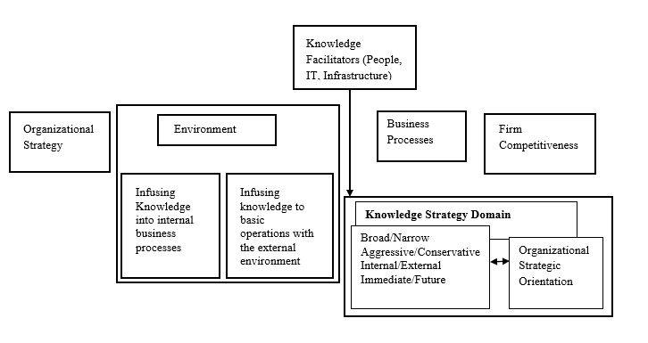Figure 1 Knowledge Strategy (KS) Model. (Ibidunni, A.S., Ogunnaike, O.O. and Abiodun, A.J., 2017).

Relationship between Data, Information and Knowledge
In the modern age, knowing the proper meaning of words as Data, Information, Knowledge is an essential need that will make it possible to better understand the world in which we live in. As the information attracts the interest of someone, it becomes clear that it can not be seen as an isolated factor in the process of knowledge acquisition: data is the basis for the creation of information, whereas information reprocessing is the basis for knowledge on a specific subject. It is often seen as a linear sequence from data to information, and from information to knowledge until we hope to gain wisdom. (Navoni, L. (2015).
It is often addressed that the data, information and knowledge is not always the same, but many researchers do use these phrases of words quite casually despite efforts to explain them. The relationship between data, information, and knowledge is linear, the distance between data and information is the same as the distance between information and knowledge, which means that the effort required to move from one to another is the same. Although it may no be possible to correctly state the true relationship between these groups there is nothing that suggests that the relationship linear. It was suggested that it has an asymmetric relationship, implying that data can be transformed into information, which could be transformed in to information, that could be transformed into knowledge, but it does not seem possible to go the other way around. But we all on some occasion used our knowledge to get information and taking out information to create data.
It signifies the appraisement that the knowledge is superior to data. That has also been questioned. Tuomi [38] argues this data arises as a result of adding value to information, which in effect is knowledge which has been structured and verbalised. As stated by him, there are no ‘raw’ data, since every collectable and measurable piece of detail has already been affected by the very process of knowledge that made it measurable and collectable in the first place. By analysing its structure of this information, we can finally redefine it into pure data. (Stenmark, D., 2002, January).
Data information is a raw material, or referred as raw data, information is a data that has been presented and organised by 1or more people and knowledge is the information you read, understood, listening to others and it also gained by watching others. (Kempe, S. (2013).
Below is a Figure 2 Knowledge Management of the cycle.

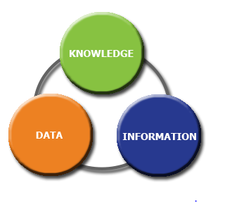
(Kempe, S. (2013).
Relationship between Individual Knowledge and Organisational Knowledge
An education innovation experience could be seen as a process that develops knowledge through individuals (individual teachers) and groups (groups of teachers) developed by the organisation of a form of creative force (the university) provided that is participants have their freedom ( law stipulated: academic freedom) to update the processes, content, models and any strategies or technique used during their subject. In the organisation that is focused on creative forces are at risk of causing a significant loss of efficiency if there is no coordination and if knowledge is not properly managed that is generated by various individuals and groups (Nonaka, 1994). The organisation knowledge of the generation has to be continual process (Nonaka, Von Krogh & Voelpel 2006). (Fidalgo-Blanco, A., Sein-Echaluce, M.L. and García-Peñalvo, F., 2015).
Knowledge can be transferred individual or in an organisation. The transfer involves the ability of a group or individual to cooperate with others and share knowledge for their mutual benefit. It is almost impossible to transfer knowledge to another person without sharing. It therefore shows that knowledge transfer would not happen in an organisation unless the staff members and group members display a high level of cooperative behaviour (Goh, 2002, p. 25). Also, knowledge is not from individual to individual, but it also involves “individual to a team or group, team or group to individual, or team or group to team or group” (Bender and Fish, 2000, p. 130).
(Omar Sharifuddin Syed-Ikhsan, S. and Rowland, F., 2004.)

Organisational knowledge is joined with experiences and understanding. This is maintained by the company. Its qualitive information is to identify understand what is important and relevant to the company issues or topic. Its analysis how information can be used by reflection and synthesis. (Kempe, S. (2013).

Analysis and modelling techniques to identify knowledge assets
Although technology is not the most important element of knowledge management, it does play a critical role in facilitating communication and collaboration within knowledge workers in the company. Tacit and explicit knowledge can be best handled by using the knowledge management system: a comprehensive framework that works with the structures of the
company to promote all forms of knowledge processing. (For Schreiber et al. (1999).
(Abdullah, M.S., Benest, I., Evans, A. and Kimble, C., 2002).

When the managers have identified the knowledge assets within the company, the challenge would be to assess how to handle them. The next segment focuses on managing knowledge assets in project-based environments.
Projects-based work is part of the chain of ‘new organisational types’ that have taken place in most industries over the last few decades.
Using this below table of categories of knowledge asset will go with the organisation.
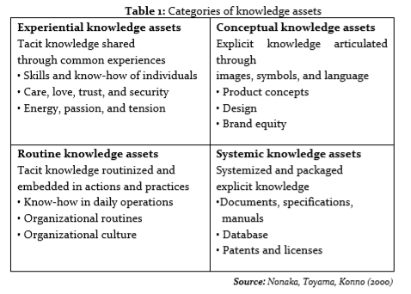
(Naftanaila, I., 2012.)

One of the main issues with knowledge is that, once it gets stuck inside the heads of the employees, filling cabinet, in the files, it then either becomes valueless or it has little value to the company. (Naftanaila, I., 2012.)

Actual and Potential Knowledge Assets
The company actual and potential asset is providing work and training for those that have joined. Direction them in the right career path will give them knowledge that they can transfer it to someone at work. in the centre there is lots of opportunities that can be recognise as the value of the tacit knowledge. The centre is not using any theory or research base but are using mixture of knowledge. It would be good if the centre used a theory to implicate the actual and potential assists. The knowledge that is shared is closely related to what has been presented, who has been involved and what their role was.
The Okunoye and Bertaux framework (2008) incorporates the knowledge gained from the other frameworks into a new “Knowledge Management” in context-based work. having a structured frame work will give others a better understanding of actual and potential knowledge asset. (Schmitz, C., 2018).
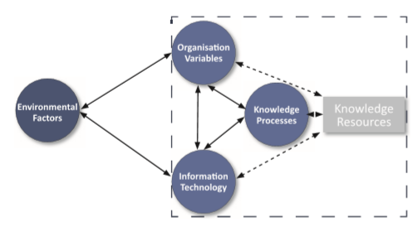
Figure 3 Context-based framework of KM. Adapted from (Okunoye and Bertaux 2008).
Knowledge management has become extremely important since the companies recognise that a sustainable competitive advantage depends on the effective management of their wide and diverse knowledge assets. To be able to get “better” management information, one needs to be aware how well one manages it in the first place. However, assessment or benchmarking should be the first step in any large-scale Knowledge Management initiative or project.

The requirement to create, store, apply and integrate knowledge
Bromley by bow centre have an Insight team that creates, applies concept and the learning at the centre. It requires the team do this by researching what influence the community, encourage learning and what can help to develop them. The team also support other communities and organisations to progress and create their own effective strategies for the need and desire of their community. Their latest project is development and delivery training for social prescribing link workers and consultancy training for emerging social prescribing schemes. It is important to store knowledge because knowledge can get lost and you don’t want to particularly lose it if it is still tacit and knowledgeable. When an employee leaves the company, they also leave with the knowledge for therefore it’s important to store it for the future use. The knowledge can be stored manually or electronically. The way you can store knowledge manually is by reports, minutes of meetings, in policies and other tangibles organisational papers. To store electronically it can be done throughout company databases, emails and portals. (Shongwe, M.M., 2016). Integration of knowledge was identified to be influenced through characteristic of activities such as complexity and objects. The more complex the function is, the further integration is required (tell 2011; Durnell Cramton, 2001; Grant, 1996; Kang et al, 2010). Anther factor found in the innovation literature is the level of uncertainty and novelty. (Alenvret, C. and Evaldsson, J., 2015).

The Importance of Intellectual Property rights
Each company will have some sort of intellectual property, not just those that deal with technology. To order to understand the value of this IP, It is important to understand the essence of different IP rights what they are protecting, and how they can be acquired and how they can best be commercialised. Intellectual Property can be usually seen as a set of property right that cover “creation of the mind”. Those right could be vital in the organisation, as they can be used not only to protect their own creations but also to provide valuable business tools that can be used effectively. It is important for the centre to have these IP right as they have projects and other organisation, they are part off. It prevents others from copying the name of the company business logo, their product or design and what they produce. (Thornton, A. (2019).
Third party cannot use these unless they have a special permission or license. The owner or the patent creator has an opportunity to use the outcome of intellectual work (either creation or invention) and produce additional copies of this work. (Mingaleva, Z. and Mirskikh, I., 2015).

Explain the contribution knowledge assets have on an organisation
In the company there are hidden assets in knowledge and other for of intellectual capital. These hidden assets do not appear in the annual reports balance sheet, but the hold future valuable creation and earnings potential. They are 7 knowledge asset the contribute ate the company and they are:
- Customer Knowledge- sharing relationship with deep knowledge development. Recognising the need of the customer and new opportunities.
- Stakeholders relationship- improvement on knowledge flows among the suppliers, shareholders, communities and with team members. Knowledge is shared and suppliers integrated for future creation and strategies
- Business environment insights- getting updates in social and environmental trends. Competitor analysis and marketing intelligence system
- Organisation memory- knowledge sharing and practice database. Every member has knowledge that could be shared. Sharing company knowledge through data base.
- Knowledge in process- inserting data in the company process and the managers decision is a knowledge intake
(Skyrme, D.J., 1998).

The knowledge requirements for the organisation
The knowledge requirement for the company is to work effectively using or planning knowledge management. The knowledge management is defined as a management tool but describe more as an operational tool or a strategically focused management tool. (Martensson, 2000). It is required managing all the collective information of the employees of expertise. The strategy in the company that reflects knowledge is the policy, guidelines and the level of all practices. (Omotayo, F. (2015).
Having knowledge requirements in the company help to reduce cost and risk, it improves productivity, better decision making, better strategic plans, new technical approaches, faster developments, fast at problem solving, rues cost of workers training, and it increases versatility at work. (Parker, J. (2012).

The organisation’s framework for enabling knowledge sharing
The sharing of knowledge refers to the process that takes place at different level, including interpersonal, between individuals and groups, between groups or with entities across and beyond organisational boundaries (Alavi and Leidner, 2001). Even though many companies have taken Knowledge Management initiatives in their company activities, it is still arguable that sharing knowledge is problematic, especially when it comes to tacit knowledge. Knowledge can be created within the company through four mode as suggested by Nonaka (1994) through four modes of adaption: socialisation (tacit to tacit), outsourcing (tacit to explicit), internalisation (explicit to tacit) and combination (explicit to explicit). As the mode of socialisation is aligned with shared activities and experiences, self-organised groups use socialisation as the primary mode in their overall process of knowledge formation, in the recent research studies underlines the important of tacit knowledge of sharing process which does simply transform explicit knowledge through technology (Murillo, 2011, Brown at al.,2013, Pyrko and Dorfler 2013). This seems to add values to the tacit knowledge that is not effortlessly found because it is expressed in the mind of a person. Individuals might try to prevent having to be dependent on knowledge management system (KMS) and attain knowledge through their own informal social networks.
It is necessary to share specific knowledge amongst individuals throughout the company and to make the knowledge available to all, which includes new team members who can come back to KMS to receive expert information.
(Aljuwaiber, A., 2016).

Improvements to the current framework
To improve the current frame work will be to have a structure framework put in place and by using the Theoretical framework will help to improve. Considering that the various reason for individual knowledge sharing behaviour within the complex context of a simulated company are obscure and complicated to understand its intensity.
Having a conceptual framework like the below diagram will benefit the company to improve their b goals, knowledge management behaviour and induvial outcome.
In figure 4 shows it is intuited that knowledge management enables structural element-based organisation strategies. Which includes data base codification and storage of intellectual capital, systems, processes and knowledge (technical section), connectivity through strategic integrated communication based on knowledge-based information (communication sector) and focused on behavioural aspects to ensure a cultural-based relationship to gain trust, satisfaction, transparency and commitment from everyone. It has been argued that if tacit knowledge is made explicit, shared knowledge of individuals can be transferred and used it to generate collective knowledge at all company’s level. It is therefore suggested that knowledge managers could be used as agents of change through the use of knowledge management because it can be represented either as an organisational tool or as a strategic tool.

From the strategic point of view, knowledge management is gaining the collection of information, furthermore, with the codification and storing of the information and knowledge in various databases that can be used for data mining; also, with making the information available and accessible to all level of the organisations; finally, to share and use this information by sharing, socialising, expressing and through exchanging information. (Barker, R., 2016).
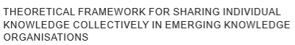
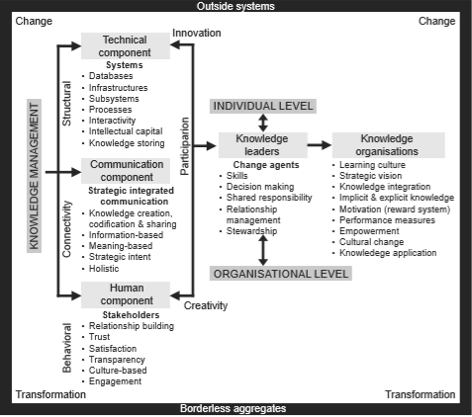
Figure 4 Theoretical frame work (Barker, R., 2016).

Conclusion
Through the centre has a very good structure but they can improve by using theories such as theorical framework. Informing others about knowledge and how it’s beneficial will help people to be more expressive in what they have done or learnt and that will benefit others for this knowledge sharing. Through identifying a business-level framework for Knowledge Management (KM) and incorporating KM with business process workflows will be best to implement knowledge management. As it’s a regular part of the business cycle, the employees collect knowledge and share knowledge as this is the way of KM method. (Parker, J. (2012). The centre is itself is trying to better the community by providing lots of help. the things that a group or induvial learn this could be passed as knowledge sharing. The centre has an insight of knowledge share where they inform the community what their plan is for next year. Their aim is to open more training programmes and more community hubs. Using the knowledge system model will help to identify the importance in the centre and will indicate more understanding information and strategy.

References
Abdullah, M.S., Benest, I., Evans, A. and Kimble, C., 2002, September. Knowledge modelling techniques for developing knowledge management systems. In Third European Conference on Knowledge Management: Trinity College Dublin, Ireland (p. 17).
Aljuwaiber, A., 2016. Communities of practice as an initiative for knowledge sharing in business organisations: a literature review. Journal of Knowledge Management, 20(4), pp.731-748.
Barker, R., 2016. Sharing individual knowledge collectively: a theoretical framework for emerging knowledge organisations Fidalgo-Blanco, A., Sein-Echaluce, M.L. and García-Peñalvo, F., 2015.
Epistemological and ontological spirals: From individual experience in educational innovation to the organisational knowledge in the university sector. Program, 49(3), pp.266-288.
Girard, J. and Girard, J., 2015. Defining knowledge management: Toward an applied compendium. Online Journal of Applied Knowledge Management, 3(1), pp.1-20.
Kulkarni, U. and Freeze, R., 2004. Development and validation of a knowledge management capability assessment model. ICIS 2004 Proceedings, p.54.
Kempe, S. (2013). The Data – Information – Knowledge Cycle - DATAVERSITY. [online] DATAVERSITY. Available at: https://www.dataversity.net/the-data-information-knowledge-cycle/ [Accessed 29 Dec. 2019].
Hislop, D., Bosua, R. and Helms, R., 2018. Knowledge management in organizations: A critical introduction. Oxford University Press.
Ibidunni, A.S., Ogunnaike, O.O. and Abiodun, A.J., 2017. Extending the knowledge strategy concept: Linking organizational knowledge with strategic orientations. Academy of strategic management journal, 16(3).
Mingaleva, Z. and Mirskikh, I., 2015. Psychological aspects of Intellectual property protection. Procedia-Social and Behavioral Sciences, 190, pp.220-226.
Năftănăilă, I., 2012. Managing knowledge assets in project environments. Journal of Knowledge Management, Economics and Information Technology, 2(1), pp.249-258.
Navoni, L. (2015). About Data, Information, Knowledge Relationships and their representation. [online] Medium. Available at: https://medium.com/@lorisnavoni/about-data-information-knowledge-relationships-and-their-representation-b1599f70130b [Accessed 26 Dec. 2019].
Parker, J. (2012). Knowledge Management Requirements - Enfocus Solutions Inc. [online] Enfocus Solutions Inc. Available at: https://enfocussolutions.com/knowledge-management-requirements/ [Accessed 30 Dec. 2019].
Schmitz, C., 2018. Development of guidelines that support organisations in managing their knowledge assets by means of IT.
Shongwe, M.M., 2016. An analysis of knowledge management lifecycle frameworks: Towards a unified framework. Electronic Journal of Knowledge Management, 14(3), p.140.
Skyrme, D.J., 1998. Developing a knowledge strategy. Strategic Planning Society, (1).
Stenmark, D., 2002, January. Information vs. knowledge: The role of intranets in knowledge management. In Proceedings of the 35th Annual Hawaii International Conference on System Sciences (pp. 928-937). IEEE.
Thornton, A. (2019). The Importance of Intellectual Property | Lexology. [online] Lexology.com. Available at: https://www.lexology.com/library/detail.aspx?g=0b676aa6-7a3b-4bcb-8570-ccb90699eeef [Accessed 28 Dec. 2019].
Omar Sharifuddin Syed-Ikhsan, S. and Rowland, F., 2004. Knowledge management in a public organization: a study on the relationship between organizational elements and the performance of knowledge transfer. Journal of knowledge management, 8(2), pp.95-111.
Omotayo, F. (2015). Knowledge Management as an important tool in Organisational. [online] Digitalcommons.unl.edu. Available at: https://digitalcommons.unl.edu/cgi/viewcontent.cgi?article=3330&context=libphilprac [Accessed 27 Dec. 2019].

