Amina Meah (2237650)
[Company name] [Company address]
amina meah DATABASE ANALYSIS AND DESIGN ASSIGNMENT

Introduction
Northern Lights is a successful event organizing company based in Swansea that specializes in arranging conferences, workshops, seminars, music festivals, and concerts for more than 10 people. Recently, they have expanded their business and opened branches in Neath and Carmarthen, each managed by a branch manager who oversees a team of staff responsible for various tasks such as setting up audio-visual equipment, selling tickets, and maintaining the event's cleanliness. The company's primary clients are companies and associations that provide event topics, and once the requirements are agreed, the branch manager delegates the tasks to the relevant department heads. Northern Lights also has multiple suppliers to order resources required for events and daily operations. To improve their administrative process, the company plans to switch to a computerized system with a database management system to ensure successful event execution. Furthermore, they intend to establish an online presence to increase their customer base and record customer details, including requested events, to maintain an accurate accounting record. The company also aims to automate customer invoices to keep track of event-generated income and calculate quarterly and yearly profits.
My initial findinging from reading my assignement brief is that there are 2 users that might access this database management system. One user is the staff of the the business and the other is the customers of the business. I have identified 4 different departments for each branch, these departments are Event planning, Finance, Maintenance and ticket sales.
The tables are designed in such a way that they will link together in a relational database environment. Each table has a primary key and foreign keys that link them to other tables. The relationships between the tables are established by the foreign keys, which represent a link to a primary key in another table.
The table design meets the rules of third normal form (3NF). This means that each table is designed to eliminate duplicate data and to store data in the most efficient way possible. The tables are designed in such a way that each field contains only one piece of information.

ERD diagram
Department has many to one relationship to branch
Branch_Manager has one to one relationship to branch
Branch has one to many relationship to staff
Branch has one to many relationship with event
Ticket has many to one relationship to event
Event has one to many relationship with patron
Customer has many to one relationship with event
Event has many to one relationship to resources
Supplier has one to many relationship to resources

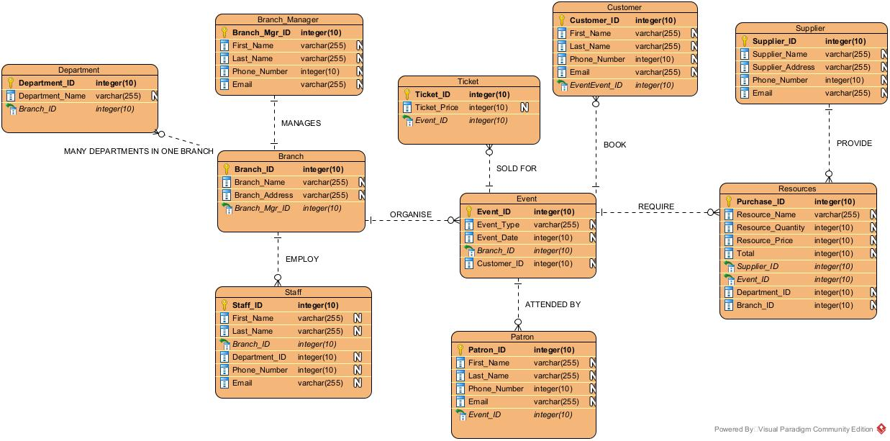

Relationship Design
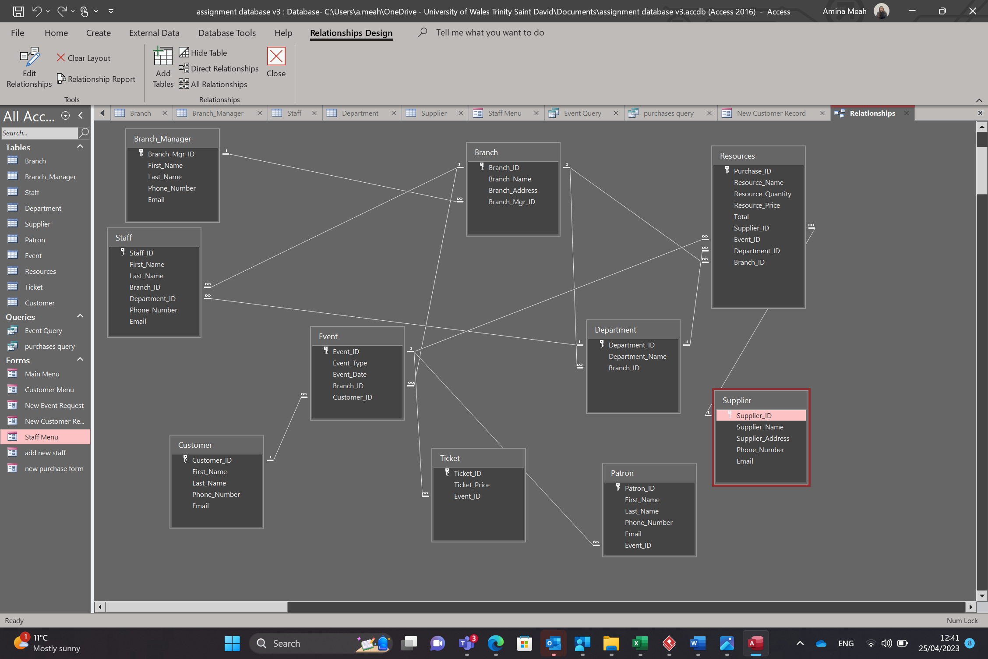
This is my relationship design on access. I have linked all the table suitabily. An example of this is the patron table it includes the foreign key Event_ID. If a user of the database was to put an invalid Event_ID in the patron table it would give you a warning message.
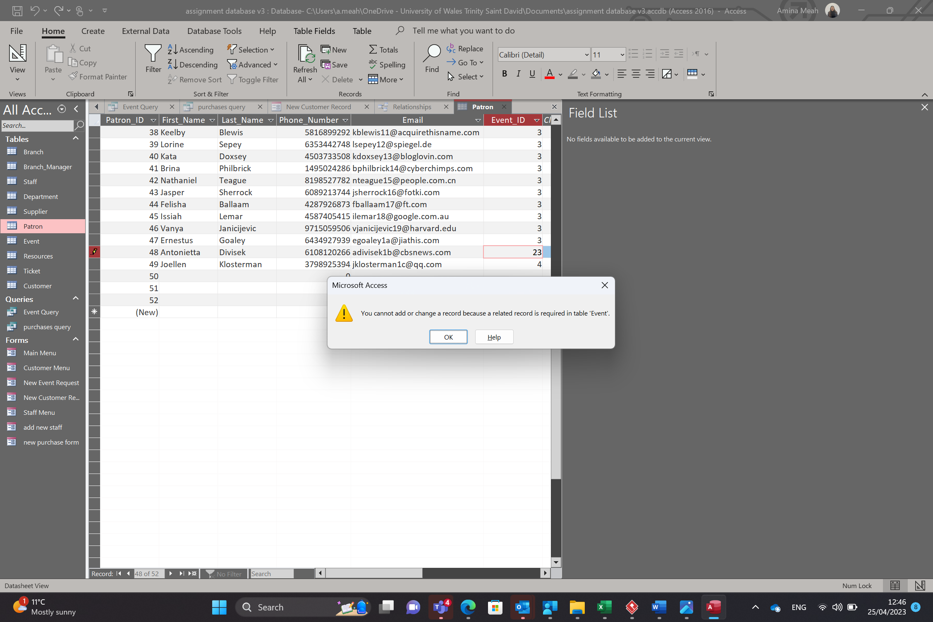
Foreign keys
- Branch Manager ID in Branch table refers to Branch Manager ID in Branch Manager table.
- Branch ID in Staff table refers to Branch ID in Branch table.
- Department ID in Staff table refers to Department ID in Department table.
- Branch ID in Department table refers to Branch ID in Branch table.
- Branch ID in Resource table refers to Branch ID in Branch table.
- Event ID in Ticket table refers to Event ID in Event table.
- Event ID in Resource table refers to Event ID in Event table.
- Event ID In Patron table refers to Event ID in Event table.
- Branch ID in Event table refers to Branch ID in Branch table.
- Customer ID in Event table refers to Customer ID in Customer table.
- Supplier ID in Resources table refers to Supplier ID in Supplier table.
- Department ID in Resources table refers to Department ID in Department table.

Tables
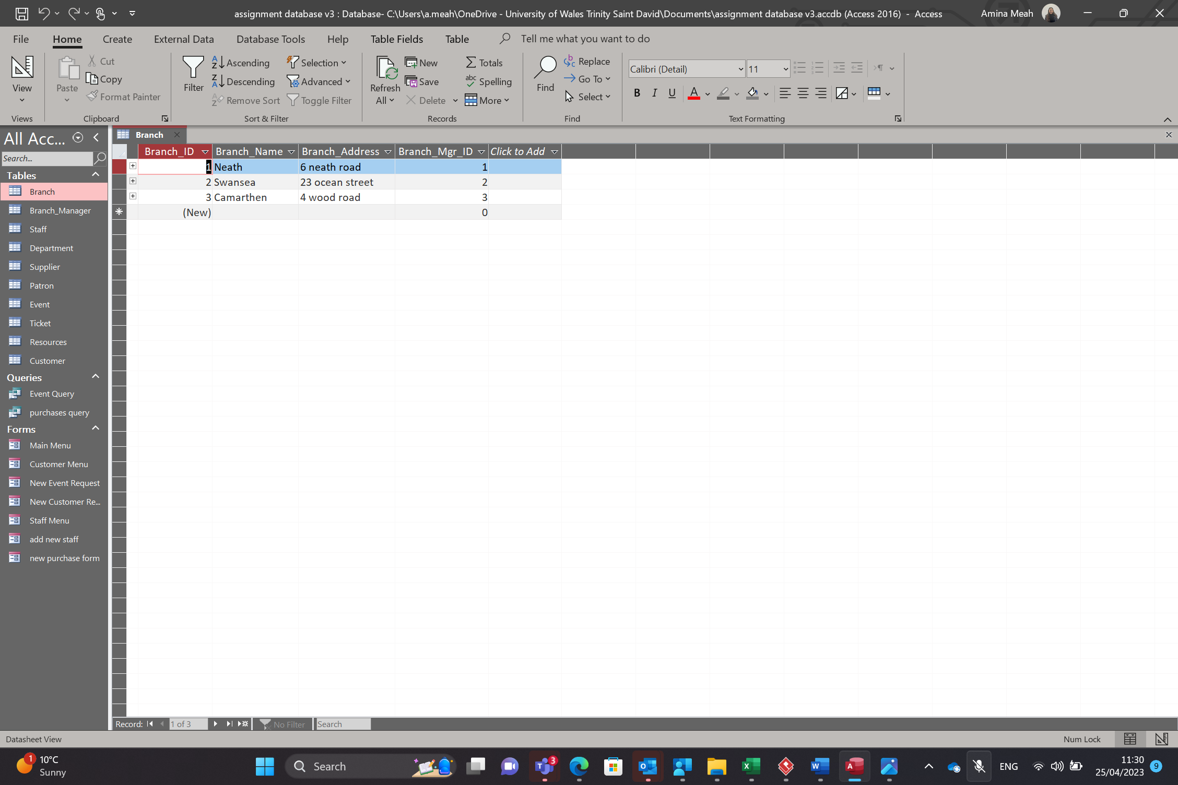
This is the branch table. This table includes the Branch ID , Branch Name, Branch Address and the Branch Mgr ID.
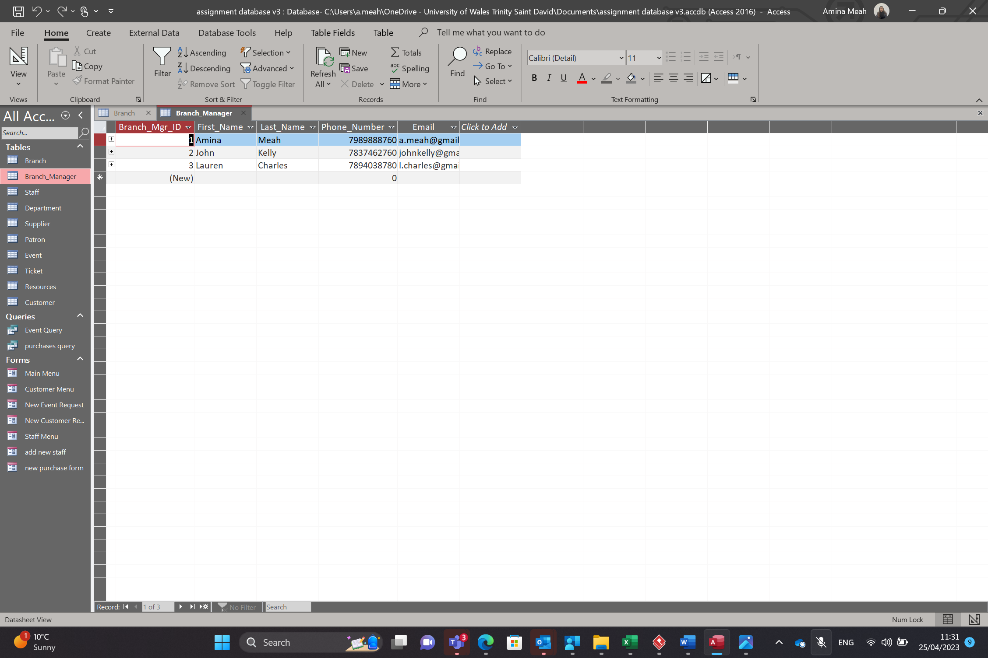
This is the Branch Mgr table this includes the fields such as Branch Mgr ID, First Name, Last Name, Phone Number and Email.
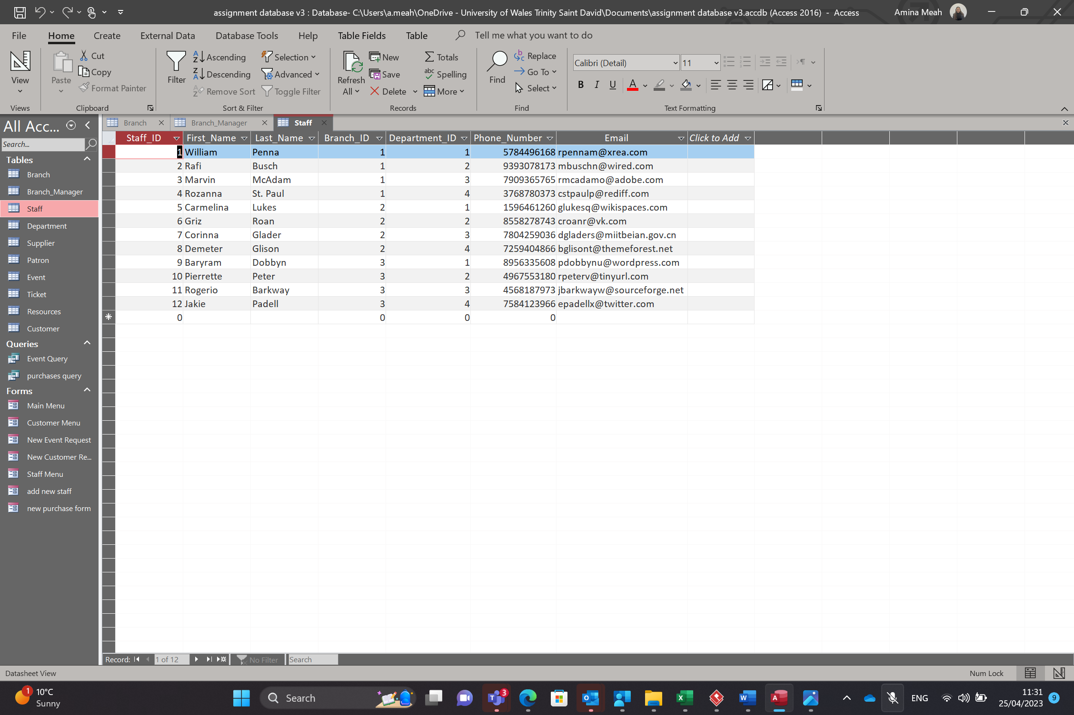
This is the Staff table. This includes the Staff ID, First Name, Last Name, Branch ID, Department ID, Phone Number and Email.
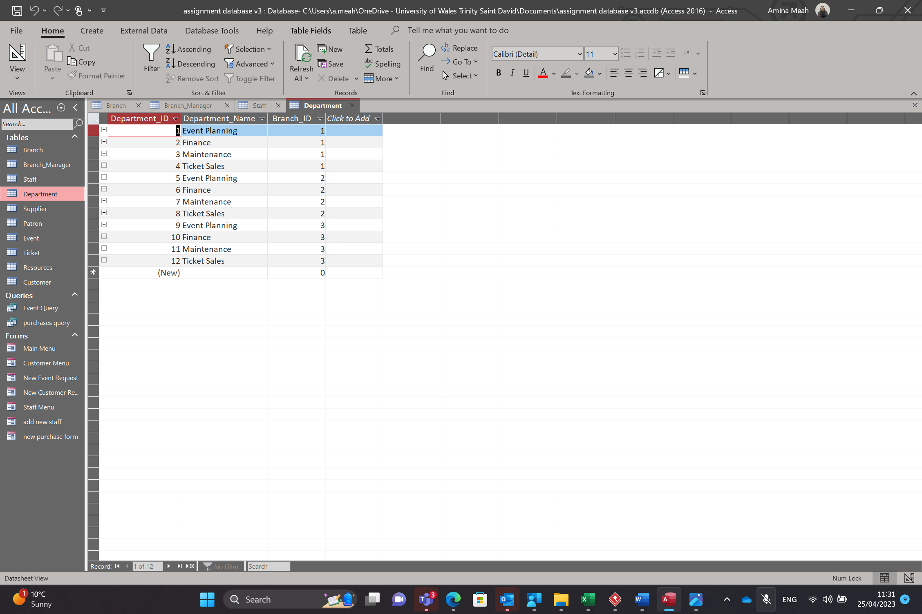
This is the Department table. The field on this table include Department ID, Department Name and Branch ID.
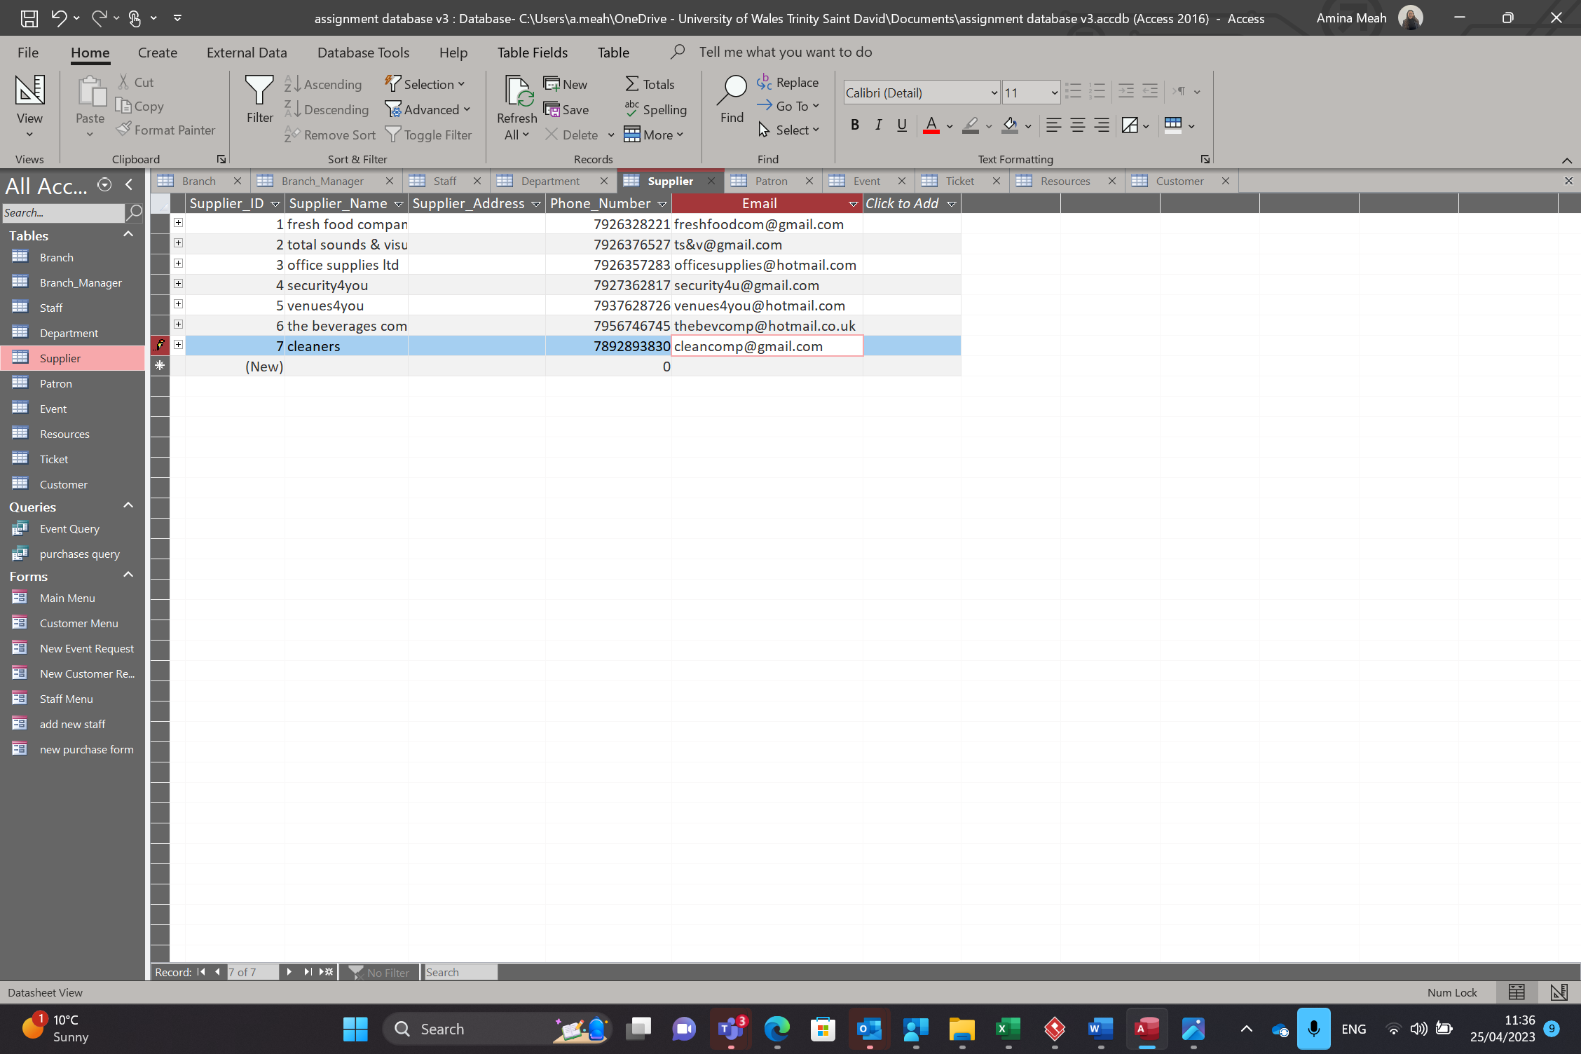
This is the Supplier table. The fields included are Supplier ID, Supplier Name, Supplier Address, Phone Number and Email.
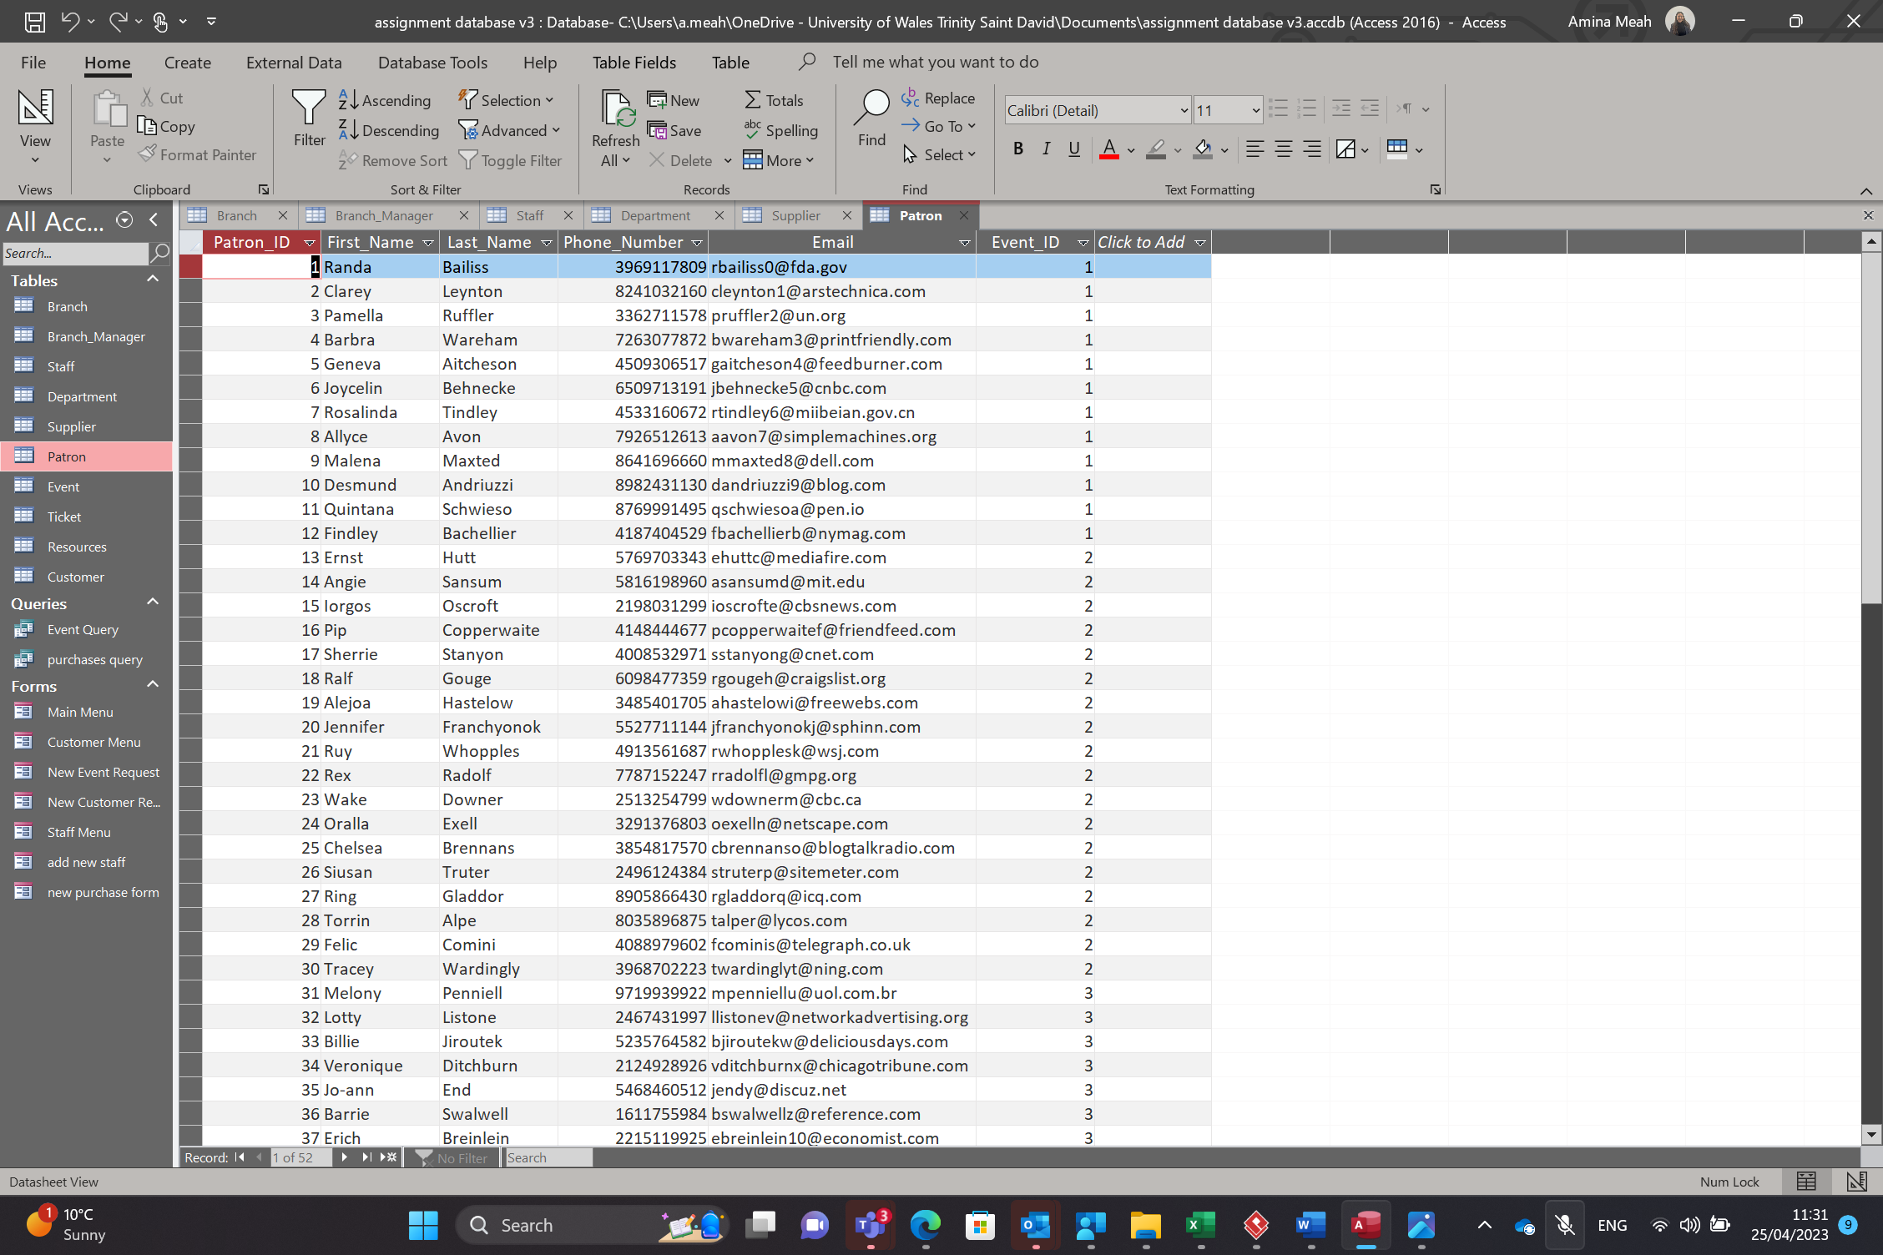
This is the Patron table. This table includes fields such as Patron ID, First Name, Last Name, Phone number, Email and Event ID.
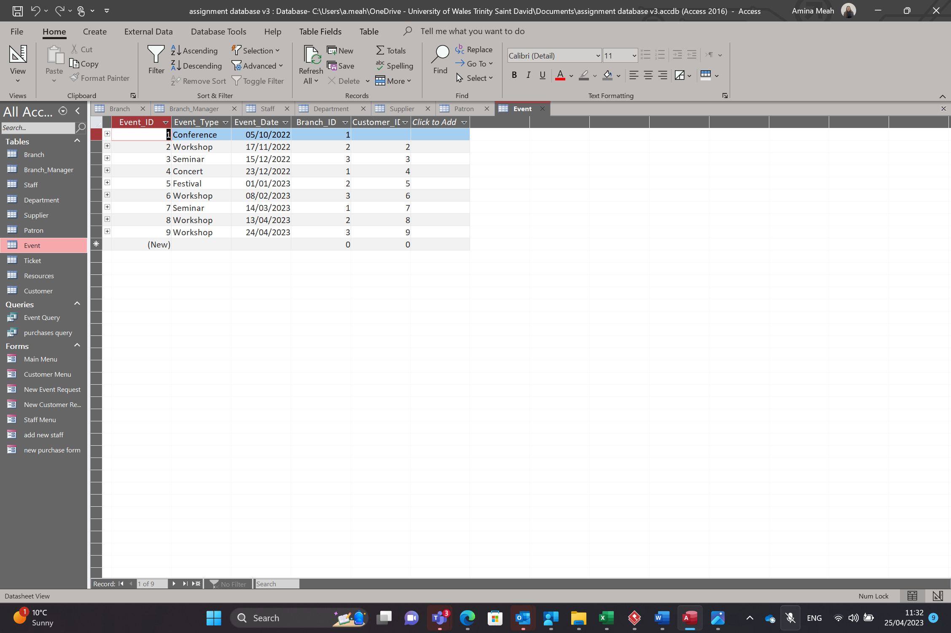
This is the event table. It includes fields such as Event ID, Event Type, Event Date , Branch ID and Customer ID.
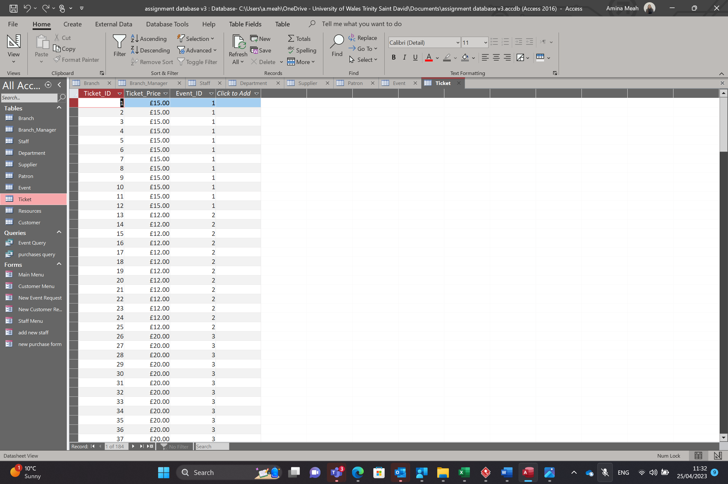
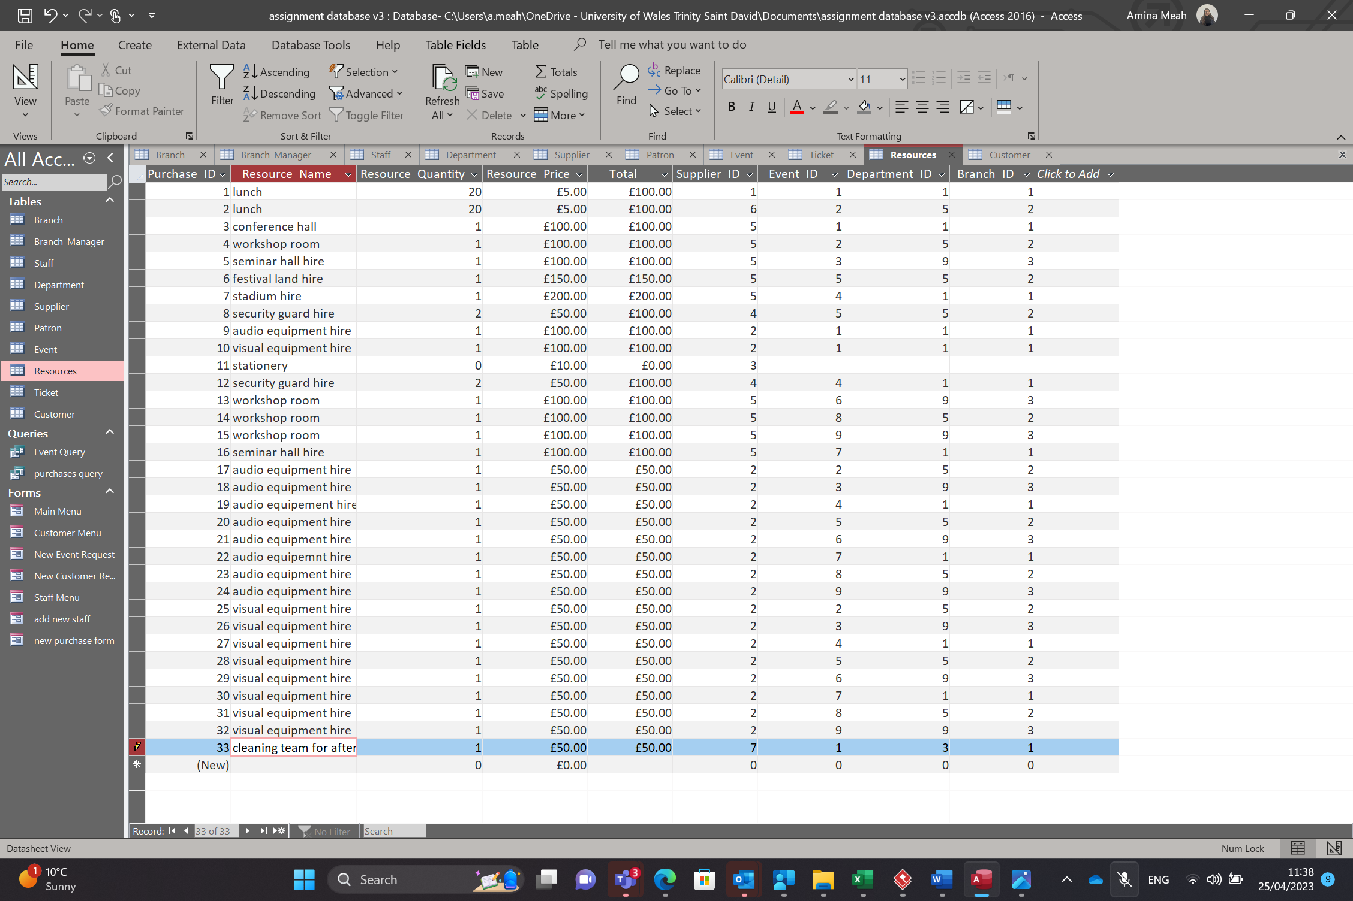
This is the resources table. This includes the fields such as Purchase ID, Resource Name, Resource quantity, Resource price, Total , Supplier ID, Event ID, Department ID and Branch ID.
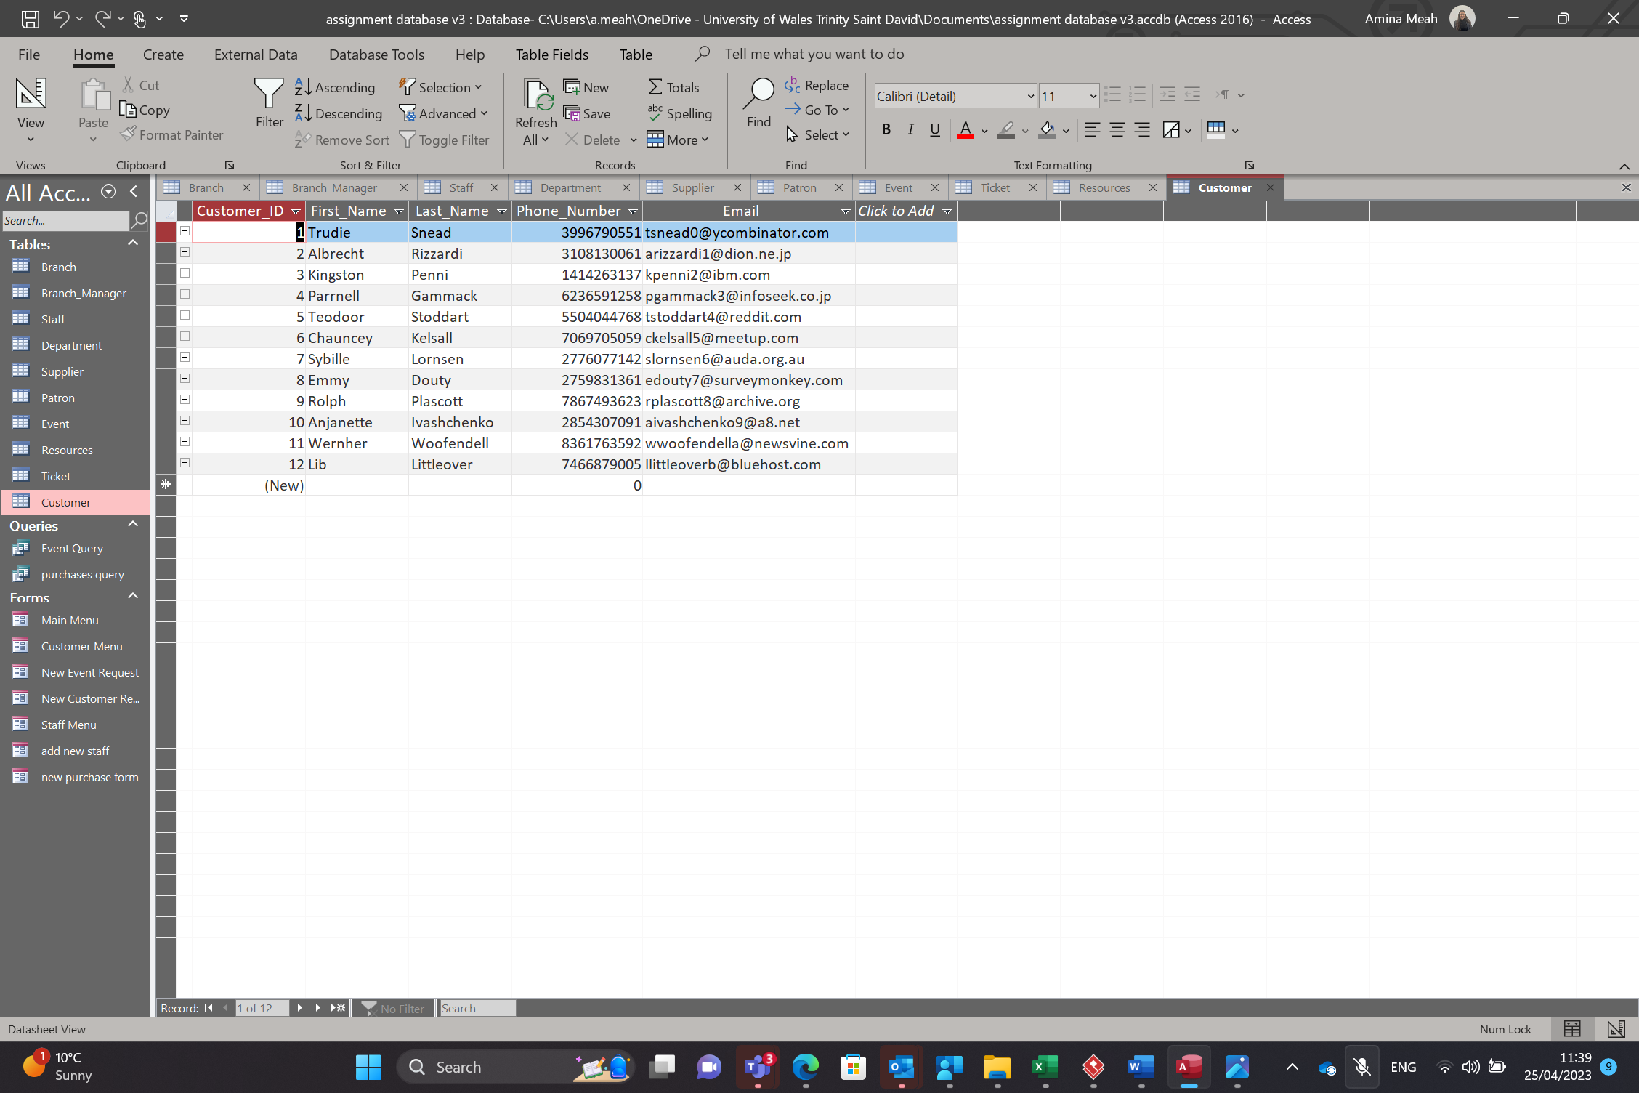
This is my last table which is the Customer table. This includes fields such as Customer ID, First Name, Last Name, Phone Number and email.
Main Menu
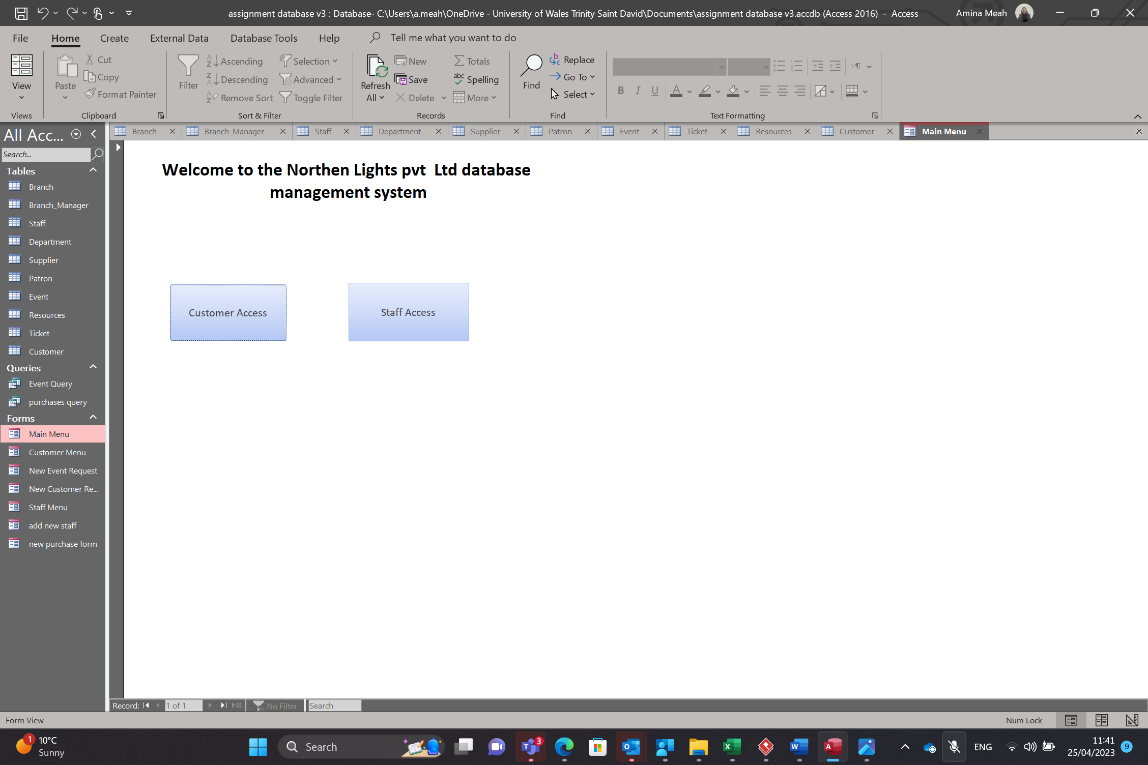
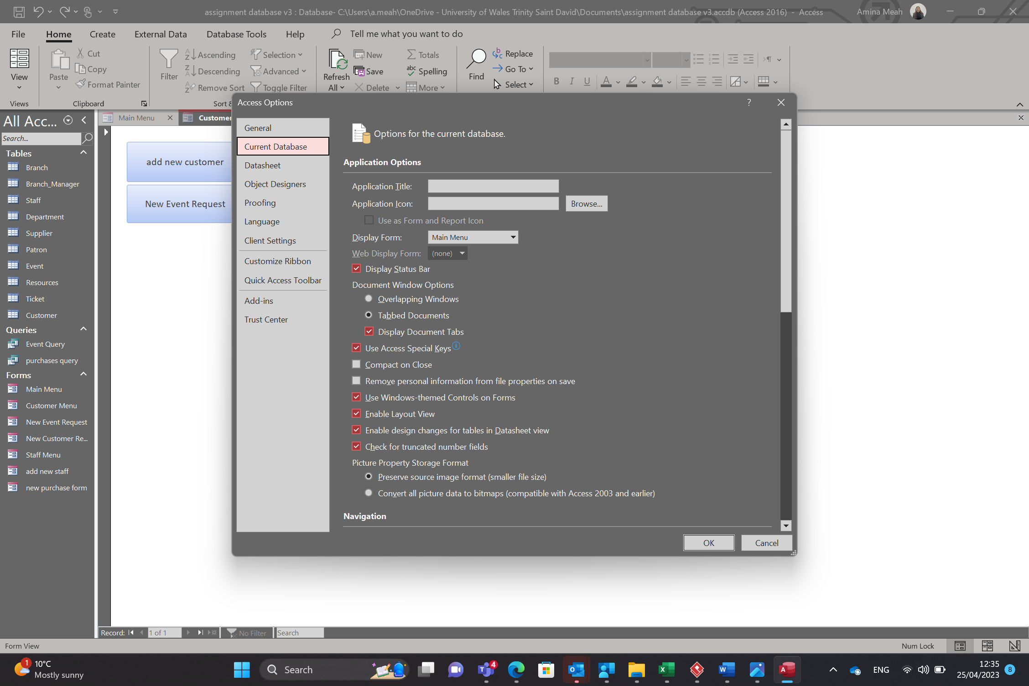
This is the Main menu for my table. I have chosen this as the first form to open when the database is opened. This means that both customers and staff will see this screen when they open the database. Customers will click the customer access button and staff will click the staff access button. This will then take them to a secondary menu labelled either staff menu or customer menu.
customer menu
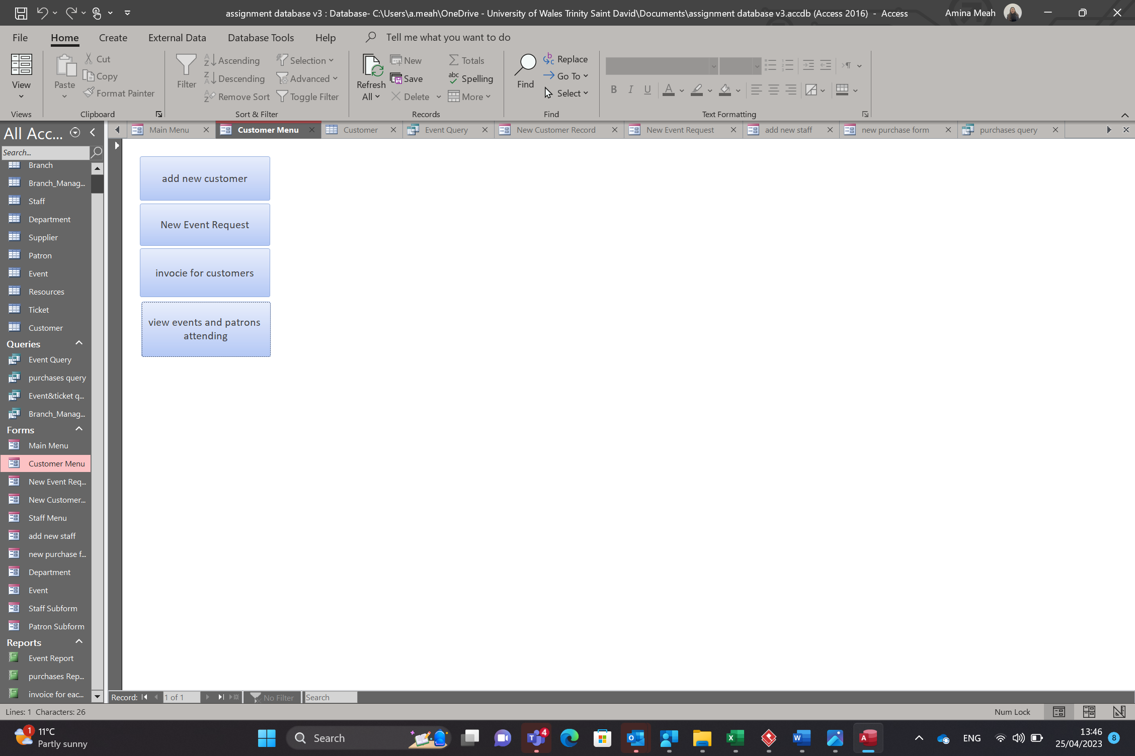
This is the customer menu pictured above. There are 4 buttons the first button takes you to a form that allows you to add a new customer record. Which is pictured below.
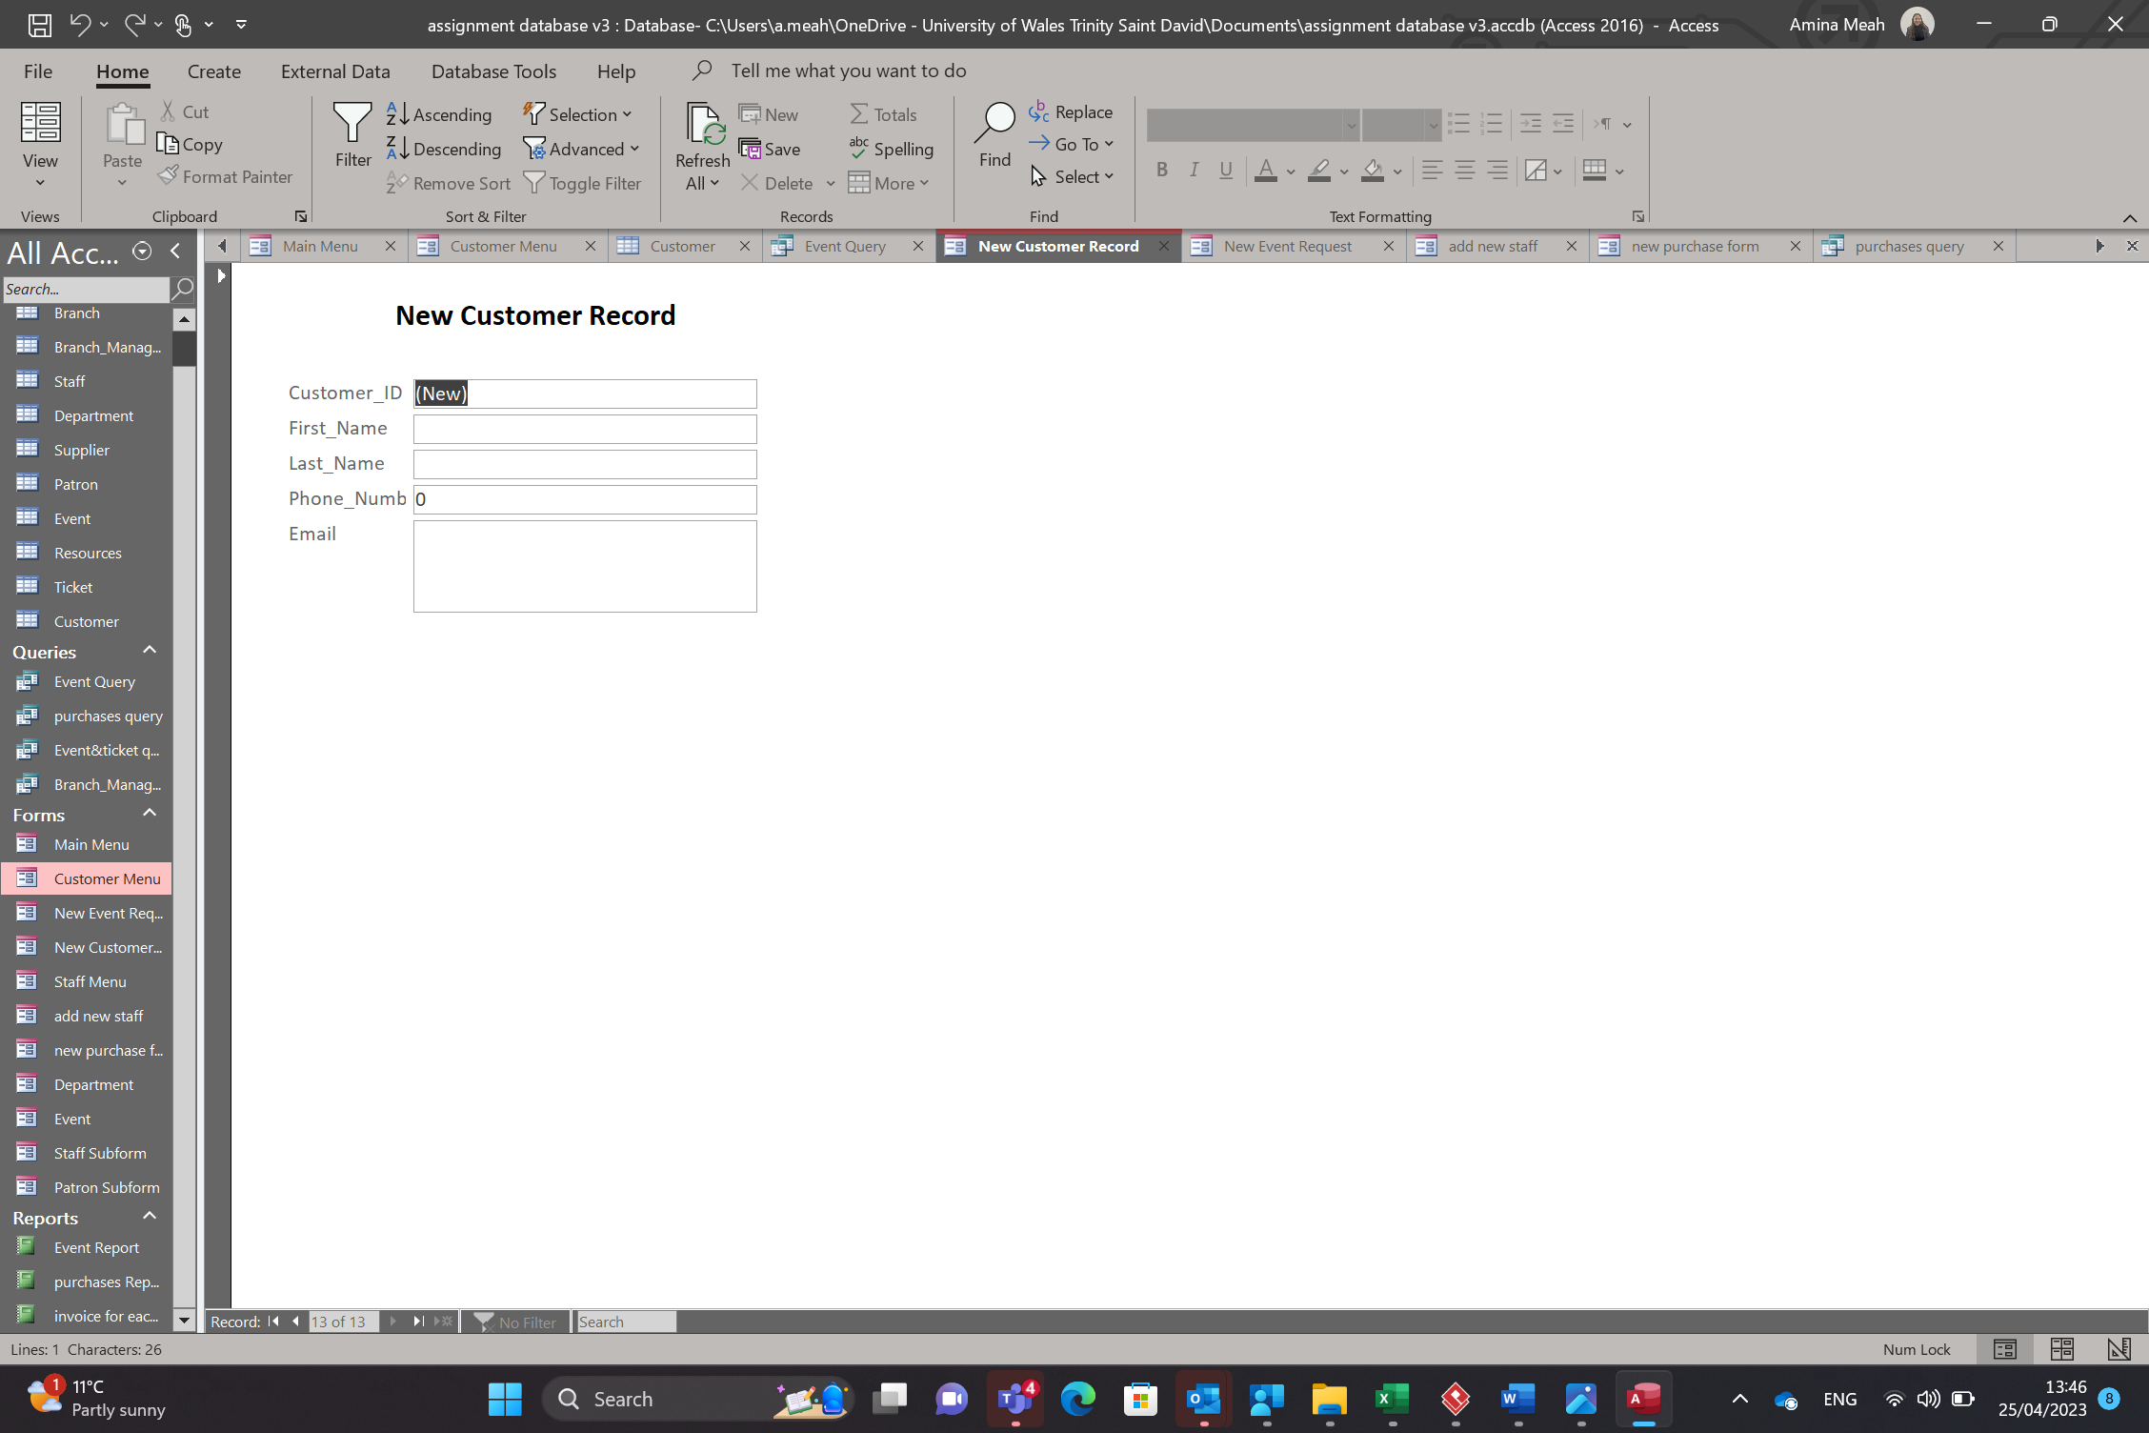
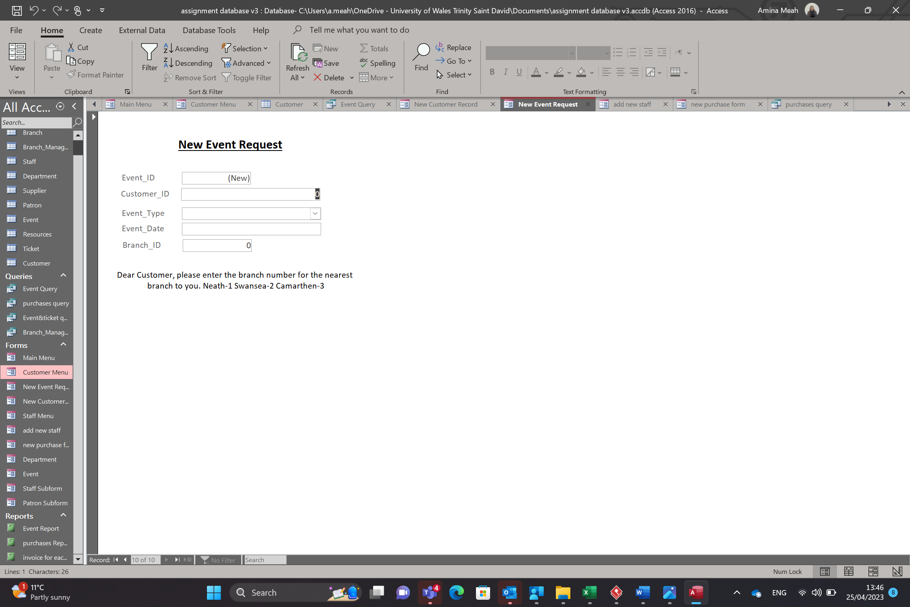
This is the second button which takes you to a event request form. The customer can use this form to add a new event request.
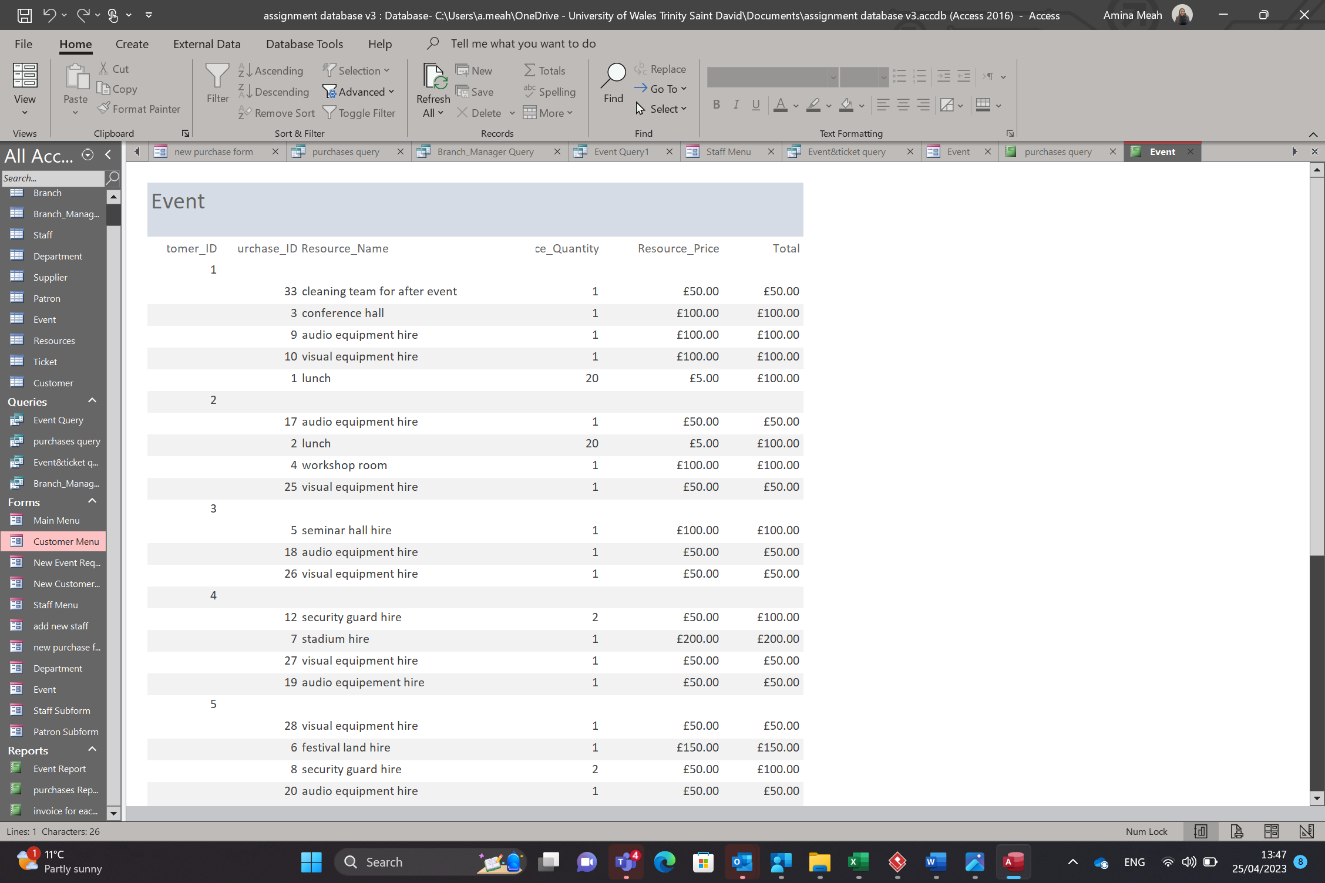
This is the third button. This takes you to a report with invoices for each event.
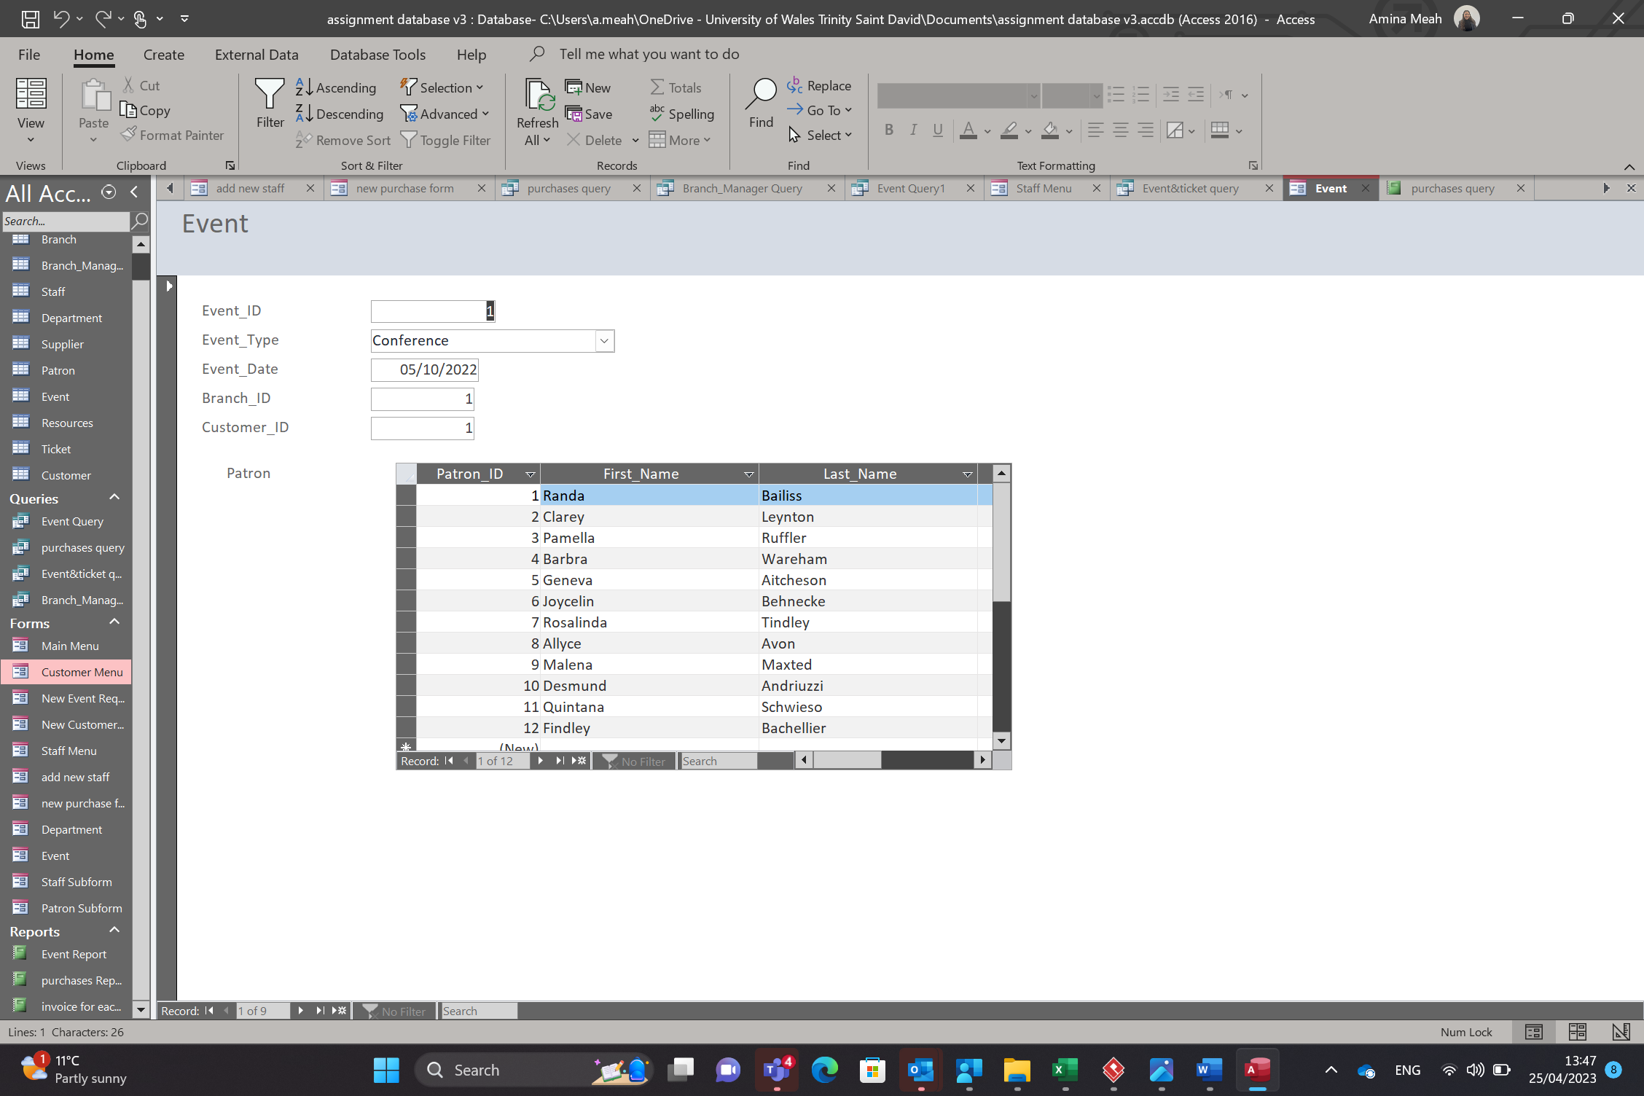
This is the forth button. This takes you to a embedded subform. This allows the user to view the event and what patrons are attending.
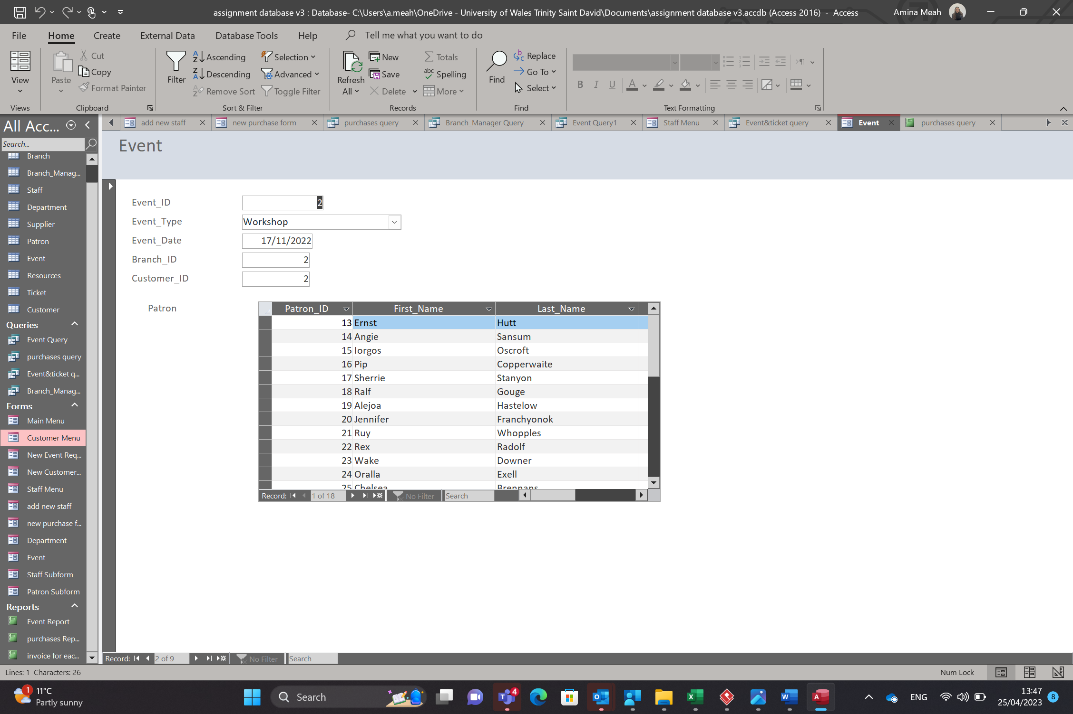

Staff menu
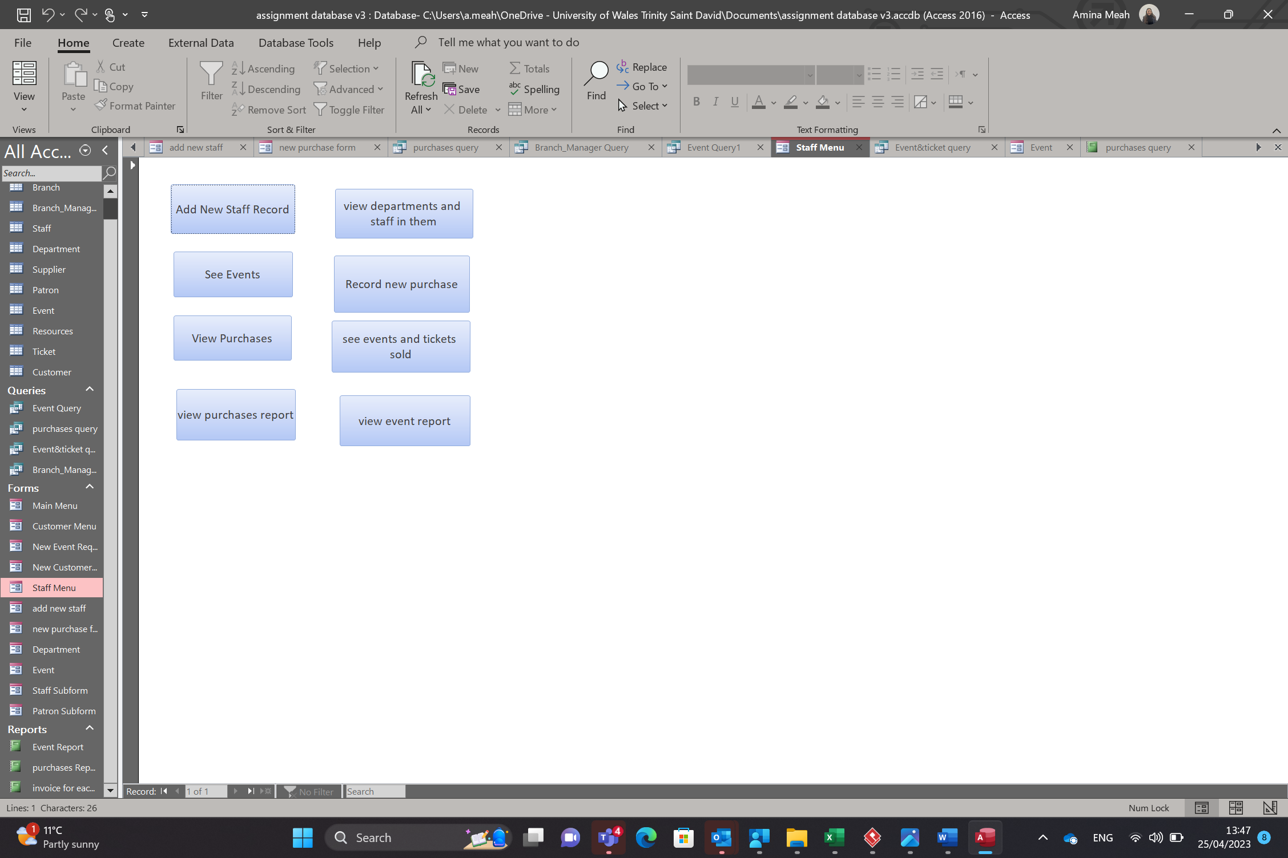
This is the staff menu. It has 8 buttons.
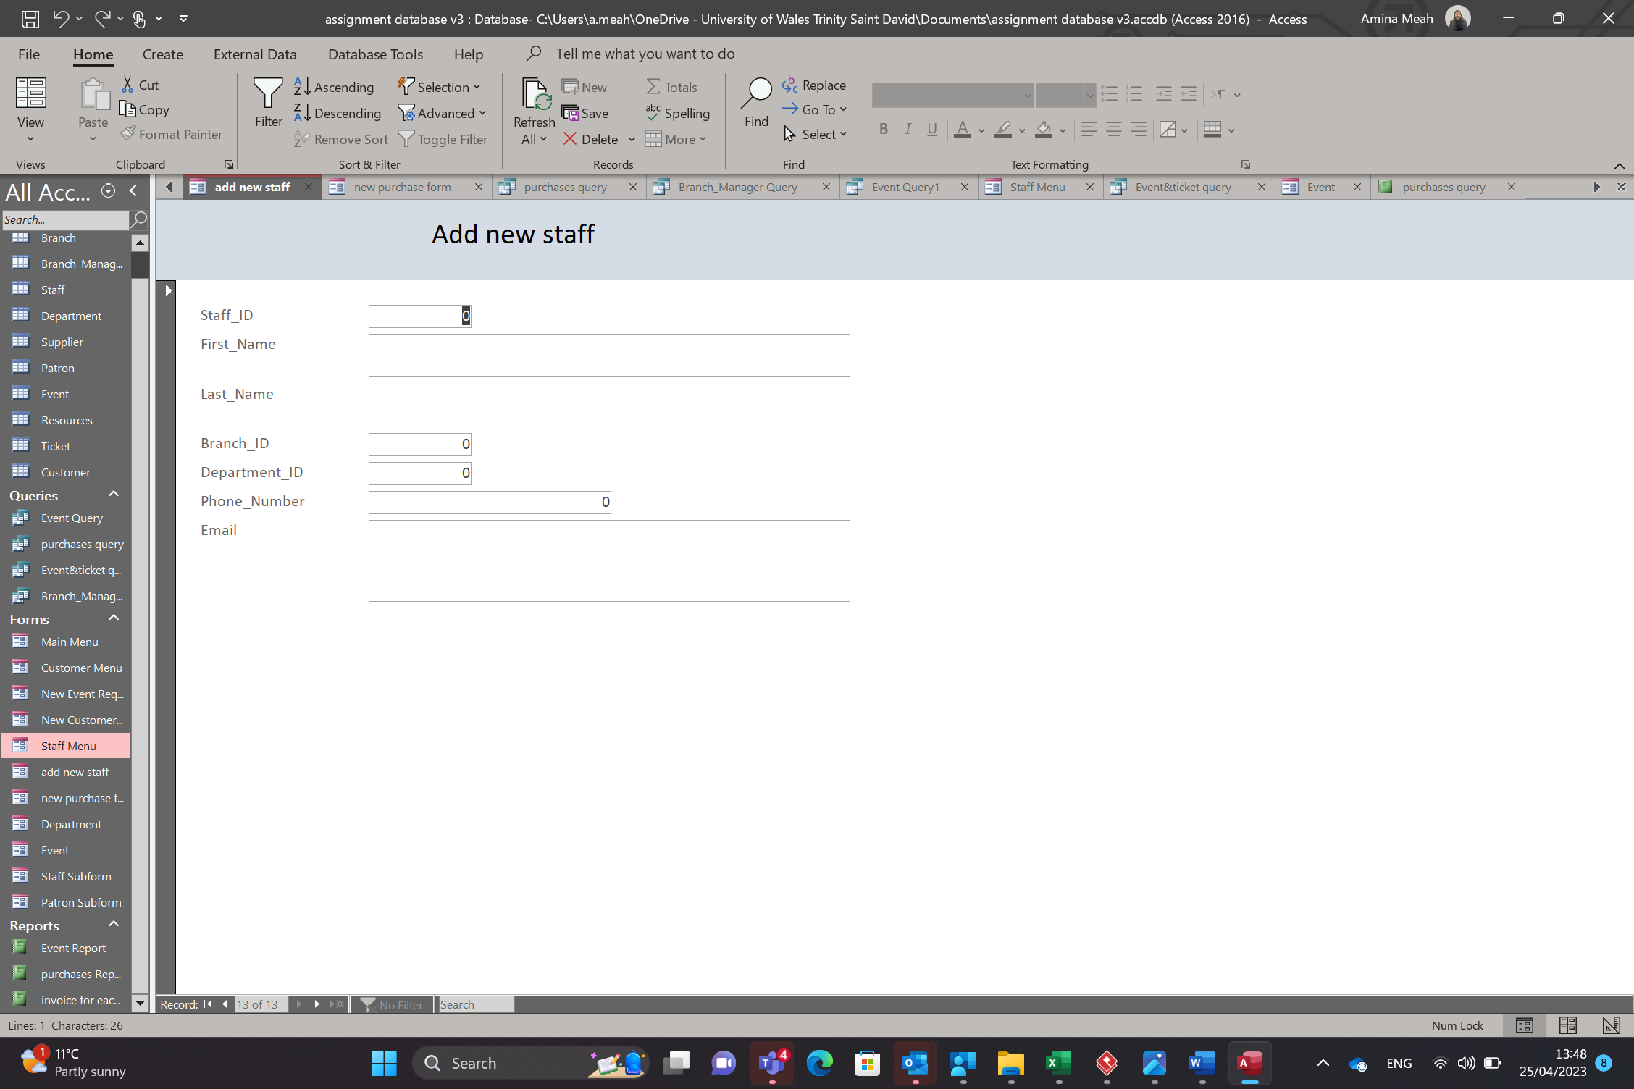
The first button takes you to a form which allows the user to add a new staff record. As seen above.
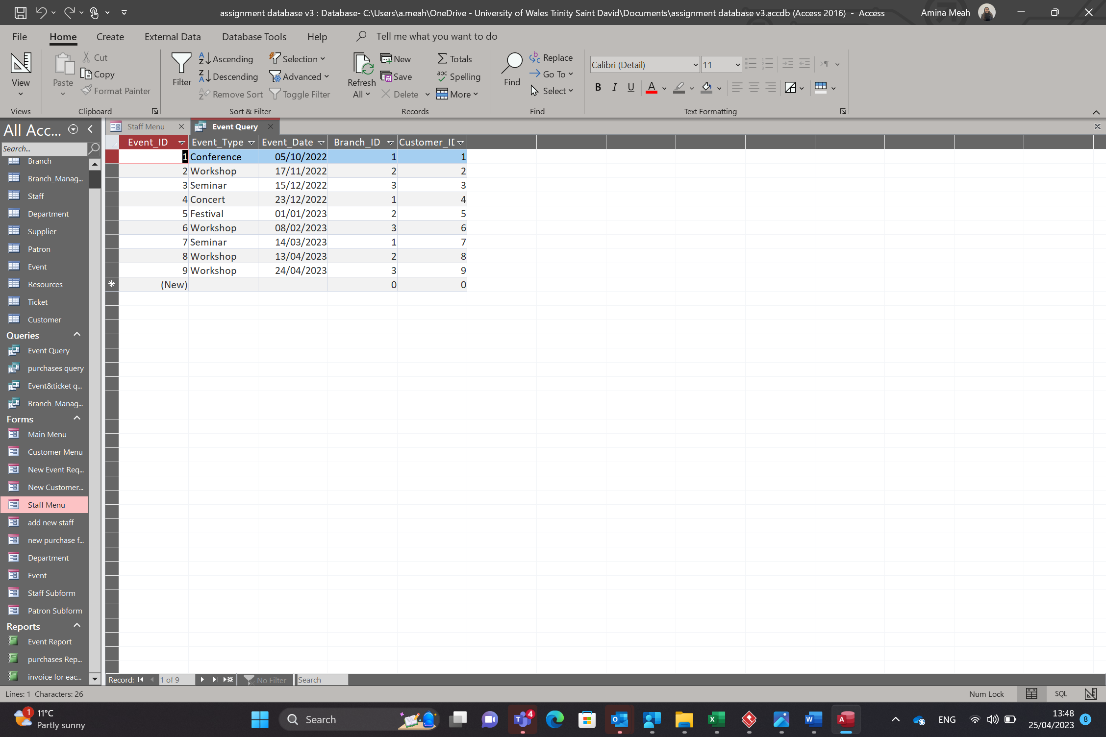
The second button takes you to a query which allows the user to view the upcoming events. As seen above.
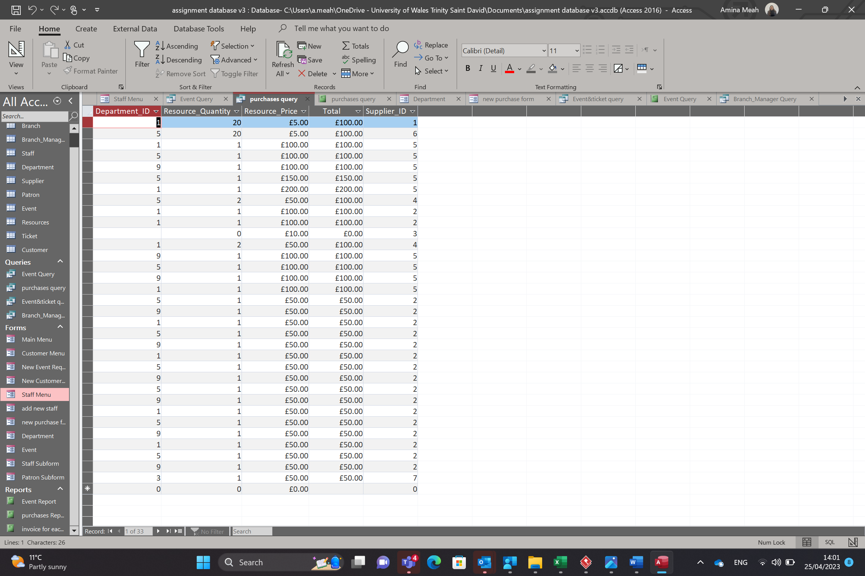
This third button takes you too a query that allows the user to view all purchases made. The user can filter the field to select which department they would like to see and what they would like to be displayed. This filter is shown below.
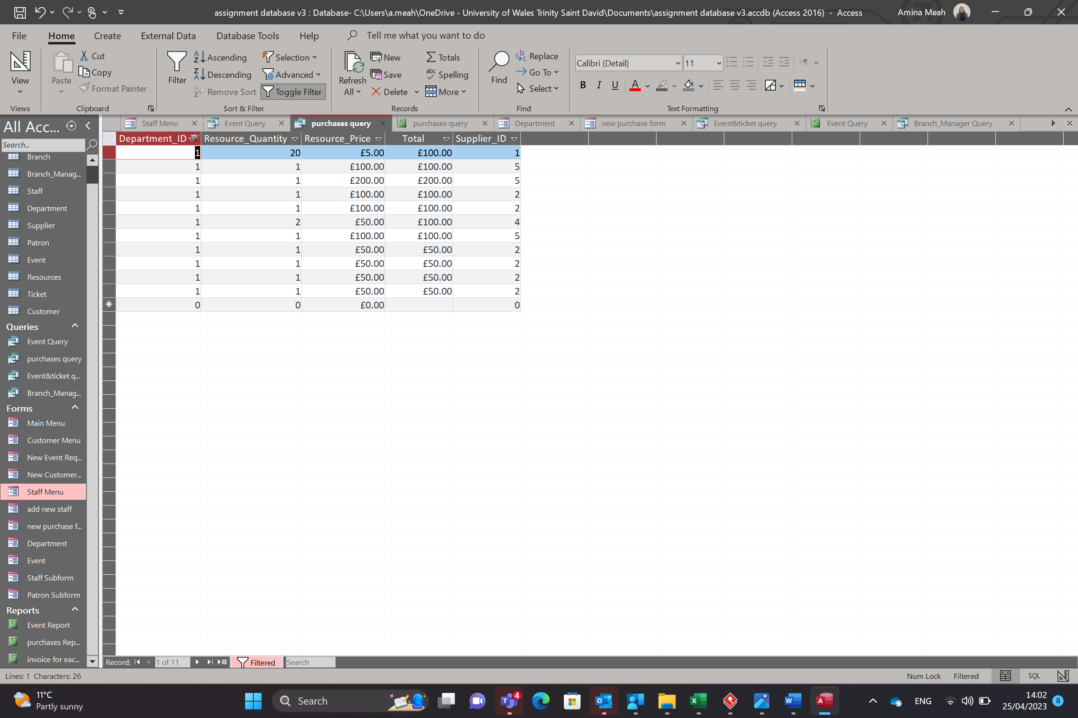

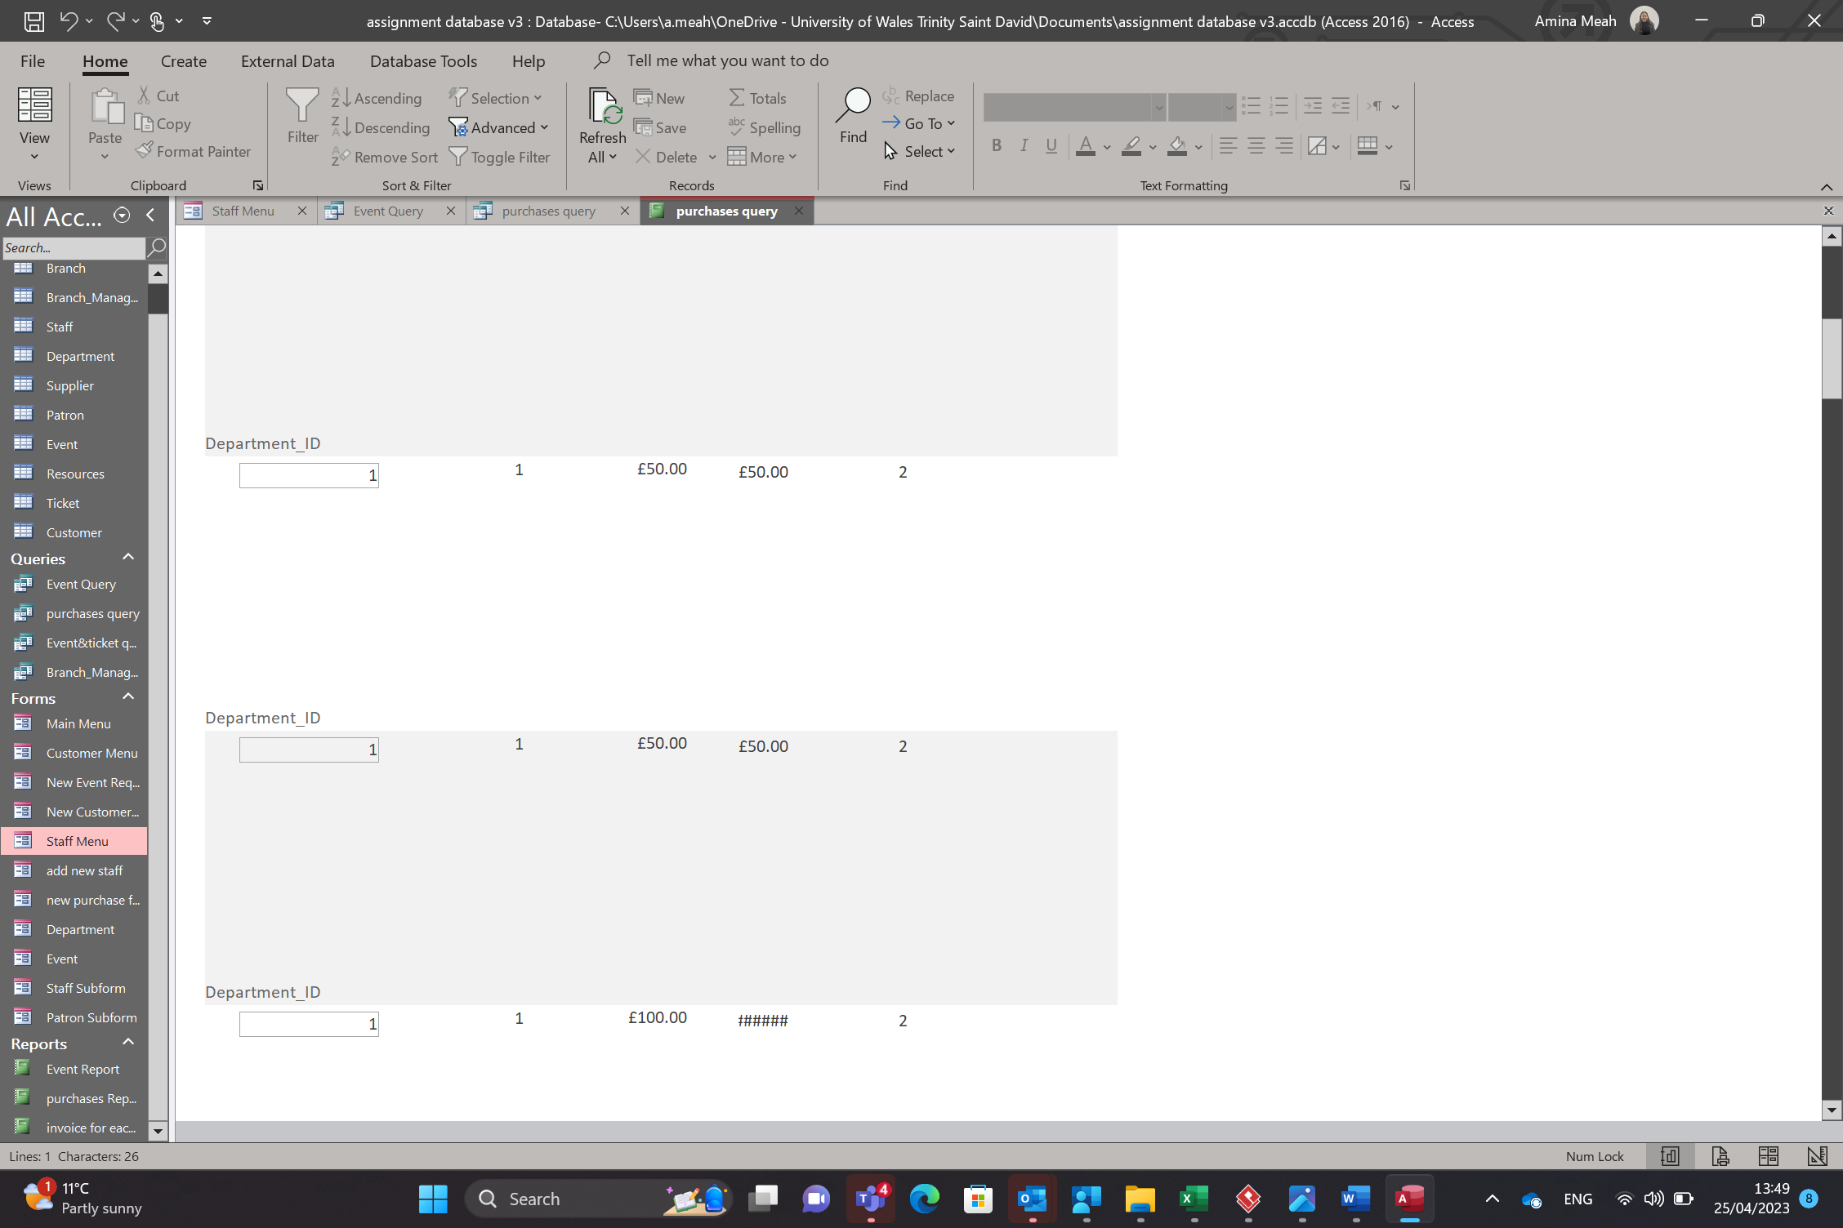
The forth button take you to a report that shows you what each department has purchased. As seen above
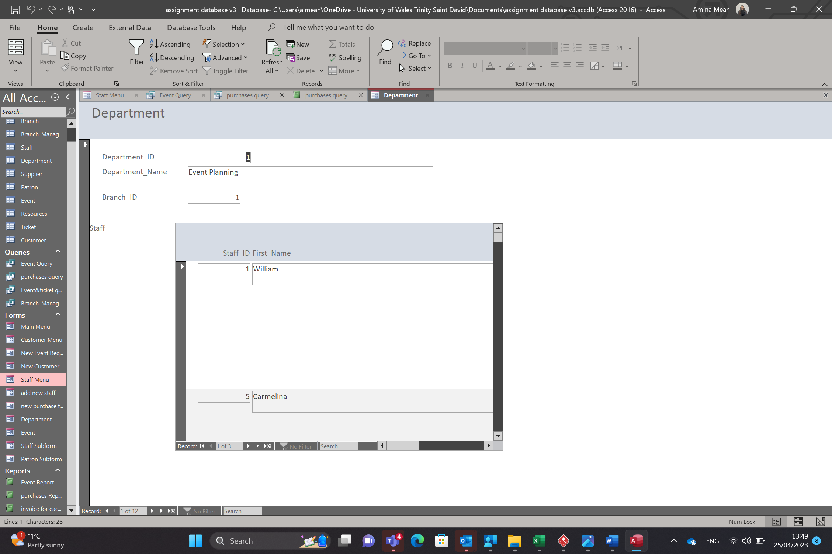
This fifth button takes you to another sub form which shows the user what staff work in which department. This is useful If you want to know what staff are in a certain department.
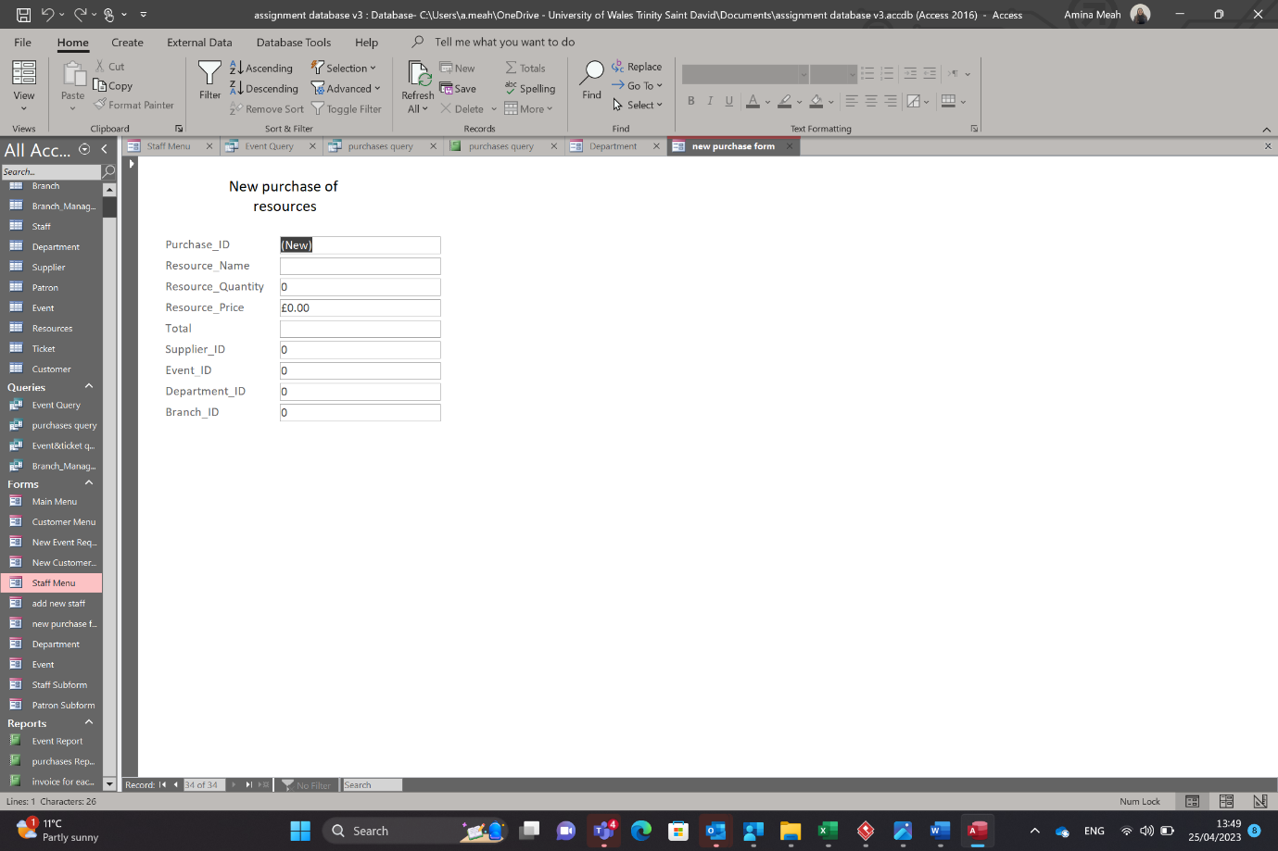
The sixth button takes you to a form which allows you to complete it in order to make a new purchase of resources.
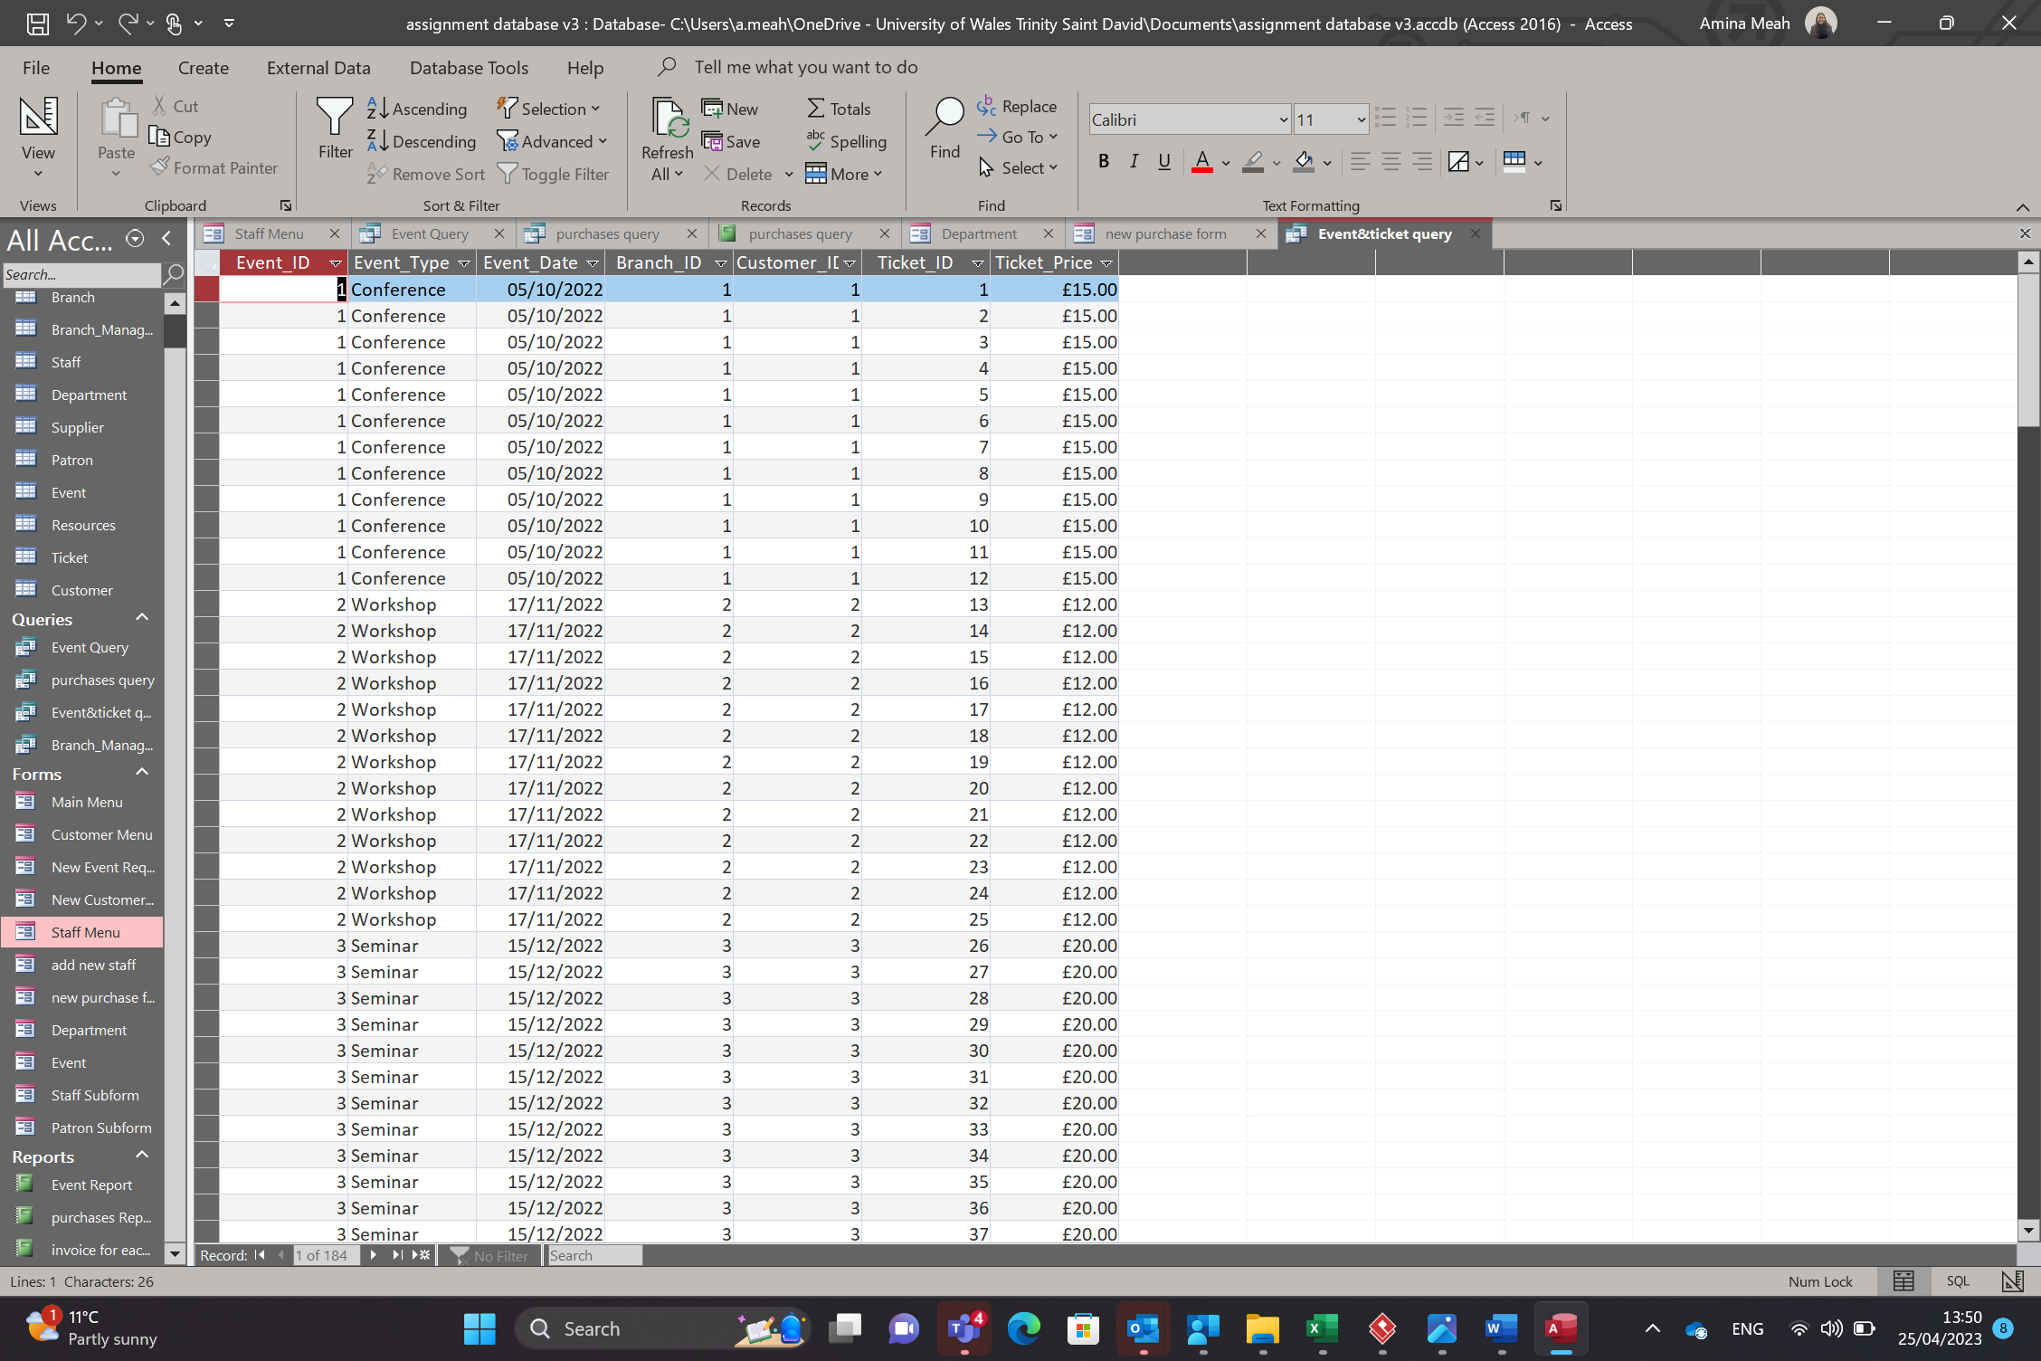
The seventh button take you to a query which shows the events and what tickets have bee sold.
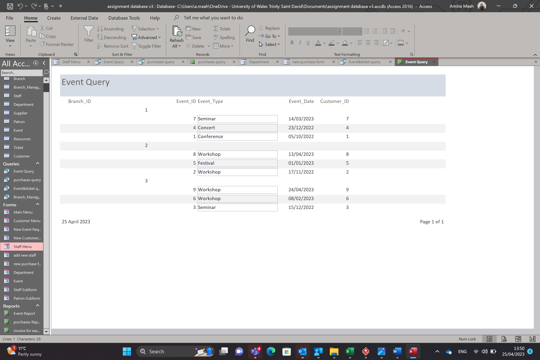
The eight button takes you to a report that shows all events upcoming or past events. It shows them in branch order too.
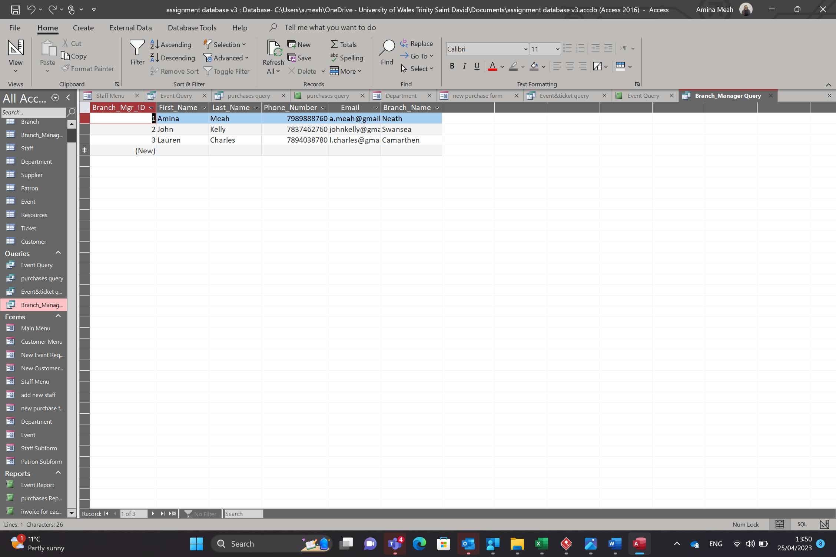
This is just an additional query I made to view the branch name next to the branch manager info.

