Courtney Grota
2203657
Learning in the digital era
BMPL4007/C
Assessment one

Preparing for Higher Education

For many, when entering university, it is their first time writing academically. This can be overwhelming but ensuring you create an effective environment will allow you to be comfortable and productive in your studying and writing.
(Goldenkey, 2020)

When creating your study environment there are several key features to consider, these include; lighting (Hendrix, 2019), according to Boelcke, (2022), working in environments which are brightly lit, allows for higher grades as a dim room can negatively affect how the brain absorbs information. The noise in your study area can affect your work performance, low-level noise can disrupt concentration and therefore hinder your workflow (Rugg, 2010). Avoiding clutter within your study area results in longer study periods. By reducing these distractions, it strengthens persistence to complete tasks (Sander, 2019). Another element of preparing for higher education is ensuring competent time management skills. This means organising your time to allow priorities to be completed. A way this can be achieved is through creating a schedule for yourself as this gives a visual insight on where the majority of your time needs to be spent and where you have some extra time to relax and enjoy (Campbell, 2022).
Throughout your time in higher education, you will use your digital skills. This is done through the use of various software. Word, created by Microsoft, is typically used for high quality documents, but can also be used within your education for essays and cover letters (Computer Hope, 2021). Another essential software is Power Point. This is mainly used for creating slide shows and is a great tool when conducting presentations (Techopedia, 2020). When using online websites, it is crucial to remain safe. You can do this by selecting a strong password, which prevents anyone gaining access to your work (NCSC.GOV, 2021). You must ensure to monitor any information you are releasing online; you should refrain from posting any personal information as this is no longer under your control once it has been posted.
Your time in higher education will include writing essays where you will gain insight from other individual’s work. When using someone else’s ideas, it is important to reference it, to ensure your work is authentic. Failing to reference can lead to plagiarism and your work being suspended. To avoid this, all ideas, quotes, data and images must be given recognition. (UNSW, 2022).
When writing academically, it is necessary to be able to differentiate between the assessment terms used. For example, when asked to ‘evaluate’ you will need to present an argument for and against a topic with evidence to support your points (Nordquist, 2019). When ‘analysing’, each area of your topic or question will need to be examined in detail, considering other perspectives, and allowing it to flow to conclude with the overall point you are trying to achieve (Bangor university, 2022). These are just a couple of examples of writing styles but recourses such as the library will have access to a wider range to guide you through your studies.

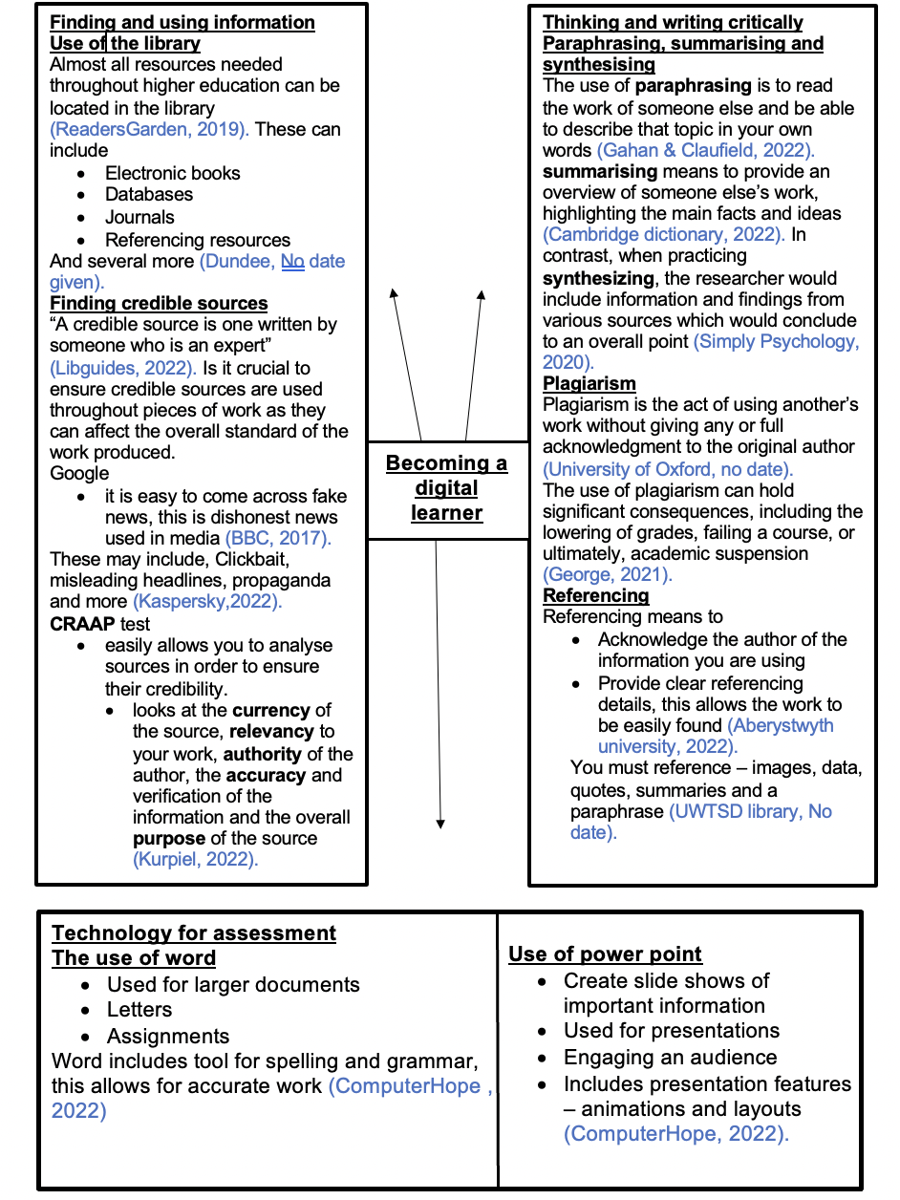
Link to ‘Becoming a team player’ video

https://www.youtube.com/watch?v=RP6J8EyXZzo

Starting Higher Education
In order to reflect on my experience of starting university I will be using Borton’s reflective method. Developed in the 1970’s, this method provides a clear structure for reflecting on recent events or work. There are three key elements to this structure. The first step focusses on ‘what?’, referring to what was the task at hand, secondly ‘So what?’, allowing you to reflect on the outcomes of the task, and thirdly ‘what now?’ concludes with key steps in ensuring improvements in the future (Dabell, 2018).

I was accepted into higher education in August 2022. This filled me with many emotions, the first being relief. It was reassuring to feel as though I had succeeded. I was excited for new opportunities and to be working towards my dream career, I knew this would be a driving force for me. My nerves and anxiety began to set in as along with beginning university, this was the first time I would be moving away from my family home. According to Ankrom, (2021) this type of anxiety is called anticipatory anxiety and is common before beginning a new event. Throughout this process, I was extremely grateful for the support of my family, as they continued to encourage me, I was able to feel relaxed and prepare myself for these changes.

Following my first few days in higher education, I was able to establish my feelings towards the new journey. I was left pleasantly surprised by aspects such as my lecturers, who ensured that everyone was feeling comfortable and frequently made sure to dissolve any issues with understanding information. Within my first day, I could feel myself developing skills such as my communication, which I did through engaging with others on my course, as well as my lecturers. I have also developed my writing skills; this is due to the new style of writing higher education has presented. I began to find the new learning style along with the workload challenging and feel as though this is something I can improve on.

Using the final stage of Borton’s reflective method, it allows me to construct what can be done to improve my experience and ensure positive experiences in the future. In order to resolve my issue of balancing a heavy workload, I believe it would be effective to develop my time management skills. By doing this, I would be able to allocate the essential time to each task, ensuring work is completed. Furthermore, I believe that due to my anxiety and nerves, I only gave myself the opportunity to prepare emotionally for higher education. In the future, I will ensure I allow the time to also prepare academically, focusing on any new learning styles which may appear.

Reference list
Aberystwyth University (2022) Referencing & plagiarism awareness: what is referencing & citation? Available at: https://libguides.aber.ac.uk/c.php?g=676952&p=4823314#:~:text=Identifying%20the%20sources%20you%20have,the%20end%20of%20the%20assignment.(Accessed: 28 October).
Ankrom, Sheryl. (2021) Anticipatory anxiety. Available at: https://www.verywellmind.com/anticipatory-anxiety-and-panic-disorder-2584252(Accessed: 29 October).
Bangor University (2022) Essay terms explained. Available at: https://www.bangor.ac.uk/studyskills/study-guides/essay-terms.php.en#:~:text=Definition,these%20interrelate%20to%20one%20another.(Accessed: 20 October).
BBC (2017) Fake news: What is it? and how to spot it. Available at: https://www.bbc.co.uk/newsround/38906931(Accessed: 26 October).
Boelcke, A. (2022) How does lighting affect learning. Available at: https://visualedgesb.com/how-does-lighting-affect-learning/ (Accessed: October 23).
Cambridge Dictionary (2022) Summarising. Available at: https://dictionary.cambridge.org/dictionary/english/summarizing(Accessed: 26 October).
Campbell, R. (2022) 7 time management tips for students. Available at: https://www.topuniversities.com/blog/7-time-management-tips-students (Accessed: 30 October).
Computer Hope (2021) Microsoft Word. Available at: https://www.computerhope.com/jargon/m/microsoft-word.htm (Accessed: 19 October).
Christian, Lynn. (2020)defining your list of values and beliefs Available at: https://soulsalt.com/list-of-values-and-beliefs/(Accessed: 3 November).
Dabell, J. (2018) Borton's model of reflection. Available at: https://johndabell.com/2018/08/05/models-of-reflection/(Accessed: 2 November).
Driskell, J et al. (2006) 'What makes a good team player? personality and team effectiveness', Vol 10, no.4, 251. Available at:https://web-s-ebscohost-com.ezproxy.uwtsd.ac.uk/ehost/pdfviewer/pdfviewer?vid=0&sid=935ca7e0-0cb6-4370-aaae-cb329039aa89%40redis(Accessed: 4 October).
Gahan, C & Claufield, J. (2022) How to paraphrase: step by step guide and examples. Available at: https://www.scribbr.co.uk/working-sources/paraphrasing/(Accessed: 27 October).
George, T. (2021) Consequences of mild, moderate, and severe plagiarism. Available at: https://www.scribbr.co.uk/preventing-plagiarism/consequences-of-plagiarism/(Accessed: 28 October).
Heffernan, K. (2014) How do places affect identity, and how can we see identities. Available at: https://prezi.com/blyy0hp2sz8m/how-do-places-affect-identity-and-how-can-we-see-identities/(Accessed: 27 October).
Hendrix, E. (2019) How your surroundings affect the way you study. Available at: https://www.ucas.com/connect/blogs/how-your-surroundings-affect-way-you-study (Accessed: 20 October 2022).
Iddon, C. (2022) Sense of place in human geography. Available at: https://study.com/learn/lesson/sense-place-facts-examples-geography.html(Accessed: 27 October).
Kaspersky (2022) How to identify fake news. Available at: https://www.kaspersky.com/resource-center/preemptive-safety/how-to-identify-fake-newsAccessed: 26 October).
Klein, S & Nichols, S. (2012) 'Memory and the sense of personal identity', Memory and the sense of personal identity, University of California, 679. Available at: https://philarchive.org/archive/KLEMAT-5
Kurpiel, S. (2022) Evaluating sources: the CRAAP test. Available at: https://researchguides.ben.edu/source-evaluation(Accessed: 26 October).
McCombes, S. (2020) How to synthesise written information from multiple sources. Available at: https://www.simplypsychology.org/synthesising.html#:~:text=Synthesizing%20simply%20means%20combining.,and%20differences%20between%20your%20sources.(Accessed: 26 October).
Mintz, S. (2018) What are values. Available at: https://www.ethicssage.com/2018/08/what-are-values.html(Accessed: 31 October).
NCSC (2021) Top tips for staying secure online. Available at:https://www.ncsc.gov.uk/collection/top-tips-for-staying-secure-online/use-a-strong-and-separate-password-for-email (Accessed: 23 October).
Nordguist, R. (2019) Explore and evaluate your writing process. Available at:https://www.thoughtco.com/explore-and-evaluate-your-writing-process-1692857(Accessed: 20 October).
Perry, J. (2022) Personal identity part two: the body theory and personality theory. Available at: https://oyc.yale.edu/philosophy/phil-176/lecture-11(Accessed:27 October).
Petty, L. (2016) How equality & diversity improves your workplace: examining the benefits. Available at: https://www.highspeedtraining.co.uk/hub/equality-diversity-benefits-workplace/(Accessed: 5 November).
Readers Garden(2019) It always seems impossible until it's done. Available at: https://readersgarden.in/(Accessed: 26 October).
Rugg, M. (2010) How does background noise affect our concentration?. Available at: https://www.scientificamerican.com/article/ask-the-brains-background-noise/ (Accessed: 27 October).
Sander, L. (2019) The case for finally cleaning your desk. Available at: https://hbr.org/2019/03/the-case-for-finally-cleaning-your-desk (Accessed: 28 October).
Techopedia (2020) Microsoft PowerPoint. Available at: https://www.techopedia.com/definition/5457/microsoft-powerpoint-ppt (Accessed: 23 October).
Thinking city (2018) How does place shape who we are?. Available at:https://thinkingcity.org/2018/07/24/how-does-place-shape-who-we-are/(Accessed: 27 October).
University of Dundee (2022) Search your library. Available at: https://www.dundee.ac.uk/library/resources/typesofresource/(Accessed: 26 October).
University of Oxford (2022) Plagiarism. Available at: https://www.ox.ac.uk/students/academic/guidance/skills/plagiarism(Accessed: 26 October).
UNSW (2022) What is plagiarism?. Available at: https://www.student.unsw.edu.au/what-plagiarism (Accessed: 24 October).
USC (2022) What are credible sources. Available at: https://libguides.usc.edu.au/credible#:~:text=A%20credible%20source%20is%20one,scholarly%20and%20peer%2Dreviewed%20sources.(Accessed: 26 October).

