Commentary on a picture of Fountains Abbey, from the Southwest

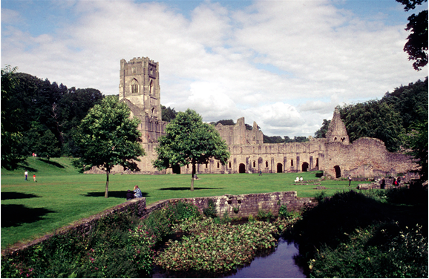

The stunning Fountains Abbey is located in North Yorkshire and placed in the valley of the river skell near west of Ripon. it had been founded by Benedictine monks in 1132. The abbey has got an extraordinary history held within the ruins which provides an interest for the public to visit even to this day. This commentary will be researching into the Fountains Abbey and discuss why this abbey is so important and meaningful towards the Cistercian period.
When researching into the Fountains Abbey, it is important to take into consideration the location of the abbey. It is clear from the image that the abbey appears to be a tranquil and peaceful setting which would have been perfect for monks who resided here. It appears that this is something that the monks wished to find in a monastery because originally, they had been located in York and it had been a rowdy and extravagant way of life which the monks decided they needed to find a place that had calmness surrounding it so that they could have a lifestyle that was simple. However, despite the tranquil look the abbey now presents which the public admire, in the 13th century it could have come across as empty and a daunting place to go. This also has been mentioned by Narratio as he states that ‘it seemed, to be the lair of wild beasts than the home of human beings’. It indicates that despite now having appealing factors of peace and quiet, this had not been the same outlook people had in the 13th century. The Abbey is also placed near the river of Skell which means that it would have been easy for the people staying there to gain access to fresh water. Another benefit for the rural location of the Fountains Abbey is that with having local stone quarries, they could access stone very easily to add onto the abbey without having to go far to find any.
The Fountains Abbey has very clearly been an important factor for the Cistercians because it had been the second outpost for the religion in the North. This means that the abbey had a great importance for the Cistercians and helped towards the growth of the religion because it had many triumphs throughout the history of the abbey. The importance and interest of the Abbey has been carried on through to the present day because the National Trust now own the site, which means that the public are able to go and visit when they like which many still do to this day.
Since the beginning of the usage of the Abbey, it has changed in a couple of ways from the original state. Because of the amount of time that has passed since the start, the majority of the site is ruins, however there is still enough of the building left to be able to gage what certain areas would have been used for. When looking close at the infrastructure of the building, it is evident that quite a bit of money would have been put towards the creation. The Fountains Abbey had been known as one of the richest and greatest houses for the Cistercians in Yorkshire and it operated for 407 years until Henry VIII brought in the dissolution of monasteries in the year 1539, which made the decline of this fascinating abbey. The Fountains Abbey has been through a lot of construction during the time it has been standing, this is because in 1146 there had been an attack on the monastery because of a disagreement in supporters meaning that massive damage had been done to the abbey resulting in a rebuild of the abbey and it had been built bigger than it previously had been. This suggests that even though the abbey had a pullback from where it had been, they were able to restore and continue the best they could despite the issues faced.
In conclusion, the Fountains Abbey in Yorkshire has got exceptional qualities that are still relevant to the public to come and view to this day. The detailed history that this abbey contains is incredible in how the abbey worked at the time and all the issues that were experienced here. Overall, Fountains Abbey is one which people should take the chance to visit and experience the peacefulness and history of the whole area.

Bibliography
Primary
‘Foundation history of Fountains’ (Narratio), in A. W. Oxford, The Ruins of Fountains Abbey (London, 1910), p. 165. In Saxon, ‘Skel’ meant ‘spring’.
Secondary
National Trust, Fountains Abbey, (2021) <https://www.nationaltrust.org.uk/fountains-abbey-and-studley-royal-water-garden/features/fountains-abbey> [accessed 7 December 2021]
The Cistercians in Yorkshire, Fountains Abbey: Location, (2021) <https://www.dhi.ac.uk/cistercians/fountains/location/index.php> [accessed 7 December 2021]
The Cistercians in Yorkshire, The Abbey Church, (2021) <https://www.dhi.ac.uk/cistercians/fountains/buildings/church/church2.php> [accessed 7 December 2021]

National Trust, Fountains Abbey, (2021) <https://www.nationaltrust.org.uk/fountains-abbey-and-studley-royal-water-garden/features/fountains-abbey> [accessed 7 December 2021]
‘Foundation history of Fountains’ (Narratio), in A. W. Oxford, The Ruins of Fountains Abbey (London, 1910), p. 165. In Saxon, ‘Skel’ meant ‘spring’.
The Cistercians in Yorkshire, Fountains Abbey: Location, (2021) <https://www.dhi.ac.uk/cistercians/fountains/location/index.php> [accessed 7 December 2021]
National Trust, Fountains Abbey, (2021) <https://www.nationaltrust.org.uk/fountains-abbey-and-studley-royal-water-garden/features/fountains-abbey> [accessed 7 December 2021]
The Cistercians in Yorkshire, The Abbey Church, (2021) <https://www.dhi.ac.uk/cistercians/fountains/buildings/church/church2.php> [accessed 7 December 2021]

