Student no.1913894
Health and Social Care Term 1
Professor Ali
31st July 2020
Effective Team Working and Communication
Working in a team is indeed a very important element in everyday life, be it in the work environment, in the community, at home or in interpersonal relationships. To have a successful team one needs to have shared interests and have sound people skills. Communication is a very important mechanism that takes place by interacting, penning, hearing, and watching as people exchange concepts, emotions, opinions, as well as the ability to effectively connect, is a fundamental skill that is needed. When there is no coordination, the project may struggle and cannot accomplish its target. Some other crucial thing that a group should have will be of diverse range and because the team offers diverse perspectives, expertise and knowledge to various participants from all workforce.

Loads of books and publications mostly about information exchange have also been published, as well as the transcribed contact theoretical framework illustrates the way two individuals interact. The sender will transmit their thoughts and opinions into statements and afterwards pass them over to the recipient. The recipient subsequently encrypts their thoughts and feelings into sayings and sends a statement that perhaps the communication is acknowledged to the initial sender. The sender’s also must guarantee that somehow the recipient reads the letter, and that the sent communication will be the original one.
(Claude E, Shannon & W, Weaver) evaluate the communication protocol on how it is used by providing all the initiatives that one mindset can influence others. Not just literacy or spoken expression, and also literature, the visual arts, the stage, the dance, human acts, crowd noise, ears, difficulties, extremely warm or cold, Intrusion, loss of anonymity, discomfort and physical problems are also potential obstacles which would otherwise intervene with both the advancement through communication. Should you choose to send a small headnote or offer details to a wider organisation, you must guarantee that the details you provide are correct and clear without confusing your staff, boss, employer, colleagues, and relatives. If establishing partnerships, trading thoughts, assigning roles and leading a group, collaboration is an utter requirement. Establishing good interpersonal skills will allow you to make your profession a success, end up making you a successful job seeker and create your network of contacts. Even though it does take training and experience, nevertheless; verbal and nonverbal communication abilities may be both improved and perfected. Besides, we utilise four primary forms of contact regularly which are as follow: verbal, nonverbal, literacy and visual. Moreover, these leadership skills are important if one wants to be an effective leader in the working environment.
I will look at an example from my casework regarding Maria and Pedro. In this scenario, neither was Pedro afraid, nor was Maria overwhelmed, but the communication between them was unsatisfactory due to the noisy background where Pedro’s works, which made it difficult for Pedro to take in the information that Maria was trying to get across. In the end, Pedro was unable to provide the response that Maria was expecting neither was she happy because it was like he was ignoring her. Berol’s way of communication clarifies communication in three stages. The speaker, the subject and the recipient. Also, Shannon & Weaver explain similar information about the sender, the message and the source.

As narrated by DR, Stephen, R. C., (1989) The lowest degree of contact arising from close to zero-trust circumstances will be distinguished by dismissiveness, defence, and sometimes legal vocabulary, covering all of the bases and spelling out conditions as well as the escape clauses in case things go bad. Such contact just brings in make the finals-lose or end up losing everything.
A typical example is that of a Chief and the citizens of his village. The Chief had no interaction with the villagers, and while his property was on fire he spoke well above the peasants' standard of intellect since they were uneducated and did not comprehend the chief use of language, as a result, the Chief was unable to obtain the help he requested from the villagers because of his bad use of language. In this scenario, I can use the Shannon & Weaver model to explain the circumstance, as well as the Berol model, so that the user sends a message, and the recipient decrypts the message and then replies to just the sender who received the message and understands it. Therefore, in situation the Chief could not successfully convey the message to the villagers, resulting in the peasants not getting the answer he requested.
You can use several verbal and visual contact methods and strategies at the workplace to exchange knowledge and keep company activities running. We can often encounter challenges as a worker which can make communication very difficult. As obstacles to communication emerge, partnerships with peers, leaders and customers may be challenging to sustain and improve. This also contributes to a misunderstanding which may hinder everyday duties.
Another example I want to mention is from the following casework. “Barry had recruited numerous people from diverse cultures and cultural groups in this casework. Barry's needed to lead by example as a boss. In certain ways, Barry was also an efficient boss but completely lacks strong leadership and business plan qualities that hindered him from handling his staff efficiently. Barry gave little or no details to his workers and frequently treated them in such an obnoxious manner, which is why Barry found it difficult with fruitful work with his workers. His workers very much failed to grasp what Barry was asking of everyone. Furthermore, Barry took his psychological and emotional or personal problems inside the office, which itself is inappropriate and that can inflict substantial damage on the intimate friendship among Barry and his staff”
Working in a team is vital to both improvement and development. Even though some individuals would like to believe that they're doing everything by themselves, the truth is they cannot. Building a fantastic diverse team around you offers stability and allows you to behave critically, expanding your viewpoint with innovative things, however most crucially, it gives you a positive good support network. It is crucial for the organization to succeed once again and that everyone should have the same goals and objectives and then help the team achieve the ultimate target. (Richard, S & Risher, J) (2013) Describes the importance of working together by suggesting that certain crucial considerations need to be addressed to achieve this. Working in teams entails a variety of participants from different cultural backgrounds, each sharing their technical experience across shared decision making.
Unit growth phases include: developing, storming, standardising and executing. Successful collaboration can create a team's common priorities, encouraging everyone to manage resources about how to make choices including how to accomplish those goals. To carry out the activities needed to accomplish these aims to be collectively responsible for their performance, a team's efforts are best when members of the group communicate with each other through a collective strategy. Besides, the following are some main components of a successful working team: contact organisation, complementary talents, experience, and an atmosphere of confidence and mutual interest. Strong leadership and organisational skills are crucial to achieving good outcomes for every workplace. The group should therefore actively aim to develop its collaboration and coordination skills.
Also, the following are some main components of a successful working team: contact organisation, complementary talents, experience, and an atmosphere of confidence and mutual interest. Strong leadership and organisational skills are crucial to achieving good outcomes for every workplace. The group should instead actively aim to develop its collaboration and coordination skills. There is no reason for our bad memories; indeed, many of us don't pay attention properly. Quintanilla, K. M. & Wahl, S.T Mound, A) Described listening ability by stating, "We've thought that listening skills rely mostly on intelligence, however, brilliant people who paying attention listen well and dull people don’t.”. I accepted that low intellect has more to do with an incapacity to pay attention, however, we have built up its increasingly important area. A weak communicator does not inherently signify a brain-dead individual. And you must be another strong listener to help others excel, and we can use qualities that are gained either through engagement or experience.
When an individual has poor listening abilities, his capacity to comprehend and hang upon what he sees would also be limited, these problems will affect people from both upper and lower intellect levels. When we talk at 125 words a minute during discussions, it can be wise to decelerate our thoughts. Whereas it could be a very complicated thing to change our words per minute while walking. When we pay attention, people would carry on thinking at such a blistering pace although the words uttered come at low speed mostly during a conversation. The distinction among reasoning and speaking implies that our minds are functioning for literally dozens of additional words among those we understand gathering ideas rather than what we are referring about. I guess there's a better approach, in which we can listen and yet have some time to consider.
As per Stenge Dixon. & Allen (2003), one very fundamental concept within that consumer product industry would be to listen to shoppers, without the need for an extensive awareness whatsoever of-changing preferences , you are prone to losing out to rivals that are more in touch. The idea that performance often relies on having to listen to workers may seem a straightforward one, although this is not as straightforward as it looks, and due to negative communication, the representatives of an organisation are often ignorant about what affects workers or even why.”. A perfect example of this is the New York Times Jayson Blair episode. Jason fabricated several publications and republished them. Subsequently, senior officials came to listen to their workers' complaints regarding the reporter's misdeeds, the credibility of the company had become impaired. The Managers' difficulty of not understanding whatever the workers say is normal in and office environment.
In summary, two - way communication is by far the most critical aspect of working as a team and requires continuous monitoring of each individual but not believing that the very same knowledge is accessible to all. Becoming an efficient communicator means having to be a diligent recipient. People treat peers accordingly by listening which is an important method of establishing trust. Teams need to work well with each other to highlight each team member's strengths and weaknesses. Another of the power coordination advantages is that team captains and participants learn and recognise all facets of a project and delegate roles to the most fitting member of the team.
From my prior experience as an interior designer in the Gambia, my work allowed me to accommodate and communicate with a variety of different customers, but also through overcoming my interaction deficiency by speaking their language. The communication barrier became subsequently an obstacle but when I was able to eliminate this difficulty it cracked open the doors to communicate effectively with my customers and staff. I truly presume that when you're unable to interact successfully, you will experience the following challenges: unable to satisfy consumer demands, meeting your target sales and/or partnering within your group to accomplish a lose-lose result. Furthermore, as mentioned earlier, once you overcome certain contact limitations, you will be able to completely practise your skills by successfully expressing your innovations. You'll however still inspire your co-workers through truthful knowledge which will then please your manager and eventually contribute to elevation. It instantly reminded me about an old expression, "working in a team allows the dream to succeed." overall, with both the experience obtained through this project through testing, along with my flexibility to change, I feel confident that as a healthcare professional that I am a perfect candidate and fair value.

References
Author (Claude, E, Shannon& Warren, Weaver) 1963) Edited by (Richard, E, Blahut& Bruce, Hajek) 1998) Publisher, University of Illinois Press. A mathematical theory of communication.

Author, Sir (Timothy, B, Lee) Publish by (John, Thornhill (2019) communication revolution.

Author Johnson, D, W, & Johnson, R, T)1995,1999) Interdependence social learning and cooperative theory.

Author Richard, S & Risher, J) 2013) Contributor (Steven, Peele) Publisher, Old, M, River) Team renaissance the art, science politics of great team.

Author Harris, P.R., & Harris, K.G(.1996) Managing Effectively through team performance management an international journal, 2(3), 23,36

Author Fisher, S. G., Hunter, T.A., & Macrosson, W. D. K. (1997) Team all or group managers perception of the differences. Journal of managerial psychology 12 (4) 232- 242.

Quintanilla, K.M.& Wahl, S.T. (Crockett, 2011) The importance of listening.

Author James, R. S, Andrea, L.D., & Chris, T. A. (2003) 88 Quintanilla, K.M.& Wahl, S. T.
Author Maund, Andrew, Quintanilla, K. M. & Wahls. T. Listening. (88-90)

Author DR, Stephen, R. C., (1989) P,270) Publisher, Free Press. the low-trust level of communication.

Appendix A
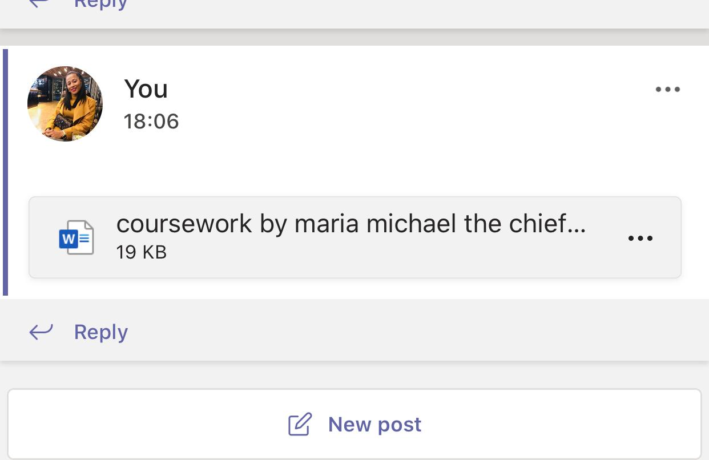

Appendix B
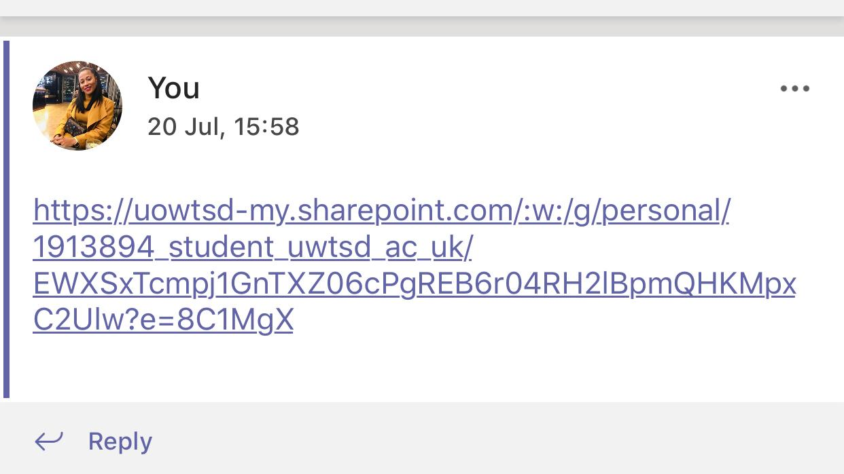

Appendix C


