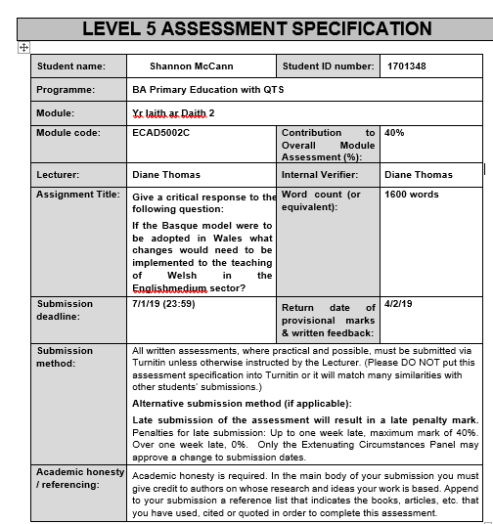

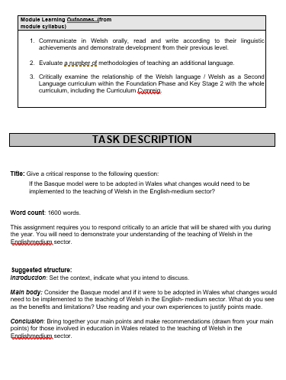
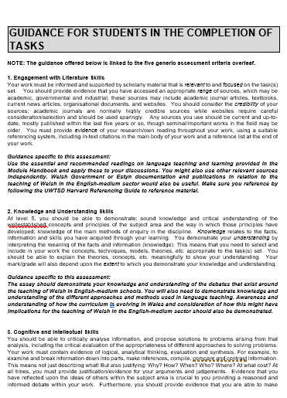
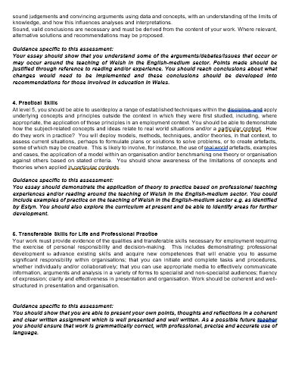
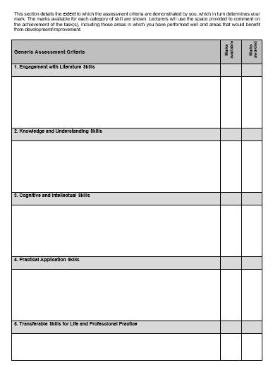

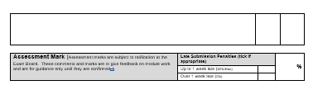
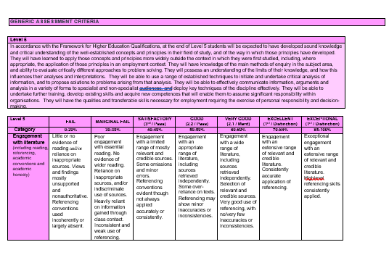
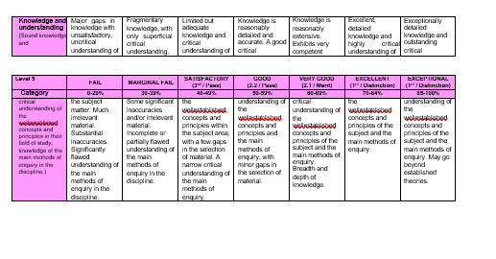
“Give a critical response to the following question: If the Basque model were to be adopted in Wales what changes would need to be implemented to the teaching of Welsh in the English-medium sector?”
This portfolio will emphasise the importance of applying the teaching of Welsh through the medium of English in relation to the Basque model proposed by Hopwood et al (2018). Currently, in education systems across Wales, there is an obligation to teach Welsh as a subject, yet the planning requires an improved strategy to engage the learners (Estyn, 2017). However, this emphasises the decline of Welsh speakers across Wales such that the Welsh Government (2017) demands the necessity of one million speakers by approximately 2050, which requires a further “483,000” (Estyn, 2017), to achieve the Government’s aim. According to Estyn (2017) and the Welsh Government (2013), implementing the Basque model will provide the population with the basic skills to use within their families, as well as the linguistical culture, that the Welsh Language provides.
According to the Welsh Government’s ‘One Language for All’ (2013) and Hopwood et al (2018), the current standard of Welsh within an education and workforce needs to progress rapidly such that practitioners are now enforced to be equipped with efficient skills within the Welsh Language, in order to portray a positive bilingual education, particularly in the foundation phase. However, the lack of confidence amongst the staff within the language averts the use of the language within the workforce such that many practitioners are reliant on the education system’s strategy rather than their individual knowledge and basic skills (Welsh Government, 2013). Consequently, according to Williams and Thomas (2017), this limits the rate of language being taught due to the lack of confidence of native speakers where the knowledge will be transferred from beyond a child’s domain.
Furthermore, according to Estyn (2013) and Furlong (2015), there is a need for consistent quality and supreme teaching standards within the upcoming practitioners who can portray the basic skills outstandingly throughout their practices. Consequently, further improvements need to be implemented with regards to training as currently, learners are not educated with the correct guidance and enough pedagogy through the Welsh language to be able to assess the development of the language successfully (Estyn, 2013). Supporting this, Richards and Rodgers (2014) synthesise that effective training programmes for both staff and pupils indicate that educators can express the Welsh skills learnt correctly in order to transfer to the pupils which complements the Welsh Government’s (2017) ‘2050’ arrangement in producing a partnership plan to practise the understanding of bilingualism. Additionally, Hopwood et al (2018) indicates that the Government in Basque provided training for trainee educators, however, Donaldson (2015)’s Successful futures states that the new curriculum should “ensure appropriate emphasis on the Welsh Language and culture”(Donaldson, 2015, p35) implying that the use of language and heritage should not interrupt the learning of other essential areas but complement it. Simultaneously, the Welsh Assembly Government (2009) acknowledges that reformation in Welsh Language requires the workers within the Government to be equipped with sufficient skills, as well as those in education, where training opportunities are provided such that “41% of the current WAG workforce” (Welsh Assembly Government, 2009, p4) are reasonably proficient within the Welsh language.
Moreover, Gruffudd (2000) and Richards and Rodgers (2014) synthesise that practitioners currently educate their pupils on the basic skills of the language in order to exceed an examination. This relies on the understanding of the four characteristics of teaching language and the practicality of the techniques that complement it (Cook, 2016). However, Hopwood et al (2018) introduces a much more beneficial programme of study within the English-medium sector, regarding model school B, where Estyn (2013) acknowledges that the expertise that have been taught through one language needs to complement the additional language, allowing enhanced communication. Additionally, Furlong (2015) complements Estyn’s (2013) synthesis such that all educators need to be able to provide an efficient environment for this process to commence along with the implementation of the LNF framework to continuously assess the progress through all areas of oracy. According to Learning Wales (2014) and Richards (2006), from the foundation Phase onwards, learners should be able to express opinions collaboratively whilst demonstrating understanding. Therefore, this implementation of enforcing B and D model schools where the use of a ‘CLIL’ approach is used, as mentioned within Hopwood’s (2018) findings, complements Garcia’s (2009) synthesis that educating a language through an intrinsic environment promotes the learners’ plurilingual understanding through the combination of both languages in all areas of the curriculum. On the other hand, an approach such as CLIL may be portrayed weakly due to the lack of resources and training that education systems can receive (Garcia, 2009).
The Basque model (Hopwood, 2018) insinuates that learners do not undertake any summative examinations until applying for higher education, therefore, learners are assessed through feedback which Garcia (2009) and Donaldson (2015) concur that constant feedback through communication is the best reliable and successful form within language. Therefore, the implementation of assessment through constant communication needs to be enhanced, as according to Estyn (2007), only a minority of the learners who partake in the current secondary level Welsh examinations, particularly the short courses, engage in being fluent after GCSEs due to not having the appropriate experiences to practise their Welsh. However, Estyn (2007) further indicates many schools are limited to short courses due to the lack and absence of educators skilled in the language.
Furthermore, Donaldson (2015) and Estyn (2008) articulate that within an English-medium sector, the outcomes and levels of attainment within Welsh Second-language at GCSE are beneath the levels within other areas across the curriculum. Despite this, the Welsh Assembly Government (2008) and Estyn (2008) propose that support to enhance the fluency of language and bilingualism is provided for learners when they leave school where “£1.2 million was allocated for developing Welsh-medium/bilingual 14-19 provision” (Welsh Assembly Government, 2008, p2).
In addition to this, Garcia (2009) and the Welsh Government (2017) acknowledge that learners need to be taught languages through environments that are linguistic and complements their first language in order to be meaningful. According to Hopwood et al (2018), language should be taught through a cross-curricular approach whereby media and technology should be enhanced supporting the third strategic theme of the Welsh Government (2017). However, Garcia (2009) also strengthens that being taught in a linguistic atmosphere impacts an individual’s life through the entitlement to observe qualities of life with the opportunity for language, implying that learners should not be differentiated against language.
Skehan (1988) and Estyn (2013) synthesises that educating a second language through differentiated abilities will provide the best teaching of the language as the learners’ abilities and outcomes will complement each other’s, however, this results in limiting most pupils to exceed their potentials. Donaldson (2015) supports this with the current view that learners do not have the confidence beyond the foundation phase to continuously use their knowledge of Welsh outside of their education system. Similarly, Williams and Thomas (2017) synthesise that a child’s confidence within language is dependent on the age where language was first introduced. Hence, the importance of the Welsh Government’s (2017) ‘2050’ proposal which complements the Basque model that schools taught through a medium of another language is much more efficient and favoured schooling system.
However, the concern of the age of introducing language occurs when, in comparison to families that include two adolescents knowledgeable in the language, Welsh is not being transferred through generations such that “one adult is able to speak Welsh, 45 per cent of children three to four years of age are able to speak Welsh” (Welsh Government, 2017, p7). Households that consist of one Welsh-speaker holds a threat of losing the Welsh Language which, as a result, will intervene with the future generation’s perceptions on the language (Welsh Government,2012). Nevertheless, individuals cannot be classified as monolingual for the lack of usage as they may develop their Welsh through other forms of communication such as through thoughts and other proficiencies in language (Baker, 2006). Although despite this, Baker (2006) supports the ideology that even though bilingualism is not as frequent as monolingualism, it can be considered to positively influence the intellect on individuals.
Therefore, to increase the use of language socially, the Welsh Government (2009,2017) intends to support the youth and families of all languages, with regards to camps such as the Urdd, in order to implement the use of language outside of a familiar education system. Additionally, it has become one of the Welbeing of Future Generation Act’s (2015) intentions to produce a community that embraces the Welsh heritage through every aspect of educational and social life. In similarity to Hopwood et al’s (2018) ‘Basque model’, children enter the foundation phase at a young age where communicating using language creates a much more positive perspective than those at key stage two (Donaldson, 2015, p59).
To conclude, Hopwood et al’s (2018) synthesis on the language system would be beneficial to implement in the practise of Welsh through English-medium schools as Baker (2006) and Garcia (2009) recognise the lack of motivation and cognitivism springs from the lack of experience children are provided within the language. Therefore, it is an essential attribute to provide language opportunities that aim to activate the learners’ knowledge along, enhancing the amount of interaction with the activities and their peers (Skehan, 1989). Thereby, emphasizing that communication is a significant element that requires more implementation as according to Gruffudd (2000) and Tabors et al (2008), dismissing experience, in an English-medium sector, that provide the learners to conspire limits the learning of the language. Moreover, applying Welsh in an English-medium sector will be of tremendous benefit when considering Hopwood et al’s (2018)’s idea of a trilingual approach, focusing on the families of the learners, as it simulates a partial role on the attitude and requirements of the learner (Baker, 2006). For instance, Baker (2006) and the Welsh Government (2017) concur that effective and purposeful planning needs to be implanted in order to create a positive approach to the medium of Welsh. However, this holistic approach can negatively differentiate learners who are non-native, therefore, it is essential to consider the levels of all learners in order to provide a meaningful approach.

Reference list
- Baker, C. (2006) Foundations of Bilingual Education and Bilingualism. 3rd edn. Clevedon: Multilingual Matters Ltd.
- Cook, V. (2016) Second Language Learning and Language Teaching. 5th edn. Oxon: Routledge.
- Donaldson, G (2015). Successful Futures. Cardiff: Crown. Available at: https://gov.wales/docs/dcells/publications/150225-successful-futures-en.pdf [Accessed: 2nd January 2019].
- Estyn (2008) Welsh-medium and Bilingual provision for 14-19 learners. Cardiff: Crown. Available at:
https://www.estyn.gov.wales/sites/default/files/documents/Welsh-medium%20and%20bilingual%20provision%20for%2014-19%20learners%20-%20May%202008.pdf [Accessed: 3rd January 2019].
- Estyn (2013). Welsh Language Development in the Foundation Phase. Cardiff: Crown. Available at:
https://www.estyn.gov.wales/sites/default/files/documents/Welsh%20Language%20Development%20in%20the%20Foundation%20Phase%20-%20January%202013.pdf
[Accessed: 2nd January 2019]
- Estyn (2017) Supplementary guidance: Welsh. Cardiff: Crown. Available at: https://www.estyn.gov.wales/sites/default/files/documents/Supplementary%20guidance%20-%20%20Welsh%20en.pdf [Accessed: 2nd January 2019].
- Furlong, J. (2015). Teaching Tomorrow’s Teachers. Oxford: University of Oxford. Available at:
https://beta.gov.wales/sites/default/files/publications/2018-03/teaching-tomorrow%E2%80%99s-teachers.pdf [Accessed: 3rd January 2019].
- Gruffudd, H (2000) Cymraeg Da. Talybont: Lolfa.
- Hopwood, M. et al., (2018) An overview of the assessment of language proficiency in a sample of bilingual jurisdictions: Section 5. The Basque Country. Yr Athrofa: UWTSD. Available at : https://www.qualificationswales.org/english/publications/bilingual-language-proficiency-2018/ [Accessed: 2nd January 2019].
- Learning Wales (2014) National Literacy and Numeracy Framework. Available at: http://learning.gov.wales/resources/browse-all/nlnf/framework?component=literacy&year=6938335_2&lnf_aspect=7853039___5808711__Speaking&lnf_aspect=7853039___5808711__Listening&lnf_aspect=7853039___5808711__Collaboration+and+discussion&lnf_aspect=7853233___5809437__Language&lnf_aspect=7853233___5809437__Handwriting,+Grammar,+Punctuation,+Spelling&selectedYear=col_5&lang=en [Accessed: 2nd January 2019].
- Richards, J.C. (2006) Communicative Language Teaching Today. Cambridge: CUP. Available at: https://www.professorjackrichards.com/wp-content/uploads/Richards-Communicative-Language.pdf [Accessed: 6th January 2019].
- Richards, J.C , Rodgers, T.S. (2014). Approaches and Methods in Language Teaching. 3rd edn. Cambridge: CUP.
- Skehan, P. (1989) Individual Differences in second-language learning. London: Edward Arnold.
- Tabors, P et al (2008). One Child, Two Languages: A Guide for Early Childhood Educators of Children Learning English as a second-language. 2nd edn. Maryland:Brookes.
- Welbeing of Future Generations Act (2015) Welbeing of Future Generations Act (Wales) 2015. Available at: https://futuregenerations.wales/wp-content/uploads/2017/01/WFGAct-English.pdf [Accessed: 3rd January 2019].
- Welsh Assembly Government (2009) Iaith Pawb and Welsh Language Scheme Annual Report 2008-09. Cardiff: Crown.
Available at:
https://gov.wales/docs/drah/publications/20100106iaithpawbwlsannualreport2008-09-e.pdf [Accessed: 3rd January 2019]
- Welsh Government (2012) A Living Language: a language for living. Welsh Language Strategy 2012-17. Cardiff:Crown.
Available at:
https://gov.wales/docs/dcells/publications/122902wls201217en.pdf [Accessed: 4th January 2019]
- Welsh Government (2013) One Language for all: Review of Welsh Second Language at Key Stages 3 and 4. Caerphilly: Crown.
Available at:
https://dera.ioe.ac.uk/20135/2/130926-review-of-welsh-second-lan-en.pdf [Accessed: 4th January 2019]
- Welsh Government (2017) Cymraeg 2050: A million Welsh speakers. Crown: Cardiff. Available at:
https://gov.wales/docs/dcells/publications/170711-welsh-language-strategy-eng.pdf [Accessed: 2nd January 2019].
- Williams, N. , Thomas, E. M, (2017). ‘Exploring Minority language input sources as means of supporting the early development of second language vocabulary and grammar.’ Vol. 38(4), pp855-880. Cambridge: CUP. DOI:10.1017/S0142716416000473

