TASK 2 - Illustrated Book Project Proposal Task
500 words, due 5pm Feb 12th, submitted via moodle.
Formatting: please use the headings below making use of the advice and resources provided. References should be made using the Harvard format.

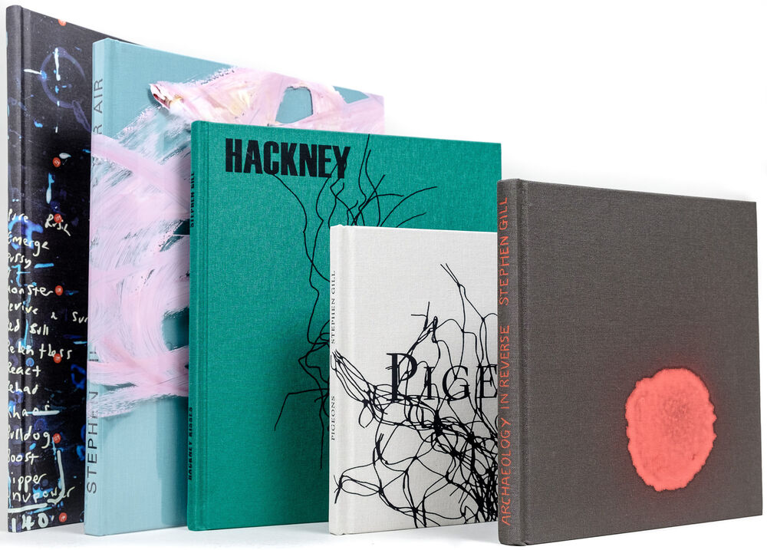
Name:

Theme/Context
Provide a brief summary of the theme or subject you want your work to focus on. You might include details about the impact you hope to achieve, how the book format will help you connect with your audience, and what will make your work stand out. (300 – 500 words)
For this project, I will use data as the foundation for my photographic work, mapping real-world statistics onto physical locations to uncover hidden narratives within everyday spaces. By using data driven photography, I aim to highlight overlooked societal issues and how they manifest in the landscapes we pass through daily. My focus will be on locations tied to significant but often unnoticed public safety concerns, using publicly available datasets to guide the project’s direction. This approach will transform abstract numbers into visual narratives, making these issues more tangible and emotionally resonant.

The final theme will be determined by the data I collect, but potential areas of exploration include fatal road crossings, overdose deaths, and missing persons cases. If I focus on Fatal Crossings, I will map road deaths and high-risk pedestrian zones using data from CrashMap.co.uk, UK Department for Transport reports, and local council safety records. This would highlight locations where infrastructure has failed to protect people, raising questions about road safety and urban planning. Another possible direction is Silent Deaths, which would document sites where overdose deaths or unclaimed fatalities have occurred, using coroner’s reports, NHS statistics, and charity data. This theme would expose the hidden spaces of crisis within urban and rural areas, drawing attention to issues such as addiction and homelessness. Alternatively, I may explore Missing Voices, investigating disappearances and unsolved cases using police missing persons databases and local news reports. This would examine how some cases receive widespread attention while others are forgotten, questioning societal perceptions of who is deemed important.

The book format will play a crucial role in how I structure this project and engage my audience. One option is to design it like a vehicle logbook, a format directly tied to the "Fatal Crossings" theme, reinforcing the idea of roads as spaces of both movement and tragedy. This format could incorporate elements such as official looking forms, annotated maps, and checklists, mimicking the structured documentation used to record a vehicle’s history, but instead chronicling lives lost on the road. If I choose another theme, the book format could shift accordingly, a coroner’s report or case file for Silent Deaths, presenting each location as an official case study.

By combining data and photography, I aim to create a project that not only documents overlooked tragedies but also challenges the audience to reconsider the spaces they interact with daily. While statistics provide factual insight, they often fail to evoke an emotional response. My work will bridge this gap by making the numbers visible within the context of the real world, demonstrating how data shapes our lived experiences.

Influence
Highlight the work of a photographer who currently inspires your work. Analyse an image of theirs and explain your interest in their work. Consider style, theme, context, practical technique. (300 – 500 words)

Edmund Clark is a photographer who merges data, documentary photography, and investigative research to expose overlooked issues related to crime, violence, and state control. His work often focuses on hidden systems of power, such as surveillance, incarceration, and extraordinary rendition, using a combination of traditional photography, archival materials, and official data sources to construct visual narratives that reveal systemic abuses.
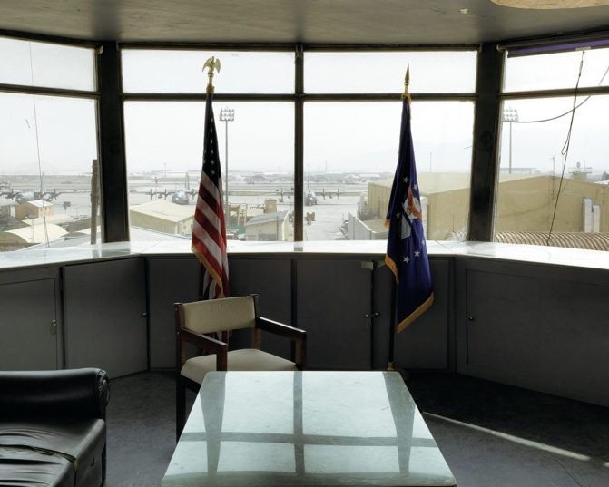
One of his most striking projects, Negative Publicity: Artefacts of Extraordinary Rendition, examines the secretive world of extraordinary rendition: the illegal detention and transportation of suspected terrorists by intelligence agencies. In this series, Clark photographs detention centres, legal documents, and restricted spaces to illustrate the scale of these hidden operations. A striking example of Clark’s approach is his photograph of a military office or control tower overlooking an airfield, which captures themes of power, surveillance, and authority. The empty chair and presence of American and Air Force flags symbolise institutional control and absence, while the sterile glass table and worn furniture suggest the transient nature of military power. The muted colour palette and lack of people create a cold, bureaucratic atmosphere, reinforcing Clark’s method of exposing hidden systems without showing direct violence. Through careful framing and natural light, the image compels viewers to consider the unseen forces behind war and state control.

I find Clark’s work very compelling because it exposes the hidden mechanisms behind state power, crime, and violence. He doesn't just document individual stories—he maps out entire systems, often using data, reports, and legal documents as visual elements. His approach to photography is investigative, forcing viewers to engage with evidence rather than just imagery.

Technically, Clark employs long-exposure and atmospheric photography to evoke a sense of unease, while also incorporating found imagery, declassified documents, and restricted-access locations into his projects. His collaborations with journalists, human rights lawyers, and activists further ground his work in factual accuracy, reinforcing its role as both art and investigative journalism. By combining data-driven research with photographic evidence, Clark’s work acts as a visual indictment of state secrecy and human rights abuses, urging viewers to question the power structures that shape contemporary society.

Book Form
Referencing the session PowerPoint on Moodle (or another relevant source), discuss at least one book that has influenced you. Explore its visual and aesthetic qualities, social or historical context, impact, or practical methods relevant to your theme. You may also evaluate its overall effectiveness. (300 – 500 words)
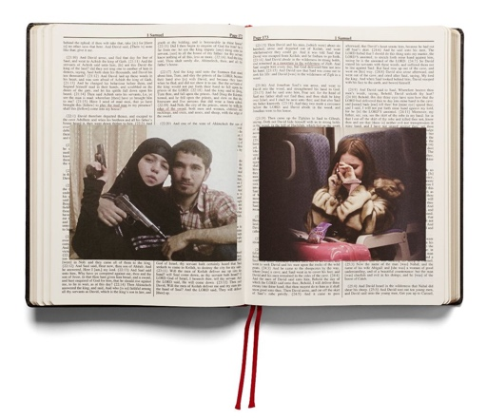
Adam Broomberg and Oliver Chanarin’s the Holy Bible has influenced how I could structure my book, particularly in using format to subvert expectations. Just as The Holy Bible mimics the appearance of a traditional religious text while revealing unsettling documentary imagery inside, I could design my book to resemble a logbook: something ordinary and official but once opened, it would challenge the viewer’s assumptions. This approach would play with perception, making readers question the authority and reliability of institutional documents while exposing hidden or overlooked narratives.

Visually, I could adopt a structured, official-looking format like a standard logbook, with numbered pages, dates, and a uniform layout. However, much like The Holy Bible integrates archival images and underlined biblical passages to critique the relationship between faith and violence, I could incorporate documentary photographs, maps, or declassified reports that contrast with the expected neutrality of a logbook.

Beyond its visual approach, The Holy Bible is significant in its critique of power, history, and ideology. It questions how religious texts have been used to justify oppression, much like how institutional records and official documents can be manipulated to obscure truth. This concept of challenging authority through unexpected presentation is something I want to incorporate into my work, using my logbook format to highlight overlooked or hidden issues.

Practically, The Holy Bible demonstrates a method of visual storytelling that merges photography, archival research, and conceptual design. By treating the Bible as both an artifact and a medium for critique, Broomberg and Chanarin push the boundaries of documentary photography, encouraging a deeper engagement with context and meaning. Their use of found imagery and text annotation serves as a reminder that photography is never neutral.

Overall, The Holy Bible is a groundbreaking work that challenges traditional perceptions of both religious texts and photographic archives. Its aesthetic qualities, social critique, and innovative use of photography make it an essential reference for understanding the relationship between imagery, history, and authority. By forcing viewers to reconsider the connections between faith and violence, the book remains a compelling and unsettling exploration of power dynamics embedded in both scripture and visual culture. Drawing from this, I could structure my book to similarly challenge perceptions of authority and documentation, using the familiarity of a logbook format to reveal deeper, often hidden truths.

