Marketing Plan of Moxy Hotel to increase the social media engagement.

Rosario del Rocio Garcia Baez

2230623

Marketing Essentials: BMIH1005

Luciana Suardi

Words count: 1374

March 09, 2023

Introduction

The purpose of this marketing plan is to increase social media engagement in Moxy hotel to strategically utilize social media platforms to increase brand awareness, attract new customers, and drive bookings. By identifying the target audience, developing a unique selling proposition, and creating visually appealing and engaging content, Moxy hotel can effectively reach its target audience and stand out from competitors. Millennial Appeal: 5 Ways Hotels Are Engaging Gen Y (huffpost, 2017).
By implementing a purposeful marketing plan for social media advertising, Moxy hotel can increase its visibility and revenue in a cost-effective manner.
Specifically, a marketing plan for Moxy hotel will include the following components:
SOSTAC analysis, 4’Ps, Marketing Mix, Bowmans (Blythe and Martin, 2019).

Situation Analysis

5 'C's analysis is a framework for evaluating a business situation to identify opportunities and threats and develop effective strategies.

- Company: Moxy Hotel is a brand owned by Marriott International, a leading hotel and hospitality company with a portfolio of more than 30 hotel brands. Moxy Hotels are designed for the modern traveller who is looking for a stylish and affordable stay in a central location. Moxy Hotels feature tech-enabled rooms, vibrant social spaces, and a welcoming atmosphere (Moxy Hotels-Marriott).
- Customers: The target customers for Moxy Hotel are young professionals and millennials who are looking for a fun and affordable travel experience. These customers are tech-savvy and value convenience, comfort, and social engagement. They prefer to stay in centrally located hotels that offer easy access to local attractions and nightlife. Cristina (2022) For which age group is Moxy Hotels designed?
- Competitors: Moxy Hotel faces competition from other mid-range hotel brands that cater to young professionals and millennials. Some of its main competitors include Aloft Hotels, Courtyard, W Hotel.
Moxy Hotel also competes with vacation rental companies such as Airbnb.
- Collaborators: Moxy Hotel collaborates with various partners to enhance its guest experience. These partners include local restaurants, bars, and attractions that provide recommendations and discounts to Moxy Hotel guests. Moxy Hotel also partners with technology providers to offer a seamless and tech-enabled experience to its customers (Marriott International, 2022).
- Climate: PESTLE (Macro analysis) (Christopher, 2011)
Political: Changes in government policies and regulations can impact the hotel industry, such as changes in tax policies or immigration policies affecting staffing.
Economic: Economic trends, such as recessions or fluctuations in currency exchange rates, can affect demand for hotel stays.
Social: Changing social trends, such as increased demand for sustainable or socially responsible hotels, can impact Moxy hotel's brand image and customer base.
Technological: Advancements in technology, such as online booking platforms or mobile apps, can impact the hotel industry and Moxy hotel's marketing strategies.
Legal: Changes in laws and regulations, such as new safety or environmental regulations, can impact hotel operations and costs.
Environmental: Changes in environmental regulations or consumer demand for sustainable practices can impact Moxy hotel's sustainability initiatives and branding.

Objectives

A smart target for Moxy Hotel to increase their social media advertising could be to achieve a 20% increase in their social media engagement rate within the next six months. This can be measured by tracking the number of likes, comments, shares, and overall interactions on their social media platforms, such as Facebook, Instagram, Twitter, and Tik Tok.
To achieve this target, Moxy Hotel could focus on creating more visually appealing and shareable content, such as high-quality photos and videos that showcase their unique and stylish design, amenities, and location. They could also collaborate with social media influencers and travel bloggers to reach new audiences and increase their brand awareness (Tuten, 2017).

.
Strategy

- User-generated content: Encourage guests to share their experiences on social media by running UGC contests, featuring guest posts on the hotel's page, and incentivizing sharing.
- Influencer partnerships: Partner with social media influencers in the travel and hospitality industry to showcase the hotel's unique offerings and generate buzz.
- Live streaming: Host live streaming events, such as virtual tours, behind-the-scenes looks, and Q&A sessions with hotel staff, to give followers a taste of the Moxy experience.
- Hashtag campaigns: Develop a branded hashtag campaign to encourage guests to share their experiences and engage with the hotel on social media.
- Social media advertising: Utilize targeted social media advertising to reach a wider audience and drive engagement with specific promotions, events, or offerings.

By implementing these strategies, Moxy Hotel can increase its social media engagement, build brand awareness, and create a community of loyal customers who are excited to share their experiences with others. Millennial tourist emotional experience in technological engagement at destination (Universiti Teknologi Malaysia, 2019).

Tactics

Marketing mix: (McCarthy 2002)
In 1960s, E. Jerome McCarthy developed the “4Ps of marketing” model, which include
product, price, place, and promotion. This model has become the most widely used
framework for understanding and managing the marketing mix (Yudelson 1999).

- Product: Moxy Hotel offers a unique and playful atmosphere that sets it apart from traditional hotels. The rooms are compact but functional and offer a range of amenities and services tailored to the needs of younger travellers. (Vastint, 2023)
Moxy Hotel can continue to differentiate itself by expanding its offerings, such as hosting more events, offering unique services, or partnering with local businesses to create memorable experiences for guests.
- Price: Moxy Hotel is known for its affordable rates, making it an attractive option for younger travellers who prioritize value for money.

- Place: Moxy Hotel can consider opening new locations in popular tourist destinations or expanding its presence in areas where it is already established (SimilarWeb, 2021).
- Promotion: Moxy Hotel can use a range of marketing tactics to promote its services, including targeted social media campaigns, influencer marketing, and hosting events. Moxy Hotel can also leverage user-generated content to showcase its unique offerings and engage with its target audience. To increase its brand awareness, Moxy Hotel can also consider running ads in online and offline media channels. Can I bring my dog to Moxy Hotels? (Bringfido, 2022).

Action

This step involves outlining what exactly the project entails, what goals the hotel wants to
achieve, and how success will be measured. Croft (2015) Learning Gannt Charts
Moxy Hotel want to increase engagement on social media such as Facebook, Instagram,
Twitter and TikTok by 20% within six months (Bowen and Ozuem, 2016)

Identify tasks:
• Conducting research to identify the hotel's target audience on social media
• Identifying relevant hashtags and keywords for social media posts
• Developing a content calendar for social media platforms
• Creating and publishing social media posts
• Monitoring engagement and adjusting the social media strategy accordingly

Each task has a certain time to be completed.

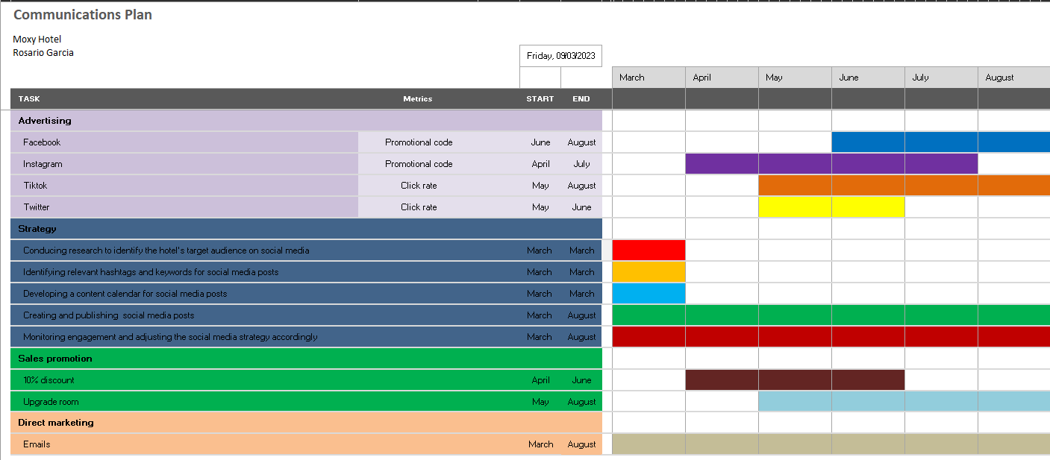

Control

To increase social media advertising, it will be implementing several strategies. Firstly, we can identify our target audience and create engaging and relevant content that appeals to them. We can also collaborate with social media influencers to reach a wider audience. Additionally, we can invest in paid advertising on various social media platforms and optimize our campaigns based on performance metrics such as click-through rates, impressions, and engagement rates.
To measure the success of our marketing plan, we can track several key performance indicators. Firstly, we can monitor the number of new customers acquired through social media advertising campaigns. We can also track changes in brand perception and customer sentiment towards our brand using social media listening tools. Finally, we can analyse the impact of our advertising campaigns on the company's profitability and return on investment. By regularly monitoring these metrics, we can assess the effectiveness of our marketing plan and make data-driven decisions to optimize our strategy.

Conclusion

Increasing social media advertising for Moxy Hotel requires a targeted approach that focuses on identifying the right audience and delivering engaging and relevant content. The use of social media influencers and paid advertising can also be employed to reach a wider audience. Measuring success through the number of new customers, positive brand attitudes, and increased profitability is crucial. With regular monitoring and analysis of key performance indicators, data-driven decisions can be made to optimize the marketing plan and ensure its effectiveness. By implementing these strategies, Moxy Hotel can increase its visibility and reach on social media platforms, attracting new customers and improving overall profitability. Social media for business (Australian government, 2022)

References

Australian Government (2022) Social media for business. Available at: Social media for business | business.gov.au (Accessed 05 March 2023)

Bowen, G. and Ozuem, W. (2016) Competitive social media marketing strategies. Edited by G. Bowen and W. Ozuem. Hershey, PA: Business Science Reference.

Blythe, J. and Martin, J. (2019) Essentials of marketing. Seventh edition. Harlow, England : Pearson Education.

Bringfido (2022) Can I bring my dog to Moxy Hotels? Available at: https://www.bringfido.co.uk/blog/moxy-hotels-pet-policy/ (Accessed 06 February 2023)

Christopher, M. (2011). The PESTLE analysis: a framework for environmental scanning. Engand: Kogan Page Publishers.

Cristina, M. (2022) For which age group is Moxy Hotels designed? Available at: (1) (pilotplans.com) (Accessed 07 March 2023)

Croft, C. (2015) Learning Gantt Charts. Carpenteria, CA: linkedin.com.

Huffpost (2017) Millennial Appeal: 5 Ways Hotels Are Engaging Gen Y
Available at: https://www.huffpost.com/entry/millennial-appeal-5-ways_b_6598652 (Accessed 06 March 2023)
.
Marriott International Inc. (2021). Moxy Hotels. Available at: Moxy Hotels | Marriott News Center (Accessed 05 March 2023).

McCarthy E.J, William D. P (2002) Basic Marketing: A Global-Managerial Approach. 14th edn. Place of publication not identified: The McGraw-Hill Companies

Nur Shuhadah Mohd et al. (2019) ‘MILLENNIAL TOURIST EMOTIONAL EXPERIENCE IN TECHNOLOGICAL ENGAGEMENT AT DESTINATION’, International Journal of Built Environment and Sustainability, 6(1-2), pp. 1–7. Available at: MILLENNIAL TOURIST EMOTIONAL EXPERIENCE IN TECHNOLOGICAL ENGAGEMENT AT DESTINATION – DOAJ
(Accessed 04 March 2023)

SimilarWeb Ltd. (2021) SimilarWeb - Digital Market Intelligence & Website Traffic. Available at: https://www.similarweb.com (Accessed 03 March 2023).

Tuten, T.L. (2017) Social media marketing. 3rd edition. Thousand Oaks, CA: SAGE Pub.

Vastint (2023) Moxy Hotel. Available at: https://vastint.eu/hospitality/moxy-hotels/ (accessed: 03 March 2023).

Yudelson, J. (1999). Adapting Mccarthy’s Four P’s for the Twenty-First Century. Available at: https://doi.org/10.1177/0273475399211008 (Accesseed 03 March 2023)

Appendix A

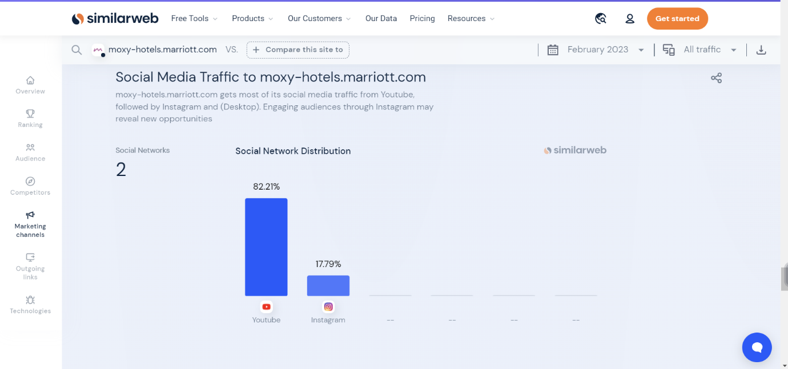
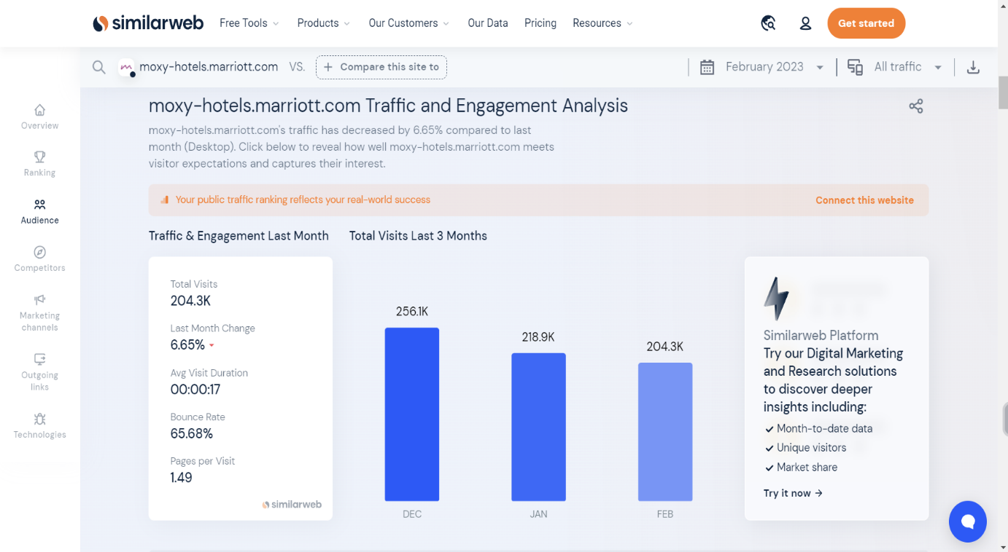

Appendix B 

