

LOCATION: Swansea | LLEOLIAD: abertawe
LEVEL 4 | LEFEL 4
EXAMINATION PERIOD | CYFNOD ARHOLIADAU
JAN 2026 | JAN 2026

MODULE CODE: ACDA4013
Embedded C

Marking Scheme

QUESTION 1
Design a circuit using the PIC16F877A microcontroller, where LEDs are connected to pins RB0 through RB7, each with a 100Ω current-limiting resistor. The LEDs should turn ON simultaneously, with a delay of half a second.
The project should include the following components:
  - Design the circuit using simulation software. [10 Marks]
  - Write a C program to accomplish the specified counting task. [10 Marks]
  - Execute the simulation to verify the operation of the circuit and program. [5 Marks]
SOLUTION

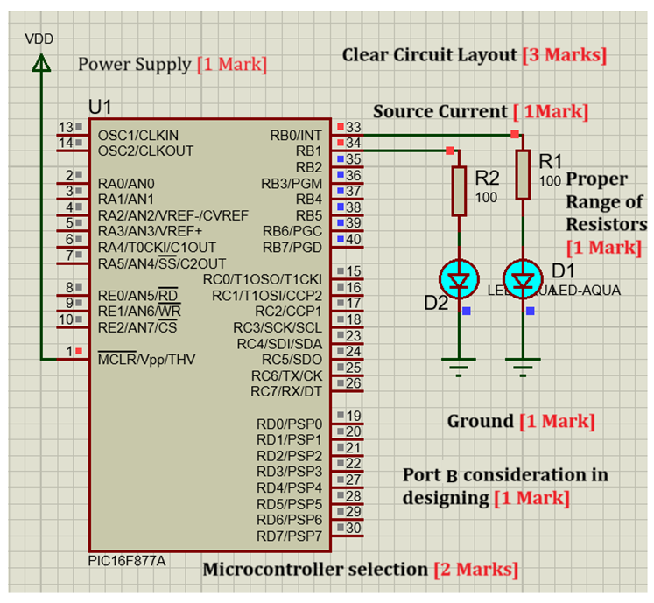
- Program
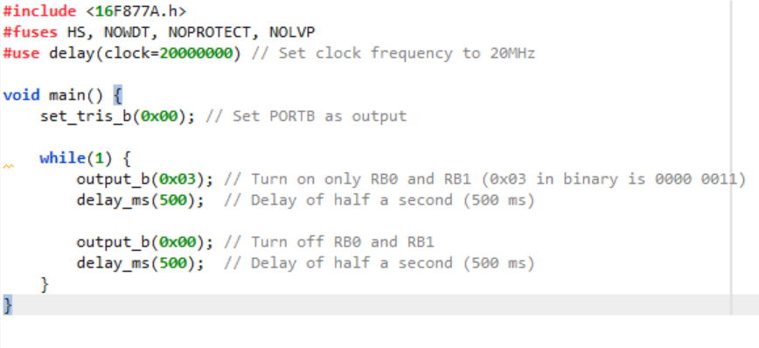
The following criteria’s could be taken into consideration while marking the programming lines :
- Comments: For adding meaningful comments in the program. [2 Marks]
- Variable Naming and Declaration: Considering the Ports from the question and declaring them. [ 1 Mark]
- Code Structure and Readability: Marks for logical Flow and easy understandability.
[2 Marks]
- For Setting Proper Delay as required. [1 Mark]
- Correctness and Functionality: Lighting up the segments as required. [2 Marks]
- Code optimization: minimizing unnecessary operations. [2 Marks]
- Executing the Simulation. [5 Marks]
QUESTION 2
Demonstrate a down counter using 7- Segment Display by considering the following conditions.
- When a push button is connected to port pin RC7 is pressed once, the 7 segments should count down from 9 to 1 within a delay of 100ms.
- The counter should stop counting when the button is released.
The project should include the following components:
- Design the circuit using simulation software. [10 Marks]
- Write a C program to accomplish the specified counting task. [10 Marks]
- Execute the simulation to verify the operation of the circuit and program. [5 Marks]
SOLUTION
- Circuit Design
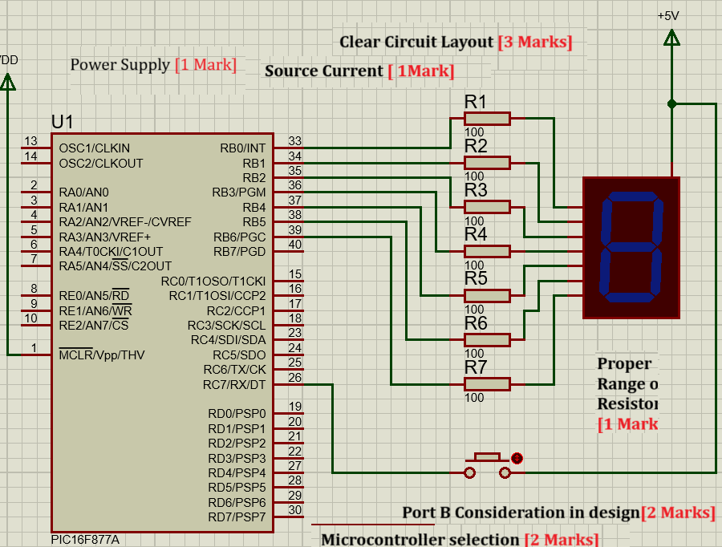
- Program
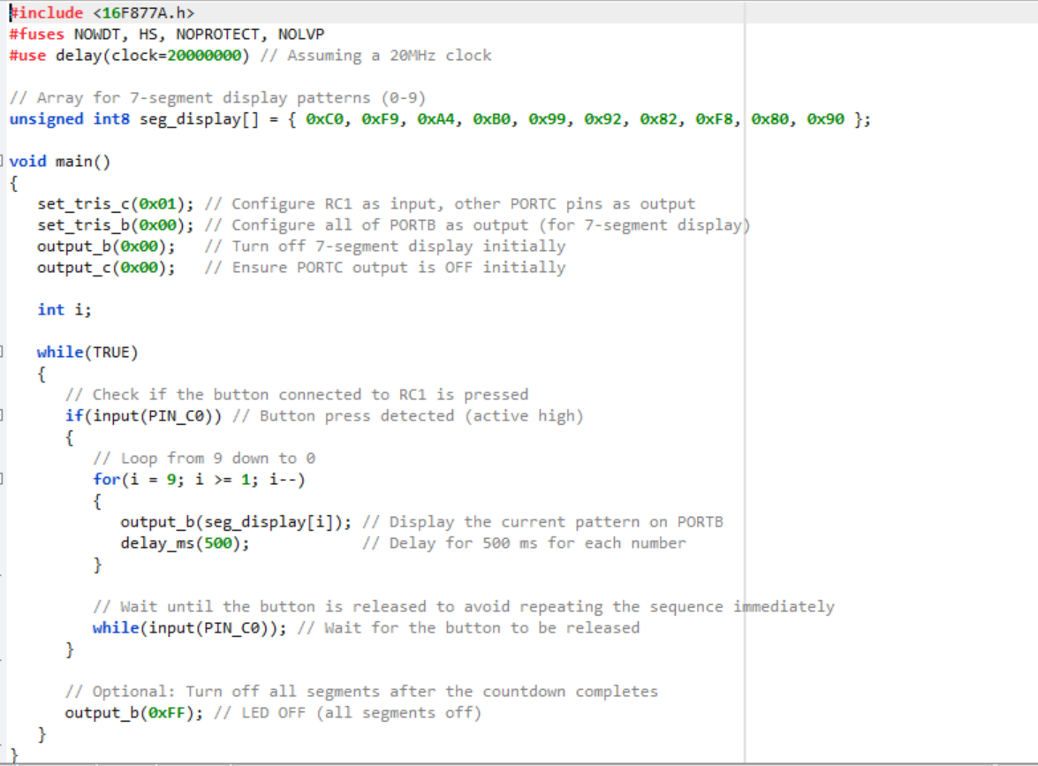

The following criteria’s could be taken into consideration while marking the programming lines :
  - Comments: For adding meaningful comments in the program. [2 Marks]
  - Variable Naming and Declaration: Considering the Ports from the question and declaring them. [ 1 Mark]
  - Code Structure and Readability: Marks for logical Flow and easy understandability
[2 Marks]
  - For Setting Proper Delay as required. [1 Mark]
  - Correctness and Functionality: Lighting up the segments as required. [2 Marks]
  - Code optimization: minimizing unnecessary operations. [2 Marks]
- Executing the Simulation. [5 Marks]

QUESTION 3
- The circuit shown below has been made available to you on Moodle, named ‘Question 3’,
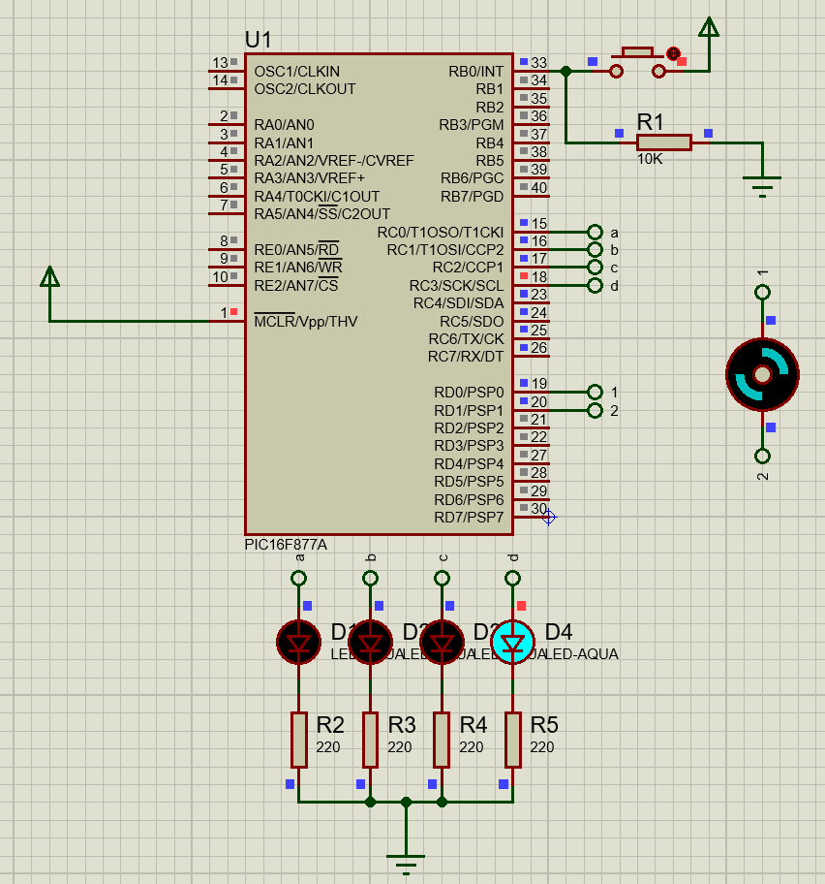
Simulate the provided Proteus circuit file on Moodle. Observe its behaviour when the push button is pressed. Identify the sequence and logic of operation of the LEDs and motor. Then, Answer the following questions.
- Based on your understanding from the simulation:
- Write a CCS C program that exactly replicates the working of the circuit. [13 Marks]
SOLUTION
SAMPLE PROGRAM
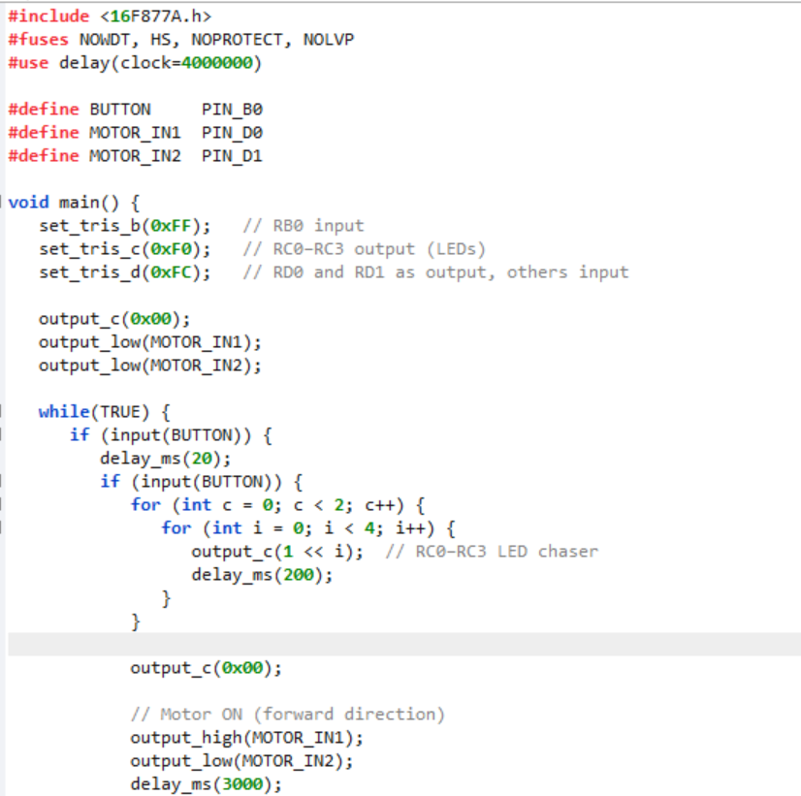
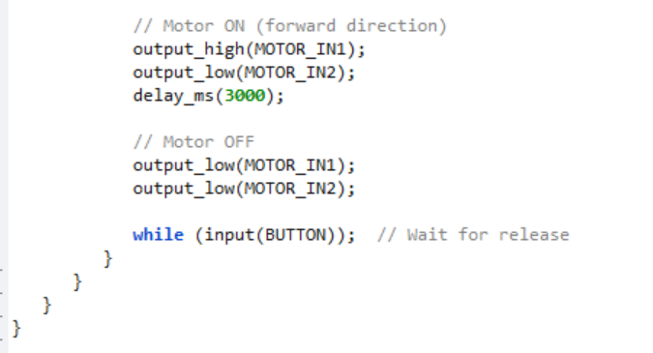
The following criteria’s could be taken into consideration while marking the programming lines :
  - Comments: For adding meaningful comments in the program. [2 Marks]
  - Variable Naming and Declaration: Considering the Ports from the question and declaring them. [ 2 Marks]
  - Code Structure and Readability: Marks for logical Flow and easy understandability
[3 Marks]
  - For Setting Proper Delay as required. [2 Marks]
  - Correctness and Functionality: Lighting up the segments as required. [2 Marks]
  - Code optimization: minimizing unnecessary operations. [2 Marks]

- Briefly explain:
- What happens when the button is pressed? [4 Marks]
SOLUTION
When the button connected to RB0 is pressed:
- A left-to-right LED chaser pattern is activated on RC0 to RC3, where each LED turns ON one at a time with a 200ms delay. This chaser effect repeats for two full cycles. [2 Marks]
- After the LED pattern completes, the DC motor is turned ON for 3 seconds. Once the 3 seconds have passed, the motor turns OFF, and the system waits for the next button press to repeat the process. [2 Marks]

- How the motor and LEDs are controlled using PORTC and PORTD. [4 Marks]
SOLUTION
- PORTC is used for controlling the LEDs, with RC0 to RC3 as output pins. Each LED is activated by sending a logic HIGH to the corresponding pin using output_c().
- PORTD is used for motor control, specifically RD0 and RD1. These pins are set HIGH or LOW to control the direction or stop the motor. [2 Marks]
- The program sets TRIS registers to configure PORTC and PORTD pins as output.
- The LEDs and motor are activated through bit manipulation and output functions (output_c(), output_high(), output_low()). [2 Marks]

- The role of RD0 and RD1 in motor control. [4 Marks]
SOLUTION
- RD0 and RD1 are connected to the IN1 and IN2 pins of an H-bridge motor driver (e.g., L293D). To turn the motor ON in one direction, RD0 is set to HIGH and RD1 is set to LOW.
[2 Marks]
- To stop the motor, both RD0 and RD1 are set to LOW. This allows the microcontroller to control the motor’s rotation and stop functions through simple digital signals.
[2 Marks]
QUESTION 4
Below is the given Program
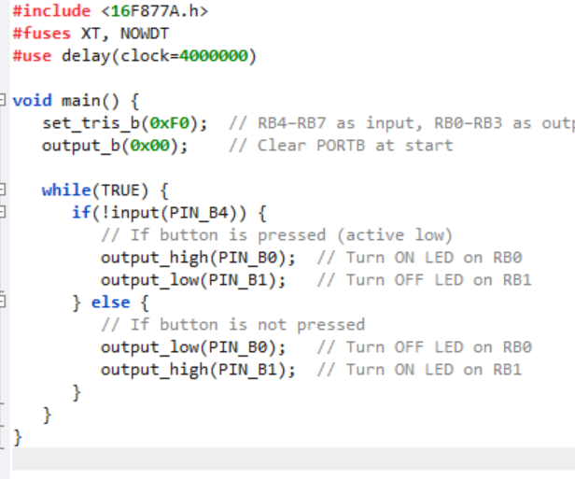
Answer the Following
- Identify and describe the operation performed by the program when executed.
[5 Marks]
SOLUTION
- The program monitors a push button connected to RB4.
- When the button is pressed (logic LOW on RB4):
  - LED on RB0 is turned ON
  - LED on RB1 is turned OFF [3 Marks]
- When the button is not pressed:
  - LED on RB0 is turned OFF
  - LED on RB1 is turned ON
- It implements conditional LED control based on button input. [2 Marks]

- Based on your understanding of the program, design a circuit schematic that would support its functionality. [5 Marks]
SOLUTION
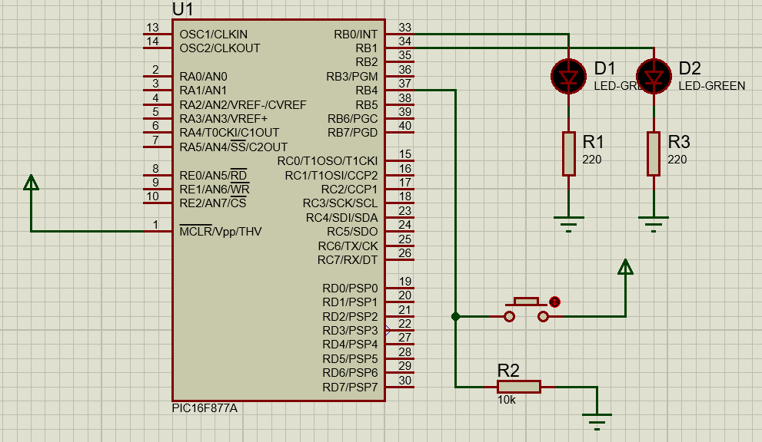
The Schematic should include the following
- PIC16F877A. [1 Mark]
- Push button connected to RB4 (PIN_B4) with a 10kΩ pull-down resistor.
[1 Mark]
- LEDs connected to RB0 and RB1, each in series with a 220Ω current-limiting resistor. [1 Mark]
- Proper microcontroller setup: power (Vdd/Vss), reset (MCLR with pull-up), and oscillator. [2 Marks]

- Write and run the program in a simulation environment. Provide a screenshot of the simulated circuit. [5 Marks]
SOLUTION
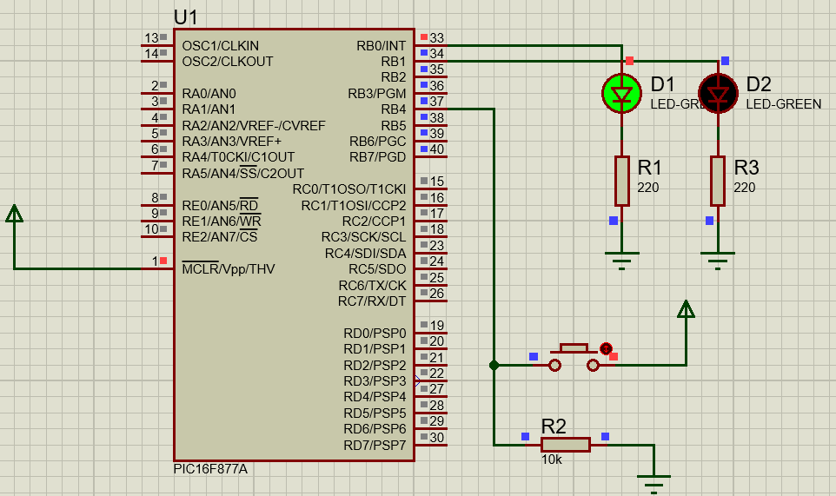
Proper Simulation Execution [5 Marks]
Partial Execution [2 to 3 Marks]
- What does the set_tris_b(0xF0) instruction indicate regarding PORTB configuration? [5 Marks]
SOLUTION
    - set_tris_b(0xF0) sets:
- RB7–RB4 (upper nibble) as inputs
- RB3–RB0 (lower nibble) as outputs [3 Marks]
- It configures PORTB to handle button input on RB4 and LED output on RB0 and RB1.
[2 Marks]
- Explain how the LED switching in the program is controlled in real time without using any delay. [2 Marks]
SOLUTION
The program continuously checks the state of the button in a while(TRUE) loop. Since there is no delay_ms() function, the microcontroller responds immediately and continuously to any change in the button state. This allows the LEDs to switch ON or OFF in real time depending on whether the button is pressed or not. [2 Marks]
- What issues may arise if the button input is connected without an appropriate pull-up or pull-down resistor? [3 Marks]
SOLUTION
- The input pin may float and pick up noise. [1 Mark]
- It can cause unstable or false triggering. [1 Mark]
- The microcontroller might misinterpret button state, leading to unpredictable behaviour. [1 Mark]

Diwedd/End

