Application of design thinking in packaging design

College: University of Wales Trnity Saint David
Major Visual communication design
Student: Jingzheng Wang

15th Dec .2022

Ⅰ. Introduction

Hong Kong is a market-driven economy, and in the early 60's it was a market-driven economy. In the early 1960s, Hong Kong design was in short supply due to a lack of professional education”（2016）“. In the early 1970s, thanks to the rise of Hong Kong's tourism industry, there was a shortage of local designers. A large number of international visitors came to Hong Kong. The return of international designers to Hong Kong. In 1966,”（2001）“ the establishment of the Hong Kong Trade Development Council (HKTDC)”（2011）“ led to the demand and development of design in many Hong Kong companies. The establishment of the Hong Kong Trade Development Council in 1966 led to the development of many of Hong Kong's corporate design needs. He had no formal education in design and only joined design firms to gain experience. With his talent for absorbing and integrating regional cultural characteristics, he has created a very Chinese yet modern design. He has won more than 100 design awards in Hong Kong and internationally, and has developed his own unique design style. "They see the East from a Western perspective, and what we see as insignificant, they see as quite artistic, such as chopsticks and birdcages. ...This is what Chen Youjian said when he talked about those foreign advertising agency owners, which gives us an important communication to understand the 'East meets West' characteristic of his designs. Chen Youjian's success, in our view, owes much to this, as many Western cultures were disseminated in Hong Kong due to the early colonial rule. In the 1970s and 1980s, Chen Youjian worked in Western advertising agencies and learnt to use a foreigner's perspective to understand traditional Chinese culture and to appreciate it, and to present his designs in a unique and innovative way. Since the 1970s, he has created a large number of outstanding works of art and design, with bright colours, simple and profound shapes, and the concept of combining East and West, which has been an example of the combination of art and merchandise in Hong Kong graphic design for over 40 years. The core design concept of "East meets West" is the best footnote of Chen Youjian's fame at home and abroad. This paper analyzes the local design form in China through the study of Chen Youjian's design philosophy and works. This paper explores how to create a design style that is both East-meets-West and marketable.

Ⅱ.The concept of design thinking

Graphic design is the communication and integration of life and art, which requires the designer to have the ability to express flexible ideas and the breadth of thinking, so as to achieve the effect of holding up one thing to another and achieving the effect of touching the other. An excellent designer should not only have the ability to create innovative works, but also have the ability to think differently, to create designs from the perspective of the viewer, which is also an important part of completing the design communication, thus capturing the psychology of the viewer.
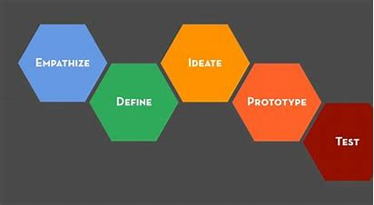
（Five stages of design thinking）
Creative thinking is the heart and soul of graphic design, and designers can give full play to reasonable associations and imagination to give deeper meaning to their works, so that the designer's ideas can be better displayed. The humanistic ideas injected into the design are the designer's guideposts. The added value contained in simple, clear design works is infinite, which means that the infectious power of the humanistic ideas in them is enormous. The process of constructing a creative concept is not an overnight result, but a process that requires the designer's repeated reflection, careful thought and constant practice; seemingly ordinary images will no longer be bland after the designer's "magic" processing, injecting new vitality into the work and producing a unique effect that resonates and moves the mind.
The ultimate purpose of design is to meet the needs of public life, but also carries the inescapable responsibility and mission of designers, so that graphic design is also an integral part of designers to experience life and sense the changes of the times, which will lead designers to conceptual innovation. The competition for far-reaching graphic design creativity is becoming increasingly fierce, and the role of technology alone cannot be based on development; designers need to have a strategic vision of development and a perfect combination of technology and art in order to close the distance with life, make full use of the platform of graphic design for bold and innovative practice, and form a good cycle for the future development of designers.

Second, the style and taste of the design work
The level of style of a graphic design work usually reflects the designer's artistic taste. Excellent designers always conceive with unique thinking ideas and design concepts, constantly thinking and innovating. Like other art disciplines, graphic design has a language of its own. The design ideas that exist in the designer's brain are integrated and conditioned by various elements, resulting in a design work with deep connotations and depth of thought. This is a testament to the fact that art is above life and comes from life.
In general, the idea of the design work should be in line with the expression of the theme, and the form should pursue novelty so that the admirer can find the centre of interest from the work; only in this way can the graphic and content-rich work be presented clearly as a whole, achieving a high degree of unity of feeling and context and obtaining a perfect communication of visual effects. Through the designer's minimalist treatment, the shapes and colours form an effective order, making the theme of the design work more prominent and clear, with a sense of beauty and latent meaning.
The language and style of graphic design is not a hollow, superficial form of worship, but a true representation of the designer's inner thoughts; there is nothing good or bad about style itself; if you are serious about style, you will often lose the most important thing. The same phrase, presented in different ways, has different meanings; the designer's duty is to bring out the innermost thoughts of the designer.The idea of design is conveyed through a unique and individual design. The passion for design drives designers to think constantly, and the pursuit of individuality does not mean that designers remain one-sided and narrow-minded, but rather that they use more innovative forms of design to give the viewer a refreshing sensation.
The breadth and depth of a designer's thinking and creativity is not the result of imagination, it is a summary of life experience and a presentation of inspiration inspired by various observations of life. The designer must learn to think from multiple perspectives and win the public's approval with his or her knowledge of graphic design; when appreciating a design work, one can feel the designer's tendency to express his or her thoughts and the type of design style through the work, which is also a reflection of the designer's comprehensive quality. The rhythm and rhyme of the work, as well as the conveyance of the theme, can be presented in a completely different way by different designers.
Adhering to their own unique design concept is also an important condition for a graphic designer to be able to gain a foothold, and can bring into play the characteristics and advantages of the region. The creative thinking of graphic design is derived from the artistic refinement and generalised expression of the national cultural accumulation. Good cultural cultivation and quality is also a good quality that designers must have. "The Tao gives birth to one, one to two, two to three, three to everything; all things bear Yin and hold Yang, and impulse the air to merge." Laozi, who advocated the Tao of nature; Confucius, who advocated "ritual", focused on the realisation of humanistic thinking; Zhuangzi, who "cared for the old as well as the old, and for the young as well as the young", also focused on the promotion of humanistic thinking. With the rapid development of science and technology and the operation of the market economy, the excessive pursuit of profit has caused a great negative impact on humanistic thinking, which has also led to a crisis of humanistic thinking, and the social responsibility of designers should also focus on those additional spiritual aspects of meaning.
It is possible for designers to absorb and learn from the excellent achievements and valuable experience of their predecessors, but it is more important to form their own set of language system on the basis of absorption and borrowing, and to reconstruct their own language system, which is also a process of self-reflection and review for designers, and a process of reacquainting themselves, so as to better expand their own design path.
In short, with the rapid changes in the era of graphic design innovation, the creation of graphic design has the support of higher technology equipment, and this rapid development is a serious challenge and a good opportunity for designers; the creation process of graphic design is not only the expression and presentation of pure technology, but also a medium and a way to convey the creativity of designers' thinking. In a new era, designers' design concepts will be deeply rooted and recognised, and the road to design will be even more colourful.

Ⅲ.Analysis of Design Thinking by Chen Youjian

"They look at things in the East from a Western perspective, and what we see as insignificant, they see as quite artistic, such as chopsticks and birdcages. This is what Chen Youjian said about the foreign advertising agency owners, which gives us an important communication point for understanding the 'East meets West' character of his designs. The success of Chen Youjian is, in our view, largely due to the fact that much Western culture was disseminated in Hong Kong during the early years of colonial rule. In the 1970s and 1980s,
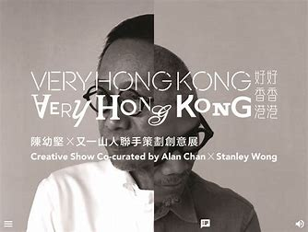
（Chen Youjian won the prize of GDC Award Professional Group in 2017）

Chen Youjian worked in Western advertising agencies and learnt to borrow a foreigner's perspective to understand Chinese traditional culture, to appreciate it and to present his design work in a unique and original way. In Chen You's work, we can see the breadth of his life experience and his understanding of the living environment, so that his work has a grounded quality, which stems from his familiarity with and love of traditional Chinese culture, and his ability to transcend himself and use a Western perspective to observe Chinese traditional culture. In the process, he discovers new things and explores new highlights, creating works that combine Western artistic expressions with Eastern charm and spirit, giving them a distinctive character. Chen Youjian's design thinking is based on a deep understanding of the spirit of traditional Chinese culture and a full appreciation of the various design trends from Western culture, combining the East with the West and the West with elements of Chinese folklore. In this way, he is able to combine tradition and modernity to create a form of art and design that meets the requirements of a pioneering society. It cannot be denied that Chen Youjian is committed to the idea of 'fusing the East and the West and re-creating them'. Chen Youjian is a solid commercial designer, but his designs are given a new lease of life that many designers do not have. His designs are always considered from a different perspective, neither purely artistic in the sense that they are appreciated, nor do they completely abandon art for the market. His designs are often presented as market-oriented, customer-oriented works. This market-oriented approach to design is linked to his initial entry into the design industry. He said, "All graphic designers come from graphic design, but I am different, I come from advertising design." In other words, when Chen Youjian creates, his design thinking starts with market research. "Creativity is all about psychology, and I am more careful. It's not just a flat design, it's a way of thinking.

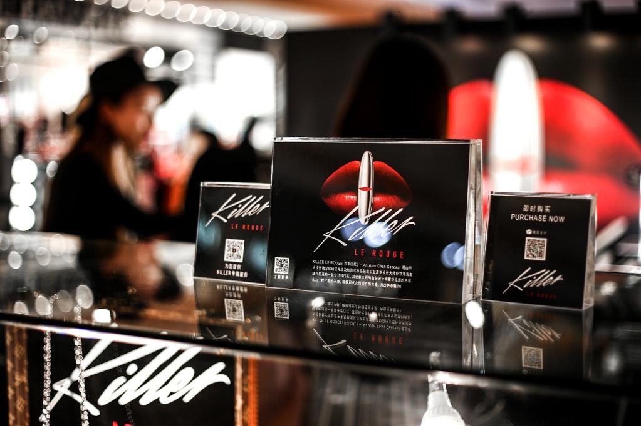
（Chen Youjian's Design Thinking on Lipstick Packaging）
In Chen Youjian's design process, he always believes that the most important thing is to have a clear positioning and a clear goal, so that a lot of creative ideas can be created naturally. This also requires a creative person to be good at observing the lives of ordinary people, the customs and habits of different places, and capturing the social psychology of different people in the wider social context. The flexibility of Chen Youjian's design thinking can be seen in his attitude towards women. He believes that "the most interesting thing about women is that out of ten women, all ten are different. Nine out of ten men are the same. It's not that men don't feel it, it's just that they don't care as much, or they don't express it. So ．．．．．． I can see a lot of insight in them that I would never have thought of normally. He also takes into account the forms and expressions that people like and innovates on this basis, giving his works a new look, a new emotion, and a visual feast of beauty. Creative thinking in Chen Youjian's designs is a form of thinking that breaks the mould and opens up new possibilities. Creative thinking is the integrated use of various forms of thinking and has the essential characteristics of scientific thinking." Chen Youjian attaches great importance to creative thinking, which he considers to be a form of pioneering and innovation. It is the harmonisation of multiple forms of thinking, an efficient synthesis and continuous development of the thinking process. We can see that Chinese traditions are always shaped by creation. If the Song people had only copied the Tang poems and dared not go beyond the limits, there would be no tradition of Song lyrics. This is particularly true in the design profession, where without a creative spirit, there would be no unique personal style, and where a focus on tradition without innovation would be as undeveloped as a failure to engage with tradition. This creativity has always been at the back of Chen Youjian's mind. In Chen Youjian's work, we can feel a sense of pride and commitment to traditional Chinese culture, and this dedication to tradition has not made him stagnant. The work is metabolised and transformed into a design that is wholeheartedly Chen Youjian's. He draws inspiration from traditional and practical art and popular culture to bring out the brightest spirits in his designs, finding valuable materials for his creations and creating a wide range of designs. "Design is not something you read, it's something you do." This quote by Chen Youjian shows that in the process of creation, one should dare to practice, to create, to go beyond the framework of books and to put them into practice. On the one hand, you can create a bond with the hearts and minds of your audience; on the other hand, you can open up the aesthetic consciousness of the public and set a trend. In Chen Youjian's work, we find that his works have taken on a new sense of life through his practice of looking at life and laying it out with clear and crisp design techniques.

IV. Chen Youjian on the packaging design of Coca-Cola

Designer Chen Youjian has created a new streamlined Chinese font for the Coca-Cola logo, replacing the Chinese font that has been used in the Chinese market since 1979. The Coca-Cola Company is the world's largest beverage company and a market leader and pioneer in the distribution of soft drinks, which have been popular worldwide for over 110 years.

（Old Coca Cola Chinese）
Wherever you are on the planet, Coca-Cola is at your fingertips - it's everywhere; it's more than just a bottle of soft drink, it's a brand and a cultural and artistic value. Whenever Coca-Cola launches a new product or changes its packaging, it attracts the attention of the market and the public, not only for the product itself, but also for the design of its packaging, which is a highlight that attracts people's attention. The packaging design of Coca-Cola's products has provided enough assurance of a successful marketing environment. The new streamlined Chinese font, designed by renowned Hong Kong advertising designer Eugene Chan in 2003, is more in tune with the overall style of the English font and logo, replacing the Chinese font that Coca-Cola had been using since its return to the Chinese market in 1979. Alan Chan, 53, is one of Hong Kong's most celebrated and award-winning designers. Alan Chan was named one of the top ten design firms in the world by GRAPHIS magazine, the only Chinese design firm to receive this award. His posters and watches are even included in the permanent collection of the Museum of Modern Art in San Francisco, USA. With a deep love of traditional Chinese culture, Chen Youjian has brought East and West together in a more rational way in his design philosophy. He has successfully blended Western aesthetics with Eastern culture, giving his work a traditional charm without losing the elegance of fashionable taste. The Coca-Cola logo is designed with a red background, a rhythmic silver and white wave pattern, and the distinctive white letters CocaCola in red, silver and white. The design of the Chinese typeface incorporates the graphic features of the English Spencerian typeface, with the starting and ending strokes of the text transformed into a wavy ribbon pattern, and the white English written in the Spencerian typeface overlaid with a silver border, thus enhancing the harmony between the stylistic features of the two typefaces. With its distinctive expression shaping a personalised visual identity and making the brand quickly recognisable to consumers, the text gives the brand a charismatic art form of individuality. The implementation of a seemingly simple design into four square characters was not easy. It took several months of conceptualisation and revision to create a new logo full of modernity, instantly recognisable as the new member of the "COCA-COLA" family, after careful study of the "COCA-COLA" English logo, using the ribbon and the curvature of the strokes.
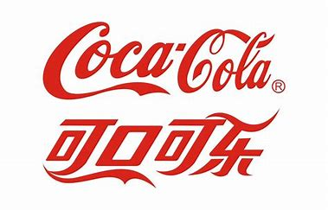
（Coca Cola Chinese and English）
A new member of the "Coca-Cola" family. It's a real feat. The new logo is now spreading rapidly with the Coca-Cola campaign and various products, and has become a new fashion icon!

V Summary

The study of the development of human history and culture is not intended to recreate the past, but only to better serve the present and the future. Western culture certainly has its own merits, but we cannot just absorb it all. Nowadays, in the field of domestic graphic design, as various waves of new art from abroad continue to flood around our traditional culture, it is particularly important for us to be able to influence the compatibility of East and West without losing the balance. Some designers in Hong Kong and Taiwan are far ahead of mainland designers in their control of the oriental flavour, and Chen Youjian, a representative of contemporary Hong Kong culture, is a leading figure in the successful integration of East and West. He is undoubtedly known as one of the leading figures in China's current art scene and the number one pioneer of contemporary graphic design. In my opinion, the idea of 'integrating the East with the West' is Chen Youjian's ultimate artistic pursuit and can also serve as a summary of his lifelong design philosophy. In order to provide a reference for the development of modern art and design in China,（2011） this paper presents an in-depth analysis of the significance of Chen Youjian's design from his own background and living environment, in order to explain the characteristics of his design style. Chen Youjian's use of Western techniques to express traditional Chinese thought and his use of advanced scientific concepts to enrich classical art have demonstrated to the world the profound cultural heritage of modern Chinese design and its unlimited potential for external development, and his unique design style has led us to the forefront of China's current graphic design scene. This paper delves into the ideological level, focusing on Chen Youjian's design and artistic style, and discusses the concept of Chen Youjian's design and artistic creation for over forty years, while focusing on his life experience, social background, and the connotation of cultural consciousness reflected in his works, with a more comprehensive analysis and deeper discussion. I also explore the design truths that have gradually emerged from the profound cultural traditions of Eastern thought; the need for human visual language to be enriched by life experiences; the fact that design is centred on creativity, which comes from life, progresses from thought and develops from innovation; and reveals the essence of design, telling people that they should stay close to reality and put people first. In addition, I read further into Chen Youjian's design thinking and design works in order to better learn from his creative thinking and the cultural meaning brewed in his works. What I like about this artist is about his infectious creativity in his design consciousness and field, a clever blend of Eastern and Western cultures, allowing traditional Chinese culture to be reinterpreted and redeveloped on the world stage, something that every one of us present-day Chinese designers should uphold.

Reference

- Submitted to University of Central Lancashire

- Submitted to Segi University College

- chinese4u.edublogs.org

- Submitted to University of Melbourne

- www.reed.edu

- Submitted to University of Sheffiffiffield

- M.W. Luke Chan, Wendy Rotenberg. "Accounting, Accounting Education, and Economic Reform in the People’s Republic of China", International Studies of Management & Organization, 2016
Publication

- thecurrentconscience.com

- W. Ling, G.2001 Taylor. "Fashion in Hong Kong: A Dual Product of Globalisation and Cultural Phenomena", Journal of the Textile Institute,

- Auyeung, Poyin 2011. "Art, urbanism, and public space: Critical spatialresponses to urban redevelopment in Beijing (1976--2000)", Proquest,

11、Xin, Mengni 2021 . "Impacto Da facilitacao Do comercio Ao Longo Do "Belt and Road" Nas exportacoes Chinesas", Universidade de Lisboa (Portugal),

Bibliography

1、Submitted to University of Central Lancashire

- Submitted to Segi University College

- chinese4u.edublogs.org

- Submitted to University of Melbourne

- www.reed.edu

- Submitted to University of Sheffiffiffield

- M.W. Luke Chan, Wendy Rotenberg. "Accounting, Accounting Education, and Economic Reform in the People’s Republic of China", International Studies of Management & Organization, 2016

8、thecurrentconscience.com

9、W. Ling, G. Taylor. "Fashion in Hong Kong: A Dual Product of Globalisation and Cultural Phenomena", Journal of the Textile Institute, 2001

10、Auyeung, Poyin. "Art, urbanism, and public space: Critical spatialresponses to urban redevelopment in Beijing (1976--2000)", Proquest, 2011.11

11、Xin, Mengni. "Impacto Da facilitacao Do comercio Ao Longo Do "Belt and Road" Nas exportacoes Chinesas", Universidade de Lisboa (Portugal), 2021

