Research Proposal
Robert James
P144088
BSc Applied Computing
Assessor: Sue Maw
Contents
Title 2
Background 2
About the DVLA 2
Field of Study 3
Aim of the Project 5
Expected Outcomes 5
In Summary 5
Research and Development Methods 6
Philosophy 6
Approach 6
Strategies 6
Data Collection 7
Development Methodology 7
Risks 9
Analysis of Data 10
Resources and Planning 11
Project Plan Gantt Chart 12
References 14
Figures 16
Bibliography 17

Title
The title of this piece of work is ‘An Evaluation of How Effective Usability Principles and Persuasive Systems Concepts Are When Designing An Account Based Mobile Application For Vehicle Management In The UK.’ This is topical due to the widespread media coverage of soaring figures of untaxed vehicles in the UK.

Background
In 2013, the then Chancellor of the Exchequer, George Osbourne, announced the abolition of the paper tax disc [6], 93 years since it was first issued on January 1st 1921. The Government announced this would result in savings of around £10 million per annum on an ongoing basis each year tax discs were not produced [6]. The paper tax disc was essentially a receipt to display in a vehicle windscreen, to evidence the tax for that vehicle had been paid. With the advances in computing and data sharing, the police and the Driver and Vehicle Licensing Agency (DVLA) no longer use tax discs to verify if a vehicle has been taxed [6]. They now enforce vehicle excise duty (VED) evasion based on their ability to use technology such as Automatic Number Plate Recognition (ANPR) to check DVLA’s electronic record [6] to see if a vehicle is taxed or not.
Coinciding with the removal of the tax disc, another change in vehicle taxation occurred. When a vehicle changes ownership, the tax is now refunded to the previous keeper. It no longer transfers to the new keeper [7]. This now requires a new keeper to tax their newly acquired vehicle prior to driving it on the road [7].
In the years since these changes were implemented, the Government’s own statistics show that VED evasion has increased threefold, since the year before the changes being introduced [8]. There has been widespread media coverage of this fact, with headlines of vast sums of money lost as a result of the abolition of the tax disc [9] [10] [11].

About the DVLA
In the United Kingdom, prior to a vehicle being used on a public highway, it must be registered with the DVLA, taxed, insured and MOT’d, dependant on its age [1]. To comply with UK legislation, all registered vehicles, must either be taxed, or have been declared SORN (Statutory Off Road Notification) [2] if not being used on the road. There are a number of exemptions to this [2], most commonly Crown and emergency services vehicles and historic vehicles, which are classified as such by having been constructed more than 40 years ago from present day.
The Motor Car Act of 1903, was the first act of Parliament that required drivers of motor cars to be registered, as of 1st January 1904 [3]. Vehicles were also registered, required to display registration plates which were unique to each vehicle, and had to be taxed annually [4]. Up until 1965, the registration of drivers and vehicles had been administered by local councils. In 1965 this was centralised at the Driver and Vehicle Licensing Centre (DVLC) in Swansea [4]. During the 1990’s the DVLC had a name change to DVLA, to reflect its status as an executive Agency of the Department for Transport (DfT) [5]. Today, DVLA’s databases hold over 48 Million active driver records and over 40 million active vehicle records [5]. They are the part of Government responsible for collecting Vehicle Excise Duty (VED) commonly referred to as road tax. DVLA collects in excess of £6 billion annually in VED [5].
The DVLA offers online, paper, telephone and face to face transaction channels, to enable customers to comply with legislation relating to driving and owning a vehicle in the UK. However, each transaction you complete with DVLA is stand alone. To tell DVLA you’ve sold a vehicle, purchased a vehicle and tax your new vehicle requires the user to complete three separate transactions. There is no single place a user can go to update the information the DVLA holds on them, to transact digitally, customers are required to visit GOV.UK’s website to select standalone online transactions [12]. DVLA’s digital services lack the ubiquitous customer account and mobile app, bringing access to the benefits such technology could bring. In 2018, DVLA is still posting out paper based V11 Vehicle Tax Reminder letters to vehicle owners who chose to tax their vehicle annually or twice per annum [13].

Field of Study
In 2018, it is common for large retailers to offer account based mobile applications (apps), such as ASOS [14], Amazon [15] and eBay [16] see figures 1 and 2 below.
Figure 1
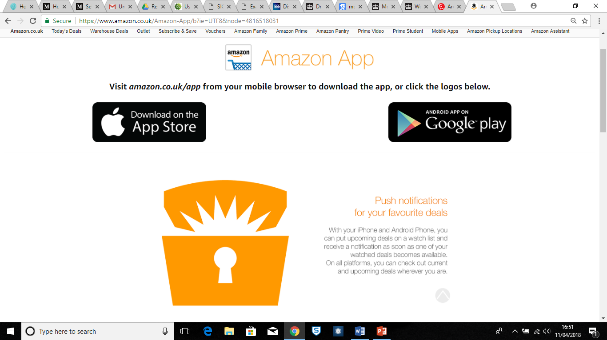

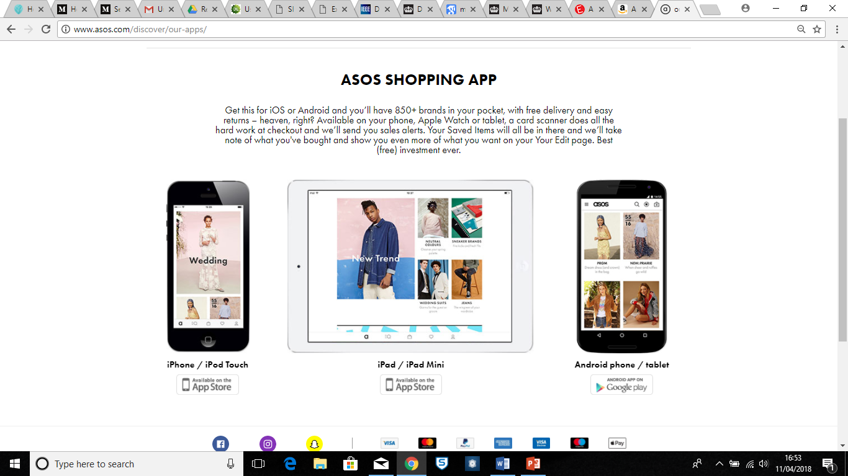
Figure 2

Use of native apps across Government is actively discouraged by the Government Digital Services (GDS) [17]. Although, some departments have managed to make a case for these and offer them to users [18]. There are different approaches to building apps for mobile, such as native apps or progressive web apps, [19] but this is not the focus of this project. However, it is the features of mobile apps and the convenience they offer both users and the issuing organisation that are of particular interest.
The two biggest mobile platforms are Android and iOS [24]. Mobile apps enable organisations to create a direct engagement and marketing channel to their users, remain visible and deliver value to their users [25]. Mobile apps allow the organisation to deliver new use cases that are uniquely enabled by mobile [26], ranging from capturing data with the devices camera to sending users push notifications. Users are drawn to using mobile apps that make transacting using paper obsolete and offer a level of convenience not found within other devices and channels [26]. Mobile apps are still able to offer value to users even when offline [27].
A feature of mobile applications that is used to deliver new and time relevant information to users are push notifications [28]. Push notifications are used in persuasive systems. These are systems which attempt to bring about a change in user behaviour [20]. Persuasive systems are commonly used in healthy eating and fitness apps [21]. In the 21st century the processes of persuading humans to alter their behaviour has moved from human to human interaction [22], to digital to human interactions. Due to the ability to communicate frequently and directly with the user by machine [23]. When building persuasive systems, it is important to consider the audience that you are trying to persuade, and tailor the design of the systems and interactions to your target audience [29]. Oinas-Kukkonen and Harjumaa created the Persuasive Systems Design Model (PSD) see figure 3, as a tool for capturing requirements for persuasive designs.
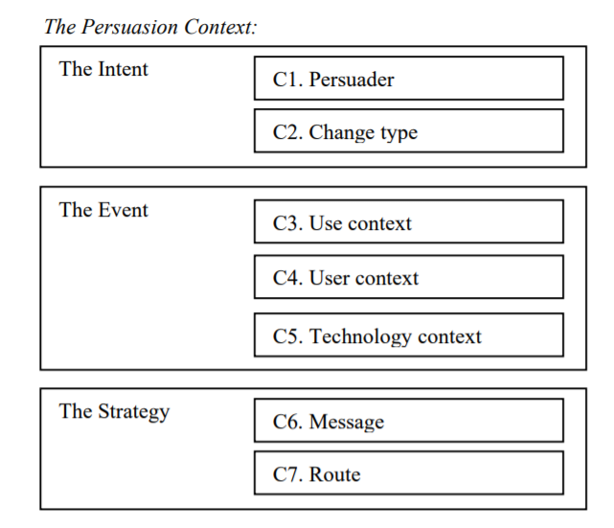
Figure 3

When it comes to designing a user interface, it is important that the user experience meets the user needs. Design guidelines can be especially useful for new and inexperienced developers and designers [31] by providing them with best practice techniques and methods in interaction design. Guidelines are a framework to design within, rather than being prescriptive design blueprints [32].
The World Wide Web Consortium (W3C) publishes guidelines relating to accessibility, usability and inclusion [30]. These guidelines are primarily focussed on removing any design elements which would prevent or impede users with disabilities from using the web, including mobile apps [30]. A quick search of the web will return many versions of interaction design guidelines [33]. Of all the guidelines out there, Jakob Nielsen’s 10 Usability Heuristics for User Interface Design [34] and Ben Schneiderman’s 8 Golden Rules of Interface Design [35] are two of the most well-known. Nielsen states that the principles he and Rolf Molich came up with, may appear obvious to most people, but he suggested executing them, is often not easy [36]. For widespread good design of user interfaces it is important that usability design principles are kept simple and are easily implementable [37]. This project will look at both Schneiderman and Nielsen’s guidelines and evaluate their impact on the design of the mobile application.

Aim of the Project
The aim of the project is to design and evaluate a mobile application interface, using persuasive system techniques and usability design guidelines, which could lead to improved DVLA customer compliance with legislation, relevant to owning and driving a vehicle in the UK and aid other aspects of vehicle management.
To achieve this aim, the following objectives need to be achieved.
- Conduct a literature review in to mobile application use, usability design guidelines and persuasive systems.
- Identify features that could lead to improved compliance with legislation relevant to owning and driving a vehicle in the UK.
- Design an interface for the mobile application.
- Evaluate the mobile app prototype for usability and ease of compliance.

Expected Outcomes
It is expected that the project will deliver a full interface design for a mobile application which could be delivered as part of an organisational project. The design will include features that are not currently available to users of DVLA’s existing digital services.
The interface design will be developed based on user needs and refined through the process of user testing. The user interface will be easy to use and intuitive. It will offer good affordance to users, allowing them to use their tacit knowledge of navigating other apps. The application design will include elements of persuasive systems, in order to encourage user compliance with vehicle related legislation in the UK.
The project will evaluate the effectiveness of usability guidelines on the interface design and make recommendations for the most effective usability guidelines.

In Summary
In this section the aim of the project has been stated, to design and evaluate a mobile application interface which will use elements of persuasive systems and follow usability guidelines and some objectives of how that will be achieved have been listed. It has been explained that this is a topical piece of work, due to the recent media coverage of increasing VED evasion and the likely influences on this this. Some information has been provided on the specific areas of mobile application design, relevant to this project, usability guidelines and persuasive systems.

Research and Development Methods

Philosophy
Before the project can start, research will need to be conducted and in order to do this a research methodology must be decided on. The philosophy being used for this research is positivism. Positivism regards human knowledge gained through experience, using human senses as factual and scientific [38]. This is advantageous for this study, where data will be collected from users of the interface. This method will allow for statistical analysis, enabling evaluation of the effectiveness of usability guidelines and persuasive system techniques. The research will collect primarily quantitative data and where qualitative data is gathered, this will be converted in to quantitative data to aid analysis. A criticism of positivism is that it aims to explain but not understand events [43]. Therefore, during data collection this project will, whilst capturing the data through observation in order to explain the ‘what’, ensure it collects data to provide elements of the ‘why’. This will attempt to mitigate against the short coming of the positivism method.
There is an overlap with the phenomenology philosophy of research, due to the subjectivity around capturing user feedback on the interface design. Phenomenology places greater emphasis on what we feel and perceive than scientific data [39]. Therefore it’s not an appropriate primary methodology for this project, but it is recognised there is an amount of overlap.

Approach
The approach for this research is deductive, meaning that it will test a hypothesis based on existing theories [40]. As this project will evaluate usability of a mobile interface based on existing usability guidelines, it is appropriate to follow the deductive approach. Deductive research starts with a theory or pattern that is expected and tests this against observations [42]. This project will test established usability guidelines, which provide the designer with certain expectations about the interfaces usability, and tests this with real world user evaluations of the design. The alternative would be to follow the inductive approach, which is a more fluid process where the nature of the research may change throughout the research period, beginning at more open and general ideas moving through towards more conceptual ideas [41]. Criticism of the deductive approach says it discourages open and unrestrained thinking by starting with an already known theory or expected outcome [44]. The aim of this project is to evaluate the effectiveness of the established thinking. Therefore this is project is focussed on understanding the benefits and disbenefits of a particular idea and is not constrained by it.

Strategies
This project will employ three strategies during the course of its research. These are:
- Document Review
- Survey
- Software Development
The document review will provide a good understanding of key subject areas including the elements of persuasive system design and usability guidelines. This will allow for a sound understanding of the key design elements required in the application design to enable it to function as a persuasive system, attempting to influence user behaviour in an ethical way. The survey will enable me to carry out a task analysis, to understand what users would want to use the application to do and how they would best like to do that. This will enable me to put together a definition of what the application should be able to do. I will use the MoSCoW criteria to define the minimum viable product (MVP), as well as identify the could haves and won’t haves.
The software development will be the development of the interface using software tools. This will enable the testing of the electronic interface with users, allowing me to simulate user journeys and evaluate the effectiveness of the interface design, in meeting user requirements and usability guidelines.

Data Collection
Once the document review has been conducted in to the topics related to this project, a task analysis will be conducted to understand user needs of an application for vehicle management. As well as their preferences when it comes to design and layout of menus and other application features. This task analysis will inform the design of the application interface, which will be subjected to user experience testing.
The task analysis will gather a mixture of quantitative and qualitative data through the use of a survey. The survey will be targeted at customers of DVLA and will seek to identify if there are differences in the use of, and preferences in design of mobile apps by different age groups. This is relevant because the results of this will impact the design features. Any qualitative data captured will be analysed and assigned value weighted classifications. This will allow for statistical analysis of the data. The user experience testing will seek to collect majority quantitative data directly from the user. Where qualitative data is collected at source from the user, this will be assigned value weighted classifications to allow for statistical analysis also.
The purpose of the collection and conversion to quantitative data, is to allow for identification of trends and patterns within the data, through the use of graphs and other visualisations.

Development Methodology
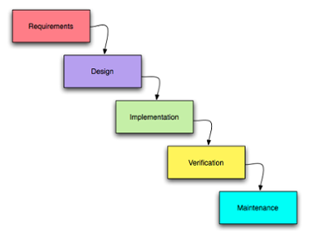
The development method used, is an important choice as it will shape the development of the product. There are many software development methods, these include:
Figure 4 - Waterfall Methodology
Waterfall – is the traditional software development or project management methodology. It’s a linear process, each phase must be fully completed before the next phase can begin. It is a simple process to follow, but doesn’t allow for any iteration or backwards steps through the cycle. This is not a problem where requirements are fully understood and do not change. However, where the design of the final product is still emerging throughout the process, it can be costly to change it with this method.

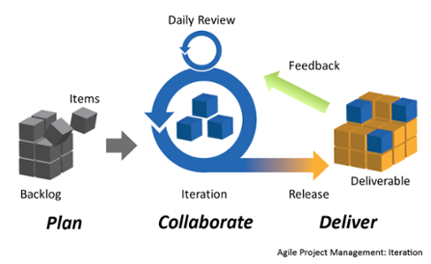
Figure 5 Agile Methodology
Agile development is a framework that encompasses many different methodologies, such as SCRUM, Feature Driver Development (FDD), Dynamic Systems Development Method (DSDM) and Extreme Programming (XP). Where as waterfall focusses on a linear process, Agile is a series of iterations, focussed on delivering some value early on to the user, and then iterating to continue adding additional features and value to the software. The iterative approach, makes allowances for changing and emerging requirements.

Agile is an appropriate methodology for this project. As the requirements for features within the app and the design of the interface will change throughout the project, based on user feedback. Specifically the SCRUM development method as it’s based on iterations of ‘inspect and adapt feedback loops’ [45]. SCRUM places weight on decision making based on results observed from the ‘real world’ [45]. Therefore, as this project seeks to capture real users feedback, to refine the interface design, Agile SCRUM, is the most relevant methodology for this project.
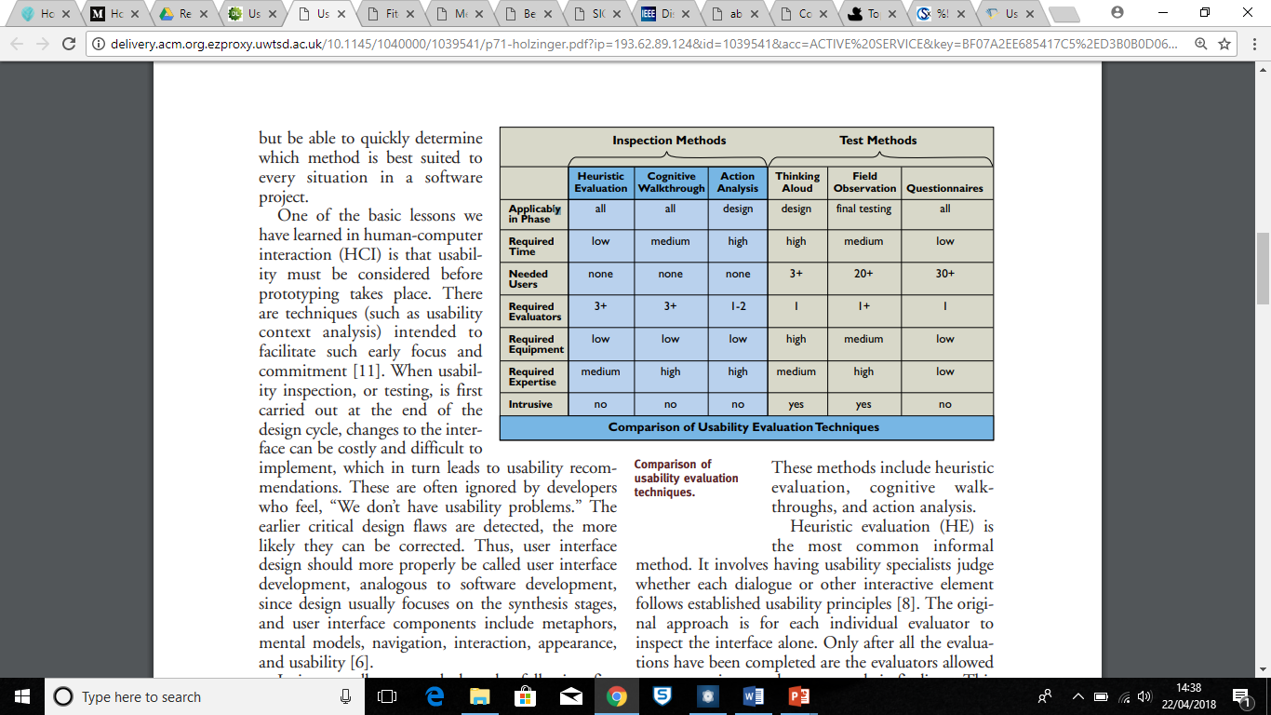
This project is developing an interface design, and the design process could just as easily be referred to as interface development. There are key components that will be developed within the design, including metaphors, mental models, interaction, navigation and usability, in addition to the appearance [46]. Testing is a key element of software development, but as a general rule when testing software, it either works or it doesn’t, resulting in a binary answer. In interface testing, the results of testing are much less binary. Largely because user testing is most commonly used, which doesn’t lend itself to providing the developer with a binary answer. So during the development phases the project will employ inspection methods (without the need for users), conducted by experienced usability professionals and testing methods conducted with real users [46]. The table below shows a summary of these methods.
Figure 6

The Heuristic Evaluation (HE) is where the usability professionals will be required, they will inspect each element of the design and assess whether or not it is in keeping with established usability guidelines [48], for example Nielsen’s Usability Heuristics[49]. The cognitive walkthrough (CW) involves a user carrying out a task, with step by step instructions, to allow for evaluation of the usability element of the interface [46]. Thinking Aloud will require the user to verbalise their thoughts [46], allowing for understanding of their thoughts and reasons for their actions when interacting with the interface. Field observation is the viewing of the user, when interacting with the interface. This can allow for detection of body language or facial contortion, which may not be verbalised. The thinking aloud can be compared to the field observation to provide more informed and cross checked data. Following their experience of using the interface, users will be asked to complete a questionnaire, that will collect data on aspects of the interface design and mobile application features related to the persuasive system design. An explanation has been provided under ‘Data Collection’ as to what type of data will be collected and how it will be used for analysis.

Risks
The table below is the risk register created for this project. This is a living document and will be updated throughout the period of the project.
Risk Name | Risk Event | Mitigating Actions
- Restricted Library Access | Prevented from accessing the library to conduct literature review for long periods. | UWTSD has online library access with access to ACM and IEEE digital libraries. DVLA has Open Resource Centre (ORC) with access to books on interface design, web design and more.
- Task Analysis Participants | Unable to get participants or sufficient numbers for task analysis. | Can obtain student email list and request participation via email. Can invite some of the 5000 colleagues at DVLA to participate, starting with known contacts circa 60. This should be more than sufficient.
- User Testing | Unable to get participants to take part in user testing of interface designs. | Can request fellow students participate. Can invite DVLA colleagues to participate. Can also approach wider groups that I’m involved in AWS South Wales User Group and Design Swansea.
- Unavailability of UX Lab | Unavailability of UX lab for user testing sessions. | Request UX lab early on. Testing not due to take place until 2019. Request booking during less busy period and time of day.  If UX lab is an absolute no go, can book a meeting room and conduct user testing in this space. If this is the case, will need to get hold of additional resources including camera to record session and PC/Laptop/mobile device to display interface designs.
- Software Trail Periods | Certain software packages have limited trial periods. This could mean interface designs are inaccessible once built. | Chose prototyping software that does not have expiry periods on trial or LITE versions.
- User feedback | User feedback is not quantifiable. | Ensure user feedback capture methods include ways to capture quantitative data, in addition to qualitative data.
- Timescale | Not enough time to complete whole project, project elements. | Create a list of tasks in advance to ensure all tasks are known and understood prior to undertaking them. This will allow for the creation of a project plan, to allow for time boxing of tasks, through to completion.

Analysis of Data
The data collected by this project will be analysed in 3 different ways:
- Statistical analysis of data collected to identify trends and patterns.
- Comparison of user requirements to completed design.
- Comparison of final design to Schneiderman’s and Nielsen’s usability guidelines.
These three methods will allow for the straightforward identification of patterns, trends and generalisations to be made from the quantitative data. The project will also employ methods to assess qualitative data collected, beyond simply the capturing of the content.
The user requirements collected through the task analysis and subsequent usability tests will be compared with the elements of the final interface design, to identify how fully the final design meets the requirements. If there is a difference between the original user requirements and the final interface design, the user feedback from the usability testing will almost provide an audit trail for the deviation away from the original requirements.
The comparison of the final design to the established usability guidelines will be interesting, as this will either confirm or deny their effectiveness, by comparing the final design to the perceived wisdom of the usability guidelines.

Resources and Planning
Resource | Timescale | Action Required
- Computer to conduct literature review and create software design | Full length of the project | None. Already have multiple laptops and access to PC’s.
- Access to online library resources | Full length of the project | None, as a student of UWTSD I have access to the online library over the summer period.
- Pens and paper to draw out paper prototypes and wireframes | 3 months max | None, have copious amounts of paper and coloured pens.
- Software to create interface design | Full length of the project (initially to learn the software and then to complete the design) | Have access to MS PowerPoint. InVision is an online software tool that allows free access for prototyping interfaces.
- Participants to conduct task analysis. | 1 Month at beginning of the project and 1 month at the end of the project. Plan is to reuse these users to review the final interface design. | Write out to a group of participants, who are representative of users, across ages, gender and digital literacy.
- Participants to take part in user testing of prototype interface designs. | 3 month period during the development phase. | Write out to know groups, colleagues to request participation and get dates in diaries. Make sure your over request to mitigate against drop outs.
- Video recording equipment to record user testing sessions. | 3 month period during the development phase. | None, can use GoPro or mobile phone to record footage.
- Forms software to create task analysis and capture user feedback of final design. | Length of the project. | Google forms is free to use and provides visualisations of data collected. Survey Monkey is free to use also.
- Use of the usability lab to conduct user testing | 3 month period during the development phase. | Book usability lab ahead of time, in a known quiet period.

Project Plan Gantt Chart




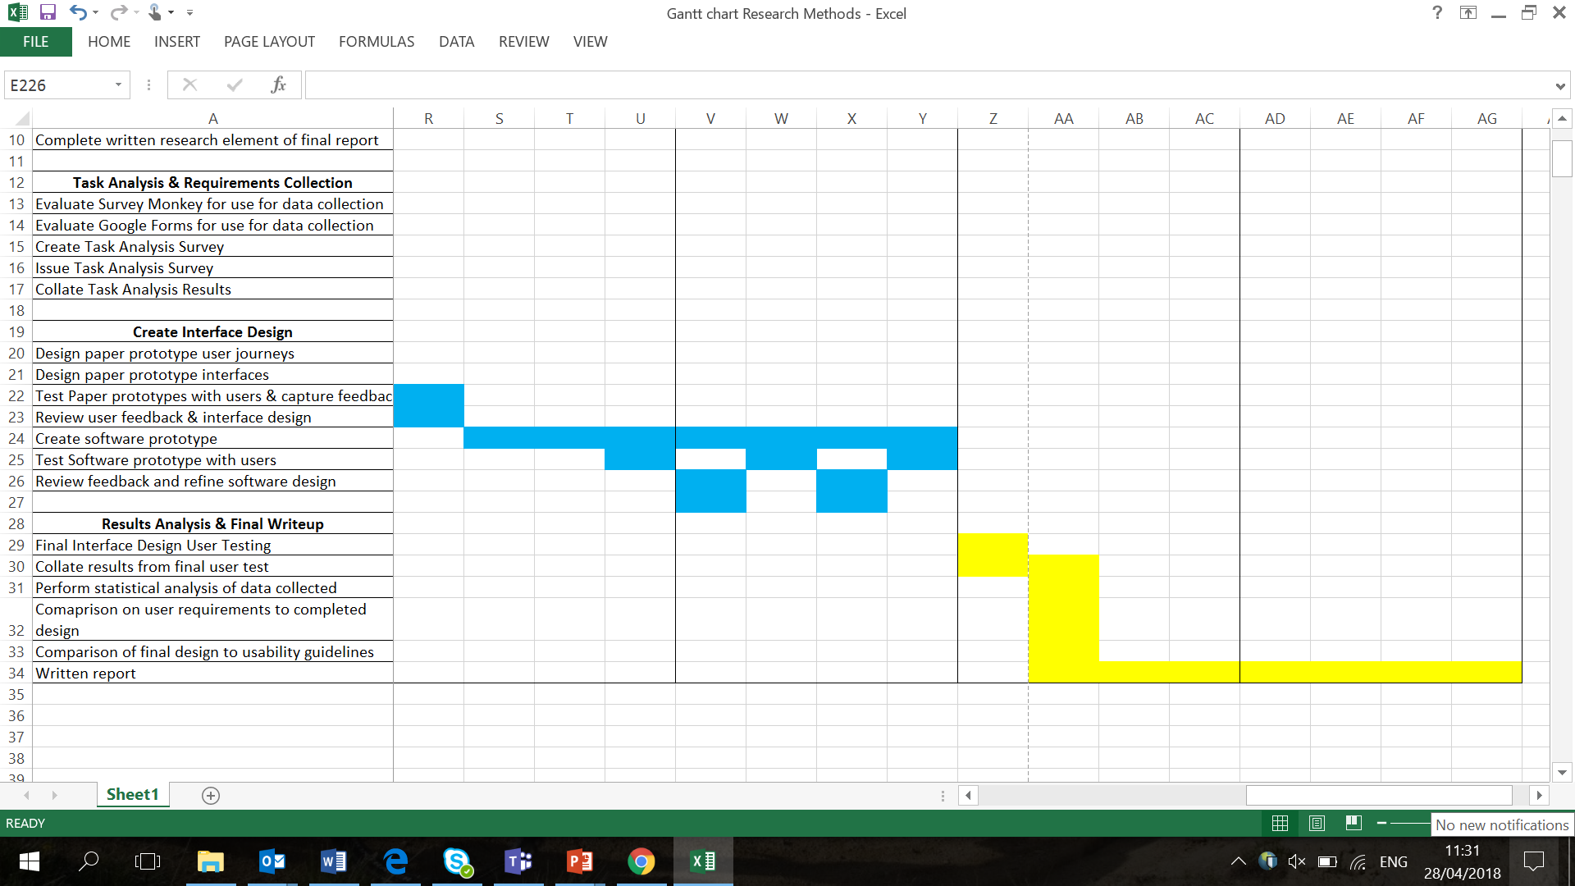

References
[1] Available at: https://www.gov.uk/legal-obligations-drivers-riders [Accessed 11.04.18]
[2] Available at: https://www.suffolk.police.uk/advice/roads-and-vehicles/vehicle-tax [Accessed 11.04.18]
[3] Available at: http://discovery.nationalarchives.gov.uk/details/r/fd59c328-ef16-46d4-b504-8d8779e28489 [Accessed 11.04.18]
[4] Available at: https://www.gov.uk/government/publications/history-of-road-safety-and-the-driving-test/history-of-road-safety-the-highway-code-and-the-driving-test [Accessed 11.04.18]
[5] Available at: https://www.gov.uk/government/organisations/driver-and-vehicle-licensing-agency/about [Accessed 11.04.18]
[6] Available at: https://assets.publishing.service.gov.uk/government/uploads/system/uploads/attachment_data/file/264624/3._Vehicle_excise_duty_-_administrative_changes.pdf [Accessed 11.04.18]
[7] Available at: https://www.gov.uk/government/news/vehicle-tax-changes [Accessed 11.04.18]
[8] Available at: https://assets.publishing.service.gov.uk/government/uploads/system/uploads/attachment_data/file/659918/vehicle-excise-duty-evasion-statistics-2017.pdf [Accessed 11.04.18]
[9] Available at: https://www.theguardian.com/money/2016/aug/18/dvla-disputes-revenue-loss-tax-disc [Accessed 11.04.18]
[10] Available at: https://www.ft.com/content/cbd26432-6492-11e6-a08a-c7ac04ef00aa [Accessed 11.04.18]
[11] Available at: http://www.bbc.co.uk/news/business-34933962 [Accessed 11.04.18]
[12] Available at: https://www.gov.uk/browse/driving [Accessed 11.04.18]
[13] Available at: https://www.gov.uk/vehicle-tax [Accessed 11.04.18]
[14] Available at: https://www.amazon.co.uk/Amazon-App/b?ie=UTF8&node=4816518031 [Accessed 11.04.18]
[15] Available at: http://www.asos.com/discover/our-apps/ [Accessed 11.04.18]
[16] Available at: https://anywhere.ebay.com/mobile/android/ebay/ [Accessed 11.04.18]
[17] Available at: https://www.gov.uk/service-manual/technology/working-with-mobile-technology [Accessed 11.04.18]
[18] Available at: https://www.gov.uk/government/news/mobile-apps [Accessed 11.04.18]
[20] M. Al-Ramahi, O. El-Gayar, J. Liu. Discovering Design Principles for Persuasive Systems: A Grounded Theory and Text Mining Approach. 49th Hawaii International Conference on System Sciences, Koloa, Hawaii. 5 – 8 Jan 2016

[21] V. Schwanda, K. Williams, W. Stubler, P. Sengers, S, Purpura. Fit4Life: The Design of a Persuasive Technology Promoting Healthy Behavior and Ideal Weight. Information Science + Electrical and Computer Engineering. Vancouver May 7–12, 2011.
[22] H. Simons, J. Morreale, and B. Gronbeck. Persuasion in Society. Thousand Oaks London New Delhi: Sage Publications, Inc 2011.
[23] M. Cassell, C. Jackson, and B. Cheuvront. Health Communication on the Internet: An Effective Channel for Health Behavior Change. Journal of Health Communication (3)1, pp. 71-79. 1998.
[24] Available at: https://www.gartner.com/newsroom/id/3609817 [Accessed 19.04.18]
[25] Available at: https://www.forbes.com/sites/allbusiness/2014/11/17/heres-why-your-business-needs-its-own-mobile-app/#7b41a834327f [Accessed on 19.04.18]
[26] D Dig, A. Abadi. How Mobile Affects Business Processes? The Research Perspective. The 2nd International Workshop on Mobile Development Lifecycle. Portland Oregon USA October 21 2014.
[27] P. Vigneswaea IIavarasan, H Ei Chew. A Toolkit on Mobile Apps for Business Growth: Insights from Design and Development. The 2nd International Conference on Information and Communication Technology for Competitive Strategies. Udaipur, India March 04 – 05 2016.
[28] Available at: https://developer.apple.com/notifications/ [Accessed 19.04.18]
[29] K Torning, H Oinas-Kukkonen. Persuasive System Design: state of the Art and future Directions. The 4th International Conference on Persuasive Technology. California USA April 26 -29 2009.
[30] Available at: https://www.w3.org/WAI/intro/usable [Accessed on 19.04.18]
[31] J. Abascal, N Colette. Moving Towards Inclusive Design Guidelines for Socially and Ethically Aware HCI. Interacting with computers. 17, 5 (2005) 484 – 505.
[32] J Van Biljon, K Renaud. Validating Mobile Phone Design Guidelines: Focusing on the Elderly in a Developing Country. The Annual Conference of the South African Institute of Computer Sciences and Information Technologists. Johannesburg, South Africa. September 26 – 28 2016.
[33] Available at: https://encrypted.google.com/search?biw=1920&bih=974&ei=x5rYWtnGFKqagAbZvoLwBw&q=interaction+design+guidelines&oq=interaction+design+guidelines&gs_l=psy-ab.3..0j0i22i30k1l8.39829.48704.0.48985.44.35.3.0.0.0.240.3713.17j15j2.34.0....0...1.1.64.psy-ab..14.18.1898...0i7i30k1j0i7i10i30k1j0i30k1j0i5i30k1j0i8i7i30k1j0i7i5i30k1j0i8i30k1j0i13k1j0i13i30k1j0i13i5i30k1j0i8i13i30k1.0.fGlLJfin11U [Accessed on 19.04.18]
[34] Available at: https://www.nngroup.com/articles/ten-usability-heuristics/ [Accessed 19.04.18]
[35] Available at: https://www.interaction-design.org/literature/article/shneiderman-s-eight-golden-rules-will-help-you-design-better-interfaces [Accessed 19.04.18]
[36] J. Nielsen, R. Molich. Heuristic Evaluation of User Interfaces. Proceedings of the SIGCHI Conference on Human Factors in Computing Systems. Pages 249 – 256. April 1990.
[37] J Nielsen. Usability for the Masses. Journal of Usability Studies, Issue 1, Vol 1 November 2005 pages 2 – 3.
[38] Available at: https://research-methodology.net/research-philosophy/positivism/ [Accessed 20.04.19]
[39] D. Remeyni, B. Williams, A. Money, E.Swartz. Doing Research in Business and Management: An Introduction to Process and Method. 1998. Sage Publications, p.97.
[40] J. Wilson. Essentials of Business Research: A Guide to Doing Your Research Project. 2010 SAGE Publications, p.7
[41] W.Neuman. Social Research Methods: Qualitative and Quantitative Approaches. Allyn and Bacon 2003.
[42] E. Babbie. The Practice of Social Research. 2010 Cengage Learning, p.52.
[43] Available at: https://research-methodology.net/research-philosophy/positivism/ [Accessed 22.04.18]
[44] C. Gratton, I Jones. Research Methods for Sports Studies, 2nd edition, 2009 London: Routledge p36.
[45] Available at: http://scrummethodology.com/ [Accessed 22.04.18]
[46] A. Holzinger. Usability engineering methods for software developers. Published in Communications of the ACM – Interaction Design and Children, Volume 48, Issue 1. Jan 2005 Pages 71 -74.
[47] B. Shneiderman. Designing the User Interface, 3rd edition. Addison-Wesley, Reading, MA, 1997.
[48] J. Nielsen, R. Mack. Usability Inspection Methods. Wiley, New York, 1994.
[49] J. Nielsen. Usability Engineering. Morgan Kaufmann, San Francisco, 1994

Figures
[1] Available at: https://www.amazon.co.uk/Amazon-App/b?ie=UTF8&node=4816518031 [Accessed 18.04.180
[2] Available at: http://www.asos.com/discover/our-apps/ [Accessed 18.04.18]
[3] H. Oinas-Kukkonen and K. Harjumaa. Persuasive design Model, A Systematic Framework for Designing and Evaluationg Persuasive Systems. Persuasive 2008.
[4] Available at: https://blog.blackducksoftware.com/top-4-software-development-methodologies [Accessed 22.04.18]
[5] Available at: https://blog.blackducksoftware.com/top-4-software-development-methodologies [Accessed 22.04.18]
[6] A. Holzinger. Usability engineering methods for software developers. Published in Communications of the ACM – Interaction Design and Children. Volume 48, issue 1. Jan 2005.

Bibliography
[1] Y. Yao, Improve Push Notification on Smartwatche. The 15th Annual International Conference on Mobile Systems, Applications, and Services. Niagra Falls, New York. June 19 – 23 2017.
[2] P. Zave, The operational versus the conventional approach to software development. Communications of the ACM. Vol 27 Issue 2 Feb 1984.
[3] R. Jabbari, N Bin Ali, K. Petersen, B. Tanveer. What is DevOps? A Systematic Mapping Study on Definition and Practices. Proceedings of the Scientific Workshop Proceedings of XP2016. Article No. 12. Edinburgh, Scotland. May 24 2016.
[4] E. Nicol, M. Dunlop, A. Komninos, M. McGee-Lennon, L. Baillie, A. Edwards, P. Eslambolchilar, J. Goodman-Deane, L. Hakobyan, J. Lumsden, I. Mulder, P. Rau, K. Siek. Proceedings of the 16th international conference on Human-computer interaction with mobile devices & services. Toronto, Canada. September 23 - 26, 2014.
[5] H. Schneider, K. Moser, A. Butz, F. Alt. Proceedings of the 2016 CHI Conference on Human Factors in Computing Systems. Pages 309 -320. San Jose, California. May 07 -12 2016.

