cerys payne

The first modern zoo opened in 1793, Paris France. The purpose of the zoo was to so scientists could research animal behaviour and anatomy. For this to happen, scientists and zookeepers constructed “habitats” the closely resemble the animal’s natural habitat on a much smaller scale so they could observe safely.
Role of zoo’s in wild life consevation.
Costal marine, wildlife conservation.

What is a zoological park?
A zoo is a place where animals live in captivity and are put on display for people to view. The word “zoo” is short for “zoological park.” Zoos contain wide varieties of animals that are native to all parts of the Earth. Nowadays, zoos can be classed as a form of conservation. Modern zoos can be anything safari parks to frozen zoos. They are all an attempt so save species that are endangered.
Even though wild animals have been kept for thousands of years, created to show peoples power and were created by the wealthy. These private collections were called menageries. (“K, Reutlede.2022. “Zoo”). Menageries are collections of both domestic and exotic animals This design was adopted particularly by the Habsburg monarchy in Austria. The first depiction zoos were wall carvings found in Egypt and the historical region of Weston Asia. They are evidence that rulers and the upper class created menageries as early as 2500 BCE. Evidence has been found of expeditions to distant places to bring back exotic animals such as giraffes, elephants and birds many other species. The records show that menagerie owners hired animal handlers to make sure their animals thrived and reproduced. In 1752 Francis I, created his Baroque menagerie in the park of Schönbrunn Palace near Vienna.
Zoos also existed in later civilizations, including Greece, Rome. The Aztec emperor Montezuma II, in what is today is known as Mexico, maintained one of the earliest animal collections in the Western Hemisphere.
The first modern zoo opened in 1793, Paris France. The purpose of the zoo was to so scientists could research animal behaviour and anatomy. For this to happen, scientists and zookeepers constructed “habitats” the closely resemble the animal’s natural habitat on a much smaller scale so they could observe safely.

How zoological parks have evolved and their role in conservation.
Zoological parks have had to change dramatically over the years, everything from their aims and objectives to animal welfare. As stated above zoos were created as privet collection to show wealth and power. However, zoos have changed their role because a growing realisation and documentation of the decline in wildlife which is driven mostly by loss of habitat. Today, zoos are meant to entertain and educate the public but have a strong emphasis on scientific research and species conservation. There is a trend toward giving animals more space and recreating natural habitats. Zoos are usually regulated and inspected by the government.
When zoos first became popular, they were not regulated for animal welfare merely for society’s entertainment. The majority animals were kept in horrific conditions, in cages with no enrichment and the cages were only big enough for the animal to turn around.
Early zoological parks like Menageie du jarin des plantes were described to be more like “museums of living animals” (“K, Reutlede.2022. “Zoo.”). In the 1600, James I and his court would watch lions and bares fight to the death as a form of entertainment. early zoos like this one would keep their animals in very small display areas, with as many species as the area would fit.
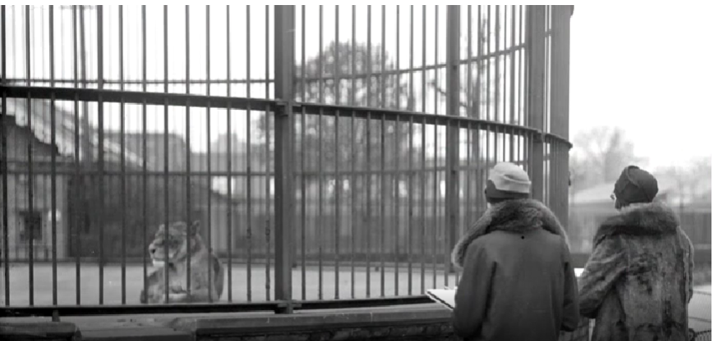
(Image 1, Video transcript, BBC Teach, what are zoos for?)
Edinburgh was the first British zoo to be open to the idea of displaying animals without bars witch then opened in 1913. Zoological parks opened at Chester and Whipsnade in 1931. These were the first non-urban zoos with larger enclosures allowing zoo owners the space to more accurately recreate the animal’s natural habitat. In 1966 “Britain’s first the first drive-through safari park” (No author, BBC Teach, what are zoos for?) opened at Longleat, Wiltshire. Wild animals could be observed roaming across acres and interacting more freely. This then further more encouraged the animals natural, wild behaviours.

Today, zoos are meant to entertain and educate the public but has a strong emphasis on scientific research and species conservation. There is a big push toward giving animals more space and recreating natural habitats. Having zoo enclosures looking and feeling like the animal’s natural habitat encourages instinctual behaviour and reproduces an animal’s native environment as closely as possible. This makes wildlife habitat enrichment a key component of animal husbandry. It is both a challenge and a joy for zoo staff to come up with new ideas to keep animals engaged and interested. For example, if you had a comodo dragon, you would need tall grass, heat lamps, rocks for basking and logs or tunnels for shade. They will also need enrichment such as logs and branches for climbing and hunting to help keep them stimulated.
Even to this day zoos are still being flagged as mistreating animals, “big cats performing in gladiator- style shows” (“R, Fobar.2019. Hundreds of zoos and aquariums accused of mistreating animals”). WAP (World Animal Protection) which is a non-profit organization has investigated in to the worlds top 12 zoos and aquariums all of which were associated with WAZA (World Association of Zoos and Aquariums) who claim to represent the world “top” zoos and aquariums. All of which were reported to be “mistreating” animals. “Confirmed that cruel and demeaning performances and activities, known to cause great physical and mental distress” (“M, Taylor.2019. Some of the World's Top Zoos and Aquariums are Mistreating Animals). These include animals such as Dolphins performing stunts and being ridden, for example Portugal, Singapore and Australia. WAP also reported Elephants performing in shows with props in Japan and so on.
Gavrielle Kirk-Cohen, WAZA’s director of communications, told National geographic that they relied on its members associations to enforce their standards among their member zoos and aquariums. According to the report, the elephant rides and dolphin stunts continue even after WAP calling out WAZA make sure their members are allowing such cruel and demeaning activities in there zoos and aquariums. It also states that some activities such as members of the public posing for photos with big cat can actually have a damaging affect on the animals physical and mental wellbeing. They can often require controversial train methods, such as “premature separation from mothers, physical restraint and pain- and fear-based conditioning. (“M, Taylor.2019. Some of the World's Top Zoos and Aquariums are Mistreating Animals).
In the 1980, the release of nature documentaries which depicted how the animals actually lived in the wild made the British people began questioning the ethics behind keeping animals in zoos. In result of this in 1981 “The Zoo Licensing Act was released and required zoos to educate the public, and for them to stop capturing most of their animals from the wild and turned to breeding programmes.
In 1959 Gerald Durrell opened a zoo in Jersey it was the first zoological park to put conservation above all else. The park was handed over to wildlife prevention trust in 1963. The jersey zoo breeds around 100 different species on it grounds that around 1,500 specimens. They do not maintain all of the animals they breed; the animals are sent to other institutions for breeding if for example an illness falls upon a primate colony.
The Jersey Zoological Park breeds many rare spices including the rarest species of bat in the world, the Rodrigues fruit bats. They also breed species, tenrecs, primates such as a Mayotte and brown lemurs.
Zoos mainly del with three aspects of conservation, “practice, advocacy and research.” (No Author, Wild Welfare. 2021). Zoo’s conservation practice consists of captive breeding, species reintroduction programs, Species survival plans and the use of zoo revenue for conservation programs in the wild.
What is captive breeding?
‘Captive breeding’ means breeding animals in a control environment. Many zoos, aquariums and conservation facilities use captive breeding as a means of preserving species while easing pressure on wild populations. Wild populations are facing many different pressures, anything from habitat loss to illegal poaching and natural disasters in particular wild fires. Breeding in captivity is a long prosses. Breeding in captivity is a very long possess which requires expert understanding of responsible breeding of species of animal by natural processes from the parent stock. It also means seeing the young though to maturity and then the cycle continues.
Captive breeding doesn’t mean housing two animals together, there are a few factors to consider such as genetic diversity, how it will benefit the species and space and environmental considerations.

Genetic diversity is important in a captive environment, inbreeding is a huge problem when trying to breed in zoos and conservation centres. Inbreeding is when two individuals the are related are bread together. Some zoos take part in the practice of inbreeding because they take the claim that it is for the repopulation of the species close to extinction. A study was conducted at the national zoological park in Washington. It consists of to sets of groups, the first a group of 534 young zoo bred animals that were not inbred. The second 380 inbred young zoo animals. With the first group only 25% died before coming six months old the second half the group so 50% of the 380 young animals died before coming six months old. “Among 534 young zoo animals that were not inbred, only 25 percent died before they were six months old. But of 380 inbred young, 50 percent died within six months”. (B, Webster. Inbreeding Called Peril in Zoos. 1979). Other that the high mortality rate in new born, other problem is, reduced fertility, reduced immune function, smaller adult size, Increased facial asymmetry and the list goose on. To ensure genetic diversity is achieved animals are selected from different source populations.
For responsible breeders it is important to consider how it will benefit the species. What needs to be consider is whether it will bring any benefit to the species, whether it’s easing pressure on wild populations or helping to boost the number of endangered species. With breeding in captivity this ultimately reduces the number of animals reduced from the wild and natural habitats. A lesser known benefit of captive breeding is that it can improve the animals health, in the case of captive breeding in aquariums fish are used to prepared foods and conditions this can help disease prevention.
A final thing that needs to be considered space and environment considerations, it is important for zoo’s, aquariums and conservation centres create the correct environment with as many natural behavers and elements as possible. This is so when the animal has reached full maturity, they can be released into the wild that is naturally possible. With that being said the release in animals when they are young doesn’t always end very well, (“R Admin, Bristol aquarium,2022)

Advocacy.
Conservations advocacy includes public engagement promoting awareness advocating stewardship, fundraising events and schemes, for the most common scheme is the ‘adopt an animal’ at zoos. another way they advocate conservation is by partnership including universities for example the university of Plymouth and Paignton Zoo they also partnership a well-known organization such as WWF and natural geographic. Zoo’s educate their visitors through programme’s and activities for example Folly Farm allows you to feed the young goats and sheep while some one on hand to answer any questions, also they educate visitors through the way individual habitats and zoo’s are being designed such as they all have plaques with information on all the animals habitats. Another example is on their websites they all have their ‘campaign’ section where they will show you their main goals.

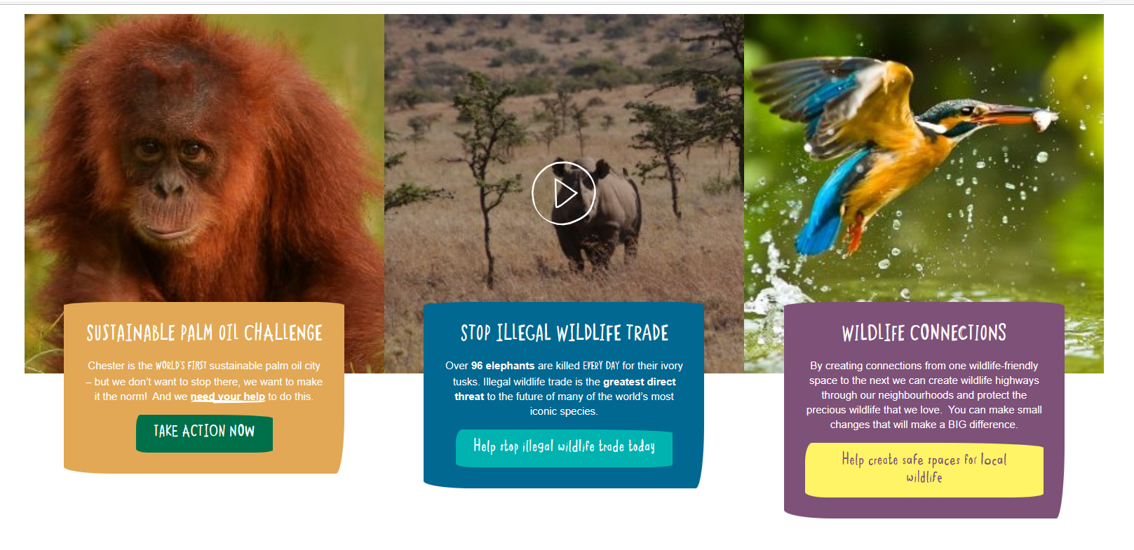
( Image 2, Chester zoos campaign page.)

Zoo research.
Zoo’s provide much needed funding for research and conservation projects across the world, their research helps preserve bio diversity that maybe threatened due to loss of land ECT. The research carried out by zoo’s and field work can help with conservation and ultimately provide better care for sick and recused animals.

AZA also known as ‘ aquarium and zoo aid ‘ in 2019 they spent more than 230 million dollars on field conservation around the world, the main focus was monitoring, reintroduction, conservation, education and more. SAFE: Saving Animals From Extinction is AZA is their main conservation program. It bring zoos and acurarums together to help save species like the sea turtles and American red wolfs .
Zoos also engage in reitaduction programs. The goal of reintroduction programs is to release animals that have been raised or rehabilitated in zoos back into their natural habitats. “AZA describes these programs as "powerful tools used for stabilizing, re-establishing, or increasing in situ animal populations that have suffered significant declines.” (J,Brove, Zoos and Endangered Species Conservation.2021). zoos participate in field conservation projects that causes on the long-term survival of species in natural ecosystems and habitats. The projects support studies of different populations in the wild, recovery efforts and even veterinary care.
Zoos do play a very important role when it comes to conservation, they help in Meany different ways. Everything from funding, education valuable research and so much more. Modern zoos conserve a wild range of animal species and their habitats, promote education amongst visitors, take part in research projects and follow the highest standards of animal care and welfare.

References.
- K, Reutlede.2022. “Zoo”. National geographic, Available at: URL https://education.nationalgeographic.org/resource/zoo/. Date accessed; 2/03/23.
- R, Fobar.2019. Hundreds of zoos and aquariums accused of mistreating animals”. National Geographic, Available at: URL https://www.nationalgeographic.com/animals/article/waza-zoos-accused-of-mistreating-animals-wap-report . Date accessed; 2/03/23
- M, Taylor.2019. Some of the World's Top Zoos and Aquariums are Mistreating Animals”. Travel pulse. Available at: URL https://www.travelpulse.com/news/features/some-of-the-worlds-top-zoos-and-aquariums-are-mistreating-animals.html. Date accessed: 03/03/23.
- M, Taylor.2019. Some of the World's Top Zoos and Aquariums are Mistreating Animals”. Travel pulse. Available at: URL https://www.travelpulse.com/news/features/some-of-the-worlds-top-zoos-and-aquariums-are-mistreating-animals.htm l. Date accessed: 04/03/23.
- No author, BBC Teach, what are zoos for? Available at: URL https://www.bbc.co.uk/teach/what-are-zoos-for/z649f4j . Date accessed: 04/03/23.
- image 1, Video transcript, BBC Teach, what are zoos for? Available at URL: https://www.bbc.co.uk/teach/what-are-zoos-for/z649f4j. Date accessed 04/03/23
- No Author, wild welfare. 2021. “practice, advocacy and research. Available at URL: https://wildwelfare.org/the-conservation-mission-of-zoos-nabila-aziz/. Date accessed 04//03/23
- B, Webster. Inbreeding Called Peril in Zoos. 1979, the new York times. Available at URL: https://www.nytimes.com/1979/11/27/archives/inbreeding-called-peril-in-zo . Date accessed 20/03/23. (I know it old but I found it very interesting)
- R Admin, Bristol aquarium,2022. “The process is designed to see animals raised to full maturity”. Available form URL: https://www.bristolaquarium.co.uk/conservation/captive-breeding-what-is-it-and-why-is-it-vital-for-conservation/. Date accessed 21/04/23.
- ( Image 2, Chester zoos campaign page. Available at URL: https://www.chesterzoo.org/what-you-can-do/our-campaigns/, Date accessed 22/03/23.
- J,Brove, Zoos and Endangered Species Conservation.2021. “powerful tools used for stabilizing, re-establishing, or increasing in situ animal populations that have suffered significant declines." Avalbel at URL: https://www.treehugger.com/zoos-and-endangered-species-conservation-1. Date accessed 25/03/23.

