

University of Wales Trinity Saint David
School of Computing
Written Report
Computer Games and GPUs and the Development of Games Graphics (M4X01498)
Paul Newman (1805494)
Foundation Year
1/3/19

Contents

Introduction:-
A brief report on what to expect in this report on GPU’s and how they have changed since there creation.

Who Invented the GPU?
The U.S. Navy and M.I.T. invented Whirlwind.
Page 1.
What is a GPU?
Graphic’s Processing Unit for mathematical calculations.
Page 2.
History of the GPU
A more in depth look at the people who made it.
Page 2.
The Evolution of the GPU
The 4 Stages of the GPU.
Page 3, 4 and 5.
Conclusion
What I think of the GPU and how it has changed my life.
Page 6.
Reference
All References are at the end of the report
Page 7 and 8.
Who Invented the GPU?
The U.S. Navy was the FIRST to develop the GPU in the 1940s called the Whirlwind as a flight simulator in Massachusetts institute of Technology to help create a new era of fighter pilots it may be considered the first 3D graphics system [1]. Jay Forrester was the founder of system dynamics which deals with the simulation of interactions between objects in dynamic systems, Whirlwind was the first computer to run in REAL TIME unlike the British Colossus used to code brake during the Second World War [1].

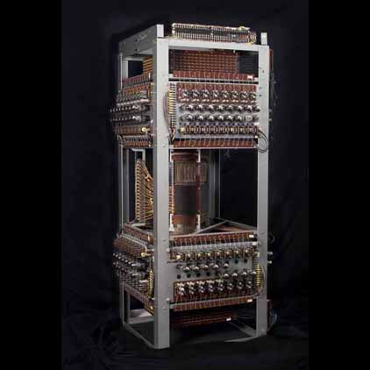
Figure 1: The Whirlwind [2]

Page 1

What IS a GPU?

GPU or Graphics Processing Unit. Or Graphics card or Video card as they are more commonly called [3]. All modern Computers use one or the other to render complex images in to 2D or 3D animations for display on monitors or even modern TVs [3]. The Graphics card performs fast mathematical calculation so it can render images, which frees up the Central Processing Unit (CPU) to work on other things The GPUs cores are designed to run thousands of smaller cores which help’s with multi-tasking, whereas the CPU sorts out sequential and serial processing [3].
The older AutoCAD put too much strain on the CPU which would cause degraded performance, so a video card was developed as the AutoCAD [3].

History of the GPU

In 1952 a man named A.S. Douglas, at the time he was a doctoral student he created a game which was a graphical tic-tac-toe using COBOL (a programing language) which was used on most mainframes at the time. In 1972 and man named Nolan Bushnell created ATARI and the game PONG[4]
It wasn’t until the late 1990’s that NVIDIA created the first GPU for home computers called GeForce 256 in 1999 [5]. The processing power of a GPU made it popular for muilti tasking. GPU’s were used for scientific calculation and easier rendering. NVIDIA recognised the potential of this so they invested time and money in modifying GPU’s so you could program high level languages such as C, C++ and FORTRAN where CUDA parallel computing for GPU’s came from. By 2010 GPU’s were used for A.I. (Artificial Intelligence) [5].

Page 2
The Evolution of the GPU
From the early 1970 -1975 the first gen of GPU’s were Wire frame and very FEW pixels were the first type of graphics used, mainly line at this time, much like a Etch-a-Sketch [6].

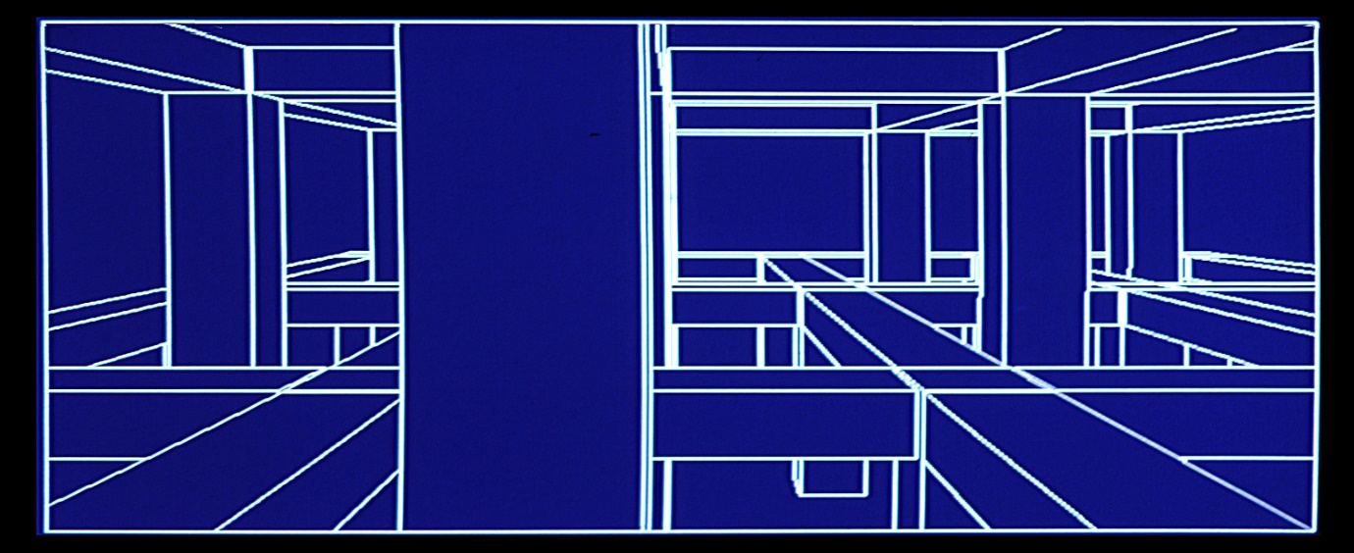
Figure 2 Lined Graphics [7]

In the second gen of GPU’s 1987-1992 shadowing, depth buffer and colouring was implemented [6].
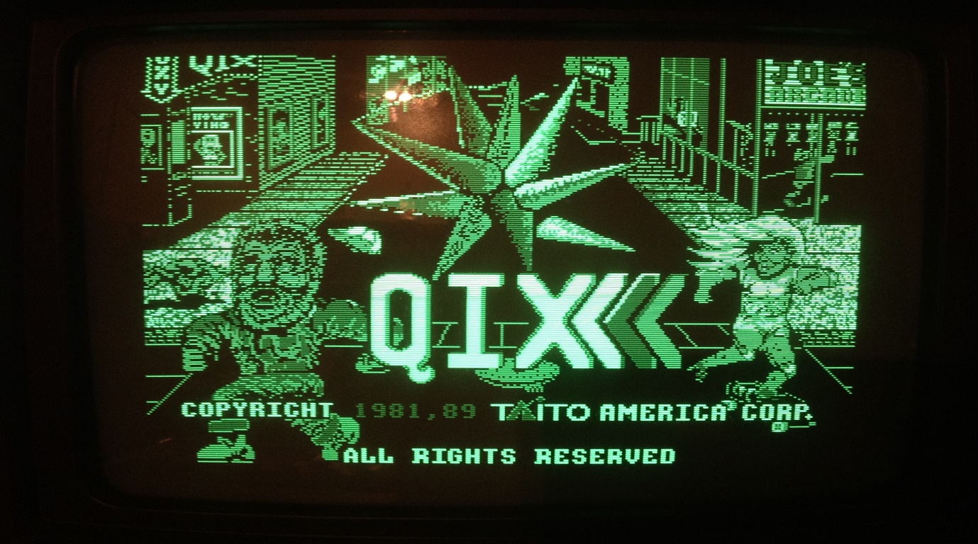Figure 3 Second Gen Graphics [8]

Page 3
The third gen 1992-2001 GPU’s were so much faster across the board, texture fitting and antialiasing were implemented [6].

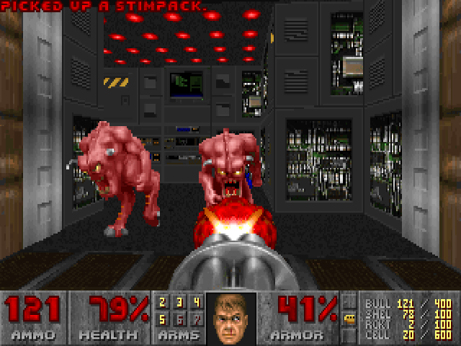
Figure 3 Third Gen Graphics [9]

In the fourth gen 2009-2019 Virtual reality or VR for short is now a more common place in the home and the graphics card run faster and are smaller than their early ancestors [6].


Figure 4 Forth Gen and Current Graphics [10]
Page 4


Figure 5 VR Graphics It almost look real [11]

Today’s top of the line GPUs
The NVIDIA Quadro P6000 workstation graphics card, powered by NVIDIA Pascal GPU technology, features 24GB memory capacity and enables an expansive visual workspace with quad display outputs. These work with larger models, complex visual effects and simulations, larger rendering tasks, and more lifelike VR experiences in your workflow today while preparing for the challenges of tomorrow[12].

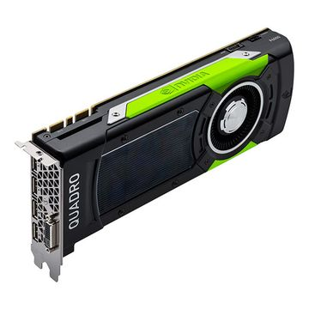
Figure 6 what The NVIDIA Quadro P6000 workstation graphics card looks like small enough to hold in your hand [12]
Page 5

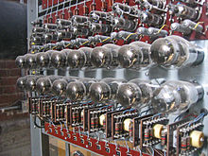
Figure 7 a closer look at the first GPU [2]
Here is the FIRST GPU the Whirlwind used by the U.S. Navy in the 1950’s. It was so big it took up several meters and would fill up a large room.

Conclusion
Over the last 40 years the Graphics cards power and speed has been increased dramatically from basic lined digital models to Graphics where you can interact while in games as you play them, graphics that look like the real world.
Personal Thoughts
I have been lucky to have witnessed the first Gen to the Forth Gen Graphics as a child I loved looking at the graphics of MY Gen (Second Gen) and looking at them with wondrous eye’s, and lots of gamming! I’m very excited to see what the next 40 years have to offer in Graphic’s. I believe it will be of world of VR, where you would not need to get up and go to University/Work all you have to do is plug in to a head set and go.

Page 6

Reference

[1] Computer History Museum, “December 14: US Navy Approaches MIT to Create Whirlwind | This Day in History | Computer History Museum,” This Day in History. [Online]. Available: https://www.computerhistory.org/tdih/december/14/. [Accessed: 15-Mar-2019].
[2] MIT Museum, “021p.jpg (422×422).” 2011.
[3] S. Harding, “What Is a GPU? A Basic Definition,” Tom’s Hardware, 2018. [Online]. Available: https://www.tomshardware.co.uk/gpu-graphics-card-definition,review-34512.html. [Accessed: 15-Mar-2019].
[4] C. Lauderdale, “Who Invented the Graphics Card? | Techwalla.com,” Techwalla. [Online]. Available: https://www.techwalla.com/articles/who-invented-the-graphics-card. [Accessed: 15-Mar-2019].
[5] M. Rouse, “What is GPU (graphics processing unit)? - Definition from WhatIs.com,” TechTarget, 2019. [Online]. Available: https://searchvirtualdesktop.techtarget.com/definition/GPU-graphics-processing-unit. [Accessed: 15-Mar-2019].
[6] Olena, “A Brief History of GPU – altumea – Medium,” Altumea, 2018. [Online]. Available: https://medium.com/altumea/a-brief-history-of-gpu-47d98d6a0f8a. [Accessed: 15-Mar-2019].
[7] Google Images, “Donald0018.jpg (2585×1961),” Google images. [Online]. Available: https://users.cs.duke.edu/~brd/Historical/hlcg/cd/big/Donald0018.jpg. [Accessed: 15-Mar-2019].
[8] Google Images2, “psrp_qix_title1.jpg (2445×1749).” [Online]. Available: https://electricthrift.files.wordpress.com/2013/08/psrp_qix_title1.jpg. [Accessed: 15-Mar-2019].
[9] Google Images3, “doom10.png (640×480).” [Online]. Available: https://image.dosgamesarchive.com/screenshots/doom10.png. [Accessed: 15-Mar-2019].

Page 7

[10] x box, “Google Image Result for https://d2skuhm0vrry40.cloudfront.net/2019/articles/2019-02-16-13-15/XOX_000.jpg.” [Online]. Available: https://www.google.co.uk/imgres?imgurl=https%3A%2F%2Fd2skuhm0vrry40.cloudfront.net%2F2019%2Farticles%2F2019-02-16-13-

15%2FXOX_000.jpg&imgrefurl=https%3A%2F%2Fwww.eurogamer.net%2
Farticles%2Fdigitalfoundry-2019-metro-exodus-tech-analysis&docid=fcAq2HDzs26Vh. [Accessed: 15-Mar-2019].
[11] Google Images4, “interior-house-in-athens_00.jpg (1000×541).” [Online]. Available: https://fourthedesign.gr/en/wp-content/uploads/2015/07/interior-house-in-athens_00.jpg. [Accessed: 15-Mar-2019].
[12] Jigsaw24, “PNY NVIDIA Quadro P6000 24GB Graphics Card,” Jigsaw24, 2018. [Online]. Available: https://www.jigsaw24.com/products/pny-nvidia-quadro-p6000-24gb-graphics-p183aaf. [Accessed: 15-Mar-2019].
Page 8

