Name; Sevila Gorahmedova
Student ID; 2113595
Marketing Fundamentals – LCBB4004
University of Wales Trinity Saint David – London

Sainsbury’s

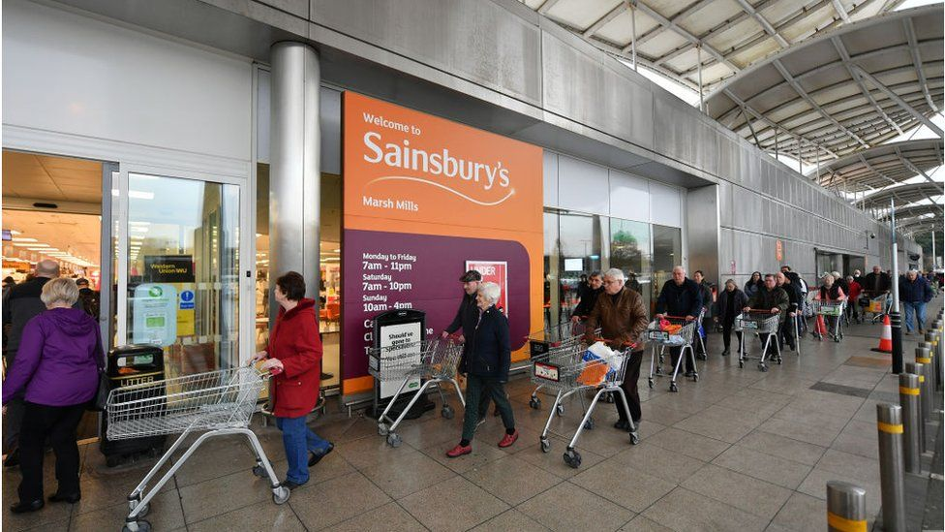

Sainsbury's has slumped to a £261m loss despite bumper food and Argos sales during the coronavirus pandemic.
The supermarket giant said that in the year to 6 March Covid costs "to help keep our colleagues and customers safe" had been "high".

However, it said it
expected profits to bounce back in the coming year.
Rival Tesco reported a sharp fall in profits earlier this month after spending nearly £900m to carry on trading during the pandemic.
Sainsbury's said it had spent £485m on Covid-related costs, including paying colleagues that were required to shield or needed to self-isolate. It also paid back business rates relief on its stores in line with rivals.
The supermarket giant also paid out restructuring costs, including to close 170 standalone Argos stores.
Sainsbury's £261m pre-tax loss for the year was despite like-for-like sales rising 8.1%

Online surge

Argos did especially well, with total sales rising almost 11% as digital sales boomed.
However, Argos standalone stores, rather than those inside the supermarkets, were closed for much of the year during lockdowns.
Sainsbury's online sales rose as coronavirus restrictions accelerated internet shopping. Online jumped from 8% of grocery sales to 17% during the year.
The retailer has already embarked on a restructuring, and announced in March that 1,150 jobs were at risk.

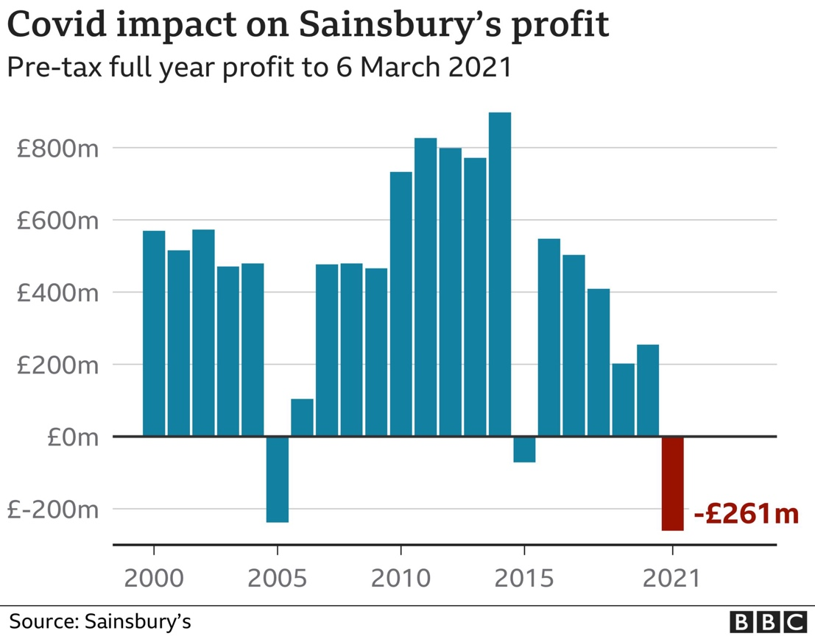

Despite a big jump in food sales Sainsbury's is nursing a £261m loss.
Supermarkets have been among the big winners during the pandemic but they've also had huge Covid-19 costs, from keeping workers and customers safe to sick pay for staff who've had to shield.
Sainsbury's also incurred £617m of exceptional costs. Most of this was the result of closing hundreds of standalone Argos stores as it restructures the business.
The boss says that like his customers, he's looking forward to things feeling more normal over the coming months.
But what is the new normal going to look like for our big grocers?
It's not just about the shift to online, grocers are thinking about the future of work, and how to respond if many of us don't return to five days a week in the office.
Sainsbury's is pressing ahead with plans to open more convenience stores and new neighbourhood hub shops - mini supermarkets in smaller towns - which could be a shrewd move if we're going to be working more from home and shopping locally.

Small store boost

On Wednesday Sainsbury's reiterated plans to open 25 to 30 convenience stores per year for three years.
Mr Roberts said this would tap into the coronavirus trend of more people working from home.
He said the return of people working a five day week in the office "is not going to happen".
"As customers find new ways of working it inevitably will mean some of the week working from home," he said. "We believe convenience stores will play a big part in the local community."
Sainsbury's already has more than 800 convenience stores, and those "acted as mini supermarkets in the crisis with sales up 13% on the year," he said.
"Hundreds of these stores will be in in important locations for customers as t
hey work locally,"

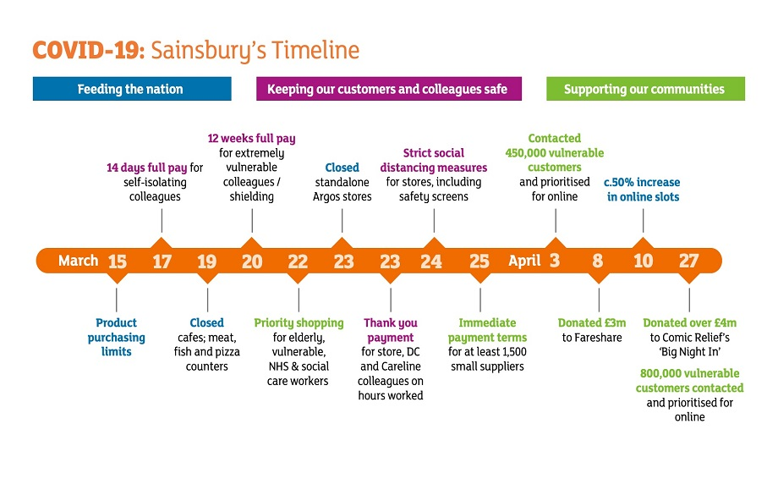

Update on the impact of COVID-19

The COVID-19 pandemic has had a significant impact on our business since early March. We have had three clear priorities throughout: keeping our customers and colleagues safe; helping to feed the nation and supporting our communities and the most vulnerable in society. Our colleagues have played an incredible role and have really pulled together to serve our customers. In particular, our store colleagues, our distribution centre colleagues, our drivers and customer Careline teams are working on the frontline, ensuring that customers have good access to food and other essential items. Our central teams have supported them, working closely with suppliers to increase orders and to move products quickly through the supply chain and into stores. Where they are able, our central teams are supporting colleagues by working in our stores. We are incredibly proud of the role our colleagues have played and their unwavering dedication and effort in serving our customers and supporting our local communities during this unprecedented time.
At this very early point in our financial year it is impossible to predict the full nature, extent and duration of the financial impact of COVID-19 over the course of the year and there is a wide range of potential profit outcomes, both short and medium term.
We have modelled a broad range of scenarios. Our base case assumes that lockdown restrictions will have eased by the end of our first quarter (end June), but that the business will continue to be disrupted until the end of the first half (mid-September). We also assume that consumer demand, particularly for general merchandise and clothing, will be impacted by weaker economic conditions thereafter. Sales assumptions are provided later in this statement. Under this scenario we would expect Group underlying profit before tax for the year to March 2021 to be broadly unchanged year on year. This includes a profit impact of over £500 million due to significant costs associated with protecting customers and colleagues, weaker fuel, general merchandise and clothing sales and lower financial services profitability, broadly offset by stronger grocery sales and approximately £450 million business rates relief. We have decided not to take up the government’s offer of furlough payments or delaying VAT payment.
There are many sensitivities that sit behind these assumptions, above and beyond the duration of different stages of lockdown and there is not necessarily a linear relationship between the duration of COVID-19 impact, costs incurred and sales impact. Hence we cannot be more certain of this base case scenario than any other. It is simply our best estimate on each of the assumptions at this stage. Sales, profit and cash flow could be additionally impacted in the event of further periods of lockdown; the cost of protecting colleagues could exceed current estimates; colleague absence and/or measures to protect colleagues and/or customers could reach levels that make it necessary to restrict the number of sites that we are able to keep open and/or services we are able to offer. Consumer spending across grocery, general merchandise and clothing and the profitability of our financial services business could additionally be more heavily impacted by the longer-term impact of COVID-19 on the UK economy than we have assumed.
We have used more negative scenarios in stress-testing for financial viability purposes. Even with additional stress, we are confident that we have sufficient cash and committed funding in place to meet our obligations for the foreseeable future.
However, given the wide range of potential profit and cash flow outcomes, the Board believes it is prudent to defer any dividend payment decisions until later in the financial year, when there will be improved visibility on the potential impact of COVID-19 on the business.
Keeping our customers and colleagues safe
Our highest priority throughout this period has been to keep our customers and colleagues safe. We have made changes to all aspects of our business to achieve this, which has added material costs. We have focused on feeding the nation and on ensuring that the most vulnerable in our communities can access food and other essential items. We have made significant donations and are working closely with Fare share, Comic Relief and other charities and organisations to help people who have no other form of support. This includes:
- Providing full basic pay for up to 12 weeks for extremely vulnerable and vulnerable colleagues and those living with extremely vulnerable members of their household. Colleagues who need to self-isolate will receive full pay for up to 14 days
- Recruiting thousands of temporary colleagues to work in stores, as drivers and in distribution centres
- Giving a 10 per cent thank you payment to 157,000 colleagues and front line managers on hours worked from 8 March to 5 April
- Prioritising all online grocery slots for elderly, disabled and vulnerable people, significantly increasing our home delivery and click and collect operations. We have now increased the total number of slots available weekly by nearly 50 per cent and we have an ambition to deliver 600,000 slots per week
- Restricting the number of products customers can buy in a single shop so that essential items are available to a larger number of customers
- Limiting the number of customers allowed into shops at any one time
- Significantly increasing security and cleaning at all sites and introducing strict social distancing and hygiene measures
- Limiting product ranges to prioritise availability of essential items
- Closing fresh food counters and cafes in our supermarkets so that colleagues can focus on keeping essential food items on shelves
- Closing all 573 standalone Argos stores from 24 March, as per Government guidance. Argos is currently an online-only retailer and we are advising customers to order home delivery where possible or to collect items from Sainsbury’s stores when shopping for food and other essential items Prioritising rapid changes to our operations over longer-term cost saving projects.

Retail Outlook – sales

We do not know how long COVID-19 will continue to directly impact our business and consumer behaviour or the impact that a changed economy will have on consumers over the remainder of the year. We have modelled a number of different scenarios. Our base case assumes that lockdown restrictions will have eased gradually by the end of the first quarter of our financial year (end June), but that the business continues to be disrupted until the end of the first half (mid-September). We additionally assume that consumer demand, particularly for general merchandise and clothing, will be impacted by weaker economic conditions thereafter. Key assumptions on sales include:
Grocery
- High single digit percentage grocery sales growth through the lockdown period
- Low single digit percentage sales growth over the remainder of H1, reflecting a greater number of meals being eaten inside the home rather than in schools, workplaces, cafes and restaurants.
- A return to normal grocery market conditions in H2
General Merchandise
- Low teens percentage sales declines at Argos whilst in lockdown, in line with more recent trends and reflecting the closure of 573 standalone Argos stores
- Low teens percentage sales declines at Argos thereafter, reflecting anticipated subdued discretionary spending
- Continued significant double digit percentage sales declines for General Merchandise in Sainsbury’s stores during lockdown and continuing through the remainder of H1, moderating to mid-single digit percentage sales declines through the remainder of the year
Clothing
- Significant continued sales declines while in lockdown, moderating through the remainder of the year towards low double digit percentage declines in H2
Fuel
- Significant fuel volume declines in line with current trends until the end of lockdown, easing through Q2
- A return to normal market conditions in H2

Retail outlook – costs

Operating expenses will be materially higher than budgeted, particularly in the areas of retail and logistics labour, absence and instore costs, where we assume disruption will continue for most of the first half of our financial year. In addition, we anticipate higher stock clearance in clothing and some key seasonal areas. Finally, many of our cost saving programmes will be delayed due to the disruption.
There are limited opportunities to mitigate these impacts. We have taken the decision not to take up the government’s offer of furlough payments or delaying VAT payment. We are redeploying colleagues to different roles within the business wherever possible and colleagues in central roles are supporting in stores where they are able. There will be some offset from approximately £450 million of business rates relief on shops in England, Scotland and Northern Ireland.

Financial Services outlook

Financial Services profits for the year to March 2021 will be impacted by actions we have taken to date and the changed macroeconomic outlook.
- Our base case outlook includes an increase in bad debt provisions, reflecting an assumed increase in unemployment
- The business will incur additional costs and reduced revenue as a result of the actions necessary to protect colleagues and customers during the pandemic. There will be delays to restructuring activity
- Commission income will be significantly impacted for both Travel Money and ATMs. Travel money bureaux are currently closed and ATM usage is significantly below normal levels. We anticipate a slow recovery in both post lockdown
As a consequence we expect the financial services business to make a loss in the financial year to February 2021.
Whilst this represents a very challenging trading environment, our financial services business is well capitalised. We have capital resources of around £1 billion, over £100 million of surplus capital at year end, an additional £58 million benefit from the Bank of England’s reduction in the counter cyclical buffer requirement and £145 million of additional stress buffers. Together these provide more than £300 million of loss absorption. The financial services business additionally has significant excess liquidity of around £200 million. We are confident that the financial services business will not require capital injections from the Group.

Strategic highlights

- Improving grocery sales, outperforming our main supermarket peers, driven by investment in low prices, entry price point ranges and new and improved products. We were named the UK’s cheapest supermarket for branded groceries in 2019 by Which? consumer magazine
- Sainsbury’s customer service scores consistently increasing as customers respond to improvements in 451 supermarkets and 362 convenience stores and rollout of technology including Smart Shop
- Groceries Online sales grew 7.6 per cent, Convenience grew 1.3 per cent and supermarket sales declined 0.1 per cent, impacted particularly by general merchandise sales declines
- General Merchandise markets remain challenging, with weakness in toy and gaming categories. Clothing grew 1.2 per cent and performed well online, growing 47 per cent
- We are making progress against our five year Financial Services strategy. We stopped underwriting new mortgages, are simplifying our product portfolio and reducing costs
- We launched our ambitious plan to invest £1 billion over 20 years to become Net Zero for greenhouse gas emissions by 2040 across all our operations by 2040
- Following Mike Coupe’s retirement, Simon Roberts will become Chief Executive Officer on 1 June.

Financial highlights

- Underlying profit before tax² down two per cent to £586 million year on year. Underlying profit² was up eight per cent in the second half, following a 15 per cent decline in the first half due to phasing of cost savings, higher marketing costs and tough weather comparatives
- Statutory profit before tax of £255 million, up 26 per cent from £202 million and statutory profit after tax of £152 million, down from £186 million, due to a higher tax charge
- Strong cash generation with retail free cash flow³ of £611 million, up 34 per cent year on year
- Retail underlying operating profit² down four per cent to £938 million
- Financial Services underlying profits² up by 55 per cent to £48 million
- Non-lease net debt⁴ reduced by £343 million, in line with guidance to reduce non-lease net debt by at least £300 million in 19/20
- Underlying net finance costs² reduced by five per cent to £400 million
- Underlying basic earnings per share² decreased 4.3 per cent to 19.8 pence per share

Our strategy

Our purpose is to help our customers live well for less. To do this we will focus on seven priorities which are designed to ensure we continue to give our customers what they want in a rapidly changing retail marketplace, while also driving value for our shareholders.
These priorities are: to be competitive on price; to offer distinctive products and categories; to provide personalised and seamless physical and digital experiences; to be fast, friendly and convenient; to drive efficiency to reinvest; to be a place where we all love to work and to be Net Zero in our own operations by 2040.

Be competitive on price

To help customers live well for less we are focused on offering them quality products at affordable prices.
Through the year our food and grocery sales have been on an improving trend and we are outperforming our main supermarket peers. This is driven by strategic investments in our customer offer, reducing our prices and ensuring customers always get great value.
In January we lowered the price of some of our most popular produce lines – including apples, mangos and avocados – to 60 pence and we have now achieved our target to launch 200 entry price point products across 15 owned brand ranges such as Daily’s, Farmhouse and J. James. We have moved away from short term promotions in favour of offering customers great every day value with regular Price Lockdown events, featuring hundreds of high-volume food lines across meat, fish, poultry, dairy, grocery and household products. This year around 2,300 products have been reduced or held at lower prices. We hold these prices for at least eight weeks, giving customers confidence that they will always get a great deal on food at Sainsbury’s. We were named the UK’s cheapest supermarket in 2019 for branded groceries by the consumer magazine, Which?.
The general merchandise market remains challenging and this year’s performance was impacted by weakness in the toy and gaming markets. We are focusing on offering customers everyday low prices and have made choices to reduce our promotional activity, including our 3 for 2 toy stunts.
Tu clothing performed well during the year, growing by 1.2 per cent and gaining share in a highly competitive market. Tu clothing online grew by 47 per cent as more people choose to order clothing online for collection or home delivery. Tu clothing online, through both Sainsbury’s and Argos’s websites, has been very successful and we have seen strong and profitable sales growth through this channel. Our strategic decision to reduce the number of promotions and change their timing has led to better markdown management.

Be a place where we all love to work

Being a company that people love to work for means being an inclusive employer where colleagues are encouraged to develop their skills and fulfil their potential. It’s about playing an active role in our communities and about having high ethical standards that we and our suppliers adhere to.
It is important for the long-term success of the business that our colleagues remain engaged and we measure this twice a year through our colleague engagement survey. We retained our Gold accreditation from Investors in People (IIP) for the fourth consecutive time over 10 years, despite the level of change in the business.
We have made good progress with our inclusivity agenda. We are a Disability Confident Leader for our work on disability and inclusivity and, looking ahead, we aim to increase our employment of Black, Asian and Minority Ethnic (BAME) representation at senior manager level. We also aim to increase the percentage of colleagues who agree with the statement ‘I feel I am able to be myself at work’ in our colleague engagement survey.
We continue to work on our gender pay balance across the business and have further reduced our gender pay gap by 1.6 per cent to 10.5 per cent this year, while our median gender pay gap remains at 3.8 per cent. Female representation at Board level is 33 per cent and female representation at senior levels has increased to 35 per cent by the year end. Across the entire business, female representation is 54.6%. There are 94,992 women and 78,983 men and the remaining colleagues did not identify as either women or men. We are committed to achieving our aspirational target of 40 per cent female representation in senior positions by 2021. For more information, see our Gender Pay Report on our corporate website.
In this complex retail environment, excellent leadership of our store teams is crucial. We have an award winning leadership programme for store colleagues and managers. We are also focused on ensuring that more junior colleagues can develop their skills and progress and measure the number of colleagues enrolled on an apprenticeship programme and the completion rate for those apprenticeships.
We play an active role in local communities and we raised £29 million this year for local and national causes. As part of our 150th birthday, we launched 150 Days of Community and over 35,000 colleagues pledged their time to volunteer during working hours for over 2,400 local community projects. For more information on how our colleagues support the communities we serve, see our Sustainability update on our corporate website.

