pREPARED BY
Michele ChiarellO [1805745]

PREPARED FOR
dr. jOY bOTU
Database management systemS
To-rent Estate Agent Database Proposal
Table of Contents
Abstract 3
Introduction 3
What is a DBMS 3
The proposed DB 4
Distributed DB 6
Data loss prevention: 6
No bottlenecks: 6
Local autonomy: 6
Modularity: 7
Reliability: 7
The implementation 7
Benefits 8
Reduced Data Redundancy 8
Data integrity 9
Security 9
Query the system 9
Conclusion 16
References 17
Appendix 18

Figure 1 – Entity Relationship Diagram 4
Figure 2. DDBMS structure 7
Figure 3. Branches table fragmentation 7
Figure 4. Admin login 9
Figure 5. Admin view 10
Figure 6. Employee login 10
Figure 7. Employee view 11
Figure 8. Query example 12
Figure 9. Query 1 task 2 12
Figure 10. Query 2 task 2 13
Figure 11. Query 3 task 2 13
Figure 12. Pivot table 1 14
Figure 13. Pivot table 2 14
Figure 14. Pivot table 3 15

Abstract
Nowadays, every company needs a computer system in order to work on an equal foot with its competitors.
The following proposal aims to explain the advantages of a Database Management System and the way the proposed one would bring these advantages to the “To-rent Estate Agent” company.

Introduction
Computers are connected to the internet, and the internet is the best channel to promote a product everywhere. Companies data must be stored somewhere in order to be easily managed by the owners and accessed by customers and, in order to achieve this, a DBMS (Database Management System) is needed.
The following document has the scope to present the DBMS solution developed by the author for the company To-rent Estate Agent, to explain how the actual design, based on an ordinary filing system, could be improved and how, the new system, could increase the productivity of the company whilst keeping in mind that the main criteria to be utilised is simplicity as the company has limited computing resources and the staff has just basic IT knowledge.

What is a DBMS
A Database Management System is a software that has the scope to manipulate the data in a Database.
A Database is a set of tables that usually represent the entities of a system and, the data, always organised in records, is given by a predefined set of attributes that represents rows and columns of these tables.
DBMSs don’t utilise external maintenance software to interact with the data they contain but rely on query languages like SQL to give the users the opportunity to directly operate with it.
Usually, final users don’t directly deal with these languages, because they mostly make use of GUI (Graphical User Interface) to interact with it and because is duty of who design and develop the system to create the right queries that the employees of a company would use to accomplish their tasks.

The proposed DB
As the most important need of To-rent Estate Agent is a system that permits to have information about the sales and the employees performances, we decided to implement it in the simplest way possible.
The company, composed by six employees and three branches, permits to the personnel to be reassigned and work in different places. This means that one of the main needs is a timetable, to identify and keep track of what place the employee have to work to.
Another important thing kept in consideration is the need to track of all the sales carried out by the employees to check their performances and the business activities of every branch, so it’s clear that another entity would be represented by the Sales.
We defined in total six main entities that the database needs in order to work properly. Here, a list of them:
- Branches
- Employees
- Customers
- Properties
- Timetable
- Sales
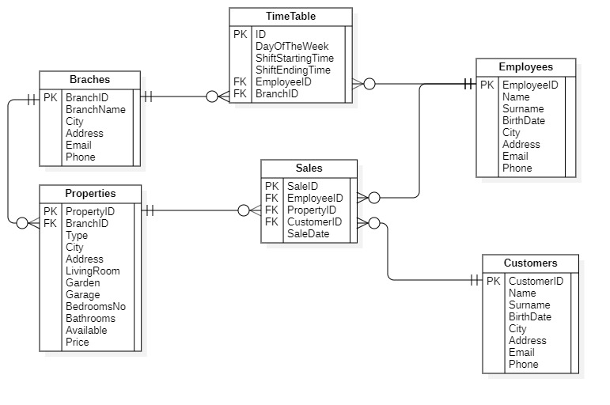
As visible in the ER diagram below (represented in 3NF), the design of the database has been kept simple, to grant a nicer user experience and satisfy the requirements the company asked for.
Figure 1 – Entity Relationship Diagram
The tables contain the attributes needed to accomplish the main tasks and the design could easily be extended and improved to introduces new functionalities, like maintenance etc if the company request them in the future.
Once defined the database structure, we considered appropriate to figure out if To-rent Estate Agent needs a Centralised or Distributed Database.
Is important, in fact, to understand what kind of system should be implemented, since both the approaches have advantages and downsides and in the next chapter, we will explain why we decided to use the Distributed one.

Distributed DB
A distributed database is a database where the information is stored in different locations and, even if could be more expensive to maintain than a centralised one, it would bring different benefits that make its use much more advantageous for the company. (Springer Nature, 2019)
Listed below, we can find some of these pros, including their explanation:

Data loss prevention:
Since the Distributed approach involves the fact that the database must be physically copied and managed by a server that runs the DBMS in every branch, the risk to lose data due to hardware fault or catastrophic event is reduced.
This brings to the customer the certainty that the data could be always recoverable if such events should happen.

No bottlenecks:
Unlike in a centralised system, the DDB one involves the fact that every location must makes use of a separate server that runs the DBMS.
This means that network and CPU resources utilised are split between the different branches avoiding bottlenecks due to user requests.

Local autonomy:
Having a backup of the database in every location means that, even in case of failure of one of the shared resources, the other location could easily access to the part of DB that is not stored in the one that encountered the problem.

Modularity:
Since every system is completely independent from the rest of the DB, it could be modified to add or remove modules, without affecting the functionalities of the main one.

Reliability:
The development of this kind of system, has the advantages that the database is replicated over every location. This make more reliable the transactions, because the system can be easily checked before proceeding with them.

The implementation
As visible in the following images, the final system implementation and how it has been fragmented.
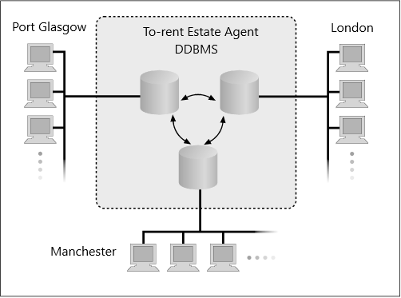
Figure 2. DDBMS structure
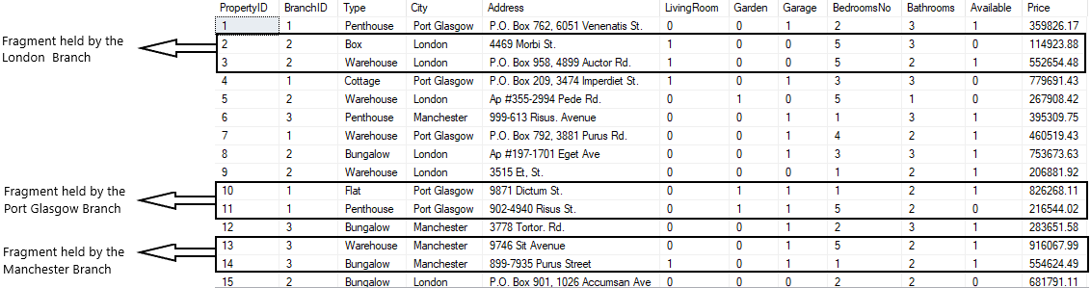
Figure 3. Branches table fragmentation
Since the company has three branches and the properties present in the Properties table belong to different cities, the table has been fragmented horizontally.
This bring the advantage that every branch has a faster access to the properties that belong to its zone.

Benefits
With technology come advantages in fact, with the implementation of the proposed DBMS, one of the main reasons that could drive the company to migrate from the current system would be that To-rent Estate Agent would benefit of the advantages listed below.
- Reduced Data Redundancy
- Data Integrity
- Security

Reduced Data Redundancy
The actual filing system is based on paper. This means that, since the company has different branches, the data needs to be copied and, if modified, updated in all the venues.
Having multiple copies leads to have data redundancy and with it, some human mistake could bring to have inconsistency with the data from one branch to another.
The proposed DBMS, aims to avoid this redundancy because the data is stored in a centralised database and all the changes made on the records happens in real time, lowering the chance to encounter duplicated or wrong records to zero.

Data integrity
With the term integrity, is intended accuracy and consistency in the DB content.
The proposed system gives the user the certainty that all the stored data can be trusted, making use of constraints that ensure the correctness of the inserted data. In the previous system, for instance, was a duty of every employee to check that all the data related to transactions, properties and customers was correct. (ResearchGate, 2019)

Security
The implementation of the new system relies on a set of policy that will be applied to every employee to avoid unauthorised access to data that should be available only to the management.
This means that every user will have access credentials and will have a different role that could be “Admin” or “Employee”.

Query the system
As evidenced before, the system can be queried to retrieve all the data need to accomplish the everyday tasks.
In the following part, we will try to show the main functionalities of the database and the way we could implement them using the SQL language.
As visible in the following screenshots, it’s possible to easily interact with it to insert new properties, edit data, proceed with the sales, create charts to analyse the performances of the employees and forecast the status of the business.
The first four pictures, show the way the system handles the access by employees and admin and what they have access once logged in.
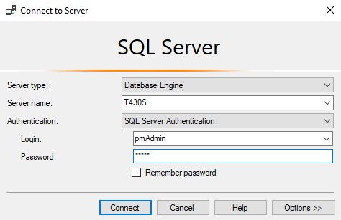
Figure 4. Admin login
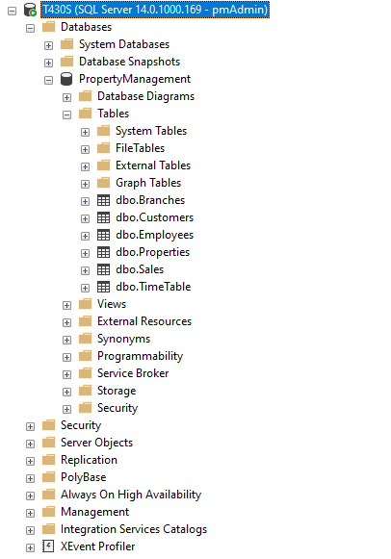
Figure 5. Admin view
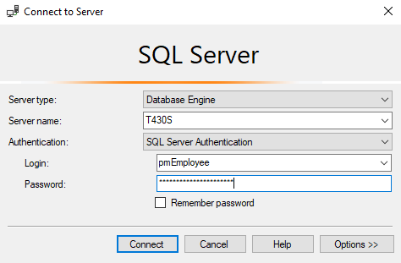
Figure 6. Employee login
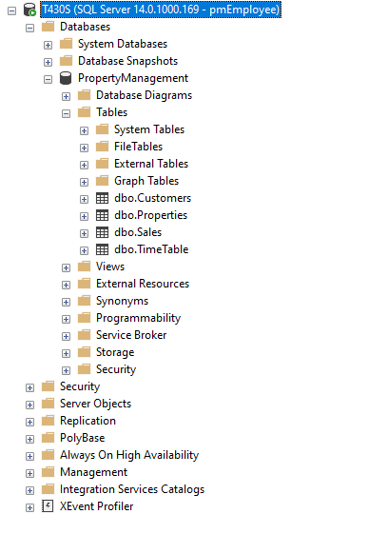
Once the user is logged in, the database can be queried.
Figure 7. Employee view
In the next screenshot, is simulated one of the most probable scenarios an employee could face. A customer that asks for a four bedrooms property located in London.
The following query is executed against the database and the following result is shown to the employee.
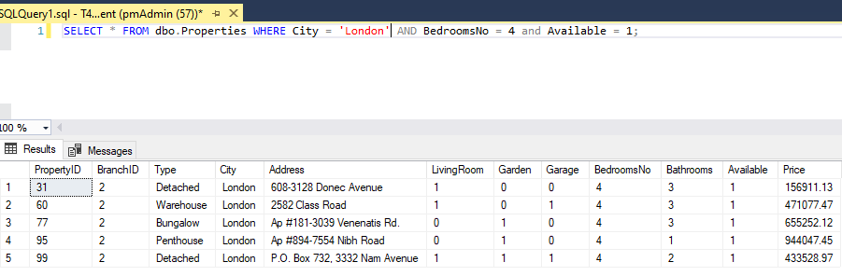
Figure 8. Query example
Like the employees, even the admin can query the system, but for different purposes.
For example, he could check which properties have been sold and the details of the transactions.
The pictures below, show the results of some queries issued to check these details.
- List all the sales with the name of the properties and the amount of each sale.
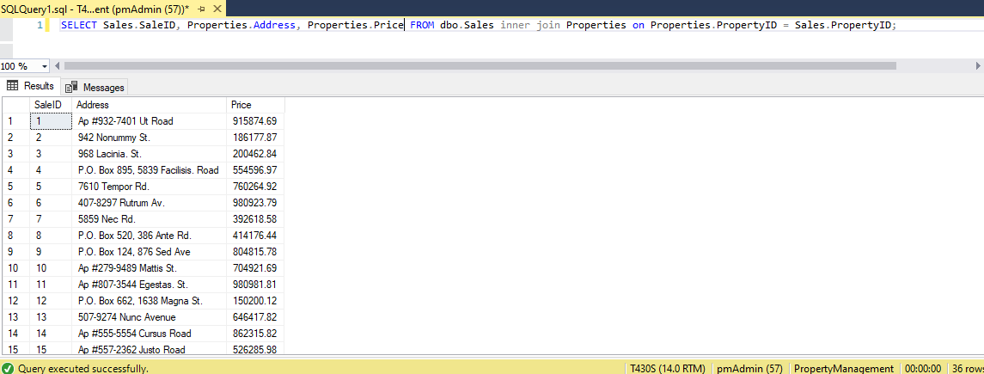
Figure 9. Query 1 task 2
- List all the sales with the name of the personnel who made the sale, the property sold, and the amount of each sale.
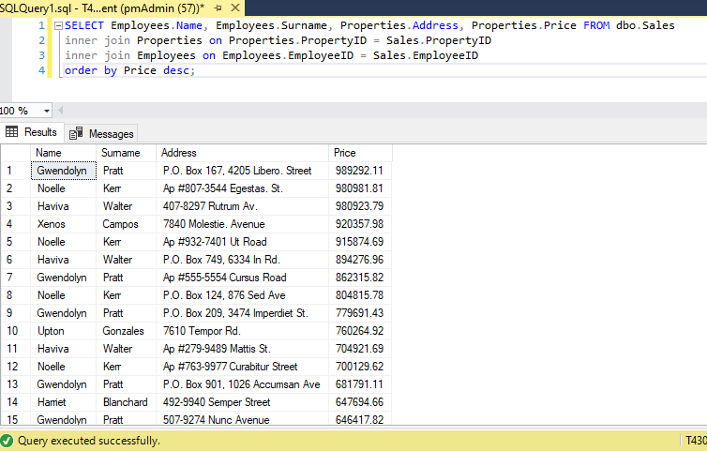
Figure 10. Query 2 task 2
- List all the sales for a year with the name of the personnel who made the sale, the property sold, and the amount of each sale for each branch.
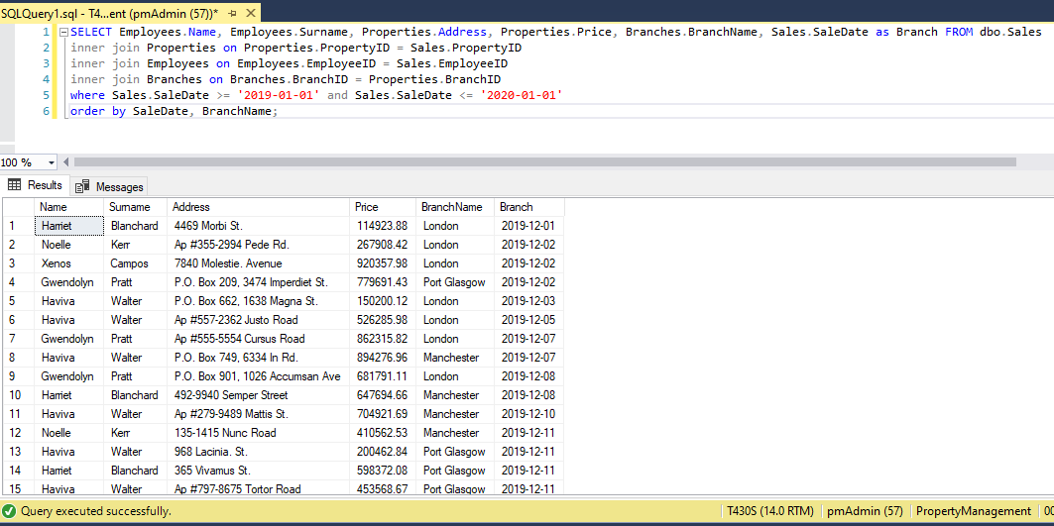
Figure 11. Query 3 task 2

The results can also be shown as pivot tables, making use of a Microsoft Excel functionality that creates charts based on the results generated by the SQL statements.

Figure 12. Pivot table 1

Figure 13. Pivot table 2

Figure 14. Pivot table 3

Conclusion
The following proposal aimed to suggest to the To-rent Estate Agent company that the implementation of a database system in its business would bring many advantages and would introduce its business to the digital era, giving the possibility to grow more efficiently.
It would simplify its daily activities increasing the productivity.

References
Ashish Srivastava, U. S. (2012, July). Transaction Processing In Replicated Data in the DDBMS. International Journal of Modern Engineering Research (IJMER), 2409-2416. Retrieved December 2019, from https://pdfs.semanticscholar.org/85c3/33bda138569f5b4195f4592112773eedcd20.pdf
ResearchGate. (2019). Role of Fragmentation in Distributed database system. Retrieved December 2019, from ResearchGate: https://www.researchgate.net/publication/323826232_Role_of_Fragmentation_in_Distributed_database_system
Springer Nature. (2019, December). Principles of Distributed Database Systems. Retrieved December 2019, from SpringerLink: https://link.springer.com/chapter/10.1007/978-3-030-26253-2_1

Appendix

DATABASE TEST

/******************************************************

Phone check constraint test
on the Employees table

THE EXECUTION WILL FAIL BECAUSE
THE NUMBER DOESN'T RESPECT THE UK FORMAT
+44XXXXXXXXXX

******************************************************/

INSERT INTO PropertyManagement.dbo.Employees VALUES('TEST','USER','1999-01-01','Port Glasgow','P.O. Box 001, 1596 Natoque Rd.','et.magnis@turpis.com','443886552836');

/******************************************************

Email check constraint test
on the Customers table

THE EXECUTION WILL FAIL BECAUSE
THE EMAIL DOESN'T RESPECT THE FORMAT
% @ % . %

******************************************************/

INSERT INTO PropertyManagement.dbo.Customers VALUES('TEST','USER','1996-04-03','Manchester','534-7443 Erat Avenue','lectus.pede.et@interdum','+445110922604');

/******************************************************

BirthDate check constraint test
on the Employees table

THE EXECUTION WILL FAIL BECAUSE
THE USER WAS BORN AFTER THE 2001/01/01

******************************************************/

INSERT INTO PropertyManagement.dbo.Employees VALUES('TEST','USER','2001-01-02','Port Glasgow','P.O. Box 001, 1596 Natoque Rd.','et.magnis@turpis.com','443886552836');

/******************************************************

COMMIT AND ROLLBACK
Swap the shift of two employees
during the 2019-06-08

In this case the transaction will fail, because
there is an error on the ID attribute
in one of the statements

******************************************************/

BEGIN TRY
BEGIN TRANSACTION
UPDATE PropertyManagement.dbo.TimeTable Set BranchID = 3 WHERE ID = 16
UPDATE PropertyManagement.dbo.TimeTable Set BranchID = 2 WHERE ID = '2a6'
COMMIT TRANSACTION
PRINT 'Transaction committed!'
END TRY
BEGIN CATCH
ROLLBACK TRANSACTION
PRINT 'Transaction Rolled Back!'
END CATCH

/******************************************************

COMMIT AND ROLLBACK
Swap the shift of two employees
during the 2019-06-08

In this case the transaction will be committed

******************************************************/

BEGIN TRY
BEGIN TRANSACTION
UPDATE PropertyManagement.dbo.TimeTable Set BranchID = 3 WHERE ID = 16
UPDATE PropertyManagement.dbo.TimeTable Set BranchID = 2 WHERE ID = 26
COMMIT TRANSACTION
PRINT 'Transaction committed!'
END TRY
BEGIN CATCH
ROLLBACK TRANSACTION
PRINT 'Transaction Rolled Back!'
END CATCH

