4/14/2026
Kyle Hall (2533563)
University of wales trinity saint david
Computer Architecture and Operating Systems

Table of Contents
Introduction 2
Task 1 – Key functions of general Operating Systems 3
Task 2 – Use of Windows OS CLI commands 5
Task 3 – Use of Linux OS CLI commands 23
Task 4 – Use of Windows OS Scripts 37
Task 5 – Use of Linux OS scripts 48
Conclusion 56
References 56

Introduction
This report aims to cover the key functions and some practical use cases of operating systems with a focus on Microsoft Windows, and Linux. The report will also cover how operating systems manage hardware resources, running applications and even providing users with interfaces to interact with the system. The aim of this report is also to practice the use of command line interfaces and other scripting tools, that may include PowerShell and bash to perform some administrative tasks. This report will also explore the primary functions like process, file, and user management, along with task scheduling and network monitoring too. Some practical examples with screenshots will be used throughout this report to further assist the understanding, alongside references to relevant technical sources.

Task 1 – Key functions of general Operating Systems
Key functions are what allow the user to see and manage the resources of a computer through a graphical user interface or a command line interface through the operating system (GUI, CLI).
Key functions include process management; this is what allows the OS to manage any running applications or processes, handling their creation, scheduling on the CPU synchronization, and termination. BBC also states that processor management allows for multitasking on the computer, but it is only possible if the operating system can support it, and if the computer has enough memory to hold more than one program in primary memory at the time. ​ [1]​ If you want to view, or investigate an issue, and you believe seeing the process management can help, a function you can use, to see, monitor and manage it, is task manager, this is a very common tool used in windows, a general operating system, that can help you monitor your processes and resources. If you need a more technical and detailed function, resource monitor is a function that can assist with this. Guiding tech provides multiple ways to access resource monitor, open “run” then type “resmon” for one example.​ [2]​and to open task manager, use “CTRL + SHIFT + ESC” this will then show you how much of your hardware is being used, and by what.

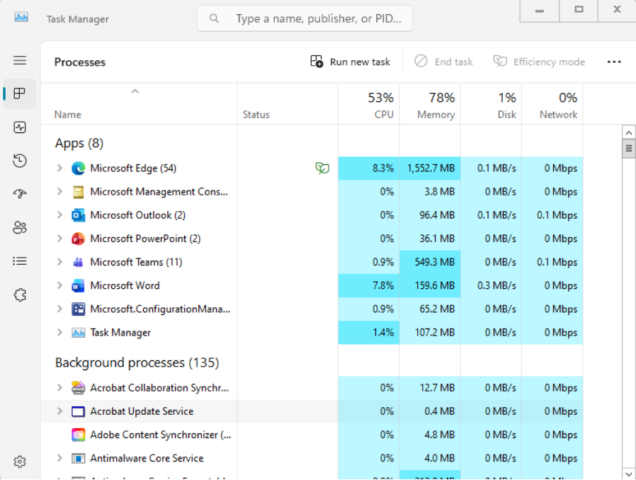
The operating system is also responsible for another function known as memory management. Geeks for Geeks states that memory management is an operating system that controls how data is stored as well as how it is organised in main memory and secondary storage alike. It is designed to ensure programs get any memory they need and it the memory manager will free it when it is no longer being used or if it is no longer needed. The memory manager is also responsible for protection, which will restrict processes from taking memory from other processes, it is also responsible for disk management and ensuring there is free space, and backups being made. The memory manager will also handle fragmentation. Fragmentation handling is designed to reduce waste. The final key activity I will discuss is the allocation and deallocation of memory, where it will give any take memory from and to processes as needed. ​ [3]When it comes to tracking your memory, a very simple overview can be provided by task manager once again, however, when the situation calls for the need to see performance counters such as, committed bytes, available Mbytes, memory compression ratio and so much more, then performance monitor is a better alternative. The Windows Club recommends a few ways to access performance monitor one of which is to open “run” and type “perfmon” ​ [3] [4]​this will 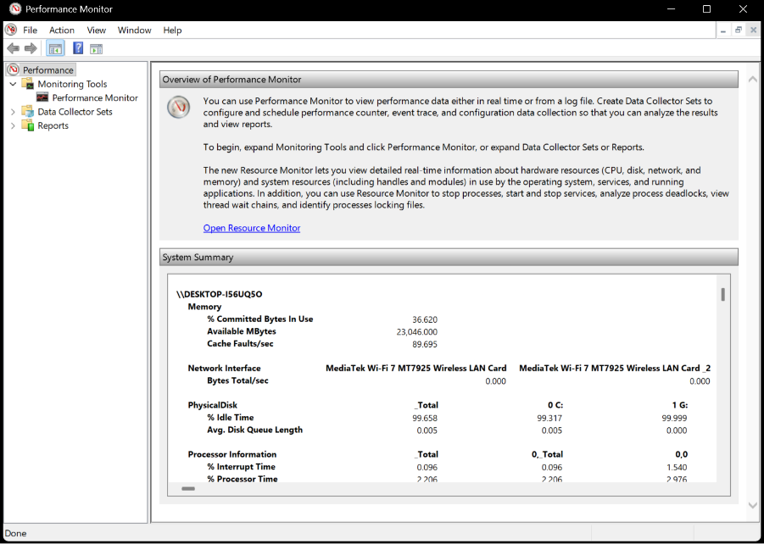allow you to see the previously stated metrics. See the below image to see what performance monitor provides you with.

Task 2 – Use of Windows OS CLI commands
For the report, I decided to use some basic user management commands, this would include, displaying the user, and some basic user information, the code was quite simple, and I utilised notes so things don’t get too confusing as I add more to my code. 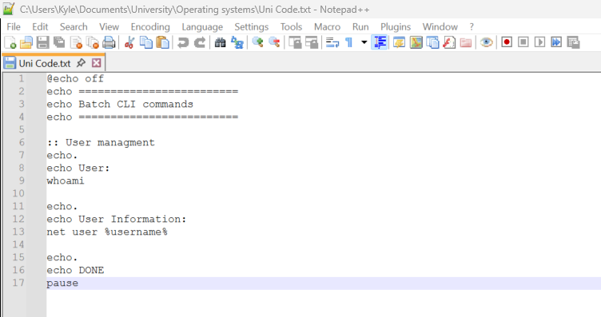
I then renamed the file extension to a .bat to view how it would output. [5]
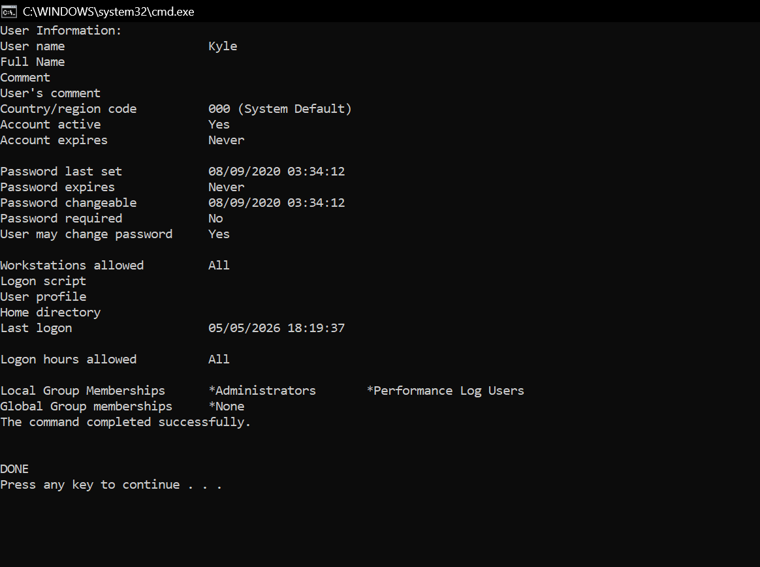
This outputted the expected information. As the tested user account does not have an associated full name or comments this was unable to be populated but nonetheless worked as expected.
Next in the report is file management and directory management. So, I change it from .bat to .txt and continue adding code. 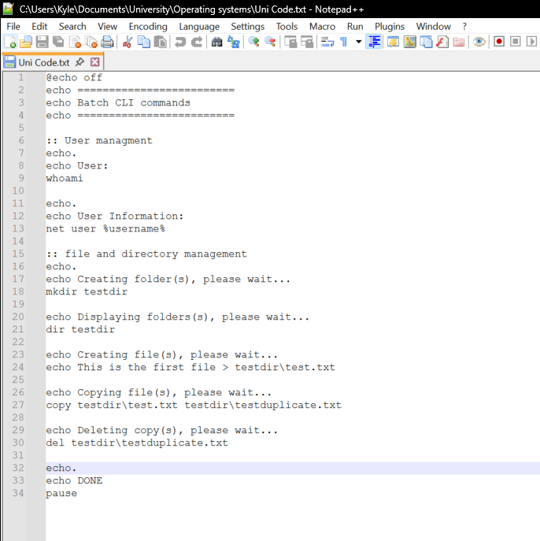
after writing up the code. This is what it outputted. 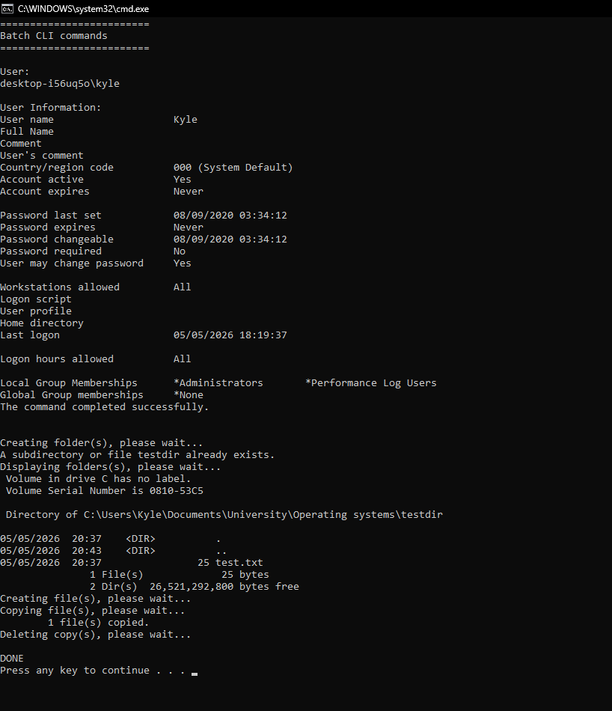
despite it displaying all the correct information it was difficult to see the different parts of the code. The work around used was to add hyphens. See below.
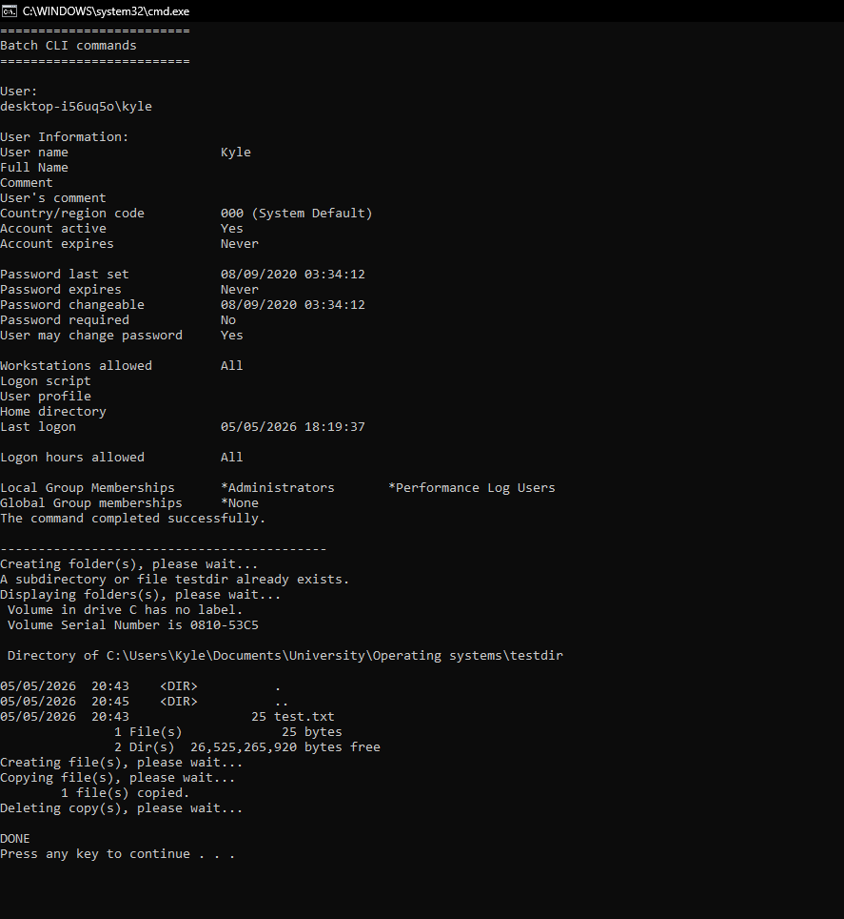
For the report, the attention then turned to process management, initially the search process was failing, due to a lowercase letter needing to be capitalised, this was quickly found and corrected and continued working as expected. 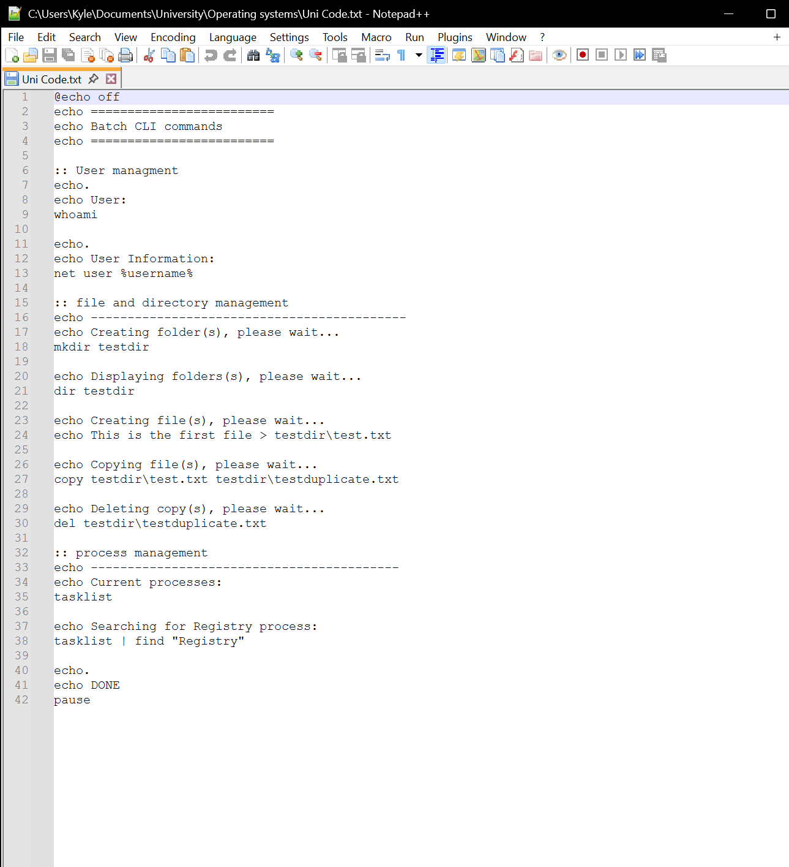
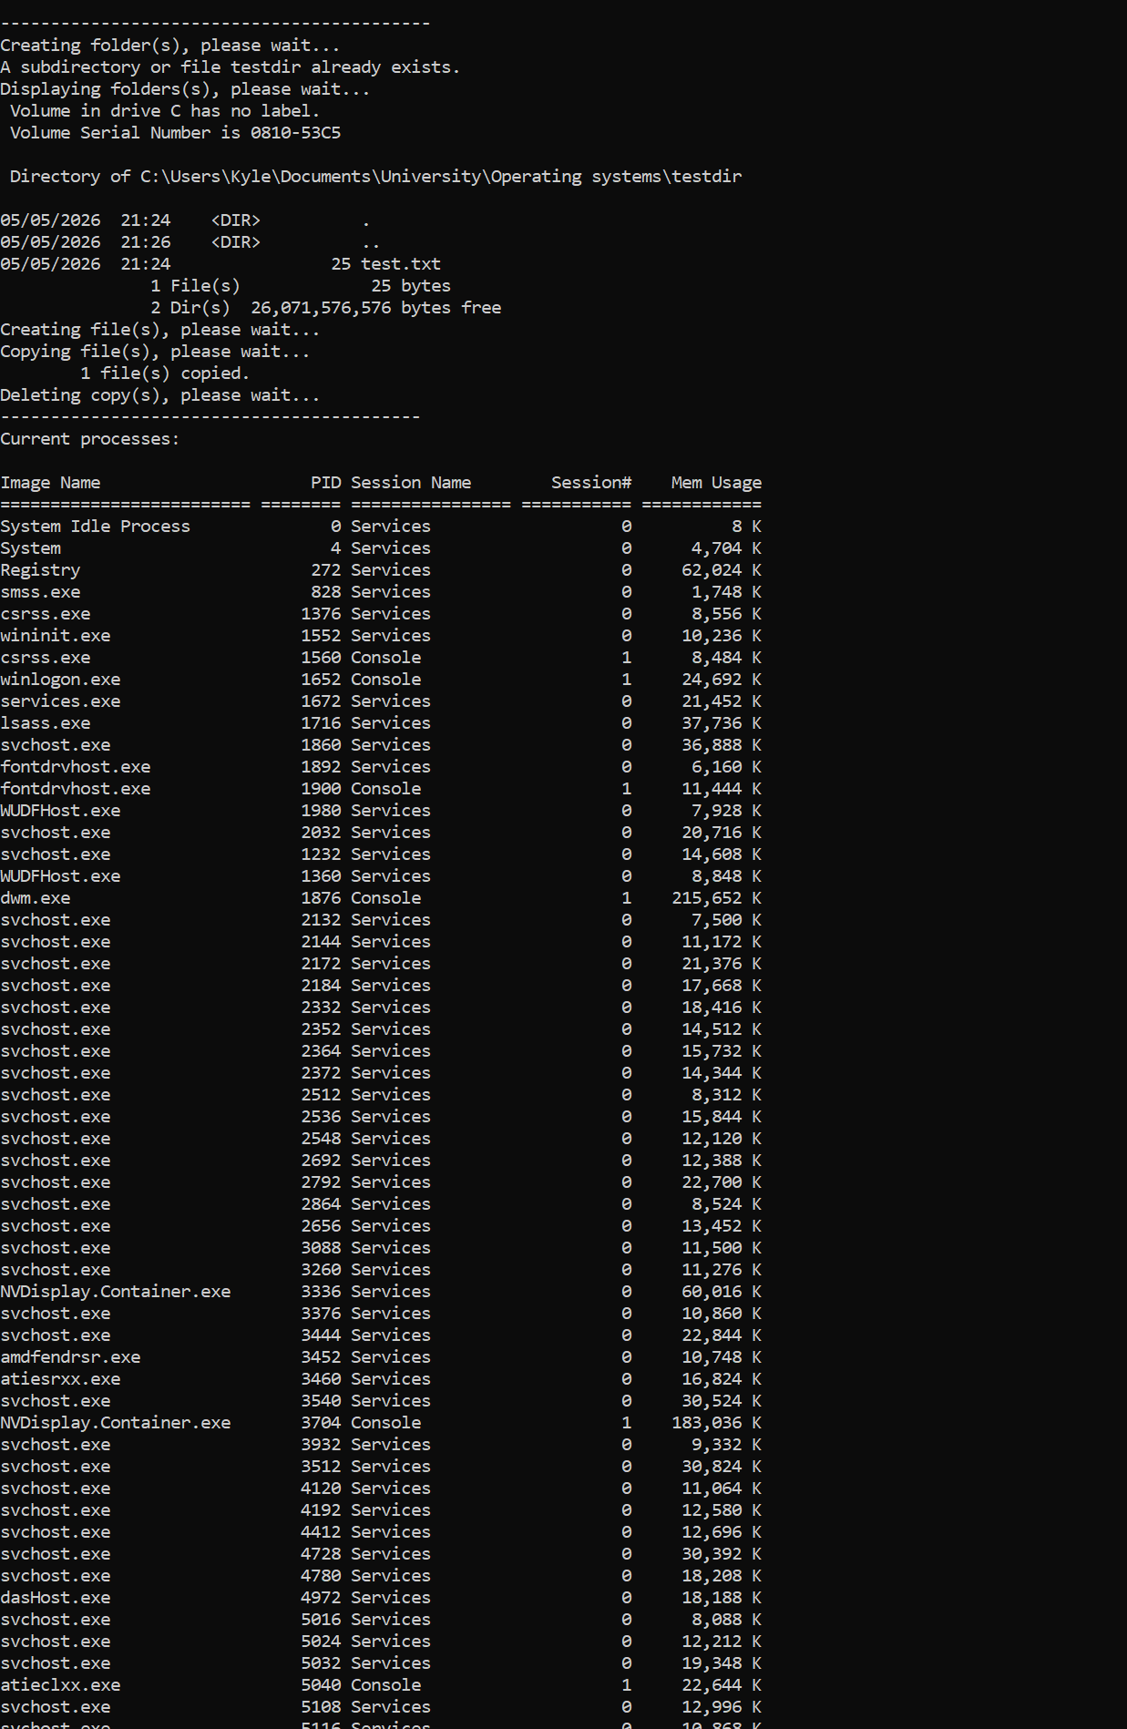
This screenshot displays the echoes working correctly and the continued hyphens for separation.
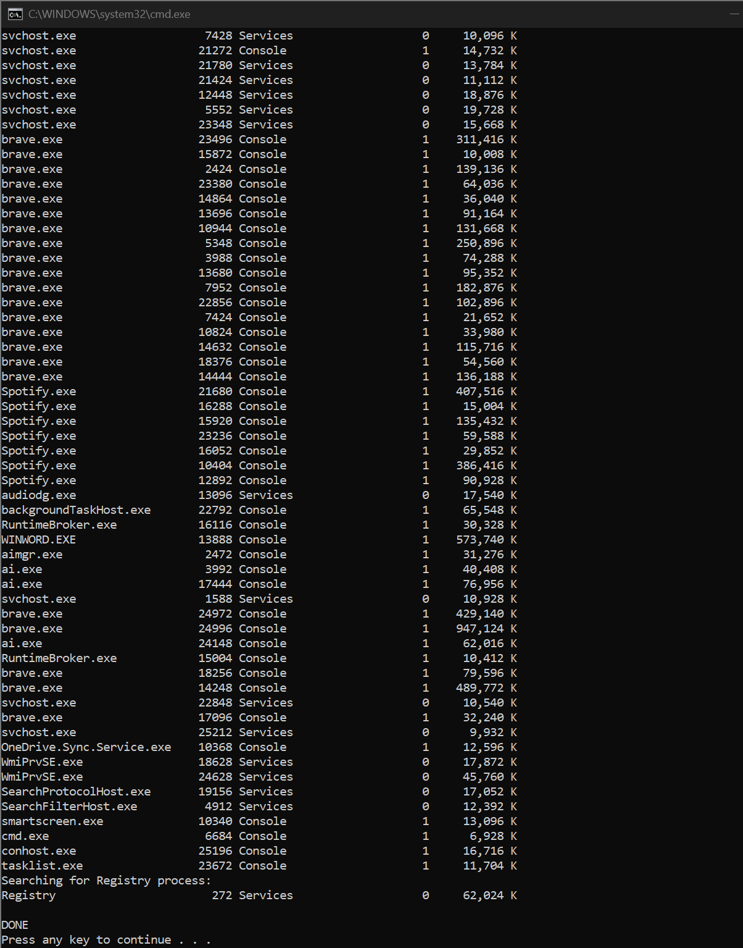In this screenshot it is visible that the searching for registry process worked correctly.
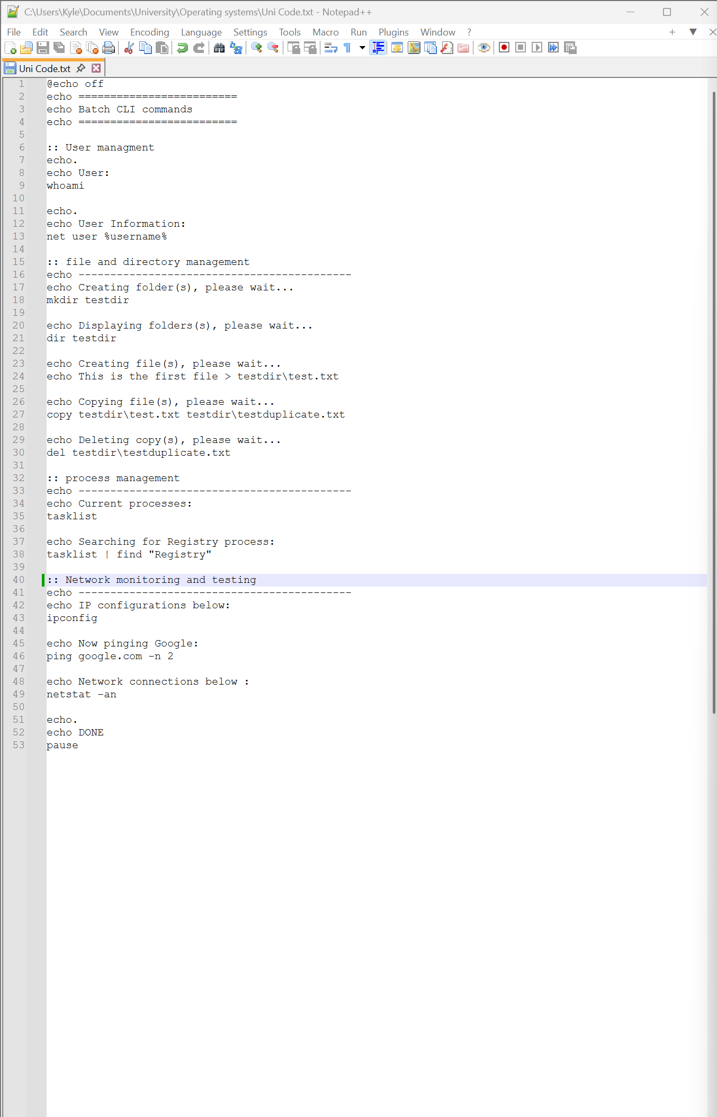

A networks testing section has now been added, which is designed to display the Ip configurations and features a switch for pinging google twice instead of four times, and showing network connections will display everything in a numeric font, with the other switch. [6]
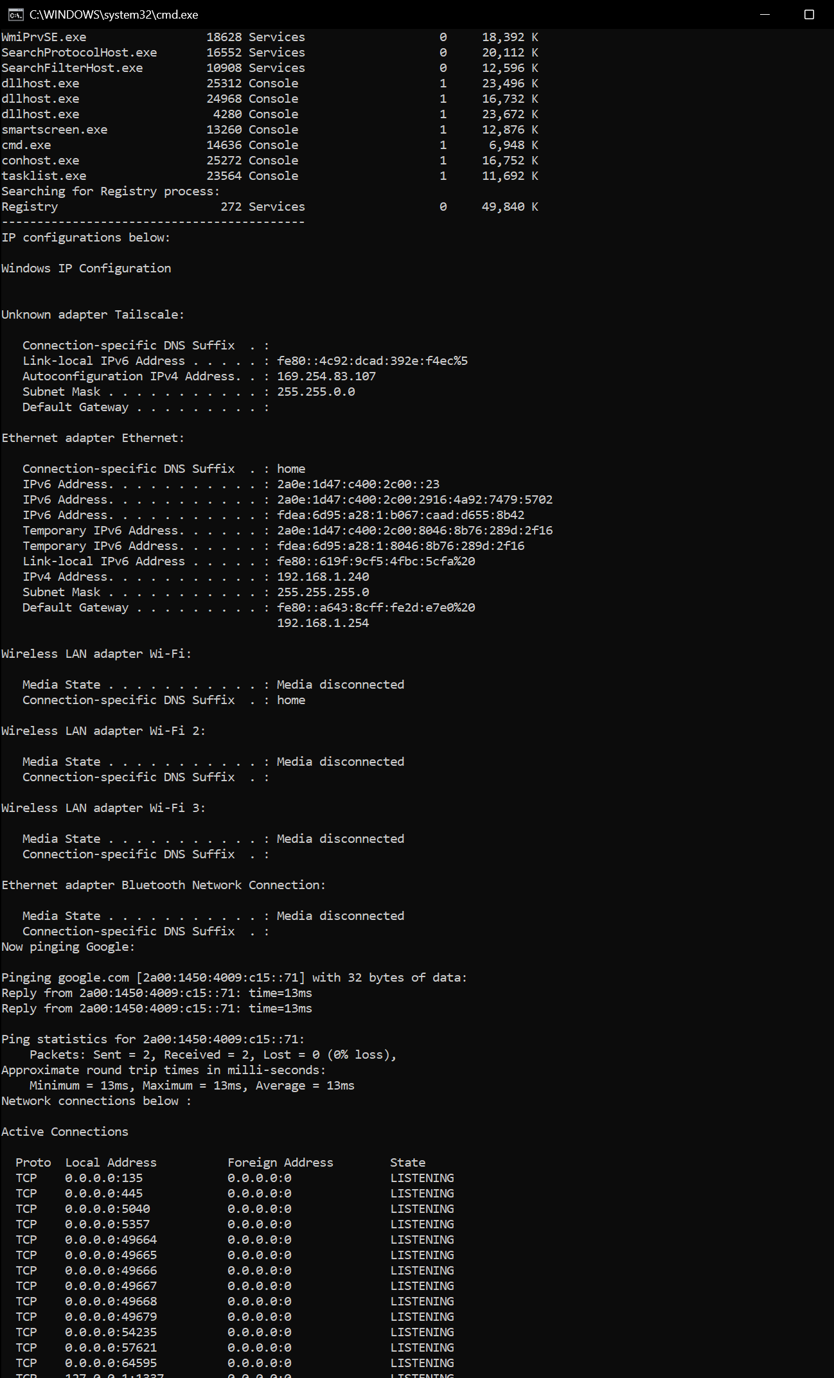
The output is above, and below.
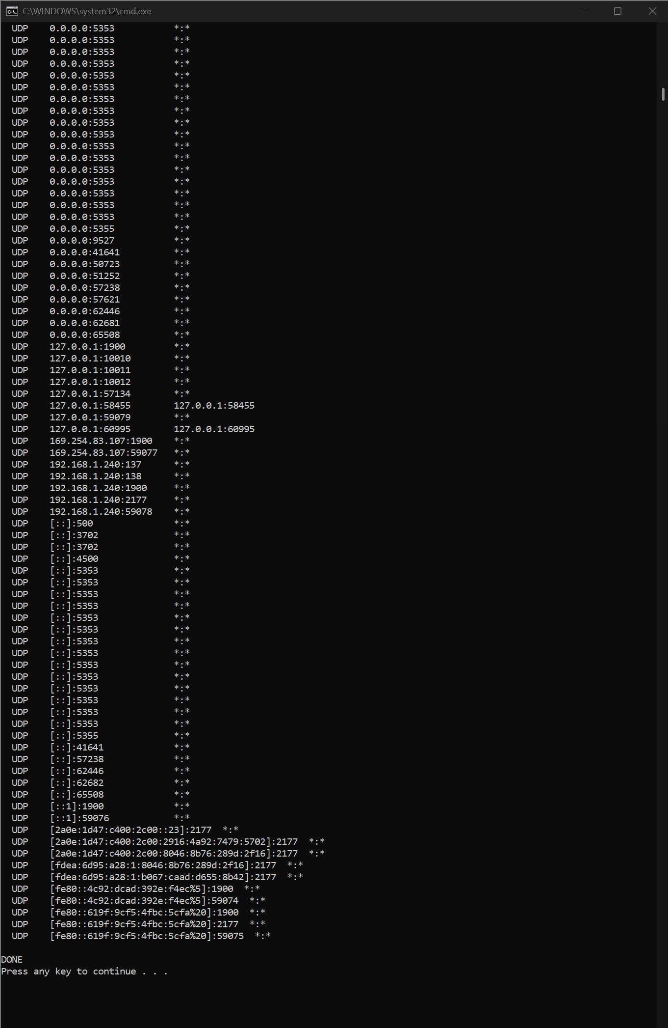
In the first image ipconfig is present and correct, the switch worked correctly and only pinged google twice. The netstat worked and the switch on that one worked as well.
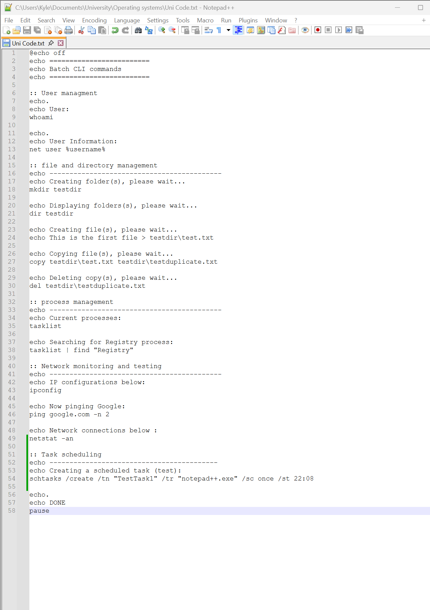Next, I created a scheduled task to open notepad++
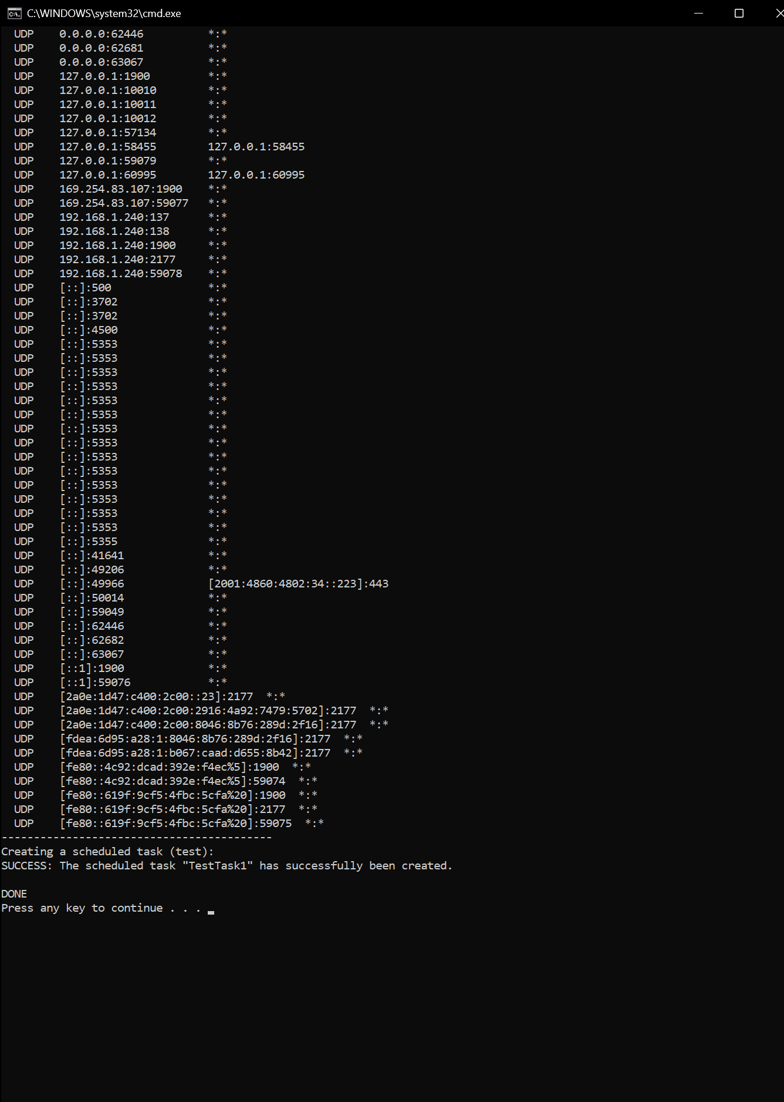
This should then create a scheduled task, which can be checked in task scheduler. See below 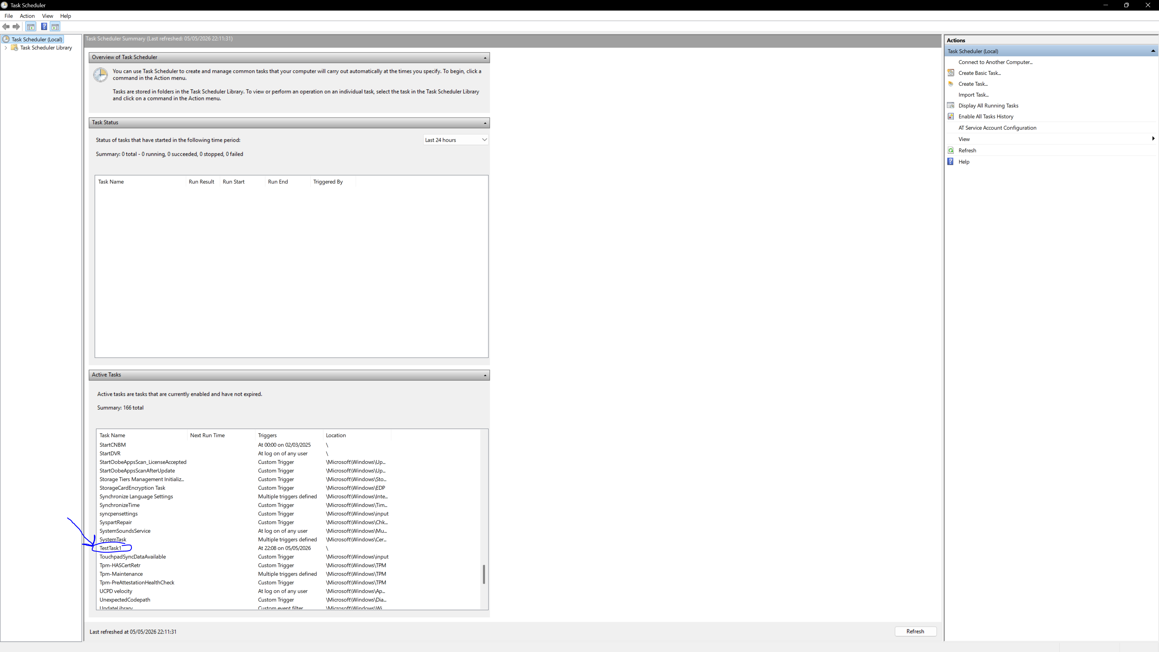
This is evidence of the command working as intended. [7]

Task 3 – Use of Linux OS CLI commands
For this report a variety of different bash commands will be used on a Linux machine. These commands will be basic, but it will contain things such as options and switches. Firstly, some process management commands on terminal.
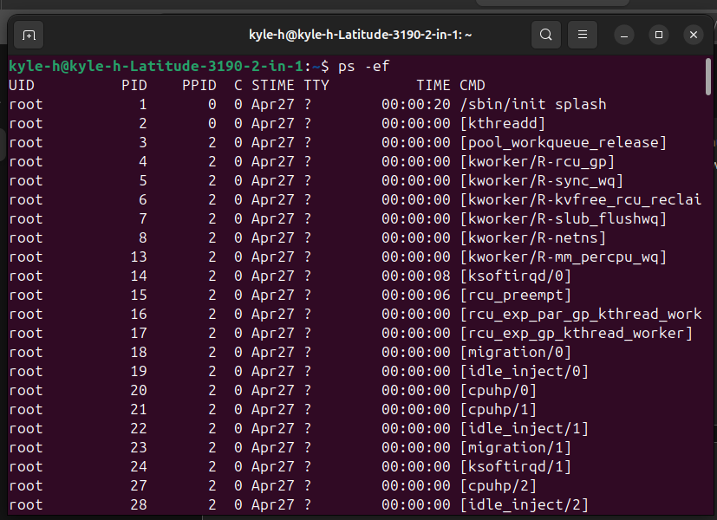This command is ‘Ps –ef’ which will show a snapshot of all active processes in full formatting for all user s. [8]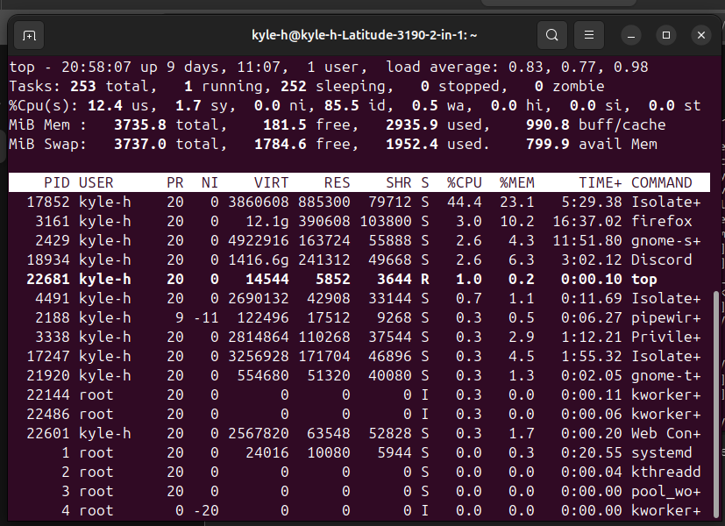This is the ‘top’ command this command provides real-time system monitoring, an important tool for viewing cpu/memory usage. [8]
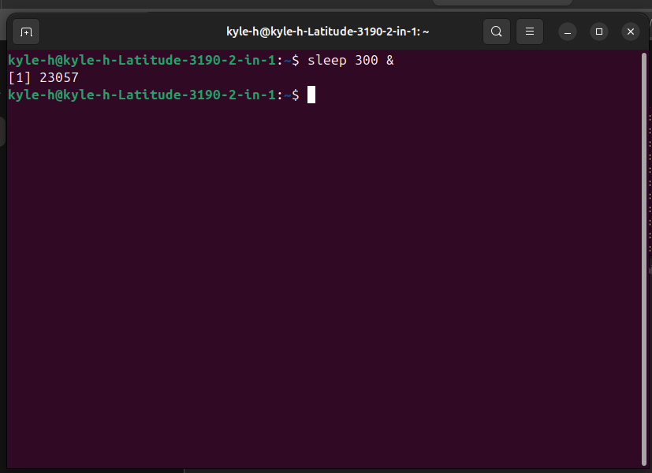The sleep command will be used to demonstrate the kill command which is a useful command you can use in bash. [8]
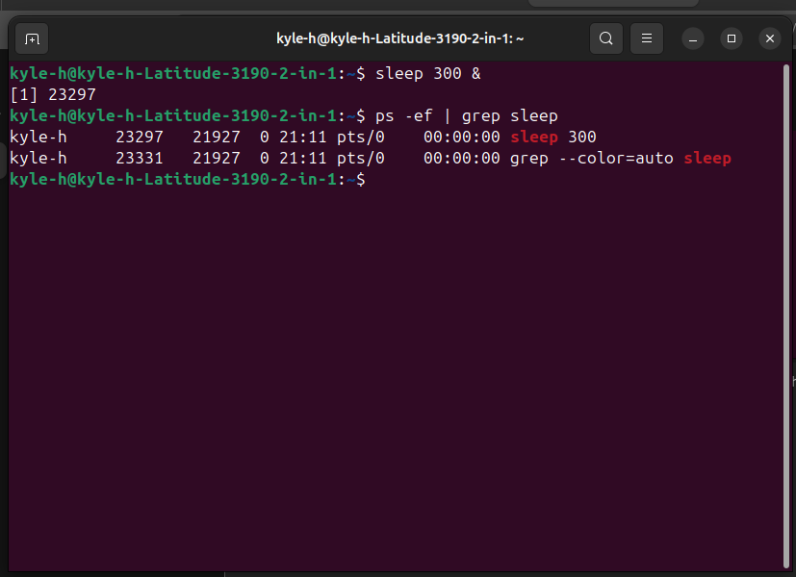
In this screenshot it is visible how previously mentioned commands can help me verify my other commands. [8]
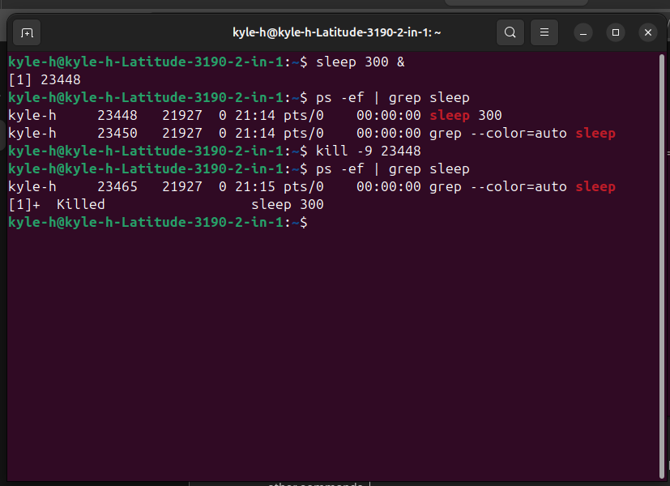In this screenshot after re-doing, it for testing purposes, you can see the creation of the dummy process, then the verification of the process, and finally the force kill commands of the dummy process. [8]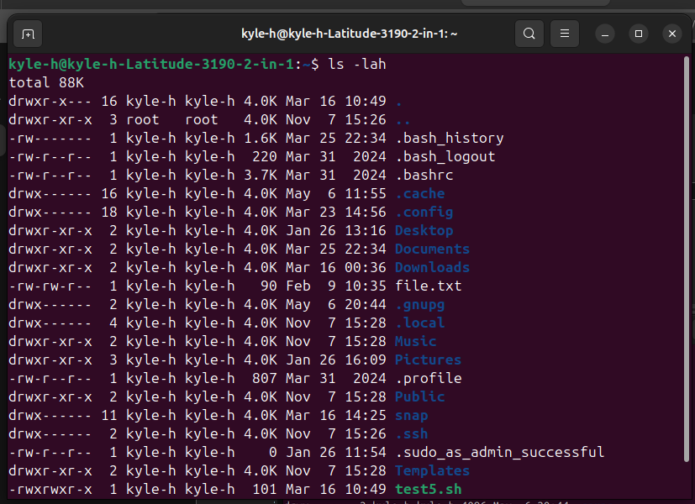
This command will list all files, including any hidden files, with their permissions, but only in human readable sizes, for example ‘4k’ instead of ‘4000’ [8]
Next was to create a directory.
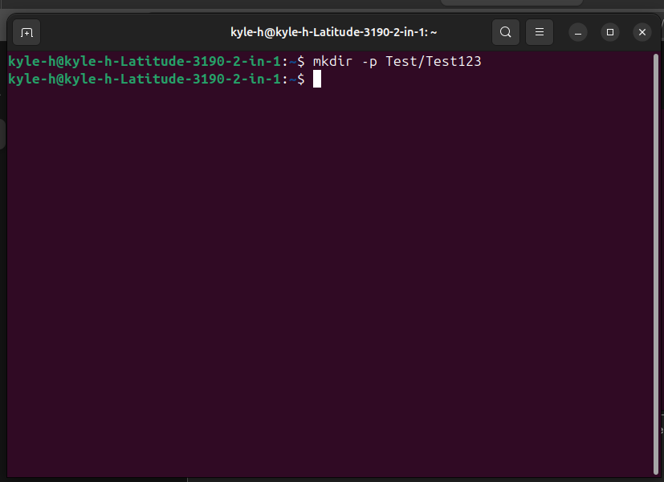This command will create a directory and create a parent directory as well.
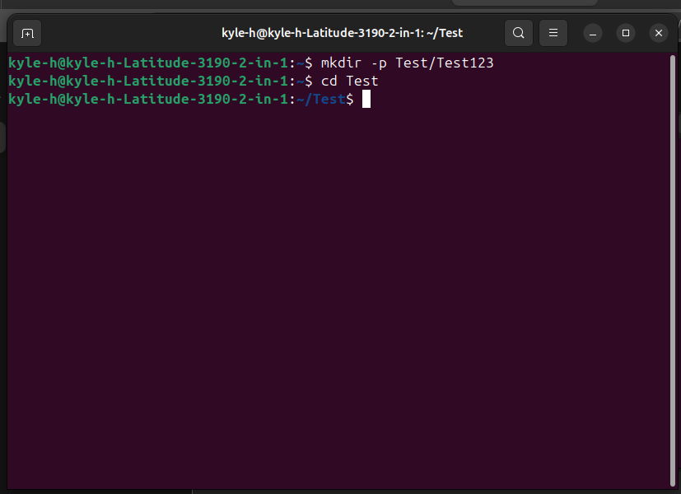
changed directory to ensure it was available and wanted to check for other directories in this one, as an attempt was made in the previous code.
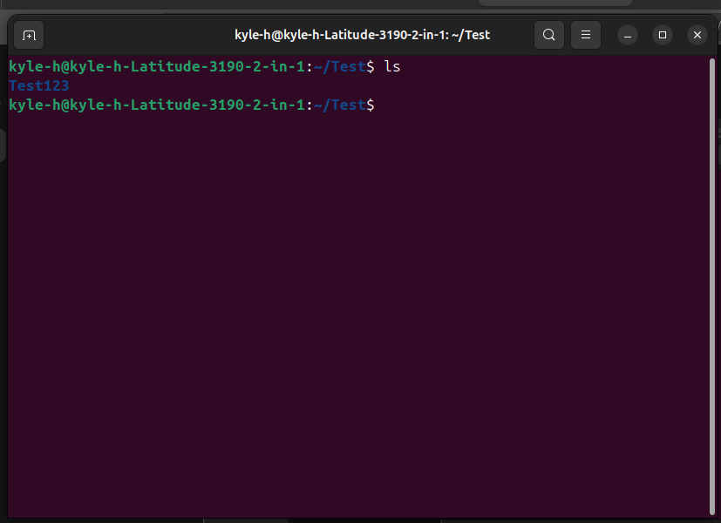Here we can see the other directory that was created earlier is present using the –p option for ‘mkdir’
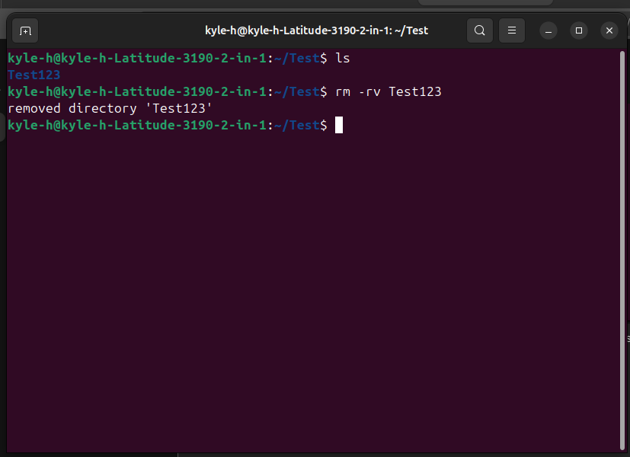
The Test123 directory was then removed using the above commands.
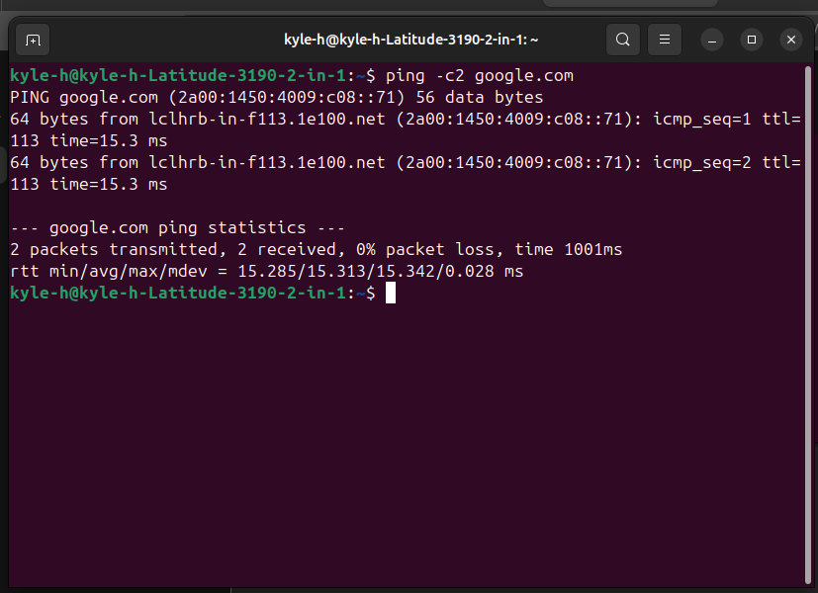Next was network management and monitoring commands as seen above, using the –c option i limited the packets sent to google.com to 2 packets only.
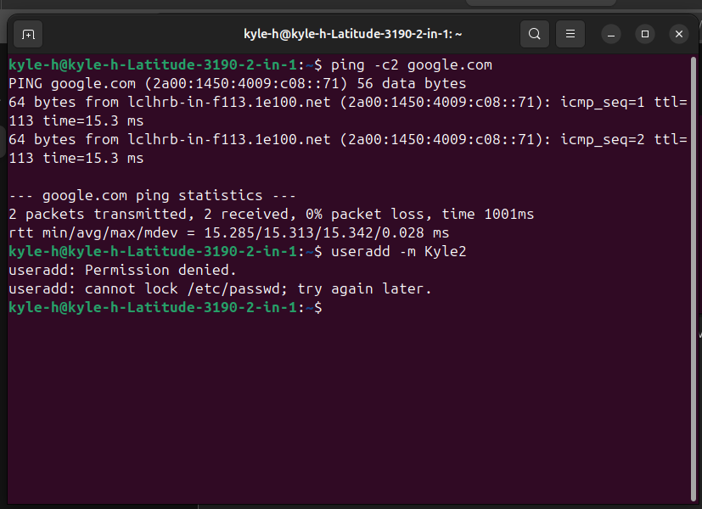If elevated permissions are used, i can use the above command to create a new user called Kyle2 along with a home directory due to option for the user.

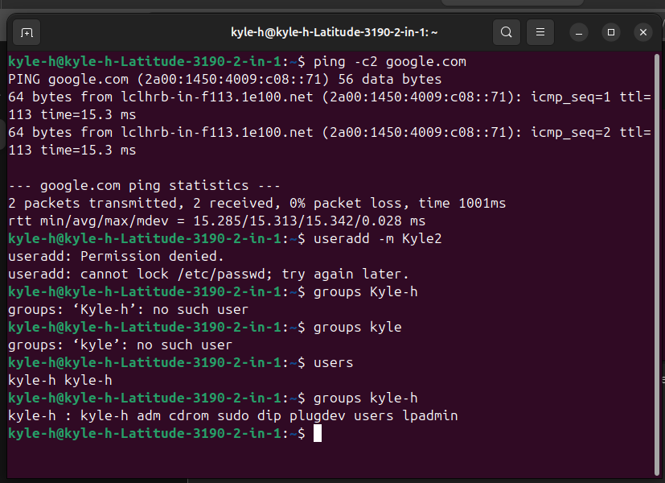The above screenshot features the users command which displays the list of users. Accompanied by the groups command which displays the group memberships for a user. [8]
Next is scheduling tasks
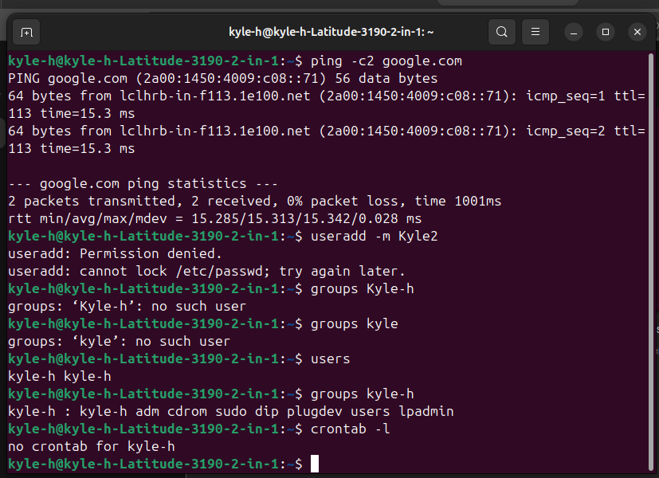As seen above the crontab –l will list all the scheduled cronjobs, in this instance there were none. [8]

Task 4 – Use of Windows OS Scripts
Next for this report, Is a demonstration of the use of OS scripts in windows. To fulfil this, the use of batch .bat/.cmd and PowerShell .ps1 may be used. The use of OS scripts is typically to reduce administrative or repetitive tasks and improve system management efficiency through automation.
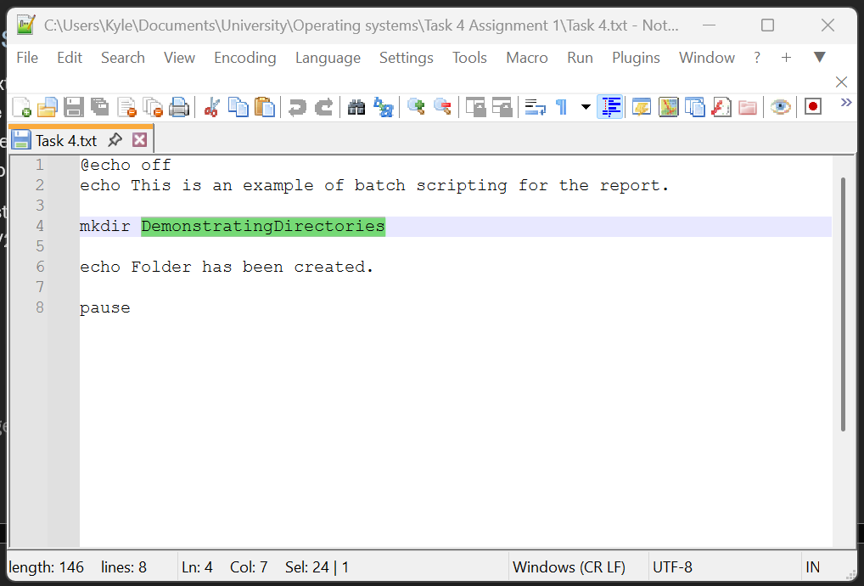
See above for the code utilised to create a folder. Followed by “echo” which will print text to the cli. Pause will allow the user to read the echo before it disappears.
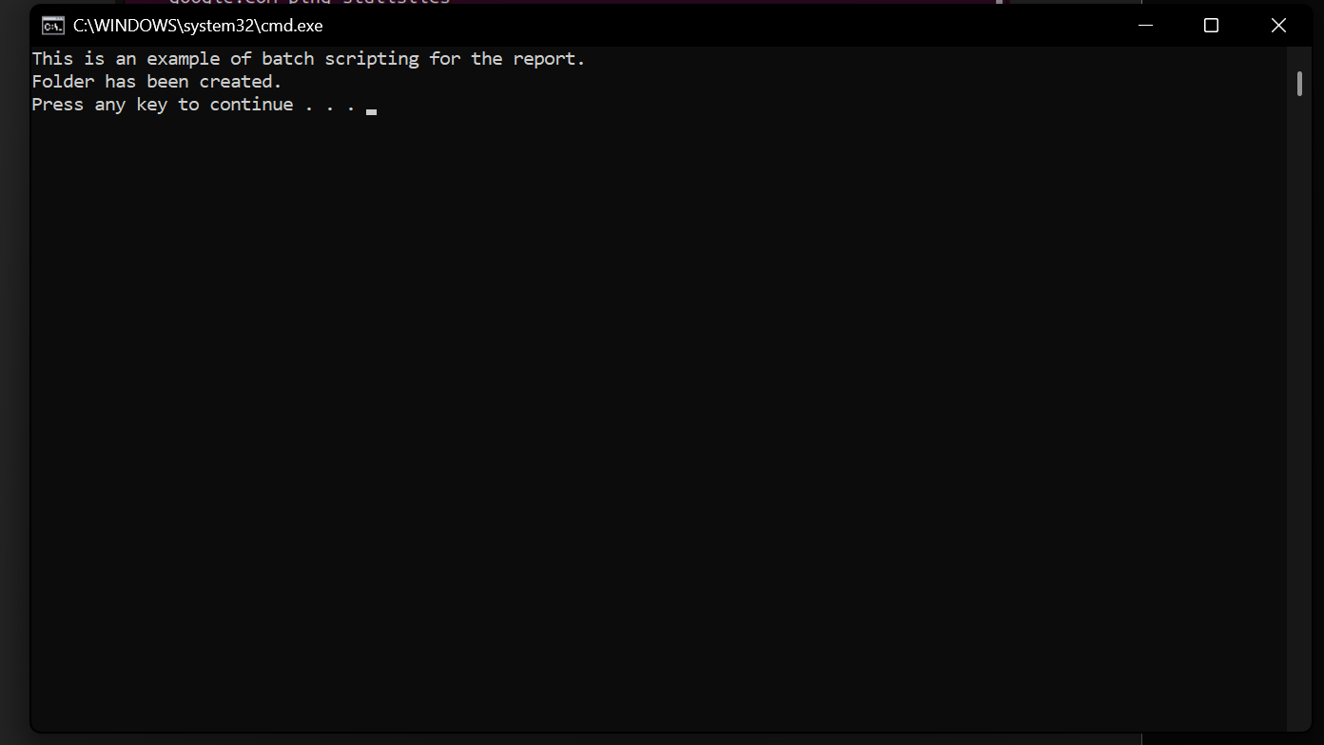
The above screenshot shows the output of the script.
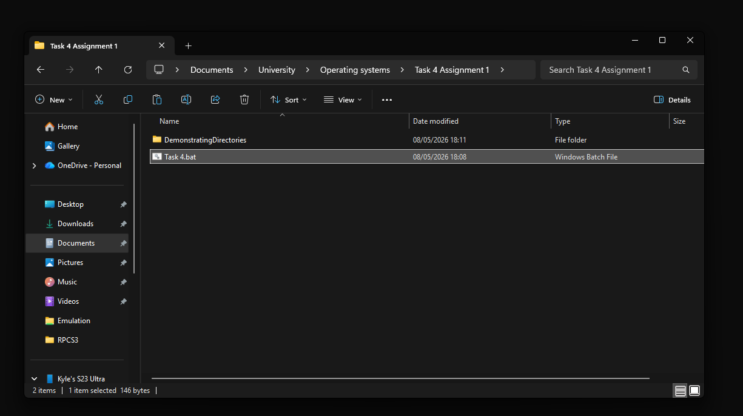
And as shown here, the directory has been made in the same location as the .bat file.
Now for some PowerShell scripts.

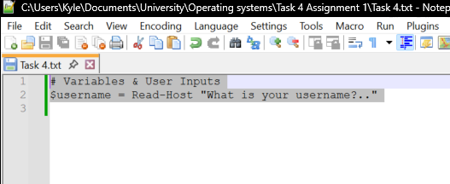
Here is my start in PowerShell, $username makes use of a variable that will store a user’s input. Read-Host is what allows users to enter information during script execution.

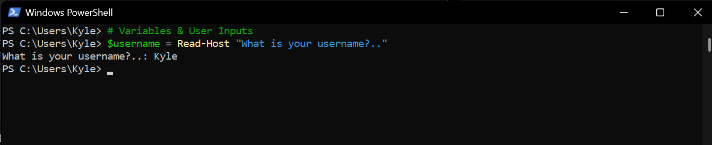
As shows above, this is what the script will output, you can see what the script is running in the background.
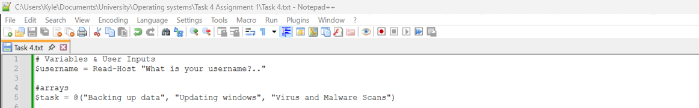
Arrays were added. arrays can store multiple values inside of one variable. As shown above this one has 3. [9]
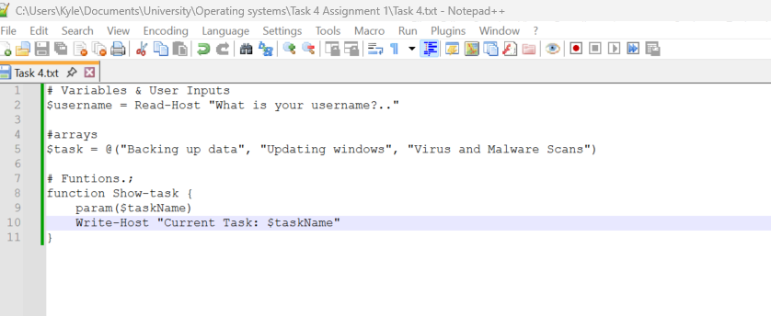
The use of functions has now been added. [10]
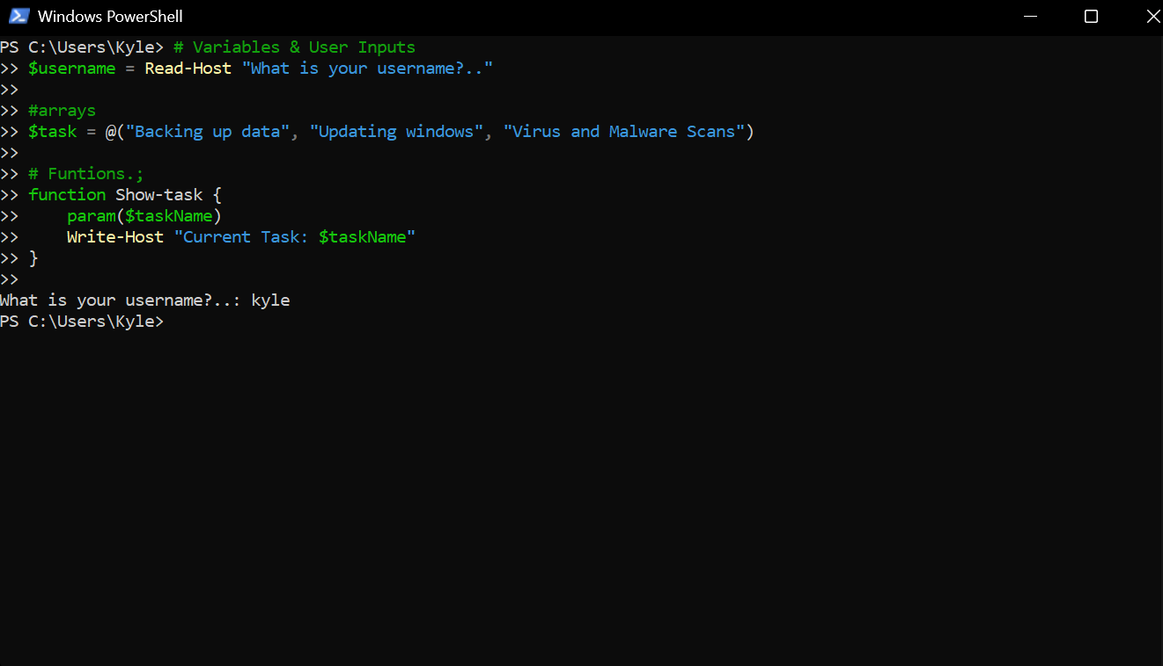
If statements have now been implemented. 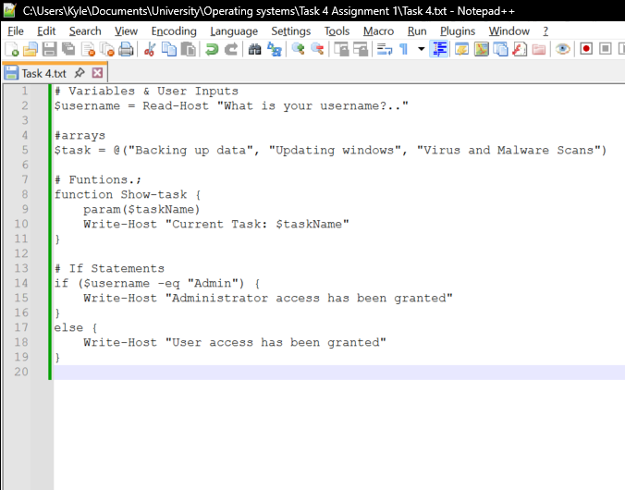
This if statement allows for a small easter egg if the user types in admin. [11]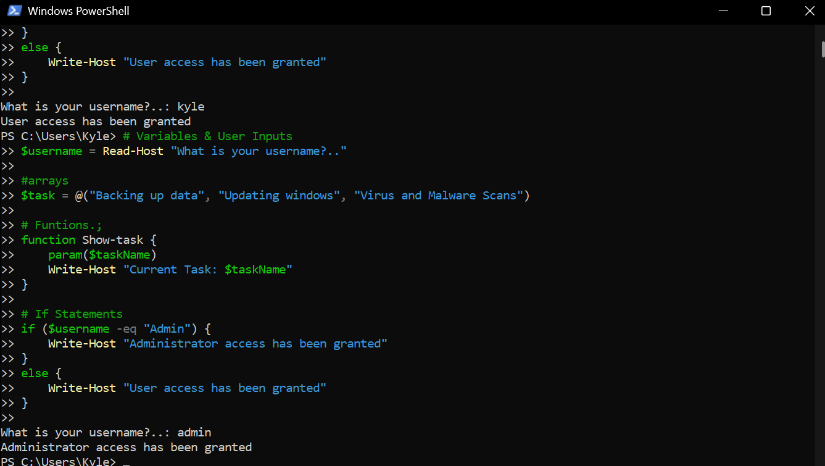
Shown above is the code working as intended. A switch statement will now be added.
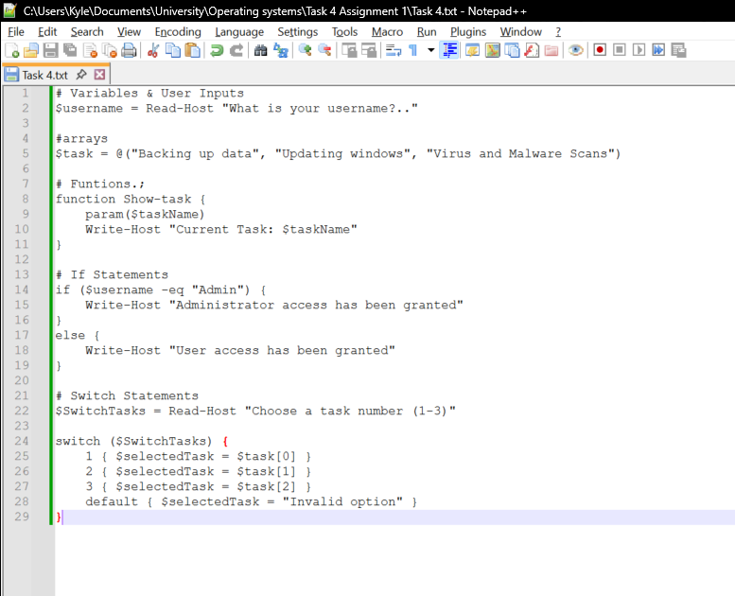
Now that the switch has been implemented the user can enter another input which will select an action depending on the chosen option. [12]
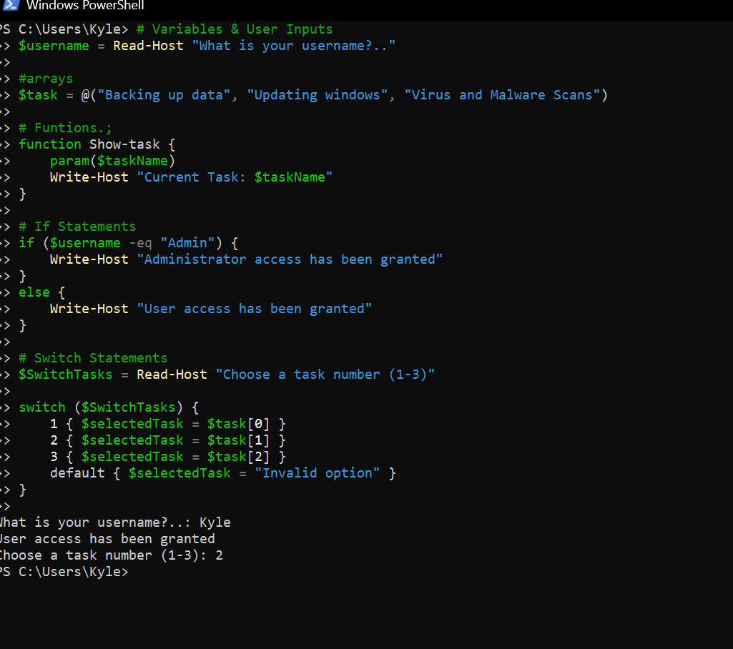
A loop will be implemented before the switch, so the user can choose what task they want to run.
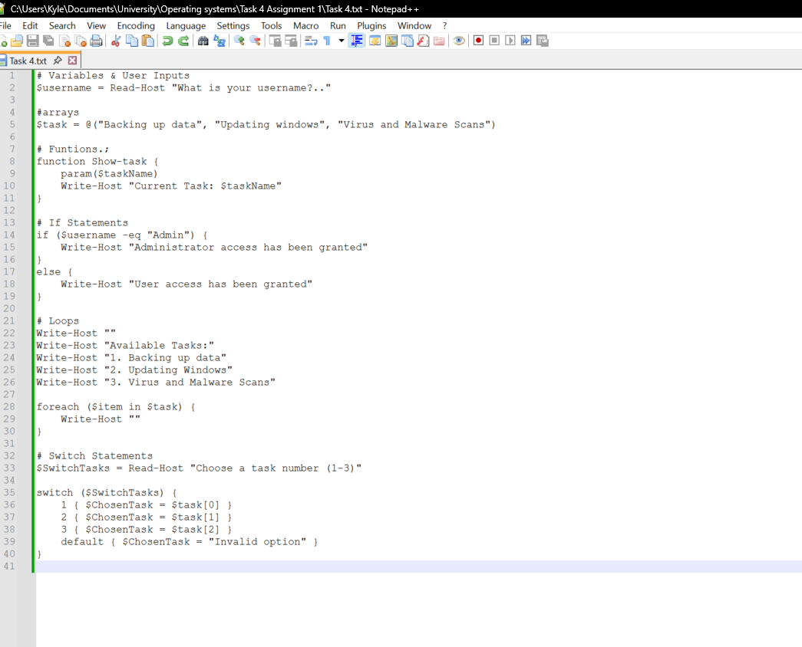
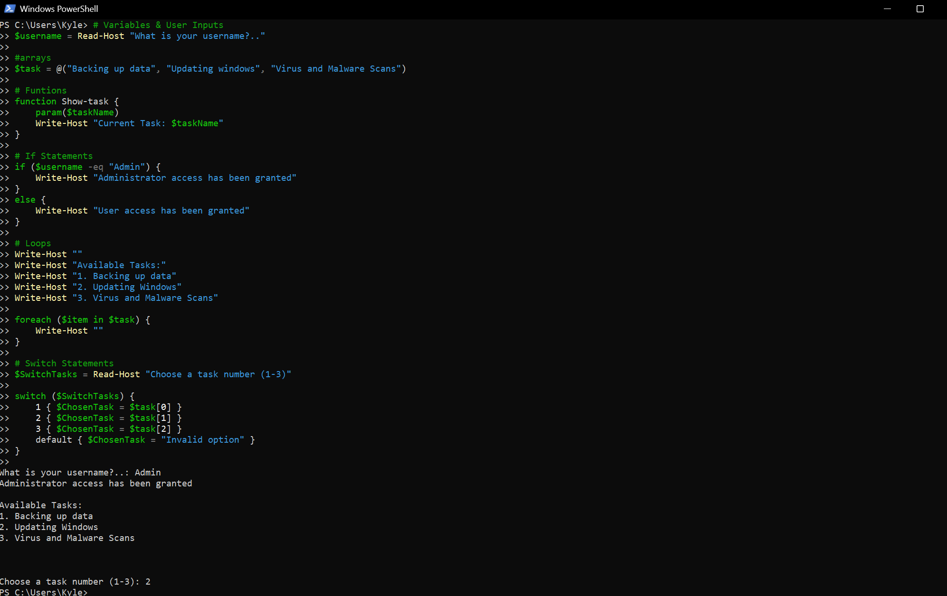
A function call will now be added so the user knows it’s working. A change to the array names was also needed.
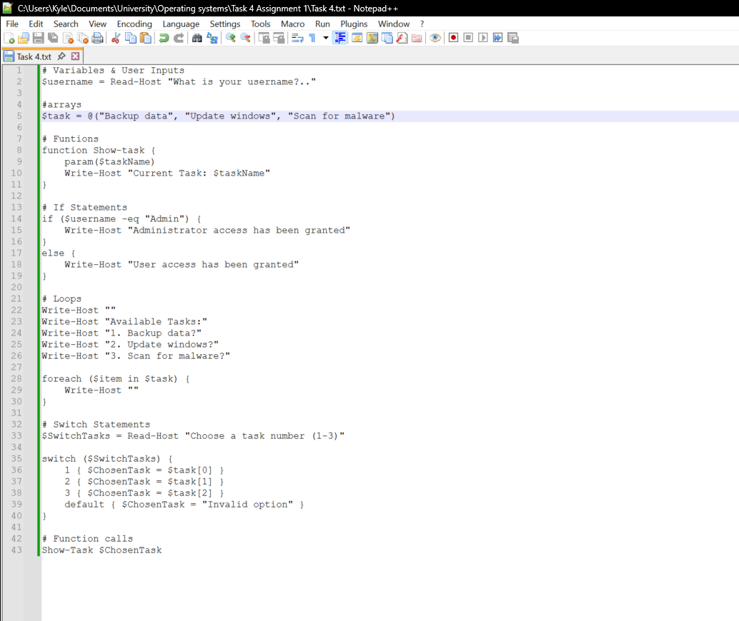
This is now what it looks like, I have altered how the loop displays the options and changed the array values which was important for the function call. [13]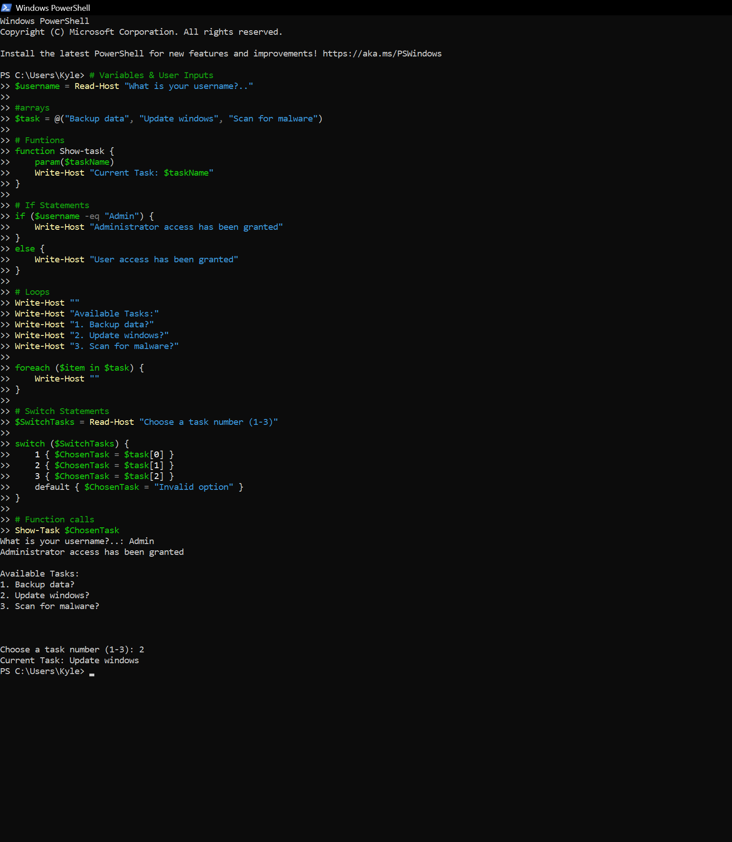
Here is the final PowerShell script. It is quite visible how this tool can help automate administrative tasks, despite it being purely demonstrative for the purpose of the report.

Task 5 – Use of Linux OS scripts
this will be a short technical demonstration displaying the basic batch scripting concepts, and how to automate tasks in Linux. Bash will be used as it’s the default CLI language. it allows users to automate repetitive tasks, manage files, and execute system commands efficiently scripts are often written in play text files with a .sh file extension executed via terminal.
The first syntax used was #!/bin/bash this will tell the system to use the bash interpreter. Next was an echo command, this is a simple bash command to print text into the terminal.
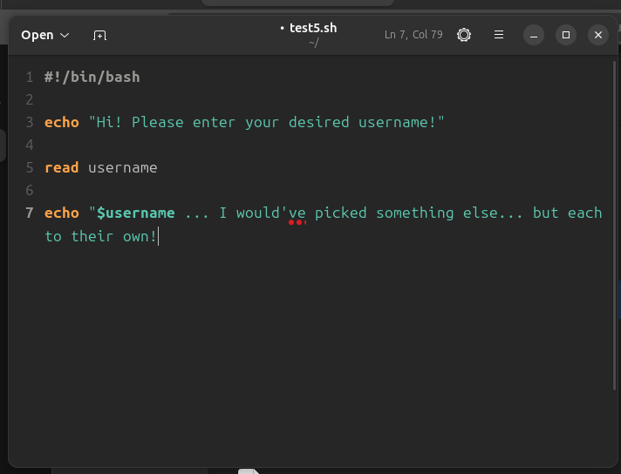
This part of the report was just playing around with the read function, and the echo commands. [14]
I did a quick test to ensure that everything worked. 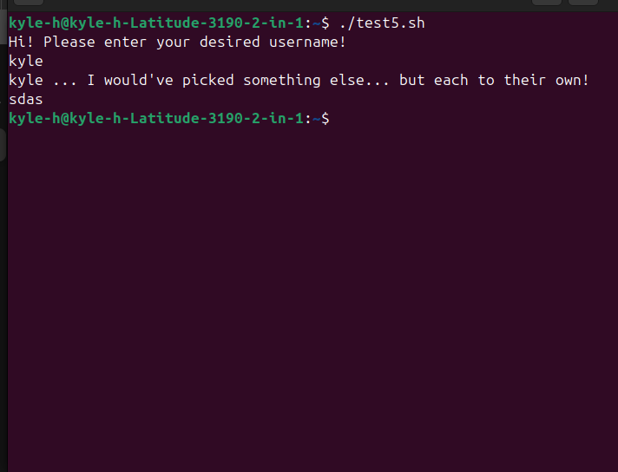
Code should now be added so any button press exits the terminal and a small prompt can be shown.
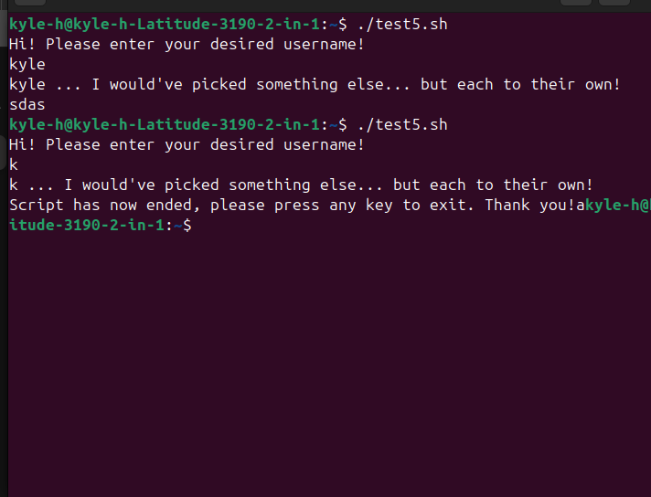
As shown above the code now prompts the user to press any key to exit.
For the next part of my script, purpose of a script was needed, so this script will be used for finding files in directories, as the current device has everything a bit clustered.
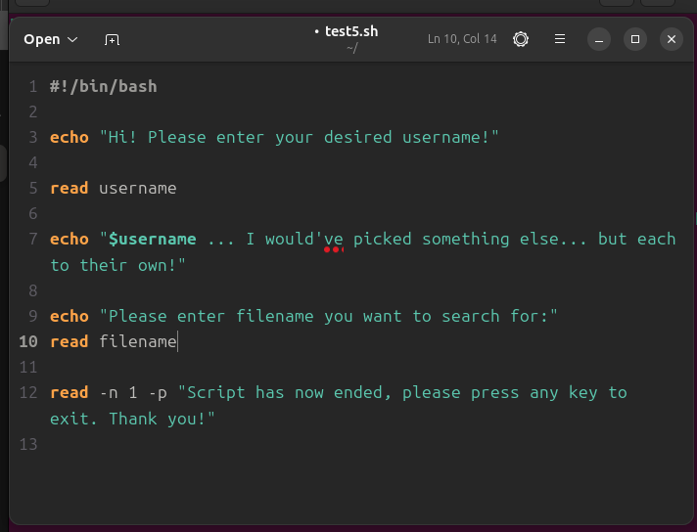
This is the first part of the implementation of the search system, I use an echo so the user understands the relevance of their next input.
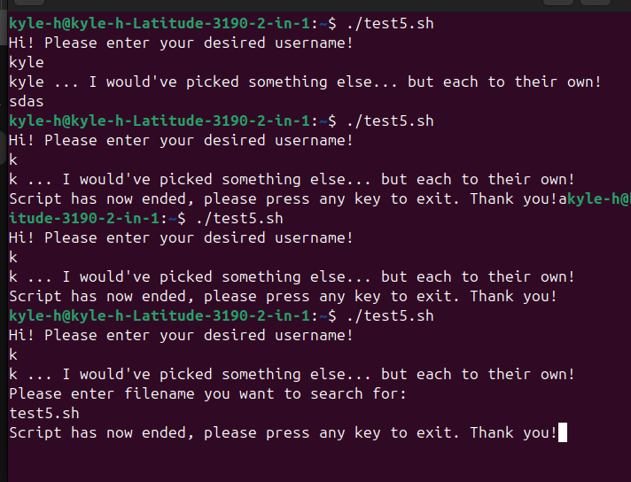
The code works so far, however, now it needs to do something. So that code will now be implemented. 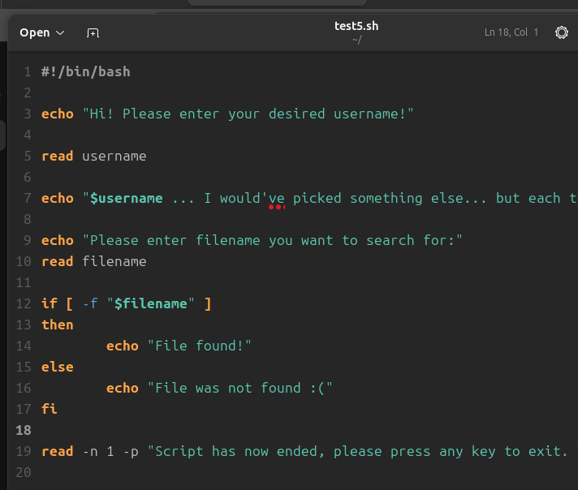
Here an if- else statement was added, to locate the file requested by the user. With an output for each situation. [14]
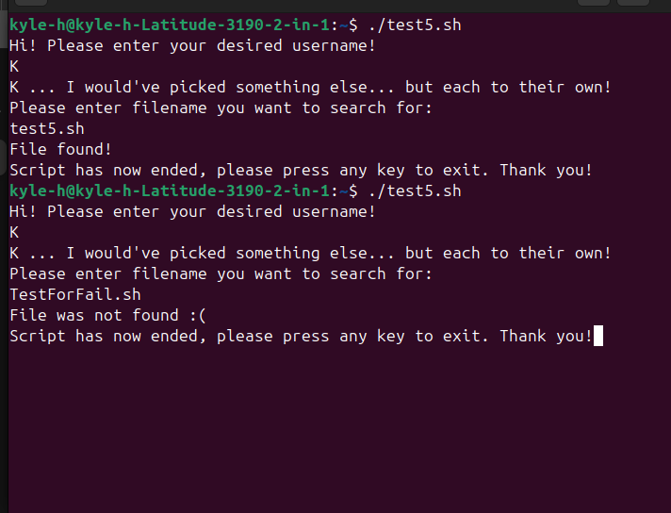
This is the evidence of both situations performing as intended.
To allow multiple files at once, loops, arrays, and other conditional statements will be added. 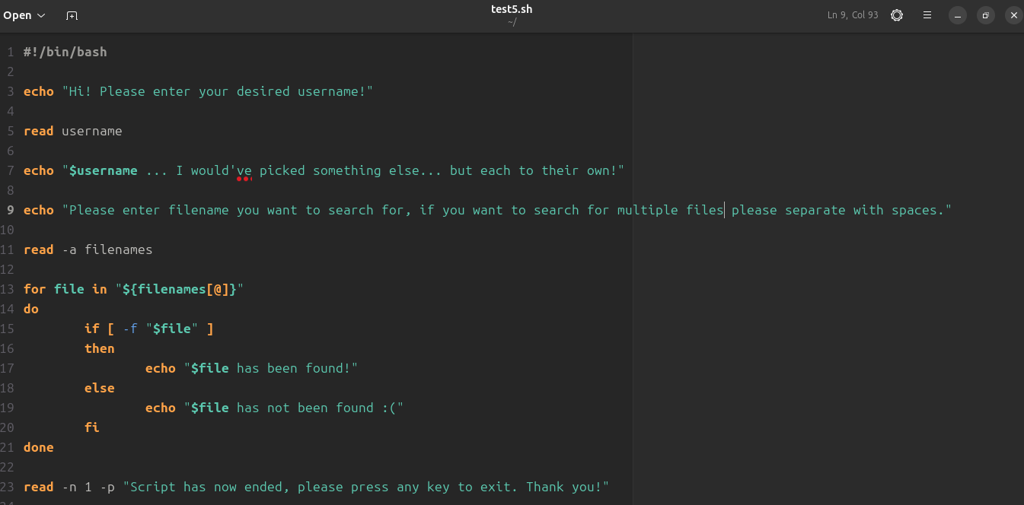
This is now the new code. it begins with the use of an array. It facilitates storing and retrieving elements from a list form that can be used for certain tasks. [15]
Next is a for loop, this worked best for code so this is what I chose to implement. [16]
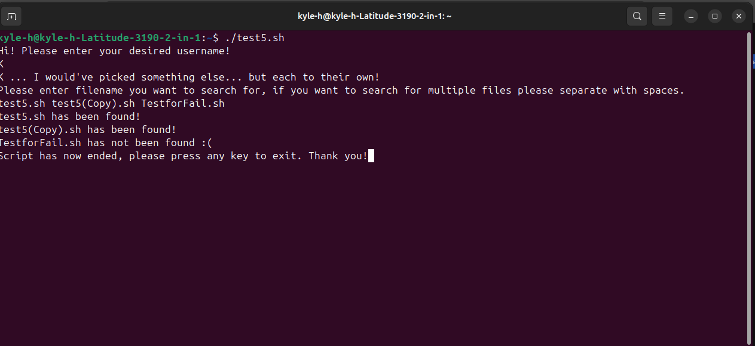
As shown above the script works in terminal and will provide different responses depending on whether the file can be found or not.

Conclusion
My report started with the key functions of an operating system, research was put into the investigation, and combined with my preexisting general understanding, I used new tools like performance monitor to keep tabs on my device.
I then used windows CLI commands, I used approximately a variety of different bash commands, to extend the result of my findings, the code included, process management, file and directory management, network monitoring and testing, user management and finally task scheduling. This task made it clear of their use and developed my understanding.
Further into the report I used Linux OS CLI commands, but used it similarly to the previous windows task, this was to develop a deeper understanding of different languages, their advantages and disadvantages, and further my confidence in operating systems and not just windows.
Next was the use of windows OS scripts, I demonstrated the key features of a windows OS script language and documented the use of PowerShell showing code and output and gave brief explanations.
Finally, I wanted to do something similar for Linux, I demonstrated they key features of a Linux OS by documenting by use of bash scripts with screenshots, and giving brief explanations .

References

[1] | BBC Bitesize, “Computer Systems - AQA,” BBC , [Online]. Available: https://www.bbc.co.uk/bitesize/guides/zkkkw6f/revision/6#:~:text=controlling%20hardware,managing%20security. [Accessed 9 Feb 2026].
[2] | A. Mishra, “3 Ways to Open Reource Monitor on Windows 11,” Guiding Tech, 15 Jul 2024. [Online]. Available: https://www.guidingtech.com/how-to-open-resource-monitor-in-windows/. [Accessed 11 Feb 2026].
[3] | geeksforgeeks, “Functions of Operating system,” Geeks for Geeks, 16 Oct 2025. [Online]. Available: https://www.geeksforgeeks.org/operating-systems/functions-of-operating-system/. [Accessed 11 Feb 2026].
[4] | TheWindowsClub, “How to use Perfmon or Performance Monitor in Windows 11,” TheWindowsClub, 14 Jan 2026. [Online]. Available: https://www.thewindowsclub.com/how-to-use-perfmon-performance-monitor-windows#google_vignette. [Accessed 11 Feb 2026].
[5] | Microsoft, “whoami,” Microsoft, 26 05 2025. [Online]. Available: https://learn.microsoft.com/en-us/windows-server/administration/windows-commands/whoami. [Accessed 05 05 2026].
[6] | Microsoft, “netstat,” Microsoft, 11 01 2024. [Online]. Available: https://learn.microsoft.com/en-us/windows-server/administration/windows-commands/netstat. [Accessed 05 05 2026].
[7] | Microsoft, “Windows Commands,” Microsoft, 24 02 2026. [Online]. Available: https://learn.microsoft.com/en-us/windows-server/administration/windows-commands/windows-commands. [Accessed 05 05 2026].
[8] | SS64, “An A-Z Index of the Linux command line: bash + utilities.,” SS64, [Online]. Available: https://ss64.com/bash/. [Accessed 06 05 2026].
[9] | tutorialspoint, “Powershell - Array,” tutorialspoint, [Online]. Available: https://www.tutorialspoint.com/powershell/powershell_array.htm. [Accessed 09 May 2026].
[10] | S. J. Bigelow, “What is PowerShell and how to use it: The ultimate tutorial,” TechTarget, 16 March 2023. [Online]. Available: https://www.techtarget.com/searchwindowsserver/definition/PowerShell. [Accessed 09 May 2026].
[11] | Microsoft Build 2026, “Everything you wanted to know about the if statement,” Microsoft, 19 January 2026. [Online]. Available: https://learn.microsoft.com/en-us/powershell/scripting/learn/deep-dives/everything-about-if?view=powershell-7.6. [Accessed 09 May 2026].
[12] | Microsoft Learn, “about switch,” Microsoft, 18 January 2026. [Online]. Available: https://learn.microsoft.com/en-us/powershell/module/microsoft.powershell.core/about/about_switch?view=powershell-7.5. [Accessed 09 May 2026].
[13] | Microsoft Learn, “Chapter 9 - Functions,” Microsoft , 06 February 2026. [Online]. Available: https://learn.microsoft.com/en-us/powershell/scripting/learn/ps101/09-functions?view=powershell-7.6. [Accessed 09 May 2026].
[14] | GeeksforGeeks, “bash scripting fundamentals.,” GeeksforGeeks, 07 May 2026. [Online]. Available: https://www.geeksforgeeks.org/linux-unix/bash-scripting-introduction-to-bash-and-bash-scripting/. [Accessed 11 May 2027].
[15] | GeeksforGeeks, “Bash Scripting - Array,” GeeksforGeeks, 13 April 2022. [Online]. Available: https://www.geeksforgeeks.org/linux-unix/bash-scripting-array/. [Accessed 11 May 2026].
[16] | GeeksforGeeks, “Bash Scripting - For Loop,” GeeksforGeeks, 15 Sep 2023. [Online]. Available: https://www.geeksforgeeks.org/linux-unix/bash-scripting-for-loop/. [Accessed 11 May 2026].
[17] | Wikipedia, “batch file,” Wikipedia, 22 March 2026. [Online]. Available: https://en.wikipedia.org/wiki/Batch_file. [Accessed 08 may 2026].

